UNITED STATES

SECURITIES AND EXCHANGE COMMISSION

Washington, D.C. 20549

FORM 6-K

REPORT OF FOREIGN PRIVATE ISSUER

PURSUANT TO RULE 13a-16 OR 15d-16

UNDER THE SECURITIES EXCHANGE ACT OF 1934

For the month of March 2026

Commission File Number: 001-40370

BITFARMS LTD.

(Translation of registrant’s name into English)

110 Yonge Street, Suite 1601, Toronto, Ontario, Canada M5C 1T4

(Address of principal executive offices)

Indicate by check mark whether the registrant files or will file annual reports under cover of Form 20-F or Form 40-F.

Form 20-F ☐ Form 40-F ☒

SIGNATURE

Pursuant to the requirements of the Securities Exchange Act of 1934, the registrant has duly caused this report to be signed on its behalf by the undersigned, thereunto duly authorized.

BITFARMS LTD.

By: /s/ Rachel Silverstein

Name: Rachel Silverstein

Title: General Counsel

Date: March 6, 2026

1

FORM 6-K EXHIBIT INDEX

Exhibits
Exhibit No. |  | Description
99.1 |  | Voting Reminder
99.2 |  | Material Change Report dated March 5, 2026

2

Exhibit 99.1
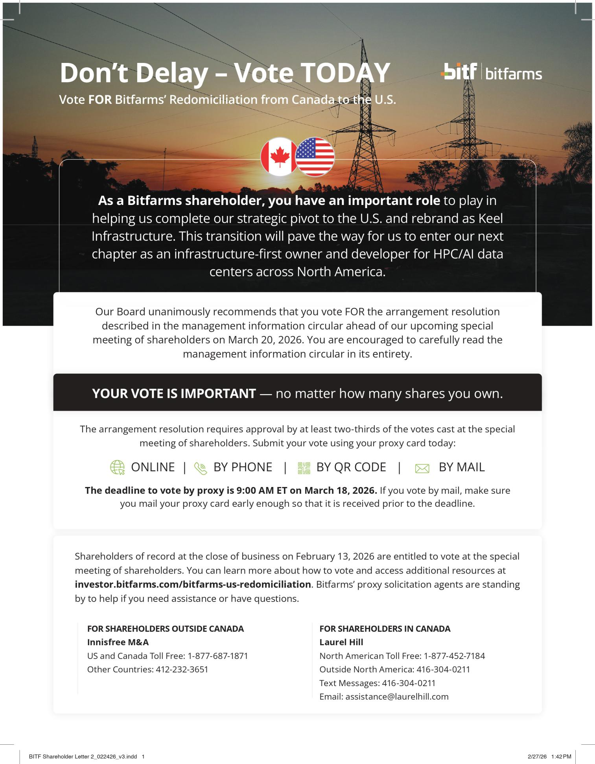

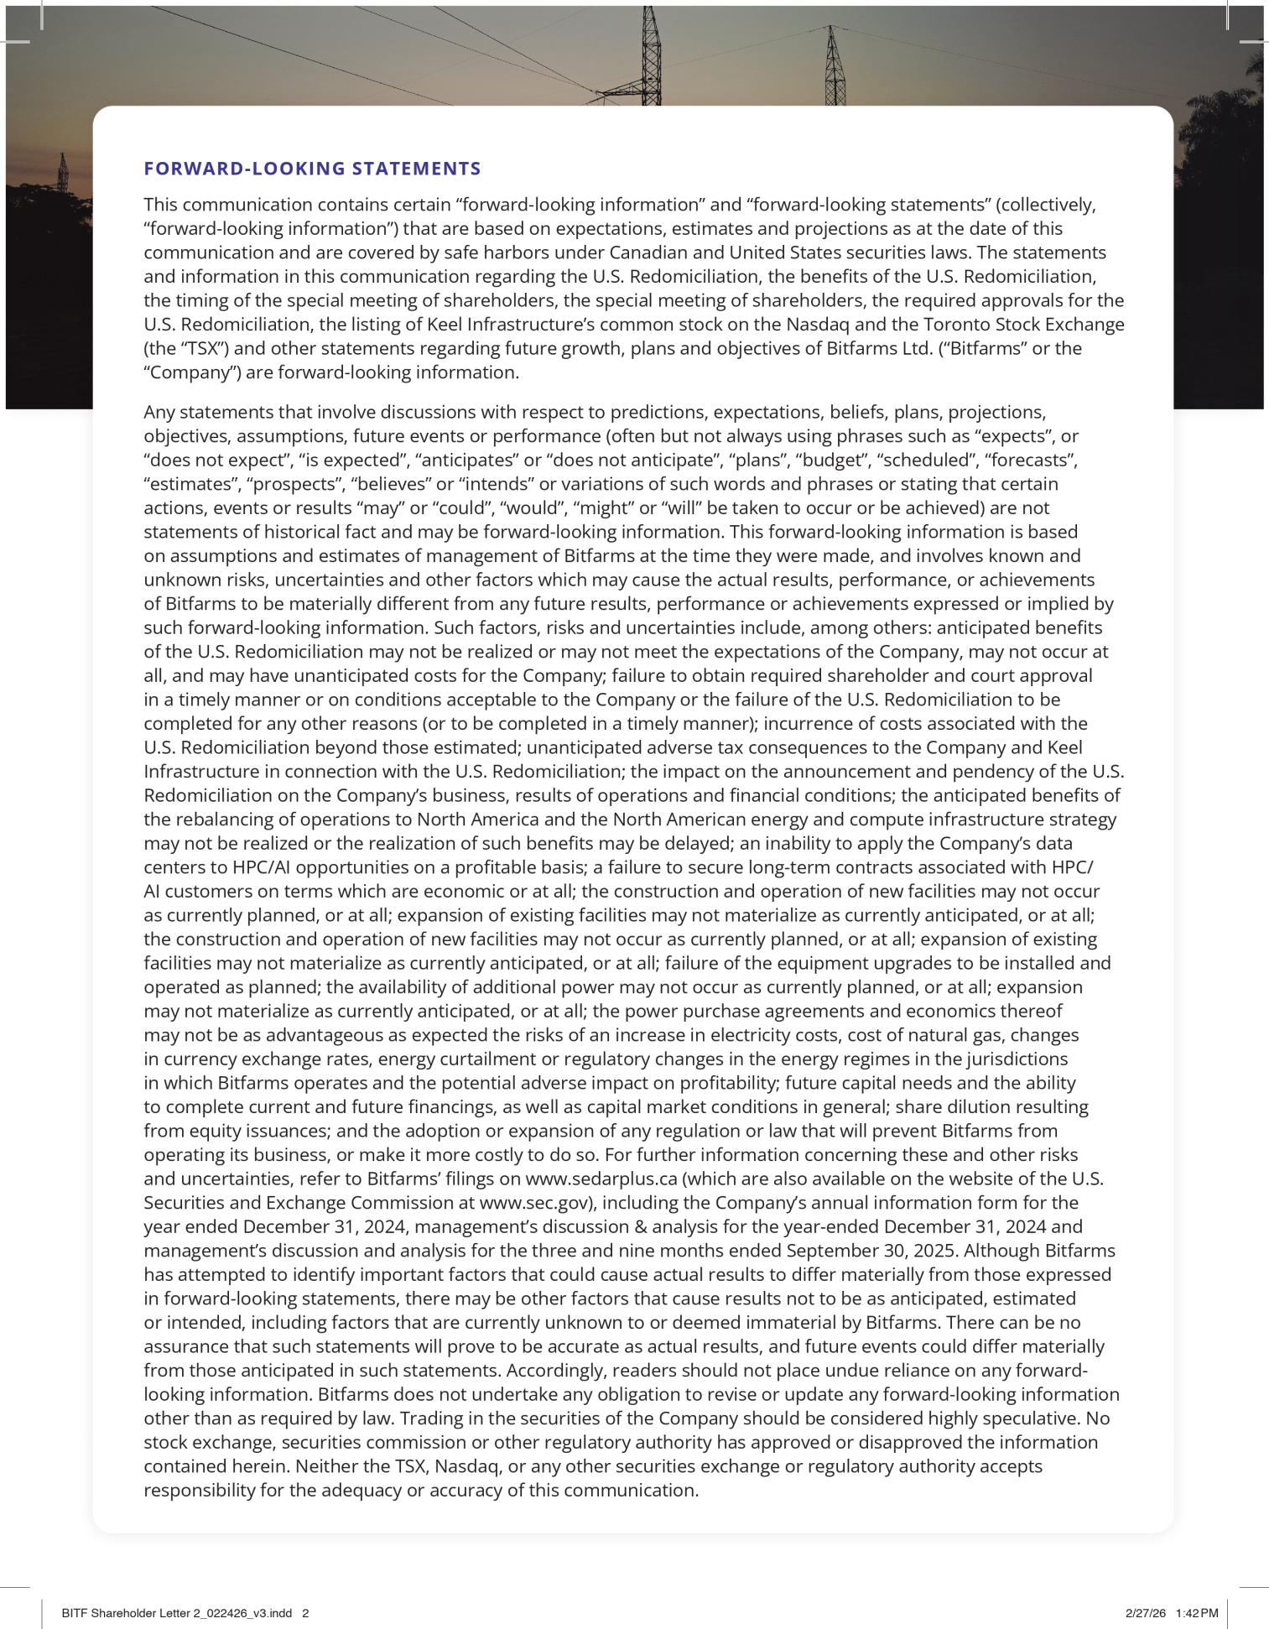

Exhibit 99.2

FORM 51-102F3

MATERIAL CHANGE REPORT

Item 1 Name and Address of Company

Bitfarms Ltd. (“Bitfarms” or the “Company”)

110 Yonge Street, Suite 1601

Toronto, Ontario M5C 1T4

Item 2 Date of Material Change

March 5, 2026

Item 3 News Release

The press release attached as Schedule “A” was released on March 5, 2026 by a newswire company in Canada.

Item 4 Summary of Material Change

The material change is described in the press release attached as Schedule “A”.

Item 5 Full Description of Material Change

The material change is described in the press release attached as Schedule “A”.

Item 6 Reliance of subsection 7.1(2) of National Instrument 51-102

Not applicable.

Item 7 Omitted Information

Not applicable.

Item 8 Executive Officer

Ben Gagnon

Chief Executive Officer

Bitfarms Ltd.

Bgagnon@bitfarms.com

+1 (647) 259-1790

Item 9 Date of Report

March 5, 2026

Schedule “A”


Independent Proxy Advisory Firms, Including ISS, Recommend Bitfarms Shareholders Vote FOR U.S. Redomiciliation

Recommendation Highlights Compelling Strategic Rationale for U.S. Redomiciliation

Board of Directors Encourages Shareholders to Vote FOR the Arrangement Resolution Today

TORONTO, Ontario and NEW YORK, March 5, 2026 -- Bitfarms Ltd. (NASDAQ/TSX: BITF) (“Bitfarms” or the “Company”), a North American digital infrastructure and energy company, today announced that the leading independent proxy advisory firms, including Institutional Shareholder Services Inc. (“ISS”), have recommended shareholders vote FOR the special resolution (the “Arrangement Resolution”) to approve Bitfarms’ U.S. redomiciliation (the “U.S. Redomiciliation”) ahead of the Company’s upcoming special meeting of shareholders (the “Meeting”) to be held at 9:00 a.m. (Eastern Time) on March 20, 2026.

In its report, ISS noted*:

“The company presents a strong economic rationale for the Redomiciliation: better access to U.S. capital, potential inclusion in additional indices, mitigation of regulatory and political risk, alignment with U.S. shareholder and customer requirements, and the transition from foreign private issuer to domestic SEC filer status.”

CEO Ben Gagnon said, “We are pleased that ISS supports our Board’s unanimous recommendation that shareholders vote to approve our U.S. redomiciliation plan. ISS’s report is an endorsement of the compelling strategic rationale for this transition and the value creation opportunities it will unlock as we complete our transformation from an international Bitcoin miner to a North American digital infrastructure and energy company, Keel Infrastructure. With the Meeting fast approaching, the Board urges shareholders to cast their votes FOR the Arrangement Resolution today.”

Your Vote is Important – No Matter How Many Shares You Own

The Arrangement Resolution requires approval by at least two-thirds of the votes cast at the Meeting. Shareholders can access the Meeting by visiting https://virtual-meetings.tsxtrust.com/1891 (password: bitfarms2026). The Company has fixed the close of business on February 13, 2026, as the record date for determining those shareholders entitled to receive notice of and to vote at the Meeting. Even if you plan to attend the Meeting, the Company recommends that you vote your shares in advance of the proxy deadline of 9:00 a.m. (Eastern Time) on March 18, 2026.

Additional details about how to vote can be found in the management information circular (the “Circular”) and related documents that have been mailed to shareholders, filed with the Canadian securities regulatory authorities and made available under the Company’s SEDAR+ and EDGAR profiles at www.sedarplus.com, and www.sec.gov. The Circular can also be accessed at investor.bitfarms.com/bitfarms-us-redomiciliation.

2

If you need assistance or have questions about how to vote your shares, Bitfarms’ proxy solicitation agents are standing by to help. Shareholders in Canada can contact Laurel Hill Advisory Group by phone at 1-877-452-7184 (North American toll free) or 416-304-0211 (outside North America), by texting “INFO” to either number, or by email at assistance@laurelhill.com. Shareholders outside of Canada can contact Innisfree M&A Incorporated by phone at 1-877-687-1871 (for U.S. and Canada toll free) or 412-232-3651 (other countries).

The terms and conditions of the U.S. Redomiciliation have been disclosed in further detail in the Circular. Shareholders are encouraged to carefully read the Circular in its entirety.

- Permission to use quotations was neither sought nor obtained.

About Bitfarms Ltd.

Bitfarms is a North American digital infrastructure and energy company that develops, owns, and operates data centers and energy infrastructure for high-performance computing and next-generation-technology applications, including artificial intelligence. We currently maintain our legacy North American Bitcoin mining operations to fund our development.

Bitfarms’ 2.1 GW North American energy portfolio is comprised of energized, under development, and pipeline MW, located in established data center clusters, with robust access to power and fiber infrastructure.

Bitfarms is headquartered in New York, NY and Toronto, ON and traded on the Nasdaq and Toronto Stock Exchange.

To learn more about Bitfarms’ events, developments, and online communities:

www.bitfarms.com

http://x.com/Bitfarms io

https://www.linkedin.com/company/bitfarms/

3

Forward-Looking Statements

This news release contains certain “forward-looking information” and “forward-looking statements” (collectively, “forward-looking information”) that are based on expectations, estimates and projections as at the date of this news release and are covered by safe harbors under Canadian and United States securities laws. The statements and information in this release regarding the U.S. Redomiciliation, the benefits of the U.S. Redomiciliation, the timing of the Meeting, and other statements regarding future growth, plans and objectives of Bitfarms are forward-looking information.

Any statements that involve discussions with respect to predictions, expectations, beliefs, plans, projections, objectives, assumptions, future events or performance (often but not always using phrases such as “expects”, or “does not expect”, “is expected”, “anticipates” or “does not anticipate”, “plans”, “budget”, “scheduled”, “forecasts”, “estimates”, “prospects”, “believes” or “intends” or variations of such words and phrases or stating that certain actions, events or results “may” or “could”, “would”, “might” or “will” be taken to occur or be achieved) are not statements of historical fact and may be forward-looking information. This forward-looking information is based on assumptions and estimates of management of Bitfarms at the time they were made, and involves known and unknown risks, uncertainties and other factors which may cause the actual results, performance, or achievements of Bitfarms to be materially different from any future results, performance or achievements expressed or implied by such forward-looking information. Such factors, risks and uncertainties include, among others: anticipated benefits of the U.S. Redomiciliation, including, but not limited to, expanded access to new capital pools, increased eligibility for index inclusion, strengthened commercial positioning with governmental bodies, utility partners and potential customers, enhanced alignment with U.S. customer requirements for data centers, reduced regulatory and political risk related to critical infrastructure and sensitive-data businesses, greater familiarity of Delaware law to U.S. investors and simplified comparison to other U.S. companies and peers, may not be realized or may not meet the expectations of the Company, may not occur at all, and may have unanticipated costs for the Company; the anticipated benefits of a recommendation of ISS in favor of the Arrangement Resolution may not be realized; failure to obtain required shareholder, and court approval in a timely manner or on conditions acceptable to the Company or the failure of the U.S. Redomiciliation to be completed for any other reasons (or to be completed in a timely manner); incurrence of costs associated with the U.S. Redomiciliation beyond those estimated; unanticipated adverse tax consequences to the Company and Keel Infrastructure in connection with the U.S. Redomiciliation; the impact on the announcement and pendency of the U.S. Redomiciliation on the Company’s business, results of operations and financial conditions; the anticipated benefits of the rebalancing of operations to North America and the North American energy and compute infrastructure strategy may not be realized or the realization of such benefits may be delayed; an inability to apply the Company’s data centers to HPC/AI opportunities on a profitable basis; a failure to secure long-term contracts associated with HPC/AI customers on terms which are economic or at all; the construction and operation of new facilities may not occur as currently planned, or at all; expansion of existing facilities may not materialize as currently anticipated, or at all; the construction and operation of new facilities may not occur as currently planned, or at all; expansion of existing facilities may not materialize as currently anticipated, or at all; failure of the equipment upgrades to be installed and operated as planned; the availability of additional power may not occur as currently planned, or at all; expansion may not materialize as currently anticipated, or at all; the power purchase agreements and economics thereof may not be as advantageous as expected the risks of an increase in electricity costs, cost of natural gas, changes in currency exchange rates, energy curtailment or regulatory changes in the energy regimes in the jurisdictions in which Bitfarms operates and the potential adverse impact on profitability; future capital needs and the ability to complete current and future financings, as well as capital market conditions in general; share dilution resulting from equity issuances; and the adoption or expansion of any regulation or law that will prevent Bitfarms from operating its business, or make it more costly to do so. For further information concerning these and other risks and uncertainties, refer to Bitfarms’ filings on www.sedarplus.ca (which are also available on the website of the U.S. Securities and Exchange Commission at www.sec.gov), including the Company’s annual information form for the year ended December 31, 2024, management’s discussion & analysis for the year-ended December 31, 2024 and management’s discussion and analysis for the three and nine months ended September 30, 2025. Although Bitfarms has attempted to identify important factors that could cause actual results to differ materially from those expressed in forward-looking statements, there may be other factors that cause results not to be as anticipated, estimated or intended, including factors that are currently unknown to or deemed immaterial by Bitfarms. There can be no assurance that such statements will prove to be accurate as actual results, and future events could differ materially from those anticipated in such statements. Accordingly, readers should not place undue reliance on any forward-looking information. Bitfarms does not undertake any obligation to revise or update any forward-looking information other than as required by law. Trading in the securities of the Company should be considered highly speculative. No stock exchange, securities commission or other regulatory authority has approved or disapproved the information contained herein. Neither the TSX, Nasdaq, or any other securities exchange or regulatory authority accepts responsibility for the adequacy or accuracy of this release.

Investor Relations Contact: | Media Contact:
Laine Yonker | Tara Goldstein
investors@bitfarms.com | media@bitfarms.com
 | 4

