UNITED STATES
SECURITIES AND EXCHANGE COMMISSION
Washington, D.C. 20549

FORM 6-K

REPORT OF FOREIGN PRIVATE ISSUER
PURSUANT TO RULE 13a-16 OR 15d-16
UNDER THE SECURITIES EXCHANGE ACT OF 1934

For the month of February 2026

Commission File Number: 001-40370

BITFARMS LTD.
(Translation of registrant’s name into English)

110 Yonge Street, Suite 1601, Toronto, Ontario, Canada M5C 1T4
(Address of principal executive offices)

Indicate by check mark whether the registrant files or will file annual reports under cover of Form 20-F or Form 40-F.

Form 20-F ☐ Form 40-F ☒

SIGNATURE

Pursuant to the requirements of the Securities Exchange Act of 1934, the registrant has duly caused this report to be signed on its behalf by the undersigned, thereunto duly authorized.

 | BITFARMS LTD.
 | By: | /s/ Rachel Silverstein
 |  | Name: | Rachel Silverstein
 |  | Title: | General Counsel

Date: February 24, 2026

1

FORM 6-K EXHIBIT INDEX

Exhibits

Exhibit No. |  | Description
99.1 |  | Notice of Special Meeting of Shareholders and Management Proxy Circular dated February 17, 2026.
99.2 |  | Letter of Transmittal for the Special Meeting of Shareholders on March 20, 2026
99.3 |  | Form of Proxy for the Special Meeting of Shareholders on March 20, 2026
99.4 |  | Letter to Shareholders
99.5 |  | Press release dated Feburary 24, 2026

2

Exhibit 99.1



February 17, 2026

Dear fellow Shareholders:

You are invited to attend a special meeting (such meeting and any adjournments and postponements thereof referred to as the “Meeting”) of the holders (the “Bitfarms Canada Shareholders”) of common shares (the “Bitfarms Canada Shares”) in the capital of Bitfarms Ltd. (“Bitfarms Canada” or the “Corporation”) to be held virtually at the following web link: https://virtual-meetings.tsxtrust.com/1891 (password: bitfarms2026) on March 20, 2026 at 9:00 a.m. (Eastern Time).

The U.S. Redomiciliation

At the Meeting, Bitfarms Canada Shareholders will be asked to consider a special resolution (the “Arrangement Resolution”) to approve the proposed plan of arrangement (the “Arrangement”) under the Business Corporations Act (Ontario) involving, among others, Bitfarms Canada, Bitfarms Canada Securityholders and Keel Infrastructure Corp. (“Keel”), a newly incorporated corporation formed under the laws of the State of Delaware in the United States of America that will be the ultimate parent company of Bitfarms Canada and its subsidiaries as a result of the Arrangement (the “U.S. Redomiciliation”). Pursuant to the Arrangement, (i) Keel, indirectly through 1576430 B.C. Unlimited Liability Company, will acquire all of the issued and outstanding Bitfarms Canada Shares in exchange for one share of common stock, par value U.S.$0.001 per share, of Keel (“Keel Common Stock”) per Bitfarms Canada Share; and (ii) Incentive Unitholders (as defined in the enclosed management information circular dated February 17, 2026 (the “Circular”)) will exchange existing incentive units for replacement incentive units in respect of Keel Common Stock, as more fully described in the enclosed Circular.

Board of Directors Recommendation

The board of directors of Bitfarms Canada (the “Bitfarms Canada Board”) unanimously recommends that Bitfarms Canada Shareholders vote FOR the Arrangement Resolution. In making its determination that the U.S. Redomiciliation is in the best interests of Bitfarms Canada, and in recommending that Bitfarms Canada Shareholders vote in favour of the Arrangement Resolution, the Bitfarms Canada Board considered and relied upon a number of factors, including, among others, the following:

 | ● | U.S. Strategic Focus – The U.S. Redomiciliation is consistent with Bitfarms Canada’s increasingly strategic focus on carrying on business in the U.S. including its strategic pivot from an international Bitcoin miner to a North American energy and digital infrastructure company, and is undertaken following its previously announced commitment to convert to U.S. GAAP. As part of this U.S. focus, Bitfarms Canada has established a second principal executive office in New York City, and continues to expand its U.S. operations and U.S.-based high-performance computing/artificial intelligence (“HPC/AI”) infrastructure, including through the conversion of its Washington site to HPC/AI workloads and the development of its Panther Creek data centre campus in Pennsylvania, and the rebalancing of its energy portfolio to 100% North American assets as illustrated by its recently announced agreement to divest its 70 MW site in Paso Pe, Paraguay.

 | ● | Access to Capital Pools in the U.S. – The Bitfarms Canada Board believes that the opportunity to enhance long-term value for Bitfarms Canada Shareholders will be greater as a U.S.-domiciled company than as a Canada-domiciled company. As a corporation governed by the laws of the Province of Ontario, Bitfarms Canada is unable to access certain pools of capital in the United States that are limited in their ability to invest in securities of foreign companies.

 | ● | Index Inclusion – Following the U.S. Redomiciliation, as a U.S. company, Keel may be able to attract deeper pools of passive investment capital in the U.S., particularly if and when Keel Common Stock becomes eligible for inclusion in U.S. stock market indices, such as the Russell 3000, and other investment vehicles that only include securities of U.S.-domiciled companies.

 | ● | Commercial Benefits from U.S. Domiciliation – The U.S. Redomiciliation is expected to offer tangible commercial benefits that are expected to include: enhanced positioning as a U.S.-domestic entity when pursuing local, state and federal permits and approvals; improved access to, and business relationships with, the regulated utility companies that Bitfarms Canada will need to partner with to provide capacity and energy to its development sites; and reduced complexity for potential U.S. customers evaluating Bitfarms Canada as a potential supplier of HPC/AI infrastructure capacity, given their familiarity with U.S. corporate law, U.S. public disclosure requirements and U.S. GAAP.

 | ● | Alignment with U.S. Customer Requirements – Certain U.S. enterprises, including those in the healthcare, critical infrastructure and defense-industrial sectors, prefer or require that data centres be owned and operated by U.S.-domiciled companies because such enterprises consider data held at such data centres to be at lower risk of being accessed by foreign parties, including sensitive data with potential security consequences. As a U.S.-domiciled company, Keel may be able to avoid the friction and expense associated with negotiating requirements such as governance rights limitations, security agreements and ongoing monitoring arrangements that are typically required of foreign entities.

 | ● | Mitigation of Regulatory and Political Risk – U.S. critical infrastructure and/or sensitive-data businesses that are owned by companies domiciled outside of the United States may be subject to heightened scrutiny under the Committee of Foreign Investment in the United Status (CFIUS) review process and increased political attention. The U.S. Redomiciliation may reduce exposure of Bitfarms Canada’s business to these risks.

 | ● | Familiarity of Delaware Law to U.S. Investors – Many U.S. public companies are incorporated in Delaware including several of Keel’s peer group companies. The Bitfarms Canada Board believes that U.S. investors generally have greater familiarity with Delaware corporate law and the U.S. domestic issuer reporting regime applicable to U.S. public companies, as compared to Ontario corporate law and the reporting requirements under Canadian securities laws. Delaware’s corporate framework is also well understood by market participants, with more than 67% of Fortune 500 companies incorporated in Delaware. Among other things, Delaware courts have over a century of experience addressing major corporate law issues and are responsible for establishing many of the modern doctrines that govern corporate law and corporate governance throughout the world. Delaware boasts a well-respected business court, the Court of Chancery, and the State has the largest body of corporate case law in the United States. All of these factors create familiarity and predictability. This familiarity could make Keel Common Stock a more attractive investment for U.S. investors, which could increase demand for Keel Common Stock as compared to Bitfarms Canada Shares prior to the U.S. Redomiciliation, and thereby provide opportunities for increased value to current stockholders.

 | ● | Comparability to U.S. Public Companies – Keel will be a Delaware corporation. The Bitfarms Canada Board believes that incorporation in Delaware may provide greater comparability to other U.S. public companies, many of which are incorporated in Delaware, including many of Bitfarms Canada’s peer group companies.

 | ● | Minimal Disruption to Operations – Keel and its subsidiaries will continue to carry on the business currently carried on by Bitfarms Canada and its subsidiaries. The U.S. Redomiciliation is not currently expected to result in any further changes in business, jobs, management, operations, properties, locations of any offices or facilities or number of employees. Following the U.S. Redomiciliation, Canadian holders of Keel Common Stock will retain access to trading on the TSX. The TSX has conditionally approved the listing of the Keel Common Stock on the TSX, and the Bitfarms Canada Board expects that, as soon as possible following the U.S. Redomiciliation, the Keel Common Stock will be listed on the TSX.

 | ● | Approval of Bitfarms Canada Shareholders - The Arrangement is subject to Bitfarms Canada Shareholder approval.

 | ● | Court Approval - The Arrangement must be approved by the Court, which will consider whether the Arrangement is fair and reasonable.

 | ● | Dissent Rights - Registered Bitfarms Canada Shareholders will have the ability to exercise Dissent Rights in respect of the Arrangement and to receive fair value for their Bitfarms Canada Shares.

The background for the U.S. Redomiciliation together with a summary of the reasons and certain other factors we considered in making our recommendation that Bitfarms Canada Shareholders vote FOR the Arrangement Resolution are described in more detail in the Circular.

Tax Treatment

The U.S. Redomiciliation may have different tax consequences for Bitfarms Canada Shareholders resident in Canada and the United States. Bitfarms Canada Shareholders are urged to carefully read the sections of the Circular entitled “Certain Canadian Federal Income Tax Considerations” and “Certain U.S. Federal Income Tax Considerations”, as applicable, and to consult with their own tax advisors.

Arrangement Completion Date

Subject to obtaining required approvals, as well as the satisfaction of all other conditions precedent, if Bitfarms Canada Shareholders approve the Arrangement Resolution, it is anticipated that the Arrangement will be completed on or about April 1, 2026.

Please refer to the Circular for a more detailed description of the Arrangement and a more detailed description of Bitfarms Canada’s reasons for the U.S. Redomiciliation and the risk factors relating to the U.S. Redomiciliation. Please give the Circular your careful consideration and consult your financial, tax or other professional advisors regarding the consequences of the Arrangement to you.

The Bitfarms Canada Board unanimously recommends that Bitfarms Canada Shareholders vote FOR the Arrangement Resolution.

Voting

The Bitfarms Canada Board has fixed February 13, 2026 as the record date (the “Record Date”) for determining the Bitfarms Canada Shareholders who are entitled to receive notice of and vote at the Meeting. Only Bitfarms Canada Shareholders whose names have been entered in the registers of Bitfarms Canada as at the close of business on the Record Date will be entitled to receive notice of and vote at the Meeting.

We are inviting Bitfarms Canada Shareholders to participate in the Meeting by accessing the virtual meeting platform at the following web link: https://virtual-meetings.tsxtrust.com/1891 (password: bitfarms2026). Participants should join at least fifteen (15) minutes prior to the scheduled start time. Bitfarms Canada has elected to hold the Meeting in this format in order to ensure Bitfarms Canada Shareholders have an equal opportunity to participate at the Meeting regardless of their geographic location.

All Bitfarms Canada Shareholders may attend the Meeting virtually or be represented by proxy. Bitfarms Canada Shareholders are requested to submit their vote prior to the proxy deadline of 9:00 a.m. (Eastern Time) on March 18, 2026. To be effective, Bitfarms Canada Shareholders must submit their vote by (i) Internet at www.voteproxyonline.com and entering their 12 digit control number, or (ii) depositing the enclosed form of proxy with TSX Trust Company (“TSX Trust”) by mail delivery at 301 - 100 Adelaide Street West, Toronto, Ontario M5H 4H1, or by facsimile at (416) 595-9593. In order to be valid and acted upon at the Meeting, the duly completed form of proxy must be received prior to 9:00 a.m. (Eastern Time) on March 18, 2026, or, if the Meeting is adjourned or postponed, be deposited with the Corporate Secretary of Bitfarms Canada or TSX Canada Trust, as Bitfarms Canada’s transfer agent, no later than 48 hours (excluding weekends and statutory holidays in Canada and the U.S.) before the Meeting is reconvened. Notwithstanding the foregoing, the Chair of the Meeting has the discretion to accept proxies received after such deadline.

A “beneficial” or “non-registered” Bitfarms Canada Shareholder will not be recognized directly at the Meeting for the purposes of voting Bitfarms Canada Shares registered in the name of its broker, custodian, nominee or other intermediary; however, a beneficial Bitfarms Canada Shareholder may attend the Meeting as proxyholder for the registered Bitfarms Canada Shareholder and vote its Bitfarms Canada Shares in that capacity. Only registered Bitfarms Canada Shareholders as of the Record Date are entitled to receive notice of and vote at the Meeting.

If you are a non-registered holder of Bitfarms Canada Shares and have received these materials through your broker, custodian, nominee or other intermediary, please complete and return the form of proxy or voting instruction form provided to you by your broker, custodian, nominee or other intermediary in accordance with the instructions provided therein.

Bitfarms Canada Shareholders are reminded to review the Circular before voting.

 | BENEFICIAL SHAREHOLDERS | REGISTERED SHAREHOLDERS
VOTING
METHOD | Bitfarms Canada Shares held with an  Intermediary. | Bitfarms Canada Shares held in own name and  represented by a physical certificate.
 | www.proxyvote.com | ONLINE: www.voteproxyonline.com
 | Call the toll-free number listed on your voting instruction form and vote using the control number provided therein. | FAX: 416-595-9593
 | Complete, date and sign the voting instruction form and return it in the enclosed postage paid envelope. | Complete, date and sign management’s form of proxy and return it in the enclosed postage paid envelope or hand deliver to:  TSX Trust Company  301-100 Adelaide Street  West Toronto, Ontario, M5H 4H1

If you require assistance with voting your Bitfarms Canada Shares, please contact Bitfarms Canada’s proxy solicitation agents: Bitfarms Canada Shareholders outside Canada should contact Innisfree M&A Incorporated, by telephone, toll-free from the U.S. and Canada at +1 (877) 687-1871 or at +1 (412) 232-3651 from other countries; and Bitfarms Canada Shareholders in Canada should contact Laurel Hill Advisory Group, by telephone or text message at 1-877-452-7184 toll-free in North America or at 416-304-0211 for collect calls or text messages outside of North America or by email at assistance@laurelhill.com.

(Signed) “Edith Hofmeister”
Edith Hofmeister
Chair of the Board

BITFARMS LTD.

NOTICE OF SPECIAL MEETING
OF SHAREHOLDERS & MANAGEMENT INFORMATION
CIRCULAR

March 20, 2026 at 9:00 a.m. (Eastern Time)

To be held virtually at

https://virtual-meetings.tsxtrust.com/1891 (password: bitfarms2026)

BITFARMS LTD.

110 Yonge Street, Suite 1601, Toronto, ON M5C 1T4

NOTICE OF SPECIAL MEETING OF SHAREHOLDERS

NOTICE IS HEREBY GIVEN that, pursuant to an order of the Ontario Superior Court of Justice (Commercial List) dated February 13, 2026 (the “Interim Order”), a special meeting (such meeting and any adjournments and postponements thereof referred to as the “Meeting”) of holders (“Bitfarms Canada Shareholders”) of common shares (“Bitfarms Canada Shares”) in the capital of Bitfarms Ltd. (“Bitfarms Canada” or the “Corporation”) will be held virtually at the following web link: https://virtual-meetings.tsxtrust.com/1891 (password: bitfarms2026), on March 20, 2026 at 9:00 a.m. (Eastern Time) for the following purposes, all as more particularly described in the enclosed management information circular of Bitfarms Canada (the “Circular”):

1. | to consider and, if deemed advisable, approve, with or without variation, a special resolution of the Bitfarms Canada Shareholders (the “Arrangement Resolution”) to approve the arrangement (the “Arrangement”) pursuant to Section 182 of the Business Corporations Act (Ontario) (the “OBCA”) to effect, among other things, the exchange of each existing Bitfarms Canada Share for one share of common stock of Keel Infrastructure Corp., a newly incorporated entity formed under the laws of the State of Delaware in the United States of America (“Keel”), that will be the ultimate parent company of Bitfarms Canada and its subsidiaries as a result of the Arrangement (the “U.S. Redomiciliation”), as more particularly described in the accompanying Circular; and

2. | to transact such other business as may properly come before the Meeting.

This notice of special meeting of Bitfarms Canada Shareholders (the “Notice of Special Meeting”) and the accompanying Circular are available on Bitfarms Canada’s website at www.bitfarms.com, on SEDAR+ at www.sedarplus.com and on EDGAR at www.sec.gov.

The board of directors of Bitfarms Canada have fixed the close of business on February 13, 2026 as the record date (the “Record Date”) for determining Bitfarms Canada Shareholders who are entitled to attend and vote at the Meeting. Only Bitfarms Canada Shareholders whose names have been entered in the register of Bitfarms Canada Shareholders as of the close of business on the Record Date are entitled to receive notice of and vote at the Meeting.

We are inviting Bitfarms Canada Shareholders to participate in the Meeting by accessing the virtual meeting platform at the following web link: https://virtual-meetings.tsxtrust.com/1891 (password: bitfarms2026). Participants should join at least fifteen (15) minutes prior to the scheduled start time. Bitfarms Canada has elected to hold the Meeting in this format in order to ensure Bitfarms Canada Shareholders have an equal opportunity to participate at the Meeting regardless of their geographic location.

All Bitfarms Canada Shareholders may attend the Meeting virtually or be represented by proxy. Bitfarms Canada Shareholders are requested to complete, date and sign the enclosed form of proxy and return it in the envelope provided. To be effective, Bitfarms Canada Shareholders must submit their vote by (i) Internet at www.voteproxyonline.com and entering their 12 digit control number, or (ii) depositing the enclosed form of proxy with TSX Trust by mail delivery at 301 - 100 Adelaide Street West, Toronto, Ontario M5H 4H1, or by facsimile at (416) 595-9593. In order to be valid and acted upon at the Meeting, the duly completed form of proxy must be received prior to 9:00 a.m. (Eastern Time) on March 18, 2026 or, if the Meeting is adjourned or postponed, be deposited with the Corporate Secretary of Bitfarms Canada or TSX Canada Trust, as Bitfarms Canada’s transfer agent, no later than 48 hours (excluding weekends and statutory holidays in Canada and the U.S.) before the Meeting is reconvened. Notwithstanding the foregoing, the Chair of the Meeting has the discretion to accept proxies received after such deadline.

A “beneficial” or “non-registered” Bitfarms Canada Shareholder will not be recognized directly at the Meeting for the purposes of voting Bitfarms Canada Shares registered in the name of its broker, custodian, nominee or other intermediary; however, a beneficial Bitfarms Canada Shareholder may attend the Meeting as proxyholder for the registered Bitfarms Canada Shareholder and vote its Bitfarms Canada Shares in that capacity. Only registered Bitfarms Canada Shareholders as of the Record Date are entitled to receive notice of and vote at the Meeting.

If you are a non-registered holder of Bitfarms Canada Shares and have received these materials through your broker, custodian, nominee or other intermediary, please complete and return the form of proxy or voting instruction form provided to you by your broker, custodian, nominee or other intermediary in accordance with the instructions provided therein.

Bitfarms Canada Shareholders are reminded to review the Circular before voting.

Pursuant to the Interim Order (as defined in the Circular), registered Bitfarms Canada Shareholders have been granted the right to dissent in respect of the Arrangement and to be paid an amount equal to the fair value of their Bitfarms Canada Shares. This dissent right, and the procedures for its exercise, are described in the Circular under the heading “The U.S. Redomiciliation – Dissenting Holder Rights”. Only registered Bitfarms Canada Shareholders are entitled to exercise the right to dissent. Failure to comply strictly with the dissent procedures described in the Circular will result in loss or unavailability of any right to dissent.

If you require assistance with voting your Bitfarms Canada Shares, please contact Bitfarms Canada’s proxy solicitation agents: Bitfarms Canada Shareholders outside Canada should contact Innisfree M&A Incorporated, by telephone, toll-free from the U.S. and Canada at +1 (877) 687-1871 or at +1 (412) 232-3651 from other countries; and Bitfarms Canada Shareholders in Canada should contact Laurel Hill Advisory Group, by telephone or text message at 1-877-452-7184 toll-free in North America or at 416-304-0211 for collect calls or text messages outside of North America or by email at assistance@laurelhill.com.

DATED February 17, 2026.

BY ORDER OF THE BOARD OF DIRECTORS
(Signed) “Edith Hofmeister”
Edith Hofmeister
Chair of the Board

Table of Contents

SOLICITATION OF PROXIES BY MANAGEMENT | 1
INFORMATION CONTAINED IN THIS CIRCULAR | 2
CAUTIONARY STATEMENT REGARDING FORWARD-LOOKING STATEMENTS | 2
NOTICE TO U.S. HOLDERS | 3
NOTICE TO HOLDERS RESIDENT OUTSIDE OF CANADA AND THE UNITED STATES | 5
CURRENCY AND EXCHANGE RATES | 5
DEFINED TERMS | 5
QUESTIONS AND ANSWERS ABOUT THE U.S. REDOMICILIATION AND THE MEETING | 5
SUMMARY | 14
THE MEETING | 14
THE ARRANGEMENT | 14
INFORMATION CONCERNING KEEL | 14
INFORMATION CONCERNING BITFARMS CANADA | 15
RECOMMENDATION OF THE BITFARMS CANADA BOARD | 15
PRINCIPAL TERMS OF THE U.S. REDOMICILIATION | 15
REASONS FOR THE U.S. REDOMICILIATION | 16
RISK FACTORS | 17
PARTICULARS OF THE ARRANGEMENT | 17
REQUIRED SHAREHOLDER APPROVAL | 18
CERTAIN LEGAL AND REGULATORY MATTERS | 18
DISSENTING HOLDER RIGHTS | 19
CERTAIN CANADIAN FEDERAL INCOME TAX CONSIDERATIONS | 19
CERTAIN U.S. FEDERAL INCOME TAX CONSIDERATIONS | 20
VOTING INFORMATION | 21
VOTING SHARES AND PRINCIPAL HOLDERS | 21
RECORD DATE AND ENTITLEMENT TO VOTE | 21
QUORUM | 21
PROXY VOTING | 21
TRANSFER AGENT | 22
VOTING VIRTUALLY AT THE MEETING | 22
APPOINTMENT AND REVOCATION OF PROXIES | 23
THE U.S. REDOMICILIATION | 25
BACKGROUND TO THE U.S. REDOMICILIATION | 25
RECOMMENDATION OF THE BITFARMS CANADA BOARD | 26
REASONS FOR THE U.S. REDOMICILIATION | 26
PARTICULARS OF THE ARRANGEMENT | 29
LETTER OF TRANSMITTAL | 30
PROCEDURE FOR THE EXCHANGE OF SHARES | 31
RETURN OF BITFARMS CANADA SHARES | 31
LOST CERTIFICATES | 31
CANCELLATION OF RIGHTS | 31
WITHHOLDING RIGHTS | 32
DEPOSITARY | 32
EXPENSES OF THE U.S. REDOMICILIATION | 32
REQUIRED SHAREHOLDER APPROVAL | 32
CERTAIN LEGAL AND REGULATORY MATTERS | 32
TREATMENT OF OUTSTANDING EQUITY AWARDS | 35
TREATMENT OF OUTSTANDING CONVERTIBLE DEBENTURES | 36
TREATMENT OF OUTSTANDING WARRANTS | 36
DISSENTING HOLDER RIGHTS | 36

i

SUMMARY OF THE ARRANGEMENT AGREEMENT | 39
CONDITIONS PRECEDENT TO THE ARRANGEMENT | 39
IMPLEMENTATION, INTERIM ORDER AND TERMS OF THE ARRANGEMENT | 39
TERMINATION | 39
INFORMATION CONCERNING KEEL | 40
GENERAL AND CORPORATE STRUCTURE | 40
BUSINESS | 40
DESCRIPTION OF KEEL CAPITAL STOCK | 40
SELECTED PRO FORMA CONDENSED CONSOLIDATED FINANCIAL INFORMATION | 44
DIRECTORS OF KEEL | 44
CORPORATE GOVERNANCE | 49
DIRECTOR AND EXECUTIVE COMPENSATION | 50
BENEFICIAL OWNERSHIP OF SECURITIES OF KEEL | 51
DIVIDENDS | 51
CONFLICTS OF INTEREST | 51
AUDITOR, REGISTRAR AND TRANSFER AGENT | 51
MATERIAL CONTRACTS | 51
INFORMATION CONCERNING BITFARMS CANADA | 51
GENERAL | 51
DOCUMENTS INCORPORATED BY REFERENCE | 53
BENEFICIAL OWNERSHIP OF BITFARMS CANADA SHARES | 54
DIVIDENDS | 54
PRIOR SALES | 54
MARKET PRICE AND TRADING VOLUME OF BITFARMS CANADA SHARES | 58
INTEREST OF INFORMED PERSONS IN MATERIAL TRANSACTIONS | 58
AUDITOR, REGISTRAR AND TRANSFER AGENT | 58
LEGAL MATTERS | 58
INTERESTS OF EXPERTS | 59
INFORMATION CONCERNING ACQUISITIONCO | 59
COMPARISON OF SHAREHOLDER RIGHTS | 59
CERTAIN CANADIAN FEDERAL INCOME TAX CONSIDERATIONS | 59
HOLDERS RESIDENT IN CANADA | 60
HOLDERS NOT RESIDENT IN CANADA | 62
ELIGIBILITY FOR INVESTMENT | 64
CERTAIN U.S. FEDERAL INCOME TAX CONSIDERATIONS | 64
U.S. FEDERAL INCOME TAX CONSEQUENCES OF THE U.S. REDOMICILIATION TO U.S. HOLDERS | 66
RISK FACTORS | 69
RISKS RELATING TO BITFARMS CANADA’S BUSINESS | 69
RISKS RELATING TO KEEL | 69
RISKS RELATING TO THE U.S. REDOMICILIATION | 73
ADDITIONAL INFORMATION | 77
APPROVAL | 78
GLOSSARY | 79

ii

Appendix A - ARRANGEMENT RESOLUTION | A-1
Appendix B – PLAN OF ARRANGEMENT | B-1
Appendix C – INTERIM ORDER | C-1
Appendix D – SECTION 185 OF THE OBCA | D-1
Appendix E – NOTICE OF APPLICATION FOR FINAL ORDER | E-1
Appendix F - COMPARISON OF SHAREHOLDER RIGHTS | F-1
Appendix G – FORM OF THE KEEL CERTIFICATE | G-1
Appendix H – FORM OF THE KEEL BYLAWS | H-1

iii

BITFARMS LTD.

MANAGEMENT INFORMATION CIRCULAR

SOLICITATION OF PROXIES BY MANAGEMENT

This management information circular (this “Circular”) is furnished in connection with the solicitation by the management (“Bitfarms Canada Management”) of Bitfarms Ltd. (“Bitfarms Canada” or the “Corporation”) of proxies to be used at the special meeting (such meeting and any adjournments and postponements thereof referred to as the “Meeting”) of the holders (the “Bitfarms Canada Shareholders”) of common shares of Bitfarms Canada (“Bitfarms Canada Shares”) to be held at the time and place and for the purposes set out in the notice of special meeting (“Notice of Special Meeting”) accompanying this Circular. It is expected that the solicitation will be made primarily by mail. However, officers and employees of Bitfarms Canada may also solicit proxies by telephone, e-mail or in person. These persons will receive no compensation for such solicitation, other than their ordinary salaries or fees. Bitfarms has also retained proxy solicitation agents, Innisfree M&A Incorporated and Laurel Hill Advisory Group (the “Proxy Solicitation Agents”) to assist in the solicitation of proxies. For these proxy solicitation services, Innisfree M&A Incorporated will receive an estimated fee of approximately $100,000 and Laurel Hill Advisory Group will receive an estimated fee of approximately C$125,000, plus, in each case, reimbursement of reasonable out-of-pocket expenses and fees for any additional services. The total cost of solicitation of proxies will be borne by Bitfarms Canada. Pursuant to National Instrument 54-101 - Communication with Beneficial Owners of Securities of a Reporting Issuer, arrangements have been made with Intermediaries to forward proxy-related materials to the beneficial owners of the Bitfarms Canada Shares. Bitfarms Canada will also reimburse Intermediaries for their expenses in sending proxy solicitation materials to the beneficial owners of Bitfarms Canada Shares and obtaining their proxies. See the section entitled “Voting Information – Appointment and Revocation of Proxies – Notice to Beneficial Bitfarms Canada Shareholders” below. Bitfarms Canada will provide, without cost to such person, upon request to the Corporate Secretary of Bitfarms Canada, additional copies of the foregoing documents for this purpose.

This Circular and related proxy materials are being sent to all Bitfarms Canada Shareholders. Bitfarms Canada will not send proxy-related materials directly to beneficial (non-registered) Bitfarms Canada Shareholders and is not relying on the notice-and-access provisions of applicable securities laws for delivery of proxy-related materials to Bitfarms Canada Shareholders. Bitfarms Canada will deliver proxy-related materials to Intermediaries, and they will be asked to promptly forward them to the beneficial Bitfarms Canada Shareholders. If you are a beneficial (non-registered) Bitfarms Canada Shareholder, your Intermediary should send you a voting instruction form or form of proxy with this Circular. Bitfarms Canada has elected to pay for the delivery of our proxy-related materials to objecting beneficial (non-registered) Bitfarms Canada Shareholders.

Bitfarms Canada has not authorized any person to give any information or to make any representation in connection with the U.S. Redomiciliation or any other matters to be considered at the Meeting other than those contained in this Circular. If any such information or representation is given or made, such information or representation should not be relied upon as having been authorized or as being accurate. For greater certainty, to the extent that any information provided on Bitfarms Canada’s website or by the Proxy Solicitation Agents is inconsistent with this Circular, the information provided in this Circular should be relied upon.

This Circular does not constitute an offer to buy, or a solicitation of an offer to sell, any securities, or the solicitation of a proxy, by any person in any jurisdiction in which such an offer or solicitation is not authorized or in which the person making such an offer or solicitation is not qualified to do so or to any person to whom it is unlawful to make such an offer or solicitation.

Bitfarms Canada Shareholders should not construe the contents of this Circular as legal, tax or financial advice and should consult with their own legal, tax, financial and other professional advisors.

All summaries of, and references to, the Arrangement Agreement and the Plan of Arrangement in this Circular are qualified in their entirety by, in the case of the Arrangement Agreement, the complete text of the Arrangement Agreement, a copy of which is available under Bitfarms Canada’s profile on SEDAR+ at www.sedarplus.com and on EDGAR at www.sec.gov, and in the case of the Plan of Arrangement, the complete text of the Plan of Arrangement, a copy of which is attached as Appendix B to this Circular. Bitfarms Canada Shareholders are urged to read carefully the full text of the Arrangement Agreement and the Plan of Arrangement.

BITFARMS | 2026 | Management Proxy Circular | Page 1

If you have any questions about the information contained in this Circular or require assistance in voting your Bitfarms Canada Shares, please contact Bitfarms Canada’s proxy solicitation agents: Bitfarms Canada Shareholders outside Canada should contact Innisfree M&A Incorporated, by telephone, toll-free from the U.S. and Canada at +1 (877) 687-1871 or at +1 (412) 232-3651 from other countries; and Bitfarms Canada Shareholders in Canada should contact Laurel Hill Advisory Group, by telephone or text message at 1-877-452-7184 toll-free in North America or at 416-304-0211 for collect calls or text messages outside of North America or by email at assistance@laurelhill.com.

Except as otherwise stated, the information contained in this Circular is given as of February 17, 2026.

INFORMATION CONTAINED IN THIS CIRCULAR

CAUTIONARY STATEMENT REGARDING FORWARD-LOOKING STATEMENTS

This Circular contains forward-looking statements about Bitfarms Canada and Keel’s objectives, plans, goals, aspirations, strategies, financial condition, results of operations, cash flows, performance, prospects, opportunities and legal and regulatory matters. Forward-looking statements are typically identified by words such as “expect”, “anticipate”, “believe”, “foresee”, “could”, “estimate”, “goal”, “intend”, “plan”, “seek”, “strive”, “will”, “may”, “maintain”, “achieve”, “grow”, “should” and similar expressions, as they relate to Bitfarms Canada and Keel.

Such forward-looking statements in this Circular include, but are not limited to, statements related to:

 | ● | information concerning the U.S. Redomiciliation;

 | ● | future financial performance and the future prospects of Bitfarms Canada’s business and operations;

 | ● | the likelihood of the U.S. Redomiciliation being completed;

 | ● | the principal steps of the Arrangement;

 | ● | the timing of the Meeting and the Final Order;

 | ● | Bitfarms Canada Shareholder approval and Court approval of the Arrangement;

 | ● | the listing of the Keel Common Stock on the Nasdaq and the TSX and the anticipated last day of trading of Bitfarms Canada Shares on the TSX and Nasdaq;

 | ● | the anticipated Effective Date;

 | ● | the timing of the implementation of the Plan of Arrangement and the potential benefits, risks and costs of the U.S. Redomiciliation;

 | ● | statements relating to the planned corporate, capital, governance, executive compensation and oversight structures of Keel and Bitfarms Canada before and following the U.S. Redomiciliation; and

 | ● | statements relating to the business and future activities of Keel and Bitfarms Canada after the date of this Circular.

BITFARMS | 2026 | Management Proxy Circular | Page 2

Forward-looking statements in this Circular are based on certain key expectations and assumptions made by Bitfarms Canada. Although Bitfarms Canada Management believes that the expectations and assumptions on which such forward-looking statements are based are reasonable, undue reliance should not be placed on the forward-looking statements because Bitfarms Canada can give no assurance that they will prove to be correct. The material assumptions upon which such forward-looking statements are based include, among others, assumptions with respect to:

 | ● | the ability to receive, in a timely manner and on satisfactory terms, Bitfarms Canada Shareholder approval and stock exchange and Court approvals for the Arrangement;

 | ● | successful listing of the Keel Common Stock on the Nasdaq and the TSX;

 | ● | general business, economic and market conditions;

 | ● | anticipated and unanticipated tax consequences of the Arrangement; and

 | ● | anticipated and unanticipated costs of the Arrangement.

Additionally, forward-looking statements are subject to various risks and uncertainties which could cause actual results and expectations to differ materially from the anticipated results or expectations expressed in this Circular. Important factors that could cause actual results and expectations to differ materially from those indicated by such forward-looking statements include, without limitation, the risks and uncertainties set forth under the section entitled “Risk Factors”, which are incorporated herein by reference. Some of the key risks and uncertainties include:

 | ● | failure to obtain required Bitfarms Canada Shareholder, stock exchange and other third-party approvals in a timely manner or on conditions acceptable to Bitfarms Canada or the failure of the U.S. Redomiciliation to be completed for any other reason (or to be completed in a timely manner);

 | ● | failure to achieve the perceived benefits of the U.S. Redomiciliation;

 | ● | incurrence of costs associated with the U.S. Redomiciliation beyond those estimated;

 | ● | unanticipated adverse tax consequences to Bitfarms Canada and Keel in connection with the U.S. Redomiciliation; and

 | ● | the impact of the announcement and pendency of the U.S. Redomiciliation on Bitfarms Canada’s business, results of operations, and financial condition.

The forward-looking statements contained in this Circular are expressly qualified in their entirety by the foregoing cautionary statements. The above is not an exhaustive list of the factors that may affect Bitfarms Canada’s forward-looking statements. For a more comprehensive discussion of factors that could affect Bitfarms Canada, refer to the risk factors discussed above. Other risks and uncertainties not presently known to Bitfarms Canada or that Bitfarms Canada presently believes are not material could also cause actual results or events to differ materially from those expressed, implied or projected in its forward-looking statements. Readers are cautioned not to place undue reliance on these forward-looking statements, which reflect Bitfarms Canada’s expectations only as of the date of this Circular. Except as required by law, Bitfarms Canada does not undertake to update or revise any forward-looking statements, whether as a result of new information, future events or otherwise.

NOTICE TO U.S. HOLDERS

THE ARRANGEMENT AND THE SECURITIES TO BE ISSUED IN CONNECTION WITH THE ARRANGEMENT HAVE NOT BEEN APPROVED OR DISAPPROVED BY THE SEC OR ANY SECURITIES REGULATORY AUTHORITY IN ANY STATE IN THE UNITED STATES, NOR HAVE THE SEC OR ANY SECURITIES REGULATORY AUTHORITY IN ANY STATE IN THE UNITED STATES PASSED ON THE ADEQUACY OR ACCURACY OF THIS CIRCULAR. ANY REPRESENTATION TO THE CONTRARY IS A CRIMINAL OFFENSE.

The issuance of Keel Common Stock and Replacement Incentive Units, in each case pursuant to the Arrangement, have not been and will not be registered under the U.S. Securities Act, or any U.S. state securities laws, and will be issued to applicable Bitfarms Canada Securityholders, in reliance upon the exemption from registration provided by section 3(a)(10) of the U.S. Securities Act (the “Section 3(a)(10) Exemption”). The Section 3(a)(10) Exemption exempts the issuance of any securities issued in exchange for one or more bona fide outstanding securities from the general requirement of registration where the terms and conditions of the issuance and exchange of such securities have been determined by a court of competent jurisdiction, expressly authorized by law to grant such approval, substantively and procedurally as fair to the recipients of the securities, after a hearing upon the fairness and reasonableness of the terms and conditions of such issuance and exchange at which all persons to whom it is proposed to issue the securities have the right to appear and receive timely and adequate notice thereof. See the section entitled “The U.S. Redomiciliation - Certain Legal and Regulatory Matters - Court Approval.”

BITFARMS | 2026 | Management Proxy Circular | Page 3

The shares of Keel Common Stock issued to Bitfarms Canada Shareholders in the United States pursuant to the Arrangement will not be registered under the U.S. Securities Act but will be freely tradeable under the U.S. Securities Act, except by persons who are “affiliates” (as defined in Rule 144 under the U.S. Securities Act) of Bitfarms Canada after the completion of the Arrangement or who were affiliates of Bitfarms Canada within ninety (90) days prior to the completion of the Arrangement. The shares of Keel Common Stock issued to Bitfarms Canada Shareholders who are such affiliates (or former affiliates) will be subject to certain restrictions on resale imposed by the U.S. Securities Act. See the section entitled “The U.S. Redomiciliation - Certain Legal and Regulatory Matters - Certain U.S. Securities Law Matters.”

The Section 3(a)(10) Exemption does not exempt the issuance of securities upon the exercise of securities that were previously issued pursuant to the Section 3(a)(10) Exemption. As a result, the shares of Keel Common Stock issuable upon exercise of the Replacement Incentive Units may not be issued in reliance upon the Section 3(a)(10) Exemption and the Replacement Incentive Units may only be exercised pursuant to an available exemption from the registration requirements of the U.S. Securities Act and applicable U.S. state securities laws or pursuant to a registration statement under the U.S. Securities Act. See the section entitled “The U.S. Redomiciliation - Certain Legal and Regulatory Matters - Certain U.S. Securities Law Matters.”

Bitfarms Canada Securityholders who are U.S. Holders (as defined under “Certain U.S. Federal Income Tax Considerations” below) should be aware that the Arrangement described herein may have both U.S. and Canadian tax consequences to them which may not be fully described in this Circular. For a general discussion of the Canadian and U.S. federal income tax consequences to investors who are U.S. Holders, see the section entitled “Certain Canadian Federal Income Tax Considerations” and “Certain U.S. Federal Income Tax Considerations.” U.S. Holders are urged to consult their own tax advisors with respect to such U.S. and Canadian income tax consequences and the applicability of any federal, state, local, foreign, and other tax laws.

Bitfarms Canada is a “foreign private issuer” within the meaning of Rule 3b-4 of the U.S. Exchange Act, and this solicitation of proxies is not subject to the proxy requirements of section 14(a) of the U.S. Exchange Act. Accordingly, the solicitation of proxies contemplated herein is made in accordance with Canadian corporate and securities laws, and this Circular has been prepared in accordance with the disclosure requirements of Canadian Securities Laws. Bitfarms Canada Shareholders located or resident in the United States should be aware that such Canadian disclosure requirements are different from those applicable to proxy statements, prospectuses or registration statements prepared in accordance with U.S. laws. The financial statements of Bitfarms Canada incorporated by reference herein have been prepared in accordance with IFRS and have been subject to Canadian generally accepted auditing standards. Accordingly, the financial statements of Bitfarms Canada may not be comparable to financial statements prepared in accordance with U.S. GAAP.

The enforcement by investors of civil liabilities under U.S. Securities Laws may be affected adversely by the fact that Bitfarms Canada is organized under the laws of a jurisdiction outside of the United States, that its officers and directors include residents of countries other than the United States, that some or all of the experts names in this Circular may be residents of countries other than the United States, or that a substantial portion of the assets of Bitfarms Canada and such persons are located outside the United States. As a result, it may be difficult or impossible for shareholders in the United States to effect service of process within the United States on Bitfarms Canada or such persons, or to realize against them upon judgments of courts of the United States predicted upon civil liabilities under the securities laws of the United States. In addition, the shareholders in the United States should not assume that the courts of Canada: (a) would enforce judgments of U.S. courts obtained in actions against such persons predicated upon civil liabilities under U.S. Securities Laws; or (b) would enforce, in original actions, liabilities against such persons predicated upon civil liabilities under U.S. Securities Laws.

BITFARMS | 2026 | Management Proxy Circular | Page 4

NOTICE TO HOLDERS RESIDENT OUTSIDE OF CANADA AND THE UNITED STATES

Bitfarms Canada is a reporting issuer in each of the provinces and territories in Canada and the Bitfarms Canada Shares are registered under the U.S. Exchange Act in the United States. Bitfarms Canada has prepared this Circular in accordance with Canadian disclosure standards and the Arrangement is to be carried out in accordance with the applicable laws in the Province of Ontario and the federal laws of Canada applicable therein.

Bitfarms Canada Shareholders who are not residents of Canada should be aware that the disposition of Bitfarms Canada Shares pursuant to the Arrangement, and the acquisition, holding and disposition of Keel Common Stock may have tax consequences in Canada, the U.S. and/or in the jurisdictions in which they are resident which may not be described fully herein. The tax treatment of such Bitfarms Canada Shareholders pursuant to the Arrangement is dependent on their individual circumstances and the tax jurisdiction applicable to such Bitfarms Canada Shareholders. It is recommended that Bitfarms Canada Shareholders consult their own tax advisors in this regard.

CURRENCY AND EXCHANGE RATES

The following table shows, for the periods and dates indicated, certain information regarding the Canadian dollar-to-U.S. dollar exchange rate. The information is based on the Canadian dollar-to-U.S. dollar daily average exchange rate reported by the Bank of Canada. Such exchange rate on February 13, 2026 was U.S.$1.00 = C$1.3614.

 |  | Period End |  |  |  | Average(1) |  |  |  | Low |  |  |  | High
Year ended December 31, (C$ per U.S.$)
2025 |  |  | 1.3706 |  |  |  | 1.3978 |  |  |  | 1.3558 |  |  |  | 1.4603
2024 |  |  | 1.4389 |  |  |  | 1.3698 |  |  |  | 1.3316 |  |  |  | 1.4416
2023 |  |  | 1.3226 |  |  |  | 1.3497 |  |  |  | 1.3128 |  |  |  | 1.3875
2022 |  |  | 1.3544 |  |  |  | 1.3013 |  |  |  | 1.2451 |  |  |  | 1.3856
2021 |  |  | 1.2678 |  |  |  | 1.2535 |  |  |  | 1.2040 |  |  |  | 1.2942
2020 |  |  | 1.2732 |  |  |  | 1.3415 |  |  |  | 1.2718 |  |  |  | 1.4496

Notes:

(1) | The average of the daily average exchange rates during the relevant period.

Except as otherwise stated, in this Circular, all dollar amounts are expressed in United States dollars.

DEFINED TERMS

This Circular contains defined terms. For a glossary of defined terms used herein, see the section entitled “Glossary.”

QUESTIONS AND ANSWERS ABOUT THE U.S. REDOMICILIATION AND THE MEETING

The following questions and answers are intended to briefly address some commonly asked questions regarding the U.S. Redomiciliation and matters to be addressed at the Meeting. These questions and answers may not address all questions that may be important to you. To better understand these matters, and for a description of the legal terms governing the U.S. Redomiciliation, you should carefully read this entire Circular, including the attached appendices, as well as the documents that have been incorporated by reference into this Circular. For more information, see the section entitled “Information Contained in this Circular”.

Q: Why am I receiving this Notice of Special Meeting and Circular?

As a Bitfarms Canada Shareholder as of the Record Date, you are receiving this Notice of Special Meeting and Circular in connection with the Meeting to be held on March 20, 2026 and the solicitation by or on behalf of the Bitfarms Canada Board and Bitfarms Canada Management of proxies of Bitfarms Canada Shareholders to vote on the Arrangement Resolution.

Q: When and Where will the Meeting be held?

The Meeting will be held virtually at the following web link: https://virtual-meetings.tsxtrust.com/1891 (password: bitfarms2026) on March 20, 2026 at 9:00 a.m. (Eastern Time).

BITFARMS | 2026 | Management Proxy Circular | Page 5

Q: What is the U.S. Redomiciliation?

On February 6, 2026, Bitfarms Canada announced a proposed Plan of Arrangement, which provides for, among other things, the exchange of each existing Bitfarms Canada Share for one share of Keel Common Stock.

The following summary highlights the principal terms and effects of the Arrangement that will occur upon the completion of the U.S. Redomiciliation and is qualified in its entirety by reference to the full text of the Plan of Arrangement, a copy of which is attached as Appendix B.

 | ● | The ultimate parent company of Bitfarms Canada will be Keel, a corporation formed under the laws of the State of Delaware and will operate under the new name “Keel Infrastructure Corp.”.

 | ● | The business and affairs of the publicly traded parent company will cease to be governed by Ontario law at the Effective Time and will instead be subject to Delaware law. See Appendix F to this Circular for a summary comparison of the rights of Bitfarms Canada Shareholders and Keel Common Stockholders.

 | ● | The existing articles and by-laws of Bitfarms Canada will cease to govern the publicly traded parent company. Instead, Keel will be governed by Keel’s Amended and Restated Certificate of Incorporation (the “Keel Certificate”) and Keel’s bylaws (“Keel Bylaws”). The form of the Keel Certificate and the Keel Bylaws substantially as they are intended to be in effect after the U.S. Redomiciliation are attached as Appendix G and Appendix H, respectively, to this Circular.

 | ● | Keel and its subsidiaries will continue to carry on the business currently carried on by Bitfarms Canada and its subsidiaries. The U.S. Redomiciliation is not currently expected to result in any change in business, jobs, management, operations, properties, locations of any offices or facilities, number of employees, obligations, assets or liabilities (other than as a result of the costs and expenses related to the U.S. Redomiciliation). See the section entitled “Information Concerning Keel – Selected Pro Forma Condensed Consolidated Financial Information” for additional information regarding the anticipated accounting treatment and illustrative financial impact of the U.S. Redomiciliation.

 | ● | Each outstanding Bitfarms Canada Share will be exchanged for one share of Keel Common Stock in accordance with the Plan of Arrangement. Bitfarms Canada Shareholders will need to surrender to the Depositary for cancellation of certificate(s) which immediately prior to the Effective Time represented outstanding Bitfarms Canada Shares to be entitled to receive in exchange therefor, the Consideration.

 | ● | Each outstanding Incentive Unit will be exchanged for a Replacement Incentive Unit, with the terms and conditions of such Replacement Incentive Unit being substantially similar to such Incentive Unit for which it was exchanged, all in accordance with the Plan of Arrangement.

 | ● | Keel expects that, as soon as possible following the Effective Date, the Keel Common Stock will be traded on the Nasdaq and the TSX under the symbol “KEEL”.

Q: Why am I being asked to approve the Arrangement Resolution?

To be effective, the Arrangement Resolution must be approved, with or without variation, by the affirmative vote of at least two-thirds of the votes cast at the Meeting on the Arrangement Resolution, in person or by proxy, by Bitfarms Canada Shareholders. See the section entitled “The U.S. Redomiciliation - Required Shareholder Approval”.

Q: Does the Bitfarms Canada Board recommend that I vote FOR the Arrangement Resolution?

Yes. The Bitfarms Canada Board unanimously recommends that Bitfarms Canada Shareholders vote FOR the Arrangement Resolution.

BITFARMS | 2026 | Management Proxy Circular | Page 6

Q: How will the directors and executive officers of Bitfarms Canada vote?

Each of the directors and executive officers of Bitfarms Canada has advised they intend to vote, and will vote, FOR the Arrangement Resolution.

As of the Record Date for the Meeting, the directors and executive officers had the right to vote approximately 1,887,154 Bitfarms Canada Shares, representing approximately 0.31% of the Bitfarms Canada Shares then outstanding and entitled to vote at the Meeting.

Q: What are Bitfarms Canada’s reasons for the U.S. Redomiciliation?

On February 5, 2026, the Bitfarms Canada Board approved by unanimous written consent resolution that the U.S. Redomiciliation is in the best interests of Bitfarms Canada. Accordingly, the Bitfarms Canada Board authorized the entering into of the Arrangement Agreement and unanimously recommended that Bitfarms Canada Shareholders vote in favour of the Arrangement Resolution.

In making its unanimous recommendation that Bitfarms Canada Shareholders vote FOR the Arrangement Resolution, the Bitfarms Canada Board considered a number of factors as described in this Circular under “The U.S. Redomiciliation – Reasons for the U.S. Redomiciliation,” including:

 | ● | U.S. Strategic Focus – The U.S. Redomiciliation is consistent with Bitfarms Canada’s increasingly strategic focus on carrying on business in the U.S. including its strategic pivot from an international Bitcoin miner to a North American energy and digital infrastructure company, and is undertaken following its previously announced commitment to convert to U.S. GAAP. As part of this U.S. focus, Bitfarms Canada has established a second principal executive office in New York City, and continues to expand its U.S. operations and U.S.-based HPC/AI infrastructure, including through the conversion of its Washington site to HPC/AI workloads and the development of its Panther Creek data centre campus in Pennsylvania, and the rebalancing of its energy portfolio to 100% North American assets as illustrated by its recently announced agreement to divest its 70 MW site in Paso Pe, Paraguay.

 | ● | Access to Capital Pools in the U.S. – The Bitfarms Canada Board believes that the opportunity to enhance long-term value for Bitfarms Canada Shareholders will be greater as a U.S.-domiciled company than as a Canada-domiciled company. As a corporation governed by the laws of the Province of Ontario, Bitfarms Canada is unable to access certain pools of capital in the United States that are limited in their ability to invest in securities of foreign companies.

 | ● | Index Inclusion – Following the U.S. Redomiciliation, as a U.S. company, Keel may be able to attract deeper pools of passive investment capital in the U.S., particularly if and when Keel Common Stock becomes eligible for inclusion in U.S. stock market indices, such as the Russell 3000, and other investment vehicles that only include securities of U.S.-domiciled companies.

 | ● | Commercial Benefits from U.S. Domiciliation – The U.S. Redomiciliation is expected to offer tangible commercial benefits that are expected to include: enhanced positioning as a U.S.-domestic entity when pursuing local, state and federal permits and approvals; improved access to, and business relationships with, the regulated utility companies that Bitfarms Canada will need to partner with to provide capacity and energy to its development sites; and reduced complexity for potential U.S. customers evaluating Bitfarms Canada as a potential supplier of HPC/AI data centre capacity, given their familiarity with U.S. corporate law, U.S. public disclosure requirements and U.S. GAAP.

 | ● | Alignment with U.S. Customer Requirements – Certain U.S. enterprises, including those in the healthcare, critical infrastructure and defense-industrial sectors, prefer or require that data centres be owned and operated by U.S.-domiciled companies because such enterprises consider data held at such data centres to be at lower risk of being accessed by foreign parties, including sensitive data with potential security consequences. As a U.S.-domiciled company, Keel may be able to avoid the friction and expense associated with negotiating requirements such as governance rights limitations, security agreements and ongoing monitoring arrangements that are typically required of foreign entities.

BITFARMS | 2026 | Management Proxy Circular | Page 7

 | ● | Mitigation of Regulatory and Political Risk – U.S. critical infrastructure and/or sensitive-data businesses that are owned by companies domiciled outside of the United States may be subject to heightened scrutiny under the Committee of Foreign Investment in the United Status (CFIUS) review process and increased political attention. The U.S. Redomiciliation may reduce exposure of Bitfarms Canada’s business to these risks.

 | ● | Familiarity of Delaware Law to U.S. Investors – Many U.S. public companies are incorporated in Delaware including several of Keel’s peer group companies. The Bitfarms Canada Board believes that U.S. investors generally have greater familiarity with Delaware corporate law and the U.S. domestic issuer reporting regime applicable to U.S. public companies, as compared to Ontario corporate law and the reporting requirements under Canadian securities laws. Delaware’s corporate framework is also well understood by market participants, with more than 67% of Fortune 500 companies incorporated in Delaware. Among other things, Delaware courts have over a century of experience addressing major corporate law issues and are responsible for establishing many of the modern doctrines that govern corporate law and corporate governance throughout the world. Delaware boasts a well-respected business court, the Court of Chancery, and the State has the largest body of corporate case law in the United States. All of these factors create familiarity and predictability. This familiarity could make Keel Common Stock a more attractive investment for U.S. investors, which could increase demand for Keel Common Stock as compared to Bitfarms Canada Shares prior to the U.S. Redomiciliation, and thereby provide opportunities for increased value to current stockholders.

 | ● | Comparability to U.S. Public Companies – Keel will be a Delaware corporation. The Bitfarms Canada Board believes that incorporation in Delaware may provide greater comparability to other U.S. public companies, many of which are incorporated in Delaware, including many of Bitfarms Canada’s peer group companies.

 | ● | Minimal Disruption to Operations – Keel and its subsidiaries will continue to carry on the business currently carried on by Bitfarms Canada and its subsidiaries. The U.S. Redomiciliation is not currently expected to result in any further changes in business, jobs, management, operations, properties, locations of any offices or facilities or number of employees. Following the U.S. Redomiciliation, Canadian Keel Common Stockholders will retain access to trading on the TSX. The TSX has conditionally approved the listing of the Keel Common Stock on the TSX, and the Bitfarms Canada Board expects that, as soon as possible following the U.S. Redomiciliation, the Keel Common Stock will be listed on the TSX.

 | ● | Approval of Bitfarms Canada Shareholders - The Arrangement is subject to Bitfarms Canada Shareholder approval.

 | ● | Court Approval - The Arrangement must be approved by the Court, which will consider whether the Arrangement is fair and reasonable.

 | ● | Dissent Rights - Registered Bitfarms Canada Shareholders will have the ability to exercise Dissent Rights in respect of the Arrangement and to receive fair value for their Bitfarms Canada Shares.

In the course of its deliberations, the Bitfarms Canada Board, in consultation with Bitfarms Canada Management, together with Bitfarms Canada’s legal, tax and other professional advisors, also considered a variety of risks (as described in greater detail under the heading “Risk Factors”) and other potentially negative factors relating to the U.S. Redomiciliation, including the following:

 | ● | Bitfarms Canada may fail to realize the perceived benefits of the U.S. Redomiciliation, including as a result of the Keel Common Stock not being included in U.S. stock market indices, demand for Keel Common Stock not increasing or certain retail and institutional shareholders being forced to sell because they cannot own securities of a U.S. company under their internal guidelines.

 | ● | The U.S. Redomiciliation is anticipated to be taxable to Canadian Bitfarms Canada Shareholders and to certain U.S. Bitfarms Canada Shareholders.

 | ● | The U.S. Redomiciliation may result in sales of shares of Keel Common Stock by certain retail and institutional shareholders or investment funds that are not permitted to hold shares of a U.S. company under their internal guidelines.

 | ● | Bitfarms Canada will allocate time and resources to effecting the U.S. Redomiciliation and incur non-recurring costs related to the U.S. Redomiciliation.

BITFARMS | 2026 | Management Proxy Circular | Page 8

 | ● | Financial reporting obligations of being a “domestic issuer” as opposed to a “foreign private issuer” in the United States are expected to be more expensive and time-consuming, and Bitfarms Canada Management will be required to devote substantial time to compliance matters.

 | ● | The U.S. Redomiciliation and transactions that may be undertaken by Bitfarms Canada and its subsidiaries in connection with the U.S. Redomiciliation may result in material adverse tax consequences to Bitfarms Canada and Keel.

 | ● | Distraction of Bitfarms Canada Management in connection with the U.S. Redomiciliation could have an adverse effect on the business of Bitfarms Canada and Keel.

 | ● | Bitfarms Canada’s business may be impacted by the uncertainty associated with the U.S. Redomiciliation.

 | ● | Bitfarms Canada may choose to defer or abandon the U.S. Redomiciliation before it is completed.

 | ● | Negative publicity resulting from the U.S. Redomiciliation could adversely affect Keel’s business and the market price of Bitfarms Canada Shares and Keel Common Stock.

 | ● | Completion of the U.S. Redomiciliation may trigger certain provisions in agreements to which Bitfarms Canada is a party and third parties may terminate or alter existing contracts with Bitfarms Canada.

 | ● | The rights of shareholders under the laws applicable to a Delaware corporation differ in certain respects from the rights of shareholders under Canadian Law. See the section entitled “Comparison of Shareholder Rights”.

 | ● | Payments in connection with the exercise of Dissent Rights by Bitfarms Canada Shareholders may impair Keel’s financial resources.

 | ● | Enforcement of rights against Keel in Canada may be limited.

The foregoing description of the information and factors considered by the Bitfarms Canada Board includes the principal positive and negative factors considered by them, but is not intended to be exhaustive and may not include all of the factors considered, and, in view of the number and complexity of factors considered by the Bitfarms Canada Board, the Bitfarms Canada Board did not find it practicable to, nor did it attempt to, quantify, rank or otherwise assign relative weights to the specific factors considered by them in making their recommendations (and individuals members of the Bitfarms Canada Board may have given different weights to different factors). The Bitfarms Canada Board reached their recommendation based on the totality of the information presented to, and considered by, them through their deliberations.

The foregoing discussion of the information and factors considered by the Bitfarms Canada Board is forward-looking in nature. This information should be read in light of the factors set forth in the section entitled “Information Contained in this Circular – Cautionary Statement Regarding Forward-Looking Statements”, “The U.S. Redomiciliation – Background to the U.S. Redomiciliation” and “Risk Factors”.

Q: What will I receive for my Bitfarms Canada Shares under the Arrangement?

Pursuant to the Arrangement Agreement, if the Arrangement is completed, each Bitfarms Canada Share will be exchanged for one share of Keel Common Stock.

Q: How do I receive Keel Common Stock in exchange for my Bitfarms Canada Shares?

Enclosed with this Circular is a Letter of Transmittal which is being delivered to all registered Bitfarms Canada Shareholders as of the Record Date. The Letter of Transmittal, when duly completed, executed and returned, together with the certificate(s)/direct registration system advice (“DRS Advice”) representing the holder’s Bitfarms Canada Shares and any other required documents, will enable the holder to receive one share of Keel Common Stock in exchange for each Bitfarms Canada Share.

BITFARMS | 2026 | Management Proxy Circular | Page 9

YOU MUST SURRENDER YOUR BITFARMS CANADA SHARES BY THE DAY THAT IS THREE YEARS LESS ONE DAY FROM THE EFFECTIVE DATE IN ORDER TO RECEIVE THE KEEL COMMON STOCK TO WHICH YOU ARE ENTITLED UNDER THE PLAN OF ARRANGEMENT.

Beneficial Bitfarms Canada Shareholders will receive their shares of Keel Common Stock through the Intermediary through which their Bitfarms Canada Shares are held.

Q: Is the obligation of Bitfarms Canada to complete the Arrangement subject to any approvals other than Bitfarms Canada Shareholder approval?

Yes. The Arrangement must also be approved by the Court. The Court will be asked to make an order approving the Arrangement and to determine that the Arrangement is fair and reasonable. Bitfarms Canada will apply to the Court for this order if the Bitfarms Canada Shareholders approve the Arrangement at the Meeting.

See the section entitled “The U.S. Redomiciliation – Certain Legal and Regulatory Matters.”

Q: Are there risks associated with the U.S. Redomiciliation?

Yes. Before making a decision on whether and how to vote, you are urged to carefully read the section entitled “Risk Factors”.

Q: Is the U.S. Redomiciliation a taxable transaction to Bitfarms Canada Shareholders?

The disposition of Bitfarms Canada Shares for Keel Common Stock under the Arrangement will generally be a taxable event to Bitfarms Canada Shareholders for purposes of the Canadian Tax Act. A Bitfarms Canada Shareholder who holds Bitfarms Canada Shares as capital property and who disposes of such Bitfarms Canada Shares and acquires Keel Common Stock as consideration will generally realize a capital gain (or capital loss) as a result of the disposition. Bitfarms Canada Shareholders who are not resident in Canada for purposes of the Canadian Tax Act will generally not be subject to Canadian income tax on gains arising on the disposition of Bitfarms Canada Shares. Bitfarms Canada Shareholders should carefully read the information in the Circular under the heading “Certain Canadian Federal Income Tax Considerations”, which qualifies the information set forth above.

Bitfarms Canada also expects that, for U.S. federal income tax purposes, the U.S. Redomiciliation will qualify as a reorganization under Section 368(a)(1)(B) of the Code or a tax-free exchange pursuant to Section 351 of the Code, or both. Assuming the U.S. Redomiciliation so qualifies, and subject to the discussion under “Certain U.S. Federal Income Tax Considerations — U.S. Federal Income Tax Consequences of the U.S. Redomiciliation to U.S. Holders – Passive Foreign Investment Company (“PFIC”) Considerations,” no gain or loss will be recognized by a Bitfarms Canada Shareholder for such purposes on the exchange of its Bitfarms Canada Shares for Keel Common Stock. If the IRS were to successfully challenge both the “reorganization” (pursuant to Section 368(a)(1)(B) of the Code) status of the U.S. Redomiciliation and the tax-free exchange (pursuant to Section 351 of the Code) status of the U.S. Redomiciliation, U.S. Holders (as defined in “Certain U.S. Federal Income Tax Considerations” below) of Bitfarms Canada Shares would be treated as if they sold their Bitfarms Canada Shares in a fully taxable transaction. Non-U.S. Holders generally will not be subject to U.S. federal income tax with respect to their exchange of Bitfarms Canada Shares for Keel Common Stock.

For more information, please read the section entitled “Certain U.S. Federal Income Tax Considerations”.

You are urged to consult your own tax advisors where applicable.

Q: When will the Arrangement become effective?

Subject to obtaining the Court approval described above, as well as the satisfaction of all other conditions precedent, if Bitfarms Canada Shareholders approve the Arrangement Resolution, it is anticipated that the Arrangement will be completed on or about April 1, 2026. Keel expects that, as soon as possible following the Effective Date, the Keel Common Stock will be traded on the Nasdaq and the TSX under the symbol “KEEL”.

BITFARMS | 2026 | Management Proxy Circular | Page 10

Q: What happens if the Arrangement is not completed?

If the Arrangement is not completed for any reason, Bitfarms Canada Shareholders will not receive Keel Common Stock and Bitfarms Canada will continue as a public company incorporated under the laws of the Province of Ontario, with the Bitfarms Canada Shares continuing to be listed for trading on both the TSX and the Nasdaq.

Q: What is the quorum for the Meeting?

At least two Bitfarms Canada Shareholders entitled to vote at the Meeting, whether present in person or represented by proxy, constitute a quorum for the Meeting. If you vote by the Internet or telephone or submit a properly executed form of proxy, you will be considered part of the quorum.

Q: What vote is required to approve the Arrangement Resolution?

Approval of the Arrangement Resolution requires the affirmative vote of at least two-thirds of the votes cast at the Meeting on the Arrangement Resolution, in person or by proxy, by Bitfarms Canada Shareholders. See the section entitled “The U.S. Redomiciliation - Required Shareholder Approval”.

The Bitfarms Canada Board unanimously recommends that Bitfarms Canada Shareholders vote FOR the Arrangement Resolution.

Your vote is very important, regardless of the number of Bitfarms Canada Shares that you own. Whether or not you expect to attend in person, you should authorize a proxyholder to vote your Bitfarms Canada Shares as promptly as possible so that your Bitfarms Canada Shares may be represented and voted at the Meeting.

Q: How do I vote my Bitfarms Canada Shares?

 | BENEFICIAL SHAREHOLDERS | REGISTERED SHAREHOLDERS
VOTING
METHOD | Bitfarms Canada Shares held with an  Intermediary. | Bitfarms Canada Shares held in own name and  represented by a physical certificate.
 | www.proxyvote.com | ONLINE: www.voteproxyonline.com
 | Call the toll-free number listed on your voting instruction form and vote using the control number provided therein. | FAX: 416-595-9593
 | Complete, date and sign the voting instruction form and return it in the enclosed postage paid envelope. | Complete, date and sign management’s form of proxy and return it in the enclosed postage paid envelope or hand deliver to:  TSX Trust Company  301-100 Adelaide Street  West Toronto, Ontario, M5H 4H1

BITFARMS | 2026 | Management Proxy Circular | Page 11

Registered Bitfarms Canada Shareholders

Bitfarms Canada Shareholders whose Bitfarms Canada Shares are registered in their names may vote their Bitfarms Canada Shares in the following ways:

 | ● | Internet: by the internet at www.voteproxyonline.com.

 | ● | Mail or Hand Delivery: by completing the enclosed form of proxy and signing, dating and returning the form of proxy using the enclosed return envelope or otherwise hand delivering it to:

TSX Trust Company
301-100 Adelaide Street West, Toronto, Ontario M5H 4H1
Attention: Proxy Voting

 | ● | Fax: by facsimile at (416)-595-9593

 | ● | At the Meeting: attending the Meeting virtually and voting in person at the Meeting.

Beneficial Bitfarms Canada Shareholders

If your Bitfarms Canada Shares are not registered in your name but are held in the name of a nominee (usually an Intermediary), you should have received a package of materials from your nominee and you should follow the instructions therein. In addition, certain beneficial Bitfarms Canada Shareholders who have not objected to Bitfarms Canada knowing who they are may be contacted by the Proxy Solicitation Agents to conveniently vote directly over the telephone using services offered by Intermediaries. Beneficial Bitfarms Canada Shareholders who wish to attend the Meeting and indirectly vote their Bitfarms Canada Shares may only do so as proxyholder for the registered Bitfarms Canada Shareholder of such Bitfarms Canada Shares.

Q: Can I appoint someone other than the person(s) designated by Bitfarms Canada Management to vote my Bitfarms Canada Shares?

Yes. A Bitfarms Canada Shareholder who wishes to appoint some other person (who is not required to be a Bitfarms Canada Shareholder) as its proxyholder at the Meeting may do so either by inserting such person’s name in the space labeled “Please print appointee name” in the form of proxy and crossing-out the names of the Management Nominees printed thereon or by completing a proper form of proxy. Such Bitfarms Canada Shareholder should notify the appointee of his, her or its appointment and instruct the appointee on how the Bitfarms Canada Shares are to be voted.

Q: If I am not going to attend the Meeting, should I return my form of proxy or otherwise vote my Bitfarms Canada Shares?

Yes. Completing, signing, dating and returning the form of proxy by mail or hand-delivery ensures that your Bitfarms Canada Shares will be represented and voted at the Meeting, even if you otherwise do not attend.

Q: Can I change or revoke my vote?

Yes. A Bitfarms Canada Shareholder who has submitted a form of proxy as directed hereunder may revoke it at any time prior to the exercise thereof. A vote in person at the Meeting by a registered Bitfarms Canada Shareholder who has given a proxy will automatically revoke any proxy previously given by such registered Bitfarms Canada Shareholder; attendance at the Meeting will not, however, in and of itself, constitute a vote or revocation of a prior proxy. In addition to the revocation in any other manner permitted by law, a proxy may be revoked by instrument in writing executed by the Bitfarms Canada Shareholder or his, her or its attorney or authorized agent and deposited with the Transfer Agent at any time up to 9:00 a.m. (Eastern Time) on March 18, 2026 by (i) Internet at www.voteproxyonline.com and entering their 12 digit control number, or (ii) mail delivery to 301-100 Adelaide Street West, Toronto, Ontario M5H 4H1, or by facsimile to (416) 595-9593, or, if the Meeting is adjourned or postponed, deposited with the Corporate Secretary of Bitfarms Canada or the Transfer Agent no later than 48 hours (excluding weekends and statutory holidays in Canada and the U.S.) before the Meeting is reconvened, and upon either of those deposits, the proxy will be revoked. If you hold your Bitfarms Canada Shares through an Intermediary, contact such Intermediary for instructions on how to change or revoke your vote.

BITFARMS | 2026 | Management Proxy Circular | Page 12

Q: What do I need to do now in order to vote on the Arrangement Resolution?

You should carefully read and consider the information contained in this Circular. If your Bitfarms Canada Shares are registered in your name, you should submit your vote prior to 9:00 a.m. (Eastern Time) on March 18, 2026 by (i) Internet at www.voteproxyonline.com and entering their 12 digit control number, (ii) depositing the enclosed form of proxy with TSX Trust by mail delivery at 301 - 100 Adelaide Street West, Toronto, Ontario M5H 4H1, or by facsimile at (416) 595-9593, or, if the Meeting is adjourned or postponed, deposit it with the Corporate Secretary of Bitfarms Canada or the Transfer Agent no later than 48 hours (excluding weekends and statutory holidays in Canada and the U.S.) before the Meeting is reconvened, so that your Bitfarms Canada Shares may be voted at the Meeting.

If your Bitfarms Canada Shares are not registered in your name, but are held in the name of an Intermediary, please complete and deliver the enclosed voting instruction form in accordance with the instructions provided by your Intermediary to ensure your vote is counted at the Meeting.

Q: Are Bitfarms Canada Shareholders entitled to Dissent Rights?

Yes. Under the Interim Order, registered holders of Bitfarms Canada Shares are entitled to Dissent Rights only if they follow the procedures specified in the OBCA, as modified by the Interim Order and the Plan of Arrangement. Persons who are beneficial owners of Bitfarms Canada Shares registered in the name of an Intermediary who wish to dissent should be aware that only registered Bitfarms Canada Shareholders are entitled to Dissent Rights. Accordingly, a beneficial owner of Bitfarms Canada Shares desiring to exercise this right must make arrangements for the Bitfarms Canada Shares beneficially owned by such Bitfarms Canada Shareholder to be registered in the Bitfarms Canada Shareholder’s name prior to the time the written objection to the Arrangement Resolution is required to be received by Bitfarms Canada or, alternatively, make arrangements for the registered holder of such Bitfarms Canada Shares to dissent on the beneficial Bitfarms Canada Shareholder’s behalf.

If you wish to exercise Dissent Rights, you should review the requirements summarized in this Circular carefully and consult with your legal advisor. See the section entitled “The U.S. Redomiciliation - Dissenting Holder Rights.”

Q: Who can answer my questions?

If you have any questions about the information contained in this Circular or require assistance in completing your form of proxy or voting instruction form, please contact Bitfarms Canada’s proxy solicitation agents: Bitfarms Canada Shareholders outside Canada should contact Innisfree M&A Incorporated, by telephone, toll-free from the U.S. and Canada at +1 (877) 687-1871 or at +1 (412) 232-3651 from other countries; and Bitfarms Canada Shareholders in Canada should contact Laurel Hill Advisory Group, by telephone or text message at 1-877-452-7184 toll-free in North America or at 416-304-0211 for collect calls or text messages outside of North America or by email at assistance@laurelhill.com.

Q: Where can I find more information about Bitfarms Canada, Keel and the transactions contemplated by the Plan of Arrangement?

You can find out more information about Bitfarms Canada, Keel and the transactions contemplated by the Plan of Arrangement by reading this Circular and from various sources described in the sections entitled “Information Concerning Bitfarms Canada - Documents Incorporated by Reference”, “Information Concerning Keel” and “Additional Information.”

BITFARMS | 2026 | Management Proxy Circular | Page 13

SUMMARY

The following is a summary of certain information contained elsewhere in this Circular. This summary is qualified in its entirety by the more detailed information appearing elsewhere in this Circular, including the appendices hereto and the documents incorporated by reference herein. It is recommended that Bitfarms Canada Shareholders read this Circular and consult with their own legal, tax, financial and other professional advisors with respect to the matters to be acted on at the Meeting. Capitalized terms used but not otherwise defined in this summary have the meanings set forth under the heading “Glossary”.

THE MEETING

Date, Time and Place

The Meeting will be held virtually at 9:00 a.m. (Eastern Time) on March 20, 2026.

Meeting Record Date and Bitfarms Canada Shareholders Entitled to Vote

Each registered Bitfarms Canada Shareholder of record at the close of business on February 13, 2026, which is the Record Date for the Meeting, will be entitled to notice of the Meeting and to vote thereat. As of the close of business on the Record Date, 602,727,574 Bitfarms Canada Shares were issued and outstanding. Each Bitfarms Canada Share carries the right to one vote on the Arrangement Resolution and one vote on each other matter to be voted on at the Meeting.

Quorum

At least two Bitfarms Canada Shareholders entitled to vote at the Meeting, whether present in person or represented by proxy, constitute a quorum for the Meeting. If you vote by the Internet or telephone or submit a properly executed form of proxy, you will be considered part of the quorum.

Purpose of the Meeting

The purpose of the Meeting is (i) for Bitfarms Canada Shareholders to consider and, if deemed advisable, approve, with or without variation, the Arrangement Resolution to approve the Arrangement pursuant to the OBCA to effect, among other things, the exchange of each existing Bitfarms Canada Share for one share of Keel Common Stock; and (ii) to transact such other business that may properly come before the Meeting.

THE ARRANGEMENT

The Arrangement is being implemented pursuant to a plan of arrangement under the OBCA. Pursuant to the terms of the Plan of Arrangement, the Arrangement will be completed on the Effective Date, which is currently anticipated to be on or about April 1, 2026.

The result of the Arrangement will be that the ultimate parent company of Bitfarms Canada will be Keel, a corporation formed under the laws of the State of Delaware.

INFORMATION CONCERNING KEEL

Keel has been incorporated for the purpose of participating in the U.S. Redomiciliation and will not carry on any active business, prior to the U.S. Redomiciliation, other than in connection with the Arrangement and related matters. Following completion of the U.S. Redomiciliation, Keel and its subsidiaries and will carry on the business currently carried on by Bitfarms Canada and its subsidiaries.

See the section entitled “Information Concerning Keel.”

BITFARMS | 2026 | Management Proxy Circular | Page 14

INFORMATION CONCERNING BITFARMS CANADA

Bitfarms Canada is a North American energy and data center infrastructure company, publicly traded on Nasdaq and TSX. Bitfarms Canada was incorporated under the Canada Business Corporations Act on October 11, 2018, and continued under the Business Corporations Act (Ontario) on August 27, 2021.

Bitfarms Canada has its registered and head office located at 110 Yonge Street, Suite 1601, Toronto ON M5C 1T4. The Bitfarms Canada Shares are listed under the symbol “BITF” on the TSX and on the Nasdaq in the United States.

See the section entitled “Information Concerning Bitfarms Canada”.

RECOMMENDATION OF THE BITFARMS CANADA BOARD

On February 5, 2026, the Bitfarms Canada Board approved by unanimous written consent resolution that the U.S. Redomiciliation is in the best interests of Bitfarms Canada. Accordingly, the Bitfarms Canada Board authorized the entering into of the Arrangement Agreement and unanimously recommended that Bitfarms Canada Shareholders vote in favour of the Arrangement Resolution. Accordingly, the Bitfarms Canada Board unanimously recommends that Bitfarms Canada Shareholders vote FOR the Arrangement Resolution.

See the section entitled “The U.S. Redomiciliation - Recommendation of the Bitfarms Canada Board”.

PRINCIPAL TERMS OF THE U.S. REDOMICILIATION

The following summary highlights the principal terms and effects of the Arrangement that will occur upon the completion of the U.S. Redomiciliation and is qualified in its entirety by reference to the full text of the Plan of Arrangement, a copy of which is attached as Appendix B.

 | ● | The ultimate parent company of Bitfarms Canada will be Keel, a corporation formed under the laws of the State of Delaware and will operate under the new name “Keel Infrastructure Corp.”.

 | ● | The business and affairs of the publicly traded parent company will cease to be governed by Ontario law at the Effective Time and will instead be subject to Delaware law. See Appendix F to this Circular for a summary comparison of the rights of Bitfarms Canada Shareholders and Keel Common Stockholders.

 | ● | The existing articles and by-laws of Bitfarms Canada will cease to govern the publicly traded parent company. Instead, Keel will be governed by the Keel Certificate and the Keel Bylaws. The form of the Keel Certificate and the Keel Bylaws substantially as they are intended to be in effect after the U.S. Redomiciliation are attached as Appendix G and Appendix H, respectively, to this Circular.

 | ● | Keel and its subsidiaries will continue to carry on the business currently carried on by Bitfarms Canada and its subsidiaries. The U.S. Redomiciliation is not currently expected to result in any change in business, jobs, management, operations, properties, locations of any offices or facilities, number of employees, obligations, assets or liabilities (other than as a result of the costs and expenses related to the U.S. Redomiciliation). See the section entitled “Information Concerning Keel – Selected Pro Forma Condensed Consolidated Financial Information” for additional information regarding the anticipated accounting treatment and illustrative financial impact of the U.S. Redomiciliation.

 | ● | Each outstanding Bitfarms Canada Share will be exchanged for one share of Keel Common Stock in accordance with the Plan of Arrangement.

 | ● | Each outstanding Incentive Unit will be exchanged for a Replacement Incentive Unit, with the terms and conditions of such Replacement Incentive Unit being substantially similar to such Incentive Unit for which it was exchanged, all in accordance with the Plan of Arrangement.

BITFARMS | 2026 | Management Proxy Circular | Page 15

 | ● | Keel expects that, as soon as possible following the Effective Date, the Keel Common Stock will be traded on the Nasdaq and the TSX under the symbol “KEEL”.

REASONS FOR THE U.S. REDOMICILIATION

In making its unanimous recommendation that Bitfarms Canada Shareholders vote FOR the Arrangement Resolution, the Bitfarms Canada Board considered a number of factors as described in this Circular under “The U.S. Redomiciliation – Reasons for the U.S. Redomiciliation,” including:

 | ● | U.S. Strategic Focus – The U.S. Redomiciliation is consistent with Bitfarms Canada’s increasingly strategic focus on carrying on business in the U.S. including its strategic pivot from an international Bitcoin miner to a North American energy and digital infrastructure company, and is undertaken following its previously announced commitment to convert to U.S. GAAP. As part of this U.S. focus, Bitfarms Canada has established a second principal executive office in New York City, and continues to expand its U.S. operations and U.S.-based HPC/AI infrastructure, including through the conversion of its Washington site to HPC/AI workloads and the development of its Panther Creek data centre campus in Pennsylvania, and the rebalancing of its energy portfolio to 100% North American assets as illustrated by its recently announced agreement to divest its 70 MW site in Paso Pe, Paraguay.

 | ● | Access to Capital Pools in the U.S. – The Bitfarms Canada Board believes that the opportunity to enhance long-term value for Bitfarms Canada Shareholders will be greater as a U.S.-domiciled company than as a Canada-domiciled company. As a corporation governed by the laws of the Province of Ontario, Bitfarms Canada is unable to access certain pools of capital in the United States that are limited in their ability to invest in securities of foreign companies.

 | ● | Index Inclusion – Following the U.S. Redomiciliation, as a U.S. company, Keel may be able to attract deeper pools of passive investment capital in the U.S., particularly if and when Keel Common Stock becomes eligible for inclusion in U.S. stock market indices, such as the Russell 3000, and other investment vehicles that only include securities of U.S.-domiciled companies.

 | ● | Commercial Benefits from U.S. Domiciliation – The U.S. Redomiciliation is expected to offer tangible commercial benefits that are expected to include: enhanced positioning as a U.S.-domestic entity when pursuing local, state and federal permits and approvals; improved access to, and business relationships with, the regulated utility companies that Bitfarms Canada will need to partner with to provide capacity and energy to its development sites; and reduced complexity for potential U.S. customers evaluating Bitfarms Canada as a potential supplier of HPC/AI data centre capacity, given their familiarity with U.S. corporate law, U.S. public disclosure requirements and U.S. GAAP.

 | ● | Alignment with U.S. Customer Requirements – Certain U.S. enterprises, including those in the healthcare, critical infrastructure and defense-industrial sectors, prefer or require that data centres be owned and operated by U.S.-domiciled companies because such enterprises consider data held at such data centres to be at lower risk of being accessed by foreign parties, including sensitive data with potential security consequences. As a U.S.-domiciled company, Keel may be able to avoid the friction and expense associated with negotiating requirements such as governance rights limitations, security agreements and ongoing monitoring arrangements that are typically required of foreign entities.

 | ● | Mitigation of Regulatory and Political Risk – U.S. critical infrastructure and/or sensitive-data businesses that are owned by companies domiciled outside of the United States may be subject to heightened scrutiny under the Committee of Foreign Investment in the United Status (CFIUS) review process and increased political attention. The U.S. Redomiciliation may reduce exposure of Bitfarms Canada’s business to these risks.

BITFARMS | 2026 | Management Proxy Circular | Page 16

 | ● | Familiarity of Delaware Law to U.S. Investors – Many U.S. public companies are incorporated in Delaware including several of Keel’s peer group companies. The Bitfarms Canada Board believes that U.S. investors generally have greater familiarity with Delaware corporate law and the U.S. domestic issuer reporting regime applicable to U.S. public companies, as compared to Ontario corporate law and the reporting requirements under Canadian securities laws. Delaware’s corporate framework is also well understood by market participants, with more than 67% of Fortune 500 companies incorporated in Delaware. Among other things, Delaware courts have over a century of experience addressing major corporate law issues and are responsible for establishing many of the modern doctrines that govern corporate law and corporate governance throughout the world. Delaware boasts a well-respected business court, the Court of Chancery, and the State has the largest body of corporate case law in the United States. All of these factors create familiarity and predictability. This familiarity could make Keel Common Stock a more attractive investment for U.S. investors, which could increase demand for Keel Common Stock as compared to Bitfarms Canada Shares prior to the U.S. Redomiciliation, and thereby provide opportunities for increased value to current stockholders.

 | ● | Comparability to U.S. Public Companies – Keel will be a Delaware corporation. The Bitfarms Canada Board believes that incorporation in Delaware may provide greater comparability to other U.S. public companies, many of which are incorporated in Delaware, including many of Bitfarms Canada’s peer group companies.

 | ● | Minimal Disruption to Operations – Keel and its subsidiaries will continue to carry on the business currently carried on by Bitfarms Canada and its subsidiaries. The U.S. Redomiciliation is not currently expected to result in any further changes in business, jobs, management, operations, properties, locations of any offices or facilities or number of employees. Following the U.S. Redomiciliation, Canadian Keel Common Stockholders will retain access to trading on the TSX. The TSX has conditionally approved the listing of the Keel Common Stock on the TSX, and the Bitfarms Canada Board expects that, as soon as possible following the U.S. Redomiciliation, the Keel Common Stock will be listed on the TSX.

 | ● | Approval of Bitfarms Canada Shareholders - The Arrangement is subject to Bitfarms Canada Shareholder approval.

 | ● | Court Approval - The Arrangement must be approved by the Court, which will consider whether the Arrangement is fair and reasonable.

 | ● | Dissent Rights - Registered Bitfarms Canada Shareholders will have the ability to exercise Dissent Rights in respect of the Arrangement and to receive fair value for their Bitfarms Canada Shares.

See the section entitled “The U.S. Redomiciliation - Reasons for the U.S. Redomiciliation”.

RISK FACTORS

The U.S. Redomiciliation and the transactions contemplated by the Arrangement Agreement involve risks, some of which are related to the U.S. Redomiciliation and others of which are related to Bitfarms Canada’s business and Keel’s business. In considering the U.S. Redomiciliation and the transactions contemplated by the Arrangement Agreement, including whether to vote for the Arrangement Resolution, Bitfarms Canada Shareholders should carefully consider the information about these risks set forth under the section entitled “Risk Factors”, together with the other information included or incorporated by reference in this Circular.

PARTICULARS OF THE ARRANGEMENT

The Arrangement is being implemented pursuant to a plan of arrangement under the OBCA. Pursuant to the terms of the Plan of Arrangement, the Arrangement will be completed on the Effective Date, which is currently anticipated to be on or about April 1, 2026. The Arrangement is subject to the satisfaction or waiver of the conditions to the Arrangement. See the section entitled “Summary of the Arrangement Agreement.”

The purpose of the Plan of Arrangement is to facilitate a series of transactions which will occur in a specific sequence and as a consequence of which the ultimate parent company of Bitfarms Canada will be Keel, a corporation formed under the laws of the State of Delaware. See the section entitled “The U.S. Redomiciliation - Particulars of the Arrangement”.

BITFARMS | 2026 | Management Proxy Circular | Page 17

REQUIRED SHAREHOLDER APPROVAL

To be effective, the Arrangement Resolution must be approved, with or without variation, by the affirmative vote of at least two-thirds of the votes cast at the Meeting on the Arrangement Resolution, in person or by proxy by Bitfarms Canada Shareholders. The Bitfarms Canada Board recommends that Bitfarms Canada Shareholders vote FOR the Arrangement Resolution.

CERTAIN LEGAL AND REGULATORY MATTERS

Court Approval

The Arrangement requires approval by the Court. Prior to the mailing of this Circular, Bitfarms Canada obtained the Interim Order authorizing and directing Bitfarms Canada to call, hold and conduct the Meeting in accordance with the Notice of Special Meeting, the OBCA and the Interim Order and, in connection therewith, to submit the Arrangement Resolution to the Meeting and to seek Bitfarms Canada Shareholder approval in the manner set forth in the Interim Order.

Subject to the approval of the Arrangement Resolution by Bitfarms Canada Shareholders at the Meeting, the hearing of Bitfarms Canada’s application for the Final Order is scheduled to take place on March 24, 2026 at 10:00 a.m. (Eastern Time) at the Ontario Superior Court of Justice (Commercial List).

At the hearing for the Final Order, the Court will consider, among other things, the fairness and reasonableness of the Arrangement. It is currently anticipated that the Arrangement will be completed on or about April 1, 2026.

Nasdaq and TSX Approval

The TSX has conditionally approved the listing of the Keel Common Stock in substitution for the currently listed Bitfarms Canada Shares effective as of the Effective Date, provided the Arrangement Resolution is passed by the Bitfarms Canada Shareholders in accordance with the Interim Order and the Arrangement is completed and subject to the receipt by the TSX of certain documentation as prescribed by the TSX in connection with its conditional approval.

Keel Common Stock will be listed on the Nasdaq by way of substituted listing event, replacing the Bitfarms Canada Shares listing with Nasdaq.

Keel expects that, as soon as possible following the Effective Date, the Keel Common Stock will be listed on the Nasdaq and the TSX under the symbol “KEEL”.

Certain Canadian Securities Law Matters

The Keel Common Stock to be issued to Bitfarms Canada Shareholders pursuant to the Arrangement will be issued pursuant to an exemption from the prospectus and registration requirements of applicable Canadian Securities Laws and will generally not be subject to any resale restrictions under applicable Canadian Securities Laws. Bitfarms Canada Shareholders should consult with their own financial and legal advisors with respect to any restrictions on the resale of Keel Common Stock received on completion of the Arrangement.

Following completion of the U.S. Redomiciliation, Keel will become a reporting issuer in each of the provinces and territories of Canada that Bitfarms Canada is currently a reporting issuer. Keel will be generally exempt from financial and other continuous and timely reporting requirements under Canadian Securities Laws, including the requirement for insiders of Keel to file reports with respect to trades of Keel securities, provided that Keel complies with the requirements of U.S. Securities Laws in respect of all financial and other continuous and timely reporting matters and that Keel files with the relevant Canadian securities regulatory authorities copies of its documents filed with the SEC under the U.S. Exchange Act. In addition, it is expected that Bitfarms Canada will apply to cease to be a reporting issuer in all jurisdictions in Canada in which it is a reporting issuer and thus will terminate its reporting obligations in Canada following completion of the U.S. Redomiciliation.

BITFARMS | 2026 | Management Proxy Circular | Page 18

Certain U.S. Securities Law Matters

The issuance of the Keel Common Stock and Replacement Incentive Units, in each case pursuant to the Arrangement, have not been and will not be registered under the U.S. Securities Act, or any U.S. state securities laws, and will be issued to applicable Bitfarms Canada Securityholders, in reliance upon the Section 3(a)(10) Exemption. The shares of Keel Common Stock issued to Bitfarms Canada Shareholders in the United States pursuant to the Arrangement will not be registered under the U.S. Securities Act but will be freely transferable under U.S. Securities Act, except by persons who are “affiliates” (as defined in Rule 144 under the U.S. Securities Act) of Bitfarms Canada after the completion of the Arrangement or who were affiliates of Bitfarms Canada within ninety (90) days prior to the completion of the Arrangement. The Section 3(a)(10) Exemption does not exempt the issuance of securities upon the exercise of securities that were previously issued pursuant to the Section 3(a)(10) Exemption. As a result, the shares of Keel Common Stock issuable upon exercise of the Replacement Incentive Units may not be issued in reliance upon the Section 3(a)(10) Exemption and the Replacement Incentive Units may only be exercised pursuant to an available exemption from the registration requirements of the U.S. Securities Act and applicable U.S. state securities laws or pursuant to a registration statement under the U.S. Securities Act. All Bitfarms Canada Shareholders in the United States who are issued Keel Common Stock pursuant to the Arrangement (“U.S. Shareholders”) are urged to consult with their own legal advisor to ensure that any subsequent resale of Keel Common Stock issued to them pursuant to the Arrangement complies with applicable U.S. Securities Laws. See the section entitled “The U.S. Redomiciliation - Certain Legal and Regulatory Matters” and “Information Contained in this Circular - Notice to U.S. Holders”.

DISSENTING HOLDER RIGHTS

Under the Interim Order, registered holders of Bitfarms Canada Shares are entitled to Dissent Rights only if they follow the procedures specified in the OBCA, as modified by the Interim Order and the Plan of Arrangement. Persons who are beneficial owners of Bitfarms Canada Shares registered in the name of an Intermediary who wish to dissent should be aware that only registered Bitfarms Canada Shareholders are entitled to Dissent Rights. Accordingly, a beneficial owner of Bitfarms Canada Shares desiring to exercise this right must make arrangements for the Bitfarms Canada Shares beneficially owned by such Bitfarms Canada Shareholder to be registered in the Bitfarms Canada Shareholder’s name prior to the time the written objection to the Arrangement Resolution is required to be received by Bitfarms Canada or, alternatively, make arrangements for the registered holder of such Bitfarms Canada Shares to dissent on the beneficial Bitfarms Canada Shareholder’s behalf.

If you wish to exercise Dissent Rights, you should review the requirements summarized in this Circular carefully and consult with your legal advisor. See the section entitled “The U.S. Redomiciliation - Dissenting Holder Rights” and Appendix D of this Circular.

CERTAIN CANADIAN FEDERAL INCOME TAX CONSIDERATIONS

The disposition of Bitfarms Canada Shares for Keel Common Stock under the Arrangement will generally be a taxable event to Bitfarms Canada Shareholders for purposes of the Canadian Tax Act. A Bitfarms Canada Shareholder who holds Bitfarms Canada Shares as capital property and who disposes of such Bitfarms Canada Shares and acquires Keel Common Stock as consideration will generally realize a capital gain (or capital loss) as a result of the disposition. Bitfarms Canada Shareholders who are not resident in Canada for purposes of the Canadian Tax Act will generally not be subject to Canadian income tax on gains arising on the disposition of Bitfarms Canada Shares.

Bitfarms Canada Shareholders should carefully read the information in the Circular under the heading “Certain Canadian Federal Income Tax Considerations”, which qualifies the information set forth above.

Bitfarms Canada Shareholders should consult their own tax advisors for advice with respect to the income tax consequences to them of disposing of their Bitfarms Canada Shares pursuant to the Arrangement, and holding and disposing of Keel Common Stock, having regard to their own particular circumstances.

BITFARMS | 2026 | Management Proxy Circular | Page 19

CERTAIN U.S. FEDERAL INCOME TAX CONSIDERATIONS

For U.S. federal income tax purposes, the U.S. Redomiciliation is intended to qualify as a “reorganization” within the meaning of Section 368(a)(1)(B) of the Code, a tax-free exchange within the meaning of Section 351 of the Code, or both. Provided that the U.S. Redomiciliation so qualifies, subject to the discussion below under “Certain U.S. Federal Income Tax Considerations — U.S. Federal Income Tax Consequences of the U.S. Redomiciliation to U.S. Holders – Passive Foreign Investment Company (”PFIC“) Considerations,” a U.S. Holder (as defined in “Certain U.S. Federal Income Tax Considerations” below) will generally not recognize gain or loss as a result of the U.S. Redomiciliation. If the IRS were to successfully challenge both the “reorganization” (pursuant to Section 368(a)(1)(B)) status of the U.S. Redomiciliation and the tax-free exchange (pursuant to Section 351 of the Code) status of the U.S. Redomiciliation, U.S. Holders would be treated as if they sold their Bitfarms Canada Shares in a fully taxable transaction. Non-U.S. Holders generally will not be subject to U.S. federal income tax with respect to their exchange of Bitfarms Canada Shares for Keel Common Stock.

Bitfarms Canada Shareholders should carefully read the information in the Circular under the heading “Certain U.S. Federal Income Tax Considerations” which qualifies the information set forth above.

Holders of Bitfarms Canada Shares or, after the completion of the Arrangement, Keel Common Stock should consult their tax advisors with respect to the U.S. federal income tax consequences of the Arrangement and of the ownership and disposition of Keel Common Stock in light of their particular circumstances, as well as the applicability of U.S. federal, state, local or non-U.S. tax laws or income tax treaties.

BITFARMS | 2026 | Management Proxy Circular | Page 20

VOTING INFORMATION

VOTING SHARES AND PRINCIPAL HOLDERS

As of the Record Date for the Meeting, 602,727,574 Bitfarms Canada Shares were outstanding. The Bitfarms Canada Shares trade under the symbol “BITF” on the TSX and the Nasdaq.

To the knowledge of the directors and executive officers of Bitfarms Canada as at February 13, 2026, no person beneficially owns or exercises control or direction over Bitfarms Canada Shares carrying more than 10% of the votes attached to all of the outstanding Bitfarms Canada Shares of the Corporation.

As of the Record Date for the Meeting, the directors and executive officers of Bitfarms Canada had the right to vote approximately 1,887,154 Bitfarms Canada Shares, representing approximately 0.31% of the Bitfarms Canada Shares then outstanding and entitled to vote at the Meeting.

Each of the directors and executive officers of Bitfarms Canada has advised they intend to vote, and will vote, FOR the Arrangement Resolution.

RECORD DATE AND ENTITLEMENT TO VOTE

Each Bitfarms Canada Shareholder of record at the close of business on February 13, 2026, which is the Record Date for the Meeting, will be entitled to vote at the Meeting the Bitfarms Canada Shares in its name on that date. Each Bitfarms Canada Share carries the right to one vote on the Arrangement Resolution and one vote on each other matter to be voted on at the Meeting.

QUORUM

At least two Bitfarms Canada Shareholders entitled to vote at the Meeting, whether present in person or represented by proxy, constitute a quorum for the Meeting.

PROXY VOTING

The persons named in the form of proxy must vote your Bitfarms Canada Shares in accordance with your instructions on the form of proxy. Signing the form of proxy gives authority to the Management Nominees, each of whom is either a director or officer of Bitfarms Canada, to vote your Bitfarms Canada Shares at the Meeting in accordance with your voting instructions.

In the absence of such instructions, however, the persons named in the form of proxy will vote your Bitfarms Canada Shares FOR the Arrangement Resolution.

All Bitfarms Canada Shareholders may attend the Meeting virtually or be represented by proxy. Bitfarms Canada Shareholders are requested to submit their vote by (i) Internet at www.voteproxyonline.com and entering their 12 digit control number, or (ii) depositing the enclosed form of proxy with TSX Trust by mail delivery at 301 - 100 Adelaide Street West, Toronto, Ontario M5H 4H1, or by facsimile at (416) 595-9593. In order to be valid and acted upon at the Meeting, the duly completed form of proxy must be received prior to 9:00 a.m. (Eastern Time) on March 18, 2026 or, if the Meeting is adjourned or postponed, be deposited with the Corporate Secretary of Bitfarms Canada or the Transfer Agent no later than 48 hours (excluding weekends and statutory holidays in Canada and the U.S.) before the Meeting is reconvened. Notwithstanding the foregoing, the Chair of the Meeting has the discretion to accept proxies received after such deadline.

The persons named in the form of proxy will have discretionary authority with respect to amendments or variations to matters identified in the Notice of Special Meeting and with respect to other matters that properly come before the Meeting. As of the date of this Circular, Bitfarms Canada Management knows of no such amendment, variation or other matter expected to come before the Meeting. If any other matters properly come before the Meeting, the persons named in the form of proxy will vote on them in accordance with their best judgment.

BITFARMS | 2026 | Management Proxy Circular | Page 21

TRANSFER AGENT

You can contact the Transfer Agent as follows: (i) by telephone at 1 (866) 600-5869 (toll-free); (ii) by fax at (416) 595-9593; or (iii) by mail at 301-100 Adelaide Street West Toronto, Ontario M5H 4H1.

VOTING VIRTUALLY AT THE MEETING

The Meeting will be hosted virtually via live webcast at the following web link: https://virtual-meetings.tsxtrust.com/1891 (password: bitfarms2026).

Registered Bitfarms Canada Shareholders entitled to vote at the Meeting may attend and vote at the Meeting virtually by following the steps listed below:

 | 1. | Type in https://virtual-meetings.tsxtrust.com/1891 on your browser at least fifteen (15) minutes before the Meeting starts. Please do not do a Google search.

 | 2. | Click on “I have a Control Number”.

 | 3. | Enter your 12-digit control number provided on your form of proxy.

 | 4. | Enter the password: bitfarms2026 (case sensitive).

 | 5. | Once the voting is announced, click on the “Voting” icon. To vote, simply select your voting direction from the options shown on screen and click “Submit”. A confirmation message will appear to show your vote has been received.

If you are a registered Bitfarms Canada Shareholder and you want to appoint someone else (other than the Management Nominees) to vote online at the Meeting, you must first submit your proxy indicating who you are appointing. You or your appointee must then register with TSX Trust in advance of the Meeting by emailing tsxtrustproxyvoting@tmx.com the “Request for Control Number” form, which can be found here https://tsxtrust.com/resource/en/75. See the section entitled “Voting Information - Appointment and Revocation of Proxies – Appointment of Proxy”.

If you are a non-registered Bitfarms Canada Shareholder and want to vote online at the Meeting, you must appoint yourself as proxyholder and register with TSX Trust in advance of the Meeting by emailing tsxtrustproxyvoting@tmx.com the “Request for Control Number” form, which can be found here https://tsxtrust.com/resource/en/75. Non-registered Bitfarms Canada Shareholders who have appointed themselves as proxyholder may attend and vote at the Meeting virtually by following the steps listed below:

 | 1. | Type in https://virtual-meetings.tsxtrust.com/1891 on your browser at least fifteen (15) minutes before the Meeting starts. Please do not do a Google search.

 | 2. | Click on “I have a Control Number”.

 | 3. | Enter the control number provided by TSX Trust.

 | 4. | Enter the password: bitfarms2026 (case sensitive).

 | 5. | Once voting is announced, click on the “Voting” icon on. To vote, simply select your voting direction from the options shown on screen and click “Submit”. A confirmation message will appear to show your vote has been received.

Guests can also listen to the Meeting by following the steps below:

 | 1. | Type in https://virtual-meetings.tsxtrust.com/1891 on your browser at least fifteen (15) minutes before the Meeting starts. Please do not do a Google search.

 | 2. | Click on “I am a Guest” and fill in the required information.

BITFARMS | 2026 | Management Proxy Circular | Page 22

Bitfarms Canada Shareholders and duly appointed proxyholders are expected to have the same ability to participate in the virtual meeting as they would at an in-person meeting, including the ability to vote and ask questions.

If you have any questions or require further information with regard to voting your Bitfarms Canada Shares, please contact TSX Trust toll-free in North America at 1-866-600-5869 or by email at tsxtis@tmx.com.

APPOINTMENT AND REVOCATION OF PROXIES

Appointment of Proxy

All Bitfarms Canada Shareholders may attend the Meeting virtually or be represented by proxy. Bitfarms Canada Shareholders are requested to complete, date and sign the enclosed form of proxy and return it in the envelope provided. To be effective, the enclosed form of proxy must be deposited with the Depository by (i) Internet at www.voteproxyonline.com and entering their 12 digit control number, (ii) mail delivery at 301 – 100 Adelaide Street West, Toronto, Ontario M5H 4H1, or by facsimile at (416) 595-9593. In order to be valid and acted upon at the Meeting, the duly completed form of proxy must be received prior to 9:00 a.m. (Eastern Time) on March 18, 2026, or, if the Meeting is adjourned or postponed, be deposited with the Corporate Secretary of Bitfarms Canada or the Transfer Agent no later than 48 hours (excluding weekends and statutory holidays in Canada and the U.S.) before the Meeting is reconvened. Notwithstanding the foregoing, the Chair of the Meeting has the discretion to accept proxies received after such deadline.

A “beneficial” or “non-registered” Bitfarms Canada Shareholder will not be recognized directly at the Meeting for the purposes of voting Bitfarms Canada Shares registered in the name of its Intermediary; however, a beneficial Bitfarms Canada Shareholder may attend the Meeting as proxyholder for the registered Bitfarms Canada Shareholder and vote its Bitfarms Canada Shares in that capacity. Only registered Bitfarms Canada Shareholders as of the Record Date are entitled to receive notice of and vote at the Meeting.

If you are a non-registered holder of Bitfarms Canada Shares and have received these materials through an Intermediary, please complete and return the form of proxy or voting instruction form provided to you by your Intermediary in accordance with the instructions provided therein.

The document appointing a proxy must be in writing and executed by the Bitfarms Canada Shareholder or his or her attorney authorized in writing or, if the Bitfarms Canada Shareholder is a corporation, under its corporate seal or by an officer or attorney thereof duly authorized.

A Bitfarms Canada Shareholder submitting a form of proxy has the right to appoint a person (who need not be a Bitfarms Canada Shareholder) to represent him, her or it at the Meeting other than the persons designated in the form of proxy furnished by Bitfarms Canada. To exercise that right, the name of the Bitfarms Canada Shareholder’s appointee should be legibly printed in the space labeled “Please print appointee name” provided in the form of proxy and crossing-out the names of the Management Nominees printed thereon or by completing a proper form of proxy. In addition, the Bitfarms Canada Shareholder should notify the appointee of the appointment, obtain his, her or its consent to act as appointee and instruct the appointee on how the Bitfarms Canada Shares are to be voted.

Bitfarms Canada Shareholders who are not registered shareholders of Bitfarms Canada should refer to “Notice to Beneficial Bitfarms Canada Shareholders” below.

Revocation of Proxy

A Bitfarms Canada Shareholder who has submitted a form of proxy as directed hereunder may revoke it at any time prior to the exercise thereof. A vote in person at the Meeting by a registered Bitfarms Canada Shareholder who has given a proxy will automatically revoke any proxy previously given by such registered Bitfarms Canada Shareholder; attendance at the Meeting will not, however, in and of itself, constitute a vote or revocation of a prior proxy. In addition to the revocation in any other manner permitted by law, a proxy may be revoked by instrument in writing executed by the Bitfarms Canada Shareholder or his, her or its attorney or authorized agent and deposited with TSX Trust at any time up to 9:00 a.m. (Eastern Time) on March 18, 2026: by (i) Internet at www.voteproxyonline.com and entering their 12 digit control number; (ii) mail delivery to Suite 301 – 100 Adelaide Street West, Toronto, Ontario M5H 4H1; or by facsimile to (416) 595-9593, or deposited with the Corporate Secretary of Bitfarms Canada or the Transfer Agent before the commencement of the Meeting, and upon either of those deposits, the proxy will be revoked. If you hold your Bitfarms Canada Shares through an Intermediary, contact such Intermediary for instructions on how to change or revoke your vote.

BITFARMS | 2026 | Management Proxy Circular | Page 23

Notice to Beneficial Bitfarms Canada Shareholders

Only registered Bitfarms Canada Shareholders or proxyholders duly appointed by registered Bitfarms Canada Shareholders are permitted to vote at the Meeting. Most Bitfarms Canada Shareholders are “beneficial” (non-registered) shareholders because the Bitfarms Canada Shares they own are not registered in their names but are instead held in the name of an Intermediary or in the name of a clearing agency of which the Intermediary is a participant. Bitfarms Canada Shareholders who do not hold their Bitfarms Canada Shares in their own name (referred to herein as “beneficial Bitfarms Canada Shareholders”) should note that only registered Bitfarms Canada Shareholders are entitled to vote at the Meeting. If Bitfarms Canada Shares are listed in an account statement provided to a Bitfarms Canada Shareholder by an Intermediary, then in almost all cases those Bitfarms Canada Shares will not be registered in such Bitfarms Canada Shareholder’s name on the records of the Corporation. Such Bitfarms Canada Shares will more likely be registered under the name of the Bitfarms Canada Shareholder’s Intermediary or an agent of that Intermediary. In Canada, the vast majority of such shares are registered under the name of CDS & Co (the registration name for CDS Clearing and Depositary Services Inc., which company acts as nominee for many Canadian brokerage firms). In the United States, the majority of such shares are registered in the name of Cede & Co., the nominee for the Depository Trust Company, which is the United States equivalent of CDS Clearing and Depository Services Inc. Bitfarms Canada Shares held by Intermediary (or their agents or nominees) on behalf of an Intermediary’s client can only be voted at the direction of the beneficial Bitfarms Canada Shareholder. Without specific instructions, Intermediaries and their agents and nominees are prohibited from voting Bitfarms Canada Shares for the Intermediaries’ clients. Therefore, each beneficial Bitfarms Canada Shareholder should ensure that voting instructions are communicated to the appropriate person well in advance of the Meeting.

Regulatory policy requires Intermediaries to seek voting instructions from beneficial shareholders in advance of shareholders’ meetings. The Intermediaries have their own mailing procedures and provide their own return instructions to clients, which should be carefully followed by beneficial Bitfarms Canada Shareholders in order to ensure that their Bitfarms Canada Shares are voted at the Meeting. Often the voting information form supplied to a beneficial shareholder by its Intermediary is identical to the form of proxy provided by the company to the registered shareholders. However, its purpose is limited to instructing the registered shareholder (i.e., the Intermediary or agent of the Intermediary) how to vote on behalf of the beneficial shareholder. The majority of Intermediaries now delegate the responsibility for obtaining instructions from clients to Broadridge Financial Solutions Inc. (“Broadridge”). Broadridge typically prepares a machine-readable voting instruction form, mails those forms to the beneficial shareholders and asks beneficial shareholders to return the forms to Broadridge, or otherwise communicate voting instructions to Broadridge (by way of the internet or telephone, for example). Broadridge then tabulates the results of all instructions received and provides appropriate instructions respecting the voting of shares to be represented at the Meeting. A beneficial Bitfarms Canada Shareholder who receives a Broadridge voting instruction form cannot use that form to vote Bitfarms Canada Shares directly at the Meeting. The voting instruction form must be returned to Broadridge (or instructions respecting the voting of Bitfarms Canada Shares must be communicated to Broadridge well in advance of the Meeting) in order to have the Bitfarms Canada Shares voted.

Although beneficial Bitfarms Canada Shareholders may not be recognized directly at the Meeting for the purposes of voting Bitfarms Canada Shares registered in the name of their Intermediary, a beneficial Bitfarms Canada Shareholder may attend the Meeting as proxyholder for the registered Bitfarms Canada Shareholder and vote the Bitfarms Canada Shares in that capacity. Beneficial Bitfarms Canada Shareholders who wish to attend the Meeting and indirectly vote their Bitfarms Canada Shares as proxyholder for the registered Bitfarms Canada Shareholder should enter their own names in the blank space on the form of proxy or voting instruction form provided to them and return the same to their Intermediary (or the Intermediary’s agent) in accordance with the instructions provided by such Intermediary.

BITFARMS | 2026 | Management Proxy Circular | Page 24

Voting

Bitfarms Canada Shares represented by any properly executed proxy in the accompanying form will be voted on any ballot that may be called for in accordance with the instructions given by the Bitfarms Canada Shareholder. In the absence of such direction, such Bitfarms Canada Shares will be voted in favour of the matters set out herein.

The accompanying form of proxy confers discretionary authority on the persons named in it with respect to amendments or variations to matters identified in the Notice of Special Meeting or other matters that may properly come before the Meeting. As of the date of this Circular, Bitfarms Canada Management is not aware of any such amendments, variations or other matters which may come before the Meeting. In the event that other matters come before the Meeting, then the Bitfarms Canada Management designees intend to vote in accordance with the judgment of Bitfarms Canada Management.

THE U.S. REDOMICILIATION

BACKGROUND TO THE U.S. REDOMICILIATION

As part of its ongoing oversight and management of Bitfarms Canada’s business, the Bitfarms Canada Board, together with Bitfarms Canada Management, continuously monitors investor sentiment and capital markets trends to identify opportunities to enhance shareholder value. Over the past twelve (12) months, the Bitfarms Canada Board, together with Bitfarms Canada Management, has periodically analyzed, among other potential transactions, a potential redomiciliation of Bitfarms Canada to the United States as a way to enhance shareholder value.

On February 13, 2025, the Bitfarms Canada Board met to discuss a potential redomiciliation of Bitfarms Canada from Canada to the United States. At that meeting, representatives of Bitfarms Canada Management presented and discussed a conceptual proposal to effect a potential redomiciliation of Bitfarms Canada from Canada to the United States and to potentially convert its financial reporting from International Financial Reporting Standards to U.S. GAAP. During this meeting, the Bitfarms Canada Board and Bitfarms Canada Management discussed strategic and process considerations associated with a potential U.S. redomiciliation, including eligibility for inclusion in U.S. stock market indices, the loss of foreign private issuer status under United States securities laws and the estimated costs of undertaking a process designed to facilitate a potential redomiciliation.

On April 17, 2025, the Bitfarms Canada Board met with Bitfarms Canada Management to review and analyze the strategic and process considerations related to a potential U.S. redomiciliation. At this meeting, Bitfarms Canada Management presented the mechanics of a redomiciliation of Bitfarms Canada from Ontario, Canada to the United States. The Bitfarms Canada Board directed Bitfarms Canada Management to consider the tax considerations and implications of a potential redomiciliation, to determine certain state jurisdictions in the United States that could serve as a new home jurisdiction and analyze the relative benefits of such jurisdictions, and to report back to the Bitfarms Canada Board with recommendations.

On July 28, 2025, in furtherance of its broader strategic ambition to redomicile to the United States, Bitfarms Canada announced its commitment to convert to U.S. GAAP and identified Bitfarms Canada’s New York office as its second principal executive office.

In October 2025, the Bitfarms Canada Board discussed with Bitfarms Canada Management the timing and process considerations in respect of a potential U.S. redomiciliation. The Bitfarms Canada Board confirmed that it was supportive of Bitfarms Canada Management continuing to pursue a potential redomiciliation. The Bitfarms Canada Board instructed Bitfarms Canada Management to develop a more detailed plan of implementation for a proposed U.S. redomiciliation and authorized the engagement of tax advisors, the evaluation of potential tax consequences and a review and analysis of the states of Delaware, Nevada and Texas as potential jurisdictions that could serve as the future home jurisdiction of Bitfarms Canada’s new public parent.

On December 10, 2025, the Bitfarms Canada Board met together with representatives of Bitfarms Canada Management, Skadden and Osler to receive a presentation on a potential U.S. redomiciliation and to discuss potential transaction structures, strategic and process considerations, tax considerations, and a comparison of the corporate law, judicial, legislative, and litigation regimes among the states of Delaware, Nevada and Texas. Following this meeting, the Bitfarms Canada Board continued its deliberations and assessment regarding whether Delaware, Nevada or Texas would be the most appropriate jurisdiction for a potential U.S. redomiciliation.

BITFARMS | 2026 | Management Proxy Circular | Page 25

On January 14, 2026, Bitfarms Canada announced that Edith Hofmeister was appointed as Chair of the Bitfarms Canada Board, among other things, to support the previously announced strategy to effect a redomiciliation of Bitfarms Canada from Canada to the United States.

On January 27, 2026, Bitfarms Canada Management, together with representatives of Skadden and Osler and other professional advisors, reviewed and considered stockholder rights and director and officer liability protections under each of the corporate statutes of Delaware and Nevada as well as the relative merits and risks of redomiciling in Delaware or Nevada at this time. Following discussions, Bitfarms Canada Management decided to recommend to the Bitfarms Canada Board that Bitfarms Canada redomicile in the State of Delaware.

On February 5, 2026, the Bitfarms Canada Board approved by unanimous written consent resolution that the U.S. Redomiciliation is in the best interests of Bitfarms Canada. Accordingly, the Bitfarms Canada Board authorized the entering into of the Arrangement Agreement and unanimously recommended that Bitfarms Canada Shareholders vote in favour of the Arrangement Resolution.

RECOMMENDATION OF THE BITFARMS CANADA BOARD

On February 5, 2026, the Bitfarms Canada Board approved by unanimous written consent resolution that the U.S. Redomiciliation is in the best interests of Bitfarms Canada. Accordingly, the Bitfarms Canada Board authorized the entering into of the Arrangement Agreement and unanimously recommended that Bitfarms Canada Shareholders vote in favour of the Arrangement Resolution. Accordingly, the Bitfarms Canada Board unanimously recommends that Bitfarms Canada Shareholders vote FOR the Arrangement Resolution.

REASONS FOR THE U.S. REDOMICILIATION

The Bitfarms Canada Board, in unanimously determining that the U.S. Redomiciliation is in the best interests of Bitfarms Canada, and in recommending that Bitfarms Canada Shareholders vote in favour of the Arrangement Resolution, considered and relied upon a number of factors, including, among others, the following:

 | ● | U.S. Strategic Focus – The U.S. Redomiciliation is consistent with Bitfarms Canada’s increasingly strategic focus on carrying on business in the U.S. including its strategic pivot from an international Bitcoin miner to a North American energy and digital infrastructure company, and is undertaken following its previously announced commitment to convert to U.S. GAAP. As part of this U.S. focus, Bitfarms Canada has established a second principal executive office in New York City, and continues to expand its U.S. operations and U.S.-based HPC/AI infrastructure, including through the conversion of its Washington site to HPC/AI workloads and the development of its Panther Creek data centre campus in Pennsylvania, and the rebalancing of its energy portfolio to 100% North American assets as illustrated by its recently announced agreement to divest its 70 MW site in Paso Pe, Paraguay.

 | ● | Access to Capital Pools in the U.S. – The Bitfarms Canada Board believes that the opportunity to enhance long-term value for Bitfarms Canada Shareholders will be greater as a U.S.-domiciled company than as a Canada-domiciled company. As a corporation governed by the laws of the Province of Ontario, Bitfarms Canada is unable to access certain pools of capital in the United States that are limited in their ability to invest in securities of foreign companies.

 | ● | Index Inclusion – Following the U.S. Redomiciliation, as a U.S. company, Keel may be able to attract deeper pools of passive investment capital in the U.S., particularly if and when Keel Common Stock becomes eligible for inclusion in U.S. stock market indices, such as the Russell 3000, and other investment vehicles that only include securities of U.S.-domiciled companies.

 | ● | Commercial Benefits from U.S. Domiciliation – The U.S. Redomiciliation is expected to offer tangible commercial benefits that are expected to include: enhanced positioning as a U.S.-domestic entity when pursuing local, state and federal permits and approvals; improved access to, and business relationships with, the regulated utility companies that Bitfarms Canada will need to partner with to provide capacity and energy to its development sites; and reduced complexity for potential U.S. customers evaluating Bitfarms Canada as a potential supplier of HPC/AI data centre capacity, given their familiarity with U.S. corporate law, U.S. public disclosure requirements and U.S. GAAP.

BITFARMS | 2026 | Management Proxy Circular | Page 26

 | ● | Alignment with U.S. Customer Requirements – Certain U.S. enterprises, including those in the healthcare, critical infrastructure and defense-industrial sectors, prefer or require that data centres be owned and operated by U.S.-domiciled companies because such enterprises consider data held at such data centres to be at lower risk of being accessed by foreign parties, including sensitive data with potential security consequences. As a U.S.-domiciled company, Keel may be able to avoid the friction and expense associated with negotiating requirements such as governance rights limitations, security agreements and ongoing monitoring arrangements that are typically required of foreign entities.

 | ● | Mitigation of Regulatory and Political Risk – U.S. critical infrastructure and/or sensitive-data businesses that are owned by companies domiciled outside of the United States may be subject to heightened scrutiny under the Committee of Foreign Investment in the United Status (CFIUS) review process and increased political attention. The U.S. Redomiciliation may reduce exposure of Bitfarms Canada’s business to these risks.

 | ● | Familiarity of Delaware Law to U.S. Investors – Many U.S. public companies are incorporated in Delaware including several of Keel’s peer group companies. The Bitfarms Canada Board believes that U.S. investors generally have greater familiarity with Delaware corporate law and the U.S. domestic issuer reporting regime applicable to U.S. public companies, as compared to Ontario corporate law and the reporting requirements under Canadian securities laws. Delaware’s corporate framework is also well understood by market participants, with more than 67% of Fortune 500 companies incorporated in Delaware. Among other things, Delaware courts have over a century of experience addressing major corporate law issues and are responsible for establishing many of the modern doctrines that govern corporate law and corporate governance throughout the world. Delaware boasts a well-respected business court, the Court of Chancery, and the State has the largest body of corporate case law in the United States. All of these factors create familiarity and predictability. This familiarity could make Keel Common Stock a more attractive investment for U.S. investors, which could increase demand for Keel Common Stock as compared to Bitfarms Canada Shares prior to the U.S. Redomiciliation, and thereby provide opportunities for increased value to current stockholders.

 | ● | Comparability to U.S. Public Companies – Keel will be a Delaware corporation. The Bitfarms Canada Board believes that incorporation in Delaware may provide greater comparability to other U.S. public companies, many of which are incorporated in Delaware, including many of Bitfarms Canada’s peer group companies.

 | ● | Minimal Disruption to Operations – Keel and its subsidiaries will continue to carry on the business currently carried on by Bitfarms Canada and its subsidiaries. The U.S. Redomiciliation is not currently expected to result in any further changes in business, jobs, management, operations, properties, locations of any offices or facilities or number of employees. Following the U.S. Redomiciliation, Canadian Keel Common Stockholders will retain access to trading on the TSX. The TSX has conditionally approved the listing of the Keel Common Stock on the TSX, and the Bitfarms Canada Board expects that, as soon as possible following the U.S. Redomiciliation, the Keel Common Stock will be listed on the TSX.

 | ● | Approval of Bitfarms Canada Shareholders - The Arrangement is subject to Bitfarms Canada Shareholder approval.

 | ● | Court Approval - The Arrangement must be approved by the Court, which will consider whether the Arrangement is fair and reasonable.

 | ● | Dissent Rights - Registered Bitfarms Canada Shareholders will have the ability to exercise Dissent Rights in respect of the Arrangement and to receive fair value for their Bitfarms Canada Shares.

BITFARMS | 2026 | Management Proxy Circular | Page 27

In the course of its deliberations, the Bitfarms Canada Board, in consultation with Bitfarms Canada Management, together with Bitfarms Canada’s legal, tax and other professional advisors, also considered a variety of risks (as described in greater detail under the heading “Risk Factors”) and other potentially negative factors relating to the U.S. Redomiciliation, including the following:

 | ● | Bitfarms Canada may fail to realize the perceived benefits of the U.S. Redomiciliation, including as a result of the Keel Common Stock not being included in U.S. stock market indices, demand for Keel Common Stock not increasing or certain retail and institutional shareholders being forced to sell because they cannot own securities of a U.S. company under their internal guidelines.

 | ● | The U.S. Redomiciliation is anticipated to be taxable to Canadian Bitfarms Canada Shareholders and to certain U.S. Bitfarms Canada Shareholders.

 | ● | The U.S. Redomiciliation may result in sales of shares of Keel Common Stock by certain retail and institutional shareholders or investment funds that are not permitted to hold shares of a U.S. company under their internal guidelines.

 | ● | Bitfarms Canada will allocate time and resources to effecting the U.S. Redomiciliation and incur non-recurring costs related to the U.S. Redomiciliation.

 | ● | Financial reporting obligations of being a “domestic issuer” as opposed to a “foreign private issuer” in the United States are expected to be more expensive and time-consuming, and Bitfarms Canada Management will be required to devote substantial time to compliance matters.

 | ● | The U.S. Redomiciliation and transactions that may be undertaken by Bitfarms Canada and its subsidiaries in connection with the U.S. Redomiciliation may result in material adverse tax consequences Bitfarms Canada and Keel.

 | ● | Distraction of Bitfarms Canada Management in connection with the U.S. Redomiciliation could have an adverse effect on the business of Bitfarms Canada and Keel.

 | ● | Bitfarms Canada’s business may be impacted by the uncertainty associated with the U.S. Redomiciliation.

 | ● | Bitfarms Canada may choose to defer or abandon the U.S. Redomiciliation before it is completed.

 | ● | Negative publicity resulting from the U.S. Redomiciliation could adversely affect Keel’s business and the market price of Bitfarms Canada Shares and Keel Common Stock.

 | ● | Completion of the U.S. Redomiciliation may trigger certain provisions in agreements to which Bitfarms Canada is a party and third parties may terminate or alter existing contracts with Bitfarms Canada.

 | ● | The rights of shareholders under the laws applicable to a Delaware corporation differ in certain respects from the rights of shareholders under Canadian Law. See the section entitled “Comparison of Shareholder Rights”.

 | ● | Payments in connection with the exercise of Dissent Rights by Bitfarms Canada Shareholders may impair Keel’s financial resources.

 | ● | Enforcement of rights against Keel in Canada may be limited.

The foregoing description of the information and factors considered by the Bitfarms Canada Board includes the principal positive and negative factors considered by them, but is not intended to be exhaustive and may not include all of the factors considered, and, in view of the number and complexity of factors considered by the Bitfarms Canada Board, the Bitfarms Canada Board did not find it practicable to, nor did it attempt to, quantify, rank or otherwise assign relative weights to the specific factors considered by them in making their recommendations (and individuals members of the Bitfarms Canada Board may have given different weights to different factors). The Bitfarms Canada Board reached their recommendation based on the totality of the information presented to, and considered by, them through their deliberations.

BITFARMS | 2026 | Management Proxy Circular | Page 28

The foregoing discussion of the information and factors considered by the Bitfarms Canada Board is forward-looking in nature. This information should be read in light of the factors set forth in the section entitled “Information Contained in this Circular - Cautionary Statement Regarding Forward-Looking Statements”, “The U.S. Redomiciliation - Background to the U.S. Redomiciliation” and “Risk Factors”.

PARTICULARS OF THE ARRANGEMENT

The following summary of certain transaction steps of the Plan of Arrangement is qualified in its entirety by reference to the full text of the Plan of Arrangement, a copy of which is attached as Appendix B.

The Arrangement is being implemented pursuant to a plan of arrangement under the OBCA. Pursuant to the terms of the Plan of Arrangement, the Arrangement will be completed at the Effective Time. The Arrangement is subject to the satisfaction or waiver of the conditions to the Arrangement. See the section entitled “Summary of the Arrangement Agreement.”

The purpose of the Plan of Arrangement is to facilitate a series of transactions which will occur in a specific sequence and as a consequence of which the ultimate parent company of Bitfarms Canada will be Keel, a corporation formed under the laws of the State of Delaware.

At the Effective Time, each of the following events shall occur and shall be deemed to occur sequentially as set out below without any further authorization, act or formality, in each case, unless stated otherwise, effective as at five minute intervals starting at the Effective Time:

 | (i) | the Bitfarms Canada Rights Plan shall terminate and cease to have any force or effect, and all rights issued pursuant to the Bitfarms Canada Rights Plan shall be cancelled without any payment therefor;

 | (ii) | each of the Bitfarms Canada Shares held by Dissenting Holders in respect of which Dissent Rights have been validly exercised shall, without any further act or formality on the part of Bitfarms Canada or such Dissenting Holders, be deemed to have been transferred to Bitfarms Canada (free and clear of all Liens) and thereupon cancelled in consideration for a debt claim against Bitfarms Canada for the amount determined under the Plan of Arrangement, and:

 | (a) | such Dissenting Holders shall cease to be the holders of such Bitfarms Canada Shares and to have any rights as holders of such Bitfarms Canada Shares, other than the right to be paid fair value by Bitfarms Canada for such Bitfarms Canada Shares, as set out in the Plan of Arrangement; and

 | (b) | such Dissenting Holders’ names shall be removed as the holders of such Bitfarms Canada Shares from the securities register of the Bitfarms Canada;

 | (iii) | each of the following steps shall occur simultaneously:

 | (a) | (A) each Bitfarms Canada Share outstanding immediately prior to the Effective Time, other than Bitfarms Canada Shares cancelled under paragraph (ii) above, shall, without any further action by or on behalf of a holder of Bitfarms Canada Shares, be assigned and transferred by the holder thereof to AcquisitionCo in exchange for the Consideration; (B) the holders of such Bitfarms Canada Shares shall cease to be the holders of such Bitfarms Canada Shares and to have any rights as holders of such Bitfarms Canada Shares other than the right to be paid the Consideration Shares in accordance with the Plan of Arrangement; (C) such holders’ names shall be removed from the securities register of Bitfarms Canada; and (D) AcquisitionCo shall be deemed to be the transferee of such Bitfarms Canada Shares (free and clear of all Liens) and shall be entered in the securities register of the Bitfarms Canada as the legal and beneficial holder of all such Bitfarms Canada Shares (free and clear of all Liens);

 | (b) | Keel will issue the Consideration to the holders of Bitfarms Canada Shares referred to in paragraph (iii)(a) above in respect of each Bitfarms Canada Share that is assigned and transferred to AcquisitionCo pursuant to paragraph (iii)(a) and such holders’ names shall be added to the stock ledger of Keel; and

 | (c) | in consideration for the issuance of the Consideration by Keel described in paragraph (iii)(b), AcquisitionCo will issue to Keel one common share of AcquisitionCo in respect of each share of Keel Common Stock that Keel issues pursuant to paragraph (iii)(b);

BITFARMS | 2026 | Management Proxy Circular | Page 29

 | (iv) | all Keel Common Stock held by the Trust shall be redeemed and cancelled by Keel without any further act or formality on the part of Keel in consideration for C$3.50 in cash; and

 | (v) | each outstanding Incentive Unit shall be exchanged for a Replacement Incentive Unit, with the terms and conditions of such Replacement Incentive Unit being substantially similar to such Incentive Unit for which it was exchanged (other than the currency of the exercise price, which shall be denominated in U.S. dollars and converted, as necessary, into U.S. dollars using the rate of exchange quoted by the Bank of Canada for the immediately preceding Business Day prior to the Effective Date), provided that, in respect of each Incentive Unit governed by section 7 of the Canadian Tax Act or Section 409A of the Code, as applicable, the exercise price of such Incentive Unit shall be increased by such minimum amount that meets the requirements of paragraph 7(1.4)(c) of the Canadian Tax Act or Treasury Regulations Section 1.409A-1(b)(5)(v)(D), as applicable.

Bitfarms Canada, Keel and AcquisitionCo may amend, modify and/or supplement the Plan of Arrangement at any time and from time to time prior to the Effective Time, provided that each such amendment, modification and/or supplement must be agreed to in writing by each of Bitfarms Canada, Keel and AcquisitionCo and set out in writing, and filed with the Court.

Any amendment, modification or supplement to the Plan of Arrangement, if agreed to by Bitfarms Canada, Keel and AcquisitionCo, may be made prior to the Effective Time by Bitfarms Canada without the approval of the Court or the Bitfarms Canada Shareholders, provided that it concerns a matter which, in the reasonable opinion of Bitfarms Canada, is of an administrative nature required to give effect to the implementation of the Plan of Arrangement (“Administrative Amendments”).

Any amendment, modification or supplement to the Plan of Arrangement, other than Administrative Amendments, may, if agreed to by Bitfarms Canada, Keel and AcquisitionCo, be proposed by Bitfarms Canada at any time prior to or at the Meeting with or without any other prior notice or communication to Bitfarms Canada Shareholders, and if so proposed and accepted by the Bitfarms Canada Shareholders voting at the Meeting (other than as required by the Interim Order), shall become part of the Plan of Arrangement for all purposes.

Bitfarms Canada may amend, modify and/or supplement the Plan of Arrangement, which are not Administrative Amendments, at any time and from time to time after Meeting and prior to the Effective Time with the approval of Keel, AcquisitionCo and the Court, and, if and as required by the Court, after communication to Bitfarms Canada Shareholders.

LETTER OF TRANSMITTAL

A Letter of Transmittal will be mailed, together with this Circular, to each person who was a registered Bitfarms Canada Shareholder on the Record Date. Each registered Bitfarms Canada Shareholder must forward a duly completed and executed Letter of Transmittal, with accompanying Bitfarms Canada Share certificate(s) and/or such other documents and instruments as the Depositary may reasonably require, in order to receive the Keel Common Stock to which such Bitfarms Canada Shareholder is entitled under the Arrangement. It is recommended that Bitfarms Canada Shareholders complete, sign and return the Letter of Transmittal and accompanying documents to the Depositary as soon as possible. All deposits of Bitfarms Canada Shares made under a Letter of Transmittal are irrevocable.

The Letter of Transmittal is available on Bitfarms Canada’s website at www.bitfarms.com, on SEDAR+ at www.sedarplus.com and on EDGAR at www.sec.gov.

BITFARMS | 2026 | Management Proxy Circular | Page 30

Any use of the mail to transmit a certificate for Bitfarms Canada Shares and a related Letter of Transmittal is at the risk of the Bitfarms Canada Shareholder. If these documents are mailed, it is recommended that registered mail, properly insured, be used.

Whether or not Bitfarms Canada Shareholders forward the certificate(s)/DRS Advice representing their Bitfarms Canada Shares, upon completion of the Arrangement on the Effective Date, Bitfarms Canada Shareholders will cease to be Bitfarms Canada Shareholders as of the Effective Date and will only be entitled to receive that number of Keel Common Stock to which they are entitled under the Arrangement or, in the case of Bitfarms Canada Shareholders who properly exercise Dissent Rights, the right to receive fair value for their Bitfarms Canada Shares in accordance with the dissent procedures. See the section entitled “Dissenting Holder Rights”.

The instructions for exchanging certificates representing Bitfarms Canada Shares and depositing such share certificates with the Depositary are set out in the Letter of Transmittal. The Letter of Transmittal provides instructions with regard to lost certificates.

PROCEDURE FOR THE EXCHANGE OF SHARES

Prior to the Effective Time, such number of Keel Common Stock as is required pursuant to the Arrangement will be deposited with the Depositary for the benefit of the Bitfarms Canada Shareholders.

Upon surrender to the Depositary for cancellation of certificate(s) which immediately prior to the Effective Time represented outstanding Bitfarms Canada Shares that were transferred pursuant to the Arrangement, together with the duly completed and executed Letter of Transmittal and such additional documents and instruments as the Depositary may reasonably require, the Bitfarms Canada Shareholder surrendering such certificate will be entitled to receive in exchange therefor, and the Depositary will deliver to such Bitfarms Canada Shareholder, the Consideration which such Bitfarms Canada Shareholder has the right to receive under the Arrangement for such Bitfarms Canada Shares and any certificate so surrendered will forthwith be cancelled.

Any exchange or transfer of Bitfarms Canada Shares pursuant to the Plan of Arrangement will be free and clear of any liens or other claims of third parties of any kind.

RETURN OF BITFARMS CANADA SHARES

If the Arrangement is not completed, any deposited Bitfarms Canada Shares will be returned to the depositing Bitfarms Canada Shareholder at Bitfarms Canada’s expense upon written notice to the Depositary from Bitfarms Canada, by returning the deposited Bitfarms Canada Shares (and any other relevant documents) by first class insured mail in the name of and to the address specified by the Bitfarms Canada Shareholder in the Letter of Transmittal or, if such name and address is not so specified, in such name and to such address as shown on the register maintained by the Transfer Agent.

LOST CERTIFICATES

If any certificate which immediately prior to the Effective Time represented one or more outstanding Bitfarms Canada Shares that were transferred pursuant to the Arrangement has been lost, stolen or destroyed, upon the making of an affidavit of that fact by the Person claiming such certificate to be lost, stolen or destroyed, Keel or the Depositary will issue in exchange for such lost, stolen or destroyed certificate, the Consideration in accordance with such holder’s Letter of Transmittal. When authorizing such Consideration in exchange for any lost, stolen or destroyed certificate, the Person to whom such Consideration is to be delivered will as a condition precedent to the delivery of such Consideration, give a bond satisfactory to Keel, AcquisitionCo and the Depositary (each acting reasonably) in such sum as AcquisitionCo or Keel may direct (acting reasonably), or otherwise indemnify AcquisitionCo and Keel in a manner satisfactory to AcquisitionCo and Keel (each acting reasonably) against any claim that may be made against Bitfarms Canada, Keel and AcquisitionCo with respect to the certificate alleged to have been lost, stolen or destroyed.

CANCELLATION OF RIGHTS

Until surrendered, each certificate that immediately prior to the Effective Time represented Bitfarms Canada Shares shall be deemed after the Effective Time to represent only the right to receive upon such surrender the Consideration to which the holder is entitled to receive, less any amounts withheld pursuant to the Plan of Arrangement. Any such certificate formerly representing Bitfarms Canada Shares not duly surrendered on or before the day that is three years less one day from the Effective Date shall cease to represent a claim by or interest of any former holder of Bitfarms Canada Shares of any kind or nature against or in Bitfarms Canada, AcquisitionCo or Keel. On such date, all shares of Keel Common Stock to which such former holder was entitled will be deemed to have been surrendered to Keel for cancellation.

BITFARMS | 2026 | Management Proxy Circular | Page 31

WITHHOLDING RIGHTS

Bitfarms Canada, Keel, AcquisitionCo and the Depositary, as applicable, shall be entitled to deduct and withhold from any amount otherwise payable or deliverable to any Person under the Plan of Arrangement, such amounts as Bitfarms Canada, Keel, AcquisitionCo or the Depositary, as applicable, are required to deduct and withhold, or reasonably believe to be required to deduct and withhold, from such amount otherwise payable or deliverable under any provision of any Laws in respect of taxes. Any such amounts will be deducted, withheld and remitted from the amount otherwise payable or deliverable pursuant to the Plan of Arrangement and shall be treated for all purposes under the Plan of Arrangement as having been paid to the Person in respect of which such deduction, withholding and remittance was made; provided that such deducted and withheld amounts are actually remitted to the appropriate Governmental Entity. To satisfy the amount required to be deducted or withheld from any payment under the Plan of Arrangement, Bitfarms Canada, Keel, AcquisitionCo, or the Depositary, as applicable, may sell or otherwise dispose of any portion of the Keel Common Stock deliverable to such holder as is necessary to provide sufficient funds to enable Bitfarms Canada, Keel, AcquisitionCo or the Depositary, as applicable, to comply with such deduction and/or withholding requirements.

DEPOSITARY

Bitfarms Canada has retained the services of the Depositary for the receipt of the Letter of Transmittal and the certificates representing Bitfarms Canada Shares and for the delivery of the Keel Common Stock in exchange for the Bitfarms Canada Shares under the Arrangement. The Depositary will receive reasonable and customary compensation for its services in connection with the Arrangement, will be reimbursed for certain reasonable out-of-pocket expenses and will be indemnified against certain liabilities, including liabilities under securities Laws and expenses in connection therewith.

EXPENSES OF THE U.S. REDOMICILIATION

Bitfarms Canada estimates that expenses in the aggregate amount of approximately $6,000,000 will be incurred by Bitfarms Canada in connection with the U.S. Redomiciliation, including legal, tax, accounting, filing and printing costs and the cost of preparing and mailing this Circular.

REQUIRED SHAREHOLDER APPROVAL

The Bitfarms Canada Board recommends that Bitfarms Canada Shareholders vote FOR the Arrangement Resolution. To be effective, the Arrangement Resolution must be approved, with or without variation, by the affirmative vote of at least two-thirds of the votes cast at the Meeting on the Arrangement Resolution, in person or by proxy by Bitfarms Canada Shareholders.

CERTAIN LEGAL AND REGULATORY MATTERS

Court Approval

An arrangement of a corporation under the OBCA requires Court approval. Prior to the mailing of this Circular, Bitfarms Canada obtained the Interim Order authorizing and directing Bitfarms Canada to call, hold and conduct the Meeting in accordance with the Notice of Special Meeting, the OBCA and the Interim Order and, in connection therewith, to submit the Arrangement Resolution to the Meeting and to seek Bitfarms Canada Shareholder approval in the manner set forth in the Interim Order. A copy of the notice of application for the Final Order and of the Interim Order are attached to this Circular as Appendix E and Appendix C, respectively.

If the Arrangement receives Bitfarms Canada Shareholder approval at the Meeting in the manner required by the Interim Order, Bitfarms Canada will apply to the Court to obtain the Final Order. The hearing in respect of the Final Order is scheduled to take place at the Court on March 24, 2026 at 10:00 a.m. (Eastern Time), or as soon after such time as counsel may be heard. At the hearing, any Bitfarms Canada Shareholder or other interested party who wishes to participate or to be represented or to present evidence or argument may do so, subject to compliance with certain procedural requirements described in the notice of application for the Final Order, including filing a notice of appearance with the Court and serving such document on Bitfarms Canada via its counsel, by the time required by the Interim Order attached to this Circular as Appendix C.

BITFARMS | 2026 | Management Proxy Circular | Page 32

At the hearing for the Final Order, the Court will consider, among other things, the fairness and reasonableness of the Arrangement. The Court has broad discretion under the OBCA when making orders with respect to arrangements. The Court may approve the Arrangement in any manner it may direct and determine appropriate, and also has discretion not to approve the Arrangement at all. Bitfarms Canada will implement the Arrangement and the Articles of Arrangement will be filed with the OBCA Director under the OBCA for the issuance of the Certificate of Arrangement giving effect to the Arrangement following the granting of the Final Order, and following the satisfaction or waiver (to the extent permitted by applicable Laws) by the party or parties for whose benefit they exist, of the other conditions set forth in the Arrangement Agreement.

The Court has been advised prior to the hearing of the application for the Final Order that the Final Order, if granted, will constitute the basis for an exemption from the registration requirements of the U.S. Securities Act, pursuant to Section 3(a)(10) thereof, with respect to the issuance of the Keel Common Stock, Replacement Incentive Units to be issued to applicable Bitfarms Canada Securityholders pursuant to the Arrangement. Consequently, if the Final Order is granted, the Keel Common Stock, Replacement Incentive Units issuable to Bitfarms Canada Securityholders pursuant to the Arrangement will not require registration under the U.S. Securities Act. See the section entitled “The Arrangement – Certain U.S. Securities Law Matters”.

Bitfarms Canada is working toward satisfying these conditions and completing the Arrangement as quickly as possible. It is currently anticipated that the Arrangement will be completed on or about April 1, 2026. Because the Arrangement is subject to a number of conditions beyond the control of Bitfarms Canada, the exact timing cannot be predicted.

Nasdaq and TSX Approval

The TSX has conditionally approved the listing of the Keel Common Stock in substitution for the currently listed Bitfarms Canada Shares effective as of the Effective Date, provided the Arrangement Resolution is passed by the Bitfarms Canada Shareholders in accordance with the Interim Order and the Arrangement is completed and subject to the receipt by the TSX of certain documentation as prescribed by the TSX in connection with its conditional approval.

Bitfarms Canada Shares are currently also listed on the Nasdaq. Keel Common Stock will be listed on the Nasdaq by way of substituted listing event, replacing the Bitfarms Canada Shares listing with Nasdaq.

Keel expects that, as soon as possible following the Effective Date, the Keel Common Stock will begin trading on the Nasdaq and the TSX under the symbol “KEEL”.

Certain Canadian Securities Law Matters

The Keel Common Stock to be issued to Bitfarms Canada Shareholders pursuant to the Arrangement will be issued pursuant to an exemption from the prospectus and registration requirements of applicable Canadian Securities Laws under Section 2.11 of NI 45-106 and will generally not be subject to any resale restrictions under applicable Canadian Securities Laws, provided that the following conditions are satisfied: (a) Keel, pursuant to Section 2.9 of NI 45-102, is and has been a reporting issuer in a jurisdiction of Canada for the four (4) months immediately preceding the trade (upon completion of the Arrangement, Keel will be deemed to have been a reporting issuer from the time that Bitfarms Canada became a reporting issuer, satisfying this requirement); (b) the trade is not a “control distribution” as defined under applicable Canadian Securities Laws; (c) no unusual effort is made to prepare the market or to create a demand for the security that is the subject of the trade; (d) no extraordinary commission or consideration is paid to a person or company in respect of the trade; and (e) if the selling Keel Common Stockholder is an insider or officer of Keel, the selling Keel Common Stockholder has no reasonable grounds to believe that Keel is in default of securities legislation (each as set out in Section 2.6(3) of NI 45-102). Bitfarms Canada Shareholders should consult with their own financial and legal advisors with respect to any restrictions on the resale of Keel Common Stock received on completion of the Arrangement.

BITFARMS | 2026 | Management Proxy Circular | Page 33

Certain U.S. Securities Law Matters

The following discussion is a general overview of certain requirements of U.S. Securities Laws that may be applicable to U.S. Shareholders. All U.S. Shareholders are urged to consult with their own legal advisor to ensure that any subsequent resale of Keel Common Stock issued to them pursuant to the Arrangement complies with applicable U.S. Securities Laws. Further information applicable to U.S. Shareholders is disclosed under the heading “Information for U.S. Shareholders”. The following discussion does not address the Canadian Securities Laws that will apply to the issue of Keel Common Stock or the resale of these securities by U.S. Shareholders within Canada. U.S. Shareholders reselling their Keel Common Stock in Canada must comply with Canadian Securities Laws.

Exemption from Registration Requirements of the U.S. Securities Act

The issuance of Keel Common Stock and Replacement Incentive Units, in each case pursuant to the Arrangement, have not been and will not be registered under the U.S. Securities Act, or any U.S. state securities laws, and will be issued to applicable Bitfarms Canada Securityholders, in reliance upon the Section 3(a)(10) Exemption. The Section 3(a)(10) Exemption exempts the issuance of any securities issued in exchange for one or more bona fide outstanding securities from the general requirement of registration where the terms and conditions of the issuance and exchange of such securities have been determined by a court of competent jurisdiction, expressly authorized by law to grant such approval, substantively and procedurally as fair to the recipients of the securities, after a hearing upon the fairness and reasonableness of the terms and conditions of such issuance and exchange at which all persons to whom it is proposed to issue the securities have the right to appear and receive timely and adequate notice thereof. The Court is authorized to conduct a hearing at which the substantive and procedural fairness and reasonableness of the terms and conditions of the Arrangement will be considered. Accordingly, the Final Order, if granted by the Court, constitutes a basis for the exemption from the registration requirements of the U.S. Securities Act with respect to the Keel Common Stock and Replacement Incentive Units issued pursuant to the Arrangement.

The Section 3(a)(10) Exemption does not exempt the issuance of securities upon the exercise of securities that were previously issued pursuant to the Section 3(a)(10) Exemption. As a result, the shares of Keel Common Stock issuable upon exercise of the Replacement Incentive Units may not be issued in reliance upon the Section 3(a)(10) Exemption and the Replacement Incentive Units may only be exercised pursuant to an available exemption from the registration requirements of the U.S. Securities Act and applicable U.S. state securities laws or pursuant to a registration statement under the U.S. Securities Act.

Resale of Keel Common Stock after the completion of the Arrangement

The Keel Common Stock to be issued in exchange for Bitfarms Canada Shares pursuant to the Arrangement may be resold without restrictions under the U.S. Securities Act, except by persons who are “affiliates” (as defined in Rule 144 under the U.S. Securities Act) of Bitfarms Canada at the time of resale or who were “affiliates” within ninety (90) days prior to such time. As defined in Rule 144 under the U.S. Securities Act, an “affiliate” of an issuer is a person that, directly or indirectly, through one or more intermediaries, controls, or is controlled by, or is under common control with, the issuer whether through the ownership of voting securities, by contract or otherwise. Persons who are executive officers, directors or 10% or greater shareholders of an issuer are generally considered to be its “affiliates”. Any resale of Keel Common Stock issued pursuant to the Arrangement by such “affiliates” or former “affiliates” will be subject to certain restrictions on resale imposed by the U.S. Securities Act and may not be resold in the absence of registration under the U.S. Securities Act or an exemption from such registration, if available, such as the exemption provided under Rule 144 under the U.S. Securities Act or the safe harbor provided by Rule 903 of Regulation S under the U.S. Securities Act.

Affiliates – Regulation S

In general, pursuant to Rule 903 of Regulation S under the U.S. Securities Act, persons who are “affiliates” of Bitfarms Canada solely by virtue of their status as an officer or director of Bitfarms Canada may sell Keel Common Stock outside the United States in an “offshore transaction” (which would include a sale through the TSX, if applicable) if neither the seller nor any person acting on its behalf engages in “directed selling efforts” in the United States and no selling commission, fee or other remuneration is paid in connection with such sale other than a usual and customary broker’s commission. For purposes of Regulation S under the U.S. Securities Act, “directed selling efforts” means “any activity undertaken for the purpose of, or that could reasonably be expected to have the effect of, conditioning the market in the United States for any of the securities being offered” in the sale transaction.

BITFARMS | 2026 | Management Proxy Circular | Page 34

Affiliates – Rule 144

In general, pursuant to Rule 144 under the U.S. Securities Act, persons that are “affiliates” of Bitfarms Canada at the time of resale of any Keel Common Stock, or were “affiliates” of Bitfarms Canada within ninety (90) days before such time, after completion of the Arrangement will be entitled to sell Keel Common Stock that they receive pursuant to the Arrangement in the United States, provided that the number of shares of Keel Common Stock sold, together with all other shares of the same class sold for their account during any three-month period, does not exceed the greater of 1% of the then outstanding securities of such class or, if such shares are listed on a U.S. securities exchange and/or reported through the automated quotation system of a U.S. registered securities association, the average weekly trading volume of such shares during the four calendar week period preceding the date of sale, subject to aggregation rules, specified restrictions on manner of sale, reporting requirements, and the availability of current public information about the relevant issuer. Persons that are affiliates of Bitfarms Canada after the Arrangement will continue to be subject to the resale restrictions described in this paragraph for so long as they continue to be affiliates of Bitfarms Canada.

Ongoing Reporting Obligations

Following completion of the U.S. Redomiciliation, Keel will become a reporting issuer in each of the provinces and territories of Canada that Bitfarms Canada is currently a reporting issuer.

Pursuant to National Instrument 71-102 - Continuous Disclosure and Other Exemptions Relating to Foreign Issuers, Keel will be generally exempt from financial and other continuous and timely reporting requirements under Canadian Securities Laws, including the requirement for insiders of Keel to file reports with respect to trades of Keel securities, provided that Keel complies with the requirements of U.S. Securities Laws in respect of all financial and other continuous and timely reporting matters and that Keel files with the relevant Canadian securities regulatory authorities copies of its documents filed with the SEC under the U.S. Exchange Act.

Upon the completion of the U.S. Redomiciliation, Keel will be subject to the reporting requirements of the SEC as a domestic issuer, the mandates of the Sarbanes-Oxley Act and the applicable corporate governance rules of the Nasdaq, and Keel will report consolidated financial results in U.S. dollars and in accordance with U.S. GAAP. Keel will file reports on Form 10-K, 10-Q and 8-K with the SEC and comply with the proxy rules under the U.S. Exchange Act. In addition, Keel will also comply with any additional corporate requirements under the General Corporation Law of the State of Delaware (“DGCL”).

In addition, it is expected that Bitfarms Canada will apply to cease to be a reporting issuer in all jurisdictions in Canada in which it is a reporting issuer and thus will terminate its reporting obligations in Canada following completion of the U.S. Redomiciliation.

TREATMENT OF OUTSTANDING EQUITY AWARDS

In connection with the U.S. Redomiciliation, Bitfarms Canada’s outstanding equity awards will be treated as follows:

Each outstanding Incentive Unit shall be exchanged for a Replacement Incentive Unit, with the terms and conditions of such Replacement Incentive Unit being substantially similar to such Incentive Unit for which it was exchanged (other than the currency of the exercise price, which shall be denominated in U.S. dollars and converted, as necessary, into U.S. dollars using the rate of exchange quoted by the Bank of Canada for the immediately preceding Business Day prior to the Effective Date), provided that, in respect of each Incentive Unit governed by section 7 of the Canadian Tax Act or Section 409A of the Code, as applicable, the exercise price of such Incentive Unit shall be increased by such minimum amount that meets the requirements of paragraph 7(1.4)(c) of the Canadian Tax Act or Treasury Regulations Section 1.409A-1(b)(5)(v)(D), as applicable.

BITFARMS | 2026 | Management Proxy Circular | Page 35

TREATMENT OF OUTSTANDING CONVERTIBLE DEBENTURES

In connection with the U.S. Redomiciliation, holders of outstanding Bitfarms Canada Debentures will have the right to surrender their Bitfarms Canada Debentures for conversion during certain periods before and after the Effective Time. Subject to applicable Laws and regulatory requirements and in accordance with the provisions of the Indenture, each outstanding Bitfarms Canada Debenture that has not been duly converted prior to the Effective Time shall thereafter be convertible into that number of Keel Common Stock equal to that number of Bitfarms Canada Shares which the holder would have been entitled to receive on conversion of the Bitfarms Canada Debentures in accordance with the terms of the Indenture; provided that Bitfarms Canada shall continue to have the right consistent with the terms of the Indenture, to determine the proportion of consideration payable in cash upon conversion of the Bitfarms Canada Debentures.

Keel and Bitfarms Canada will execute, along with the Indenture Trustee, the Supplemental Indenture as contemplated by the Indenture, and such other instruments as contemplated and required by the Indenture. The Conversion Price in respect of the Bitfarms Canada Debentures will continue to be calculated in accordance with the terms of the Indenture.

TREATMENT OF OUTSTANDING WARRANTS

Following the Effective Date and upon exercise of a Bitfarms Canada Warrant by a Bitfarms Canada Warrantholder, Keel will cooperate with Bitfarms Canada and issue Keel Common Stock as “Alternate Consideration” (as defined in the Bitfarms Canada Warrants) in accordance with the terms of such Bitfarms Canada Warrants.

DISSENTING HOLDER RIGHTS

Registered Bitfarms Canada Shareholders may exercise their Dissent Rights, thus requiring Bitfarms Canada to acquire the Bitfarms Canada Shares held by such shareholder for the fair value thereof, determined as of the close of business on the day before the Arrangement Resolution is adopted. In order to do so, registered Bitfarms Canada Shareholders are required to follow the procedure set out in Section 185 of the OBCA with modifications to the provisions of Section 185 as provided in the Plan of Arrangement and the Interim Order. See Appendix B to this Circular for the full text of the Plan of Arrangement, Appendix C to this Circular for the full text of the Interim Order and Appendix D to this Circular for the full text of Section 185 of the OBCA. The Court hearing the application for the Final Order has the discretion to alter the Dissent Rights described herein based on the evidence presented at such hearing.

In addition to any other restrictions under Section 185 of the OBCA, Bitfarms Canada Shareholders who vote or have instructed a proxyholder to vote their Bitfarms Canada Shares in favour of the Arrangement Resolution shall not be entitled to exercise Dissent Rights.

Section 185 provides that a shareholder may only make a claim with respect to all the shares of a class held by him, her or it on behalf of any one beneficial owner and registered in that shareholder’s name. One consequence of this provision is that Bitfarms Canada Shareholders may only exercise Dissent Rights under Section 185 (as modified by the Plan of Arrangement and the Interim Order) in respect of Bitfarms Canada Shares which are registered in their name. In many cases Bitfarms Canada Shares owned by beneficial Bitfarms Canada Shareholders are registered either (a) in the name of an Intermediary or (b) in the name of a clearing agency (such as CDS) of which the Intermediary is a participant. Accordingly, beneficial Bitfarms Canada Shareholders who wish to exercise Dissent Rights should immediately contact their Intermediary with whom they deal in respect of their Bitfarms Canada Shares and either (i) instruct the Intermediary to exercise the Dissent Rights on their behalf (which, if the Bitfarms Canada Shares are registered in the name of CDS or other clearing agency, may require that such Bitfarms Canada Shares first be re-registered in the name of the Intermediary) or (ii) instruct the Intermediary to re-register such Bitfarms Canada Shares in their name, in which case the beneficial Bitfarms Canada Shareholder would be able to exercise the Dissent Rights directly.

A registered Bitfarms Canada Shareholder who wishes to dissent must provide a written objection to the Arrangement Resolution (the “Notice of Dissent”) to 110 Yonge Street, Suite 1601, Toronto, ON M5C 1T4, Attention: Corporate Secretary, no later than 5:00 p.m. (Eastern Time) on the Business Day that is two (2) Business Days immediately preceding the date of the Meeting, or in the case of any adjournment or postponement of the Meeting, no later than 5:00 p.m. (Eastern Time) on the Business Day that is two (2) Business Days immediately preceding the date of such adjourned or postponed meeting. It is important that registered Bitfarms Canada Shareholders strictly comply with this requirement, which is different from the statutory dissent provision of the OBCA.

BITFARMS | 2026 | Management Proxy Circular | Page 36

The sending of a Notice of Dissent does not deprive a registered Bitfarms Canada Shareholder of their right to vote on the Arrangement Resolution at the Meeting. A vote, either in person or by proxy, against the Arrangement Resolution does not constitute a Notice of Dissent and is not required in order to dissent. Similarly, the revocation of a proxy conferring authority on the proxyholder to vote for approval of the Arrangement Resolution does not constitute a Notice of Dissent. However, any proxy granted by a registered Bitfarms Canada Shareholder who intends to exercise Dissent Rights, other than a proxy that instructs the proxyholder to vote against the Arrangement Resolution, should be validly revoked in order to prevent the proxyholder from voting such Dissenting Bitfarms Canada Shares for approval of the Arrangement Resolution and thereby causing the registered Bitfarms Canada Shareholder to forfeit its Dissent Rights. Under the OBCA, there is no right of partial dissent and, accordingly, a Dissenting Holder may only dissent with respect to all shares held and registered in the name of the Dissenting Holder.

Within ten (10) days after the adoption of the Arrangement Resolution, Bitfarms Canada is required to notify, in writing, each Dissenting Holder that the Arrangement Resolution has been adopted. Such notice is not required to be sent to any Bitfarms Canada Shareholder who voted for the Arrangement Resolution or who has withdrawn its Notice of Dissent.

Dissenting Holders must, within twenty (20) days after receiving notice of adoption of the Arrangement Resolution or, if no such notice is received, within twenty (20) days after such Dissenting Holder learns that the Arrangement Resolution has been adopted, send to Bitfarms Canada a written notice (the “Demand for Payment”) containing the Dissenting Holder’s name and address, the number and class of Bitfarms Canada Shares in respect of which a dissent is made and a demand for payment of the fair value of such Bitfarms Canada Shares. Within thirty (30) days after sending the Demand for Payment, the Dissenting Holder must send the share certificate(s), if any, representing the Bitfarms Canada Shares in respect of which a dissent is made to Bitfarms Canada or TSX Trust. Bitfarms Canada or TSX Trust will endorse on the share certificates a notice that the holder thereof is a Dissenting Holder under Section 185 of the OBCA and will forthwith return the share certificate(s) to the Dissenting Holder.

Dissenting Holders that fail to send the Notice of Dissent, the Demand for Payment or the share certificate(s) within the applicable time periods have no right to make a claim under Section 185 of the OBCA or the Interim Order.

Under Section 185 of the OBCA and the Interim Order, after sending a Demand for Payment, Dissenting Holders cease to have any rights as a holder of the Bitfarms Canada Shares in respect of which they have dissented, other than the right to be paid the fair value of such Bitfarms Canada Shares as determined under Section 185 of the OBCA, unless: (a) the Demand for Payment is withdrawn before Bitfarms Canada makes a written offer to pay (the “Offer to Pay”); (b) Bitfarms Canada fails to make a timely Offer to Pay to the Dissenting Holder and the Dissenting Holder withdraws his, her or its Demand for Payment; or (c) the Bitfarms Canada Board revokes the Arrangement Resolution relating to the Arrangement. In all three cases described above, the Dissenting Holder’s rights as a Bitfarms Canada Shareholder are reinstated as of the date of the Demand for Payment, and in the first two cases, the Bitfarms Canada Shares in respect of which Dissent Rights had been exercised will be subject to the Arrangement if it has been completed.

Not later than seven (7) days after the later of the Effective Date or the day Bitfarms Canada receives the Demand for Payment, Bitfarms Canada shall send to each Dissenting Holder who has sent a Demand for Payment an Offer to Pay for the Bitfarms Canada Shares in respect of which the Dissenting Holder has dissented in an amount considered by the Bitfarms Canada Board to be the fair value thereof, accompanied by a statement showing how the fair value was determined or a notification that Bitfarms Canada is unable to lawfully pay for the Bitfarms Canada Shares if Bitfarms Canada is, or after the payment would be, unable to pay its liabilities as they become due, or the realizable value of Bitfarms Canada assets would thereby be less than the aggregate of its liabilities. Every Offer to Pay made to Dissenting Holders for Bitfarms Canada Shares will be on the same terms. The amount specified in an Offer to Pay which has been accepted by a Dissenting Holder will be paid by Bitfarms Canada within ten (10) days of the acceptance, but an Offer to Pay lapses if Bitfarms Canada has not received an acceptance thereof within thirty (30) days after the Offer to Pay has been made.

BITFARMS | 2026 | Management Proxy Circular | Page 37

If an Offer to Pay is not made by Bitfarms Canada or if a Dissenting Holder fails to accept an Offer to Pay, Bitfarms Canada may, within fifty (50) days after the Effective Date of the Arrangement or within such further period as the Court may allow, apply to the Court to fix a fair value for the Bitfarms Canada Shares of any Dissenting Holder. If Bitfarms Canada fails to so apply to the Court, a Dissenting Holder may apply to the Court for the same purpose within a further period of twenty (20) days or within such further period as the Court may allow. A Dissenting Holder is not required to give security for costs in any such application to the Court.

Upon an application to the Court, all Dissenting Holders whose Dissenting Bitfarms Canada Shares have not been paid for by Bitfarms Canada will be joined as parties and bound by the decision of the Court, and Bitfarms Canada will be required to notify each affected Dissenting Holder of the date, place and consequences of the application and of the Dissenting Holder’s right to appear and be heard in person or by counsel. Upon any such application to the Court, the Court may determine whether any other person is a Dissenting Holder who should be joined as a party, and the Court will then fix a fair value for the Dissenting Bitfarms Canada Shares of all Dissenting Holders. The final order of the Court will be rendered against Bitfarms Canada in favour of each Dissenting Holder and for the amount of the fair value of such Dissenting Bitfarms Canada Shares as fixed by the Court. The Court may, in its discretion, allow a reasonable rate of interest on the amount payable to each Dissenting Holder from the Effective Date until the date of payment.

Pursuant to the Plan of Arrangement, holders of Bitfarms Canada Shares who validly exercise Dissent Rights and who are ultimately determined to be entitled to be paid fair value for their Bitfarms Canada Shares, shall be deemed to have transferred those Bitfarms Canada Shares as of the Effective Time, without any further act or formality, and free and clear of all Liens in consideration for a debt claim against Bitfarms Canada.

In no case shall Bitfarms Canada or any other Person be required to recognize any Dissenting Holder as holders of Bitfarms Canada Shares after the Effective Time, and the names of such Dissenting Holders shall be removed from the registers of holders of Bitfarms Canada Shares at the Effective Time.

Pursuant to the Plan of Arrangement, holders of Bitfarms Canada Shares who validly exercise Dissent Rights and who are ultimately determined not entitled, for any reason, to be paid fair value for the Bitfarms Canada Shares held by them in respect of which Dissent Rights have been validly exercised, shall be deemed to have participated in the Arrangement on the same basis as a non-Dissenting Holders.

Registered Bitfarms Canada Shareholders who are considering exercising Dissent Rights should be aware that there can be no assurance that the fair value of their Bitfarms Canada Shares as determined under applicable provisions of the OBCA (as modified by the Plan of Arrangement and the Interim Order) will be more than or equal to the consideration under the Arrangement. In addition, any judicial determination of fair value will result in delay of receipt by a Dissenting Holder of consideration for such Dissenting Bitfarms Canada Shares.

The above is only a summary of the dissenting shareholder provisions of the OBCA (as modified by the Plan of Arrangement and the Interim Order), which are technical and complex. The full text of Section 185 is attached as Appendix D to this Circular. It is strongly advised that any Bitfarms Canada Shareholders wishing to exercise Dissent Rights seek independent legal advice, as the failure to strictly comply with the requirements set out in Section 185 of the OBCA (as modified by the Plan of Arrangement and the Interim Order) will result in the loss or unavailability of the Dissent Rights.

BITFARMS | 2026 | Management Proxy Circular | Page 38

SUMMARY OF THE ARRANGEMENT AGREEMENT

The following description of certain material provisions of the Arrangement Agreement is a summary only, is not comprehensive and is qualified in its entirety by reference to the full text of the Arrangement Agreement, a copy of which is available under Bitfarms Canada’s profile on SEDAR+ at www.sedarplus.com.

The parties to the Arrangement Agreement are Bitfarms Canada, Keel and AcquisitionCo.

CONDITIONS PRECEDENT TO THE ARRANGEMENT

The respective obligations of the parties to the Arrangement Agreement to complete the Arrangement are subject to the satisfaction of, or mutual waiver by Bitfarms Canada, Keel and AcquisitionCo on or before the Effective Date of each of the following conditions:

 | (a) | The Interim Order shall have been obtained in form and substance satisfactory to each of Bitfarms Canada, Keel and AcquisitionCo, each acting reasonably.

 | (b) | The Arrangement Resolution shall have been approved at the Meeting by the Bitfarms Canada Shareholders as required by the Interim Order.

 | (c) | The Final Order shall have been granted in form and substance satisfactory to Bitfarms Canada, Keel and AcquisitionCo, each acting reasonably, and shall not have been set aside or modified in a manner unacceptable to Bitfarms Canada, Keel or AcquisitionCo, each acting reasonably, on appeal or otherwise.

 | (d) | All approvals and consents, regulatory or otherwise, which are necessary or advisable in connection with the consummation of the transactions contemplated in the Arrangement Agreement and in the Plan of Arrangement shall have been obtained (including, without limitation, the conditional approval of the listing of the Keel Common Stock on the TSX and the approval of the listing of the Keel Common Stock on the Nasdaq).

 | (e) | Bitfarms Canada Shareholders shall not have exercised Dissent Rights with respect to that number of Bitfarms Canada Shares that would make it inadvisable to proceed with the implementation of the Arrangement, as determined by Bitfarms Canada in its sole discretion.

 | (f) | No preliminary or permanent injunction, restraining order, cease trading order or order or decree of any Governmental Entity, and no law, regulation, policy, directive or order shall have been enacted, promulgated, made, issued or applied to cease trade, enjoin, prohibit or impose material limitations on, the Arrangement or the transactions contemplated in the Arrangement Agreement or in the Plan of Arrangement and no such action, proceeding or order shall, to the best of the knowledge of Bitfarms Canada, Keel or AcquisitionCo, be pending or threatened and, without limiting the generality of the foregoing, no Person shall have filed any notice of appeal of the Final Order, and no Person shall have communicated to Bitfarms Canada, Keel or AcquisitionCo any intention to appeal the Final Order which, in the reasonable opinion of Bitfarms Canada, Keel or AcquisitionCo, would make it inadvisable to proceed with the implementation of the Arrangement.

 | (g) | The Arrangement Agreement shall not have been terminated. See the section entitled “Summary of the Arrangement Agreement – Termination”.

IMPLEMENTATION, INTERIM ORDER AND TERMS OF THE ARRANGEMENT

In the Arrangement Agreement, Bitfarms Canada has provided covenants relating to the Interim Order, the Meeting and the Final Order in order to complete the Arrangement.

The Arrangement Agreement also sets out the terms of the Arrangement. See the section entitled “The U.S. Redomiciliation – Particulars of the Arrangement”.

TERMINATION

The Arrangement Agreement shall be effective from the date thereof until the earlier of the Effective Time and the termination of the Arrangement Agreement in accordance with its terms. The Arrangement Agreement may be terminated prior to the Effective Time: (a) by Bitfarms Canada for any reason on written notice to AcquisitionCo and Keel; (b) by mutual written agreement of the parties thereto; or (c) by any party if the Meeting is duly convened and held and the Arrangement Resolution is voted on by Bitfarms Canada Shareholders and not approved by Bitfarms Canada Shareholders as required by the Interim Order. See the section entitled “The U.S. Redomiciliation – Required Shareholder Approval”.

BITFARMS | 2026 | Management Proxy Circular | Page 39

INFORMATION CONCERNING KEEL

GENERAL AND CORPORATE STRUCTURE

Keel was incorporated under the DGCL on February 5, 2026. Keel is owned and will continue to be owned by the Trust until immediately prior to the Effective Time. Its registered office is located at 850 New Burton Road, Suite 201, Dover, County of Kent, DE 19904 and its principal business office is located at Equitable Life Building, 120 Broadway, Suite 1075, New York, NY 10004.

Intercorporate Relationships

Assuming the Arrangement Resolution is approved at the Meeting, following the Effective Time and completion of the U.S. Redomiciliation, the Keel Common Stockholders will be the same persons who were Bitfarms Canada Shareholders immediately prior to the U.S. Redomiciliation (other than those who have validly exercised Dissent Rights) and Keel will be the direct or indirect owner of all of the assets and liabilities of Bitfarms Canada. As a result, there will be no effective change of control of Bitfarms Canada as a result of the U.S. Redomiciliation, as ultimate control will remain with the public stockholders. Upon completion of the U.S. Redomiciliation, Keel will have the general structure shown below.

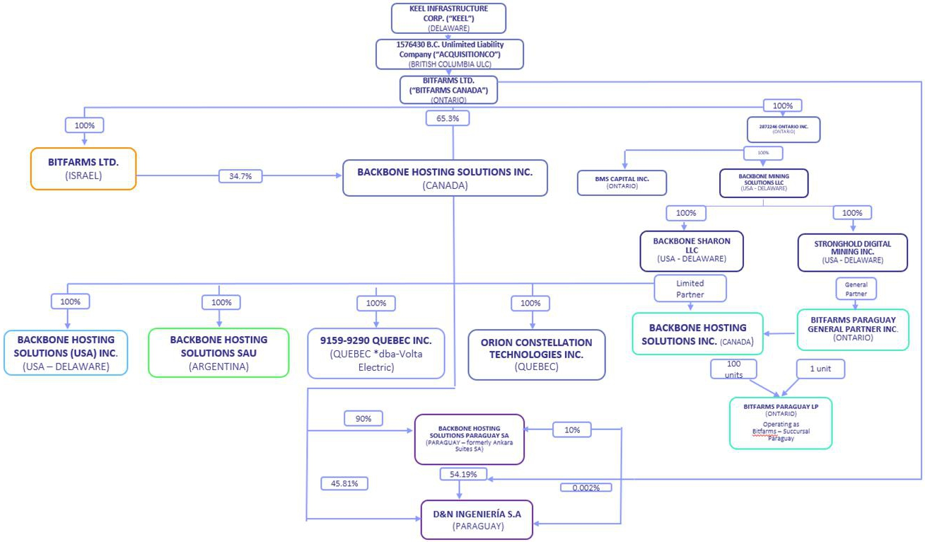

BUSINESS

Keel has been incorporated for the purpose of participating in the U.S. Redomiciliation and will not carry on any active business, prior to the U.S. Redomiciliation, other than in connection with the Arrangement and related matters. Following completion of the U.S. Redomiciliation, Keel and its subsidiaries will carry on the business currently carried on by Bitfarms Canada and its subsidiaries.

DESCRIPTION OF KEEL CAPITAL STOCK

The following summary description of the Keel capital stock is based on the provisions of each of Keel Certificate and Keel Bylaws and the applicable provisions of the DGCL. This information may not be complete in all respects and is qualified entirely by reference to the provisions of the Keel Certificate, Keel Bylaws and the DGCL. For information on how to obtain copies of the Keel Certificate and Keel Bylaws, see the section entitled “Information Concerning Bitfarms Canada - Documents Incorporated by Reference”.

BITFARMS | 2026 | Management Proxy Circular | Page 40

General

Keel’s authorized capital stock will consist of 1,500,000,000 shares of common stock, par value U.S.$0.001 per share (referred in this Circular as “Keel Common Stock”), and 120,000,000 shares of class A preferred stock, par value U.S.$0.001 per share (the “Keel Preferred Stock”).

Common Stock

Voting Rights

Each holder of Keel Common Stock will be entitled to one vote for each share on all matters submitted to a vote of the stockholders, including the election of directors. Keel Common Stockholders will not have cumulative voting rights in the election of directors. Accordingly, in an uncontested election, holders of a majority of the voting shares will be able to elect all of the directors.

Dividends

Keel will continue Bitfarms Canada’s dividend practices as described below under “Information Concerning Bitfarms Canada – Dividends”. Subject to preferences that may be applicable to any then outstanding holders of Keel Preferred Stock, Keel Common Stockholders will be entitled to receive dividends, if any, as may be declared from time to time by the board of directors of Keel (“Keel Board”) out of legally available funds. Under the DGCL, the Keel Board may declare and pay a dividend to Keel Common Stockholders out of surplus or, if there is no surplus (as defined and computed in accordance with the DGCL), out of net profits for the fiscal year in which the dividend is declared or the immediately preceding fiscal year, or both. Dividends may be paid in cash, in Keel Common Stock or in other property. Declaration and payment of any dividend will be subject to the discretion of the Keel Board. Each quarter the Keel Board will review Keel’s dividend in light of Keel’s other financial commitments before declaring the dividend. Any decision to pay dividends on the Keel Common Stock in the future will be made by the Keel Board on the basis of Keel’s earnings, financial requirements, provisions of the DGCL affecting the payment of distributions to stockholders and other factors existing at such future time.

Liquidation

In the event of Keel’s liquidation, dissolution or winding up, holders of Keel Common Stock will be entitled to share ratably in the net assets legally available for distribution to stockholders after the payment of all of Keel’s debts and other liabilities and the satisfaction of any liquidation preference granted to the holders of any then outstanding shares of preferred stock. If a dissolution is authorized, a certificate of dissolution must be filed with the Secretary of State of the State of Delaware.

Rights and Preferences

Holders of Keel Common Stock will have no pre-emptive, conversion, subscription or other rights, and there will be no redemption or sinking fund provisions applicable to Keel Common Stock. The rights, preferences and privileges of the holders of Keel Common Stock will be subject to and may be adversely affected by the rights of the holders of shares of any series of Keel Preferred Stock that we may designate in the future.

Fully Paid and Non-assessable

All outstanding shares of Keel Common Stock are, and the Keel Common Stock to be issued pursuant to the U.S. Redomiciliation will be, fully paid and non-assessable.

Preferred Stock

The Keel Certificate will authorize the Keel Board to issue Keel Preferred Stock in one or more series and to determine the preferences, limitations and relative rights of any shares of Keel Preferred Stock that it shall choose to issue, without vote or action by the stockholders, subject to certain limitations on voting and other rights set forth in the Keel Certificate. Keel expects that the authorized Keel Preferred Stock may be used as part of its capital-raising strategy, including for future financings or other transactions intended to support its growth and financial flexibility. While the authorized Keel Preferred Stock could have the effect of delaying or preventing a change in control, it has not been authorized solely for defensive or anti-takeover purposes.

BITFARMS | 2026 | Management Proxy Circular | Page 41

Annual Stockholder Meetings

The Keel Certificate and Keel Bylaws will provide that annual stockholder meetings will be held at a date, place (if any) and time, as exclusively selected by the Keel Board. To the extent permitted under applicable law, we may but are not obligated to conduct meetings by remote communications, including by webcast.

Anti-Takeover Effects of Provisions of the Keel Certificate, the Keel Bylaws and Delaware Law

Some provisions of the DGCL, the Keel Certificate and Keel Bylaws could make the following transactions difficult: acquisition of Keel by means of a tender offer; acquisition of Keel by means of a proxy contest or otherwise; and removal of incumbent officers and directors of Keel. It is possible that these provisions could make it more difficult to accomplish or could deter transactions that stockholders may otherwise consider to be in their best interest or in the best interests of Keel, including transactions that might result in a premium over the market price for Keel Common Stock. These provisions replace and substitute applicable provisions of the OBCA and we cannot predict whether they will make an acquisition more or less likely compared to those provisions.

These provisions, summarized below, are expected to discourage coercive takeover practices and inadequate takeover bids. These provisions are also designed to encourage persons seeking to acquire control of Keel to first negotiate with the Keel Board. We believe that the benefits of protection to Keel’s potential ability to negotiate with the proponent of an unfriendly or unsolicited proposal to acquire or restructure Keel outweigh the disadvantages of discouraging these proposals because negotiation of these proposals could result in an improvement of their terms.

Delaware Anti-Takeover Statutes

Keel will be subject to Section 203 of the DGCL, which prohibits persons deemed “interested stockholders” from engaging in a “business combination” with a publicly held Delaware corporation for three years following the date these persons become interested stockholders unless the business combination is, or the transaction in which the person became an interested stockholder was, approved in a prescribed manner or another prescribed exception applies. Generally, an “interested stockholder” is a person who, together with affiliates and associates, owns, or within three years prior to the determination of interested stockholder status did own, 15% or more of a corporation’s voting stock and a “business combination” includes a merger, asset or stock sale, or other transaction resulting in a financial benefit to the interested stockholder. The existence of this provision may have an anti-takeover effect with respect to transactions not approved in advance by the Keel Board, such as discouraging takeover attempts that might result in a premium over the market price of the Keel Common Stock.

Undesignated Preferred Stock

The ability to authorize undesignated Keel Preferred Stock will make it possible for the Keel Board to issue preferred stock with voting or other rights or preferences that could impede the success of any attempt to change control of Keel. These and other provisions may have the effect of deterring hostile takeovers or delaying changes in control or management of Keel.

Special Stockholder Meetings

The Keel Bylaws will provide that a special meeting of stockholders may be called only by the Keel Board or by two or more stockholders holding at least 15% of the capital stock of the Corporation issued and outstanding and entitled to vote on the matter for which the special meeting is called.

Requirements for Advance Notification of Stockholder Nominations and Proposals

The Keel Bylaws establish advance notice procedures with respect to stockholder proposals and the nomination of candidates for election as directors, other than nominations made by or at the direction of the Keel Board or a committee of the Keel Board.

BITFARMS | 2026 | Management Proxy Circular | Page 42

Stockholder Action by Unanimous Written Consent

The Keel Certificate and Keel Bylaws will provide for the right of stockholders to act by unanimous written consent without a meeting.

Composition of the Board of Directors; Election and Removal of Directors; Filling Vacancies

The Keel Board will consist of not less than one nor more than 10 directors. In any elections of directors, a director nominee for the Keel Board will be elected by a plurality of the votes cast with respect to such director by the shares represented and entitled to vote at a meeting of the stockholders for the election of directors at which a quorum is present, voting together as a single class. The directors of Keel are elected until the expiration of the term for which they are elected and until their respective successors are duly elected and qualified.

The directors of Keel may be removed only by the affirmative vote of at least a majority of the holders of the issued and outstanding capital stock of the Corporation entitled to vote in the election of directors. Furthermore, any vacancy on the Keel Board, however occurring, including a vacancy resulting from an increase in the size of the board, may be filled only by a majority vote of the directors then in office, even if less than a quorum, by the sole remaining director, or by a majority of the votes cast by the stockholders. This system of electing and removing directors and filling vacancies may tend to discourage a third party from making a tender offer or otherwise attempting to obtain control of Keel, because it generally makes it more difficult for stockholders to replace a majority of the directors.

Choice of Forum

The Keel Certificate and Keel Bylaws will provide that, except for claims for which the U.S. federal courts have jurisdiction, unless Keel consents in writing to the selection of an alternative forum, the Court of Chancery of the State of Delaware will be the exclusive forum for: any derivative action or proceeding brought on our behalf; any action asserting a breach of fiduciary duty; any action asserting a claim against us arising pursuant to the DGCL, the Keel Certificate or the Keel Bylaws; or any action asserting a claim against Keel that is governed by the internal affairs doctrine. Although the Keel Certificate contains the choice of forum provision described above, it is possible that a court could find that such a provision is inapplicable for a particular claim or action or that such provision is unenforceable.

Amendment of the Keel Certificate and Keel Bylaws

The amendment of any of the provisions in the Keel Certificate will require approval by a stockholder vote by the holders of at least a majority of the voting power of the then outstanding voting stock voting as a single class. The Keel Bylaws may be amended by the Keel Board or by the holders of at least a majority of the voting power of the then outstanding voting stock voting as a single class.

The provisions of the DGCL, the Keel Certificate and Keel Bylaws could have the effect of discouraging others from attempting hostile takeovers and, as a consequence, they may also inhibit temporary fluctuations in the market price of Keel Common Stock that often result from actual or rumored hostile takeover attempts. These provisions may also have the effect of preventing changes in the management of Keel. It is possible that these provisions could make it more difficult to accomplish transactions that stockholders may otherwise deem to be in their best interests.

Limitations of Liability and Indemnification Matters

The Keel Certificate will contain provisions that limit the liability of the directors and officers of Keel for monetary damages to the fullest extent permitted by Delaware law. Consequently, Keel directors and officers will not be personally liable to Keel or its stockholders for monetary damages for any breach of fiduciary duties as directors, except liability for:

 | ● | any breach of the director’s or officer’s duty of loyalty to Keel or its stockholders;

 | ● | any act or omission not in good faith or that involves intentional misconduct or a knowing violation of law;

BITFARMS | 2026 | Management Proxy Circular | Page 43

 | ● | unlawful payments of dividends or unlawful stock repurchases or redemptions as provided in Section 17 4 of the DGCL; or

 | ● | any transaction from which the director or officer derived an improper personal benefit.

Each of the Keel Certificate and Keel Bylaws will provide that we are required to indemnify the directors and officers of Keel, in each case to the fullest extent permitted by the DGCL. The Keel Bylaws will also obligate us to advance expenses incurred by a director or officer in advance of the final disposition of any action or proceeding, and permit us to secure insurance on behalf of any officer, director, employee or other agent for any liability arising out of his or her actions in that capacity regardless of whether we would otherwise be permitted to indemnify him or her under the DGCL. We have entered into agreements with the Bitfarms Canada directors, officers and other employees and expect to enter into agreements to indemnify the Keel directors, executive officers and other employees as determined by the Keel Board. With specified exceptions, these agreements provide for indemnification for related expenses including, among other things, attorneys’ fees, judgments, fines and settlement amounts incurred by any of these individuals in any action or proceeding to the fullest extent permitted by applicable law. We believe that these bylaw provisions and indemnification agreements are necessary to attract and retain qualified persons as directors and officers. Keel will also maintain directors’ and officers’ liability insurance.

The limitation of liability and indemnification provisions in the Keel Certificate and Keel Bylaws may discourage stockholders from bringing a lawsuit against Keel directors and officers for breach of their fiduciary duty. They may also reduce the likelihood of derivative litigation against Keel directors and officers, even though an action, if successful, might benefit Keel and its stockholders. Furthermore, a stockholder’s investment may be adversely affected to the extent that we pay the costs of settlement and damage.

Uncertificated Shares

Holders of Keel Common Stock will not have the right to require Keel to issue certificates for their shares. Keel will only issue uncertificated shares of common stock, provided that the Keel Board may provide by resolution that some or all of the shares of any class or series of stock of Keel shall be represented by certificates.

No Sinking Fund

The shares of Keel Common Stock have no sinking fund provisions.

SELECTED PRO FORMA CONDENSED CONSOLIDATED FINANCIAL INFORMATION

The U.S. Redomiciliation is not expected to result in any material pro forma adjustments to the condensed consolidated financial information of Bitfarms Canada. Accordingly, no pro forma financial information has been included in this Circular.

DIRECTORS OF KEEL

Following the U.S. Redomiciliation, the directors of Keel Board will continue to be the same as the directors of the Bitfarms Canada Board immediately prior to the Arrangement. Each of the directors of Keel will hold office until the first annual meeting of the Keel Common Stockholders or until such person’s successor is duly elected or appointed, unless such person’s office is earlier vacated in accordance with the Keel Certificate or Keel Bylaws.

BITFARMS | 2026 | Management Proxy Circular | Page 44

Benjamin Gagnon

Province/State and Country of Residence | San José, Costa Rica
Principal Occupations(2) | ● Chief Executive Officer of Bitfarms Canada (2024 – present)  ● Chief Mining Officer of Bitfarms Canada (2021 – 2024)  ● Director of Mining Operations of Bitfarms Canada (2019 – 2021)
Director of Bitfarms Canada Since | August 12, 2024
Bitfarms Canada Shares Owned or Controlled(3) | 1,073,269

Benjamin (Ben) Gagnon will serve as the Chief Executive Officer of Keel and as a director of Keel. Mr. Gagnon started his career at Bitfarms Canada as Director of Business Development in 2019 and was promoted to the Director of Mining Operations in 2020 and Chief Mining Officer in 2021. Mr. Gagnon is a proven strategy and people focused executive in the Bitcoin mining space. At Bitfarms, he has overseen the development and execution of the Bitfarms Canada’s growth strategy, which has driven organic growth, captured market share in Bitcoin mining and diversified and strengthened the Bitfarms Canada’s energy assets. Mr. Gagnon brings in a deep familiarity with all aspects of operations at Keel, having worked intimately with every department, as well as extensive leadership experience from previous executive roles with cryptocurrency Mining companies. His successful track record overseeing the growth of Bitfarms Canada’s Mining operations and integration of new technologies amidst a rapidly evolving landscape has been critical to Bitfarms Canada’s value creation strategy, which includes diversification into synergistic new areas like energy generation, heat recycling, energy trading and HPC for AI, as well as execution of strategies related to the 2028 halving event. Prior to joining Bitfarms Canada, Mr. Gagnon founded and operated two Bitcoin mining companies, holding roles as Chief Executive Officer, Chief Mining Officer and Chief Technology Officer. Mr. Gagnon earned his M.Sc. in Internet Computing from Hong Kong University and has a B.Sc. in Economic Consulting and International Business from the Kelley School of Business at Indiana University. In addition, Mr. Gagnon currently serves as co-chair of the Canadian Bitcoin Consortium’s Infrastructure Committee (formerly Mining Committee) and is a lead analyst for the Bitcoin Mining Council.

Edith Hofmeister, JD(4)

Province/State and Country of Residence | California, USA
Principal Occupations(2) | ● Independent Director of Bitfarms Canada (2022 – present)  ● Director of Osisko Gold Royalties (TSX: OR and NYSE: OR), a precious metal royalty company (2022 – present)  ● Director of Nighthawk Gold Corp., a gold development company (2022 – 2024)  ● Director of Prime Mining Corp. (TSXV: PRYM), a mineral resource company (2021 – 2025)  ● Executive Vice-President Corporate Affairs & General Counsel of Tahoe Resources Inc., an international precious metals mining company (2010 – 2019)
Director of Bitfarms Canada Since | November 16, 2022
Bitfarms Canada Shares Owned or Controlled(3) | 240,001

BITFARMS | 2026 | Management Proxy Circular | Page 45

Edith Hofmeister will serve as the Chair of the Keel Board and will be a member of the Audit Committee. Ms. Hofmeister brings over two decades of expertise in legal affairs, corporate governance, sustainable finance and business strategy. As an American business leader, she successfully guided multinational companies through large-scale infrastructure development, public and private offerings, NYSE and Nasdaq listings, intricate debt financings, joint ventures, complex litigation and multi-billion-dollar acquisitions. Drawing on her deep understanding of U.S. corporate and securities law, she played a pivotal role in shaping governance practices and risk management aligned with American standards. From 2010-2019 she served as EVP Corporate Affairs and General Counsel for Tahoe Resources where, as its first employee, she helped build the company from a start-up to a mid-cap precious metals producer with operations throughout the Americas. In this role, she helped lead capital raises and infrastructure projects, including EPCM contract oversight. Ms. Hofmeister joined the Bitfarms Board in November 2022. She was a best Canadian General Counsel finalist in the category of ESG and led Tahoe’s achievement of best governance award (for a mid-cap Mining company) by the Canadian Society of Corporate Secretaries. Ms. Hofmeister has worked alongside rural and indigenous communities in India, Peru, Guatemala, Mexico and Canada to enhance food, work and water security. Ms. Hofmeister served as the Chair of the International Bar Association’s Business and Human Rights Committee, a group dedicated to promoting high ESG standards in multi-national corporations. Ms. Hofmeister received a Bachelor of Arts degree in international relations from UCLA, a Master of Arts degree in international peace studies from the University of Notre Dame and a Juris Doctor degree from the University of San Francisco.

Brian Howlett, CPA(1)(4)

Province/State and Country of Residence | Ontario, Canada
Principal Occupations(2) | ● Director of Bitfarms Canada (2026 – present)  ● Independent Chairman of Bitfarms Canada (2024 – 2026)  ● Lead Director of Bitfarms Canada (2020 – 2024)  ● Chairman, Rocky Shore Gold Ltd. (2025 – present)  ● President and CEO, Copper Road Resources Inc. (2025 – present)  ● Director, Voyageur Mineral Explorers Corp. (2025)  ● President, Chief Executive Officer and Director of Hemlo Explorers Inc. (TSXV: HMLO), a natural resource exploration and development company (2020 – 2025)  ● Director of Nighthawk Gold Corp. (TSX:NHK / OTCQX:MIMZF), a gold development company (2016 – 2024)  ● President, Chief Executive Officer and Director of Copper Road Resources Inc. (TSXV: CRD), a copper exploration company (2014 – 2021)  ● President, Chief Executive Officer and Director of Voyageur Mineral Explorers Corp. (CSE: VOY), a mineral exploration company (2020 – 2021)  ● President, Chief Executive Officer and Director of Dundee Sustainable Technologies Inc. (CSE: DST), a metallurgical process company (2015 – 2020)
Director of Bitfarms Canada Since | April 17, 2020
Bitfarms Canada Shares Owned or Controlled(3) | 144,946

Brian Howlett will serve as an independent director of Keel, as Chair of the Governance, Nomination, Safety and Sustainability Committee and will be a member of the Audit Committee. Mr. Howlett is a seasoned public company senior executive with more than thirty-five years of experience in operational and financial leadership. His extensive service as senior officer and director of public companies equips him with valuable insights to oversee Keel’s operations. As a Chartered Professional Accountant (CPA), he also contributes to Keel Board’s oversight of financial reporting, internal controls and risk management. Mr. Howlett also serves on the board of one junior mining company and has formerly served as C-Suite Executive and board member in several publicly listed companies, including Dundee Sustainable Technologies Inc. and Nighthawk Gold Corp., among others. Mr. Howlett graduated in 1982 with a B. Comm. in Finance from Concordia University and received his CMA designation in 1989 which became a Chartered Professional Accountant (CPA) designation in 2022.

BITFARMS | 2026 | Management Proxy Circular | Page 46

Fanny Philip, CPA(1)(4)(5)

Province/State and Country of Residence | Gironde, France
Principal Occupations(2) | ● Independent Director of Bitfarms Canada (2024 – present)  ● Infrastructure Committee (formerly Mining Committee) Member & President of the Québec Chapter of Canadian Bitcoin Consortium, a non-profit organization for Canada’s blockchain technology ecosystem (2022 – present)  ● Founder and President, MTI Conseils Inc., an accounting and advisory firm (2021 – present)  ● General Director (2021 – present) and Director of Administration and Finance (2020 – 2021) of SOVIAGO, a food distribution company leader in South-West France  ● Chief Operating Officer (2022 – 2024), Chief Financial Officer (2020 – 2021), Vice President of Finance (2021), of SATO Technologies Corp. (TSXV:SATO), a digital assets mining and infrastructure company  ● Associate Partner of Bois Montpetit S.E.N.C.R.L., a public accounting and tax advisory firm (2018 – 2020)
Director of Bitfarms Canada Since | June 27, 2024
Bitfarms Canada Shares Owned or Controlled(3) | 180,685

Fanny Philip will serve as an independent director of Keel, as Chair of the Audit Committee and will be a member of the Governance, Nomination, Safety and Sustainability Committee and the Compensation Committee. Ms. Philip is a CPA auditor and recognized leader in Digital Assets, Energy and Infrastructure ecosystem since 2019, and contributes to the Keel Board her deep expertise in finance, public accounting, audit, and strategic mergers and acquisitions. Her extensive knowledge of the North American and European energy sectors, mining and AI provide valuable perspectives to the Keel Board’s oversight of Keel’s expansion strategies. She is the founder and president of MTI Conseils Inc., an accounting firm that provides outsourced accounting, advisory services and Chief Financial Officer services. Ms. Philip brings over 10 years of assurance and accounting expertise mainly in audit and public issues. Formerly, she was the Chief Operating Officer of SATO Technologies Corp. (TSXV: SATO, OTCQB: CCPU.F) and the Chief Financial Officer and VP Finance of Canada Computational Unlimited Inc. As a former C-Suite Executive at a publicly traded company and recognized leader, she engages extensively in education and industry representation, advocating for regulatory changes and fostering a deeper understanding of the sector’s complexities among stakeholders, especially on reporting and financial matters. Since 2022 she has been a member of the Infrastructure Committee (formerly Mining Committee) of the Canadian Bitcoin Consortium (formerly Canadian Blockchain Consortium) and the President of its Québec Chapter. She was rewarded as one of the “Most Inspirational Women in Web3 & AI” (2024) by Forbes Web3, 100 Davos Women and World Leaders in Data and AI. She currently serves as General Director at SOVIAGO, where she oversees financial reporting and compliance, and she has been instrumental in various strategic acquisitions and in securing various public funding mainly from the European Regional Development Fund. Ms. Philip graduated in 2010 with a Trilingual Bachelor of Business Administration (B.B.A) (English, Spanish and French) and in 2013 with a Specialized Graduate Diploma (DESS) in public accounting – CA, both from HEC Montréal. She received her Chartered Accountant designation in 2014 which became a Chartered Professional Accountant (CPA) auditor designation in 2022.

BITFARMS | 2026 | Management Proxy Circular | Page 47

Amy Freedman(5)

Province/State and Country of Residence | Ontario, Canada
Principal Occupations(2) | ● Independent Director of Bitfarms Canada (2024 – present)  ● Partner at Longacre Square Partners, a strategy and communications firm (present)  ● Chief Executive Officer of Kingsdale Advisors, a shareholder services and advisory firm (2017 – 2021)  ● Executive Vice President of Kingsdale Advisors, a shareholder services and advisory firm (2014 – 2021)  ● Partner at Ewing Morris and Co. Partners Ltd., an investment firm (2022 – 2023)
Director of Bitfarms Canada Since | September 23, 2024
Bitfarms Canada Shares Owned or Controlled(3) | 69,568

Amy Freedman will serve as an independent director of Keel and as Chair of the Compensation Committee. Amy Freedman is a corporate governance and public capital markets expert with over 25 years of experience. Ms. Freedman is currently a Partner and Head of Canada at Longacre Square Partners, a leading North American strategic advisor in matters of shareholder activism, crisis communications and corporate governance. Prior to joining Longacre, Ms. Freedman was a Partner and Head of Engagement Fund Investing at Ewing Morris. Previously, Ms. Freedman was the Chief Executive Officer of Kingsdale Advisors, a leading shareholder services and corporate governance advisory firm. Prior to joining Kingsdale Advisors, Ms. Freedman spent over 15 years in capital markets as an investment banker with global firms including Stifel Financial Corp. (NYSE: SF) and Morgan Stanley (NYSE: MS). Ms. Freedman is a director of the following public companies: (a) Irish Residential Properties REIT plc (ISE: IRES) since May 2024; and (b) American Hotel Income Properties REIT LP (TSX: HOT.UN, HOT.U) since October 2023. Ms. Freedman was also a director on the board of (a) Mandalay Resources Corporation (TSX: MND, OTCQB: MNDJF) since May 2016 until July 2025; (b) Canaccord Genuity Group Inc. (TSX: CF) from March 2023 to August 2024; and (c) Park Lawn Corporation (TSX: PLC) from June 2020 to August 2022 (now private). Ms. Freedman holds an MBA and JD from the University of Toronto.

Andrew J. Chang(1)

Province/State and Country of Residence | New Jersey, USA
Principal Occupations(2) | ● Independent Director of Bitfarms Canada (2024 – present)  ● Co-Founder of Lynx Collective, a startup founder advisory and services provider (2023 – present)  ● Adjunct Professor, NYU Stern School of Business (2025 – present)  ● Self-employed (Advisor/Consultant) (2021 – present)  ● Chief Operating Officer, of Paxos, a financial institution and technology company specializing in blockchain technology (2014 – 2021)
Director of Bitfarms Canada Since | November 20, 2024
Bitfarms Canada Shares Owned or Controlled(3) | 178,685

Andrew J. Chang will serve as an independent director of Keel Infrastructure and will be a member of the Governance, Nomination, Safety and Sustainability Committee. Mr. Chang is a seasoned executive and entrepreneur with extensive experience in the cryptocurrency and blockchain industry. He served as the Chief Operating Officer at Paxos for over 7 years, where he played a pivotal role in growing the company from a small startup to a $2.4 billion valuation. During his tenure, Mr. Chang oversaw the launch of the first regulated blockchain-focused trust company. His expertise lies in navigating complex regulatory environments, scaling operations, and creating effective communication frameworks. Prior to Paxos, Mr. Chang held operational and growth positions at Google, Techstars, WPP and several innovative startups. Mr. Chang is also an Adjunct Professor at NYU Stern School of Business, where he teaches courses focused on venture-scale startups and the venture capital ecosystem. He is currently a co-founder of Lynx Collective and regularly advises and invests in early-stage startups. Mr. Chang holds an MBA from NYU Stern School of Business and a BS from Boston College, bringing a blend of financial technology acumen and technological insight to his roles in the rapidly evolving digital asset space.

BITFARMS | 2026 | Management Proxy Circular | Page 48

Wayne Duso(5)

Province/State and Country of Residence | New York, USA
Principal Occupations(2) | ● Independent Director of the Corporation (2025 – present)  ● Vice President, Engineering and Technology, 1Password (2025 – present)  ● Vice President, Storage, Edge Compute, and Data Services, Amazon Web Services (2012 – 2024)
Director of Bitfarms Canada Since | August 15, 2025
Bitfarms Canada Shares Owned or Controlled(3) | None

Notes to the Director Tables:

(1) | Member of the Governance, Nomination, Safety and Sustainability Committee. Brian Howlett serves as Chair.

(2) | Information about principal occupation, business or employment, not being within the knowledge of Keel, has been furnished by respective persons set forth above.

 | (3) | The information with respect to the Bitfarms Canada Shares beneficially owned, controlled or directed is not within the direct knowledge of Keel and has been obtained from SEDI or furnished by the respective individuals. This table does not include Bitfarms Canada Shares underlying unexercised Bitfarms Canada Share purchase options, warrants and restricted share units.

(4) | Member of the Audit Committee. Fanny Philip serves as Chair.

(5) | Member of the Compensation Committee. Amy Freedman serves as Chair.

Wayne Duso will serve as an independent director of Keel and will be a member of the Compensation Committee. Mr. Duso is a senior engineering and product executive with over 25 years of experience in enterprise and cloud infrastructure. He currently serves as Vice President, Engineering and Technology at 1Password, where he is innovating and delivering at the intersection of identity, security, and AI infrastructure. At AWS, he launched and scaled multiple data and storage services into multibillion-dollar businesses, while building AWS Boston into one of Amazon’s largest development centers. At EMC, he defined strategy for a $3B ARR product line and introduced EMC’s first software-defined storage array. His advisory roles with Snyk, Anjuna Security, and Bedrock Security underscore his continued influence in shaping next-generation cloud, data, and cybersecurity solutions. His expertise lies in scaling global organizations, launching category-defining platforms, and aligning technology with customer and business outcomes.

CORPORATE GOVERNANCE

The Keel Board will be committed to the highest standards of corporate governance. To this end, the Keel Board will adopt corporate governance guidelines (“Governance Guidelines”) that provide specific provisions for the governance of the Keel Board and Keel. The Keel Board will also adopt a Code of Business Conduct and Ethics (“Code of Conduct”) applicable to all directors, officers and employees that represents Keel’s commitment to the highest standards of ethics and integrity in the conduct of its business. The Keel Bylaws, together with the Governance Guidelines, the Keel Board committee charters and the Code of Conduct will serve as the governance and compliance framework of Keel. From the Effective Time, the Keel Board intends to comply with the DGCL, the rules of Nasdaq and SEC and applicable Canadian Securities Laws.

The Nasdaq rules require that listed company boards have at least a majority of independent directors. Each of Edith Hofmeister, Brian Howlett, Fanny Philip, Amy Freedman, Andrew J. Chang and Wayne Duso, representing six of Keel’s seven future directors will be independent directors under the Nasdaq rules. Ben Gagnon, who will be Keel’s Chief Executive Officer, is the only member of the Keel Board who will not be independent.

Committees of the Keel Board

The Keel Board will be responsible for providing oversight of Keel’s business and affairs, including Keel’s strategic direction, as well as the management and financial and operational execution that can best perpetuate the success of the business and support the long-term interest of Keel Common Stockholders. To effectively support its responsibilities, the Keel Board is expected to have three committees: an Audit Committee, a Compensation Committee, and a Governance, Nomination, Safety and Sustainability Committee. These Keel Board committees will carry out responsibilities in specific committee charters approved by the Keel Board and consistent with applicable requirements of Nasdaq and the SEC. Each of the Keel Board committees shall be empowered to retain independent advisors as necessary to fulfill their duties.

BITFARMS | 2026 | Management Proxy Circular | Page 49

Audit Committee

The Audit Committee will be responsible for assisting the Keel Board in its oversight responsibilities relating to the integrity of Keel’s financial statements and Keel’s accounting and financial reporting processes and financial statement audits; the effectiveness of Keel’s internal controls over financial reporting and disclosure; the design, implementation and performance of Keel’s internal audit function; the independent auditor’s qualifications, independence and performance; advising the Keel Board on regulatory matters; Keel’s compliance with legal and regulatory requirements; risk assessment and risk management pertaining to the financial, accounting and tax matters of Keel; and the performance of Keel internal audit function and internal auditors. The Audit Committee will be established in accordance with Section 3(a)(58)(A) of the Exchange Act and each director on the Audit Committee will be independent within the meaning of Nasdaq listing standards and applicable rules and regulations of the SEC and have sufficient knowledge in financial and auditing matters to serve on the Audit Committee. Fanny Philip is expected to be the Chair of the Audit Committee and Edith Hofmeister and Brian Howlett are expected to be members of the Audit Committee following the U.S. Redomiciliation.

Compensation Committee

The Compensation Committee will be responsible for evaluating, recommending, approving and reviewing executive officer and director compensation arrangements, plans, policies and programs maintained by Keel, administering Keel’s cash- and equity-based compensation plans overseeing the management of risks related to Keel’s executive compensation plans and arrangements, reviewing with management Keel’s organization and people activities, reviewing and discussing with management Keel’s compensation discussion and analysis to be included in Keel’s public filings. Each director serving on the Compensation Committee will be independent within the meaning of the Nasdaq listing standards and applicable rules and regulations of the SEC. The Compensation Committee will operate under a written charter pursuant to applicable standards and rules of the SEC and the Nasdaq. Amy Freedman is expected to be the Chair of the Compensation Committee and Fanny Philip and Wayne Duso are expected to be members of the Compensation Committee following the U.S. Redomiciliation.

Governance, Nomination, Safety and Sustainability Committee

The Governance, Nomination, Safety and Sustainability Committee will be responsible for identifying, considering and recommending to the Keel Board individuals qualified to serve as directors of Keel and on committees of the Keel Board, consistent with criteria approved by the Keel Board, advising the Keel Board with respect to the Keel Board composition, procedures and committees, reviewing developments in corporate governance and developing and recommending to the Keel Board a set of corporate governance guidelines applicable to Keel, evaluating the overall effectiveness of the Keel Board, the Keel Board’s committees and Keel Management, overseeing Keel’s programs, policies and practices relating to health and safety, environmental sustainability and corporate social responsibility. Each director serving on the Governance, Nomination, Safety and Sustainability Committee will be independent within the meaning of the Nasdaq listing standards. Brian Howlett is expected to be the Chair of the Governance, Nomination, Safety and Sustainability Committee and Fanny Philip and Andrew J. Chang are expected to be members of the Governance, Nomination, Safety and Sustainability Committee following the U.S. Redomiciliation.

DIRECTOR AND EXECUTIVE COMPENSATION

The director and executive compensation programs currently offered by Bitfarms Canada are described in Bitfarms Canada’s Notice of Annual General and Special Meeting of Shareholders and management proxy circular filed on SEDAR+ and EDGAR on May 23, 2025, available under its profile on SEDAR+ at www.sedarplus.com or its profile at EDGAR at www.sec.gov.

In anticipation of the U.S. Redomiciliation, Bitfarms Canada’s Compensation Committee and its independent compensation advisors are reviewing Bitfarms Canada’s director and executive compensation programs. As a result of this review, the director and executive compensation programs offered by Keel following the U.S. Redomiciliation may be different from the programs currently offered by Bitfarms Canada.

BITFARMS | 2026 | Management Proxy Circular | Page 50

BENEFICIAL OWNERSHIP OF SECURITIES OF KEEL

The Trust will be the sole holder of Keel Common Stock prior to the Effective Time. To the knowledge of the Keel Board no person will beneficially own, directly or indirectly, or exercise control or discretion over 10% or more of any class of outstanding voting securities of Keel following the completion of the Arrangement.

DIVIDENDS

Keel has neither declared nor paid any dividends on its common stock since its incorporation. When permitted to do so, the Keel Board may declare dividends at its discretion, and as of the date of this Circular, the Keel Board does not currently anticipate paying dividends in the near future. The Keel Board will determine if, and when, to declare and pay dividends in the future from funds properly applicable to the payment of dividends based on Keel’s financial position at the relevant time. The Keel Board expects to retain earnings to finance future growth of Keel and its subsidiaries. All of the Keel Common Stock are entitled to an equal share in any dividends declared and paid on a per share basis.

CONFLICTS OF INTEREST

Other than as disclosed in this Circular, no director or executive officer, nominee for election as a director or any Bitfarms Canada Shareholder will hold more than 10% of the voting rights attached to the Keel Common Stock or an associate or affiliate of any of the foregoing in any transaction in the preceding financing year or any proposed or ongoing transaction which has or will materially affect Keel or any of its subsidiaries.

AUDITOR, REGISTRAR AND TRANSFER AGENT

The auditor of Keel is expected to be PricewaterhouseCoopers LLP (“PwC”), Chartered Professional Accountants. The transfer agent and registrar for Keel Common Stock will be Continental Stock Transfer & Trust Company. The address of the transfer agent and registrar for Keel Common Stock is 1 State Street, 30th Floor, New York, NY 10004-1561.

MATERIAL CONTRACTS

Except as described in this Circular, Keel will not enter into any material contracts prior to the Effective Time. Since Bitfarms Canada’s last periodic filing, the Arrangement Agreement is the only contract that affect Bitfarms Canada or Keel that could reasonably be regarded as material to a proposed investor, other than contracts entered into in the ordinary course of business.

INFORMATION CONCERNING BITFARMS CANADA

GENERAL

Corporate Overview

Bitfarms Canada was incorporated under the Canada Business Corporations Act on October 11, 2018, and continued under the Business Corporations Act (Ontario) on August 27, 2021. Bitfarms has its registered and head office located at 110 Yonge Street, Suite 1601, Toronto ON M5C 1T4. The Bitfarms Canada Shares are listed under the symbol “BITF” on the TSX and on the Nasdaq in the United States.

Additional information about Bitfarms Canada can be found under its profile on SEDAR+ at www.sedarplus.com, its profile at EDGAR at www.sec.gov or its website at www.bitfarms.com. The information contained in, or that can be accessed through, Bitfarms Canada’s website is not intended to be incorporated into this Circular.

BITFARMS | 2026 | Management Proxy Circular | Page 51

Bitfarms Canada has the following main controlled subsidiaries:

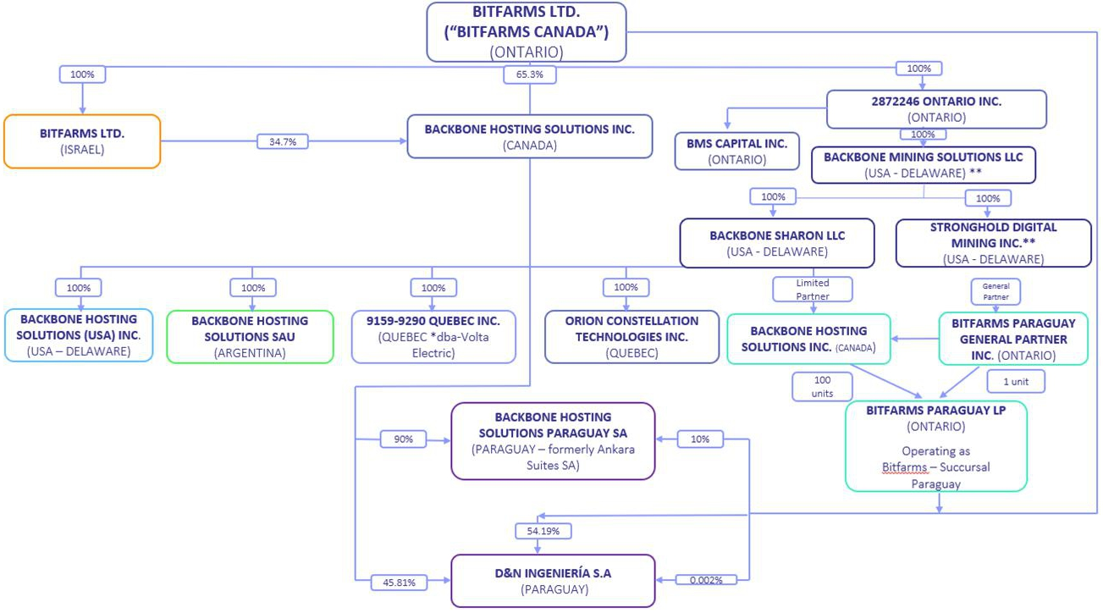

Business of Bitfarms Canada

Bitfarms Canada is a North American energy and data center infrastructure company, publicly traded on Nasdaq and the TSX. Founded in 2017, Bitfarms Canada’s strategy has centered on developing and managing a robust portfolio of industrial electricity contracts and energy infrastructure in strategic markets with abundant, cost-effective energy resources. Historically, Bitfarms Canada monetized these assets through the development and operation of data centers primarily focused on Bitcoin mining, which provided rapid monetization and exposure to rising Bitcoin prices.

In 2024, recognizing HPC and AI as a more valuable utilization of its North American energy assets, Bitfarms Canada initiated a strategic pivot. This involves growing and converting its North American energy portfolio to support HPC/AI infrastructure, while divesting its Latin American and Bitcoin-focused assets to concentrate solely on HPC and AI development. By leveraging existing energy and real estate assets in key data center markets—such as Pennsylvania and Washington State in the United States, and Quebec in Canada—Bitfarms Canada is able to accelerate the development of HPC and AI infrastructure and aims to realize greater long-term value.

HPC/AI Infrastructure Strategy

Bitfarms Canada’s pivot to HPC/AI is driven by a surging global demand for compute infrastructure, capacity constraints in traditional data center markets, and the potential for multiple expansions through long-term contracted revenue streams with investment-grade counterparties. It is expected that these multi-year lease contracts provide greater cashflows per unit of energy and more predictable monthly recurring revenue, than Bitcoin mining due to fluctuations in cryptocurrency prices and network conditions.

HPC/AI infrastructure differs markedly from Bitcoin mining facilities, requiring higher power density per square foot, advanced cooling systems to handle heat from graphics processing unit (“GPU”) clusters, enhanced redundancy and uptime for enterprise customers, and high-speed network connectivity for data transfer and low-latency applications. Converting existing facilities will necessitate capital expenditures for upgrades, specialized cooling, and network improvements.

Bitfarms Canada plans a phased implementation, leveraging current assets while preserving operational Bitcoin mining capacity during the transition where feasible. Conversions will be prioritized based on site readiness, market demand, and customer commitments. Bitfarms Canada’s geographic footprint across North America aligns with enterprise and cloud service providers’ needs for HPC and AI inference in strategic metropolitan areas.

BITFARMS | 2026 | Management Proxy Circular | Page 52

Bitfarms Canada intends to develop and lease infrastructure supporting GPU clusters and specialized AI hardware to investment-grade hyperscalers, cloud service providers, AI companies, and enterprises needing high-density compute capacity. This transition capitalizes on Bitfarms Canada’s long-term, competitively priced power contracts to offer an efficient, cost-effective path for developing HPC/AI operations. However, this strategic shift carries significant risks, including attracting and retaining HPC/AI customers, competitive pressures in the hosting market, substantial capital investments for conversions, regulatory changes impacting Bitcoin mining or data centers, and broader market conditions in cryptocurrency and technology sectors. See the section entitled “Risk Factors” for a detailed discussion of these and other risks that could materially affect the Corporation’s business, financial condition, and results of operations.

On March 14, 2025, Bitfarms Canada acquired Stronghold, adding ownership and operation of two refuse power generation facilities in Pennsylvania. These facilities qualify as an “Alternative Energy System” under Pennsylvania law, as mining refuse is classified as a Tier II Alternative Energy Source (alongside large-scale hydropower). Bitfarms Canada sells electricity into the Pennsylvania-New Jersey-Maryland Interconnection merchant market under a professional services agreement with Customized Energy Solutions, Ltd. The primary fuel source is waste supplied by third parties, and Bitfarms Canada earns waste tax credits by utilizing refuse to generate electricity. Bitfarms Canada either consumes this energy internally for computational activities, such as hashing calculations, or sells it to local energy suppliers.

Region1 |  | Energized capacity |  | Secured contracted  growth capacity |  |  |  | Capacity under  application |  |  |  | Total pipeline
North America
United States |  | 171 | MW2 |  | 430 | MW3 |  |  | 1,360 | MW |  |  | 1,961 | MW
Canada |  | 170 | MW |  | 10 | MW4 |  |  | — |  |  |  | 180 | MW
 |  | 341 | MW |  | 440 | MW |  |  | 1,360 | MW |  |  | 2,141 | MW
South America
Paraguay5 |  | 70 | MW |  | — |  |  |  | — |  |  |  | 70 | MW
Total |  | 411 | MW |  | 440 | MW |  |  | 1,360 | MW |  |  | 2,211 | MW

Notes:

1 | This data excludes the discontinued operations in Rio Cuarto, Argentina and in Paraguay. On May 12, 2025, Bitfarms Canada’s energy provider, Generación Mediterránea S.A., halted the supply of electricity to Bitfarms Canada’s Rio Cuarto Bitcoin data center with energized capacity of 58 MW. On August 11, 2025, three (3) months after being informed that electricity supply was being halted and with no expected path forward to resume operations in the future, the decision was made to shut down the plant, which was abandoned as of September 30, 2025.

2 | Bitfarms Canada has a hosting contract to operate 21 MW of Miners on behalf of a third party at the Panther Creek Bitcoin data center.

3 | Refer to Section 7 - HPC/AI Infrastructure and BTC Mining Expansion Projects in Management’s Discussion and Analysis of Bitfarms Canada for the nine (9) months ended September 30, 2025 incorporated by reference herein for details on the timing of the remaining MW not yet operational.

4 | Bitfarms Canada has secured the rights for 10 MW of hydro-electricity in the province of Quebec, Canada and is continuing its efforts to search for economically viable properties for the available 10 MW of hydro-electricity.

5 | As of September 30, 2025, the Paso Pe operations were classified as a disposal group held for sale, and all operations in Paraguay were designated as discontinued operations as Bitfarms Canada makes a strategic shift towards HPC/AI infrastructure in North America. On January 2, 2026, Bitfarms announced the entry into a definitive share purchase agreement to sell its Paso Pe site and its exit from Latin America. The transaction is expected to close within sixty (60) days of announcement.

DOCUMENTS INCORPORATED BY REFERENCE

The following documents of Bitfarms Canada are specifically incorporated by reference into and form an integral part of this Circular:

 | 1. | annual information form of Bitfarms Canada dated March 26, 2025 for the year ended December 31, 2024;

 | 2. | audited consolidated financial statements of Bitfarms Canada and accompanying notes for the years ended December 31, 2024 and 2023 and the auditors’ report thereon;

 | 3. | unaudited condensed consolidated interim financial statements of Bitfarms Canada for the three (3) and nine (9) months ended September 30, 2025 and 2024;

 | 4. | management’s discussion and analysis of financial condition and results of operations of Bitfarms Canada for the year ended December 31, 2024;

BITFARMS | 2026 | Management Proxy Circular | Page 53

 | 5. | management’s discussion and analysis of financial condition and results of operations of Bitfarms Canada for the three (3) and nine (9) months ended September 30, 2025; and

 | 6. | material change reports of Bitfarms Canada dated January 2, 2025, January 28, 2025, February 3, 2025, March 3, 2025, March 17, 2025, March 18, 2025, March 27, 2025, April 2, 2025, May 14, 2025, July 1, 2025, July 28, 2025, August 12, 2025, October 10, 2025, October 14, 2025, October 15, 2025, October 16, 2025, October 21, 2025, November 13, 2025, January 14, 2026 and February 9, 2026.

Any documents of the type referred to above, any audited annual consolidated financial statements, unaudited interim consolidated financial statements and related management’s discussion and analysis of financial condition and results of operations, any material change reports (except confidential material change reports) and business acquisition reports filed by Bitfarms Canada with the various securities commissions or similar authorities in Canada or the U.S., which are subsequently filed by Bitfarms Canada on SEDAR+ and EDGAR, after the date of the Circular and prior to the Effective Time, shall be deemed to be incorporated by reference into this Circular.

The foregoing documents may be viewed on SEDAR+ at www.sedarplus.com and EDGAR at www.sec.gov and are also available on request without charge from the Corporate Secretary of Bitfarms Canada by sending a written request to 110 Yonge Street, Suite 1601, Toronto ON M5C 1T4.

BENEFICIAL OWNERSHIP OF BITFARMS CANADA SHARES

To the knowledge of the Bitfarms Canada Board, no person beneficially owns, directly or indirectly, or exercises control or discretion over 10% or more of any class of outstanding voting securities of Bitfarms Canada as of the date of this Circular.

DIVIDENDS

Bitfarms Canada has neither declared nor paid any dividends on its common shares since its incorporation. When permitted to do so, the Bitfarms Canada Board may declare dividends at its discretion but does not anticipate paying dividends in the near future. The Bitfarms Canada Board will determine if, and when, to declare and pay dividends in the future from funds properly applicable to the payment of dividends based on Bitfarms Canada’s financial position at the relevant time. The Bitfarms Canada Board expects to retain earnings to finance future growth of Bitfarms Canada and its subsidiaries. All of the Bitfarms Canada Shares are entitled to an equal share in any dividends declared and paid on a per share basis.

PRIOR SALES

Except as detailed below, within the last twelve (12) months from the date of this Circular, no Bitfarms Canada Shares or other securities of Bitfarms Canada (including Bitfarms Canada Warrants, Bitfarms Canada Debentures, options and restricted share units) have been issued or exercised or converted, as applicable, into Bitfarms Canada Shares.

Date | Type | Description
January 10, 2025 | Stock options | ● Grant of 540,000 Bitfarms Canada options to purchase 540,000 Bitfarms Canada Shares at an exercise price of C$2.27 per Bitfarms Canada Share.
January 1 - January 31, 2025 | Common shares | ● Issuance of 14,444,643 Bitfarms Canada Shares under the Bitfarms Canada at-the-market offering (“ATM”), at prices ranging from $1.62 to $3.53 per Bitfarms Canada Share, with an average weighted price of $2.27 per Bitfarms Canada Share, for proceeds of approximately $72.7 million.
March 14, 2025 | Common shares | ● Issuance of 59,866,852 Bitfarms Canada Shares at a price of $1.11 per Bitfarms Canada Share to Stronghold shareholders in connection with the acquisition of Stronghold.

BITFARMS | 2026 | Management Proxy Circular | Page 54

March 14, 2025 | Warrants | ● Issuance of Bitfarms Canada Warrants to acquire 12,893,650 Bitfarms Canada Shares at an average exercise price of $1.30 as part of the consideration paid to acquire Stronghold.
March 14, 2025 | Restricted share units | ● Grant of 1,890,000 restricted share units to receive 1,890,000 Bitfarms Canada Shares with a market value of $1.11 per Bitfarms Canada Share as of the date of grant.
April 1, 2025 | Common shares | ● Issuance of 1,543,320 Bitfarms Canada Shares at a price of C$1.16 per Bitfarms Canada Share to a former executive of Stronghold in connection with a consulting agreement.
April 1, 2025 | Warrants | ● Issuance of 5,330,946 Bitfarms Canada Warrants to Macquarie at an exercise price of $1.17.
April 3, 2025 | Stock options | ● Grant of 1,996,227 Bitfarms Canada options to purchase 1,996,227 Bitfarms Canada Shares at an exercise price of C$1.16.
April 11, 2025 | Restricted share units | ● Grant of 893,425 restricted share units to receive 893,425 Bitfarms Canada Shares with a market value of $0.78 per Bitfarms Canada Share as of the date of grant.
April 1 - April 30, 2025 | Common shares | ● Issuance of 13,900 Bitfarms Canada Shares on exercise of 13,900 Bitfarms Canada options at an exercise price of C$0.55.
April 1 – April 30, 2025 | Restricted share units | ● Grant of 760,233 restricted share units to receive 760,233 Bitfarms Canada Shares with a market value of C$1.15 per Bitfarms Canada Share as of the date of grant.
June 1 – June 30, 2026 | Restricted share units | ● Issuance of 1,587,267 Bitfarms Canada Shares at a price of C$1.23 per Bitfarms Canada Share on settlement of 1,587,267 restricted share units.
July 10, 2025 | Restricted share units | ● Grant of 3,550,453 restricted share units to receive 3,550,453 Bitfarms Canada Shares with a market value of $1.03 per Bitfarms Canada Share as of the date of grant.
August 15, 2025 | Stock options | ● Grant of 150,000 Bitfarms Canada options to purchase 150,000 Bitfarms Canada Shares at an exercise price of C$1.75.
August 1 - August 31, 2025 | Common shares | ● Issuance of 325,000 Bitfarms Canada Shares on exercise of 325,000 Bitfarms Canada options at an exercise price of C$0.55.
August 1 - August 31, 2025 | Restricted share units | ● Issuance of 122,200 Bitfarms Canada Shares at a price of C$1.73 per Bitfarms Canada Share on settlement of 122,200 restricted share units.
September 1 - September 30, 2025 | Common shares | ● Issuance of 400,000 Bitfarms Canada Shares on exercise of 400,000 Bitfarms Canada options at an exercise price of C$0.35.  ● Issuance of 392,500 Bitfarms Canada Shares on exercise of 392,500 Bitfarms Canada options at an exercise price of C$0.55.  ● Issuance of 53,125 Bitfarms Canada Shares on exercise of 53,125 Bitfarms Canada options at an exercise price of C$1.16.  ● Issuance of 20,000 Bitfarms Canada Shares on exercise of 20,000 Bitfarms Canada options at an exercise price of C$1.50.  ● Issuance of 349,800 Bitfarms Canada Shares on exercise of 349,800 Bitfarms Canada options at an exercise price of C$1.76.  ● Issuance of 3,111,624 Bitfarms Canada Shares on exercise of 3,111,624 Bitfarms Canada options at an exercise price of C$1.89.  ● Issuance of 111,000 Bitfarms Canada Shares on exercise of 111,000 Bitfarms Canada options at an exercise price of C$2.27.  ● Issuance of 1,102,500 Bitfarms Canada Shares on exercise of 1,102,500 Bitfarms Canada options at an exercise price of C$2.45.  ● Issuance of 112,500 Bitfarms Canada Shares on exercise of 112,500 Bitfarms Canada options at an exercise price of C$2.55.  ● Issuance of 250,000 Bitfarms Canada Shares on exercise of 250,000 Bitfarms Canada options at an exercise price of C$2.62.  ● Issuance of 812,500 Bitfarms Canada Shares on exercise of 812,500 Bitfarms Canada options at an exercise price of C$3.03.  ● Issuance of 200,000 Bitfarms Canada Shares on exercise of 200,000 Bitfarms Canada options at an exercise price of C$3.83.
September 30, 2025 | Stock options | ● Grant of 1,427,500 Bitfarms Canada options to purchase 1,427,500 Bitfarms Canada Shares at an exercise price of C$2.19.

BITFARMS | 2026 | Management Proxy Circular | Page 55

September 1 - September 30, 2025 | Common shares | ● Issuance of 4,726,499 Bitfarms Canada Shares under the Bitfarms Canada ATM, at prices ranging from $3.10 to $3.19 per Bitfarms Canada Share, with an average weighted price of $3.13 per Bitfarms Canada Share, for proceeds of approximately $14.4 million.
September 22-23, 2025 | Common Shares | ● Issuance of 1,000,000 Bitfarms Canada Shares on exercise of 1,000,000 Bitfarms Canada Warrants for proceeds of approximately $1.3 million.  ● 111,111 2023 Bitfarms Canada Warrants were exercised on a cashless basis in exchange for 65,672 Bitfarms Canada Shares.
October 1 - October 31, 2025 | Common shares | ● Issuance of 237,500 Bitfarms Canada Shares on exercise of 237,500 Bitfarms Canada options at an exercise price of C$0.55.  ● Issuance of 20,000 Bitfarms Canada Shares on exercise of 20,000 Bitfarms Canada options at an exercise price of C$1.00.  ● Issuance of 266,550 Bitfarms Canada Shares on exercise of 266,550 Bitfarms Canada options at an exercise price of C$1.16.  ● Issuance of 290,625 Bitfarms Canada Shares on exercise of 290,625 Bitfarms Canada options at an exercise price of C$1.89.  ● Issuance of 43,375 Bitfarms Canada Shares on exercise of 43,375 Bitfarms Canada options at an exercise price of C$2.19.  ● Issuance of 67,000 Bitfarms Canada Shares on exercise of 67,000 Bitfarms Canada options at an exercise price of C$2.27.  ● Issuance of 902,500 Bitfarms Canada Shares on exercise of 902,500 Bitfarms Canada options at an exercise price of C$2.45.  ● Issuance of 1,534,250 Bitfarms Canada Shares on exercise of 1,534,250 Bitfarms Canada options at an exercise price of C$3.03.  ● Issuance of 1,605,700 Bitfarms Canada Shares on exercise of 1,605,700 Bitfarms Canada options at an exercise price of C$3.83.  ● Issuance of 157,500 Bitfarms Canada Shares on exercise of 157,500 Bitfarms Canada options at an exercise price of C$5.01.
October 1 - October 31, 2025 | Restricted share units | ● Issuance of 40,950 Bitfarms Canada Shares at a price of C$5.12 per Bitfarms Canada Share on settlement of 40,950 restricted shares units.
October 3, 2025 | Warrants | ● Issuance of 67,297 Bitfarms Canada Shares on exercise of 67,297 Bitfarms Canada Warrants at a strike price of C$0.01.  ● Issuance of 117,936 Bitfarms Canada Shares on exercise of 117,936 Bitfarms Canada Warrants at a strike price of C$0.04.
October 14, 2025 | Warrants | ● Issuance of 7,525,031 Bitfarms Canada Shares on exercise of 7,525,031 Bitfarms Canada Warrants at a strike price of $1.24.
October 15, 2025 | Warrants | ● Issuance of 2,061,652 Bitfarms Canada Shares on exercise of 2,061,652 Bitfarms Canada Warrants at a strike price of $1.24.
October 20, 2025 | Warrants | ● Issuance of 1,030,826 Bitfarms Canada Shares on exercise of 1,030,826 Bitfarms Canada Warrants at a strike price of $1.24.
October 24, 2025 | Warrants | ● Issuance of 2,197,127 Bitfarms Canada Warrants to Macquarie at an exercise price of $5.69.
October 31, 2025 | Stock options | ● Grant of 250,000 Bitfarms Canada options to purchase 250,000 Bitfarms Canada Shares at an exercise price of C$5.86.
October 1- October 31, 2025 | Common shares | ● Issuance of 10,445,797 Bitfarms Canada Shares under the Bitfarms Canada ATM, at prices ranging from $3.11 to $3.53 per Bitfarms Canada Share, with an average weighted price of $3.35 per Bitfarms Canada Share, for proceeds of approximately $34.7 million.
October 31, 2025 | Common shares | ● Issuance of 8,500,000 Bitfarms Canada Shares at a price of $3.97 in connection with the acquisition of the property in Sharon, PA.
November 1 - November 30, 2025 | Common shares | ● Issuance of 1,250 Bitfarms Canada Shares on exercise of 1,250 Bitfarms Canada options at an exercise price of C$1.16.  ● Issuance of 5,000 Bitfarms Canada Shares on exercise of 5,000 Bitfarms Canada options at an exercise price of C$2.19.
December 1 - December 31, 2025 | Common shares | ● Issuance of 23,125 Bitfarms Canada Shares on exercise of 23,125 Bitfarms Canada options at an exercise price of C$1.16.  ● Issuance of 52,500 Bitfarms Canada Shares on exercise of 52,500 Bitfarms Canada options at an exercise price of C$1.76.  ● Issuance of 118,125 Bitfarms Canada Shares on exercise of 118,125 Bitfarms Canada options at an exercise price of C$1.89.  ● Issuance of 12,000 Bitfarms Canada Shares on exercise of 12,000 Bitfarms Canada options at an exercise price of C$2.19.

BITFARMS | 2026 | Management Proxy Circular | Page 56

December 1 -December 31, 2025 | Restricted share units | ● Issuance of 233,433 Bitfarms Canada Shares at a price of $4.37 on settlement of 233,433 restricted share units.
December 15, 2025 | Warrants | ● 5,330,946 Bitfarms Canada Warrants were exercised on a cashless basis in exchange for 3,212,330 Bitfarms Canada Shares.
December 29, 2025 | Restricted share units | ● Grant of 53,979 restricted share units to receive 53,979 Bitfarms Canada Shares with a market value of $2.48 per Bitfarms Canada Share as of the date of grant.
December 31, 2025 | Restricted share units | ● Grant of 380,000 restricted share units to receive 380,000 Bitfarms Canada Shares with a market value of $2.38 per Bitfarms Canada Share as of the date of grant.
January 21, 2026 | Stock options | ● Grant of 1,440,000 Bitfarms Canada options to purchase 1,440,000 Bitfarms Canada Shares at an exercise price of C$3.71.
January 1 – January 31, 2025 | Common shares | ● Issuance of 2,500 Bitfarms Canada Shares on exercise of 2,500 Bitfarms Canada options at an exercise price of C$3.50.  ● Issuance of 3,750 Bitfarms Canada Shares on exercise of 3,750 Bitfarms Canada options at an exercise price of C$3.58.  ● Issuance of 12,750 Bitfarms Canada Shares on exercise of 12,750 Bitfarms Canada options at an exercise price of C$3.75.  ● Issuance of 2,500 Bitfarms Canada Shares on exercise of 2,500 Bitfarms Canada options at an exercise price of C$3.76.  ● Issuance of 1,250 Bitfarms Canada Shares on exercise of 1,250 Bitfarms Canada options at an exercise price of C$3.79.  ● Issuance of 1,250 Bitfarms Canada Shares on exercise of 1,250 Bitfarms Canada options at an exercise price of C$3.80.  ● Issuance of 8,750 Bitfarms Canada Shares on exercise of 8,750 Bitfarms Canada options at an exercise price of C$3.82.  ● Issuance of 5,000 Bitfarms Canada Shares on exercise of 5,000 Bitfarms Canada options at an exercise price of C$3.93.  ● Issuance of 1,875 Bitfarms Canada Shares on exercise of 1,875 Bitfarms Canada options at an exercise price of C$3.93.  ● Issuance of 3,750 Bitfarms Canada Shares on exercise of 3,750 Bitfarms Canada options at an exercise price of C$3.96.  ● Issuance of 1,250 Bitfarms Canada Shares on exercise of 1,250 Bitfarms Canada options at an exercise price of C$3.97.  ● Issuance of 2,500 Bitfarms Canada Shares on exercise of 2,500 Bitfarms Canada options at an exercise price of C$3.97.  ● Issuance of 1,250 Bitfarms Canada Shares on exercise of 1,250 Bitfarms Canada options at an exercise price of C$4.00.  ● Issuance of 2,500 Bitfarms Canada Shares on exercise of 2,500 Bitfarms Canada options at an exercise price of C$4.03.  ● Issuance of 1,300 Bitfarms Canada Shares on exercise of 3,750 Bitfarms Canada options at an exercise price of C$4.05.  ● Issuance of 2,500 Bitfarms Canada Shares on exercise of 2,500 Bitfarms Canada options at an exercise price of C$4.08.  ● Issuance of 30,000 Bitfarms Canada Shares on exercise of 30,000 Bitfarms Canada options at an exercise price of C$4.12.  ● Issuance of 2,500 Bitfarms Canada Shares on exercise of 2,500 Bitfarms Canada options at an exercise price of C$4.16.  ● Issuance of 1,250 Bitfarms Canada Shares on exercise of 1,250 Bitfarms Canada options at an exercise price of C$4.21.  ● Issuance of 22,500 Bitfarms Canada Shares on exercise of 22,500 Bitfarms Canada options at an exercise price of C$4.27.  ● Issuance of 2,500 Bitfarms Canada Shares on exercise of 2,500 Bitfarms Canada options at an exercise price of C$4.31.  ● Issuance of 85,000 Bitfarms Canada Shares on exercise of 85,000 Bitfarms Canada options at an exercise price of C$4.36.
January 1 – January 31, 2026 | Restricted share units | ● Issuance of 932,275 Bitfarms Canada Shares at an average price of C$4.02 on settlement of 932,275 restricted share units.

BITFARMS | 2026 | Management Proxy Circular | Page 57

MARKET PRICE AND TRADING VOLUME OF BITFARMS CANADA SHARES

The Bitfarms Canada Shares are traded on the TSX and Nasdaq under the symbol “BITF”. The following table sets out the price range and aggregate volumes traded or quoted monthly on the TSX and Nasdaq on a monthly basis for a period from February 2025 to February 13, 2026:

 | TSX |  |  | Nasdaq
Month | High (C$) | Low (C$) | Volume | High (U.S.$) | Low (U.S.$) | Volume
February 2025 | 2.16 | 1.54 | 43,009,493 | 1.51 | 1.07 | 66,290,000
March 2025 | 1.86 | 1.10 | 44,712,084 | 1.30 | 0.77 | 56,800,000
April 2025 | 1.48 | 0.96 | 35,415,073 | 1.07 | 0.68 | 35,990,000
May 2025 | 1.65 | 1.22 | 36,023,160 | 1.19 | 0.89 | 42,490,000
June 2025 | 1.31 | 0.98 | 21,363,001 | 0.96 | 0.70 | 36,630,000
July 2025 | 1.84 | 1.15 | 54,030,355 | 1.35 | 0.80 | 61,280,000
August 2025 | 1.97 | 1.60 | 67,253,058 | 1.42 | 1.14 | 71,150,000
September 2025 | 4.96 | 1.71 | 199,197,752 | 3.59 | 1.24 | 300,070,000
October 2025 | 9.27 | 3.89 | 292,417,755 | 6.60 | 2.79 | 453,880,000
November 2025 | 6.40 | 3.28 | 133,993,628 | 4.55 | 2.32 | 215,130,000
December 2025 | 4.87 | 3.08 | 111,612,710 | 3.48 | 2.25 | 137,950,000
January 2026 | 4.49 | 3.11 | 97,596,710 | 3.24 | 2.29 | 109,630,000
February 2026 (up to and including February 13, 2026) | 3.27 | 2.31 | 52,788,223 | 2.40 | 1.69 | 68,503,455

INTEREST OF INFORMED PERSONS IN MATERIAL TRANSACTIONS

Other than as set forth in this Circular, Bitfarms Canada is not aware of any material interests, direct or indirect, by way of beneficial ownership of securities or otherwise, of any director or executive officer or any Bitfarms Canada Shareholder holding more than 10% of the voting rights attached to the Bitfarms Canada Shares or an associate or affiliate of any of the foregoing in any transaction in the preceding financing year or any proposed or ongoing transaction of Bitfarms Canada (including the Arrangement) which has or will materially affect Bitfarms Canada or any of its subsidiaries.

AUDITOR, REGISTRAR AND TRANSFER AGENT

PwC is the independent registered public accounting firm of the Bitfarms Canada. TSX Trust is the registrar and transfer agent for the Bitfarms Canada Shares. Transfer of the Bitfarms Canada Shares can be effected at TSX Trust’s principal office in Toronto, Ontario.

LEGAL MATTERS

Certain legal matters in connection with the Arrangement will be passed upon by Osler, Hoskin & Harcourt LLP, as Canadian counsel to Bitfarms Canada and by Skadden, Arps, Slate, Meagher & Flom LLP, as U.S. counsel to Bitfarms Canada.

BITFARMS | 2026 | Management Proxy Circular | Page 58

Refer to Section 11(D) [Lawsuits] in the Management’s Discussion and Analysis of Bitfarms Canada for the nine (9) months ended September 30, 2025 incorporated by reference herein for details relating to pending legal material proceedings to which Bitfarms Canada is or was party to, or that any of its property is or was the subject of.

No penalties or sanctions were imposed against Bitfarms Canada by a court relating to provincial and territorial securities legislation or by a securities regulatory authority since incorporation. Bitfarms Canada has not entered into any settlement agreements before a court relating to provincial and territorial securities legislation or with a securities regulatory authority since incorporation.

INTERESTS OF EXPERTS

Bitfarms Canada’s consolidated financial statements for the most recently completed financial year have been audited by PwC. PwC has advised Bitfarms Canada that they are independent with respect of Bitfarms Canada within the meaning of the relevant rules and related interpretations prescribed by the relevant professional bodies in Canada and any other standards or applicable legislation or regulation.

INFORMATION CONCERNING ACQUISITIONCO

AcquisitionCo was incorporated under the Business Corporations Act (British Columbia) on February 5, 2026. Its registered office and principal business office is located at 1055 Dunsmuir Street, Suite 3000, Vancouver, British Columbia, V7X 1K8. AcquisitionCo has been incorporated for the purpose of participating in the Arrangement and will not carry on any active business, prior to U.S. Redomiciliation, other than in connection with the Arrangement and related matters. As at the time that is immediately before the Effective Time, AcquisitionCo is a wholly-owned subsidiary of Keel. Following the completion of the U.S. Redomiciliation, AcquisitionCo will remain a direct wholly-owned subsidiary of Keel and will be the sole shareholder of Bitfarms Canada.

COMPARISON OF SHAREHOLDER RIGHTS

Your rights as a Bitfarms Canada Shareholder and the powers of the Bitfarms Canada Board are governed by Ontario law and Bitfarms Canada’s articles and by-laws. As a result of the U.S. Redomiciliation, you will be a shareholder of Keel, and your rights and the powers of the Keel Board will be governed by Delaware law and the Keel Certificate and Keel Bylaws as they will be in effect upon the completion of the U.S. Redomiciliation. See Appendix F to this Circular for a summary comparison of the rights of Bitfarms Canada Shareholders and Keel Common Stockholders.

CERTAIN CANADIAN FEDERAL INCOME TAX CONSIDERATIONS

The following summary describes the principal Canadian federal income tax considerations in respect of the Arrangement generally applicable to a Bitfarms Canada Shareholder who is the beneficial owner of Bitfarms Canada Shares and who, for the purposes of the Canadian Tax Act and at all relevant times, holds Bitfarms Canada Shares, and will hold any Keel Common Stock, as capital property, and who deals at arm’s length with, and is not affiliated with, any of Bitfarms Canada, AcquisitionCo, or Keel (a “Holder”).

Generally, Bitfarms Canada Shares and Keel Common Stock will be capital property to a Holder provided the Holder does not acquire or hold such shares in the course of carrying on a business or as part of an adventure in the nature of trade. Certain Bitfarms Canada Shareholders who are or are deemed to be resident in Canada for purposes of the Canadian Tax Act and whose Bitfarms Canada Shares might not otherwise qualify as capital property may be entitled to make or may have already made an irrevocable election in accordance with subsection 39(4) of the Canadian Tax Act, the effect of which may be to deem to be capital property such shares and every “Canadian security” (as such term is defined in the Canadian Tax Act) owned by such Bitfarms Canada Shareholder in the taxation year of the election and in all subsequent taxation years. Bitfarms Canada Shareholders should consult their own tax advisors for advice with respect to whether an election under subsection 39(4) is available or advisable in their particular circumstances.

This summary does not apply to a Holder in respect of whom Keel is or will be a foreign affiliate within the meaning of the Canadian Tax Act. This summary is also not applicable to a Holder that is a corporation resident in Canada or a corporation that does not deal at arm’s length, for purposes of the Canadian Tax Act, with a corporation resident in Canada, and is, or becomes, controlled by a non-resident corporation for purposes of the “foreign affiliate dumping” rules in section 212.3 of the Canadian Tax Act. Such Holders should consult their own tax advisors.

BITFARMS | 2026 | Management Proxy Circular | Page 59

This summary is not applicable to a Holder: (a) that is a “financial institution” (as such term is defined in the Canadian Tax Act) for purposes of the mark-to-market rules; (b) an interest in which is a “tax shelter investment” (as such term is defined in the Canadian Tax Act); (c) that reports its “Canadian tax results” in a currency other than Canadian currency; (d) that is a “specified financial institution” (as such term is defined in the Canadian Tax Act); (e) that enters into a “derivative forward agreement”, “synthetic disposition arrangement” or a “dividend rental arrangement” (as such terms are defined in the Canadian Tax Act) with respect to their Bitfarms Canada Shares or Keel Common Stock; or (f) who acquired their Bitfarms Canada Shares under or in connection with a Bitfarms Canada Equity Plan or any other equity based compensation arrangement (e.g., on the exercise of an employee stock option). Such Holders should consult their own tax advisors.

This summary does not address persons who hold Incentive Units, Bitfarms Canada Warrants, Bitfarms Canada Debentures or other rights to acquire Bitfarms Canada Shares and such persons should consult their own tax advisors with respect to the Canadian income tax consequences to them of the expiry, exercise or conversion of, the continued holding of, replacement or disposition of such Incentive Units, Bitfarms Canada Warrants, Bitfarms Canada Debentures or other rights, as applicable.

This summary is based on the facts set out in this Circular, the current provisions of the Canadian Tax Act, the regulations thereunder, all specific proposals to amend the Canadian Tax Act publicly announced by or on behalf of the Minister of Finance (Canada) prior to the date of this Circular (the “Tax Proposals”) and an understanding of the current administrative practices and assessing policies of the Canada Revenue Agency (the “CRA”) published in writing prior to the date hereof. No assurances can be given that the Tax Proposals will be enacted as proposed, if at all.

This summary is not exhaustive of all possible Canadian federal income tax considerations and, except for the Tax Proposals, does not take into account or anticipate any changes in law, whether by legislative, governmental or judicial decision or action, or any changes in the administrative practices or assessing policies of the CRA. This summary does not take into account tax legislation of any province, territory or foreign jurisdiction, which may differ from the Canadian federal income tax considerations discussed below.

This summary is of a general nature only and is not intended to be, nor should it be construed to be, legal or tax advice to any particular Bitfarms Canada Shareholder. Accordingly, Bitfarms Canada Shareholders should consult their own tax advisors for advice with respect to the income tax consequences to them of disposing of their Bitfarms Canada Shares pursuant to the Arrangement, and holding and disposing of Keel Common Stock, having regard to their own particular circumstances.

Generally, for purposes of the Canadian Tax Act, all amounts relating to the acquisition, holding or disposition of the Bitfarms Canada Shares and Keel Common Stock must be converted into Canadian dollars based on exchange rates as determined in accordance with the Canadian Tax Act. The amount of dividends required to be included in the income of, and capital gains or capital losses realized by, a Holder may be affected by fluctuations in the Canadian / U.S. dollar exchange rate.

HOLDERS RESIDENT IN CANADA

The following portion of this summary is applicable to a Holder who, at all relevant times, is, or is deemed to be, resident in Canada for the purposes of the Canadian Tax Act and any applicable income tax treaty or convention (a “Canadian Holder”).

Disposition of Bitfarms Canada Shares pursuant to the Arrangement

A Canadian Holder who disposes of Bitfarms Canada Shares to AcquisitionCo and receives Keel Common Stock as consideration will be considered to have disposed of such Bitfarms Canada Shares for proceeds of disposition equal to the fair market value, at the time of acquisition, of such Keel Common Stock. Such Holder will realize a capital gain (or capital loss) equal to the amount by which the proceeds of disposition of such Bitfarms Canada Shares, net of any reasonable costs of disposition, exceed (or are less than) the adjusted cost base to the Canadian Holder of such Bitfarms Canada Shares immediately before the disposition. See the section entitled “Certain Canadian Federal Income Tax Considerations – Holders Resident in Canada – Taxation of Capital Gain or Capital Loss”, below.

BITFARMS | 2026 | Management Proxy Circular | Page 60

The cost to the Canadian Holder of Keel Common Stock acquired as consideration for such Holder’s Bitfarms Canada Shares will be equal to the fair market value, at the time of acquisition, of such Keel Common Stock.

Dividends on Keel Common Stock Following the Arrangement

Dividends on Keel Common Stock, if any, will be required to be included in the Canadian Holder’s income for the purposes of the Canadian Tax Act. Such dividends received by a Canadian Holder who is an individual will not be subject to the gross-up and dividend tax credit rules in the Canadian Tax Act. A Canadian Holder that is a corporation will include such dividends in computing its income and generally will not be entitled to deduct the amount of such dividends in computing its taxable income.

Any U.S. non-resident withholding tax on such dividends generally should be eligible, subject to certain limitations under the Canadian Tax Act, to be credited against the Canadian Holder’s income tax or deducted from income.

Disposition of Keel Common Stock Following the Arrangement

A disposition or deemed disposition of Keel Common Stock by a Canadian Holder will generally result in a capital gain (or capital loss) to the extent that the proceeds of disposition, net of any reasonable costs of disposition, exceed (or are less than) the adjusted cost base to the Canadian Holder of such Keel Common Stock immediately before the disposition. See the section below entitled “Certain Canadian Federal Income Tax Considerations – Holders Resident in Canada – Taxation of Capital Gain or Capital Loss”.

Taxation of Capital Gain or Capital Loss

Generally, one-half of any capital gain (a “taxable capital gain”) realized by a Canadian Holder in a taxation year must be included in computing the income of that Holder, and one-half of any capital loss (an “allowable capital loss”) realized by a Canadian Holder in a taxation year must be applied to reduce taxable capital gains realized by the Canadian Holder in that year. Allowable capital losses for the year in excess of taxable capital gains generally may be applied by the Canadian Holder to reduce net taxable capital gains realized in any of the three preceding years or in any subsequent year, subject to the detailed provisions of the Canadian Tax Act.

Capital gains realized by an individual or trust, other than certain specified trusts, may be relevant for purposes of calculating liability for alternative minimum tax under the Canadian Tax Act.

In the case of a Canadian Holder that is a corporation, the amount of any capital loss arising on a disposition, or deemed disposition, of any Bitfarms Canada Share may be reduced by the amount of dividends received, or deemed to have been received, by it on such share to the extent and under the circumstances prescribed by the Canadian Tax Act. Similar rules may apply where a corporation is a member of a partnership or a beneficiary of a trust that owns shares, or where a trust or partnership of which a corporation is a beneficiary or a member is a member of a partnership or a beneficiary of a trust that owns any shares. Canadian Holders to whom these rules may be relevant should consult their own tax advisors.

Additional Refundable Tax

A Canadian Holder that is a “Canadian-controlled private corporation” or a “substantive CCPC” (as such terms are defined in the Canadian Tax Act) is liable for tax, a portion of which may be refundable, on certain investment income, including taxable capital gains, interest and dividends received or deemed to be received in respect of Keel Common Stock and Bitfarms Canada Shares (but not dividends or deemed dividends that are deductible in computing taxable income).

Foreign Property Information Reporting

A Canadian Holder that is a “specified Canadian entity” (as such term is defined in the Canadian Tax Act) for a taxation year or fiscal period whose total cost amount of “specified foreign property” (as such term is defined in the Canadian Tax Act), which includes the Keel Common Stock, at any time in the year or fiscal period exceeds C$100,000, is required to file an information return for the year or period disclosing prescribed information in respect of such property. Such holders are advised to consult their tax advisors.

BITFARMS | 2026 | Management Proxy Circular | Page 61

Dissenting Holders

A Canadian Holder that properly exercises Dissent Rights (“Dissenting Canadian Holder”) will dispose of its Bitfarms Canada Shares to Bitfarms Canada and will be entitled to be paid the fair value of such Bitfarms Canada Shares by Bitfarms Canada. Such Dissenting Canadian Holder will be deemed to have received a taxable dividend (subject to the application of subsection 55(2) of the Canadian Tax Act to a Dissenting Canadian Holder that is a corporation, as discussed below) equal to the amount by which the amount received (other than that portion that is in respect of interest, if any, awarded by the court) exceeds the paid-up capital for tax purposes of the Bitfarms Canada Shares held by such Dissenting Canadian Holder immediately before the Effective Time.

In the case of a Dissenting Canadian Holder that is an individual, the amount of any such deemed dividend will be subject to the normal dividend gross-up and tax credit rules generally applicable to dividends received from a corporation resident in Canada, including the enhanced gross-up and dividend tax credit if such dividends are designated as “eligible dividends” by Bitfarms Canada. Taxable dividends received by a Dissenting Canadian Holder that is an individual or a trust, other than certain specified trusts, may increase such Dissenting Canadian Holder’s liability for alternative minimum tax.

In the case of a Dissenting Canadian Holder that is a corporation, the amount of any such deemed dividend will generally be included in the Dissenting Canadian Holder’s income for the taxation year in which such dividend is deemed to be received and generally will be deductible in computing the Dissenting Canadian Holder’s taxable income. In certain circumstances, subsection 55(2) of the Canadian Tax Act will treat a taxable dividend received by a Dissenting Canadian Holder that is a corporation as proceeds of disposition. Dissenting Canadian Holders that are corporations should consult their own tax advisors having regard to their own circumstances.

A Dissenting Canadian Holder that is a “private corporation” (as defined in the Canadian Tax Act) or any other corporation resident in Canada controlled, whether because of a beneficial interest in one or more trusts or otherwise, by or for the benefit of an individual (other than a trust) or a related group of individuals (other than trusts), may be liable to pay a refundable tax under Part IV of the Canadian Tax Act on any such deemed taxable dividend to the extent such deemed dividend is deductible in computing the Dissenting Canadian Holder’s taxable income for the year.

A Dissenting Canadian Holder will also generally realize a capital gain (or a capital loss) on the disposition of Bitfarms Canada Shares to Bitfarms Canada to the extent that the proceeds of disposition, net of any reasonable costs of disposition, exceed (or are less than) the adjusted cost base of such shares to such Holder. For purposes of determining a Dissenting Canadian Holder’s capital gain (or capital loss) on the disposition of a Bitfarms Canada Share to Bitfarms Canada, the Dissenting Canadian Holder’s proceeds of disposition will be equal to the amount received less the amount of any deemed dividend, as described above, and interest, if any, awarded by the court. See the section entitled “Certain Canadian Federal Income Tax Considerations – Holders Resident in Canada – Taxation of Capital Gain or Capital Loss”.

Interest, if any, awarded to a Dissenting Canadian Holder by the court will be included in the Dissenting Canadian Holder’s income for the purposes of the Canadian Tax Act.

Dissenting Canadian Holders should consult their own tax advisors for advice regarding the tax consequences of exercising their Dissent Rights.

HOLDERS NOT RESIDENT IN CANADA

The following portion of the summary is generally applicable to a Holder who, for purposes of the Canadian Tax Act and any applicable income tax convention, at all relevant times, is not, and is not deemed to be, resident in Canada and does not use or hold, and is not deemed to use or hold, the Bitfarms Canada Shares in carrying on a business in Canada (a “Non-Canadian Holder”). Special rules, which are not discussed in this summary, may apply to a Non-Canadian Holder that is an insurer carrying on business in Canada and elsewhere.

BITFARMS | 2026 | Management Proxy Circular | Page 62

Disposition of Bitfarms Canada Shares Pursuant to the Arrangement

A Non-Canadian Holder will not be subject to tax under the Canadian Tax Act in respect of any capital gain realized by such Non-Canadian Holder on a disposition of a Bitfarms Canada Share unless the Bitfarms Canada Share constitutes “taxable Canadian property” (as defined in the Canadian Tax Act) of the Non-Canadian Holder at the time of disposition and the Non-Canadian Holder is not entitled to relief under an applicable income tax treaty or convention.

Generally, Bitfarms Canada Shares will not constitute taxable Canadian property of a Non-Canadian Holder at a particular time provided that such shares are listed at that time on a designated stock exchange (which currently includes the TSX and the Nasdaq), unless at any particular time during the 60-month period that ends at that time, (A) the Bitfarms Canada Shares derived more than 50% of their fair market value, directly or indirectly, from one or any combination of: (a) real or immoveable properties situated in Canada, (b) “timber resource property” (as such term is defined in the Canadian Tax Act), (c) “Canadian resource property” (as such term is defined in the Canadian Tax Act) or (d) options in respect of, or interests in, or for civil law, rights in, any of the foregoing property, whether or not the property exists, and (B) 25% or more of the issued shares of any class or series of the capital stock of Bitfarms Canada were owned by the Non-Canadian Holder, persons with whom the Non-Canadian Holder did not deal at arm’s length, partnerships in which the Non-Canadian Holder or such non-arm’s length person holds a membership interest (either directly or indirectly through one or more partnerships), or the Non-Canadian Holder together with all such persons. Notwithstanding the foregoing, in certain circumstances set out in the Canadian Tax Act, Bitfarms Canada Shares could be deemed to be taxable Canadian property to a Non-Canadian Holder.

In the event that the Bitfarms Canada Shares constitute or are deemed to constitute taxable Canadian property to a Non-Canadian Holder, the Non-Canadian Holder may be entitled to relief under the provisions of an applicable income tax treaty or convention. Non-Canadian Holders whose Bitfarms Canada Shares may be taxable Canadian property should consult with their own tax advisors.

The Canadian Tax Act may apply to deem the portion of a Non-Canadian Holders’ proceeds of disposition of its Bitfarms Canada Shares as a dividend (subject to withholding tax) if the Non-Canadian Holder, directly or indirectly, together with four other Bitfarms Canada Shareholders, hold in aggregate more than 50% of Bitfarms Canada Shares. As of the Record Date, no Bitfarms Canada Shareholders owns more than six percent (6%) of Bitfarms Canada Shares. Non-Canadian Holders who may receive a deemed dividend should consult with their own tax advisors.

Dissenting Non-Canadian Holders

A Non-Canadian Holder that properly exercises Dissent Rights (“Dissenting Non-Canadian Holder”) in respect of its Bitfarms Canada Shares will dispose of its Bitfarms Canada Shares to Bitfarms Canada and will be entitled to be paid the fair value of such Bitfarms Canada Shares by Bitfarms Canada. Such Dissenting Non-Canadian Holder will be deemed to have received a taxable dividend equal to the amount by which the amount received (other than that portion that is in respect of interest, if any, awarded by the court) exceeds the paid-up capital for tax purposes of the Bitfarms Canada Shares held by such Dissenting Non-Canadian Holder immediately before the Effective Time.

A Dissenting Non-Canadian Holder will be subject to Canadian withholding tax on the amount of any dividend deemed to be received by such Dissenting Non-Canadian Holder. Under the Canadian Tax Act, the rate of withholding is 25% of the gross amount of the dividend. The withholding rate may be reduced pursuant to the provisions of an applicable income tax treaty or convention to which Canada is a party. Under the Canada-United States Tax Convention (the “Treaty”) the withholding rate on any such dividend beneficially owned by a Dissenting Non-Canadian Holder who is a resident of the United States for purposes of the Treaty and fully entitled to the benefits of such Treaty is generally reduced to 15%. Unless a Dissenting Non-Canadian Holder provides forms and other information satisfactory to Bitfarms Canada to establish the application of a lower withholding rate under an applicable Canadian tax treaty, Bitfarms Canada will withhold at a rate of 25% in respect of any deemed dividend arising on the disposition of Bitfarms Canada Shares from such Dissenting Non-Canadian Holder on the exercise of its Dissent Rights.

A Dissenting Non-Canadian Holder will also generally realize a capital gain (or a capital loss) on the disposition of Bitfarms Canada Shares to Bitfarms Canada to the extent that the proceeds of disposition, net of any reasonable costs of disposition, exceed (or are less than) the adjusted cost base of such shares to such Holder. For purposes of determining a Dissenting Non-Canadian Holder’s capital gain (or capital loss) on the disposition of a Bitfarms Canada Share to Bitfarms Canada on the exercise of Dissent Rights, the Dissenting Non-Canadian Holder’s proceeds of disposition will be equal to the amount received less the amount of any deemed dividend, as described above, and interest, if any, awarded by the court. A Dissenting Non-Canadian Holder will not be subject to tax under the Canadian Tax Act in respect of any capital gain realized by such Dissenting Non-Canadian Holder on a disposition of a Bitfarms Canada Share unless the Bitfarms Canada Share constitutes “taxable Canadian property” (as defined in the Canadian Tax Act) of the Dissenting Non-Canadian Holder at the time of disposition and the Non-Canadian Holder is not entitled to relief under an applicable income tax treaty or convention.

BITFARMS | 2026 | Management Proxy Circular | Page 63

Interest, if any, awarded by the court to a Dissenting Non-Canadian Holder should generally not be subject to Canadian withholding tax under the Canadian Tax Act provided the interest is not “participating debt interest” as defined in the Canadian Tax Act.

Dissenting Non-Canadian Holders should consult their own tax advisors for advice regarding the tax consequences of exercising their Dissent Rights.

ELIGIBILITY FOR INVESTMENT

Provided the Keel Common Stock are listed on a designated stock exchange (which currently includes the TSX and the Nasdaq), the Keel Common Stock would, on the date of issuance, be qualified investments on such date under the Canadian Tax Act for trusts governed by a Registered Retirement Savings Plan (“RRSP”), Registered Retirement Income Fund (“RRIF”), Registered Education Savings Plan (“RESP”), deferred profit sharing plan (“DPSP”), Registered Disability Savings Plan (“RDSP”), First Home Savings Account (“FHSA”) or Tax-Free Savings Account (“TFSA”).

Notwithstanding the foregoing, if the Keel Common Stock are a “prohibited investment” for a FHSA, TFSA, RRSP, RRIF, RESP or RDSP, the holder of the FHSA, TFSA or RDSP, the annuitant of the RRSP or RRIF, or the subscriber of the RESP, as the case may be, will be subject to a penalty tax as set out in the Canadian Tax Act. Provided that, for purposes of the Canadian Tax Act, the holder, annuitant, or subscriber, as the case may be, deals at arm’s length with Keel and does not have a “significant interest” (as defined in the Canadian Tax Act for purposes of the prohibited investment rules) in Keel, the Keel Common Stock will not be a “prohibited investment” for such RRSPs, RRIFs, RESPs, RDSPs, FHSAs and TFSAs, as the case may be, under the Canadian Tax Act.

Nothing in the Arrangement prior to the disposition of the Bitfarms Canada Shares will, in and of itself, cause the Bitfarms Canada Shares to cease to be a qualified investment under the Canadian Tax Act for trusts governed by RRSPs, RRIFs, RESPs, DPSPs, RDSPs, FHSAs and TFSAs.

CERTAIN U.S. FEDERAL INCOME TAX CONSIDERATIONS

The following discussion is a summary of certain U.S. federal income tax considerations generally applicable to U.S. Holders and Non-U.S. Holders (each as defined below) of the U.S. Redomiciliation and, with respect to Non-U.S. Holders (as defined below), of owning and disposing of Keel Common Stock received pursuant to the U.S. Redomiciliation.

This discussion is based on the U.S. Internal Revenue Code of 1986, as amended (the “Code”), the Treasury Regulations promulgated thereunder (“Treasury Regulations”), published guidance of the U.S. Internal Revenue Service (the “IRS”) and court decisions, in each case, as of the date of this Circular, all of which are subject to change, possibly with retroactive effect, and to differing interpretations.

The following discussion assumes that the Arrangement will be consummated as described in this Circular and applies only to shareholders that hold their Bitfarms Canada Shares as “capital assets” within the meaning of Section 1221 of the Code (generally, property held for investment).

This discussion does not address all aspects of U.S. federal income taxation that may be relevant to any particular shareholder in light of their personal circumstances, or to any shareholder subject to special treatment under the Code, such as:

 | ● | banks, mutual funds and other financial institutions;

 | ● | real estate investment trusts and regulated investment companies;

BITFARMS | 2026 | Management Proxy Circular | Page 64

 | ● | traders in securities who elect to apply a mark-to-market method of accounting;

 | ● | brokers or dealers in securities;

 | ● | tax-exempt organizations or governmental organizations;

 | ● | insurance companies;

 | ● | dealers or brokers in securities or foreign currency;

 | ● | individual retirement and other deferred accounts;

 | ● | U.S. Holders whose functional currency is not the U.S. dollar;

 | ● | U.S. expatriates and former citizens or long-term residents of the United States;

 | ● | “passive foreign investment companies” or “controlled foreign corporations”, and corporations that accumulate earnings to avoid U.S. federal income tax;

 | ● | persons subject to the alternative minimum tax;

 | ● | persons who hold their shares as part of a straddle, hedging, conversion or constructive sale;

 | ● | “S corporations”, partnerships or other entities or arrangements classified as partnerships for U.S. federal income tax purposes, or other pass-through entities (and investors therein);

 | ● | persons who own (directly, indirectly, or by attribution) 10% or more, by voting power or value, of the Bitfarms Canada Shares;

 | ● | persons who exercise Dissent Rights with respect to their Bitfarms Canada Shares; and

 | ● | persons who hold Incentive Units, Bitfarms Canada Warrants, Bitfarms Canada Debentures or other rights to acquire Bitfarms Canada Shares.

This discussion also does not address any considerations under the U.S. federal tax laws other than those pertaining to the income tax, nor does it address any state, local or non-U.S. tax considerations. We do not intend to seek any rulings from the IRS with respect to the Arrangement, and there can be no assurance that the IRS will not take a position contrary to the tax consequences described herein or that such a contrary position would not be sustained by a court.

If a partnership, including for this purpose any arrangement or entity that is treated as a partnership for U.S. federal income tax purposes, holds Bitfarms Canada Shares or, after the completion of the Arrangement, Keel Common Stock, the tax treatment of a partner in the partnership will generally depend upon the status of the partners and the activities of such partnership. A Holder that is a partnership for U.S. federal income tax purposes and the partners in such partnership are urged to consult their tax advisors about the U.S. federal income tax consequences of the Arrangement and of the ownership and disposition of Keel Common Stock.

THIS DISCUSSION IS FOR INFORMATIONAL PURPOSES ONLY. HOLDERS OF BITFARMS CANADA SHARES OR, AFTER THE COMPLETION OF THE ARRANGEMENT, KEEL COMMON STOCK SHOULD CONSULT THEIR TAX ADVISORS WITH RESPECT TO THE U.S. FEDERAL INCOME TAX CONSEQUENCES OF THE ARRANGEMENT AND OF THE OWNERSHIP AND DISPOSITION OF KEEL COMMON STOCK IN LIGHT OF THEIR PARTICULAR CIRCUMSTANCES, AS WELL AS THE APPLICABILITY OF U.S. FEDERAL, STATE, LOCAL OR NON-U.S. TAX LAWS OR INCOME TAX TREATIES.

BITFARMS | 2026 | Management Proxy Circular | Page 65

U.S. FEDERAL INCOME TAX CONSEQUENCES OF THE U.S. REDOMICILIATION TO U.S. HOLDERS

For purposes of this discussion, a “U.S. Holder” means a beneficial owner of Bitfarms Canada Shares or, after the completion of the Arrangement, Keel Common Stock, that for U.S. federal income tax purposes is:

 | ● | an individual who is a citizen or resident of the United States;

 | ● | a corporation created or organized in or under the laws of the United States, any state thereof, or the District of Columbia;

 | ● | an estate, the income of which is subject to U.S. federal income tax regardless of its source; or

 | ● | a trust (1) if a court within the United States is able to exercise primary supervision over its administration and one or more U.S. persons have the authority to control all of its substantial decisions, or (2) that has made a valid election to be treated as a U.S. person for U.S. federal income tax purposes.

For U.S. federal income tax purposes, the U.S. Redomiciliation is intended to qualify as a “reorganization” within the meaning of Section 368(a)(1)(B) of the Code, a tax free exchange within the meaning of Section 351 of the Code, or both. Provided that the U.S. Redomiciliation so qualifies, subject to the discussion below under the caption heading “Certain U.S. Federal Income Tax Considerations — Passive Foreign Investment Company (”PFIC“) Considerations” a U.S. Holder will generally not recognize gain or loss as a result of the U.S. Redomiciliation. A U.S. Holder’s aggregate tax basis in its Keel Common Stock received pursuant to the U.S. Redomiciliation will equal the U.S. Holder’s aggregate tax basis in the Bitfarms Canada Shares exchanged therefor. A U.S. Holder’s holding period in its Keel Common Stock received pursuant to the U.S. Redomiciliation will include the holding period for its Bitfarms Canada Shares surrendered in exchange therefor. U.S. Holders with differing bases or holding periods in their Bitfarms Canada Shares should consult their tax advisors with regard to identifying the bases or holding periods of the particular shares of Keel Common Stock received in the U.S. Redomiciliation.

If the IRS were to successfully challenge both the “reorganization” (pursuant to Section 368(a)(1)(B)) status of the U.S. Redomiciliation and the tax free exchange (pursuant to Section 351 of the Code) status of the U.S. Redomiciliation, U.S. Holders would be treated as if they sold their Bitfarms Canada Shares in a fully taxable transaction.

Passive Foreign Investment Company (“PFIC”) Considerations

A foreign corporation will generally be considered a PFIC for any taxable year in which (1) 75% or more of its gross income is “passive income” under the PFIC rules or (2) 50% or more of the average quarterly value of its assets produce (or are held for the production of) “passive income.” For this purpose, “passive income” generally includes dividends, interest, certain rents and royalties and certain gains, including the excess of gains over losses from certain commodities transactions. Net gains from commodities transactions are generally treated as passive income unless such gains are active business gains from the sale of commodities and “substantially all” of the corporation’s commodities are shares in trade or inventory, depreciable property used in a trade or business, or supplies regularly used or consumed in a trade or business. Moreover, for purposes of determining if the foreign corporation is a PFIC, if the foreign corporation owns, directly or indirectly, at least 25%, by value, of the shares of another corporation, it will be treated as if it directly holds its proportionate share of the assets and receives directly its proportionate share of the income of such other corporation. If a corporation is treated as a PFIC with respect to a U.S. Holder for any taxable year, the corporation will continue to be treated as a PFIC with respect to that U.S. Holder in all succeeding taxable years, regardless of whether the corporation continues to meet the PFIC requirements in such years, unless certain elections are made.

Although not free from doubt, Bitfarms Canada does not believe it was a PFIC for 2024 or 2025 and does not expect to be a PFIC for the current year. Bitfarms Canada’s status as a PFIC in any taxable year, however, requires a factual determination that can only be made annually after the close of each taxable year. Moreover, the application of the PFIC rules to cryptocurrency such as bitcoin and transactions related thereto is subject to uncertainty. Accordingly, there can be no assurance that Bitfarms Canada will not be classified as a PFIC for any taxable year, including the taxable year that includes the U.S. Redomiciliation.

BITFARMS | 2026 | Management Proxy Circular | Page 66

If Bitfarms Canada is determined to be a PFIC for any taxable year during which a U.S. Holder held Bitfarms Canada Shares, certain adverse tax consequences, including recognition of gain and application of an interest charge, could apply to such U.S. Holder as a result of the U.S. Redomiciliation, unless an exception under the relevant Treasury Regulations can be relied upon. Specifically, Section 1291(f) of the Code generally requires that, to the extent provided in regulations, a United States person who disposes of stock of a PFIC recognizes gain notwithstanding any other provision of the Code. No final Treasury Regulations have been promulgated under this statute. The IRS could, however, take the position that Section 1291(f) of the Code is effective even in the absence of finalized Treasury Regulations. Proposed Treasury Regulations were promulgated in 1992 (the “Proposed PFIC Regulations”) with a retroactive effective date but these regulations remain proposed. Accordingly, no assurances can be provided as to the potential applicability of Section 1291(f) of the Code to the U.S. Redomiciliation. Even if Section 1291(f) of the Code and the Proposed PFIC Regulations apply to the U.S. Redomiciliation, however, the Proposed PFIC Regulations provide an exception to the general gain recognition rule for direct or indirect dispositions of PFIC stock if such stock is owned by a U.S. person immediately after the transfer and certain other requirements are met. It is expected that the conditions set forth in the Proposed PFIC Regulations will be met with respect to the transfer by U.S. Holders of Bitfarms Canada Shares to AcquisitionCo, which will be disregarded as separate from Keel for U.S. federal income tax purposes at the time of the U.S. Redomiciliation. Accordingly, it is expected that no gain would be recognized by U.S. Holders in the U.S. Redomiciliation pursuant to Section 1291(f) even if the Proposed PFIC Regulations were to be finalized in their current form with an effective date that includes the date of the U.S. Redomiciliation. To qualify for the exception described above, the Proposed PFIC Regulations require a U.S. Holder to report certain information to the IRS on Form 8621 together with such U.S. Holder’s U.S. federal income tax return for the tax year in which the U.S. Redomiciliation occurs.

Certain U.S. Federal Income Tax Considerations of the Ownership and Disposition of Keel Common Stock to Non-U.S. Holders

For purposes of this discussion, a “Non-U.S. Holder” means a beneficial owner of Bitfarms Canada Shares or, after the completion of the Arrangement, Keel Common Stock, that is not a U.S. Holder.

Dividends and Other Distributions on Keel Common Stock

Any distribution made by Keel to a Non-U.S. Holder with respect to Keel Common Stock will generally constitute a dividend for U.S. federal income tax purposes to the extent that such distribution is paid out of Keel’s current or accumulated earnings and profits (as determined under U.S. federal income tax principles). To the extent that the amount of the distribution exceeds Keel’s current and accumulated earnings and profits, such excess will be treated first as a tax-free return of the Non-U.S. Holder’s tax basis in the Keel Common Stock, and then, to the extent such excess amount exceeds the Non-U.S. Holder’s tax basis in the Keel Common Stock, as capital gain.

Subject to the discussion below regarding effectively connected income and Sections 1471 through 1474 of the Code and administrative guidance promulgated thereunder (commonly referred to as the “Foreign Account Tax Compliance Act” or “FATCA”), dividends paid to a Non-U.S. Holder with respect to such Non-U.S. Holder’s Keel Common Stock generally will be subject to U.S. federal withholding tax at a rate of 30% (or a lower rate specified by an applicable income tax treaty, provided that the Non-U.S. Holder furnishes a valid IRS Form W- 8BEN or W-8BEN-E (or other applicable documentation) certifying its qualification for the lower treaty rate). A Non-U.S. Holder that does not timely furnish the required documentation, but that qualifies for a reduced treaty rate, may obtain a refund of any excess amounts withheld by timely filing an appropriate claim for refund with the IRS. Non-U.S. Holders should consult their tax advisors regarding their entitlement to benefits under any applicable income tax treaty and the procedures for claiming such benefits.

If dividends paid to a Non-U.S. Holder are effectively connected with the Non-U.S. Holder’s conduct of a trade or business within the United States (and, if required by an applicable income tax treaty, the Non-U.S. Holder maintains a permanent establishment in the United States to which such dividends are attributable), the Non-U.S. Holder generally will not be subject to the 30% U.S. federal withholding tax described in the previous paragraph provided that the Non-U.S. Holder furnishes a valid IRS Form W-8ECI, certifying that the dividends are effectively connected with the Non-U.S. Holder’s conduct of a trade or business within the United States. Any such effectively connected dividends will instead be subject to U.S. federal income tax on a net income basis at regular graduated tax rates, generally in the same manner as if such Non-U.S. Holder were a United States person. A Non-U.S. Holder that is a corporation may also be subject to a branch profits tax at a rate of 30% (or a lower rate specified by an applicable income tax treaty) on such effectively connected dividends, as adjusted for certain items. Non-U.S. Holders should consult their tax advisors regarding any applicable tax treaties that may provide for different rules.

BITFARMS | 2026 | Management Proxy Circular | Page 67

Dispositions of Keel Common Stock

A Non-U.S. Holder generally will not be subject to U.S. federal income tax on any gain realized upon the sale, taxable exchange or other taxable disposition of Keel Common Stock, unless:

 | ● | the gain is effectively connected with the Non-U.S. Holder’s conduct of a trade or business within the United States (and, if required by an applicable income tax treaty, such gain is attributable to a permanent establishment maintained by the Non-U.S. Holder in the United States);

 | ● | the Non-U.S. Holder is a non-resident alien individual present in the United States for one-hundred and eighty three (183) days or more during the taxable year of the disposition and certain other requirements are met; or

 | ● | the Keel Common Stock constitute a U.S. real property interest (“USRPI”) by reason of Keel being, or having been, a U.S. real property holding corporation (“USRPHC”) for U.S. federal income tax purposes at any applicable time within the shorter of the five-year period preceding the Non-U.S. Holder’s disposition of the Keel Common Stock or the Non-U.S. Holder’s holding period for the Keel Common Stock.

Gain described in the first bullet point above generally will be subject to U.S. federal income tax on a net income basis at regular graduated tax rates, generally in the same manner as if such Non-U.S. Holder were a United States person. A Non-U.S. Holder that is a corporation may also be subject to a branch profits tax at a rate of 30% (or such lower rate specified by an applicable income tax treaty) on such effectively connected gain, as adjusted for certain items.

Gain described in the second bullet point above generally will be subject to U.S. federal income tax at a rate of 30% (or a lower rate specified by an applicable income tax treaty), which may be offset by certain U.S. source capital losses of the Non-U.S. Holder, provided the Non-U.S. Holder has timely filed U.S. federal income tax returns with respect to such losses.

With respect to the third bullet point above, the determination of whether Keel is a USRPHC will depend on the fair market value of its USRPIs relative to the fair market value of its non-U.S. real property interests and other trade or business assets, and there can be no assurance that Keel will not be or become a USRPHC in the future. Even if Keel were to be or become a USRPHC, gain arising from the sale or other taxable disposition by a Non-U.S. Holder of Keel Common Stock will not be subject to U.S. federal income tax if Keel Common Stock are “regularly traded,” as defined by applicable Treasury Regulations, on an established securities market, and such Non-U.S. Holder did not own, actually or constructively, more than 5% of the Keel Common Stock at any time during the shorter of the five-year period ending on the date of the sale or other taxable disposition of the Keel Common Stock or the Non-U.S. Holder’s holding period for the Keel Common Stock.

Foreign Account Tax Compliance Act

FATCA generally imposes withholding at a rate of 30% in certain circumstances on dividends in respect of securities (including Keel Common Stock) which are held by or through certain foreign financial institutions (including investment funds), unless such institution undertakes certain diligence and reporting obligations with respect to interests in, and accounts maintained by, the institution that are owned by certain U.S. persons and by certain non-U.S. entities that are wholly or partially owned by U.S. persons and withholds on certain payments or otherwise qualifies for an exemption from these rules. An intergovernmental agreement between the United States and an applicable foreign country may modify these requirements. Accordingly, the entity through which shares of Keel Common Stock are held will affect the determination of whether such withholding is required. Similarly, dividends in respect of Keel Common Stock held by Non-U.S. Holder that is a non-financial non-U.S. entity that does not qualify under certain exceptions will generally be subject to withholding at a rate of 30%, unless such entity either (i) certifies to the applicable withholding agent that such entity does not have any “substantial United States owners” or (ii) provides certain information regarding the entity’s “substantial United States owners,” which will in turn be provided to the U.S. Department of Treasury. Such certifications or exemptions must typically be evidenced by a Non-U.S. Holder’s delivery of a properly executed IRS Form W-8BEN-E.

BITFARMS | 2026 | Management Proxy Circular | Page 68

Prospective investors should consult their tax advisors regarding the potential application of withholding under FATCA to their investment in Keel Common Stock.

THE U.S. FEDERAL INCOME TAX CONSIDERATIONS SUMMARIZED ABOVE ARE FOR GENERAL INFORMATION ONLY. EACH SHAREHOLDER SHOULD CONSULT HIS, HER OR ITS TAX ADVISOR AS TO THE PARTICULAR CONSEQUENCES THAT MAY APPLY TO SUCH SHAREHOLDER.

RISK FACTORS

An investment in the Keel Common Stock is subject to a number of risks. Prior to making any decision as to whether or not to vote in favour of the Arrangement Resolution, prospective investors should carefully consider risk factors associated with any investment in the Keel Common Stock, Bitfarms Canada’s business and the industry in which it operates together with all other information contained in this Circular, including, in particular the risk factors described below.

You should carefully consider the following factors as well as the other information contained in and incorporated by reference into this Circular. For information about the filings incorporated by reference in this Circular, see the section entitled “Additional Information”.

RISKS RELATING TO BITFARMS CANADA’S BUSINESS

You should read and consider the risk factors specific to Bitfarms Canada’s business that will continue to affect Keel after completion of the U.S. Redomiciliation. These risks are described in the section entitled “Risk Factors” in the Management’s Discussion and Analysis of Bitfarms Canada for the year ended December 31, 2024, as supplemented by the section entitled “Risk Factors” in the Management’s Discussion and Analysis of Bitfarms Canada for the nine (9) months ended September 30, 2025, each of which is incorporated by reference into this Circular, and in other documents that are incorporated by reference into this Circular. See the section entitled “Information Concerning Bitfarms Canada - Documents Incorporated by Reference” for the location of information incorporated by reference into this Circular.

RISKS RELATING TO KEEL

Risks Relating to Keel

The rights of shareholders under Delaware law may differ from the rights of shareholders under Canadian law.

If the U.S. Redomiciliation is completed, Bitfarms Canada Shareholders will be stockholders of a Delaware corporation upon the Effective Date in the case of holders who receive Keel Common Stock. The consummation of the U.S. Redomiciliation will change the governing law that applies to our stockholders from Canadian law (which applies to the Bitfarms Canada Shares) to Delaware law (which applies to Keel Common Stock). Many of the principal attributes of Keel Common Stock and Bitfarms Canada Shares will be similar. However, if the U.S. Redomiciliation is consummated, Keel Common Stockholders’ future rights as a stockholder under Delaware corporate law will differ from Bitfarms Canada Shareholders’ current rights as a shareholder under Canadian corporate law and the enforcement of such rights may involve different considerations and may be more difficult than would be the case if Keel had been incorporated in Canada. In addition, the Keel Certificate and Keel Bylaws will differ from Bitfarms Canada’s articles of incorporation and bylaws. See the section entitled “Comparison of Shareholder Rights.”

BITFARMS | 2026 | Management Proxy Circular | Page 69

Provisions in the Keel Certificate and under the DGCL could discourage a takeover that stockholders may consider favourable.

The Keel Certificate and Keel Bylaws will contain provisions that could have the effect of delaying or preventing changes in control or changes in management or the Keel Board. These provisions include:

 | ● | no cumulative voting in the election of directors, which limits the ability of minority stockholders to elect director candidates;

 | ● | limitations on the liability of the Keel Board’s directors in accordance with Delaware law, and Keel Board’s obligation to indemnify the Keel directors and officers;

 | ● | the ability of the Keel Board to issue shares of Keel Preferred Stock and to determine the price and other terms of those shares, including preferences and voting rights (consistent with the terms set forth in the Keel Certificate), without stockholder approval, which could be used to significantly dilute the ownership of a hostile acquirer;

 | ● | the requirement that a special meeting of stockholders may be called only by the chairman of the Keel Board or stockholders who hold, in the aggregate, at least fifteen percent (15%) of the voting power of the outstanding shares of Keel, which may delay the ability of our stockholders to force consideration of a proposal or to take action, including the removal of directors; and

 | ● | advance notice procedures that stockholders must comply with in order to nominate candidates to the Keel Board or to propose matters to be acted upon at a stockholders’ meeting, which may discourage or deter a potential acquirer from conducting a solicitation of proxies to elect the acquirer’s own slate of directors or otherwise attempting to obtain control of Keel.

Provisions in Delaware corporate law may discourage, delay or prevent a merger or acquisition involving Keel that Keel Common Stockholders may consider favorable. For example, Delaware corporate law contains strong “anti-takeover” provisions, which may prohibit Keel from entering into a business combination with an “interested stockholder” or their affiliates for a period of three years after they become an “interested stockholder” unless conditions provisions are satisfied. For purposes of Delaware law, an “interested stockholder” is any person who is (i) the beneficial owner, directly or indirectly, of ten percent or more of the voting power of the outstanding voting shares of the corporation or (ii) an affiliate or associate of the corporation and at any time within the three previous years was the beneficial owner, directly or indirectly, of ten percent or more of the voting power of the then outstanding shares of the corporation. The definition of the term “business combination” is sufficiently broad to cover virtually any kind of transaction that would allow a potential acquirer to use the corporation’s assets to finance the acquisition or otherwise to benefit its own interests rather than the interests of the corporation and its other stockholders.

As a result, a proposed merger favored by Keel Common Stockholders could be blocked by operation of Delaware law.

Keel Bylaws have an exclusive forum provision, which could limit a stockholder’s ability to obtain an alternative judicial forum for disputes with Keel or Keel’s directors, officers or other employees.

Keel Bylaws have an exclusive forum provision providing that, unless Keel consents in writing to the selection of an alternative forum, the Court of Chancery of the State of Delaware shall be the sole and exclusive forum for any (i) derivative action or proceeding brought on behalf of Keel, (ii) action asserting a claim of breach of a duty (including any fiduciary duty) owed by any current or former director, officer, stockholder, employee or agent of Keel to Keel or Keel’s stockholders, (iii) action asserting a claim against Keel or any current or former director, officer, stockholder, employee or agent of Keel arising out of or relating to any provision of the DGCL, the Keel Certificate or the Keel Bylaws (each, as in effect from time to time), (iv) action asserting a claim against Keel or any current or former director, officer, stockholder, employee or agent of Keel governed by the internal affairs doctrine of the State of Delaware, or (v) other action asserting an internal corporate claim, as defined in Section 115 of the DGCL; provided, however, that, in the event that the Court of Chancery of the State of Delaware lacks subject matter jurisdiction over any such action or proceeding, the sole and exclusive forum for such action or proceeding shall be another state or federal district court located within the State of Delaware, in each such case, unless the Court of Chancery (or such other state or federal district court located within the State of Delaware, as applicable) has dismissed a prior action by the same plaintiff asserting the same claims because such court lacked personal jurisdiction over an indispensable party named as a defendant therein.

BITFARMS | 2026 | Management Proxy Circular | Page 70

Section 22 of the U.S. Securities Act creates concurrent jurisdiction for federal and state courts over all claims brought to enforce any duty or liability created by the U.S. Securities Act or the rules and regulations thereunder. Keel Bylaws will provide that the federal district courts of the United States will, to the fullest extent permitted by law, be the sole and exclusive forum for resolving any complaint asserting a cause of action arising under the U.S. Securities Act. This means that suits brought by Keel Common Stockholders to enforce any duty or liability created by the Securities Act must be brought in federal court and cannot be brought in state court.

These exclusive forum provisions may limit a stockholder’s ability to bring a claim in a judicial forum that it finds favorable for disputes with Keel or Keel’s directors, officers or other employees, and may result in increased costs to stockholders of bringing a claim, each of which may discourage lawsuits against Keel and Keel’s directors, officers and other employees. Any person or entity purchasing or otherwise acquiring any interest in any of Keel securities shall be deemed to have notice of and consented to these provisions.

Financial reporting obligations of being a “domestic issuer” as opposed to a “foreign private issuer” in the United States are expected to be more expensive and time-consuming, and our management will be required to devote substantial time to compliance matters.

As a publicly traded company in the United States, Keel will incur significant legal, accounting and other expenses that may exceed the expenses incurred by Bitfarms Canada prior to the U.S. Redomiciliation. The obligations of being a public company in the United States, incorporated in the United States and reporting as a domestic issuer require significant expenditures and will place significant demands on Keel Management and other personnel, including costs resulting from domestic issuer reporting obligations under the U.S. Exchange Act, and the rules and regulations regarding corporate governance practices, including those under the Sarbanes-Oxley Act of 2002, the Dodd-Frank Wall Street Reform and Consumer Protection Act, and the listing requirements of the Nasdaq. These rules require the maintenance of effective disclosure and financial controls and procedures, internal control over financial reporting, changes in corporate governance practices and Keel is required to present Keel’s financial statements in accordance with U.S. GAAP instead of in accordance with IFRS as Bitfarms Canada previously did, among many other complex rules that are often difficult to monitor and maintain compliance with. Keel Management and other personnel will need to devote a substantial amount of time to ensure compliance with all of these requirements and to keep pace with new regulations, otherwise Keel may fall out of compliance and risk becoming subject to litigation or being delisted, among other potential problems. Keel will prepare its consolidated financial statements in accordance with U.S. GAAP, as opposed to IFRS. Such conversion and modifications incurred additional one-time costs to present Keel financial statements retrospectively.

Risks Relating to the Keel Common Stock

The market price of the Keel Common Stock may be subject to volatility.

The market price of Keel Common Stock may be volatile. The value of an investment in Keel Common Stock may decrease or increase abruptly, and such volatility may bear little or no relation to Bitfarms Canada’s performance. The price of Keel Common Stock may fall in response to market appraisal of our strategy or if our results of operations and/or prospects are below the expectations of market analysts or shareholders. In addition, stock markets have, from time to time, experienced significant price and volume fluctuations that have affected the market price of securities, and may, in the future, experience similar fluctuations which may be unrelated to our operating performance and prospects but nevertheless affect the price of Keel Common Stock. This volatility may affect the ability of holders of Keel Common Stock to sell these at an advantageous price. Keel Common Stock could be subject to wide fluctuations due to a number of factors, which include, but are not limited to:

 | ● | volatility in the price of Bitcoin;

 | ● | actual or anticipated fluctuations in Keel’s results of operations and/or future prospects;

 | ● | changes in estimates of Keel’s future results of operations by Keel or securities analysts;

 | ● | the publication of research reports and recommendations by securities research analysts;

 | ● | changes in the economic performance or market valuations of companies in the industry in which Keel operates;

BITFARMS | 2026 | Management Proxy Circular | Page 71

 | ● | speculation, whether or not well founded, regarding the intentions of major shareholders or significant sales of the Keel Common Stock by any such shareholders or short selling of the Keel Common Stock;

 | ● | speculation, whether or not well founded, about our business, about mergers or acquisitions involving us and/or major divestments by us in the press, media or investment community;

 | ● | speculation, whether or not well-founded, about significant issues of Keel Common Stock;

 | ● | speculation, whether or not well-founded, regarding possible changes in the management team;

 | ● | additions to or departure of Keel executive officers, directors, and/or other key personnel;

 | ● | additional sales or perceived sales of Keel Common Stock;

 | ● | operating and financial performance that vary from the expectations of management, securities analysts, and investors;

 | ● | regulatory changes affecting Keel’s industry generally and its business and operations;

 | ● | announcements of technological innovations, new solutions or other developments and material events by Keel or its competitors;

 | ● | fluctuations to the costs of vital products and services used by Keel in its business;

 | ● | changes in global financial markets, global economies, and/or general market conditions, such as interest rates;

 | ● | strategic actions by Keel or its competitors, such as mergers, acquisitions, divestitures, partnerships and restructurings;

 | ● | changes in laws, rules and regulations applicable to Keel, its operations and the operations in which Keel has interests, and actual or threatened litigation or regulatory action against Keel;

 | ● | news reports, investor speculation, social media, chat rooms, and other methods of information dissemination concerning trends, concerns, technological, or competitive developments, regulatory matters, and other related issues in Keel’s industry or target markets;

 | ● | the level of short interest in Keel’s stock;

 | ● | dilution caused by the exercise of outstanding warrants and options;

 | ● | current and future global economic, political and social conditions, including in the regions in which Keel operates; and

 | ● | other events or factors.

Following periods of volatility in the market price of a company’s securities, securities class-action litigation has often been brought against that company. Following the U.S. Redomiciliation, Keel may become the subject of such litigation in the future, which litigation may be expensive to defend and may divert Keel Management’s attention and resources from the operation of Keel’s business.

BITFARMS | 2026 | Management Proxy Circular | Page 72

Broad market fluctuations, as well as economic conditions generally may adversely affect the market price of the Keel Common Stock.

There has been no prior public trading for the Keel Common Stock on the TSX or the Nasdaq.

Although Bitfarms Canada Shares have historically been listed on the TSX and the Nasdaq, there has been no public trading market for Keel. Following the listing of the Keel Common Stock on the TSX and the Nasdaq, there can be no assurance that an active trading market for the Keel Common Stock will develop, or if developed, can be sustained following completion of the listings.

Keel’s ability to pay dividends in the future is not guaranteed.

Bitfarms Canada has neither declared nor paid any dividends on its common shares since its incorporation. Any future determination for Keel to pay dividends will be at the discretion of the Keel Board and will depend upon many factors, including Keel’s results of operations, financial position, capital requirements, distributable reserves, credit terms, general economic conditions and other factors as the Keel Board may deem relevant from time to time. Consequently, investors may not receive any return on investment unless they sell their Keel Common Stock for a price greater than that which they paid for them.

The possibility of future sales by existing shareholders could negatively impact the market price of Keel’s securities.

If Keel Common Stockholders sell substantial amounts of Keel securities in the public market, the market price of the Keel securities could fall. The perception among investors that these sales will occur could also produce this effect.

The U.S. Redomiciliation may result in sales of shares of Keel Common Stock by certain retail and institutional shareholders or investment funds that are not permitted to hold shares of a U.S. company under their internal guidelines.

The U.S. Redomiciliation may result in sales of shares of Keel Common Stock by certain retail and institutional shareholders or investment funds (including Canadian-focused funds) that are not permitted to hold shares of a U.S. company under their internal guidelines or are limited in the size of any such investments. Such sales could result in increased selling pressure and/or decreased demand for Keel Common Stock, which could increase stock price volatility or cause the market price of the shares of Keel Common Stock to fall. As a result of the foregoing, certain of these investors may be required under their internal guidelines to sell their shares at times when, or at prices for which, they would otherwise not have sold. If an investor sells its shares at a time when the market price is lower than their cost basis in the shares, the investor will suffer a loss that could be significant to such investor.

The issuance of additional Keel Common Stock in connection with future acquisitions or growth opportunities, any share incentive or share option plan or otherwise may dilute all other shareholdings.

Keel may seek to raise financing to fund future growth opportunities. In certain circumstances, Keel may, for these and other purposes, including pursuant to any share incentive or share option plan, issue additional equity or convertible equity securities. As a result, existing holders of Keel Common Stock may suffer dilution in their percentage ownership or the market price of the Keel Common Stock may be adversely affected.

RISKS RELATING TO THE U.S. REDOMICILIATION

The Arrangement is conditional and the conditions may not be satisfied.

Completion of the Arrangement is conditional, among other things, upon the receipt of approvals and the satisfaction of other conditions, including the approval of the TSX, the Nasdaq and the Court as well as receipt of the Bitfarms Canada Shareholder approval. Although Bitfarms Canada is diligently applying its efforts to take, or cause to be taken, all actions to do, or cause to be done, all things necessary, proper or advisable to obtain the requisite approvals, there can be no assurance that these conditions will be fulfilled or that the Arrangement will be completed.

Bitfarms Canada may fail to realize the perceived benefits of the U.S. Redomiciliation, including as a result of the shares of Keel not being included in a U.S. stock market index.

There can be no assurance that all of the anticipated benefits of the U.S. Redomiciliation will be achieved. Achieving the anticipated benefits of the U.S. Redomiciliation is subject to a number of risks and uncertainties, including factors that we do not and cannot control. In addition, if the perceived benefits of the U.S. Redomiciliation do not meet expectations of investors or securities analysts, the price of Keel Common Stock following completion of the U.S. Redomiciliation may decline.

BITFARMS | 2026 | Management Proxy Circular | Page 73

Bitfarms Canada has pursued the U.S. Redomiciliation because it believes that the U.S. Redomiciliation will be beneficial to Bitfarms Canada’s business and operations, the Bitfarms Canada Shareholders and other stakeholders over the long-term. Bitfarms Canada believes that the U.S. Redomiciliation will raise the profile and marketability of Bitfarms Canada’s capital stock in the United States through, among other things, the ability to attract deeper pools of passive investment capital in the United States, particularly if shares of Keel Common Stock are included in certain U.S. stock market indices and other investment vehicles that only include securities of U.S.-incorporated companies. However, following the U.S. Redomiciliation, when Bitfarms Canada Shares are removed from Canadian stock market indices and if shares of Keel Common Stock are not included in such U.S. stock market indices, this could result in increased selling pressure and/or decreased demand for Keel Common Stock that would increase stock price volatility or cause the market price of the shares of Keel Common Stock to fall. Initial inclusion and continued inclusion in a stock market index or fund is not guaranteed and is subject to numerous factors which can be applied subjectively by the entity managing the index or fund. If not listed on a designated stock exchange, there will also be an absence of certain tax benefits, such as the Keel Common Stock being qualified investments for trusts governed by registered plans under the Canadian Tax Act. There are no assurances that Keel will be included in any U.S. stock market indices or funds in a timely manner, or at all. Even if Keel is included in a U.S. stock market index or fund, the entities managing such indices or funds may change their inclusion criteria, resulting in the future exclusion from such index or fund.

The success of the U.S. Redomiciliation will depend, in part, on the ability of Bitfarms Canada to realize the anticipated benefits associated with the U.S. Redomiciliation and associated reorganization of Bitfarms Canada’s corporate structure, and Keel may not be able to realize such benefits on a timely basis or at all.

Bitfarms Canada will incur non-recurring costs related to the U.S. Redomiciliation.

Bitfarms Canada expects to incur a number of non-recurring costs associated with the U.S. Redomiciliation. There can be no assurance that the actual costs will not exceed those estimated and the actual completion of the U.S. Redomiciliation may result in additional and unforeseen expenses. In addition, Bitfarms Canada will incur legal, accounting and other professional services fees and other costs related to the U.S. Redomiciliation. Most of these costs will be payable whether or not the U.S. Redomiciliation is completed. While it is expected that benefits of the U.S. Redomiciliation achieved by Keel will offset these transaction costs over time, this net benefit may not be achieved in the short-term or at all, particularly if the U.S. Redomiciliation is delayed or does not happen at all. In addition, Keel may incur increased compliance costs arising from complying with both the U.S. and Canadian ongoing reporting and disclosure regimes. These combined factors could adversely affect the business, operating profit and overall financial condition of Keel.

The U.S. Redomiciliation is anticipated to be taxable to Canadian Bitfarms Canada.

Bitfarms Canada expects that the U.S. Redomiciliation will be a taxable transaction for Canadian income tax purposes. Bitfarms Canada Shareholders are urged to carefully review the section entitled “Certain Canadian Federal Income Tax Considerations” and consult with their tax advisors as to the particular consequences that may apply to them as a result of the U.S. Redomiciliation.

The U.S. Redomiciliation and transactions that may be undertaken by Bitfarms Canada and its subsidiaries in connection with the U.S. Redomiciliation may result in material adverse tax consequences.

Although Bitfarms Canada does not expect the U.S. Redomiciliation, or transactions that may be undertaken by the Corporation and its subsidiaries in connection with the U.S. Redomiciliation (including transactions undertaken in furtherance of the restructuring of the corporate and operational structure of Bitfarms Canada), to result in material adverse tax consequences to Keel, Bitfarms Canada, or any subsidiaries thereof, there can be no assurances that material adverse tax consequences will not result from the U.S. Redomiciliation or such transactions in Canada, the U.S. or other jurisdictions. The IRS or the CRA has not provided (and we have not requested) a ruling on the U.S. federal income tax aspects of the U.S. Redomiciliation. There can be no assurance that the IRS or CRA will agree with our interpretation of the tax aspects of the U.S. Redomiciliation or any related matters associated therewith.

BITFARMS | 2026 | Management Proxy Circular | Page 74

Any such adverse tax consequences could adversely affect Keel, its share price, the dividends that may be paid to Keel Common Stockholders or any tax attributes of the Keel Common Stock following completion of the Arrangement.

Completion of the U.S. Redomiciliation may affect the timing of audit or reassessments by tax authorities.

The determination of income and other tax liabilities of Bitfarms Canada and its subsidiaries requires interpretation of complex domestic and foreign Laws and regulations that are subject to change. Bitfarms Canada’s interpretation of any applicable taxation Law may differ from the interpretation of the appropriate tax authorities. There are tax matters under review for which the timing of resolution is uncertain. While Bitfarms Canada believes that the provision for income taxes is adequate, completion of the U.S. Redomiciliation may affect the timing of audit and reassessment of such taxes (and other applicable tax liabilities) by certain tax authorities, which reassessments may be without technical merit and possibly material.

Bitfarms Canada’s effective tax rate may increase in the future, including as a result of the U.S. Redomiciliation and recent U.S. tax legislation.

Following the U.S. Redomiciliation, we may be subject to current U.S. federal income taxes on the earnings of such non-U.S. affiliates in a manner that may adversely impact our effective tax rate. For example, as a Delaware corporation, we may be subject to U.S. federal income tax on income earned outside of the United States under the U.S. “controlled foreign corporation,” or “CFC,” rules, subject to the application of certain credits and exemptions related to the taxes paid in those jurisdictions. Moreover, a significant change in U.S. or Canadian tax laws and regulations, including with respect to the treatment of Bitcoin and related transactions, may adversely affect our income tax liability, provision for income taxes, and effective tax rate. In light of these factors, we cannot assure you that our effective income tax rate will not change in future periods, including as a result of and following the U.S. Redomiciliation. Moreover, U.S. tax laws significantly limit the Corporation’s ability to redomicile outside of the U.S. once the U.S. Redomiciliation is complete. Accordingly, if our effective tax rate were to increase as a result of the U.S. Redomiciliation, our business could be adversely affected.

Management distraction in connection with the U.S. Redomiciliation could have an adverse effect on the business of Bitfarms Canada and Keel

Bitfarms Canada Management anticipates that benefits will result from the completion of the U.S. Redomiciliation and the implementation of the U.S. Redomiciliation. However, Bitfarms Canada and Bitfarms Canada Management have devoted and will continue to be required to devote significant attention, time and resources to effecting the completion of the U.S. Redomiciliation and related and incidental activities. There is a risk that the challenges associated with managing these various initiatives as described in this Circular will result in management distraction and that consequently the underlying businesses will not perform in line with expectations. This could have an adverse effect on the business, financial condition and reputation of Keel.

Bitfarms Canada’s business may be impacted by the uncertainty associated with the U.S. Redomiciliation.

Although Keel expects to maintain Bitfarms Canada’s existing business and the U.S. Redomiciliation is not currently expected to result in any change in its business, management, properties or location of offices or facilities, certain relationships, including with employees, suppliers, contract research organizations, partners, collaborators, governments and other stakeholders, may be subject to disruption due to uncertainty associated with the U.S. Redomiciliation. Specifically, certain stakeholders may be reluctant to engage in business with Bitfarms Canada prior to, or with Keel following completion of, the U.S. Redomiciliation, or may impose additional conditions on or apply less favourable terms to transactions involving Bitfarms Canada and/or Keel. This could have an adverse effect on the business and operations of Bitfarms Canada prior to, or Keel following, completion of the U.S. Redomiciliation.

Bitfarms Canada may choose to defer or abandon the U.S. Redomiciliation.

Even if the Bitfarms Canada Shareholder approval have been obtained and other conditions required to complete the U.S. Redomiciliation have been satisfied, Bitfarms Canada may decide to defer or abandon the U.S. Redomiciliation at any time prior to the Effective Time of the U.S. Redomiciliation and in such case Bitfarms Canada will have incurred costs and will have directed attention and resources relating to the U.S. Redomiciliation, but will not realize any of the anticipated benefits of the U.S. Redomiciliation.

BITFARMS | 2026 | Management Proxy Circular | Page 75

Negative publicity resulting from the U.S. Redomiciliation could adversely affect Bitfarms Canada’s business and the market price of the Bitfarms Canada Shares and the Keel Common Stock.

Transactions similar to the U.S. Redomiciliation that have been undertaken by other companies have in some cases generated significant news coverage, some of which has been negative. Negative publicity generated by the U.S. Redomiciliation could cause certain persons with whom Bitfarms Canada has a business relationship to be more reluctant to do business with Bitfarms Canada prior to the U.S. Redomiciliation, or Keel following the U.S. Redomiciliation. In addition, negative publicity could cause certain of Bitfarms Canada and Keel employees, particularly those in Canada, to perceive uncertainty regarding future opportunities available to them. Either of these events could have a significant adverse impact on Bitfarms Canada’s business. Negative publicity could also cause some Bitfarms Canada Shareholders to sell Bitfarms Canada Shares or decrease the demand for new investors to purchase such shares, which could have an adverse impact on the price of the Bitfarms Canada Shares and the Keel Common Stock.

Completion of the U.S. Redomiciliation may trigger certain provisions in agreements to which Bitfarms Canada is a party and third parties may terminate or alter existing contracts with Bitfarms Canada.

While the U.S. Redomiciliation will not result in an effective change of control of Bitfarms Canada, the completion of the U.S. Redomiciliation may trigger certain technical change in control, right of first offer, notice, consent, assignment or other provisions in agreements to which Bitfarms Canada or its subsidiaries are a party. If Bitfarms Canada or Keel are unable to assert that such provisions should not apply, or is unable to comply with or negotiate waivers of those provisions, the counterparties may exercise their rights and remedies under the agreements, including potentially terminating such agreements or seeking monetary damages. Even if Bitfarms Canada or Keel is able to negotiate waivers, the counterparties may require a fee for such waivers or seek to renegotiate the agreements on terms less favourable to it. Further, Keel may also lose the benefit of such contracts going forward, including benefits that may be material to Keel’s business following the U.S. Redomiciliation. Keel does not anticipate knowing whether any contracts will be terminated, or whether any such contracts will be renegotiated, until the U.S. Redomiciliation has been completed and, accordingly, Keel cannot currently quantify the financial impact, if any, of the loss of any benefits of such contract.

Keel and Bitfarms Canada may be targets of securities class action and derivative lawsuits which could result in substantial costs and may delay or prevent the U.S. Redomiciliation from being completed.

Even if the securities class actions or derivative lawsuits are without merit, defending against these claims can result in substantial costs and divert management time and resources. Additionally, if a plaintiff is successful in obtaining an injunction prohibiting consummation of the U.S. Redomiciliation, then that injunction may delay or prevent the U.S. Redomiciliation from being completed. Moreover, any litigation could be time consuming and expensive and could divert Bitfarms Canada Management’s attention away from their regular business.

Payments in connection with the exercise of Dissent Rights by Bitfarms Canada Shareholders may impair Keel’s financial resources.

Under the OBCA, Bitfarms Canada Shareholders who (a) do not vote and do not instruct a proxyholder to vote their Bitfarms Canada Shares in favour of the Arrangement Resolution, (b) deliver to Bitfarms Canada a written objection to the Arrangement Resolution, (c) continuously hold their Bitfarms Canada Shares through the Effective Time and (d) otherwise comply with the requirements and procedures of Section 185 of the OBCA (as modified by the Interim Order, Plan of Arrangement and any further order of the Court), are entitled to receive payment in cash of the “fair value” of their Bitfarms Canada Shares, determined as of the close of business on the day before the Arrangement Resolution is adopted. Should a material number of Bitfarms Canada Shareholders exercise Dissent Rights, a substantial cash payment may be required to be made to such Dissenting Holders that could have an adverse effect on Keel’s financial condition and cash resources if the Arrangement is completed. It is a condition precedent to completion of the Arrangement that Bitfarms Canada Shareholders shall not have exercised (or otherwise be deemed to have exercised) Dissent Rights with respect to that number of Bitfarms Canada Shares that would make it inadvisable to proceed with the implementation of the Arrangement, as determined by Bitfarms Canada in its sole discretion.

BITFARMS | 2026 | Management Proxy Circular | Page 76

We have changed the financial reporting standards that we apply to our financial statements from IFRS to U.S. GAAP and, as a result, some of our financial data may not be easily comparable to historical financial results.

Keel financial statements will be prepared according to U.S. GAAP and will no longer be prepared under IFRS as Bitfarms Canada previously did, and any changes in accounting standards and subjective assumptions, estimates and judgments by management related to complex accounting matters as a result of the application of U.S. GAAP instead of IFRS could significantly affect our reported financial results or financial condition.

Historical filings of Bitfarms Canada consolidated interim period and full year financial statements were previously prepared in accordance with IFRS and may not be comparable to financial statements prepared according to U.S. GAAP. Although generally similar in principle, U.S. GAAP includes specific disclosure requirements that are not explicitly required in IFRS. Therefore, disclosures provided under IFRS and U.S. GAAP may differ depending on the nature of the risks and uncertainties associated with the underlying transaction.

In addition, U.S. GAAP and related accounting pronouncements, implementation guidelines and interpretations are highly complex and involve many subjective assumptions, estimates and judgments, including with regard to a wide range of matters that are relevant to our business, including (but not limited to) revenue recognition, business combinations, impairment of property, plant and equipment, intangibles and goodwill, right-of-use assets, prepaid expenses and other assets, income taxes, liabilities and litigation. Changes in these rules or their interpretation or changes in underlying assumptions, estimates or judgments could significantly change our reported financial performance or financial condition in accordance with generally accepted accounting principles.

In connection with this transition, we have invested significant resources and time to convert historical financial statements prepared under IFRS from prior fiscal years into U.S. GAAP financial statements. There have been and there may in the future be significant differences between U.S. GAAP and IFRS, including differences related to intangible assets, capitalized development costs, lease accounting, income tax, treatment of warrants and other convertible securities. As a result, our financial information and reported earnings for future periods within a fiscal year or any interim period could be significantly different. Consequently, one may not be able to meaningfully compare Keel financial statements under U.S. GAAP with Bitfarms Canada’s historical financial statements under IFRS.

Enforcement of Rights Against Keel in Canada.

Keel will be located outside of Canada and, following the Effective Time, the majority of its directors, officers and experts are expected to reside outside of Canada. Accordingly, it may not be possible for Keel Common Stockholders to effect service of process within Canada upon Keel or the majority of its directors, officers or experts, or to enforce judgments obtained in Canadian courts against Keel or the majority of its directors, officers or experts.

ADDITIONAL INFORMATION

Bitfarms Canada is a reporting issuer in Canada and the United States and is required to file various documents, including an annual information form and financial statements. Financial information is provided in Bitfarms Canada’s comparative financial statements and Management’s Discussion and Analysis for its most recently completed financial year. Copies of these documents and additional information relating to Bitfarms Canada are available on SEDAR+ at www.sedarplus.com and EDGAR at www.sec.gov or may be obtained upon written request to the Chief Financial Office of Bitfarms Canada at Equitable Life Building, 120 Broadway, Suite 1075, New York, NY 10004. See the section entitled “Information Concerning Bitfarms Canada – Documents Incorporated by Reference” for further details on documents incorporated by reference.

BITFARMS | 2026 | Management Proxy Circular | Page 77

APPROVAL

The contents and the distribution of this Circular have been unanimously approved by the Bitfarms Canada Board.

(Signed) “Edith Hofmeister”
Edith Hofmeister
Chair of the Board
February 17, 2026

BITFARMS | 2026 | Management Proxy Circular | Page 78

GLOSSARY

Unless otherwise specified or if the context so requires, the following terms have the meanings set forth below for purposes of this Circular:

“2023 Warrants” means each common share purchase warrant issued on November 28, 2023, pursuant to a private placement, to purchase Bitfarms Canada Shares that is outstanding and unexercised;

“AcquisitionCo” means 1576430 B.C. Unlimited Liability Company, an unlimited liability company existing under the laws of the province of British Columbia and, as at the time that is immediately before the Effective Time, a wholly-owned subsidiary of Keel;

“AI” means artificial intelligence;

“April 2025 Warrants” means each common share purchase warrant issued on April 1, 2025 to Macquarie to purchase Bitfarms Canada Shares that is outstanding and unexercised.

“Arrangement” means the arrangement under Section 182 of the OBCA on the terms and subject to the conditions set out in the Plan of Arrangement, subject to any amendments or variations made in accordance with the terms of the Arrangement Agreement or Section 5.1 of the Plan of Arrangement, or made at the direction of the Court in the Final Order;

“Arrangement Agreement” means the arrangement agreement dated as of February 6, 2026 between Bitfarms Canada, Keel and AcquisitionCo (including the schedules thereto), as it may be amended, modified or supplemented from time to time in accordance with its terms;

“Arrangement Resolution” means the special resolution approving the Plan of Arrangement to be considered at the Meeting by Bitfarms Canada Shareholders, a copy of which is set out in Appendix A;

“Bitfarms Canada” or the “Corporation” means Bitfarms Ltd., a corporation existing under the laws of the Province of Ontario;

“Bitfarms Canada Board” means the board of directors of Bitfarms Canada;

“Bitfarms Canada Debentures” means the Corporation’s $588,000,000 aggregate principal amount of 1.375% convertible senior notes due January 15, 2031 issued pursuant to the Indenture;

“Bitfarms Canada Equity Plans” means the Bitfarms Canada’s 2021 Long-term Incentive Plan, as amended on March 3, 2022, January 15, 2024 and April 16, 2024, Bitfarms Canada’s 2025 Long-term Incentive Plan and Stronghold’s Omnibus Incentive Plan, as amended on January 18, 2023, June 18, 2024 and March 14, 2025;

“Bitfarms Canada Management” means the management of Bitfarms Canada;

“Bitfarms Canada Rights Plan” means the shareholder rights plan dated as of July 24, 2024, between Bitfarms Canada and TSX Trust Company;

“Bitfarms Canada Securityholders” means the Bitfarms Canada Shareholders and the Incentive Unitholders;

“Bitfarms Canada Shareholders” means the registered and/or the beneficial holders of Bitfarms Canada Shares, as the context requires;

“Bitfarms Canada Shares” means the common shares in the capital of Bitfarms Canada;

“Bitfarms Canada Warrantholders” means the holders of Bitfarms Canada Warrants;

BITFARMS | 2026 | Management Proxy Circular | Page 79

“Bitfarms Canada Warrants” means the 2023 Warrants, the April 2025 Warrants, the October 2025 Warrants and the Stronghold Warrants;

“Business Day” means any day of the year, other than a Saturday, Sunday or any day on which major banks are closed for business in Toronto, Ontario or New York, New York;

“Canadian Holder” refers to any Holder who, at all relevant times, is, or is deemed to be, resident in Canada for the purposes of the Canadian Tax Act and any applicable income tax treaty or convention;

“Canadian Securities Laws” means all applicable securities laws in each of the provinces and territories of Canada and the respective rules, regulations, instruments, blanket orders and blanket rulings under such laws together with applicable published policies, policy statements and notices of the securities regulatory authorities in the provinces and territories of Canada, as now in effect and as they may be promulgated or amended from time to time;

“Canadian Tax Act” means the Income Tax Act (Canada);

“Circular” means this management information circular of Bitfarms Canada relating to the Meeting, including all schedules, appendices and exhibits to, and information incorporated by reference in, such management information circular, to be sent to Bitfarms Canada Securityholders in connection with the Meeting, as amended, supplemented or otherwise modified from time to time;

“Code” means the U.S. Internal Revenue Code of 1986, as amended;

“Code of Conduct” means the Code of Business Conduct and Ethics that Keel will adopt;

“Consideration” means one (1) share of Keel Common Stock per Bitfarms Canada Share;

“Consideration Shares” means the shares of Keel Common Stock issued as Consideration;

“Conversion Price” has the meaning ascribed to such term in the Indenture;

“Court” means the Ontario Superior Court of Justice (Commercial List);

“CRA” means the Canada Revenue Agency;

“Depositary” means TSX Trust, or such other Person as Bitfarms Canada may appoint to act as depositary in relation to the Arrangement, with the approval of AcquisitionCo and Keel, each acting reasonably;

“DGCL” refers to the General Corporation Law of the State of Delaware;

“Dissent Rights” means the rights of Bitfarms Canada Shareholders to exercise dissent rights with respect to Bitfarms Canada Shares held by such holders in connection with the Arrangement pursuant to and in the manner set out under Section 185 of the OBCA, which is attached to this Circular as Appendix D, as modified by the Interim Order and the Plan of Arrangement;

“Dissenting Bitfarms Canada Shares” means Bitfarms Canada Shares held by a Dissenting Holder;

“Dissenting Holder” means a registered Bitfarms Canada Shareholder who has validly exercised its Dissent Rights and has not withdrawn or been deemed to have withdrawn such exercise of Dissent Rights, but only in respect of the Bitfarms Canada Shares in respect of which Dissent Rights are validly exercised by such registered Bitfarms Canada Shareholder;

“DPSP” means deferred profit sharing plan;

“Effective Date” means the date upon which the Arrangement becomes effective, as specified in the Arrangement Agreement;

“Effective Time” means 12:01 a.m. (Eastern Time) on the Effective Date, or such other time as Bitfarms Canada, Keel and AcquisitionCo agree to in writing before the Effective Date;

BITFARMS | 2026 | Management Proxy Circular | Page 80

“FHSA” means First Home Savings Account;

“Final Order” means the final order of the Court pursuant to Section 182 of the OBCA, after being informed of the intention of Bitfarms Canada, Keel and AcquisitionCo to rely upon the Section 3(a)(10) Exemption from the registration requirements of the U.S. Securities Act with respect to the issuance of Consideration Shares and Replacement Incentive Units issued pursuant to the Arrangement, approving the Arrangement, after hearing upon the procedural and substantive fairness of the terms and conditions of the Arrangement, as such order may be amended by the Court at any time prior to the Effective Date or, if appealed, then, unless such appeal is withdrawn or denied, as affirmed or as amended on appeal;

“Foreign Account Tax Compliance Act” or “FATCA” refers to Sections 1471 through 1474 of the Code;

“Governance Guidelines” means the Corporate Governance Guidelines that Keel will adopt;

“Governmental Entity” means: (i) any international, multinational, national, federal, provincial, state, regional, municipal, local or other government, governmental or public department, central bank, court, tribunal, arbitral body, commission, commissioner, board, bureau, minister, ministry, governor in council, cabinet, agency or instrumentality, domestic or foreign; (ii) any subdivision or authority of any of the above; (iii) any quasi-governmental or private body exercising any regulatory, expropriation or taxing authority under or for the account of any of the foregoing; or (iv) any stock exchange;

“Holder” means a Bitfarms Canada Shareholder who is the beneficial owner of Bitfarms Canada Shares and who, for the purposes of the Canadian Tax Act and at all relevant times, holds Bitfarms Canada Shares, and will hold any Keel Common Stock, as capital property, and who deals at arm’s length with, and is not affiliated with, any of Bitfarms Canada, AcquisitionCo, or Keel;

“HPC” means high-performance computing;

“IFRS” means generally accepted accounting principles in Canada, including the standards prescribed in Part I of the CPA Canada Handbook - Accounting (International Financing Reporting Standards) as the same may be amended, supplemented or replaced from time to time;

“Incentive Unitholders” means the holders of Incentive Units;

“Incentive Units” means the vested and unvested incentive share purchase options, stock options, restricted share units, restricted stock units, deferred share units and performance share units, in each case, granted under the Bitfarms Canada Equity Plans;

“Indenture” means the trust indenture dated October 21, 2025 between the Corporation and the Indenture Trustee, governing the terms and conditions of the Bitfarms Canada Debentures;

“Indenture Trustee” means, together, Computershare Trust Company, N.A. and Computershare Trust Company of Canada;

“Interim Order” means the interim order of the Court providing for, among other things, the calling and holding of the Meeting, after the Court having been informed of the intention of Bitfarms Canada, Keel and AcquisitionCo to rely upon the Section 3(a)(10) Exemption from the registration requirements of the U.S. Securities Act with respect to the issuance of Consideration Shares and Replacement Incentive Units issued pursuant to the Arrangement;

“Intermediary” means an intermediary with which a Bitfarms Canada Shareholder who is not a registered shareholder (and therefore does not hold a certificate representing its Bitfarms Canada Shares and is considered a “beneficial holder”) may deal, including a broker, custodian, nominee or other intermediary (i.e., a bank, trust company, securities dealer or trustees or administrators of self-directed trusts governed by registered retirement savings plans, registered retirement income funds, registered education savings plans (collectively, as such term are defined in the Tax Act) and similar plans, and their nominees);

“IRS” refers to the U.S. Internal Revenue Service;

BITFARMS | 2026 | Management Proxy Circular | Page 81

“Keel” means Keel Infrastructure Corp., a corporation formed under the laws of the State of Delaware and, as of the time that is immediately before the Effective Time, a wholly-owned subsidiary of the Trust;

“Keel Board” means the board of directors of Keel;

“Keel Bylaws” means the bylaws of Keel;

“Keel Certificate” means the Keel’s Amended and Restated Certificate of Incorporation;

“Keel Common Stock” means the common stock, par value U.S.$0.001 per share, of Keel;

“Keel Common Stockholders” means the holders of Keel Common Stock;

“Keel Management” means the management of Keel;

“Keel Preferred Stock” means the class A preferred stock, par value U.S.$0.001 per share, of Keel;

“Law” means, with respect to any Person, any applicable law, constitution, treaty, convention, ordinance, code, rule, regulation, order, injunction, judgment, decree, ruling or other similar requirement, whether domestic or foreign, enacted, adopted, promulgated or applied by a Governmental Entity that is binding upon or applicable to such Person or its business, undertaking, property or securities, and to the extent that they have the force of law, policies, guidelines, notices and protocols of any Governmental Entity, as amended unless expressly specified otherwise;

“Letter of Transmittal” means the letter of transmittal delivered by Bitfarms Canada to all registered Bitfarms Canada Shareholders, together with this Circular;

“Lien” means any mortgage, charge, pledge, encumbrance, hypothec, security interest, prior claim or lien (statutory or otherwise), in each case, whether contingent or absolute;

“Macquarie” means Macquarie Equipment Capital, Inc;

“Management Nominees” means Edith Hofmeister, failing whom Marieve Rodrigue;

“Meeting” means the special meeting of the Bitfarms Canada Shareholders, including any adjournment or postponement thereof in accordance with the terms of the Arrangement Agreement, to be called and held in accordance with the Interim Order, to consider the Arrangement Resolution and for any other purpose as may be set out in the Circular;

“MW” means megawatt;

“Nasdaq” means Nasdaq Stock Market;

“NI 45-106” means National Instrument 45-106 - Prospectus Exemptions;

“Non-Canadian Holder” refers to any Holder who, for purposes of the Canadian Tax Act and any applicable income tax convention, at all relevant times, is not, and is not deemed to be, resident in Canada and does not use or hold, and is not deemed to use or hold, the Bitfarms Canada Shares in carrying on a business in Canada;

“Non-U.S. Holder” has the meaning given to that term in “Certain U.S. Federal Income Tax Considerations - Non-U.S. Holders- Definition of Non-U.S. Holder”;

“Notice of Special Meeting” refers to the notice regarding the Meeting accompanying this Circular;

“OBCA” means the Business Corporations Act (Ontario);

“October 2025 Warrants” means each common share purchase warrant issued on October 24, 2025 to Macquarie to purchase Bitfarms Canada Shares that is outstanding and unexercised;

BITFARMS | 2026 | Management Proxy Circular | Page 82

“Osler” refers to the law firm of Osler, Hoskin & Harcourt LLP, Canadian counsel to Bitfarms Canada;

“Person” includes any individual, partnership, association, body corporate, organization, trust, estate, trustee, executor, administrator, legal representative, government (including a Governmental Entity), syndicate or other entity, whether or not having legal status;

“PFIC” refers to a passive foreign investment company as defined under Section 1297 of the Code;

“Plan of Arrangement” means the plan of arrangement proposed under Section 182 of the OBCA, subject to any amendments or variations made in accordance with the Arrangement Agreement and the Plan of Arrangement or made at the direction of the Court in the Final Order;

“Proxy Solicitation Agents” means, collectively, Innisfree M&A Incorporated and Laurel Hill Advisory Group;

“PwC” refers to PricewaterhouseCoopers LLP;

“RDSP” means Registered Disability Savings Plan;

“Record Date” refers to the close of business in Toronto, Ontario on February 13, 2026;

“Replacement Incentive Unit” means, as applicable, a vested or unvested incentive share purchase option, stock option, deferred share unit, restricted share unit, restricted stock unit or performance share unit, in each case, granted in respect of Keel Common Stock in replacement of an Incentive Unit on the basis set forth in the Plan of Arrangement;

“RESP” means Registered Education Savings Plan;

“RRIF” means Registered Retirement Income Fund;

“RRSP” means Registered Retirement Savings Plan;

“SEC” refers to the U.S. Securities and Exchange Commission;

“Section 3(a)(10) Exemption” means the exemption from registration requirements of the U.S. Securities Act provided by Section 3(a)(10) of the U.S. Securities Act;

“SEDAR+” refers to the System for Electronic Data Analysis and Retrieval +;

“Skadden” refers to the law firm of Skadden, Arps, Slate, Meagher & Flom LLP, U.S. counsel to Bitfarms Canada;

“Stronghold” means Stronghold Digital Mining, Inc.;

“Stronghold Warrants” means each common share purchase warrant issued on March 14, 2025 and March 20, 2025, respectively, pursuant to Bitfarms Canada’s acquisition of Stronghold effective as of March 14, 2025, to purchase Bitfarms Canada Shares that is outstanding and unexercised;

“Supplemental Indenture” means the supplemental indenture to be entered into by Keel, Bitfarms Canada and the Indenture Trustee to evidence that the Bitfarms Canada Debentures shall become convertible into Keel Common Stock (subject to Bitfarms Canada’s continued right to elect a settlement method under the Indenture);

“Tax Proposals” refers to all specific proposals to amend the Canadian Tax Act publicly announced by or on behalf of the Minister of Finance (Canada) prior to the date of this Circular;

“TFSA” means Tax-Free Savings Account;

“Transfer Agent” refers to TSX Trust, in its capacity as registrar and transfer agent for the Bitfarms Canada Shares;

“Treasury Regulations” means the U.S. Treasury Regulations promulgated under the Code;

BITFARMS | 2026 | Management Proxy Circular | Page 83

“Trust” means Bitfarms 2026 Reorganization Trust, a trust organized under the laws of the Province of Ontario;

“TSX” refers to the Toronto Stock Exchange;

“TSX Trust” means TSX Trust Company;

“U.S.” or “United States” refers to the United States of America;

“U.S. Exchange Act” refers to the U.S. Securities Exchange Act of 1934 and, as applicable, the rules and regulations promulgated thereunder, in each case, as amended;

“U.S. GAAP” refers to accounting principles generally accepted in the United States;

“U.S. Holders” has the meaning given to that term in “Certain U.S. Federal Income Tax Considerations – U.S. Federal Income Tax Consequences of the U.S. Redomiciliation to U.S. Holders”;

“U.S. Redomiciliation” refers to the ultimate parent company of Bitfarms Canada becoming Keel, a Delaware corporation;

“USRPHC” refers to a U.S. real property holding corporation as defined in Section 897(c) of the Code;

“USRPI” refers to a U.S. real property interest as defined in Section 897(c) of the Code;

“U.S. Securities Act” means the U.S. Securities Act of 1933 and, as applicable, the rules and regulations promulgated thereunder, in each case, as amended; and

“U.S. Securities Laws” means the United States federal and state securities laws and all of the rules, regulations and orders promulgated thereunder, as amended from time to time.

BITFARMS | 2026 | Management Proxy Circular | Page 84

Appendix A - ARRANGEMENT RESOLUTION

BE IT RESOLVED AS A SPECIAL RESOLUTION THAT:

1. The arrangement (the “Arrangement”) under Section 182 of the Business Corporations Act (Ontario) (the “OBCA”) of Bitfarms Ltd. (“Bitfarms”) pursuant to the arrangement agreement made as of February 6, 2026, between Bitfarms, Keel Infrastructure Corp. and 1576430 B.C. Unlimited Liability Company, as it may be modified, supplemented or amended from time to time in accordance with its terms (the “Arrangement Agreement”), as the Arrangement may be amended, modified or supplemented in accordance with the Arrangement Agreement and the Plan of Arrangement (as defined below), as more particularly described and set forth in the accompanying management information circular (the “Circular”) of Bitfarms in connection with the Arrangement (as it may be amended, supplemented or otherwise modified from time to time), and all transactions contemplated thereby, are hereby authorized, approved and adopted.

2. The plan of arrangement of Bitfarms (as it has been or may be amended, modified or supplemented in accordance with its terms and with the Arrangement Agreement (the “Plan of Arrangement”)), the full text of which is set out in Appendix B to the Circular, is hereby authorized, approved and adopted.

3. The: (i) Arrangement Agreement and related transactions, (ii) actions of the directors of Bitfarms in approving the Arrangement and the Arrangement Agreement, and (iii) actions of the directors and officers of Bitfarms in executing and delivering the Arrangement Agreement, and any amendments, modifications or supplements thereto, are hereby ratified and approved.

4. Bitfarms be and is hereby authorized to apply for a final order from the Ontario Superior Court of Justice (Commercial List) (the “Court”) to approve the Arrangement on the terms set forth in the Arrangement Agreement and the Plan of Arrangement (as they have been or may be amended, modified or supplemented and as described in the Circular).

5. Notwithstanding that this resolution has been passed (and the Arrangement adopted) by the holders of common shares of Bitfarms or that the Arrangement has been approved by the Court, the directors of Bitfarms are hereby authorized and empowered to, without notice to or approval of the shareholders of Bitfarms (i) amend, modify or supplement the Arrangement Agreement or the Plan of Arrangement to the extent permitted by their terms; and (ii) subject to the terms of the Arrangement Agreement, not to proceed with the Arrangement and related transactions.

6. Any officer or director of Bitfarms is hereby authorized and directed for and on behalf of Bitfarms to execute or cause to be executed and to deliver or cause to be delivered all such other documents and instruments and to perform or cause to be performed all such other acts and things as such person determines may be necessary or desirable to give full effect to the foregoing resolution and the matters authorized thereby, such determination to be conclusively evidenced by the execution and delivery of such document or instrument or the doing of any such act or thing.

A-1

Appendix B – PLAN OF ARRANGEMENT

Please see attached.

B-1

PLAN OF ARRANGEMENT UNDER SECTION 182
OF THE BUSINESS CORPORATIONS ACT (ONTARIO)

 | 1.1 | Definitions

ARTICLE 1
INTERPRETATION

Unless indicated otherwise, where used in this Plan of Arrangement, capitalized terms used but not defined shall have the meanings specified in the Arrangement Agreement and the following terms shall have the following meanings (and grammatical variations of such terms shall have corresponding meanings):

“AcquisitionCo” means 1576430 B.C. Unlimited Liability Company, an unlimited liability company existing under the laws of the province of British Columbia and, as at the time that is immediately before the Effective Time, a wholly-owned subsidiary of Keel Infrastructure US.

“Arrangement” means the arrangement under Section 182 of the OBCA on the terms and subject to the conditions set out in this Plan of Arrangement, subject to any amendments or variations made in accordance with the terms of the Arrangement Agreement or Section 5.1 of this Plan of Arrangement, or made at the direction of the Court in the Final Order.

“Arrangement Agreement” means the arrangement agreement dated as of February 6, 2026 between AcquisitionCo, Keel Infrastructure US and the Corporation (including the Schedules thereto) as it may be amended, modified or supplemented from time to time in accordance with its terms.

“Arrangement Resolution” means the special resolution approving this Plan of Arrangement to be considered at the Meeting by Shareholders.

“Business Day” means any day of the year, other than a Saturday, Sunday or any day on which major banks are closed for business in Toronto, Ontario or New York, New York.

“Consideration” means one (1) share of Keel Infrastructure US Common Stock per Corporation Share.

“Consideration Shares” means the shares of Keel Infrastructure US Common Stock issued as Consideration.

“Corporation” means Bitfarms Ltd., a corporation existing under the laws of the Province of Ontario.

“Corporation Circular” means the management information circular relating to the Meeting, including all schedules, appendices and exhibits to, and information incorporated by reference in, such management information circular, to be sent to Securityholders in connection with the Meeting, as amended, supplemented or otherwise modified from time to time.

B-2

“Corporation Equity Plans” means the Corporation’s 2021 Long-term Incentive Plan, as amended on March 3, 2022, January 15, 2024 and April 16, 2024, the Corporation’s 2025 Long-term Incentive Plan and Stronghold’s Omnibus Incentive Plan, as amended on January 18, 2023, June 18, 2024 and March 14, 2025.

“Corporation Rights Plan” means the shareholder rights plan dated as of July 24, 2024, between the Corporation and TSX Trust Company.

“Corporation Shares” means the common shares in the capital of the Corporation.

“Court” means the Ontario Superior Court of Justice (Commercial List).

“Depositary” means TSX Trust Company or such other Person as the Corporation may appoint to act as depositary in relation to the Arrangement, with the approval of AcquisitionCo and Keel Infrastructure US, each acting reasonably.

“Dissent Rights” has the meaning specified in Section 3.1.

“Dissenting Holder” means a registered Shareholder who has validly exercised its Dissent Rights and has not withdrawn or been deemed to have withdrawn such exercise of Dissent Rights, but only in respect of the Corporation Shares in respect of which Dissent Rights are validly exercised by such registered Shareholder.

“Effective Date” means the date upon which the Arrangement becomes effective as specified in the Arrangement Agreement.

“Effective Time” means 12:01 a.m. (Eastern Daylight Time) on the Effective Date, or such other time as Corporation, Keel Infrastructure US, and AcquisitionCo agree to in writing before the Effective Date.

“Final Order” means the final order of the Court pursuant to Section 182 of the OBCA, after being informed of the intention of the Parties to rely upon the Section 3(a)(10) Exemption (as such term is defined in the Arrangement Agreement) from the registration requirements of the U.S. Securities Act with respect to the issuance of Consideration Shares and Replacement Incentive Units issued pursuant to the Arrangement, approving the Arrangement, after hearing upon the procedural and substantive fairness of the terms and conditions of the Arrangement, as such order may be amended by the Court at any time prior to the Effective Date or, if appealed, then, unless such appeal is withdrawn or denied, as affirmed or as amended on appeal.

“Governmental Entity” means: (i) any international, multinational, national, federal, provincial, state, regional, municipal, local or other government, governmental or public department, central bank, court, tribunal, arbitral body, commission, commissioner, board, bureau, minister, ministry, governor in council, cabinet, agency or instrumentality, domestic or foreign; (ii) any subdivision or authority of any of the above; (iii) any quasi-governmental or private body exercising any regulatory, expropriation or taxing authority under or for the account of any of the foregoing; or (iv) any stock exchange.

B-3

“Incentive Unitholders” means the holders of Incentive Units.

“Incentive Units” means the vested and unvested incentive share purchase options, stock options, restricted share units, restricted stock units, deferred share units and performance share units, in each case, granted under the Corporation Equity Plans.

“Interim Order” means the interim order of the Court providing for, among other things, the calling and holding of the Meeting, after the Court having been informed of the intention of the Parties to rely upon the Section 3(a)(10) Exemption (as such term is defined in the Arrangement Agreement) from the registration requirements of the U.S. Securities Act with respect to the issuance of Consideration Shares and Replacement Incentive Units issued pursuant to the Arrangement.

“Keel Infrastructure US” means Keel Infrastructure Corp., a corporation formed under the laws of the State of Delaware and, as of the time that is immediately before the Effective Time, a wholly-owned subsidiary of the Trust.

“Keel Infrastructure US Common Stock” means the common stock, par value U.S.$0.001 per share, of Keel Infrastructure US.

“Law” means, with respect to any Person, any applicable law, constitution, treaty, convention, ordinance, code, rule, regulation, order, injunction, judgment, decree, ruling or other similar requirement, whether domestic or foreign, enacted, adopted, promulgated or applied by a Governmental Entity that is binding upon or applicable to such Person or its business, undertaking, property or securities, and to the extent that they have the force of law, policies, guidelines, notices and protocols of any Governmental Entity, as amended unless expressly specified otherwise.

“Letter of Transmittal” means the letter of transmittal delivered by the Corporation to all Shareholders, together with the Corporation Circular.

“Lien” means any mortgage, charge, pledge, encumbrance, hypothec, security interest, prior claim or lien (statutory or otherwise), in each case, whether contingent or absolute.

“Meeting” means the special meeting of Shareholders, including any adjournment or postponement thereof, to be called and held in accordance with the Interim Order to consider the Arrangement Resolution and for any other purpose as may be set out in the Corporation Circular.

“OBCA” means the Business Corporations Act (Ontario).

“Parties” means the Corporation, Keel Infrastructure US and AcquisitionCo, and “Party” means each of them.

B-4

“Person” includes any individual, partnership, association, body corporate, organization, trust, estate, trustee, executor, administrator, legal representative, government (including a Governmental Entity), syndicate or other entity, whether or not having legal status.

“Plan of Arrangement” means this plan of arrangement proposed under Section 182 of the OBCA, subject to any amendments or variations made in accordance with the Arrangement Agreement and Section 5.1 of this Plan of Arrangement or made at the direction of the Court in the Final Order.

“Replacement Incentive Unit” means, as applicable, a vested or unvested incentive share purchase option, stock option, deferred share unit, restricted share unit, restricted stock unit or performance share unit, in each case, granted in respect of Keel Infrastructure US Common Stock in replacement of an Incentive Unit on the basis set forth herein.

“Securityholders” means the Shareholders and the Incentive Unitholders.

“Shareholders” means the registered and/or the beneficial holders of the Corporation Shares, as the context requires.

“Trust” means Bitfarms 2026 Reorganization Trust, a trust organized under the laws of the Province of Ontario.

 | 1.2 | Certain Rules of Interpretation

In this Plan of Arrangement, unless otherwise specified:

 | (1) | Headings, etc. The division of this Plan of Arrangement into Articles and Sections and the insertion of headings are for convenient reference only and do not affect the construction or interpretation of this Plan of Arrangement.

 | (2) | Currency. Except where otherwise specified, all sums of money which are referred to in this Agreement are expressed in U.S. dollars.

 | (3) | Gender and Number. Any reference to gender includes all genders. Words importing the singular number only include the plural and vice versa.

 | (4) | Certain Phrases, etc. The words: (i) “including”, “includes” and “include” mean “including (or includes or include) without limitation”; (ii) “the aggregate of”, “the total of”, “the sum of”, or a phrase of similar meaning means “the aggregate (or total or sum), without duplication, of”; and (iii) unless stated otherwise, “Article”, “Section”, and “Schedule” followed by a number or letter mean and refer to the specified Article or Section of or Schedule to this Plan of Arrangement.

 | (5) | Statutes. Any reference to a statute refers to such statute and all rules, resolutions and regulations made under it, as it or they may have been or may from time to time be amended or re-enacted, unless stated otherwise.

 | (6) | Computation of Time. A period of time is to be computed as beginning on the day following the event that began the period and ending at 4:30 p.m. on the last day of the period, if the last day of the period is a Business Day, or at 4:30 p.m. on the next Business Day if the last day of the period is not a Business Day. If the date on which any action is required or permitted to be taken under this Plan of Arrangement by a Person is not a Business Day, such action shall be required or permitted to be taken on the next succeeding day which is a Business Day.

B-5

 | (7) | Time References. References to time herein or in any Letter of Transmittal are to local time in Toronto, Ontario.

ARTICLE 2
THE ARRANGEMENT

 | 2.1 | Arrangement Agreement

This Plan of Arrangement is made pursuant to the Arrangement Agreement.

 | 2.2 | Binding Effect

This Plan of Arrangement and the Arrangement will become effective and be binding on the Corporation, Keel Infrastructure US, AcquisitionCo, all Securityholders, including Dissenting Holders, the register and transfer agent of the Corporation, the Depositary and all other Persons, at and after the Effective Time without any further act or formality required on the part of any Person.

 | 2.3 | Arrangement

At the Effective Time, each of the following events shall occur and shall be deemed to occur sequentially as set out below without any further authorization, act or formality, in each case, unless stated otherwise, effective as at five minute intervals starting at the Effective Time:

 | (a) | the Corporation Rights Plan shall terminate and cease to have any force or effect, and all rights issued pursuant to the Corporation Rights Plan shall be cancelled without any payment therefor;

 | (b) | each of the Corporation Shares held by Dissenting Holders in respect of which Dissent Rights have been validly exercised shall, without any further act or formality on the part of the Corporation or such Dissenting Holders, be deemed to have been transferred to the Corporation (free and clear of all Liens) and thereupon cancelled in consideration for a debt claim against the Corporation for the amount determined under Article 3, and:

 | (i) | such Dissenting Holders shall cease to be the holders of such Corporation Shares and to have any rights as holders of such Corporation Shares, other than the right to be paid fair value by the Corporation for such Corporation Shares, as set out in Section 3.1; and

 | (ii) | such Dissenting Holders’ names shall be removed as the holders of such Corporation Shares from the securities register of the Corporation;

B-6

 | (c) | each of the following steps shall occur simultaneously:

 | (i) | (A) each Corporation Share outstanding immediately prior to the Effective Time, other than Corporation Shares cancelled under (b) above, shall, without any further action by or on behalf of a holder of Corporation Shares, be assigned and transferred by the holder thereof to AcquisitionCo in exchange for the Consideration; (B) the holders of such Corporation Shares shall cease to be the holders of such Corporation Shares and to have any rights as holders of such Corporation Shares other than the right to be paid the Consideration Shares in accordance with this Plan of Arrangement; (C) such holders’ names shall be removed from the securities register of the Corporation; and (D) AcquisitionCo shall be deemed to be, the transferee of such Corporation Shares (free and clear of all Liens) and shall be entered in the securities register of the Corporation as the legal and beneficial holder of all such Corporation Shares (free and clear of all Liens);

 | (ii) | Keel Infrastructure US will issue the Consideration to the holders of Corporation Shares referred to in Section 2.3(c)(i) in respect of each Corporation Share that is assigned and transferred to AcquisitionCo pursuant to Section 2.3(c)(i) and such holders’ names shall be added to the stock ledger of Keel Infrastructure US; and

 | (iii) | in consideration for the issuance of the Consideration by Keel Infrastructure US described in Section 2.3(c)(ii), AcquisitionCo will issue to Keel Infrastructure US one common share of AcquisitionCo in respect of each share of Keel Infrastructure US Common Stock that Keel Infrastructure US issues pursuant to Section 2.3(c)(ii);

 | (d) | all Keel Infrastructure US Common Stock held by the Trust shall be redeemed and cancelled by Keel Infrastructure US without any further act or formality on the part of Keel Infrastructure US in consideration for C$3.50 in cash; and

 | (e) | each outstanding Incentive Unit shall be exchanged for a Replacement Incentive Unit, with the terms and conditions of such Replacement Incentive Unit being substantially similar to such Incentive Unit for which it was exchanged (other than the currency of the exercise price, which shall be denominated in U.S. dollars and converted, as necessary, into U.S. dollars using the rate of exchange quoted by the Bank of Canada for the immediately preceding Business Day prior to the Effective Date), provided that, in respect of each Incentive Unit governed by section 7 of the Income Tax Act (Canada) or Section 409A of the U.S. Internal Revenue Code, as applicable, the exercise price of such Incentive Unit shall be increased by such minimum amount that meets the requirements of paragraph 7(1.4)(c) of the Income Tax Act (Canada) or U.S. Treasury Regulations Section 1.409A-1(b)(5)(v)(D), as applicable.

B-7

ARTICLE 3
RIGHTS OF DISSENT

 | 3.1 | Rights of Dissent

 | (a) | Shareholders may exercise dissent rights with respect to the Corporation Shares held by such holders (“Dissent Rights“) in connection with the Arrangement pursuant to and in the manner set out under Section 185 of the OBCA, as modified by the Interim Order and this Section 3.1; provided, however, that, notwithstanding subsection 185(6) of the OBCA, written objection to the Arrangement Resolution contemplated by subsection 185(6) of the OBCA must be received by the Corporation not later than 5:00 p.m. (Toronto time) on the Business Day that is two Business Days immediately preceding the date of the Meeting (as it may be adjourned or postponed from time to time). Dissenting Holders who:

 | (i) | ultimately are entitled to be paid fair value for the Corporation Shares held by them in respect of which Dissent Rights have been validly exercised, shall be deemed to have had the Corporation Shares held by them and in respect of which Dissent Rights have been validly exercised transferred to the Corporation and thereupon cancelled, as provided in Section 2.3(b), and they: (i) shall be deemed not to have participated in the transactions in Article 2 (other than Section 2.3(b)); (ii) will be entitled to be paid the fair value of such Corporation Shares by the Corporation, which fair value, notwithstanding anything to the contrary contained in Part XIV of the OBCA, shall be determined as of the close of business on the day before the Arrangement Resolution was adopted; and (iii) will not be entitled to any other payment or consideration, including any payment that would be payable under the Arrangement had such holders not exercised their Dissent Rights in respect of such Corporation Shares; and

 | (ii) | ultimately are not entitled, for any reason, to be paid fair value for the Corporation Shares held by them in respect of which Dissent Rights have been validly exercised, shall be deemed to have participated in the Arrangement on the same basis as a non-dissenting holder of Corporation Shares.

 | 3.2 | Recognition of Dissenting Holders

 | (a) | In no circumstances shall the Corporation, Keel Infrastructure US or any other Person be required to recognize a Person exercising Dissent Rights unless such Person is the registered holder of those Corporation Shares in respect of which such rights are sought to be exercised.

 | (b) | For greater certainty, in no case shall the Corporation, Keel Infrastructure US or any other Person be required to recognize Dissenting Holders as holders of Corporation Shares in respect of which Dissent Rights have been validly exercised after the completion of the transfer under Section 2.3(b), and the names of such Dissenting Holders shall be removed from the registers of holders of the Corporation Shares in respect of which Dissent Rights have been validly exercised at the same time as the event described in Section 2.3(b) occurs. In addition to any other restrictions under section 185 of the OBCA, none of the following shall be entitled to exercise Dissent Rights: (i) Incentive Unitholders (in their capacity as such); (ii) Shareholders who vote or have instructed a proxyholder to vote Corporation Shares in favour of the Arrangement Resolution; and (iii) any other Person who is not a registered holder of Corporation Shares.

B-8

ARTICLE 4
CERTIFICATES AND PAYMENTS

 | 4.1 | Payment of Consideration

 | (a) | Prior to the Effective Time, such number of shares of Keel Infrastructure US Common Stock as is required pursuant to Section 2.3(c) shall be deposited with the Depositary for the benefit of Shareholders.

 | (b) | Upon surrender to the Depositary for cancellation of a certificate which immediately prior to the Effective Time represented outstanding Corporation Shares that were transferred pursuant to Section 2.3(c), together with a duly completed and executed Letter of Transmittal and such additional documents and instruments as the Depositary may reasonably require, the Shareholder surrendering such certificate shall be entitled to receive in exchange therefor, and the Depositary shall deliver to such holder, the Consideration which such holder has the right to receive under this Plan of Arrangement for such Corporation Shares, less any amounts withheld pursuant to Section 4.3, and any certificate so surrendered shall forthwith be cancelled.

 | (c) | Until surrendered as contemplated by this Section 4.1, each certificate that immediately prior to the Effective Time represented Corporation Shares, shall be deemed after the Effective Time to represent only the right to receive upon such surrender the Consideration, less any amounts withheld pursuant to Section 4.3. Any such certificate formerly representing Corporation Shares not duly surrendered on or before the day that is three years less one day from the Effective Date shall cease to represent a claim by or interest of any former holder of Corporation Shares of any kind or nature against or in the Corporation, Keel Infrastructure US or AcquisitionCo. On such date, all Keel Infrastructure US Common Stock to which such former holder was entitled shall be deemed to have been surrendered to Keel Infrastructure US for cancellation.

 | (d) | Any right or claim to consideration hereunder that remains outstanding on the day that is three years less one day from the Effective Time shall cease to represent a right or claim of any kind or nature and the right of the holder to receive the applicable consideration for the Corporation Shares pursuant to this Plan of Arrangement shall terminate and be deemed to be surrendered and forfeited to AcquisitionCo for no consideration.

B-9

 | (e) | No holder or former holder of Corporation Shares shall be entitled to receive any consideration with respect to such Corporation Shares other than any Keel Infrastructure US Common Stock to which such holder is entitled to receive in accordance with Section 2.3 and this Section 4.1 and, for greater certainty, no such holder will be entitled to receive any interest, dividends, premium or other payment in connection therewith.

 | 4.2 | Lost Certificates

If any certificate which immediately prior to the Effective Time represented one or more outstanding Corporation Shares that were transferred pursuant to Section 2.3 shall have been lost, stolen or destroyed, upon the making of an affidavit of that fact by the Person claiming such certificate to be lost, stolen or destroyed, Keel Infrastructure US or the Depositary will issue in exchange for such lost, stolen or destroyed certificate, the Consideration in accordance with such holder’s Letter of Transmittal. When authorizing such Consideration in exchange for any lost, stolen or destroyed certificate, the Person to whom such Consideration is to be delivered shall as a condition precedent to the delivery of such Consideration, give a bond satisfactory to Corporation, Keel Infrastructure US, AcquisitionCo, and the Depositary (each acting reasonably) in such sum as the Corporation, Keel Infrastructure US or AcquisitionCo may direct (acting reasonably), or otherwise indemnify the Corporation, Keel Infrastructure US and AcquisitionCo in a manner satisfactory to the Corporation, Keel Infrastructure US and AcquisitionCo, acting reasonably, against any claim that may be made against the Corporation, Keel Infrastructure US and AcquisitionCo, with respect to the certificate alleged to have been lost, stolen or destroyed.

 | 4.3 | Withholding Rights

The Corporation, Keel Infrastructure US, AcquisitionCo and the Depositary, as applicable, shall be entitled to deduct and withhold from any amount otherwise payable or deliverable to any Person under this Plan of Arrangement (including, without limitation, any amounts payable pursuant to Section 3.1), such amounts as the Corporation, Keel Infrastructure US, AcquisitionCo, or the Depositary, as applicable, are required to deduct and withhold, or reasonably believe to be required to deduct and withhold, from such amount otherwise payable or deliverable under any provision of any Laws in respect of taxes. Any such amounts will be deducted, withheld and remitted from the amount otherwise payable or deliverable pursuant to this Plan of Arrangement and shall be treated for all purposes under this Plan of Arrangement as having been paid to the Person in respect of which such deduction, withholding and remittance was made; provided that such deducted and withheld amounts are actually remitted to the appropriate Governmental Entity. To satisfy the amount required to be deducted or withheld from any payment under this Plan of Arrangement, the Corporation, Keel Infrastructure US, AcquisitionCo, or the Depositary, as applicable, may sell or otherwise dispose of any portion of the Keel Infrastructure US Common Stock deliverable to such holder as is necessary to provide sufficient funds to enable the Corporation, Keel Infrastructure US, AcquisitionCo, or the Depositary, as applicable, to comply with such deduction and/or withholding requirements.

 | 4.4 | No Liens

Any exchange or transfer of securities pursuant to this Plan of Arrangement shall be free and clear of any Liens or other claims of third parties of any kind.

B-10

 | 4.5 | Paramountcy

From and after the Effective Time: (a) this Plan of Arrangement shall take precedence and priority over any and all Corporation Shares and Incentive Units issued or outstanding prior to the Effective Time, (b) the rights and obligations of Securityholders, the Corporation, Keel Infrastructure US, AcquisitionCo, the Depositary and any transfer agent or other depositary therefor in relation thereto, shall be solely as provided for in this Plan of Arrangement, and (c) all actions, causes of action, claims or proceedings (actual or contingent and whether or not previously asserted) based on or in any way relating to any Corporation Shares or Incentive Units shall be deemed to have been settled, compromised, released and determined without liability except as set forth in this Plan of Arrangement.

ARTICLE 5
AMENDMENTS

 | 5.1 | Amendments to Plan of Arrangement

 | (a) | The Corporation, Keel Infrastructure US and AcquisitionCo may amend, modify and/or supplement this Plan of Arrangement at any time and from time to time prior to the Effective Time, provided that each such amendment, modification and/or supplement must be agreed to in writing by each of the Corporation, Keel Infrastructure US, and AcquisitionCo, and set out in writing, and filed with the Court.

 | (b) | Any amendment, modification or supplement to this Plan of Arrangement, if agreed to by the Corporation, Keel Infrastructure US and AcquisitionCo, may be made prior to the Effective Time by the Corporation without the approval of the Court or the Shareholders, provided that it concerns a matter which, in the reasonable opinion of the Corporation, is of an administrative nature required to give effect to the implementation of this Plan of Arrangement.

 | (c) | Subject to Section 5.1(b), any amendment, modification or supplement to this Plan of Arrangement may, if agreed to by the Corporation, Keel Infrastructure US and AcquisitionCo, be proposed by the Corporation at any time prior to or at the Meeting with or without any other prior notice or communication to Shareholders, and if so proposed and accepted by the Shareholders voting at the Meeting (other than as required by the Interim Order), shall become part of this Plan of Arrangement for all purposes.

 | (d) | Subject to Section 5.1(b), the Corporation may amend, modify and/or supplement this Plan of Arrangement at any time and from time to time after the Meeting and prior to the Effective Time with the approval of AcquisitionCo, Keel Infrastructure US and the Court, and, if and as required by the Court, after communication to Shareholders.

B-11

ARTICLE 6
FURTHER ASSURANCES

 | 6.1 | Further Assurances

Notwithstanding that the transactions and events set out in this Plan of Arrangement shall occur and shall be deemed to occur in the order set out in this Plan of Arrangement without any further act or formality, each of the Corporation, Keel Infrastructure US and AcquisitionCo, shall make, do and execute, or cause to be made, done and executed, all such further acts, deeds, agreements, transfers, assurances, instruments or documents as may reasonably be required by either of them in order to further document or evidence any of the transactions or events set out in this Plan of Arrangement.

ARTICLE 7
U.S. SECURITIES LAW MATTERS

 | 7.1 | U.S. Securities Law Matters

Notwithstanding any provision herein to the contrary, this Plan of Arrangement will be carried out with the intention that all Consideration Shares and Replacement Incentive Units to be issued to Securityholders in exchange for their Corporation Shares and Incentive Units pursuant to this Plan of Arrangement will be issued and exchanged in reliance on the exemption from the registration requirements of the United States Securities Act of 1933, as amended, provided by Section 3(a)(10) thereof and exemptions from applicable U.S. state securities laws, and pursuant to the terms, conditions and procedures set forth in the Arrangement Agreement

B-12

Appendix C – INTERIM ORDER

Please see attached

C-1

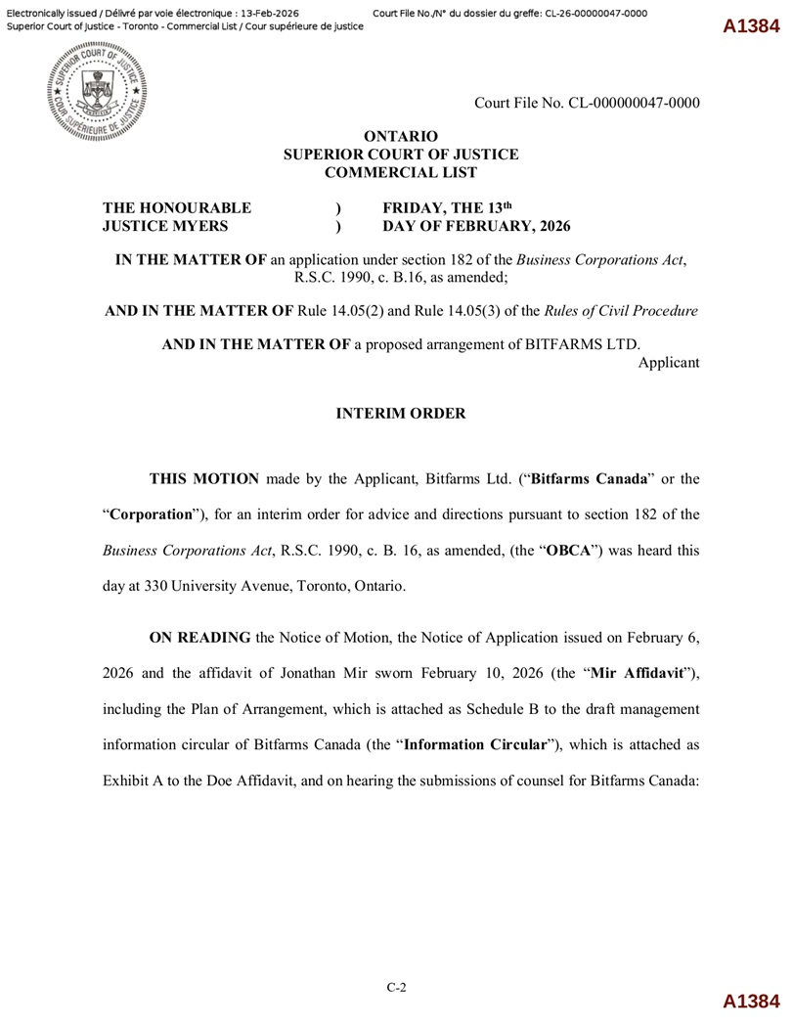
Court File No. CL - 000000047 - 0000 ONTARIO SUPERIOR COURT OF JUSTICE COMMERCIAL LIST THE HONOURABLE JUSTICE MYERS ) FRIDAY, THE 13 th ) DAY OF FEBRUARY, 2026 IN THE MATTER OF an application under section 182 of the Business Corporations Act , R.S.C. 1990, c. B.16, as amended; AND IN THE MATTER OF Rule 14.05(2) and Rule 14.05(3) of the Rules of Civil Procedure AND IN THE MATTER OF a proposed arrangement of BITFARMS LTD. Applicant INTERIM ORDER THIS MOTION made by the Applicant, Bitfarms Ltd . (“ Bitfarms Canada ” or the “ Corporation ”), for an interim order for advice and directions pursuant to section 182 of the Business Corporations Act , R . S . C . 1990 , c . B . 16 , as amended, (the “ OBCA ”) was heard this day at 330 University Avenue, Toronto, Ontario . ON READING the Notice of Motion, the Notice of Application issued on February 6 , 2026 and the affidavit of Jonathan Mir sworn February 10 , 2026 (the “ Mir Affidavit ”), including the Plan of Arrangement, which is attached as Schedule B to the draft management information circular of Bitfarms Canada (the “ Information Circular ”), which is attached as Exhibit A to the Doe Affidavit, and on hearing the submissions of counsel for Bitfarms Canada : A1384 C - 2 A1384

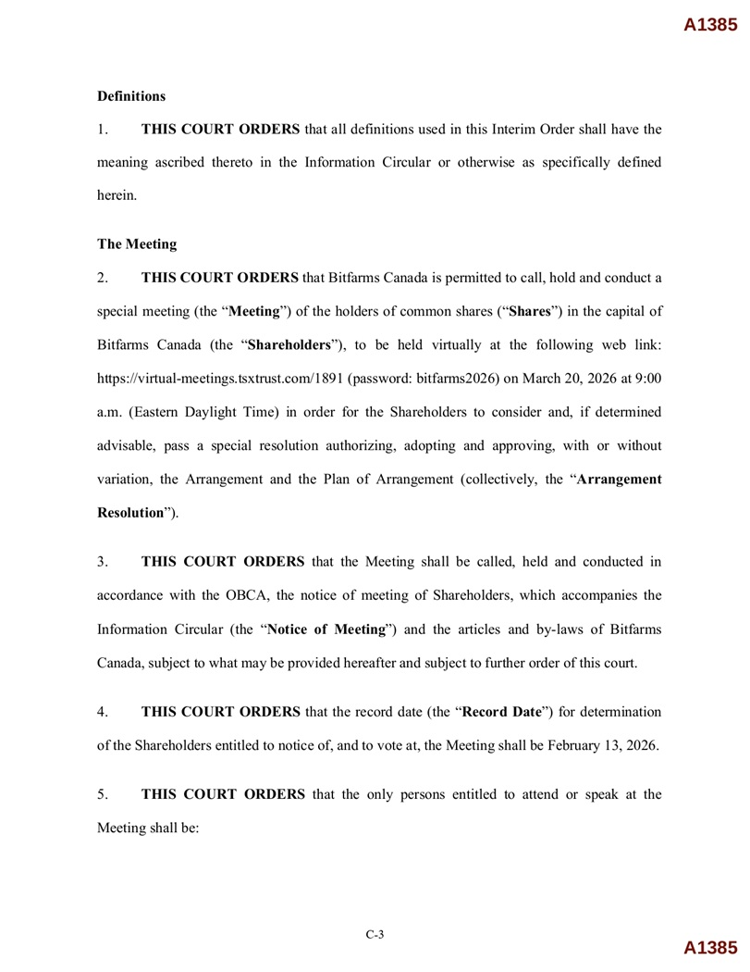
A1385 Definitions 1. THIS COURT ORDERS that all definitions used in this Interim Order shall have the meaning ascribed thereto in the Information Circular or otherwise as specifically defined herein . The Meeting 2. THIS COURT ORDERS that Bitfarms Canada is permitted to call, hold and conduct a special meeting (the “ Meeting ”) of the holders of common shares (“ Shares ”) in the capital of Bitfarms Canada (the “ Shareholders ”), to be held virtually at the following web link : https : //virtual - meetings . tsxtrust . com/ 1891 (password : bitfarms 2026 ) on March 20 , 2026 at 9 : 00 a . m . (Eastern Daylight Time) in order for the Shareholders to consider and, if determined advisable, pass a special resolution authorizing, adopting and approving, with or without variation, the Arrangement and the Plan of Arrangement (collectively, the “ Arrangement Resolution ”) . 3. THIS COURT ORDERS that the Meeting shall be called, held and conducted in accordance with the OBCA, the notice of meeting of Shareholders, which accompanies the Information Circular (the “ Notice of Meeting ”) and the articles and by - laws of Bitfarms Canada, subject to what may be provided hereafter and subject to further order of this court . 4. THIS COURT ORDERS that the record date (the “ Record Date ”) for determination of the Shareholders entitled to notice of, and to vote at, the Meeting shall be February 13 , 2026 . 5. THIS COURT ORDERS that the only persons entitled to attend or speak at the Meeting shall be : A1385 C - 3

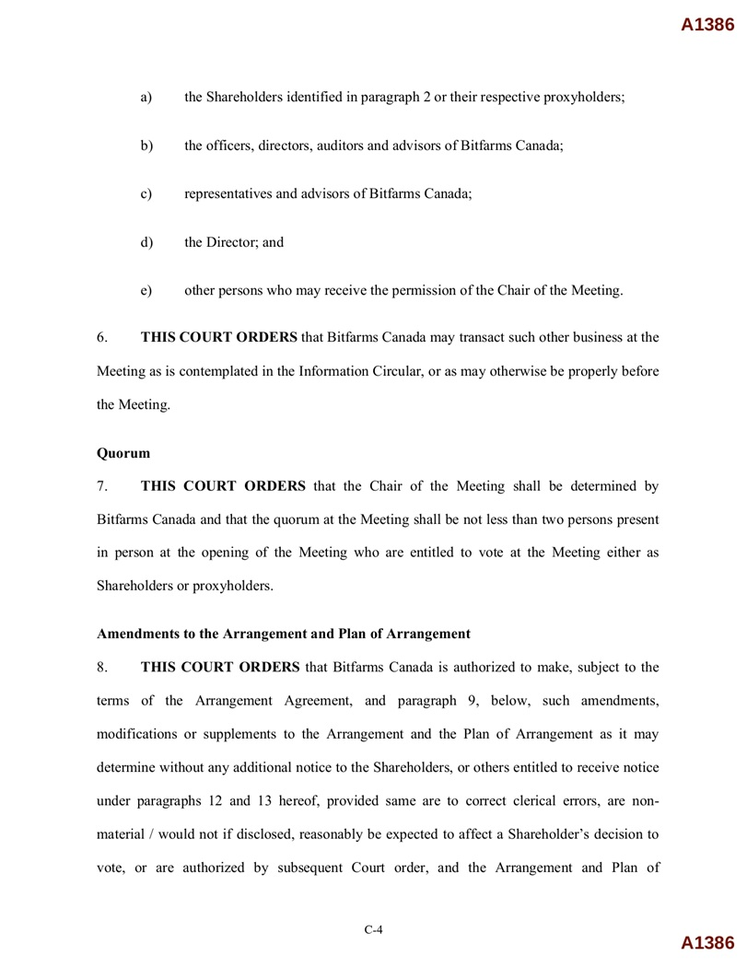
C - 4 A1386 a) the Shareholders identified in paragraph 2 or their respective proxyholders; b) the officers, directors, auditors and advisors of Bitfarms Canada; c) representatives and advisors of Bitfarms Canada; d) the Director; and e) other persons who may receive the permission of the Chair of the Meeting. 6. THIS COURT ORDERS that Bitfarms Canada may transact such other business at the Meeting as is contemplated in the Information Circular, or as may otherwise be properly before the Meeting. Quorum 7. THIS COURT ORDERS that the Chair of the Meeting shall be determined by Bitfarms Canada and that the quorum at the Meeting shall be not less than two persons present in person at the opening of the Meeting who are entitled to vote at the Meeting either as Shareholders or proxyholders . Amendments to the Arrangement and Plan of Arrangement 8. THIS COURT ORDERS that Bitfarms Canada is authorized to make, subject to the terms of the Arrangement Agreement, and paragraph 9 , below, such amendments, modifications or supplements to the Arrangement and the Plan of Arrangement as it may determine without any additional notice to the Shareholders, or others entitled to receive notice under paragraphs 12 and 13 hereof, provided same are to correct clerical errors, are non - material / would not if disclosed, reasonably be expected to affect a Shareholder’s decision to vote, or are authorized by subsequent Court order, and the Arrangement and Plan of A1386

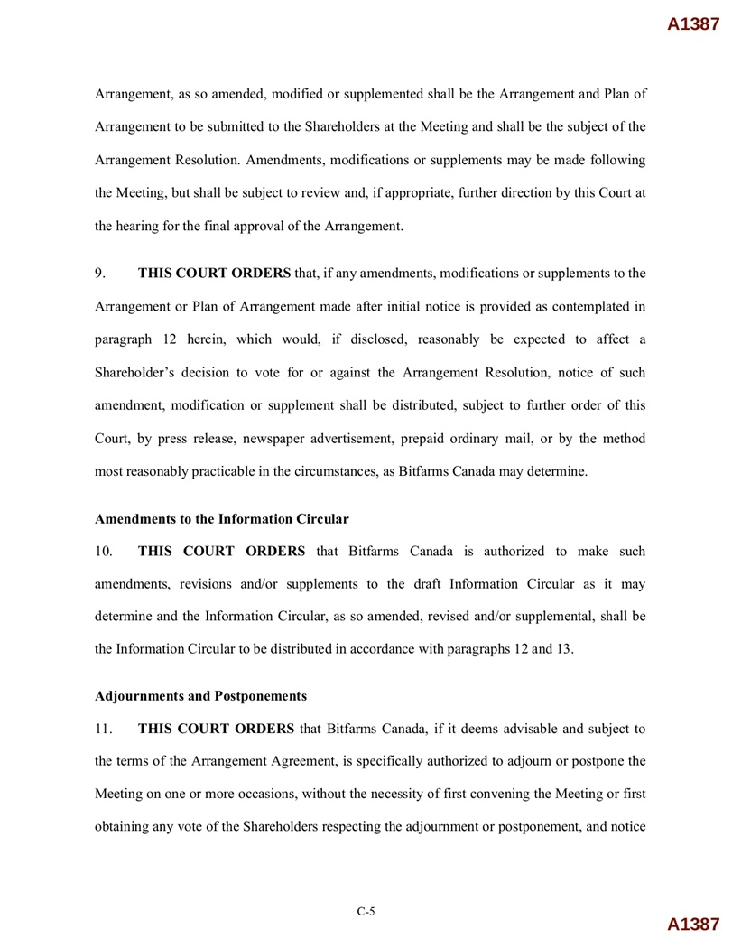
C - 5 A1387 Arrangement, as so amended, modified or supplemented shall be the Arrangement and Plan of Arrangement to be submitted to the Shareholders at the Meeting and shall be the subject of the Arrangement Resolution . Amendments, modifications or supplements may be made following the Meeting, but shall be subject to review and, if appropriate, further direction by this Court at the hearing for the final approval of the Arrangement . 9. THIS COURT ORDERS that, if any amendments, modifications or supplements to the Arrangement or Plan of Arrangement made after initial notice is provided as contemplated in paragraph 12 herein, which would, if disclosed, reasonably be expected to affect a Shareholder’s decision to vote for or against the Arrangement Resolution, notice of such amendment, modification or supplement shall be distributed, subject to further order of this Court, by press release, newspaper advertisement, prepaid ordinary mail, or by the method most reasonably practicable in the circumstances, as Bitfarms Canada may determine . Amendments to the Information Circular 10. THIS COURT ORDERS that Bitfarms Canada is authorized to make such amendments, revisions and/or supplements to the draft Information Circular as it may determine and the Information Circular, as so amended, revised and/or supplemental, shall be the Information Circular to be distributed in accordance with paragraphs 12 and 13 . Adjournments and Postponements 11. THIS COURT ORDERS that Bitfarms Canada, if it deems advisable and subject to the terms of the Arrangement Agreement, is specifically authorized to adjourn or postpone the Meeting on one or more occasions, without the necessity of first convening the Meeting or first obtaining any vote of the Shareholders respecting the adjournment or postponement, and notice A1387

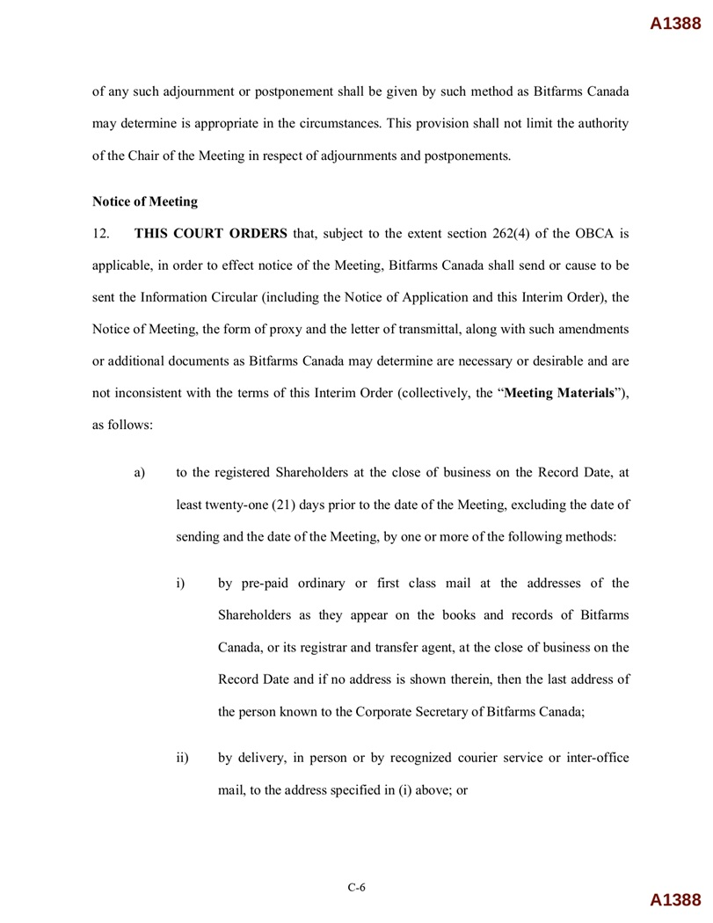
C - 6 A1388 of any such adjournment or postponement shall be given by such method as Bitfarms Canada may determine is appropriate in the circumstances . This provision shall not limit the authority of the Chair of the Meeting in respect of adjournments and postponements . Notice of Meeting 12 . THIS COURT ORDERS that, subject to the extent section 262 ( 4 ) of the OBCA is applicable, in order to effect notice of the Meeting, Bitfarms Canada shall send or cause to be sent the Information Circular (including the Notice of Application and this Interim Order), the Notice of Meeting, the form of proxy and the letter of transmittal, along with such amendments or additional documents as Bitfarms Canada may determine are necessary or desirable and are not inconsistent with the terms of this Interim Order (collectively, the “ Meeting Materials ”), as follows : a) to the registered Shareholders at the close of business on the Record Date, at least twenty - one (21) days prior to the date of the Meeting, excluding the date of sending and the date of the Meeting, by one or more of the following methods: i) by pre - paid ordinary or first class mail at the addresses of the Shareholders as they appear on the books and records of Bitfarms Canada, or its registrar and transfer agent, at the close of business on the Record Date and if no address is shown therein, then the last address of the person known to the Corporate Secretary of Bitfarms Canada ; ii) by delivery, in person or by recognized courier service or inter - office mail, to the address specified in (i) above; or A1388

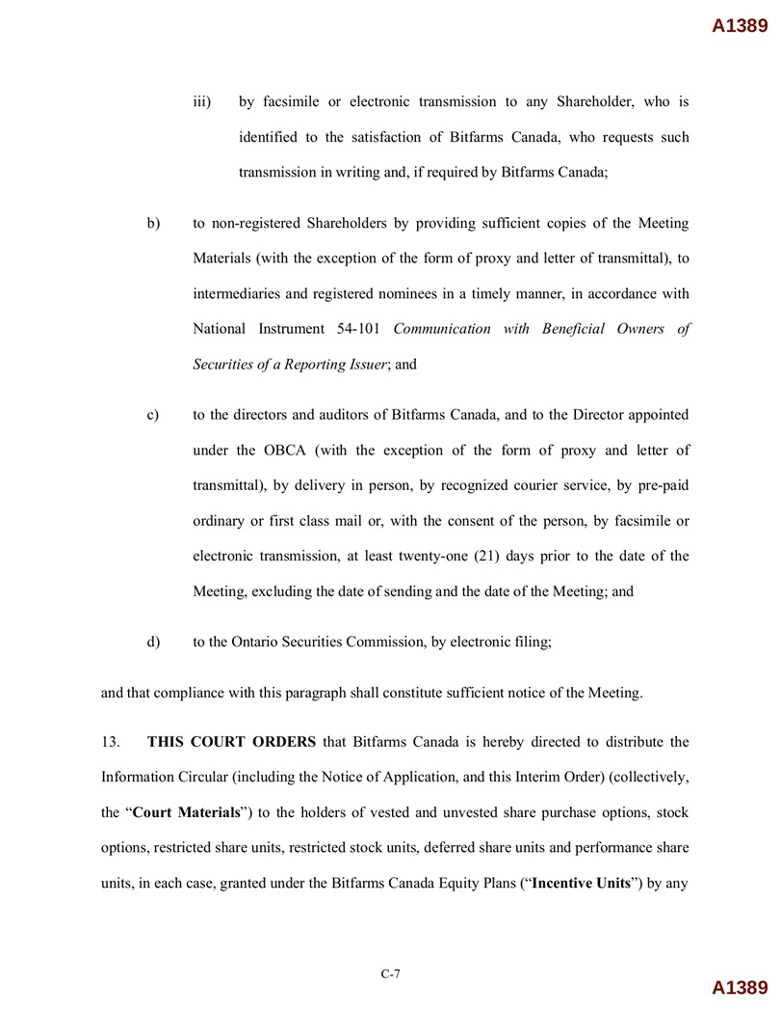
C - 7 A1389 iii) by facsimile or electronic transmission to any Shareholder, who is identified to the satisfaction of Bitfarms Canada, who requests such transmission in writing and, if required by Bitfarms Canada; b) to non - registered Shareholders by providing sufficient copies of the Meeting Materials (with the exception of the form of proxy and letter of transmittal), to intermediaries and registered nominees in a timely manner, in accordance with National Instrument 54 - 101 Communication with Beneficial Owners of Securities of a Reporting Issuer ; and c) to the directors and auditors of Bitfarms Canada, and to the Director appointed under the OBCA (with the exception of the form of proxy and letter of transmittal), by delivery in person, by recognized courier service, by pre - paid ordinary or first class mail or, with the consent of the person, by facsimile or electronic transmission, at least twenty - one ( 21 ) days prior to the date of the Meeting, excluding the date of sending and the date of the Meeting ; and d) to the Ontario Securities Commission, by electronic filing; and that compliance with this paragraph shall constitute sufficient notice of the Meeting . 13 . THIS COURT ORDERS that Bitfarms Canada is hereby directed to distribute the Information Circular (including the Notice of Application, and this Interim Order) (collectively, the “ Court Materials ”) to the holders of vested and unvested share purchase options, stock options, restricted share units, restricted stock units, deferred share units and performance share units, in each case, granted under the Bitfarms Canada Equity Plans (“ Incentive Units ”) by any A1389

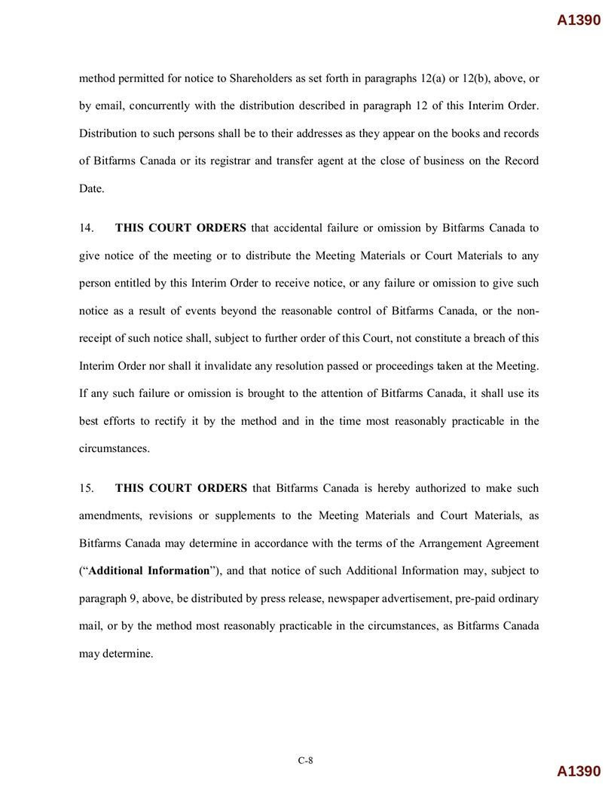
C - 8 A1390 method permitted for notice to Shareholders as set forth in paragraphs 12 (a) or 12 (b), above, or by email, concurrently with the distribution described in paragraph 12 of this Interim Order . Distribution to such persons shall be to their addresses as they appear on the books and records of Bitfarms Canada or its registrar and transfer agent at the close of business on the Record Date . 14. THIS COURT ORDERS that accidental failure or omission by Bitfarms Canada to give notice of the meeting or to distribute the Meeting Materials or Court Materials to any person entitled by this Interim Order to receive notice, or any failure or omission to give such notice as a result of events beyond the reasonable control of Bitfarms Canada, or the non - receipt of such notice shall, subject to further order of this Court, not constitute a breach of this Interim Order nor shall it invalidate any resolution passed or proceedings taken at the Meeting . If any such failure or omission is brought to the attention of Bitfarms Canada, it shall use its best efforts to rectify it by the method and in the time most reasonably practicable in the circumstances . 15. THIS COURT ORDERS that Bitfarms Canada is hereby authorized to make such amendments, revisions or supplements to the Meeting Materials and Court Materials, as Bitfarms Canada may determine in accordance with the terms of the Arrangement Agreement (“ Additional Information ”), and that notice of such Additional Information may, subject to paragraph 9 , above, be distributed by press release, newspaper advertisement, pre - paid ordinary mail, or by the method most reasonably practicable in the circumstances, as Bitfarms Canada may determine . A1390

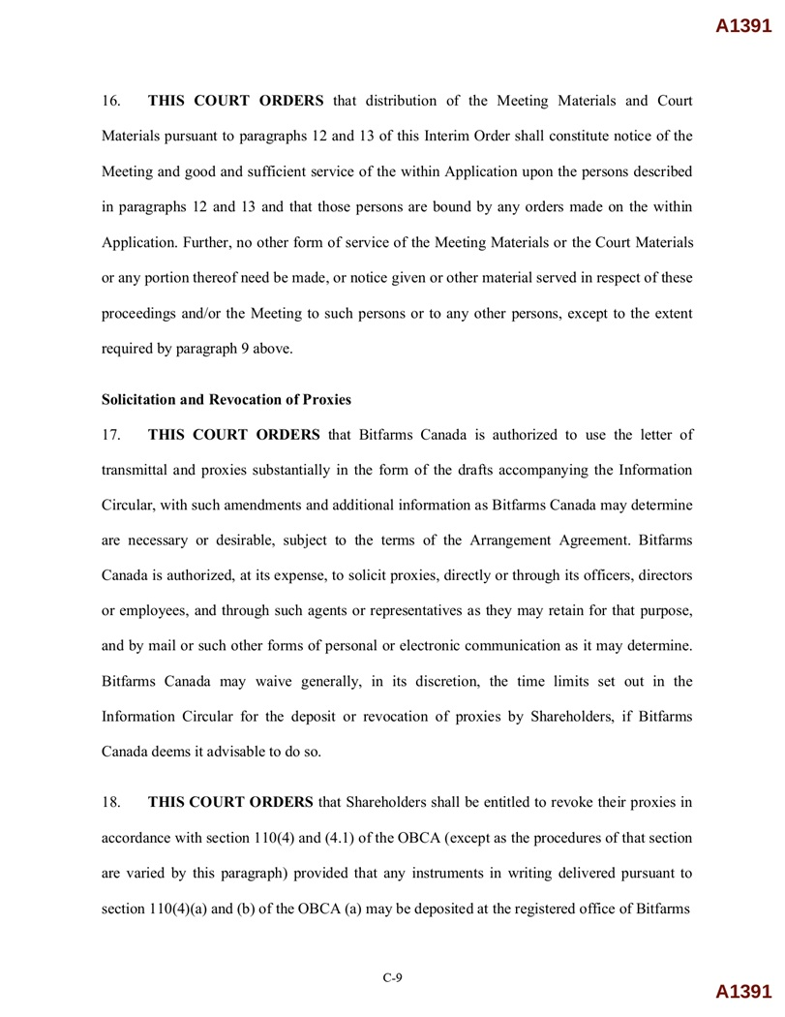
C - 9 A1391 16. THIS COURT ORDERS that distribution of the Meeting Materials and Court Materials pursuant to paragraphs 12 and 13 of this Interim Order shall constitute notice of the Meeting and good and sufficient service of the within Application upon the persons described in paragraphs 12 and 13 and that those persons are bound by any orders made on the within Application . Further, no other form of service of the Meeting Materials or the Court Materials or any portion thereof need be made, or notice given or other material served in respect of these proceedings and/or the Meeting to such persons or to any other persons, except to the extent required by paragraph 9 above . Solicitation and Revocation of Proxies 17. THIS COURT ORDERS that Bitfarms Canada is authorized to use the letter of transmittal and proxies substantially in the form of the drafts accompanying the Information Circular, with such amendments and additional information as Bitfarms Canada may determine are necessary or desirable, subject to the terms of the Arrangement Agreement . Bitfarms Canada is authorized, at its expense, to solicit proxies, directly or through its officers, directors or employees, and through such agents or representatives as they may retain for that purpose, and by mail or such other forms of personal or electronic communication as it may determine . Bitfarms Canada may waive generally, in its discretion, the time limits set out in the Information Circular for the deposit or revocation of proxies by Shareholders, if Bitfarms Canada deems it advisable to do so . 18. THIS COURT ORDERS that Shareholders shall be entitled to revoke their proxies in accordance with section 110 ( 4 ) and ( 4 . 1 ) of the OBCA (except as the procedures of that section are varied by this paragraph) provided that any instruments in writing delivered pursuant to section 110 ( 4 )(a) and (b) of the OBCA (a) may be deposited at the registered office of Bitfarms A1391

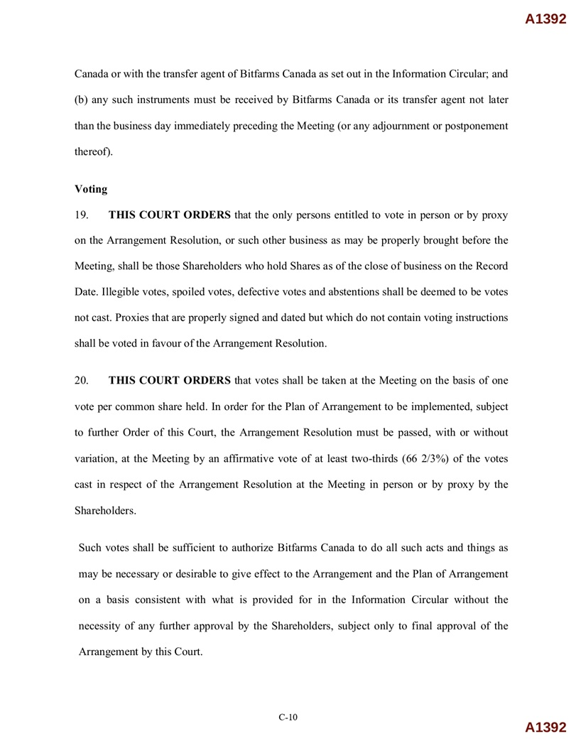
C - 10 A1392 Canada or with the transfer agent of Bitfarms Canada as set out in the Information Circular ; and (b) any such instruments must be received by Bitfarms Canada or its transfer agent not later than the business day immediately preceding the Meeting (or any adjournment or postponement thereof) . Voting 19. THIS COURT ORDERS that the only persons entitled to vote in person or by proxy on the Arrangement Resolution, or such other business as may be properly brought before the Meeting, shall be those Shareholders who hold Shares as of the close of business on the Record Date . Illegible votes, spoiled votes, defective votes and abstentions shall be deemed to be votes not cast . Proxies that are properly signed and dated but which do not contain voting instructions shall be voted in favour of the Arrangement Resolution . 20. THIS COURT ORDERS that votes shall be taken at the Meeting on the basis of one vote per common share held . In order for the Plan of Arrangement to be implemented, subject to further Order of this Court, the Arrangement Resolution must be passed, with or without variation, at the Meeting by an affirmative vote of at least two - thirds ( 66 2 / 3 % ) of the votes cast in respect of the Arrangement Resolution at the Meeting in person or by proxy by the Shareholders . Such votes shall be sufficient to authorize Bitfarms Canada to do all such acts and things as may be necessary or desirable to give effect to the Arrangement and the Plan of Arrangement on a basis consistent with what is provided for in the Information Circular without the necessity of any further approval by the Shareholders, subject only to final approval of the Arrangement by this Court . A1392

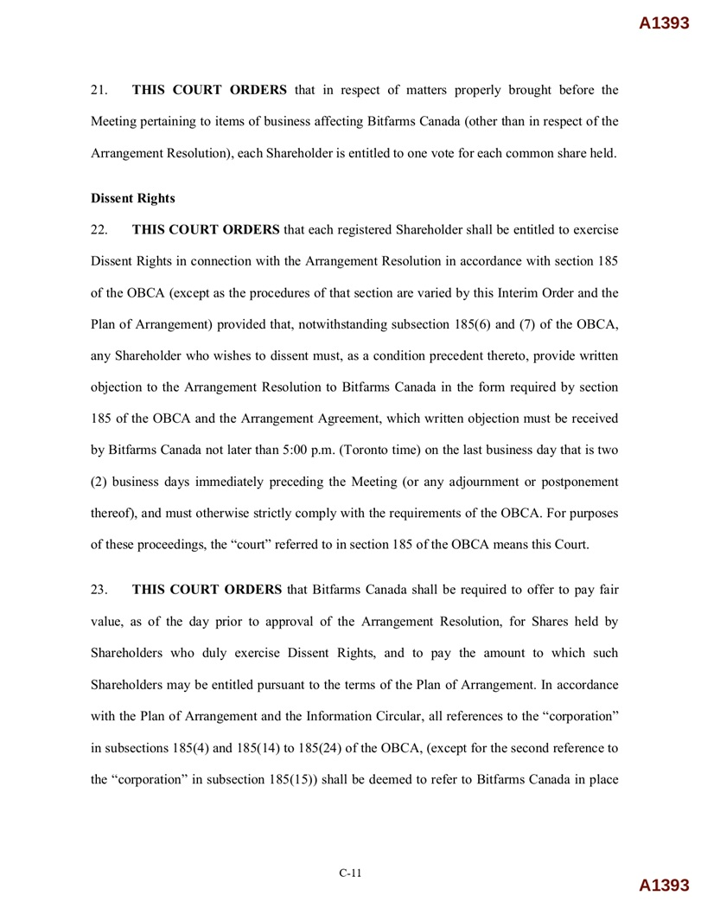
C - 11 A1393 21. THIS COURT ORDERS that in respect of matters properly brought before the Meeting pertaining to items of business affecting Bitfarms Canada (other than in respect of the Arrangement Resolution), each Shareholder is entitled to one vote for each common share held . Dissent Rights 22. THIS COURT ORDERS that each registered Shareholder shall be entitled to exercise Dissent Rights in connection with the Arrangement Resolution in accordance with section 185 of the OBCA (except as the procedures of that section are varied by this Interim Order and the Plan of Arrangement) provided that, notwithstanding subsection 185 ( 6 ) and ( 7 ) of the OBCA, any Shareholder who wishes to dissent must, as a condition precedent thereto, provide written objection to the Arrangement Resolution to Bitfarms Canada in the form required by section 185 of the OBCA and the Arrangement Agreement, which written objection must be received by Bitfarms Canada not later than 5 : 00 p . m . (Toronto time) on the last business day that is two ( 2 ) business days immediately preceding the Meeting (or any adjournment or postponement thereof), and must otherwise strictly comply with the requirements of the OBCA . For purposes of these proceedings, the “court” referred to in section 185 of the OBCA means this Court . 23. THIS COURT ORDERS that Bitfarms Canada shall be required to offer to pay fair value, as of the day prior to approval of the Arrangement Resolution, for Shares held by Shareholders who duly exercise Dissent Rights, and to pay the amount to which such Shareholders may be entitled pursuant to the terms of the Plan of Arrangement . In accordance with the Plan of Arrangement and the Information Circular, all references to the “corporation” in subsections 185 ( 4 ) and 185 ( 14 ) to 185 ( 24 ) of the OBCA, (except for the second reference to the “corporation” in subsection 185 ( 15 )) shall be deemed to refer to Bitfarms Canada in place A1393

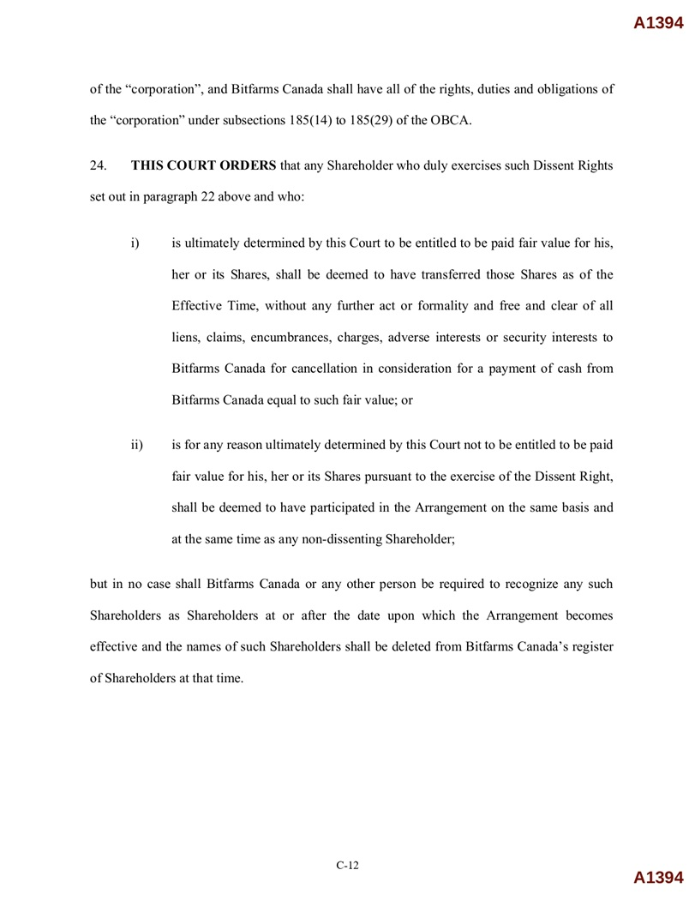
C - 12 A1394 of the “corporation”, and Bitfarms Canada shall have all of the rights, duties and obligations of the “corporation” under subsections 185(14) to 185(29) of the OBCA. 24. THIS COURT ORDERS that any Shareholder who duly exercises such Dissent Rights set out in paragraph 22 above and who: i) is ultimately determined by this Court to be entitled to be paid fair value for his, her or its Shares, shall be deemed to have transferred those Shares as of the Effective Time, without any further act or formality and free and clear of all liens, claims, encumbrances, charges, adverse interests or security interests to Bitfarms Canada for cancellation in consideration for a payment of cash from Bitfarms Canada equal to such fair value ; or ii) is for any reason ultimately determined by this Court not to be entitled to be paid fair value for his, her or its Shares pursuant to the exercise of the Dissent Right, shall be deemed to have participated in the Arrangement on the same basis and at the same time as any non - dissenting Shareholder ; but in no case shall Bitfarms Canada or any other person be required to recognize any such Shareholders as Shareholders at or after the date upon which the Arrangement becomes effective and the names of such Shareholders shall be deleted from Bitfarms Canada’s register of Shareholders at that time . A1394

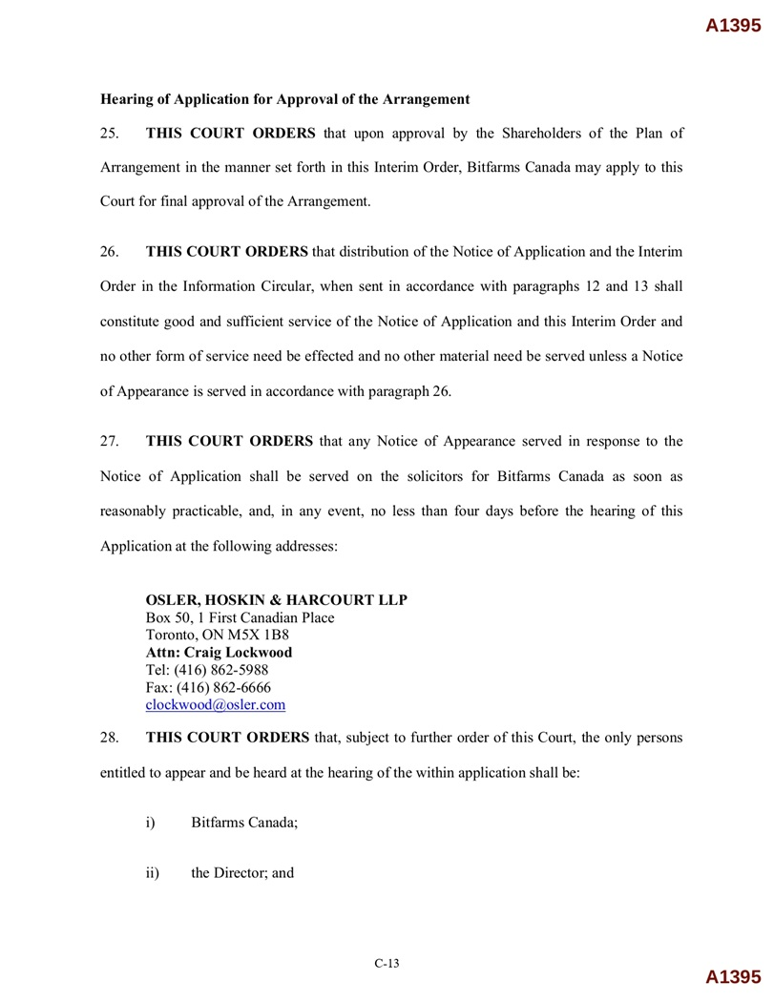
C - 13 A1395 Hearing of Application for Approval of the Arrangement 25. THIS COURT ORDERS that upon approval by the Shareholders of the Plan of Arrangement in the manner set forth in this Interim Order, Bitfarms Canada may apply to this Court for final approval of the Arrangement . 26. THIS COURT ORDERS that distribution of the Notice of Application and the Interim Order in the Information Circular, when sent in accordance with paragraphs 12 and 13 shall constitute good and sufficient service of the Notice of Application and this Interim Order and no other form of service need be effected and no other material need be served unless a Notice of Appearance is served in accordance with paragraph 26 . 27. THIS COURT ORDERS that any Notice of Appearance served in response to the Notice of Application shall be served on the solicitors for Bitfarms Canada as soon as reasonably practicable, and, in any event, no less than four days before the hearing of this Application at the following addresses : OSLER, HOSKIN & HARCOURT LLP Box 50, 1 First Canadian Place Toronto, ON M5X 1B8 Attn: Craig Lockwood Tel: (416) 862 - 5988 Fax: (416) 862 - 6666 clockwood@osler.com 28. THIS COURT ORDERS that, subject to further order of this Court, the only persons entitled to appear and be heard at the hearing of the within application shall be: i) Bitfarms Canada; ii) the Director; and A1395

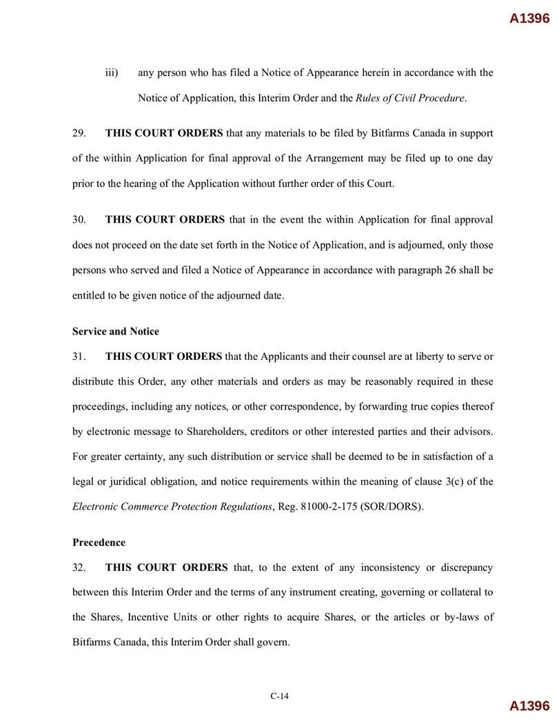
C - 14 A1396 iii) any person who has filed a Notice of Appearance herein in accordance with the Notice of Application, this Interim Order and the Rules of Civil Procedure . 29. THIS COURT ORDERS that any materials to be filed by Bitfarms Canada in support of the within Application for final approval of the Arrangement may be filed up to one day prior to the hearing of the Application without further order of this Court . 30. THIS COURT ORDERS that in the event the within Application for final approval does not proceed on the date set forth in the Notice of Application, and is adjourned, only those persons who served and filed a Notice of Appearance in accordance with paragraph 26 shall be entitled to be given notice of the adjourned date . Service and Notice 31. THIS COURT ORDERS that the Applicants and their counsel are at liberty to serve or distribute this Order, any other materials and orders as may be reasonably required in these proceedings, including any notices, or other correspondence, by forwarding true copies thereof by electronic message to Shareholders, creditors or other interested parties and their advisors . For greater certainty, any such distribution or service shall be deemed to be in satisfaction of a legal or juridical obligation, and notice requirements within the meaning of clause 3 (c) of the Electronic Commerce Protection Regulations , Reg . 81000 - 2 - 175 (SOR/DORS) . Precedence 32. THIS COURT ORDERS that, to the extent of any inconsistency or discrepancy between this Interim Order and the terms of any instrument creating, governing or collateral to the Shares, Incentive Units or other rights to acquire Shares, or the articles or by - laws of Bitfarms Canada, this Interim Order shall govern . A1396

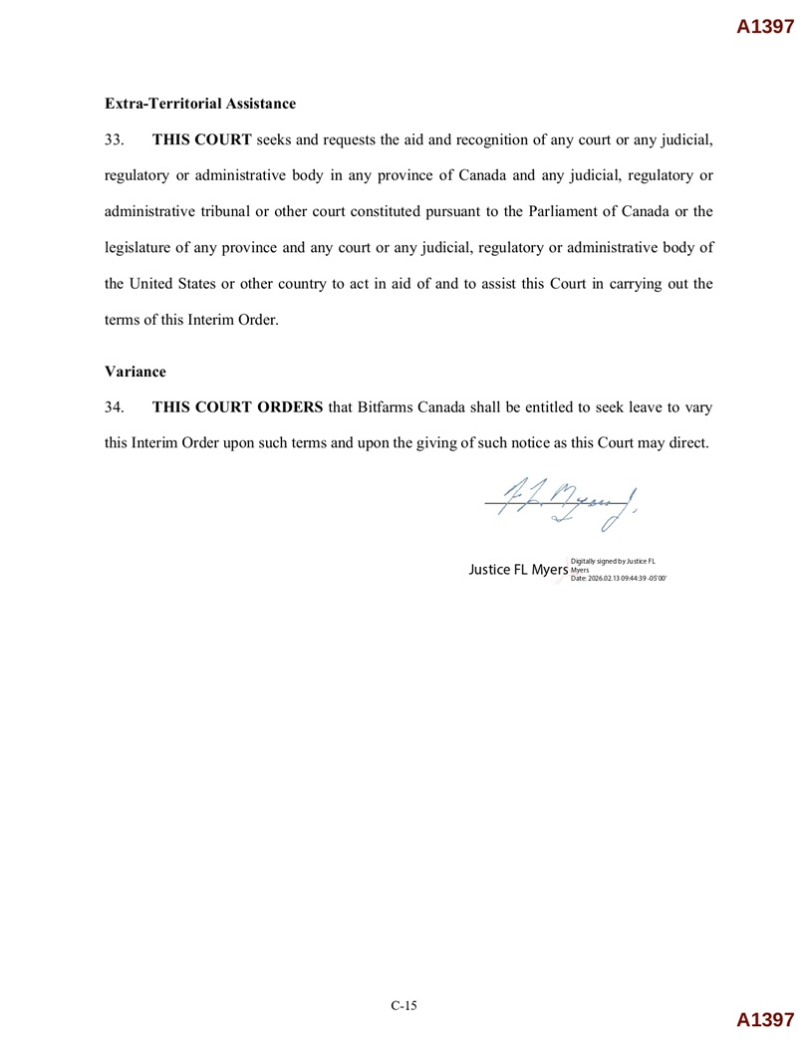
Extra - Territorial Assistance 33. THIS COURT seeks and requests the aid and recognition of any court or any judicial, regulatory or administrative body in any province of Canada and any judicial, regulatory or administrative tribunal or other court constituted pursuant to the Parliament of Canada or the legislature of any province and any court or any judicial, regulatory or administrative body of the United States or other country to act in aid of and to assist this Court in carrying out the terms of this Interim Order . Variance 34. THIS COURT ORDERS that Bitfarms Canada shall be entitled to seek leave to vary this Interim Order upon such terms and upon the giving of such notice as this Court may direct. A1397 Digitally signed by Justice FL C - 15 A1397 Justice FL Myers Myers Date: 2026.02.13 09:44:39 - 05'00'

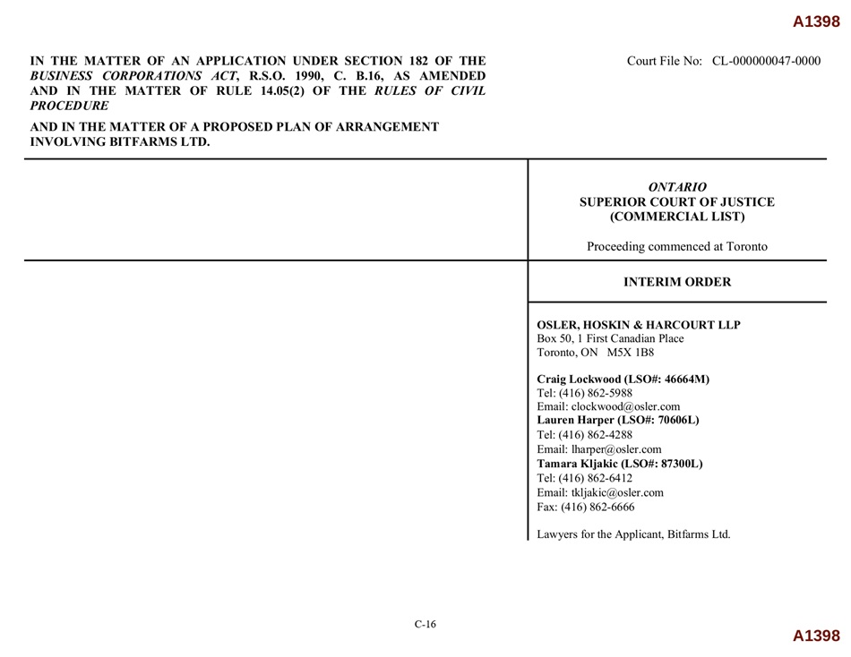
A1398 IN THE MATTER OF AN APPLICATION UNDER SECTION 182 OF THE BUSINESS CORPORATIONS ACT , R.S.O. 1990, C. B.16, AS AMENDED CIVIL AND IN THE MATTER OF RULE 14.05(2) OF THE RULES OF PROCEDURE AND IN THE MATTER OF A PROPOSED PLAN OF ARRANGEMENT INVOLVING BITFARMS LTD. Court File No: CL - 000000047 - 0000 ONTARIO SUPERIOR COURT OF JUSTICE (COMMERCIAL LIST) Proceeding commenced at Toronto INTERIM ORDER OSLER, HOSKIN & HARCOURT LLP Box 50, 1 First Canadian Place Toronto, ON M5X 1B8 Craig Lockwood (LSO#: 46664M) Tel: (416) 862 - 5988 Email: clockwood@osler.com Lauren Harper (LSO#: 70606L) Tel: (416) 862 - 4288 Email: lharper@osler.com Tamara Kljakic (LSO#: 87300L) Tel: (416) 862 - 6412 Email: tkljakic@osler.com Fax: (416) 862 - 6666 Lawyers for the Applicant, Bitfarms Ltd. A1398 C - 16


A1399 A1399 C - 17

Appendix D – SECTION 185 OF THE OBCA

Rights of dissenting shareholders

185 (1) Subject to subsection (3) and to sections 186 and 248, if a corporation resolves to,

 | (a) | amend its articles under section 168 to add, remove or change restrictions on the issue, transfer or ownership of shares of a class or series of the shares of the corporation;

 | (b) | amend its articles under section 168 to add, remove or change any restriction upon the business or businesses that the corporation may carry on or upon the powers that the corporation may exercise;

 | (c) | amalgamate with another corporation under sections 175 and 176;

 | (d) | be continued under the laws of another jurisdiction under section 181;

 | (d.1) | be continued under the Co-operative Corporations Act under section 181.1;

 | (d.2) | be continued under the Not-for-Profit Corporations Act, 2010 under section 181.2; or

 | (e) | sell, lease or exchange all or substantially all its property under subsection 184 (3),

a holder of shares of any class or series entitled to vote on the resolution may dissent. R.S.O. 1990, c. B.16, s. 185 (1); 2017, c. 20, Sched. 6, s. 24.

Idem

(2) If a corporation resolves to amend its articles in a manner referred to in subsection 170 (1), a holder of shares of any class or series entitled to vote on the amendment under section 168 or 170 may dissent, except in respect of an amendment referred to in,

 | (a) | clause 170 (1) (a), (b) or (e) where the articles provide that the holders of shares of such class or series are not entitled to dissent; or

 | (b) | subsection 170 (5) or (6). R.S.O. 1990, c. B.16, s. 185 (2).

One class of shares

(2.1) The right to dissent described in subsection (2) applies even if there is only one class of shares. 2006, c. 34, Sched. B, s. 35.

Exception

(3) A shareholder of a corporation incorporated before the 29th day of July, 1983 is not entitled to dissent under this section in respect of an amendment of the articles of the corporation to the extent that the amendment,

 | (a) | amends the express terms of any provision of the articles of the corporation to conform to the terms of the provision as deemed to be amended by section 277; or

 | (b) | deletes from the articles of the corporation all of the objects of the corporation set out in its articles, provided that the deletion is made by the 29th day of July, 1986. R.S.O. 1990, c. B.16, s. 185 (3).

Shareholder’s right to be paid fair value

(4) In addition to any other right the shareholder may have, but subject to subsection (30), a shareholder who complies with this section is entitled, when the action approved by the resolution from which the shareholder dissents becomes effective, to be paid by the corporation the fair value of the shares held by the shareholder in respect of which the shareholder dissents, determined as of the close of business on the day before the resolution was adopted. R.S.O. 1990, c. B.16, s. 185 (4).

D-1

No partial dissent

(5) A dissenting shareholder may only claim under this section with respect to all the shares of a class held by the dissenting shareholder on behalf of any one beneficial owner and registered in the name of the dissenting shareholder. R.S.O. 1990, c. B.16, s. 185 (5).

Objection

(6) A dissenting shareholder shall send to the corporation, at or before any meeting of shareholders at which a resolution referred to in subsection (1) or (2) is to be voted on, a written objection to the resolution, unless the corporation did not give notice to the shareholder of the purpose of the meeting or of the shareholder’s right to dissent. R.S.O. 1990, c. B.16, s. 185 (6).

Idem

(7) The execution or exercise of a proxy does not constitute a written objection for purposes of subsection (6). R.S.O. 1990, c. B.16, s. 185 (7).

Notice of adoption of resolution

(8) The corporation shall, within ten days after the shareholders adopt the resolution, send to each shareholder who has filed the objection referred to in subsection (6) notice that the resolution has been adopted, but such notice is not required to be sent to any shareholder who voted for the resolution or who has withdrawn the objection. R.S.O. 1990, c. B.16, s. 185 (8).

Idem

(9) A notice sent under subsection (8) shall set out the rights of the dissenting shareholder and the procedures to be followed to exercise those rights. R.S.O. 1990, c. B.16, s. 185 (9).

Demand for payment of fair value

(10) A dissenting shareholder entitled to receive notice under subsection (8) shall, within twenty days after receiving such notice, or, if the shareholder does not receive such notice, within twenty days after learning that the resolution has been adopted, send to the corporation a written notice containing,

 | (a) | the shareholder’s name and address;

 | (b) | the number and class of shares in respect of which the shareholder dissents; and

 | (c) | a demand for payment of the fair value of such shares. R.S.O. 1990, c. B.16, s. 185 (10).

Certificates to be sent in

(11) Not later than the thirtieth day after the sending of a notice under subsection (10), a dissenting shareholder shall send the certificates, if any, representing the shares in respect of which the shareholder dissents to the corporation or its transfer agent. R.S.O. 1990, c. B.16, s. 185 (11); 2011, c. 1, Sched. 2, s. 1 (9).

Idem

(12) A dissenting shareholder who fails to comply with subsections (6), (10) and (11) has no right to make a claim under this section. R.S.O. 1990, c. B.16, s. 185 (12).

Endorsement on certificate

(13) A corporation or its transfer agent shall endorse on any share certificate received under subsection (11) a notice that the holder is a dissenting shareholder under this section and shall return forthwith the share certificates to the dissenting shareholder. R.S.O. 1990, c. B.16, s. 185 (13).

D-2

Rights of dissenting shareholder

(14) On sending a notice under subsection (10), a dissenting shareholder ceases to have any rights as a shareholder other than the right to be paid the fair value of the shares as determined under this section except where,

 | (a) | the dissenting shareholder withdraws notice before the corporation makes an offer under subsection (15);

 | (b) | the corporation fails to make an offer in accordance with subsection (15) and the dissenting shareholder withdraws notice; or

 | (c) | the directors revoke a resolution to amend the articles under subsection 168 (3), terminate an amalgamation agreement under subsection 176 (5) or an application for continuance under subsection 181 (5), or abandon a sale, lease or exchange under subsection 184 (8),

in which case the dissenting shareholder’s rights are reinstated as of the date the dissenting shareholder sent the notice referred to in subsection (10). R.S.O. 1990, c. B.16, s. 185 (14); 2011, c. 1, Sched. 2, s. 1 (10).

Same

(14.1) A dissenting shareholder whose rights are reinstated under subsection (14) is entitled, upon presentation and surrender to the corporation or its transfer agent of any share certificate that has been endorsed in accordance with subsection (13),

 | (a) | to be issued, without payment of any fee, a new certificate representing the same number, class and series of shares as the certificate so surrendered; or

 | (b) | if a resolution is passed by the directors under subsection 54 (2) with respect to that class and series of shares,

 | (i) | to be issued the same number, class and series of uncertificated shares as represented by the certificate so surrendered, and

 | (ii) | to be sent the notice referred to in subsection 54 (3). 2011, c. 1, Sched. 2, s. 1 (11).

Same

(14.2) A dissenting shareholder whose rights are reinstated under subsection (14) and who held uncertificated shares at the time of sending a notice to the corporation under subsection (10) is entitled,

 | (a) | to be issued the same number, class and series of uncertificated shares as those held by the dissenting shareholder at the time of sending the notice under subsection (10); and

 | (b) | to be sent the notice referred to in subsection 54 (3). 2011, c. 1, Sched. 2, s. 1 (11).

Offer to pay

(15) A corporation shall, not later than seven days after the later of the day on which the action approved by the resolution is effective or the day the corporation received the notice referred to in subsection (10), send to each dissenting shareholder who has sent such notice,

 | (a) | a written offer to pay for the dissenting shareholder’s shares in an amount considered by the directors of the corporation to be the fair value thereof, accompanied by a statement showing how the fair value was determined; or

 | (b) | if subsection (30) applies, a notification that it is unable lawfully to pay dissenting shareholders for their shares. R.S.O. 1990, c. B.16, s. 185 (15).

D-3

Idem

(16) Every offer made under subsection (15) for shares of the same class or series shall be on the same terms. R.S.O. 1990, c. B.16, s. 185 (16).

Idem

(17) Subject to subsection (30), a corporation shall pay for the shares of a dissenting shareholder within ten days after an offer made under subsection (15) has been accepted, but any such offer lapses if the corporation does not receive an acceptance thereof within thirty days after the offer has been made. R.S.O. 1990, c. B.16, s. 185 (17).

Application to court to fix fair value

(18) Where a corporation fails to make an offer under subsection (15) or if a dissenting shareholder fails to accept an offer, the corporation may, within fifty days after the action approved by the resolution is effective or within such further period as the court may allow, apply to the court to fix a fair value for the shares of any dissenting shareholder. R.S.O. 1990, c. B.16, s. 185 (18).

Idem

(19) If a corporation fails to apply to the court under subsection (18), a dissenting shareholder may apply to the court for the same purpose within a further period of twenty days or within such further period as the court may allow. R.S.O. 1990, c. B.16, s. 185 (19).

Idem

(20) A dissenting shareholder is not required to give security for costs in an application made under subsection (18) or (19). R.S.O. 1990, c. B.16, s. 185 (20).

Costs

(21) If a corporation fails to comply with subsection (15), then the costs of a shareholder application under subsection (19) are to be borne by the corporation unless the court otherwise orders. R.S.O. 1990, c. B.16, s. 185 (21).

Notice to shareholders

(22) Before making application to the court under subsection (18) or not later than seven days after receiving notice of an application to the court under subsection (19), as the case may be, a corporation shall give notice to each dissenting shareholder who, at the date upon which the notice is given,

 | (a) | has sent to the corporation the notice referred to in subsection (10); and

 | (b) | has not accepted an offer made by the corporation under subsection (15), if such an offer was made,

of the date, place and consequences of the application and of the dissenting shareholder’s right to appear and be heard in person or by counsel, and a similar notice shall be given to each dissenting shareholder who, after the date of such first mentioned notice and before termination of the proceedings commenced by the application, satisfies the conditions set out in clauses (a) and (b) within three days after the dissenting shareholder satisfies such conditions. R.S.O. 1990, c. B.16, s. 185 (22).

D-4

Parties joined

(23) All dissenting shareholders who satisfy the conditions set out in clauses (22) (a) and (b) shall be deemed to be joined as parties to an application under subsection (18) or (19) on the later of the date upon which the application is brought and the date upon which they satisfy the conditions, and shall be bound by the decision rendered by the court in the proceedings commenced by the application. R.S.O. 1990, c. B.16, s. 185 (23).

Idem

(24) Upon an application to the court under subsection (18) or (19), the court may determine whether any other person is a dissenting shareholder who should be joined as a party, and the court shall fix a fair value for the shares of all dissenting shareholders. R.S.O. 1990, c. B.16, s. 185 (24).

Appraisers

(25) The court may in its discretion appoint one or more appraisers to assist the court to fix a fair value for the shares of the dissenting shareholders. R.S.O. 1990, c. B.16, s. 185 (25).

Final order

(26) The final order of the court in the proceedings commenced by an application under subsection (18) or (19) shall be rendered against the corporation and in favour of each dissenting shareholder who, whether before or after the date of the order, complies with the conditions set out in clauses (22) (a) and (b). R.S.O. 1990, c. B.16, s. 185 (26).

Interest

(27) The court may in its discretion allow a reasonable rate of interest on the amount payable to each dissenting shareholder from the date the action approved by the resolution is effective until the date of payment. R.S.O. 1990, c. B.16, s. 185 (27).

Where corporation unable to pay

(28) Where subsection (30) applies, the corporation shall, within ten days after the pronouncement of an order under subsection (26), notify each dissenting shareholder that it is unable lawfully to pay dissenting shareholders for their shares. R.S.O. 1990, c. B.16, s. 185 (28).

Idem

(29) Where subsection (30) applies, a dissenting shareholder, by written notice sent to the corporation within thirty days after receiving a notice under subsection (28), may,

 | (a) | withdraw a notice of dissent, in which case the corporation is deemed to consent to the withdrawal and the shareholder’s full rights are reinstated; or

 | (b) | retain a status as a claimant against the corporation, to be paid as soon as the corporation is lawfully able to do so or, in a liquidation, to be ranked subordinate to the rights of creditors of the corporation but in priority to its shareholders. R.S.O. 1990, c. B.16, s. 185 (29).

D-5

Idem

(30) A corporation shall not make a payment to a dissenting shareholder under this section if there are reasonable grounds for believing that,

 | (a) | the corporation is or, after the payment, would be unable to pay its liabilities as they become due; or

 | (b) | the realizable value of the corporation’s assets would thereby be less than the aggregate of its liabilities. R.S.O. 1990, c. B.16, s. 185 (30).

Court order

(31) Upon application by a corporation that proposes to take any of the actions referred to in subsection (1) or (2), the court may, if satisfied that the proposed action is not in all the circumstances one that should give rise to the rights arising under subsection (4), by order declare that those rights will not arise upon the taking of the proposed action, and the order may be subject to compliance upon such terms and conditions as the court thinks fit and, if the corporation is an offering corporation, notice of any such application and a copy of any order made by the court upon such application shall be served upon the Commission. 1994, c. 27, s. 71 (24).

Commission may appear

(32) The Commission may appoint counsel to assist the court upon the hearing of an application under subsection (31), if the corporation is an offering corporation. 1994, c. 27, s. 71 (24).

Section Amendments with date in force (d/m/y)

1994, c. 27, s. 71 (24) - 01/03/1995

2006, c. 34, Sched. B, s. 35 - 01/08/2007

2011, c. 1, Sched. 2, s. 1 (9-11) - 31/12/2015

2017, c. 20, Sched. 6, s. 24 - 19/10/2021

D-6

Appendix E – NOTICE OF APPLICATION FOR FINAL ORDER

Please see attached.

E-1

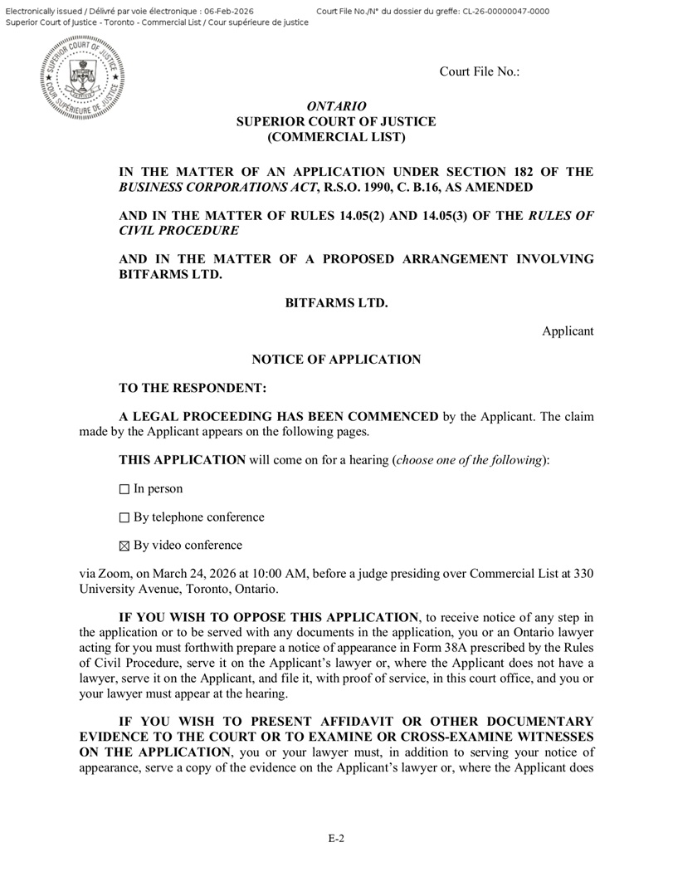
Court File No.: ONTARIO SUPERIOR COURT OF JUSTICE (COMMERCIAL LIST) IN THE MATTER OF AN APPLICATION UNDER SECTION 182 OF THE BUSINESS CORPORATIONS ACT , R.S.O. 1990, C. B.16, AS AMENDED AND IN THE MATTER OF RULES 14.05(2) AND 14.05(3) OF THE RULES OF CIVIL PROCEDURE AND IN THE MATTER OF A PROPOSED ARRANGEMENT INVOLVING BITFARMS LTD. BITFARMS LTD. Applicant NOTICE OF APPLICATION TO THE RESPONDENT: A LEGAL PROCEEDING HAS BEEN COMMENCED by the Applicant. The claim made by the Applicant appears on the following pages. THIS APPLICATION will come on for a hearing ( choose one of the following ): In person By telephone conference By video conference via Zoom, on March 24, 2026 at 10:00 AM, before a judge presiding over Commercial List at 330 University Avenue, Toronto, Ontario. IF YOU WISH TO OPPOSE THIS APPLICATION , to receive notice of any step in the application or to be served with any documents in the application, you or an Ontario lawyer acting for you must forthwith prepare a notice of appearance in Form 38 A prescribed by the Rules of Civil Procedure, serve it on the Applicant’s lawyer or, where the Applicant does not have a lawyer, serve it on the Applicant, and file it, with proof of service, in this court office, and you or your lawyer must appear at the hearing . IF YOU WISH TO PRESENT AFFIDAVIT OR OTHER DOCUMENTARY EVIDENCE TO THE COURT OR TO EXAMINE OR CROSS - EXAMINE WITNESSES ON THE APPLICATION , you or your lawyer must, in addition to serving your notice of appearance, serve a copy of the evidence on the Applicant’s lawyer or, where the Applicant does E - 2

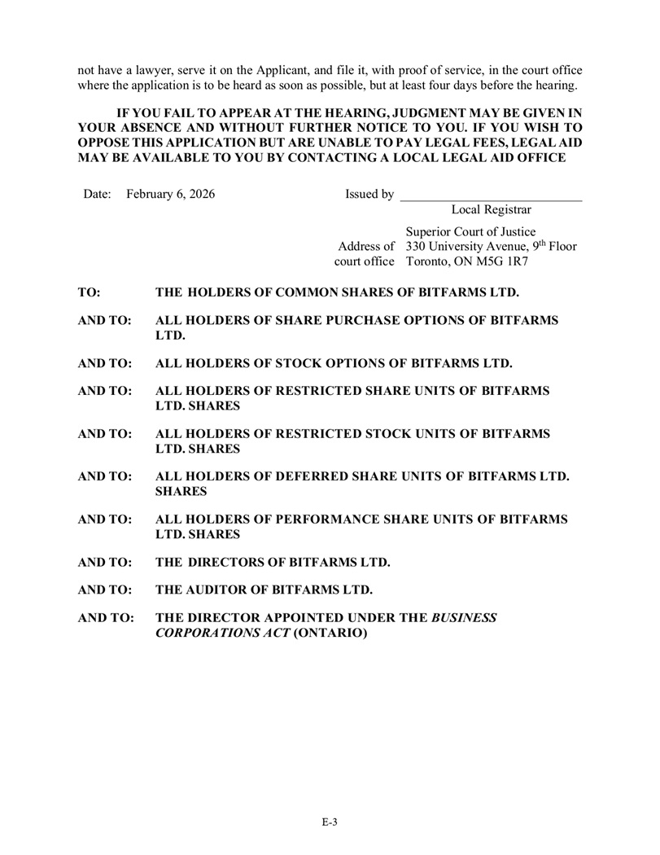
E - 3 not have a lawyer, serve it on the Applicant, and file it, with proof of service, in the court office where the application is to be heard as soon as possible, but at least four days before the hearing. IF YOU FAIL TO APPEAR AT THE HEARING, JUDGMENT MAY BE GIVEN IN YOUR ABSENCE AND WITHOUT FURTHER NOTICE TO YOU . IF YOU WISH TO OPPOSE THIS APPLICATION BUT ARE UNABLE TO PAY LEGAL FEES, LEGAL AID MAY BE AVAILABLE TO YOU BY CONTACTING A LOCAL LEGAL AID OFFICE Date: February 6, 2026 Issued by Local Registrar Superior Court of Justice Address of 330 University Avenue, 9 th Floor court office Toronto, ON M5G 1R7 TO: THE HOLDERS OF COMMON SHARES OF BITFARMS LTD. AND TO: ALL HOLDERS OF SHARE PURCHASE OPTIONS OF BITFARMS LTD. AND TO: ALL HOLDERS OF STOCK OPTIONS OF BITFARMS LTD. AND TO: ALL HOLDERS OF RESTRICTED SHARE UNITS OF BITFARMS LTD. SHARES AND TO: ALL HOLDERS OF RESTRICTED STOCK UNITS OF BITFARMS LTD. SHARES AND TO: ALL HOLDERS OF DEFERRED SHARE UNITS OF BITFARMS LTD. SHARES AND TO: ALL HOLDERS OF PERFORMANCE SHARE UNITS OF BITFARMS LTD. SHARES AND TO: THE DIRECTORS OF BITFARMS LTD. AND TO: THE AUDITOR OF BITFARMS LTD. AND TO: THE DIRECTOR APPOINTED UNDER THE BUSINESS CORPORATIONS ACT (ONTARIO)

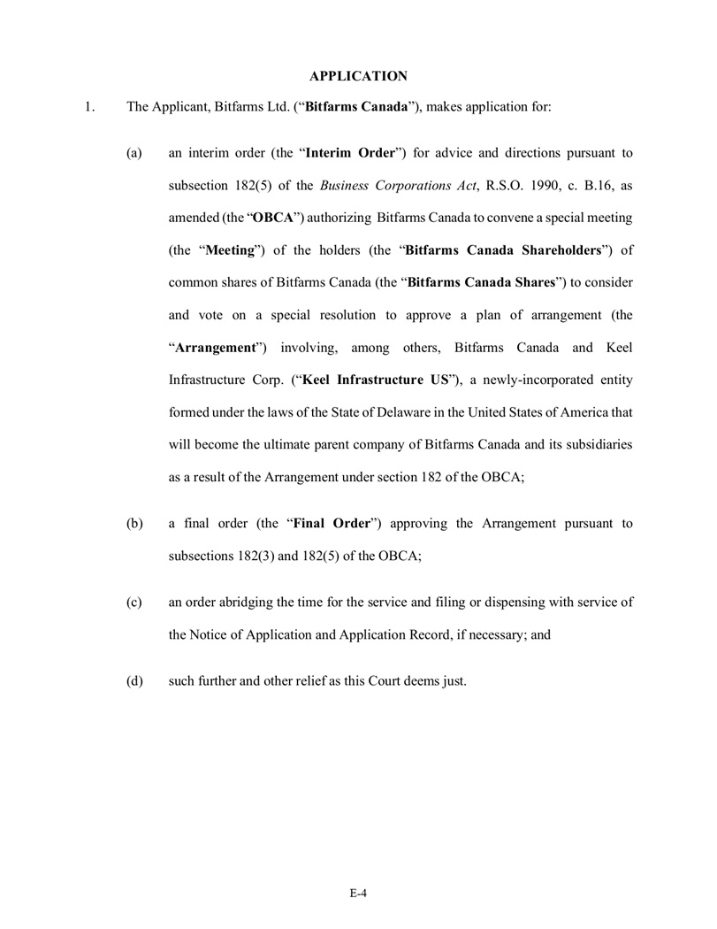
E - 4 APPLICATION 1. The Applicant, Bitfarms Ltd. (“ Bitfarms Canada ”), makes application for: (a) an interim order (the “ Interim Order ”) for advice and directions pursuant to subsection 182 ( 5 ) of the Business Corporations Act , R . S . O . 1990 , c . B . 16 , as amended (the “ OBCA ”) authorizing Bitfarms Canada to convene a special meeting (the “ Meeting ”) of the holders (the “ Bitfarms Ca n a da Shareholders ”) of common shares of Bitfarms Canada (the “ Bitfarms Ca n a da Shares ”) to consider and vote on a special resolution to approve a plan of arrangement (the “ Arrangement ”) involving, among others, Bitfarms Canada and Keel Infrastructure Corp . (“ Keel Infrastructure US ”), a newly - incorporated entity formed under the laws of the State of Delaware in the United States of America that will become the ultimate parent company of Bitfarms Canada and its subsidiaries as a result of the Arrangement under section 182 of the OBCA ; (b) a final order (the “ Final Order ”) approving the Arrangement pursuant to subsections 182 ( 3 ) and 182 ( 5 ) of the OBCA ; (c) an order abridging the time for the service and filing or dispensing with service of the Notice of Application and Application Record, if necessary ; and (d) such further and other relief as this Court deems just .

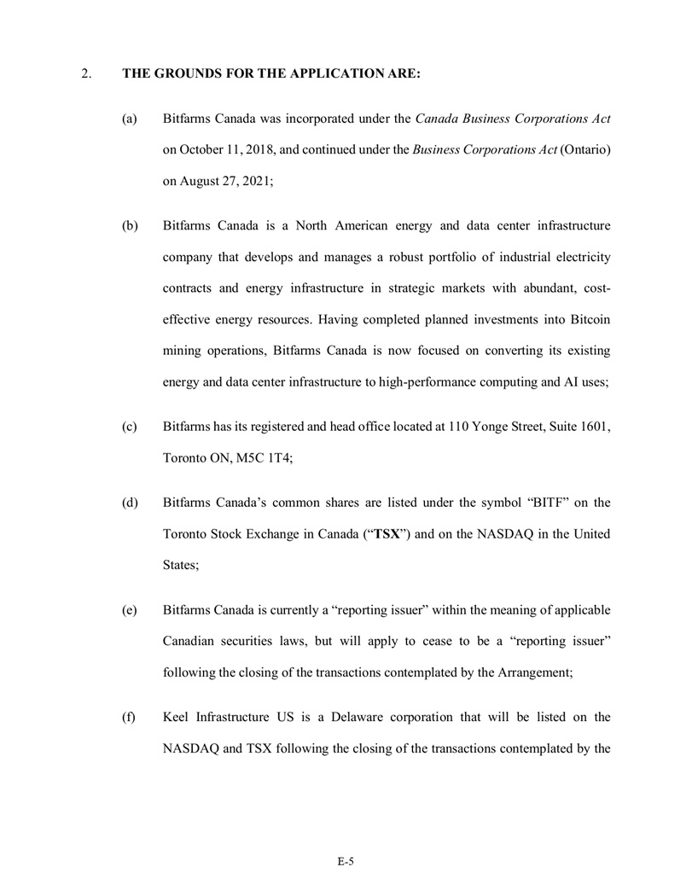
E - 5 2. THE GROUNDS FOR THE APPLICATION ARE: (a) Bitfarms Canada was incorporated under the Canada Business Corporations Act on October 11 , 2018 , and continued under the Business Corporations Act (Ontario) on August 27 , 2021 ; (b) Bitfarms Canada is a North American energy and data center infrastructure company that develops and manages a robust portfolio of industrial electricity contracts and energy infrastructure in strategic markets with abundant, cost - effective energy resources . Having completed planned investments into Bitcoin mining operations, Bitfarms Canada is now focused on converting its existing energy and data center infrastructure to high - performance computing and AI uses ; (c) Bitfarms has its registered and head office located at 110 Yonge Street, Suite 1601 , Toronto ON, M 5 C 1 T 4 ; (d) Bitfarms Canada’s common shares are listed under the symbol “BITF” on the Toronto Stock Exchange in Canada (“ TSX ”) and on the NASDAQ in the United States ; (e) Bitfarms Canada is currently a “reporting issuer” within the meaning of applicable Canadian securities laws, but will apply to cease to be a “reporting issuer” following the closing of the transactions contemplated by the Arrangement ; (f) Keel Infrastructure US is a Delaware corporation that will be listed on the NASDAQ and TSX following the closing of the transactions contemplated by the

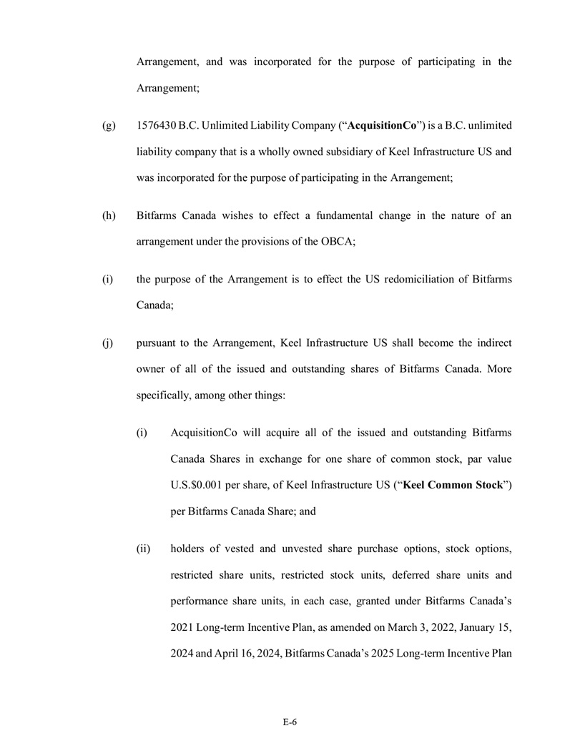
E - 6 Arrangement, and was incorporated for the purpose of participating in the Arrangement; (g) 1576430 B . C . Unlimited Liability Company (“ AcquisitionCo ”) is a B . C . unlimited liability company that is a wholly owned subsidiary of Keel Infrastructure US and was incorporated for the purpose of participating in the Arrangement ; (h) Bitfarms Canada wishes to effect a fundamental change in the nature of an arrangement under the provisions of the OBCA ; (i) the purpose of the Arrangement is to effect the US redomiciliation of Bitfarms Canada; (j) pursuant to the Arrangement, Keel Infrastructure US shall become the indirect owner of all of the issued and outstanding shares of Bitfarms Canada. More specifically, among other things: (i) AcquisitionCo will acquire all of the issued and outstanding Bitfarms Canada Shares in exchange for one share of common stock, par value U.S.$0.001 per share, of Keel Infrastructure US (“ Keel Common Stock ”) per Bitfarms Canada Share; and (ii) holders of vested and unvested share purchase options, stock options, restricted share units, restricted stock units, deferred share units and performance share units, in each case, granted under Bitfarms Canada’s 2021 Long - term Incentive Plan, as amended on March 3, 2022, January 15, 2024 and April 16, 2024, Bitfarms Canada’s 2025 Long - term Incentive Plan

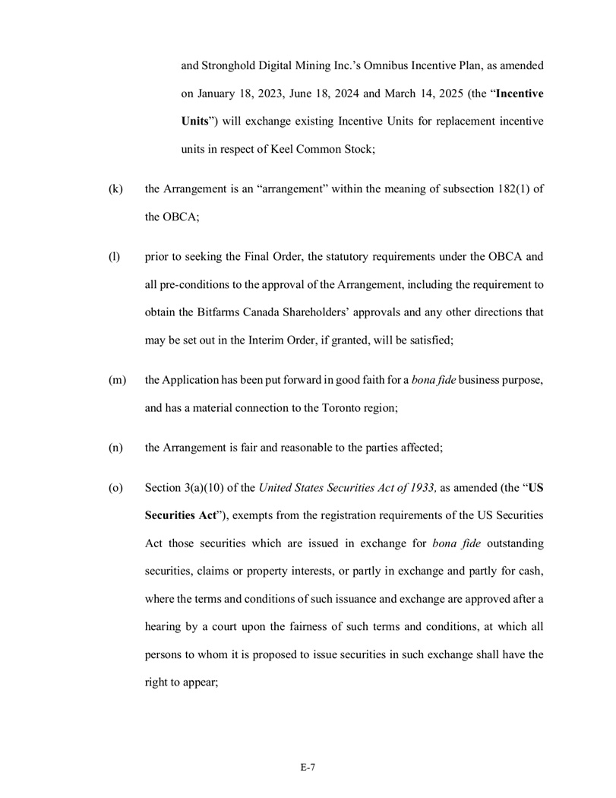
E - 7 and Stronghold Digital Mining Inc . ’s Omnibus Incentive Plan, as amended on January 18 , 2023 , June 18 , 2024 and March 14 , 2025 (the “ Incentive Units ”) will exchange existing Incentive Units for replacement incentive units in respect of Keel Common Stock ; (k) the Arrangement is an “arrangement” within the meaning of subsection 182 ( 1 ) of the OBCA ; (l) prior to seeking the Final Order, the statutory requirements under the OBCA and all pre - conditions to the approval of the Arrangement, including the requirement to obtain the Bitfarms Canada Shareholders’ approvals and any other directions that may be set out in the Interim Order, if granted, will be satisfied; (m) the Application has been put forward in good faith for a bona fide business purpose, and has a material connection to the Toronto region; (n) the Arrangement is fair and reasonable to the parties affected ; (o) Section 3 (a)( 10 ) of the United States Securities Act of 1933 , as amended (the “ US Securities Act ”), exempts from the registration requirements of the US Securities Act those securities which are issued in exchange for bona fide outstanding securities, claims or property interests, or partly in exchange and partly for cash, where the terms and conditions of such issuance and exchange are approved after a hearing by a court upon the fairness of such terms and conditions, at which all persons to whom it is proposed to issue securities in such exchange shall have the right to appear ;

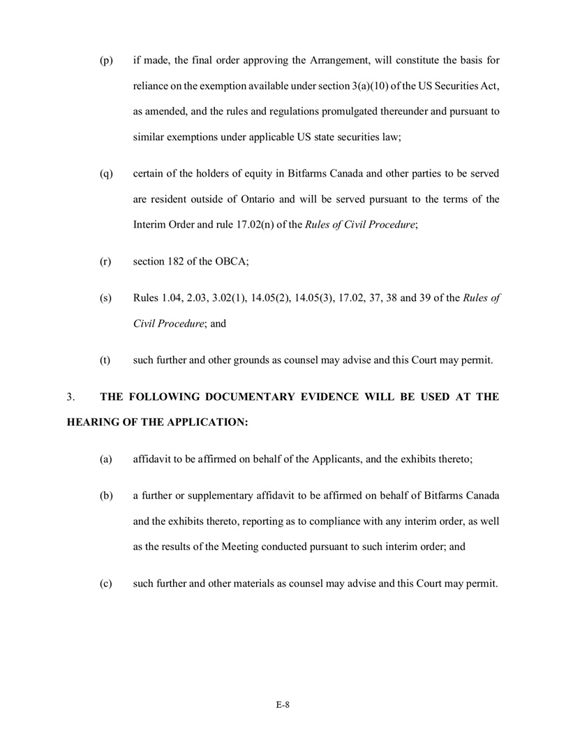
E - 8 (p) if made, the final order approving the Arrangement, will constitute the basis for reliance on the exemption available under section 3 (a)( 10 ) of the US Securities Act, as amended, and the rules and regulations promulgated thereunder and pursuant to similar exemptions under applicable US state securities law ; (q) certain of the holders of equity in Bitfarms Canada and other parties to be served are resident outside of Ontario and will be served pursuant to the terms of the Interim Order and rule 17 . 02 (n) of the Rules of Civil Procedure ; (r) section 182 of the OBCA; (s) Rules 1.04, 2.03, 3.02(1), 14.05(2), 14.05(3), 17.02, 37, 38 and 39 of the Rules of Civil Procedure ; and (t) such further and other grounds as counsel may advise and this Court may permit. 3. THE FOLLOWING DOCUMENTARY EVIDENCE WILL BE USED AT THE HEARING OF THE APPLICATION: (a) affidavit to be affirmed on behalf of the Applicants, and the exhibits thereto ; (b) a further or supplementary affidavit to be affirmed on behalf of Bitfarms Canada and the exhibits thereto, reporting as to compliance with any interim order, as well as the results of the Meeting conducted pursuant to such interim order ; and (c) such further and other materials as counsel may advise and this Court may permit .

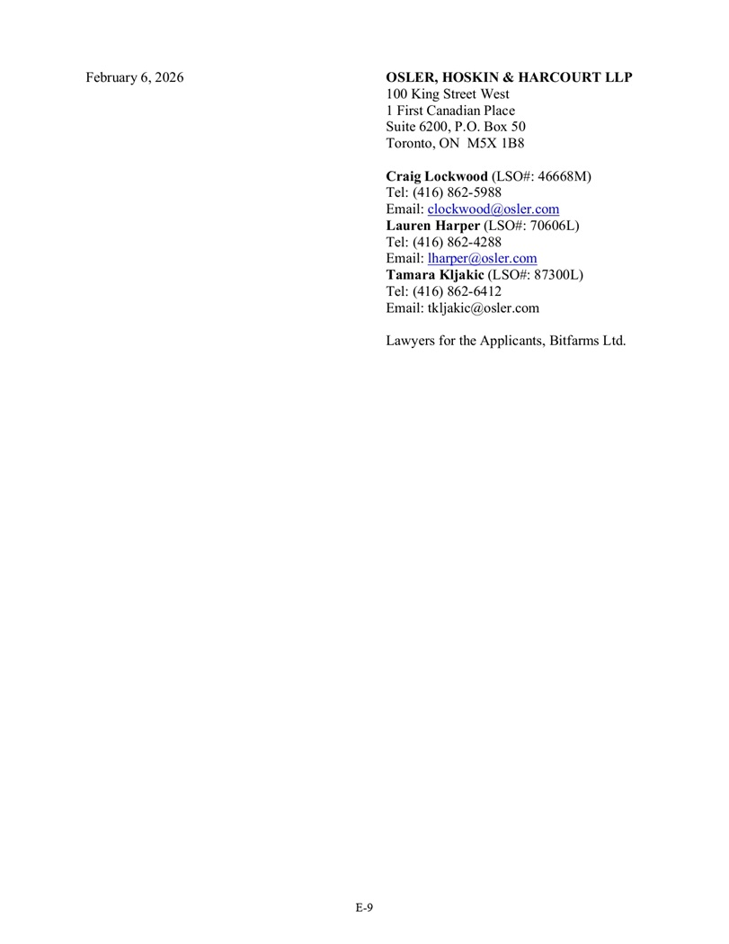
E - 9 February 6, 2026 OSLER, HOSKIN & HARCOURT LLP 100 King Street West 1 First Canadian Place Suite 6200, P.O. Box 50 Toronto, ON M5X 1B8 Craig Lockwood (LSO#: 46668M) Tel: (416) 862 - 5988 Email: clockwood@osler.com Lauren Harper (LSO#: 70606L) Tel: (416) 862 - 4288 Email: lharper@osler.com Tamara Kljakic (LSO#: 87300L) Tel: (416) 862 - 6412 Email: tkljakic@osler.com Lawyers for the Applicants, Bitfarms Ltd.

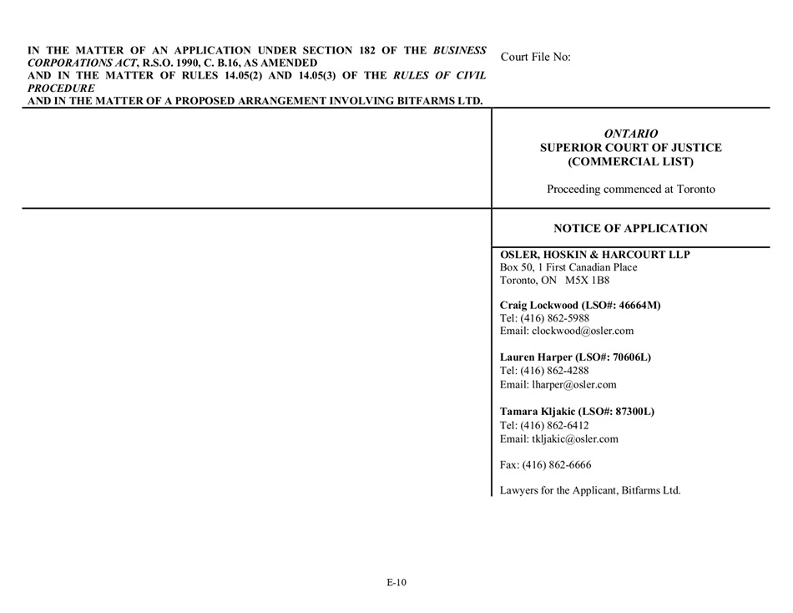
E - 10 IN THE MATTER OF AN APPLICATION UNDER SECTION 182 OF THE BUSINESS CORPORATIONS ACT , R.S.O. 1990, C. B.16, AS AMENDED AND IN THE MATTER OF RULES 14.05(2) AND 14.05(3) OF THE RULES OF CIVIL PROCEDURE AND IN THE MATTER OF A PROPOSED ARRANGEMENT INVOLVING BITFARMS LTD. Court File No: ONTARIO SUPERIOR COURT OF JUSTICE (COMMERCIAL LIST) Proceeding commenced at Toronto NOTICE OF APPLICATION OSLER, HOSKIN & HARCOURT LLP Box 50, 1 First Canadian Place Toronto, ON M5X 1B8 Craig Lockwood (LSO#: 46664M) Tel: (416) 862 - 5988 Email: clockwood@osler.com Lauren Harper (LSO#: 70606L) Tel: (416) 862 - 4288 Email: lharper@osler.com Tamara Kljakic (LSO#: 87300L) Tel: (416) 862 - 6412 Email: tkljakic@osler.com Fax: (416) 862 - 6666 Lawyers for the Applicant, Bitfarms Ltd.

Appendix F - COMPARISON OF SHAREHOLDER RIGHTS

Your rights as a Bitfarms Canada Shareholder and the powers of the Bitfarms Canada Board are governed by Ontario law and Bitfarms Canada’s articles and by-laws. As a result of the U.S. Redomiciliation, you will be a shareholder of Keel, and your rights and the powers of the Keel Board will be governed by the laws of the State of Delaware and the Keel Certificate and Keel Bylaws as they will be in effect upon the completion of the U.S. Redomiciliation.

Many of the principal attributes of Bitfarms Canada Shares and Keel Common Stock will be similar. However, there are differences between what your rights are under Ontario law and what they will be after the U.S. Redomiciliation under Delaware law. In addition, there are differences between Bitfarms Canada’s articles and by-laws and the Keel Certificate and Keel Bylaws as they will be in effect after the U.S. Redomiciliation, especially as it relates to changes (i) that are required by Delaware law (i.e., certain provisions of the Bitfarms Canada articles and by-laws were not replicated in the Keel Certificate and Keel Bylaws because Delaware law would not permit such replication, and certain provisions were included in the Keel Certificate and Keel Bylaws although they were not in the Bitfarms Canada articles and by-laws because Delaware law requires such provisions to be included in the certificate of incorporation and bylaws of a Delaware corporation or to provide for provisions customarily provided in respect of publicly-traded Delaware corporations), or (ii) that are necessary in order to preserve the current rights of Bitfarms Canada Shareholders and powers of the Bitfarms Canada Board following the U.S. Redomiciliation.

The following discussion is a summary of material changes in your rights resulting from the U.S. Redomiciliation. This summary does not cover all of the differences between Canadian law and Delaware law affecting companies and their shareholders or all the differences between Bitfarms Canada’s articles and by-laws and the Keel Certificate and Keel Bylaws. This summary is subject to the complete text of the relevant provisions of the OBCA, the DGCL, Bitfarms Canada’s articles and by-laws and the Keel Certificate and Keel Bylaws as they will be in effect after the U.S. Redomiciliation. We encourage you to read those laws and documents carefully.

The form of the Keel Certificate and Keel Bylaws substantially as they are intended to be in effect after the U.S. Redomiciliation are attached as Appendix G and Appendix H, respectively, to this Circular. For information as to how you can obtain Bitfarms Canada’s articles and by-laws, please see the section entitled “Additional Information”. Except where otherwise indicated, the discussion of Keel below reflects the Keel Certificate and Keel Bylaws as those documents will be in effect upon completion of the U.S. Redomiciliation.

Corporate Governance Item | Bitfarms Canada | Keel
Capital Stock | Bitfarms Canada is authorized to issue (a) an unlimited number of Bitfarms Canada Shares; and (b) an unlimited number of Class A Preferred Shares, issuable in one or more series. As of the date of this Circular, there are no Class A Preferred Shares outstanding. Holders of Bitfarms Canada Shares are entitled to all of the respective rights and obligations provided to shareholders under the OBCA and Bitfarms Canada’s articles and by-laws. | The Keel Certificate will authorize the issuance of (a) up to 1.5 billion shares of common stock and (b) up to 120 million shares of Class A Preferred Stock, issuable in one or more series.  The Keel Common Stock will be issued in the contemplated exchange. Holders of the Keel Common Stock and Class A Preferred Stock, if issued, will be entitled to all of the respective rights and obligations provided to stockholders under the DGCL, the Keel Certificate, and the Keel Bylaws.  The Keel Board, without Keel Common Stockholder approval, is entitled to issue shares of Keel Common Stock or shares of preferred stock up to the number of shares authorized in the Keel Certificate.
Designation of Preferred Stock | Bitfarms Canada’s articles provide that the Class A Preferred Shares may be issued at any time or from time to time in one or more series. Subject to the Bitfarms Canada’s articles, the Bitfarms Canada Board shall, before the issue thereof, fix the number of shares in, and determine the designation, rights, privileges, restrictions and conditions attaching to the shares of each series of Class A Preferred Shares, the whole subject to the filing of articles of amendment setting forth the designation, rights, privileges, restrictions, conditions and limitations attaching to the Class A Preferred Shares of such series and the issuance of a certificate of amendment in respect thereof.  The approval of the holders of the Class A Preferred Shares to add to, change or remove any right, privilege, restriction or condition attaching to the Class A Preferred Shares as a class or in respect of any other matter requiring the consent of the holders of the Class A Preferred Shares may be given in such manner as may then be required by law, subject to a minimum requirement that such approval be given by resolution signed by all the holders of the Class A Preferred Shares or passed by the affirmative vote of at least two-thirds of the votes cast at the meeting of the holders of the Class A Preferred Shares duly called for that purpose. | The Keel Certificate will authorize the Keel Board, without Keel Common Stockholder approval, to issue up to 120 million shares of Class A Preferred Stock in one or more series and to fix the number of shares in, and determine the designation, rights, privileges, restrictions and conditions attaching to the shares of each series of Class A Preferred Stock, to be stated and expressed in the resolution(s) adopted by the Keel Board providing for the issuance of such class or series as may be permitted by the DGCL.  The approval of the holders of the Class A Preferred Stock to add to, change or remove any right, privilege, restriction or condition attaching to the Class A Preferred Stock as a class or in respect of any other matter requiring the consent of the holders of the Class A Preferred Stock may be given in such manner as may then be required by law, subject to a minimum requirement that such approval be given by resolution signed by all the holders of the Class A Preferred Stock or passed by the affirmative vote of at least two-thirds of the votes cast at the meeting of the holders of the Class A Preferred Stock duly called for that purpose.
F-1

Corporate Governance Item | Bitfarms Canada | Keel
Voting Rights | Bitfarms Canada’s articles provide that the holders of Bitfarms Canada Shares shall be entitled to receive notice of and to attend all meetings of the Bitfarms Canada Shareholders and to one (1) vote in respect of each Bitfarms Canada Share held at all such meetings.  Bitfarms Canada’s articles provide that the holders of any series of Class A Preferred Shares will not be entitled (except as otherwise provided by law and except for meetings of the holders of Class A Preferred Shares or a series thereof) to receive notice of, attend at, or vote at any meeting of Bitfarms Canada Shareholders, unless the Bitfarms Canada Board determines otherwise, in which case voting rights will only be provided in circumstances where Bitfarms Canada has failed to pay a certain number of dividends on such series of Class A Preferred Shares, which determination and number of dividends and any other terms in respect of such voting rights, will be determined by the Bitfarms Canada Board and set out in the designations, rights, privileges, restrictions and conditions of such series of Class A Preferred Shares.  Bitfarms Canada’s by-laws and the OBCA provide that subject to the OBCA, the articles, the by-laws and any unanimous shareholder agreement, all questions proposed for the consideration of the shareholders shall be determined by a majority of the votes cast thereon and, in case of an equality of votes, the chairman of the meeting shall not have a second or casting vote. For any question proposed for consideration at a meeting of shareholders, either before or after a vote by show of hands has been taken, the chairman, or any shareholder or proxyholder may demand a ballot, in which case the ballot shall be taken in such manner as the chairman directs and the decision of the shareholders on the question shall be determined by the result of such ballot. | Each Keel Common Stock will entitle the holder thereof to one vote at all meetings of Keel Common Stockholders at which the holders of Keel Common Stock are voting.  The Keel Board will be entitled to set the voting rights and powers for the Class A Preferred Stock.  The Keel Bylaws will provide that any question brought before any meeting of the stockholders, other than the election of directors, shall be decided by the vote of the holders of a majority of the total number of votes of Keel’s capital stock present at the meeting at which a quorum is present, in person or represented by proxy and entitled to vote on such question, voting as a single class.  Under Delaware law, the default rule is that the chairman of the board (or any presiding officer) does not have a casting vote unless such authority is expressly granted in the corporation’s certificate of incorporation or bylaws. If the governing documents are silent on this point, the chairman does not possess a casting vote by default. The Keel Bylaws and Keel Certificate will be silent on this point and so the chairman does not have a casting vote.
F-2

Corporate Governance Item | Bitfarms Canada | Keel
Quorum of Shareholders | Bitfarms Canada’s by-laws provide that two holders of shares entitled to vote at a meeting of shareholders, whether present in person or represented by proxy, constitute a quorum for the transaction of business at any meeting of shareholders. If a quorum is present at the opening of a meeting of shareholders, the shareholders present may proceed with the business of the meeting even if a quorum is not present throughout the meeting. If Bitfarms Canada has only one shareholder, or only one holder of any class or series of shares, the shareholder present in person or by proxy constitutes a meeting. | The Keel Bylaws will provide that holders of at least one-third (1/3) of Keel’s capital stock issued and outstanding and entitled to vote thereat, present in person or represented by proxy, shall constitute a quorum at all meetings of the stockholders for the transaction of business. If, however, such quorum shall not be present or represented at any meeting of the stockholders, the stockholders entitled to vote thereat, present in person or represented by proxy, shall have power to adjourn the meeting from time to time, in the manner provided in Keel Bylaws, until a quorum shall be present or represented.
Adjournment of Shareholder Meetings | Bitfarms Canada’s by-laws provide that the chairman of the meeting of shareholders may, with the consent of the meeting and subject to such conditions as the meeting may decide, or where otherwise permitted under the provisions of the OBCA, adjourn the meeting from time to time and from place to place. Additionally, Bitfarms Canada’s by-laws provide that in the event of the adjournment of a meeting, notice, if any is required, shall be given in accordance with the provisions of the OBCA. Under the OBCA, if a meeting of shareholders is adjourned by one or more adjournments for an aggregate of less than thirty (30) days, it is not necessary, unless the by-laws otherwise provide, to give notice of the adjourned meeting other than by announcement of all of the following at the time of an adjournment (a) the time of the continue meeting; (b) if applicable, the place of the continued meeting; and (c) if applicable, instructions for attending and participating in the continued meeting by the telephonic or electronic means that will be made available for the meeting, including, if applicable, instructions for voting by such means at the meeting. The OBCA further stipulates that if a meeting of shareholders is adjourned by one or more adjournments for an aggregate of thirty (30) days or more, notice of the adjourned meeting shall be given as for an original meeting but, unless the meeting is adjourned by one or more adjournments for an aggregate of more than ninety (90) days, management is not required to send a form of proxy to each shareholder who is entitled to receive notice of the meeting concurrently with or prior to sending notice of the adjourned meeting. | The Keel Bylaws will provide that any meeting of the stockholders may be adjourned or postponed from time to time by the chairman of such meeting or by the Keel Board, without the need for approval thereof by stockholders to reconvene or convene, respectively at the same or some other place. Notice need not be given of any such adjourned or postponed meeting (including an adjournment taken to address a technical failure to convene or continue a meeting using remote communication) if the time and place, if any, thereof, and the means of remote communications, if any, by which stockholders and proxy holders may be deemed to be present in person and vote at such adjourned or postponed meeting are (i) with respect to an adjourned meeting, (a) announced at the meeting at which the adjournment is taken, (b) displayed during the time scheduled for the meeting, on the same electronic network used to enable stockholders and proxy holders to participate in the meeting by means of remote communication, or (c) set forth in the notice of meeting given in accordance with the terms set out in the Keel Bylaws, or (ii) with respect to a postponed meeting, are publicly announced. If the adjournment or postponement is for more than thirty (30) days, notice of the adjourned or postponed meeting in accordance with the requirements set out in the Keel Bylaws shall be given to each stockholder of record entitled to vote at the meeting. If, after the adjournment or postponement, a new record date for stockholders entitled to vote is fixed for the adjourned or postponed meeting, the Keel Board shall fix a new record date for notice of such adjourned or postponed meeting in accordance with in accordance with the terms set out in the Keel Bylaws, and shall give notice of the adjourned or postponed meeting to each stockholder of record entitled to vote at such adjourned or postponed meeting as of the record date fixed for notice of such adjourned or postponed meeting. At the adjourned or postponed meeting, Keel may transact any business which might have been transacted at the original meeting.
F-3

Corporate Governance Item | Bitfarms Canada | Keel
Dividends, Repurchases and Redemptions | Dividends  Bitfarms Canada’s articles provide that, subject to the provisions of the OBCA, the Bitfarms Canada Shareholders shall be entitled to receive dividends and Bitfarms Canada shall pay dividends thereon, as and when declared by the Bitfarms Canada Board out of moneys or other property properly applicable to the payment of dividends, in such amounts and in such form as the Bitfarms Canada Board may in its discretion determine from time to time. Bitfarms Canada’s articles further provide that the holders of each series of Class A Preferred Shares will be entitled to receive dividends as and when declared by the Bitfarms Canada Board in respect of such series.  Bitfarms Canada’s by-laws and the OBCA provide that dividends may be paid by issuing fully paid shares of the corporation or options or rights to acquire fully paid shares of the Corporation or the Corporation may pay a dividend in money or property.  Under the OBCA, directors shall not declare and a corporation shall not pay a dividend if there are reasonable grounds for believing that (a) the corporation is or, after the payment, would be unable to pay its liabilities as they become due; or (b) the realizable value of the corporation’s assets would thereby be less than the aggregate of, (i) its liabilities; and (ii) its stated capital of all classes.  Repurchases/Redemptions  Bitfarms Canada’s articles provide that each series of Class A Preferred Shares may be redeemable by Bitfarms Canada, on such terms as may be determined by the Bitfarms Canada Board. | Dividends  Under the Keel Certificate and the DGCL, Keel Common Stockholders will be entitled to receive dividends if, as and when declared by the Keel Board, subject to the rights of any preferred stockholders.  Under the DGCL, the Keel Board may declare and pay a dividend to Keel Common Stockholders out of surplus or, if there is no surplus (as defined and computed in accordance with the DGCL), out of net profits for the fiscal year in which the dividend is declared or the immediately preceding fiscal year, or both. A dividend may be paid in cash, in Keel Common Stock, in shares of Keel Preferred Stock or in other property.  Repurchases/Redemptions  Under the DGCL, Keel is able to redeem or repurchase Keel Common Stock, except that generally it may not redeem or repurchase those shares if the capital of Keel is impaired at the time or would become impaired as a result of the redemption or repurchase of such shares. Keel Preferred Stock is redeemable in accordance with its terms. Repurchased and redeemed shares may be retired or held as treasury shares. Shares that have been repurchased but have not been retired may be resold by the corporation for such consideration as the board of directors shall determine.
F-4

Corporate Governance Item | Bitfarms Canada | Keel
Size of the Board of Directors | Bitfarms Canada’s articles and by-laws provide that the Bitfarms Canada Board shall consist of a minimum of one (1) and a maximum of ten (10). The Bitfarms Canada’s by-laws further provide that, until changed in accordance with the OBCA, the Bitfarms Canada Board shall consist of that number of directors, being a minimum of one (1) and a maximum of ten (10), as determined from time to time by special resolution or, if the special resolution empowers the directors to determine the number, by resolution of the Bitfarms Canada Board.  Under the OBCA, a board of directors of an offering corporation (a corporation that is offering its securities to the public) shall have not fewer than three individuals (a natural person, but does not include a partnership, unincorporated association, unincorporated syndicate, unincorporated organization, trust, or a natural person in his or her capacity as trustee, executor, administrator or other legal representative). The OBCA provides that at least one-third of the directors of an offering corporation shall not be officers or employees of the corporation or any of its affiliates.  Bitfarms Canada’s by-laws provide that a majority of the directors elected to office constitutes a quorum at any meeting of the board. | The Keel Certificate and Keel Bylaws will provide that Keel shall have a minimum of one (1) and a maximum of ten (10) directors as determined by the Keel Board. Between annual meetings, the Keel Board may appoint additional directors.  The Keel Bylaws provide that a quorum for a meeting of directors is a majority of directors.
Election and Term of Directors | Under the OBCA, shareholders of a corporation shall, by ordinary resolution, elect, at the first meeting of shareholders and at each succeeding annual meeting at which an election of directors is required, directors to hold office for a term expiring not later than the close of the third annual meeting of shareholders following the election. A director not elected for an expressly stated term ceases to hold office at the close of the first annual meeting of shareholders following his or her election.  Bitfarms Canada’s by-laws provide that the election of directors shall take place at the first meeting of shareholders and at each annual meeting of shareholders and all the directors then in office shall retire, but, if qualified, shall be eligible for re-election. Bitfarms Canada’s by-laws further provide that the number of directors to be elected at any such meeting shall be the number of directors then in office unless the directors or shareholders shall have otherwise determined in accordance with the OBCA. Where the shareholders adopt an amendment to the articles to increase the number or minimum number of directors, the shareholders may, at the meeting at which they adopt the amendment, elect the additional number of directors authorized by the amendment. The election shall be by resolution. If an election of directors is not held at the proper time, the incumbent directors shall continue in office until their successors are elected. | Directors of Keel will be elected by an affirmative plurality of the votes cast represented and entitled to vote at a meeting of stockholders for the election of directors.  The Keel Certificate and Keel Bylaws will provide that directors will hold office until the next annual meeting of stockholders and until such director’s successor is duly elected and qualified, or until such director’s earlier death, resignation or removal.
F-5

Corporate Governance Item | Bitfarms Canada | Keel
Removal of Directors | Bitfarms Canada’s by-laws provide that subject to the provisions of the OBCA, the shareholders may, by ordinary resolution passed at an annual or special meeting of shareholders, remove any director from office before the expiration of his or her term and may elect a qualified individual to fill the resulting vacancy for the remainder of the term of the director so removed, failing which such vacancy may be filled by the board. Notice of intention to pass such resolution shall be given in the notice calling the meeting.  Under the OBCA, the shareholders of a corporation may by ordinary resolution at an annual or special meeting remove any director or directors from office, provided that a director may not be removed from office if the votes cast against the director’s removal would be sufficient to elect him or her and such votes could be voted cumulatively at an election at which the same total number of votes were cast and the number of directors required by the articles were then being elected. | The Keel Certificate and Keel Bylaws will provide that, subject to the rights of any holders of preferred stock, directors may be removed from office at any time, only by the affirmative vote of the holders of a at least a majority in voting power of the issued and outstanding capital stock of the Keel entitled to vote in the election of directors.
Filling of Vacancies on the Board of Directors | Bitfarms Canada’s by-laws provide that a director ceases to hold office when he dies, resigns, is removed from office by the shareholders, or becomes disqualified to serve as director.  Bitfarms Canada’s by-laws further provide that, subject to the provisions of the OBCA, a vacancy on the board may be filled for the remainder of its term by a qualified individual by resolution of a quorum of the board. The OBCA provides that, subject to certain exceptions, a quorum of directors may fill a vacancy among the directors, except a vacancy resulting from (a) an increase in the number of directors or in the maximum number of directors, as the case may be; or (b) a failure to elect the number of directors required to be elected at any meeting of shareholders. Bitfarms Canada’s by-laws and the OBCA further provide that, if there is not a quorum of directors or if a vacancy results from the failure to elect the number of directors required to be elected at any meeting of shareholders, the directors then in office shall forthwith call a special meeting of shareholders to fill the vacancy and, if they fail to call a meeting or if there are no directors then in office, the meeting may be called by any shareholder. | The Keel Certificate and Keel Bylaws will provide that any vacancies may be filled by (i) a majority of the Keel Board then in office, even if such directors constitute less than a quorum, (ii) a sole remaining director, or (iii) a majority of the votes cast by the stockholders.
F-6

Corporate Governance Item | Bitfarms Canada | Keel
Ability to Call Special Meeting of Shareholders / Stockholders | Under the OBCA, a corporation’s board of directors may call a special meeting at any time. In addition, the holders of not less than five (5) per cent of the issued shares of a corporation that carry the right to vote at a meeting sought to be held may requisition the directors to call a meeting of shareholders for the purposes stated in the requisition. Upon receiving such a requisition, the directors shall call a meeting of shareholders to transact the business stated in the requisition unless, (a) a record date has been fixed and notice thereof has been given; (b) the directors have called a meeting and notice thereof has been given; or (c) the business of the meeting as stated in the requisition includes certain matters enumerated in the OBCA.  Bitfarms Canada’s by-laws provide that the board, the chairman of the board, the managing director or the president may at any time call a special meeting of shareholders for the transaction of any business which may properly be brought before such meeting of shareholders. | The Keel Certificate and Keel Bylaws will provide that a special meeting of stockholders may be (a) called by (i) the Chair of the Keel Board and (ii) the President (iii) any Vice President, or (iv) the Secretary, and (b) called by any such officer at the request in writing of (i) the Keel Board, (ii) a committee of the Keel Board that has been duly designated by the Keel Board and whose powers and authority include the power to call such meetings or (iii) stockholders owning at least fifteen percent (15%) of the capital stock of Keel issued and outstanding and entitled to vote on the matter for which such special meeting of stockholders is called.
Notice of Annual and Special Meetings of Shareholders / Stockholders | Under the OBCA and Bitfarms Canada’s by-laws, taken together, the Bitfarms Canada Board shall call, at such date and time as it determines, the first annual meeting of shareholders not later than eighteen (18) months after Bitfarms Canada comes into existence and thereafter not later than fifteen (15) months after holding the last preceding annual meeting, so as to place before the shareholders the financial statements and reports required by the OBCA to be presented thereat, to elect directors, appoint auditors and to transact such other business as may properly be brought before the meeting. | Under the DGCL and the Keel Bylaws, written notice of annual and special meetings of Keel Common Stockholders will be required to be given not less than ten (10) nor more than sixty (60) days before the date of the meeting to each stockholder entitled to vote at such meeting as of the record date for determining stockholders entitled to notice of such meeting.  The Keel Bylaws provide that notice of a special meeting must also state the purpose for which the special meeting is called.
F-7

Corporate Governance Item | Bitfarms Canada | Keel
 | Under Bitfarms Canada’s by-laws, the meetings of shareholders shall be held at such place in or outside Ontario as the board determines or, in the absence of such a determination, at the place where the registered office of Bitfarms Canada is located.  Under the OBCA and Bitfarms Canada’s by-laws, taken together, a notice of time and place of a meeting of shareholders shall be sent, in the case of an offering corporation, not less than twenty-one (21) days and not more than fifty (50) days before the meeting to each shareholder entitled to vote at the meeting, to each director and to the auditor of the corporation. However, Bitfarms Canada’s by-laws provide that a meeting of shareholders may be held at any time without notice if all the shareholders entitled to vote thereat are present or represented by proxy and do not object to the holding of the meeting or those not so present by proxy have waived notice, if all the directors are present or have waived notice of or otherwise consent to the meeting and if the auditor, if any, is present or has waived notice of or otherwise consents to the meeting.  Under the OBCA, for the purpose of determining shareholders entitled to receive notice of a meeting of shareholders, the directors may fix in advance a date as the record date for such determination of shareholders, but the record date shall not precede by more than sixty (60) days or by less than thirty (30) days the date on which the meeting is to be held. Where no record date is fixed, (a) the record date for the determination of shareholders entitled to receive notice of a meeting of shareholders shall be, (i) at the close of business on the day immediately preceding the day on which the notice is given, or (ii) if no notice is given, the day on which the meeting is held; and (b) the record date for the determination of shareholders for any purpose other than to establish a shareholder’s right to receive notice of a meeting or to vote shall be at the close of business on the day on which the directors pass the resolution relating thereto. | Under the DGCL, an annual meeting of stockholders is required for the election of directors and for such other proper business as may be conducted thereat.  The Delaware Court of Chancery may order a corporation to hold an annual meeting if a corporation has failed to do so for a period of thirteen (13) months after its last annual meeting.  The Keel Bylaws will provide that the annual meeting of stockholders will be held at such time as shall be designated from time to time by the Keel Board. The Keel Certificate will provide that meetings of stockholders may be held within or without the State of Delaware. The Board of Directors may, in its sole discretion, determine that a meeting of the stockholders shall not be held at any place, but may instead be held solely by means of remote communication in the manner authorized by Section 211 of the DGCL.  Under the Keel Bylaws, the directors will be entitled to fix a record date to determine the stockholders entitled to notice of any meeting or any adjournment thereof, which record date shall not precede the date upon which the resolution fixing the record date is adopted by the Keel Board, and which record date shall not be more than sixty (60) nor less than ten (10) days before the date of such meeting. If no record date is fixed by the Keel Board, the record date for determining stockholders entitled to notice of or to vote at a meeting of stockholders shall be at the close of business on the day next preceding the day on which notice is given, or, if notice is waived, at the close of business on the day next preceding the day on which the meeting is held.
Stockholder/ Shareholder Action by Written Consent | Under Bitfarms Canada’s by-laws and the OBCA, except where, pursuant to the OBCA, a written statement is submitted to Bitfarms Canada by a director or representations in writing are submitted to Bitfarms Canada by an auditor: (a) a resolution in writing signed by all the shareholders entitled to vote on that resolution at a meeting of shareholders is as valid as if it had been passed at a meeting of the shareholders; and (b) a resolution in writing dealing with all matters required by the OBCA to be dealt with at a meeting of shareholders, and signed by all the shareholders entitled to vote at that meeting, satisfies all the requirements of the OBCA relating to that meeting of shareholders. Where Bitfarms Canada has only one shareholder, all business which Bitfarms Canada may transact at an annual or special meeting of shareholders shall be transacted in the manner provided for above.  For an offering corporation such as Bitfarms Canada, this necessitates all actions requiring shareholder approval be taken at a duly convened shareholder meeting. | Under the DGCL, unless otherwise provided in the certificate of incorporation, stockholders may act by written consent of the holders of outstanding stock having not less than the minimum number of votes that would be necessary to authorize or take action at a meeting of stockholders at which all shares entitled to vote were present and voted. The corporation must give prompt notice of any action taken by less than unanimous consent to all non-consenting stockholders entitled to vote on the action.  The Keel Common Stockholders will have the ability to take action by unanimous written consent of stockholders.
F-8

Corporate Governance Item | Bitfarms Canada | Keel
Shareholder / Stockholder Proposals and Advance Notice Requirements for Director Nominations and Other Proposals | Under the OBCA, a registered holder of shares entitled to vote or a beneficial owner of shares that are entitled to be voted at a meeting of shareholders of a corporation may submit notice of a proposal and discuss at the meeting any matter in respect of which the registered holder or beneficial owner would have been entitled to submit a proposal.  Under the OBCA, where a corporation receives notice of a proposal, (a) if the corporation provides a management information circular, it shall set out the proposal in the management information circular or attach the proposal to that circular; or (b) if the corporation does not provide a management information circular, it shall set out the proposal in the notice of meeting for the shareholders’ meeting at which the matter is proposed to be raised or shall attach the proposal to such notice of meeting.  Under the OBCA, a proposal may include nominations for the election of directors if the proposal is signed by one or more holders of shares representing in the aggregate not less than five (5) per cent of the shares of a class or series of shares of the corporation entitled to vote at the meeting to which the proposal is to be presented. | The Keel Bylaws will provide that a stockholder wishing to nominate a director for election to the Keel Board or propose other business to be considered at the annual meeting must provide written notice (in proper form) to the Secretary not less than ninety (90) days nor more than one-hundred twenty (120) days prior to the anniversary date of the immediately preceding annual meeting of stockholders; provided, however, that in the event that the annual meeting is called for a date that is more than twenty-five (25) days before or after anniversary date, notice by the stockholder must be so received not later than the close of business on the tenth (10th) day following the day on which such notice of the date of the annual meeting of stockholders was mailed or such public disclosure of the date of the annual meeting of stockholders was made, whichever first occurs.  A Keel Common Stockholder wishing to nominate a director for election to the Keel Board at a special meeting of stockholders must give written notice (in proper form) to the Secretary not earlier than the close of business on the one hundred twentieth (120th) day prior to such special meeting nor later than the close of business on the later of the ninetieth (90th) day prior to such special meeting or the tenth (10th) day following the day on which public announcement is first made of the date of the special meeting and of the nominees proposed by the Keel Board to be elected at such special meeting.  The public announcement of an adjournment or postponement of an annual or special meeting of stockholders will not commence a new time period for the giving of a stockholder’s notice as described above.
F-9

Corporate Governance Item | Bitfarms Canada | Keel
 | Under the OBCA, a corporation need not present a proposal to shareholders where: (a) in the case of an offering corporation, notice of the proposal is submitted to the corporation less than sixty (60) days before, (i) the anniversary date of the last annual meeting (if the matter is proposed to be raised at an annual meeting), or (ii) the date of a meeting other than the annual meeting (if the matter is proposed to be raised at a meeting other than the annual meeting); (b) it clearly appears that the primary purpose of the proposal is to enforce a personal claim or redress a personal grievance against the corporation or its directors, officers or security holders; (c) it clearly appears that the proposal does not appear to relate in a significant way to the corporation’s business or affairs; (d) within two years before the receipt by the corporation of a person’s notice of proposal, the person failed to present, in person or by proxy, at a meeting of the corporation’s shareholders, a proposal which had been submitted by the person and had been included in a management information circular or a notice of meeting relating to that shareholders’ meeting; or (e) the following has occurred: (x) substantially the same proposal was submitted to shareholders of the corporation in a management information circular, dissident’s information circular, or notice of a meeting relating to a previous meeting of shareholders, (y) the previous meeting referred to above was held within five years, or such other period as may be prescribed, before the receipt by the corporation of the person’s current notice of proposal, and (z) at that previous meeting, the proposal did not receive the minimum amount of support required under the OBCA.  Bitfarms Canada’s by-laws provide that subject only to the OBCA, Bitfarms Canada’s articles and any other by-law of Bitfarms Canada, only persons who are nominated in accordance with its by-laws shall be eligible for election as directors. Bitfarms Canada’s by-laws provide that at any annual meeting of shareholders or any special meeting of shareholders (where one of the purposes for which such special meeting was called was the election of directors), nominations of persons for election to the Bitfarms Canada Board may be made: (a) by or at the direction of the Bitfarms Canada Board or an authorized officer of Bitfarms Canada; (b) by one or more shareholders pursuant to a “proposal” made in accordance with the provisions of the OBCA, or a requisition by one or more of the shareholders made in accordance with the provisions of the OBCA; or (c) by any person (a “Nominating Shareholder”) who at the close of business on the date of the giving of the notice provided for below and at the close of business on the record date for notice of such meeting, is a registered or beneficial holder of one or more shares carrying the right to vote at such meeting, and who complies with the timing and notice procedures set forth in the Bitfarms Canada by-laws. | To be in proper form, the notice must set forth:  (i) as to each person whom the stockholder proposes to nominate for election as a director (1) all information relating to such person that is required to be disclosed in solicitations of proxies for election of directors in an election contest, (2) such person’s written consent to being named in the proxy statement as a nominee and to serving as a director if elected, (3) a description of any direct or indirect material interest in any material contract or agreement between or among the stockholder and the nominee and (4) a completed and signed questionnaire, representation and agreement to be required by the Keel Bylaws;  (ii) as to any other business that the stockholder proposes to bring before the annual meeting, a brief description of the business desired to be brought before the annual meeting, the text of the proposal or business, the reasons for conducting such business at the annual meeting and any material interest in such business of such stockholder and the beneficial owner, if any, on whose behalf the proposal is made; and  (iii) as to the stockholder giving the notice and the beneficial owner, if any, on whose behalf the nomination or proposal is made: (1) the name and record address of such stockholder, as they appear on Keel’s books, and of such beneficial owner, (2) the class or series and number of shares of Keel capital stock which are owned beneficially and of record by such stockholder, including any derivative securities, and such beneficial owner as of the date of the notice, (3) a description of any material pending or threatened legal proceeding in which such stockholder is a party or material participant involving Keel, its officers, directors or affiliates; (4) a description of any material relationship between such stockholder and Keel or an affiliate, (5) any direct or indirect material interest in any material contract or agreement between such stockholder and Keel or an affiliate and (6) any other information relating to such stockholder or beneficial owner that would be required to be made in connection with solicitation of proxies with the SEC.  To be in proper form, the notice of other business (other than a nomination) is satisfied if the stockholder has notified Keel of his, her or its intention to present a proposal at an annual meeting in compliance with U.S. Exchange Act rules and regulations and such proposal has been included in Keel’s proxy statement for the annual meeting.
F-10

Corporate Governance Item | Bitfarms Canada | Keel
In addition to any other requirements under applicable law, Bitfarms Canada’s articles and any other by-law of Bitfarms Canada, for a nomination to be made by a Nominating Shareholder, the Nominating Shareholder must have given notice thereof that is both timely and in proper written form to the Secretary of the Corporation.

To be timely, a Nominating Shareholder’s notice to the Secretary of the Corporation must be made: (a) in the case of an annual meeting of shareholders, not fewer than thirty (30) days nor more than sixty-five (65) days prior to the date of the annual meeting of shareholders (but in any event, not prior to the “Notice Date”, i.e., the date the public announcement of an annual shareholder meeting or special shareholder meeting (which is not also an annual shareholder meeting), as applicable, is made); provided, however, that in the event such meeting is called for a date that is fewer than fifty (50) days after the Notice Date, notice by the Nominating Shareholder must be made not later than the close of business on the 10th day following the Notice Date; or (b) in the case of a special meeting of shareholders (which is not also an annual shareholder meeting) called for the purpose of electing directors (whether or not also called for other purposes), not later than the close of business on the 15th day following the Notice Date.

To be in proper written form, a Nominating Shareholder’s notice to the Secretary of the Corporation must set forth: (a) as to each person whom the Nominating Shareholder proposes to nominate for election as a director: (i) the name, age, citizenship, business and residential address of the person; (ii) the principal occupation or employment of the person; (iii) the class/series and number of Bitfarms Canada Shares controlled or directed, or owned beneficially (directly or indirectly) or of record by the person as of the record date for notice of the shareholders’ meeting (if it has occurred) and as of the notice date; and (iv) any other information relating to the person that would be required to be disclosed in a dissident’s proxy circular in connection with solicitations of proxies for election of directors pursuant to the OBCA and applicable securities laws; and (b) as to the Nominating Shareholder (including the Nominating Shareholder’s affiliates): (i) the class/series and number of Bitfarms Canada Shares controlled or directed, or owned beneficially (directly or indirectly) or of record by the Nominating Shareholder as of the record date for notice of the shareholders’ meeting (if it has occurred) and as of the notice date; (ii) particulars of any proxy, contract, agreement, arrangement, understanding or relationship conferring a right to vote any Bitfarms Canada Shares; (iii) particulars of any derivatives, hedges or other economic or voting interests (including short positions) relating to the Nominating Shareholder’s interest in Bitfarms Canada Shares; and (iv) any other information relating to such Nominating Shareholder that would be required in a dissident’s proxy circular in connection with solicitations of proxies for election of directors pursuant to the OBCA and applicable securities laws.

Bitfarms Canada may require any proposed nominee to furnish such other information as may reasonably be required by Bitfarms Canada to determine the eligibility of such proposed nominee to serve as a director of Bitfarms Canada or that could be material to a reasonable shareholder’s understanding of the independence, or lack thereof, of such proposed nominee. Bitfarms Canada may also require any proposed nominee to provide Bitfarms Canada with a written consent to be named as a nominee and to act as a director, if elected.
F-11

Corporate Governance Item | Bitfarms Canada | Keel
Amendments to the Articles / Certificate of Incorporation | Under the OBCA, certain amendments to the articles require a special resolution of the shareholders and/or a resolution of the directors. Under the OBCA, a special resolution means a resolution that is (a) submitted to a special meeting of the shareholders of a corporation duly called for the purpose of considering the resolution and passed, with or without amendment, at the meeting by at least two-thirds of the votes cast, or (b) consented to in writing by each shareholder of the corporation entitled to vote at such a meeting or the shareholder’s attorney authorized in writing. | The Keel Certificate will provide that Keel may amend, alter, change or repeal any provision in the Keel Certificate in the manner provided in the DGCL; provided, however, that the affirmative vote of the holders of at least a majority of the voting power of the shares entitled to vote at an election of directors, voting as a single class, is required to amend, alter or change the Keel Certificate.
Amendments to the Bylaws | Under the OBCA, the directors may, by resolution, make, amend or repeal any by-laws that regulate the business or affairs of a corporation and they must submit the by-law, amendment or repeal to the shareholders at the next meeting of shareholders, and the shareholders may, by ordinary resolution, confirm, reject or amend the by-law, amendment or repeal. | The Keel Certificate and Keel Bylaws will provide that the Keel Board has the power to adopt, amend, alter or repeal the Keel Bylaws.  The Keel Bylaws provide that they may be adopted, amended, altered or repealed by the affirmative vote by either the holders of a majority of the outstanding capital stock entitled to vote thereon or by a majority of the entire Keel Board then in office.
Anti-takeover Statute | The OBCA does not contain an anti-takeover statute comparable to that in DGCL with respect to business combinations. | Keel will be subject to the provisions of Section 203 of the DGCL. In general, Section 203 prohibits a publicly-held Delaware corporation from engaging in a business combination with any interested stockholder (or an affiliate or associate of the affiliated stockholder) for a three-year period following the date that such stockholder became an interested stockholder, unless the board of directors approves the business combination or the transaction by which such stockholder becomes an interested stockholder, in either case, before the stockholder becomes an interested stockholder, the interested stockholder acquires 85% of the corporation’s outstanding voting stock in the transaction by which such stockholder becomes an interested stockholder, or the business combination is subsequently approved by the board of directors and authorized at a meeting of stockholders by the affirmative vote of the holders of at least 66 2/3 % of the corporation’s outstanding voting stock not owned by the interested stockholder.
F-12

Corporate Governance Item | Bitfarms Canada | Keel
Mergers, Consolidations and Other Transactions | Under the OBCA, certain corporate actions are required to be approved by a special resolution of the shareholders (as explained under the section in this chart, “Amendments to the Articles / Certificate of Incorporation”). Such corporate actions include, without limitation: (a) a reorganization of the shares of any class or series of the corporation or of the stated capital of any such class or series; (b) the addition to or removal from the articles of the corporation of any provision that is permitted by the OBCA to be, or that is, set out in the articles or the change of any such provision; (c) an amalgamation of the corporation with another corporation; (d) an amalgamation of a body corporate with a corporation that results in an amalgamated corporation subject to the OBCA; (e) a transfer of all or substantially all the property of the corporation to another body corporate in exchange for securities, money or other property of the body corporate; (f) an exchange of securities of the corporation held by security holders for other securities, money or other property of the corporation or securities, money or other property of another body corporate that is not a take-over bid as defined in Part XX of the Securities Act; (g) a liquidation or dissolution of the corporation; (h) any other reorganization or scheme involving the business or affairs of the corporation or of any or all of the holders of its securities or of any options or rights to acquire any of its securities that is, at law, an arrangement; and (i) any combination of the foregoing. | Under Delaware law, a sale, lease or exchange of all or substantially all of a corporation’s assets, a merger or consolidation of a corporation with another corporation or a dissolution of a corporation generally requires the approval of the corporation’s board of directors and, with limited exceptions, the affirmative vote of a majority of the aggregate voting power of the outstanding stock entitled to vote on the transaction.  Subject to a number of requirements (including a requirement that the corporation have a class or series of stock that is listed on a national securities exchange or held of record by more than 2,000 holders immediately prior to the execution of the merger agreement by the corporation), Section 251(h) permits merger agreements to contain a provision eliminating the need for a stockholder vote for a second-step merger following consummation of a tender or exchange offer for all of the outstanding stock of a corporation on the terms provided in such merger agreement that, absent Section 251(h), would be entitled to vote on the adoption or rejection of the merger agreement.  Additionally, Section 253 of the DGCL permits a corporation to merge with a subsidiary corporation without a vote of stockholders of the subsidiary if the parent owns 90 percent (90%) or more of the outstanding shares of each class of the subsidiary’s stock that would otherwise be entitled to vote on the merger (provided that certain other requirements are met).
Pre-emptive Rights of Stockholders / Shareholders | Under the OBCA, shareholders of a corporation do not have any pre-emptive rights unless the articles of the corporation provide otherwise.  Bitfarms Canada’s articles do not contain such a provision. | Under the DGCL, stockholders have no pre-emptive rights on any issuances of stock unless, and to the extent, such rights are expressly provided for in the certificate of incorporation. Keel Common Stockholders will not have pre-emptive rights to acquire newly issued shares of stock.
Limitation of Personal Liability of Directors and Officers | Under the OBCA, no provision in a contract, the articles, the by-laws or a resolution of Bitfarms Canada relieves a director or officer from the duty to act in accordance with the OBCA and the regulations thereunder or relieves him or her from liability for a breach thereof.  Bitfarms Canada’s by-laws provide that, provided that the standard of care required of him or her has been satisfied, no director or officer shall be liable for the acts, receipts, neglects or defaults of any other director or officer or employee, or for joining in any receipt or other act for conformity, or for any loss, damage or expense happening to Bitfarms Canada through the insufficiency or deficiency of title to any property acquired for or on behalf of Bitfarms Canada, or for the insufficiency or deficiency of any security in or upon which any of the monies of Bitfarms Canada shall be invested, or for any loss or damage arising from the bankruptcy, insolvency or tortious acts of any person with whom any of the monies, securities or effects of Bitfarms Canada shall be deposited, or for any loss occasioned by any error of judgment or oversight on his or her part, or for any other loss, damage or misfortune which shall happen in the execution of the duties of his or her office or in relation thereto, unless the same are occasioned by his or her own willful neglect or default. | As permitted by the DGCL, the Keel Certificate will provide that no director or officer shall be personally liable to Keel or its stockholder for monetary damages for breach of fiduciary duty as a director or officer, except for liability of: (i) a director or officer for any breach of the director’s or officer’s duty of loyalty to the Keel or its stockholders; (ii) a director or officer for acts or omissions not in good faith or which involve intentional misconduct or a knowing violation of law; (iii) a director under Section 174 of the DGCL; or (iv) a director or officer for any transaction from which the director or officer derived an improper personal benefit or (v) an officer in any action by or in the right of the Keel. Section 102(b)(7) of the DGCL does not permit the limitation of a director’s liability for the following:  any breach of the director’s duty of loyalty to Keel or its stockholders;  any act or omission not in good faith or which involved intentional misconduct or a knowing violation of law;  or which involved intentional misconduct or a knowing violation of law;  any transaction from which the Director derived an improper personal benefit.
F-13

Corporate Governance Item | Bitfarms Canada | Keel
Indemnification of Directors and Officers | Bitfarms Canada’s by-laws provide that, subject to the OBCA, Bitfarms Canada shall indemnify a director or officer of the Bitfarms Canada, a former director of officer of Bitfarms Canada or a person who acts or acted at Bitfarms Canada’s request as a director or officer of a body corporate of which Bitfarms Canada is or was a shareholder or creditor, and their heirs and legal representatives, against all costs, charges and expenses, including an amount paid to settle an action or satisfy a judgment, reasonably incurred by him or her in respect of any civil, criminal administrative, investigative or other action or proceeding to which he is made a party by reason of being or having been a director or officer of such corporation or body corporate if, (a) they acted honestly and in good faith with a view to the best interests of Bitfarms Canada, as is required under the OBCA; and (b) in the case of a criminal or administrative action or proceeding that is enforced by a monetary penalty, he had reasonable grounds for believing that his or her conduct was lawful, as is required under the OBCA. Bitfarms Canada shall indemnify such person in all such other matters, actions, proceedings and circumstances as may be permitted by the OBCA or the law.  Under the OBCA, an individual with indemnity rights granted by a corporation is entitled to indemnity from the corporation in respect of all costs, charges and expenses reasonably incurred by the individual in connection with the defense of any civil, criminal, administrative, investigative or other proceeding to which the individual is subject because of the individual’s association with the corporation, if the individual seeking an indemnity, (a) was not judged by a court or other competent authority to have committed any fault or omitted to do anything that the individual ought to have done; and (b) fulfils the condition of having acted honestly and in good faith and, in respect to any criminal or administrative action, had reasonable grounds for believing the individual’s conduct was lawful. | Section 145 of the DGCL provides that a corporation may indemnify directors and officers as well as other employees and individuals against expenses (including attorneys’ fees), judgments, fines and amounts paid in settlement in connection with any threatened, pending or completed action, suit or proceeding, whether civil, criminal, administrative or investigative, in which such person is made a party by reason of the fact that the person is or was a director, officer, employee or agent of the corporation (other than a derivative action), if such person acted in good faith and in a manner such person reasonably believed to be in or not opposed to the best interests of the corporation and, with respect to any criminal action or proceeding, had no reasonable cause to believe such person’s conduct was unlawful.  A similar standard is applicable in the case of derivative actions, except that indemnification only extends to expenses (including attorneys’ fees) incurred in connection with the defense or settlement of such action, and the statute requires court approval before there can be any indemnification where the person seeking indemnification has been found liable to the corporation.  Also under Section 145 of the DGCL, a corporation may pay the expenses (including attorneys’ fee) incurred by officers and directors in defending against lawsuits in advance, provided that such director or officer undertakes to repay any advanced funds if indemnification is ultimately determined not to be permissible.  The Keel Certificate and Keel Bylaws will provide mandatory indemnification and advancement of expenses to directors and officers to the fullest extent permitted by Delaware law. The Keel Certificate will provide that Keel may provide rights of indemnification and advancement to its employees and agents.  Section 145 of the DGCL provides that a determination regarding indemnification shall be made by Keel with respect to a person who is a director or officer of the corporation at the time of such determination by: (i) a majority vote of the directors who are not parties to the action, suit or proceeding, even though less than a quorum, (ii) by a committee of such directors designated by a majority vote of such directors, even though less than a quorum, (iii) if there are no such directors, or if such directors so direct, by independent legal counsel in a written opinion, or (iv) by the Keel Common Stockholders.  A director or officer may also apply to the Delaware Court of Chancery or any other court of competent jurisdiction in Delaware for a determination that indemnification is proper in the circumstances.  Section 145 of the DGCL provides and the Keel Bylaws provide that it is not exclusive of other indemnification that may be granted by the Keel Certificate, the Keel Bylaws, disinterested director vote, shareholder vote, agreement or otherwise.  The Keel Bylaws will also provide that, except for proceedings to enforce rights to indemnification, Keel shall not be obligated to indemnify any director or officer (or his or her heirs, executors or personal or legal representatives) or advance expenses in connection with a proceeding (or part thereof) initiated by such person unless such proceeding (or part thereof) was authorized or consented to by the Keel Board.
F-14

Corporate Governance Item | Bitfarms Canada | Keel
Indemnity Insurance | Bitfarms Canada’s by-laws and the OBCA provide that the Corporation may purchase and maintain such insurance for the benefit of any person entitled to be indemnified by the Corporation as the board may from time to time determine. See the section in this chart entitled “Indemnification of Directors and Officers” above. | Pursuant to the DGCL and the Keel Bylaws, Keel may purchase and maintain insurance on behalf of any person who is or was a director, officer, employee or agent of Keel, or is or was serving at the request of Keel as a director, officer, employee or agent of another corporation partnership, joint venture, trust or other enterprise against any liability asserted against such person and incurred in any such capacity.  Delaware mandates indemnification for directors and officers who have been successful (on the merits or otherwise) in defending litigation. The mandatory coverage includes all reasonable expenses (including attorneys’ fees).
Oppression Remedy | The oppression remedy under the OBCA allows a complainant (including shareholders, directors, officers and other proper persons) to apply to the court for an order. Where the court is satisfied that in respect of a corporation or any of its affiliates (a) any act or omission of the corporation or any of its affiliates effects or threatens to effect a result; (b) the business or affairs of the corporation or any of its affiliates are, have been or are threatened to be carried on or conducted in a manner; or (c) the powers of the directors of the corporation or any of its affiliates are, have been or are threatened to be exercised in a manner, that is oppressive or unfairly prejudicial to or that unfairly disregards the interests of any security holder, creditor, director or officer of the corporation, the court may make an order to rectify the matters complained of.  The court may make any interim or final order it thinks fit including, without limiting the generality of the foregoing, (a) an order restraining the conduct complained of; (b) an order directing an issue or exchange of securities; (c) an order varying or setting aside a transaction or contract to which a corporation is a party and compensating the corporation or any other party to the transaction or contract; (d) an order compensating an aggrieved person; (e) an order directing rectification of the registers or other records of a corporation under the OBCA; and (f) an order requiring the trial of any issue. | The DGCL does not provide for a remedy similar to the oppression remedy as provided under the OBCA; however, Delaware courts have broad authority to impose equitable remedies for violations of a director’s fiduciary duties under Delaware common law.
F-15

Corporate Governance Item | Bitfarms Canada | Keel
Inspection of Corporate Records | Under the OBCA, all records are open to examination by any director of the corporation during normal business hours of a corporation.  Under the OBCA, registered holders of shares, beneficial owners of shares and creditors of a corporation, their agents and legal representatives may examine the following records during the usual business hours of the corporation, and may take extracts from those records, free of charge, and, if the corporation is an offering corporation, any other person may do so upon payment of a reasonable fee: (a) the articles and the by-laws and all amendments thereto, and a copy of any unanimous shareholder agreement known to the directors; (b) minutes of meetings and resolutions of shareholders; (c) a register of directors in which are set out the names and residence addresses, while directors, including the street and number, if any, and an e-mail address if one is provided, of all persons who are or have been directors of the corporation with the several dates on which each became or ceased to be a director; (d) a securities register; and (e) a register of ownership interests in land. | Under the DGCL, a stockholder, in person or by agent, has the right to inspect Keel’s stock ledger, a list of all of its stockholders and its other books and records during the usual hours of business upon written demand stating his purpose (which must be reasonably related to such person’s interest as a stockholder). A stockholder can request emails and other informal documents, but they must demonstrate a “compelling need” for them and show by “clear and convincing evidence” that the records are “necessary and essential” to their proper purpose.  If Keel refuses to permit such inspection or refuses to reply to the request within five (5) Business Days of the demand, the stockholder may apply to the Delaware Court of Chancery for an order to compel such inspection.
Dissent and Appraisal Rights | Under the OBCA, subject to specific exceptions, a shareholder may exercise rights of dissent if a corporation resolves to: (a) amend its articles to add, change or remove any provisions restricting the issue, transfer or ownership of shares of a class or series of the shares of the corporation; (b) amend its articles to add, change or remove any restriction upon the business or businesses that the corporation may carry on or upon the powers that the corporation may exercise; (c) amalgamate with another corporation (other than with certain affiliated corporations); (d) be continued under the laws of another jurisdiction; (e) be continued under the Co-operative Corporations Act; and (f) be continued under the Not-for-Profit Corporations Act, 2010; (g) sell, lease or exchange all or substantially all the property of the corporation other than in the ordinary course of business. | Under the DGCL, a stockholder may dissent from certain mergers, consolidations, conversions, transfers, domestications and continuances and have the fair value of his or her shares appraised by the Delaware Court of Chancery. However, stockholders do not have appraisal rights if the shares of stock they hold, at the record date for determination of stockholders entitled to vote at the meeting of stockholders to act upon the merger or consolidation, or on the record date with respect to action by written consent, are either (i) listed on a national securities exchange or (ii) held of record by more than 2,000 holders.
F-16

Corporate Governance Item | Bitfarms Canada | Keel
 | The OBCA provides these dissent rights for both listed and unlisted shares.  However, under the OBCA, a shareholder is not entitled to dissent in connection with a court order made in connection with an action for an oppression remedy, an order made under the Bankruptcy and Insolvency Act (Canada) or an order made under the Companies Creditors Arrangement Act (Canada) approving a proposal.  Under the OBCA, a dissenting shareholder shall send to the corporation, at or before any meeting of shareholders at which a resolution subject to dissent rights is to be voted on, a written objection to the resolution in accordance with the OBCA. The corporation shall, within ten (10) days after the shareholders adopt the resolution, send to each shareholder who has filed the objection notice that the resolution has been adopted, but such notice is not required to be sent to any shareholder who voted for the resolution or who has withdrawn the objection. This notice shall set out the rights of the dissenting shareholder and procedures to be followed to exercise those rights. A dissenting shareholder entitled to receive notice shall, within twenty (20) days after receiving such notice, or, if the shareholder does not receive such notice, within twenty (20) days after learning that the resolution has been adopted, send to the corporation a written notice containing, (a) the shareholder’s name and address; (b) the number and class of shares in respect of which the shareholder dissents; and (c) a demand for payment of the fair value of such shares. On sending a notice, a dissenting shareholder ceases to have any rights as a shareholder other than the right to be the fair value of the shares as determined in accordance with the OBCA, except in limited circumstances where the dissenting shareholder’s rights are reinstated. | Notwithstanding the foregoing, appraisal rights are available if stockholders are required by the terms of the merger agreement to accept for their shares anything other than (a) shares of stock of the surviving corporation, (b) shares of stock of another corporation that will either be listed on a national securities exchange or held of record by more than 2,000 holders, (c) cash instead of fractional shares or (d) any combination of clauses (a)-(c).
F-17

Corporate Governance Item | Bitfarms Canada | Keel
Derivative Actions | Under the OBCA, a complainant (including shareholders, directors, officers and other proper persons) may apply to the court for leave to bring an action in the name and on behalf of a corporation or any of its subsidiaries, or to intervene in an existing action to which any such body corporate is a party, for the purpose of prosecuting, defending or discontinuing the action on behalf of the body corporate. However, no action may be brought and no intervention in an action may be made unless the shareholder has given fourteen (14) days’ notice to the directors of the corporation or its subsidiary of the complainant’s intention to apply to the court and the court is satisfied that: (a) the directors of the corporation or its subsidiary will not bring, diligently prosecute or defend or discontinue the action; (b) the complainant is acting in good faith; and (c) it appears to be in the interests of the corporation or its subsidiary that the action be brought, prosecuted, defended or discontinued.  Under the OBCA, the court may at any time make any order it thinks fit including, without limiting the generality of the foregoing: (a) an order authorizing the complainant or any other person to control the conduct of the action; (b) an order giving directions for the conduct of the action; (c) an order directing that any amount adjudged payable by a defendant in the action shall be paid, in whole or in part, directly to former and present security holders of the corporation or its subsidiary instead of to the corporation or its subsidiary; and (d) an order requiring the corporation or its subsidiary to pay reasonable legal fees and any other costs reasonably incurred by the complainant in connection with the action. | Under the DGCL, a stockholder may bring a derivative action on behalf of the corporation to enforce the rights of the corporation. Generally, a person may institute and maintain such a suit only if such person was a stockholder at the time of the transaction that is the subject of the suit or his or her shares thereafter devolved upon him or her by operation of law. Delaware law requires that the derivative plaintiff make a demand on the directors of the corporation to assert the corporate claim before the suit may be prosecuted by the derivative plaintiff, unless such demand would be futile. In certain circumstances, class action lawsuits are available to stockholders.  The Keel Certificate will provide that, unless Keel consents in writing to the selection of an alternative forum, the Delaware Court of Chancery will be the sole and exclusive forum for (i) any derivative action or proceeding brought on behalf of Keel, (ii) any action asserting a claim of breach of a fiduciary duty owed by any current or former director, officer, other employee or Keel Common Stockholder, (iii) any action asserting a claim arising pursuant to any provision of the DGCL, the Keel Certificate or the Keel Bylaws or as to which the DGCL confers jurisdiction on the Delaware Court of Chancery, or (iv) any action asserting a claim governed by the internal affairs doctrine.
F-18

Appendix G – FORM OF THE KEEL CERTIFICATE

Please see attached.

G-1

CERTIFICATE OF INCORPORATION

OF

KEEL INFRASTRUCTURE CORP.

FIRST: The name of the Corporation is Keel Infrastructure Corp. (the “Corporation”).

SECOND: The address of the registered office of the Corporation in the State of Delaware is 850 New Burton Road, Suite 201, Dover, County of Kent, 19904. The name of its registered agent at that address is Cogency Global Inc.

THIRD: The purpose of the Corporation is to engage in any lawful act or activity for which a corporation may be organized under the General Corporation Law of the State of Delaware as set forth in Title 8 of the Delaware Code (as amended from time to time, the “DGCL”).

FOURTH: The total number of shares of stock which the Corporation shall have authority to issue is 1,620,000,000 of which the Corporation shall have authority to issue 1,500,000,000 shares of Common Stock, each having a par value of $0.001, and 120,000,000 shares of Class A Preferred Stock, each having a par value of $0.001.

The Board of Directors is authorized to issue all or any shares of Class A Preferred Stock, in one or more series.

The Class A Preferred Stock, issuable in a series, shall have attached thereto the following rights, privileges, restrictions and conditions:

(1) The Class A Preferred Stock may be issued at any time or from time to time in one or more series. Subject to the provisions set out herein, the Board of Directors shall, before the issue thereof, fix the number of shares in, and determine the designation, rights, privileges, restrictions and conditions attaching to the shares of each series of Class A Preferred Stock, as shall be stated and expressed in the resolution or resolutions adopted by the Board of Directors providing for the issuance of such class or series and as may be permitted by the DGCL.

(2) The Class A Preferred Stock is entitled to priority over the Common Stock and all other shares ranking junior to the Class A Preferred Stock with respect to the payment of dividends and the distribution of assets of the Corporation in the event of any liquidation, dissolution or winding up of the Corporation or other distribution of assets of the Corporation among its stockholders for the purpose of winding up its affairs.

(3) Each series of Class A Preferred Stock will rank on parity with every other series of Class A Preferred Stock with respect to the priority in the payment of dividends and in the distribution of assets of the Corporation in the event of any liquidation, dissolution or winding up of the Corporation or other distribution of assets of the Corporation among its stockholders for the purpose of winding up its affairs.

G-2

(4) Any series of Class A Preferred Stock may also be given such other preferences, not inconsistent with the provisions hereof, over the common shares and any other shares of the Corporation ranking junior to the Class A Preferred Stock, as may be determined by the Board of Directors in designating a particular series of Class A Preferred Stock.

(5) In the event of the liquidation, dissolution or winding up of the Corporation or other distribution of assets of the Corporation among its stockholders for the purpose of winding up its affairs, the holders of the shares of Class A Preferred Stock will be entitled to receive from the assets of the Corporation any cumulative dividends, whether or not declared, or declared non-cumulative dividends or amounts payable on a return of capital which are not paid in full in respect of any shares of Class A Preferred Stock, before any amount is paid or any assets of the Corporation are distributed to the holders of any shares of Common Stock or shares of any other class ranking junior to the Class A Preferred Stock. After payment to the holders of the shares of the Class A Preferred Stock of the amount so payable to them as provided above, they will not be entitled to share in any further distribution of assets of the Corporation among its stockholders for the purpose of winding up its affairs.

(6) The holders of each series of Class A Preferred Stock will be entitled to receive dividends as and when declared by the Board of Directors in respect of such series.

(7) Shares of Class A Preferred Stock may be convertible into any other class of shares of the Corporation, including convertible into another series of Class A Preferred Stock, on such terms as may be determined by the Board of Directors in designating a particular series of Preferred Stock.

(8) Each series of Class A Preferred Stock may be redeemable by the Corporation, on such terms as may be determined by the Board of Directors.

(9) The approval of the holders of the Class A Preferred Stock to add to, change or remove any right, privilege, restriction or condition attaching to the Class A Preferred Stock as a class or in respect of any other matter requiring the consent of the holders of the Class A Preferred Stock may be given in such manner as may then be required by law, subject to a minimum requirement that such approval be given by resolution signed by all the holders of the Class A Preferred Stock or passed by the affirmative vote of at least two-thirds (2/3) of the votes cast at a meeting of the holders of the Class A Preferrred Stock duly called for that purpose.

FIFTH: The name and mailing address of the Sole Incorporator is as follows:

Name |  | Address
Bitfarms 2026 Reorganization Trust |  | 301-100 Adelaide Street West  Toronto, ON M5H 4H1

SIXTH: The following provisions are inserted for the management of the business and the conduct of the affairs of the Corporation, and for further definition, limitation and regulation of the powers of the Corporation and of its directors and stockholders:

(1) The business and affairs of the Corporation shall be managed by or under the direction of the Board of Directors.

(2) The Board of Directors shall consist of not less than one (1) nor more than ten (10) members, each of whom shall be a natural person, the exact number of which shall initially be fixed by the Incorporator and thereafter from time to time by the Board of Directors. Election of directors need not be by written ballot unless the bylaws of the Corporation (the “Bylaws”) so provide.

G-3

(3) No director or Officer (as defined below) shall be personally liable to the Corporation or any of its stockholders for monetary damages for breach of fiduciary duty as a director or Officer, except for liability of: (i) a director or Officer for any breach of the director’s or Officer’s duty of loyalty to the Corporation or its stockholders; (ii) a director or Officer for acts or omissions not in good faith or which involve intentional misconduct or a knowing violation of law; (iii) a director under Section 174 of the DGCL; or (iv) a director or Officer for any transaction from which the director or Officer derived an improper personal benefit or (v) an Officer in any action by or in the right of the Corporation. Any amendment, repeal or elimination of this Article SIXTH shall not affect its application with respect to an act or omission by a director or Officer occurring before such amendment, repeal or elimination. All references in this Article SIXTH and Article SEVENTH to an “Officer” shall mean only a person who, at the time of an act or omission as to which liability is asserted, falls within the meaning of the term “officer,” as defined in Section 102(b)(7) of the DGCL.

(4) In addition to the powers and authority hereinbefore or by statute expressly conferred upon them, the directors are hereby empowered to exercise all such powers and do all such acts and things as may be exercised or done by the Corporation, subject, nevertheless, to the provisions of the DGCL, this Certificate of Incorporation, and the Bylaws; provided, however, that no Bylaws hereafter adopted, amended or repealed by the stockholders shall invalidate any prior act of the directors that would have been valid if such Bylaws had not been so adopted, amended or repealed.

SEVENTH: The Corporation shall indemnify its directors and officers to the fullest extent authorized or permitted by applicable law, as now or hereafter in effect, and such right to indemnification shall continue as to a person who has ceased to be a director or officer of the Corporation and shall inure to the benefit of his or her heirs, executors and personal and legal representatives; provided, however, that, except for proceedings to enforce rights to indemnification, the Corporation shall not be obligated to indemnify any director or officer (or his or her heirs, executors or personal or legal representatives) in connection with a proceeding (or part thereof) initiated by such person unless such proceeding (or part thereof) was authorized or consented to by the Board of Directors. The right to indemnification conferred by this Article SEVENTH shall include the right to be paid by the Corporation the expenses incurred in defending or otherwise participating in any proceeding in advance of its final disposition upon receipt by the Corporation of an undertaking by or on behalf of the director or officer receiving advancement to repay the amount advanced if it shall ultimately be determined that such person is not entitled to be indemnified by the Corporation under this Article SEVENTH.

The Corporation may, to the extent authorized from time to time by the Board of Directors, provide rights to indemnification and to the advancement of expenses to employees and agents of the Corporation similar to those conferred in this Article SEVENTH to directors and officers of the Corporation.

The rights to indemnification and to the advancement of expenses conferred in this Article SEVENTH shall not be exclusive of any other right which any person may have or hereafter acquire under this Certificate of Incorporation, the Bylaws of the Corporation, any statute, agreement, vote of stockholders or disinterested directors or otherwise.

G-4

Any right to indemnification or to advancement of expenses arising under this Article SEVENTH shall not be eliminated or impaired by an amendment to, or repeal or elimination of, this Article SEVENTH after the occurrence of the act or omission that is the subject of any proceeding for which indemnification or advancement of expenses is sought.

EIGHTH: Meetings of stockholders may be held within or without the State of Delaware, as the Bylaws may provide. Any action required or permitted to be taken at any meeting of stockholders of the Corporation may be taken without a meeting, without prior notice and without a vote, if a consent or consents, setting forth the action so taken, shall be signed by the holders of all outstanding stock that would be necessary to authorize or take such action at a meeting at which all shares entitled to vote thereon were present and voted, as the Bylaws may provide. The books and records of the Corporation may be kept (subject to any provision contained in the DGCL) outside the State of Delaware at such place or places as may be designated from time to time by the Board of Directors or in the Bylaws.

NINTH: The Corporation reserves the right to amend, alter, change or repeal any provision contained in this Certificate of Incorporation, in the manner now or hereafter prescribed by statute, and all rights conferred upon stockholders herein are granted subject to this reservation; provided, however, that notwithstanding any other provision of this Certificate of Incorporation (and in addition to any vote that may be required by law), the affirmative vote of the holders of at least a majority of the voting power of the shares entitled to vote at an election of directors shall be required to amend, alter, change or repeal, or to adopt any provision as part of this Certificate of Incorporation.

TENTH: In furtherance and not in limitation of the powers conferred upon it by the laws of the State of Delaware, the Board of Directors shall have the power to adopt, amend, alter or repeal the Corporation’s Bylaws. The affirmative vote of at least a majority of the entire Board of Directors shall be required to adopt, amend, alter or repeal the Corporation’s Bylaws. The Corporation’s Bylaws also may be adopted, amended, altered or repealed by the affirmative vote of the holders of a majority of the outstanding capital stock entitled to vote thereon.

G-5

Appendix H – FORM OF THE KEEL BYLAWS

Please see attached.

BYLAWS

OF

KEEL INFRASTRUCTURE CORP.

A Delaware Corporation

Effective [ ], 2026

TABLE OF CONTENTS

 |  |  |  | Page
ARTICLE I
OFFICES
Section 1. |  | Registered Office |  | 1
Section 2. |  | Other Offices |  | 1
ARTICLE II
MEETINGS OF STOCKHOLDERS
Section 1. |  | Place of Meetings |  | 1
Section 2. |  | Annual Meetings |  | 1
Section 3. |  | Special Meetings |  | 2
Section 4. |  | Notice |  | 4
Section 5. |  | Adjournments and Postponements |  | 4
Section 6. |  | Quorum |  | 4
Section 7. |  | Voting |  | 5
Section 8. |  | Proxies |  | 5
Section 9. |  | Consent of Stockholders in Lieu of Meeting |  | 6
Section 10. |  | List of Stockholders Entitled to Vote |  | 7
Section 11. |  | Record Date |  | 7
Section 12. |  | Stock Ledger |  | 8
Section 13. |  | Conduct of Meetings |  | 8
Section 14. |  | Inspectors of Election |  | 8
Section 15. |  | Nature of Business at Meetings of Stockholders |  | 9
Section 16. |  | Nomination of Directors |  | 11
ARTICLE III
DIRECTORS
Section 1. |  | Number and Election of Directors |  | 13
Section 2. |  | Vacancies |  | 14
Section 3. |  | Duties and Powers |  | 14
Section 4. |  | Meetings |  | 14
Section 5. |  | Organization |  | 14
Section 6. |  | Resignations and Removals of Directors |  | 15
Section 7. |  | Quorum |  | 15
Section 8. |  | Actions of the Board by Written Consent |  | 15
Section 9. |  | Meetings by Means of Conference Telephone |  | 15
Section 10. |  | Committees |  | 16
Section 11. |  | Subcommittees |  | 16

H-i

Section 12. |  | Compensation |  | 16
Section 13. |  | Interested Directors |  | 16
ARTICLE IV
EMERGENCY BYLAW PROVISIONS
Section 1. |  | Emergency Provisions |  | 17
Section 2. |  | Emergency Powers |  | 17
Section 3. |  | Meetings of the Board of Directors and Committees |  | 17
Section 4. |  | Quorum; Manner of Acting |  | 18
Section 5. |  | Officers’ Succession |  | 18
Section 6. |  | Change of Office |  | 18
Section 7. |  | Liability |  | 18
Section 8. |  | Other Actions |  | 18
Section 9. |  | Termination; Amendment |  | 19
ARTICLE V
OFFICERS
Section 1. |  | General |  | 19
Section 2. |  | Election |  | 19
Section 3. |  | Voting Securities Owned by the Corporation |  | 19
Section 4. |  | Chairman of the Board of Directors |  | 20
Section 5. |  | Chief Financial Officer |  | 20
Section 6. |  | General Counsel |  | 20
Section 7. |  | Chief Operating Officer |  | 20
Section 8. |  | Secretary |  | 20
Section 9. |  | Treasurer |  | 20
Section 10. |  | Other Officers |  | 21
ARTICLE VI
STOCK
Section 1. |  | Shares of Stock |  | 21
Section 2. |  | Signatures |  | 21
Section 3. |  | Lost Certificates |  | 21
Section 4. |  | Transfers |  | 22
Section 5. |  | Dividend Record Date |  | 22
Section 6. |  | Record Owners |  | 22
Section 7. |  | Transfer and Registry Agents |  | 22

H-ii

ARTICLE VII
NOTICES
Section 1. |  | Notices |  | 23
Section 2. |  | Waivers of Notice |  | 23
ARTICLE VIII
GENERAL PROVISIONS
Section 1. |  | Dividends |  | 24
Section 2. |  | Disbursements |  | 24
Section 3. |  | Fiscal Year |  | 24
Section 4. |  | Corporate Seal |  | 24
Section 5. |  | Construction; Definitions |  | 24
ARTICLE IX
INDEMNIFICATION
Section 1. |  | Power to Indemnify in Actions, Suits or Proceedings other than Those by or in the Right of the Corporation |  | 24
Section 2. |  | Power to Indemnify in Actions, Suits or Proceedings by or in the Right of the Corporation |  | 25
Section 3. |  | Authorization of Indemnification |  | 25
Section 4. |  | Good Faith Defined |  | 25
Section 5. |  | Indemnification by a Court |  | 26
Section 6. |  | Expenses Payable in Advance |  | 26
Section 7. |  | Nonexclusivity of Indemnification and Advancement of Expenses |  | 26
Section 8. |  | Insurance |  | 27
Section 9. |  | Certain Definitions |  | 27
Section 10. |  | Survival of Indemnification and Advancement of Expenses |  | 27
Section 11. |  | Limitation on Indemnification |  | 27
Section 12. |  | Indemnification of Employees and Agents |  | 27
ARTICLE X
FORUM FOR ADJUDICATION OF CERTAIN DISPUTES
Section 1. |  | Forum for Adjudication of Certain Disputes |  | 28
ARTICLE XI
AMENDMENTS
Section 1. |  | Amendments |  | 28
Section 2. |  | Entire Board of Directors |  | 28

H-iii

BYLAWS
OF
KEEL INFRASTRUCTURE CORP.

(hereinafter called the “Corporation”)

ARTICLE I

OFFICES

Section 1. Registered Office. The registered office of the Corporation shall be 850 New Burton Road, Suite 201 in the City of Dover, County of Kent, State of Delaware, 19904.

Section 2. Other Offices. The Corporation may also have offices at such other places, both within and without the State of Delaware, as the Board of Directors may from time to time determine.

ARTICLE II

MEETINGS OF STOCKHOLDERS

Section 1. Place of Meetings. Meetings of the stockholders for the election of directors or for any other purpose shall be held at such time and place, either within or without the State of Delaware, as shall be designated from time to time by the Board of Directors. The Board of Directors may, in its sole discretion, determine that a meeting of the stockholders shall not be held at any place, but may instead be held solely by means of remote communication in the manner authorized by Section 211 of the General Corporation Law of the State of Delaware (the “DGCL”).

Section 2. Annual Meetings. The Annual Meeting of Stockholders for the election of directors shall be held on such date and at such time as shall be designated from time to time by the Board of Directors. Any other proper business may be transacted at the Annual Meeting of Stockholders.

H-1

Section 3. Special Meetings.

(a) Unless otherwise required by law or by the certificate of incorporation of the Corporation, as amended and restated from time to time (the “Certificate of Incorporation”), Special Meetings of Stockholders, for any purpose or purposes, may be called by either (i) the Chairman of the Board of Directors, if there be one, or (ii) the President, (iii) any Vice President, if there be one, or (iv) the Secretary, if there be one, and shall be called by any such officer at the request in writing of (i) the Board of Directors, (ii) a committee of the Board of Directors that has been duly designated by the Board of Directors and whose powers and authority include the power to call such meetings or (iii) stockholders owning at least fifteen percent (15%) of the capital stock (the “Requisite Percentage”) of the Corporation issued and outstanding and entitled to vote on the matter for which such Special Meeting of Stockholders is called (a “Special Meeting Request”). A Special Meeting Request must be delivered to the attention of the Secretary at the principal executive offices of the Corporation. A Special Meeting Request shall be valid only if it is signed and dated by each stockholder of record submitting the Special Meeting Request, or such stockholder’s duly authorized agent (each, a “Requesting Stockholder”), collectively representing the Requisite Percentage, and includes (A) a statement of the specific purpose(s) of the Special Meeting and the reasons for conducting such business at the Special Meeting; (B) as to any director nominations proposed to be presented at the Special Meeting, and any matter (other than a director nomination) proposed to be conducted at the Special Meeting, and as to each Requesting Stockholder, the information, statements, representations, agreements and other documents that would be required to be set forth in or included with a stockholder’s notice of a nomination pursuant to Section 16 of this Article II; (C) a representation that each Requesting Stockholder, or one or more representatives of each such stockholder, intends to appear in person or by proxy at the Special Meeting to present the proposal(s) or business to be brought before the Special Meeting; (D) an agreement by each Requesting Stockholder to notify the Corporation promptly in the event of any disposition prior to the record date for the Special Meeting of shares of common stock of the Corporation owned of record and an acknowledgment that any such disposition shall be deemed to be a revocation of such Special Meeting Request with respect to such disposed shares; (E) the number of shares of common stock owned of record by each such Requesting Stockholder; and (F) documentary evidence that the Requesting Stockholders in the aggregate own the Requisite Percentage as of the date on which the Special Meeting Request is delivered to the Secretary. In addition, the Requesting Stockholders shall (x) further update and supplement the information provided in the Special Meeting Request, if necessary, so that all information provided or required to be provided therein shall be true and correct as of the record date for the Special Meeting, and such update and supplement (or a written certification that no such updates or supplements are necessary and that the information previously provided remains true and correct as of the record date) shall be delivered to or be mailed and received by the Secretary at the principal executive offices of the Corporation not later than five business days after the record date for the Special Meeting and (y) promptly provide any other information reasonably requested by the Corporation.

(b) A Special Meeting Request shall not be valid, and a Special Meeting requested by stockholders shall not be held, if (A) the Special Meeting Request does not comply with this Section 3; (B) the Special Meeting Request relates to an item of business that is not a proper subject for stockholder action under applicable law (as determined in good faith by the Board of Directors); (C) the Special Meeting Request is delivered during the period commencing one-hundred twenty (120) days prior to the first anniversary of the date of the immediately preceding Annual Meeting and ending on the earlier of (x) the date of the next Annual Meeting and (y) thirty (30) days after the first anniversary of the date of the previous Annual Meeting; (D) an identical or substantially similar item (as determined in good faith by the Board of Directors, a “Similar Item”), other than the election of directors, was presented at an Annual Meeting or Special Meeting held not more than twelve (12) months before the Special Meeting Request is delivered; (E) a Similar Item was presented at an Annual Meeting or Special Meeting held not more than one-hundred twenty (120) days before the Special Meeting Request is delivered (and, for purposes of this clause (E), the election of directors shall be deemed to be a “Similar Item” with respect to all items of business involving the election or removal of directors, changing the size of the Board of Directors and the filling of vacancies and/or newly created directorships resulting from any increase in the authorized number of directors); (F) a Similar Item is included in the Corporation’s notice of meeting as an item of business to be brought before an Annual Meeting or Special Meeting that has been called but not yet held or that is called for a date within one-hundred twenty (120) days of the receipt by the Corporation of a Special Meeting Request; or (G) the Special Meeting Request was made in a manner that involved a violation of Regulation 14A under the Securities Exchange Act of 1934, as amended (the “Exchange Act”), or other applicable law.

H-2

(i) Special Meetings called pursuant to this Section 3 shall be held at such place, on such date, and at such time as the Board of Directors shall fix; provided, however, that the Special Meeting shall not be held more than one-hundred twenty (120) days after receipt by the Corporation of a valid Special Meeting Request.

(ii) The Requesting Stockholders may revoke a Special Meeting Request by written revocation delivered to the Secretary at the principal executive offices of the Corporation at any time prior to the Special Meeting. If, at any point following the earliest dated Special Meeting Request, the unrevoked requests from Requesting Stockholders (whether by specific written revocation or deemed revocation pursuant to clause (D) of Section 3(a), represent in the aggregate less than the Requisite Percentage, the Board of Directors, in its discretion, may cancel the Special Meeting.

(iii) In determining whether a Special Meeting has been requested by the Requesting Stockholders representing in the aggregate at the least the Requisite Percentage, multiple Special Meeting Requests delivered to the Secretary will be considered together only if (A) each Special Meeting Request identifies substantially the same purpose or purposes of the Special Meeting and substantially the same matters proposed to be acted on at the Special Meeting, in each case as determined by the Board of Directors (which, if such purpose is the election or removal of directors, changing the size of the Board of Directors and/or the filling of vacancies and/or newly created directorships resulting from any increase in the authorized number of directors, will mean that the exact same person or persons are proposed for election or removal in each relevant Stockholder Meeting Request), and (B) such Special Meeting Requests have been dated and delivered to the Secretary within sixty (60) days of the earliest dated Special Meeting Request.

(iv) If none of the Requesting Stockholders appear or send a duly authorized agent to present the business to be presented for consideration specified in the Special Meeting Request, the Corporation need not present such business for a vote at the Special Meeting, notwithstanding that proxies in respect of such matter may have been received by the Corporation.

(v) Business transacted at any Special Meeting called pursuant to this Section 3 shall be limited to (A) the purpose(s) stated in the valid Special Meeting Request received from the Requisite Percentage of record holders, and (B) any additional matters that the Board of Directors determines to include in the Corporation’s notice of the Special Meeting.

H-3

Section 4. Notice. Whenever stockholders are required or permitted to take any action at a meeting, a notice of the meeting shall be given in accordance with Section 232 of the DGCL, and such notice shall state the place, if any, date and hour of the meeting, the means of remote communications, if any, by which stockholders and proxy holders may be deemed to be present in person and vote at such meeting, the record date for determining the stockholders entitled to vote at such meeting, if such date is different from the record date for determining stockholders entitled to notice of such meeting and, in the case of a Special Meeting of Stockholders, the purpose or purposes for which the meeting is called. Unless otherwise required by law, notice of any meeting shall be given not less than ten (10) nor more than sixty (60) days before the date of the meeting to each stockholder entitled to vote at such meeting as of the record date for determining stockholders entitled to notice of such meeting.

Section 5. Adjournments and Postponements. Any meeting of the stockholders may be adjourned or postponed from time to time by the chairman of such meeting or by the Board of Directors, without the need for approval thereof by stockholders to reconvene or convene, respectively at the same or some other place. Notice need not be given of any such adjourned or postponed meeting (including an adjournment taken to address a technical failure to convene or continue a meeting using remote communication) if the time and place, if any, thereof, and the means of remote communications, if any, by which stockholders and proxy holders may be deemed to be present in person and vote at such adjourned or postponed meeting are (i) with respect to an adjourned meeting, (a) announced at the meeting at which the adjournment is taken, (b) displayed during the time scheduled for the meeting, on the same electronic network used to enable stockholders and proxy holders to participate in the meeting by means of remote communication, or (c) set forth in the notice of meeting given in accordance with Section 4 of this Article II, or (ii) with respect to a postponed meeting, are publicly announced. At the adjourned or postponed meeting, the Corporation may transact any business which might have been transacted at the original meeting. If the adjournment or postponement is for more than thirty (30) days, notice of the adjourned or postponed meeting in accordance with the requirements of Section 4 hereof shall be given to each stockholder of record entitled to vote at the meeting. If, after the adjournment or postponement, a new record date for stockholders entitled to vote is fixed for the adjourned or postponed meeting, the Board of Directors shall fix a new record date for notice of such adjourned or postponed meeting in accordance with Section 11 of this Article II, and shall give notice of the adjourned or postponed meeting to each stockholder of record entitled to vote at such adjourned or postponed meeting as of the record date fixed for notice of such adjourned or postponed meeting.

Section 6. Quorum. Unless otherwise required by the DGCL or other applicable law or the Certificate of Incorporation, the holders of at least one-third (1/3) of the Corporation’s capital stock issued and outstanding and entitled to vote thereat, present in person or represented by proxy, shall constitute a quorum at all meetings of the stockholders for the transaction of business. A quorum, once established, shall not be broken by the withdrawal of enough votes to leave less than a quorum. If, however, such quorum shall not be present or represented at any meeting of the stockholders, the stockholders entitled to vote thereat, present in person or represented by proxy, shall have power to adjourn the meeting from time to time, in the manner provided in Section 5 of this Article II, until a quorum shall be present or represented.

H-4

Section 7. Voting. Unless otherwise required by law, the Certificate of Incorporation or these Bylaws, or permitted by the rules and regulations of any securities exchange or quotation system on which the securities of the Corporation are listed or quoted for trading, any question brought before any meeting of the stockholders, other than the election of directors, shall be decided by the vote of the holders of a majority of the total number of votes of the Corporation’s capital stock present at the meeting in person or represented by proxy and entitled to vote on such question, voting as a single class. Unless otherwise provided in the Certificate of Incorporation, and subject to Section 11(a) of this Article II, each stockholder represented at a meeting of the stockholders shall be entitled to cast one (1) vote for each share of the capital stock entitled to vote thereat held by such stockholder. Such votes may be cast in person or by proxy as provided in Section 8 of this Article II. The Board of Directors, in its discretion, or the chairman of a meeting of the stockholders, in his or her discretion, may require that any votes cast at such meeting shall be cast by written ballot.

Section 8. Proxies. Each stockholder entitled to vote at a meeting of the stockholders or to express consent or dissent to corporate action in writing without a meeting may authorize another person or persons to act for such stockholder as proxy, but no such proxy shall be voted or acted upon after three (3) years from its date, unless the proxy provides for a longer period. A proxy shall be irrevocable if it states that it is irrevocable and if, and only as long as, it is coupled with an interest sufficient in law to support an irrevocable power. A proxy may be made irrevocable regardless of whether the interest with which it is coupled is an interest in the stock itself or an interest in the Corporation generally. A stockholder may revoke any proxy which is not irrevocable by attending the meeting and voting in person or by delivering to the Secretary a revocation of the proxy or a new proxy bearing a later date. Without limiting the manner in which a stockholder may authorize another person or persons to act for such stockholder as proxy, the following shall constitute a valid means by which a stockholder may grant such authority:

(i) A stockholder, or such stockholder’s authorized officer, director, employee or agent, may execute a document, as such term is defined in Section 116(a) of the DGCL, authorizing another person or persons to act for such stockholder as proxy.

(ii) A stockholder may authorize another person or persons to act for such stockholder as proxy by transmitting or authorizing the transmission of an electronic transmission to the person who will be the holder of the proxy or to a proxy solicitation firm, proxy support service organization or like agent duly authorized by the person who will be the holder of the proxy to receive such transmission; provided that any such transmission must either set forth or be submitted with information from which it can be determined that the transmission was authorized by the stockholder. If it is determined that such transmissions are valid, the inspectors or, if there are no inspectors, such other persons making that determination shall specify the information on which they relied.

H-5

(iii) The authorization of a person to act as proxy may be documented, signed and delivered in accordance with Section 116 of the DGCL; provided that such authorization shall set forth, or be delivered with information enabling the Corporation to determine, the identity of the stockholder granting such authorization.

Any copy, facsimile telecommunication or other reliable reproduction of the document (including any electronic transmission) authorizing another person or persons to act as proxy for a stockholder may be substituted or used in lieu of the original document for any and all purposes for which the original document could be used; provided, however, that such copy, facsimile telecommunication or other reproduction shall be a complete reproduction of the entire original document.

Section 9. Consent of Stockholders in Lieu of Meeting. Unless otherwise provided in the Certificate of Incorporation, any action required or permitted to be taken at any Annual or Special Meeting of Stockholders of the Corporation may be taken without a meeting, without prior notice and without a vote, if a consent or consents, setting forth the action so taken, shall be signed by the holders of all outstanding stock that would be necessary to authorize or take such action at a meeting at which all shares entitled to vote thereon were present and voted and shall be delivered to the Corporation in accordance with Section 228(d) of the DGCL. A consent must be set forth in writing or in an electronic transmission. No consent shall be effective to take the corporate action referred to therein unless consents signed by a sufficient number of holders to take action are delivered to the Corporation in the manner required by this Section 9 within sixty (60) days of the first date on which a consent is so delivered to the Corporation. Any person executing a consent may provide, whether through instruction to an agent or otherwise, that such a consent will be effective at a future time (including a time determined upon the happening of an event), no later than sixty (60) days after such instruction is given or such provision is made, if evidence of such instruction or provision is provided to the Corporation. If the person is not a stockholder of record when the consent is executed, the consent shall not be valid unless the person is a stockholder of record as of the record date for determining stockholders entitled to consent to the action. Unless otherwise provided, any such consent shall be revocable prior to its becoming effective. Any copy, facsimile or other reliable reproduction of a consent in writing may be substituted or used in lieu of the original writing for any and all purposes for which the original writing could be used; provided that such copy, facsimile or other reproduction shall be a complete reproduction of the entire original writing.

H-6

Section 10. List of Stockholders Entitled to Vote. The Corporation shall prepare, not later than the tenth (10th) day before each meeting of the stockholders, a complete list of the stockholders entitled to vote at the meeting; provided, however, if the record date for determining the stockholders entitled to vote is less than ten (10) days before the meeting date, the list shall reflect the stockholders entitled to vote as of the tenth (10th) day before the meeting date. Such list shall be arranged in alphabetical order, and show the address of each stockholder and the number of shares registered in the name of each stockholder; provided, that the Corporation shall not be required to include electronic mail addresses or other electronic contact information on such list. Such list shall be open to the examination of any stockholder for any purpose germane to the meeting for a period of ten (10) days ending on the day before the meeting date (i) on a reasonably accessible electronic network; provided that the information required to gain access to such list is provided with the notice of the meeting, or (ii) during ordinary business hours, at the principal place of business of the Corporation. In the event that the Corporation determines to make the list available on an electronic network, the Corporation may take reasonable steps to ensure that such information is available only to stockholders of the Corporation.

Section 11. Record Date.

(a) In order that the Corporation may determine the stockholders entitled to notice of any meeting of the stockholders or any adjournment thereof, the Board of Directors may fix a record date, which record date shall not precede the date upon which the resolution fixing the record date is adopted by the Board of Directors, and which record date shall not be more than sixty (60) nor less than ten (10) days before the date of such meeting. If the Board of Directors so fixes a date, such date shall also be the record date for determining the stockholders entitled to vote at such meeting unless the Board of Directors determines, at the time it fixes such record date, that a later date on or before the date of the meeting shall be the date for making such determination. If no record date is fixed by the Board of Directors, the record date for determining stockholders entitled to notice of and to vote at a meeting of the stockholders shall be at the close of business on the day next preceding the day on which notice is given, or, if notice is waived, at the close of business on the day next preceding the day on which the meeting is held. A determination of stockholders of record entitled to notice of or to vote at a meeting of the stockholders shall apply to any adjournment of the meeting; provided, however, that the Board of Directors may fix a new record date for determination of stockholders entitled to vote at the adjourned meeting, and in such case shall also fix, as the record date for stockholders entitled to notice of such adjourned meeting, the same or an earlier date as that fixed for determination of stockholders entitled to vote at the adjourned meeting in accordance with the foregoing provisions of this Section 11.

(b) In order that the Corporation may determine the stockholders entitled to consent to corporate action without a meeting, the Board of Directors may fix a record date, which record date shall not precede the date upon which the resolution fixing the record date is adopted by the Board of Directors, and which date shall not be more than ten (10) days after the date upon which the resolution fixing the record date is adopted by the Board of Directors. Any stockholder of record seeking to have the stockholders authorize or take corporate action by consent shall, by written notice to the Secretary of the Corporation, request the Board of Directors to fix a record date. The Board of Directors shall promptly, but in all events within ten (10) days after the date on which such a request is received, adopt a resolution fixing the record date. If no record date has been fixed by the Board of Directors within ten (10) days of the date on which such a request is received, the record date for determining stockholders entitled to consent to corporate action without a meeting, when no prior action by the Board of Directors is required by applicable law, shall be the first date on which a signed written consent setting forth the action taken or proposed to be taken is delivered to the Corporation in accordance with Section 228(d) of the DGCL. If no record date has been fixed by the Board of Directors and prior action by the Board of Directors is required by applicable law, the record date for determining stockholders entitled to consent to corporate action without a meeting shall be at the close of business on the date on which the Board of Directors adopts the resolution taking such prior action.

H-7

Section 12. Stock Ledger and Records. The stock ledger of the Corporation shall be the only evidence as to who are the stockholders entitled to examine the list of stockholders required by Section 10 of this Article II or the books and records of the Corporation, or to vote in person or by proxy at any meeting of stockholders. As used herein, the stock ledger of the Corporation shall refer to one (1) or more records administered by or on behalf of the Corporation in which the names of all of the Corporation’s stockholders of record, the address and number of shares registered in the name of each such stockholder, and all issuances and transfer of stock of the Corporation are recorded in accordance with Section 224 of the DGCL. Any records administered by or on behalf of the Corporation in the regular course of its business, including its stock ledger, books of account, and minute books, may be kept on, or by means of, or be in the form of, any information storage device, or method, or one (1) or more electronic networks or databases (including one (1) or more distributed electronic networks or databases); provided that the records so kept can be converted into clearly legible paper form within a reasonable time and, with respect to the stock ledger, that the records so kept (i) can be used to prepare the list of stockholders specified in Sections 219 and 220 of the DGCL, (ii) record the information specified in Sections 156, 159, 217(a) and 218 of the DGCL, and (iii) record transfers of stock as governed by Article 8 of the Uniform Commercial Code.

Section 13. Conduct of Meetings. The Board of Directors of the Corporation may adopt by resolution such rules and regulations for the conduct of any meeting of the stockholders as it shall deem appropriate. Meetings of stockholders shall be presided over by the Chairman of the Board of Directors, if there shall be one, or in his or her absence, or there shall not be a Chairman of the Board of Directors or in his or her absence, the President. The Board of Directors shall have the authority to appoint a temporary chairman to serve at any meeting of the stockholders if the Chairman of the Board of Directors or the President is unable to do so for any reason. Except to the extent inconsistent with any rules and regulations adopted by the Board of Directors, the chairman of any meeting of the stockholders shall have the right and authority to prescribe such rules, regulations and procedures and to do all such acts as, in the judgment of such chairman, are appropriate for the proper conduct of the meeting. Such rules, regulations or procedures, whether adopted by the Board of Directors or prescribed by the chairman of the meeting, may include, without limitation, the following: (i) the establishment of an agenda or order of business for the meeting; (ii) the determination of when the polls shall open and close for any given matter to be voted on at the meeting; (iii) rules and procedures for maintaining order at the meeting and the safety of those present; (iv) limitations on attendance at or participation in the meeting to stockholders of record of the Corporation, their duly authorized and constituted proxies or such other persons as the chairman of the meeting shall determine; (v) restrictions on entry to the meeting after the time fixed for the commencement thereof; and (vi) limitations on the time allotted to questions or comments by stockholders.

Section 14. Inspectors of Election. In advance of any meeting of the stockholders, the Board of Directors, by resolution, the Chairman of the Board of Directors or the President shall appoint one (1) or more inspectors to act at the meeting and make a written report thereof. One (1) or more other persons may be designated as alternate inspectors to replace any inspector who fails to act. If no inspector or alternate is able to act at a meeting of the stockholders, the chairman of the meeting shall appoint one (1) or more inspectors to act at the meeting. Unless otherwise required by applicable law, inspectors may be officers, employees or agents of the Corporation. Each inspector, before entering upon the discharge of the duties of inspector, shall take and sign an oath faithfully to execute the duties of inspector with strict impartiality and according to the best of such inspector’s ability. The inspector shall have the duties prescribed by law and shall take charge of the polls and, when the vote is completed, shall execute and deliver to the Corporation a certificate of the result of the vote taken and of such other facts as may be required by applicable law.

H-8

Section 15. Nature of Business at Meetings of Stockholders. Only such business (other than nominations for election to the Board of Directors, which must comply with the provisions of Section 16 of this Article II) may be transacted at an Annual Meeting of Stockholders as is either (a) specified in the notice of meeting (or any supplement thereto) given by or at the direction of the Board of Directors (or any duly authorized committee thereof), (b) otherwise properly brought before the Annual Meeting of Stockholders by or at the direction of the Board of Directors (or any duly authorized committee thereof), or (c) otherwise properly brought before the Annual Meeting of Stockholders by any stockholder of the Corporation (i) who is a stockholder of record on the date of the giving of the notice provided for in this Section 15 of this Article II and on the record date for the determination of stockholders entitled to notice of and to vote at such Annual Meeting of Stockholders and (ii) who complies with the notice procedures set forth in this Section 15 of this Article II.

In addition to any other applicable requirements, for business to be properly brought before an Annual Meeting of Stockholders by a stockholder, such stockholder must have given timely notice thereof in proper written form to the Secretary of the Corporation.

To be timely, a stockholder’s notice to the Secretary must be delivered to or be mailed and received at the principal executive offices of the Corporation not less than ninety (90) days nor more than one-hundred twenty (120) days prior to the anniversary date of the immediately preceding Annual Meeting of Stockholders; provided, however, that in the event that the Annual Meeting of Stockholders is called for a date that is not within twenty-five (25) days before or after such anniversary date, notice by the stockholder in order to be timely must be so received not later than the close of business on the tenth (10th) day following the day on which such notice of the date of the Annual Meeting of Stockholders was mailed or such public disclosure of the date of the Annual Meeting of Stockholders was made, whichever first occurs. In no event shall the adjournment or postponement of an Annual Meeting of Stockholders, or the public announcement of such an adjournment or postponement, commence a new time period (or extend any time period) for the giving of a stockholder’s notice as described above.

H-9

To be in proper written form, a stockholder’s notice to the Secretary must set forth the following information: (a) as to each matter such stockholder proposes to bring before the Annual Meeting of Stockholders, a brief description of the business desired to be brought before the Annual Meeting of Stockholders and the proposed text of any proposal regarding such business (including the text of any resolutions proposed for consideration and, if such business includes a proposal to amend these Bylaws, the text of the proposed amendment), and the reasons for conducting such business at the Annual Meeting of Stockholders, and (b) as to the stockholder giving notice and the beneficial owner, if any, on whose behalf the proposal is being made, (i) the name and address of such person, (ii) (A) the class or series and number of all shares of stock of the Corporation which are owned beneficially or of record by such person and any affiliates or associates of such person, (B) the name of each nominee holder of shares of all stock of the Corporation owned beneficially but not of record by such person or any affiliates or associates of such person, and the number of such shares of stock of the Corporation held by each such nominee holder, (C) whether and the extent to which any derivative instrument, swap, option, warrant, short interest, hedge or profit interest or other transaction has been entered into by or on behalf of such person, or any affiliates or associates of such person, with respect to stock of the Corporation and (D) whether and the extent to which any other transaction, agreement, arrangement or understanding (including any short position or any borrowing or lending of shares of stock of the Corporation) has been made by or on behalf of such person, or any affiliates or associates of such person, the effect or intent of any of the foregoing being to mitigate loss to, or to manage risk or benefit of stock price changes for, such person, or any affiliates or associates of such person, or to increase or decrease the voting power or pecuniary or economic interest of such person, or any affiliates or associates of such person, with respect to stock of the Corporation; (iii) a description of all agreements, arrangements, or understandings (whether written or oral) between or among such person, or any affiliates or associates of such person, and any other person or persons (including their names) in connection with or relating to (A) the Corporation or (B) the proposal, including any material interest in, or anticipated benefit from the proposal to such person, or any affiliates or associates of such person, (iv) a representation that the stockholder giving notice intends to appear in person or by proxy at the Annual Meeting of Stockholders to bring such business before the meeting; and (v) any other information relating to such person that would be required to be disclosed in a proxy statement or other filing required to be made in connection with the solicitation of proxies by such person with respect to the proposed business to be brought by such person before the Annual Meeting of Stockholders pursuant to Section 14 of the Exchange Act, and the rules and regulations promulgated thereunder.

A stockholder providing notice of business proposed to be brought before an Annual Meeting of Stockholders shall further update and supplement such notice, if necessary, so that the information provided or required to be provided in such notice pursuant to this Section 15 of this Article II shall be true and correct as of the record date for determining the stockholders entitled to receive notice of the Annual Meeting of Stockholders and such update and supplement shall be delivered to or be mailed and received by the Secretary at the principal executive offices of the Corporation not later than five (5) business days after the record date for determining the stockholders entitled to receive notice of the Annual Meeting of Stockholders.

No business shall be conducted at the Annual Meeting of Stockholders except business brought before the Annual Meeting of Stockholders in accordance with the procedures set forth in this Section 15 of this Article II; provided, however, that, once business has been properly brought before the Annual Meeting of Stockholders in accordance with such procedures, nothing in this Section 15 of this Article II shall be deemed to preclude discussion by any stockholder of any such business. If the chairman of an Annual Meeting of Stockholders determines that business was not properly brought before the Annual Meeting of Stockholders in accordance with the foregoing procedures, the chairman shall declare to the meeting that the business was not properly brought before the meeting and such business shall not be transacted.

Nothing contained in this Section 15 of this Article II shall be deemed to affect any rights of stockholders to request inclusion of proposals in the Corporation’s proxy statement pursuant to Rule 14a-8 under the Exchange Act (or any successor provision of law).

H-10

Section 16. Nomination of Directors. Only persons who are nominated in accordance with the following procedures shall be eligible for election as directors of the Corporation, except as may be otherwise provided in the Certificate of Incorporation with respect to the right of holders of preferred stock of the Corporation to nominate and elect a specified number of directors in certain circumstances. Nominations of persons for election to the Board of Directors may be made at any Annual Meeting of Stockholders, or at any Special Meeting of Stockholders called for the purpose of electing directors, (a) by or at the direction of the Board of Directors (or any duly authorized committee thereof) or (b) by any stockholder of the Corporation (i) who is a stockholder of record on the date of the giving of the notice provided for in this Section 16 of this Article II and on the record date for the determination of stockholders entitled to notice of and to vote at such Annual or Special Meeting of Stockholders, (ii) who complies with the notice procedures set forth in this Section 16 of this Article II and (iii) who complies with the requirements of Rule 14a-19 promulgated under the Exchange Act.

In addition to any other applicable requirements, for a nomination to be made by a stockholder, such stockholder must have given timely notice thereof in proper written form to the Secretary of the Corporation.

To be timely, a stockholder’s notice to the Secretary must be delivered to or be mailed and received at the principal executive offices of the Corporation (a) in the case of an Annual Meeting of Stockholders, not less than ninety (90) days nor more than one hundred twenty (120) days prior to the anniversary date of the immediately preceding Annual Meeting of Stockholders; provided, however, that in the event that the Annual Meeting of Stockholders is called for a date that is not within twenty-five (25) days before or after such anniversary date, notice by the stockholder in order to be timely must be so received not later than the close of business on the tenth (10th) day following the day on which such notice of the date of the Annual Meeting of Stockholders was mailed or such public disclosure of the date of the Annual Meeting of Stockholders was made, whichever first occurs; and (b) in the case of a Special Meeting of Stockholders called for the purpose of electing directors, not later than the close of business on the tenth (10th) day following the day on which notice of the date of the Special Meeting of Stockholders was mailed or public disclosure of the date of the Special Meeting of Stockholders was made, whichever first occurs. In no event shall the adjournment or postponement of an Annual Meeting of Stockholders or a Special Meeting of Stockholders called for the purpose of electing directors, or the public announcement of such an adjournment or postponement, commence a new time period (or extend any time period) for the giving of a stockholder’s notice as described above.

H-11

To be in proper written form, a stockholder’s notice to the Secretary must set forth the following information: (a) as to each person whom the stockholder proposes to nominate for election as a director (i) the name, age, business address and residence address of such person, (ii) the principal occupation or employment of such person, (iii) (A) the class or series and number of all shares of stock of the Corporation which are owned beneficially or of record by such person and any affiliates or associates of such person, (B) the name of each nominee holder of shares of all stock of the Corporation owned beneficially but not of record by such person or any affiliates or associates of such person, and the number of such shares of stock of the Corporation held by each such nominee holder, (C) whether and the extent to which any derivative instrument, swap, option, warrant, short interest, hedge or profit interest or other transaction has been entered into by or on behalf of such person, or any affiliates or associates of such person, with respect to stock of the Corporation and (D) whether and the extent to which any other transaction, agreement, arrangement or understanding (including any short position or any borrowing or lending of shares of stock of the Corporation) has been made by or on behalf of such person, or any affiliates or associates of such person, the effect or intent of any of the foregoing being to mitigate loss to, or to manage risk or benefit of stock price changes for, such person, or any affiliates or associates of such person, or to increase or decrease the voting power or pecuniary or economic interest of such person, or any affiliates or associates of such person, with respect to stock of the Corporation, (iv) such person’s written representation and agreement that such person (A) is not and will not become a party to any agreement, arrangement or understanding with, and has not given any commitment or assurance to, any person or entity as to how such person, if elected as a director of the Corporation, will act or vote on any issue or question, (B) is not and will not become a party to any agreement, arrangement or understanding with any person or entity other than the Corporation with respect to any direct or indirect compensation, reimbursement or indemnification in connection with service or action as a director of the Corporation that has not been disclosed to the Corporation in such representation and agreement, (C) in such person’s individual capacity, would be in compliance, if elected as a director of the Corporation, and will comply with, all applicable publicly disclosed confidentiality, corporate governance, conflict of interest, Regulation FD (Fair Disclosure), code of conduct and ethics, and stock ownership and trading policies and guidelines of the Corporation and (D) such person’s written undertaking, if elected as a director of the Corporation, to submit a conditional letter of resignation upon election, the effectiveness of such resignation to be conditioned on a finding by a court of competent jurisdiction that such person, in their capacity as a director of the Corporation, intentionally disclosed confidential information to third parties in breach of such person’s confidentiality obligations to the Corporation under applicable law, any applicable agreement or any policies or guidelines of the Corporation and (v) any other information relating to such person that would be required to be disclosed in a proxy statement or other filings required to be made in connection with solicitations of proxies for election of directors pursuant to Section 14 of the Exchange Act, and the rules and regulations promulgated thereunder; and (b) as to the stockholder giving the notice, and the beneficial owner, if any, on whose behalf the nomination is being made, (i) the name and record address of the stockholder giving the notice and the name and principal place of business of such beneficial owner; (ii) (A) the class or series and number of all shares of stock of the Corporation which are owned beneficially or of record by such person and any affiliates or associates of such person, (B) the name of each nominee holder of shares of the Corporation owned beneficially but not of record by such person or any affiliates or associates of such person, and the number of shares of stock of the Corporation held by each such nominee holder, (C) whether and the extent to which any derivative instrument, swap, option, warrant, short interest, hedge or profit interest or other transaction has been entered into by or on behalf of such person, or any affiliates or associates of such person, with respect to stock of the Corporation and (D) whether and the extent to which any other transaction, agreement, arrangement or understanding (including any short position or any borrowing or lending of shares of stock of the Corporation) has been made by or on behalf of such person, or any affiliates or associates of such person, the effect or intent of any of the foregoing being to mitigate loss to, or to manage risk or benefit of stock price changes for, such person, or any affiliates or associates of such person, or to increase or decrease the voting power or pecuniary or economic interest of such person, or any affiliates or associates of such person, with respect to stock of the Corporation; (iii) a description of (A) all agreements, arrangements, or understandings (whether written or oral) between such person, or any affiliates or associates of such person, and any proposed nominee, or any affiliates or associates of such proposed nominee, (B) all agreements, arrangements, or understandings (whether written or oral) between such person, or any affiliates or associates of such person, and any other person or persons (including their names) pursuant to which the nomination(s) are being made by such person, or otherwise relating to the Corporation or their ownership of capital stock of the Corporation, and (C) any material interest of such person, or any affiliates or associates of such person, in such nomination, including any anticipated benefit therefrom to such person, or any affiliates or associates of such person; (iv) a representation that the stockholder giving notice intends to appear in person or by proxy at the Annual Meeting of Stockholders or Special Meeting of Stockholders to nominate the persons named in its notice; and (v) any other information relating to such person that would be required to be disclosed in a proxy statement or other filings required to be made in connection with the solicitation of proxies for election of directors pursuant to Section 14 of the Exchange Act and the rules and regulations promulgated thereunder. Such notice must include all other information required by Rule 14a-19 under the Exchange Act and must be accompanied by a written consent of each proposed nominee to being named as a nominee in any proxy statement relating to the Annual or Special Meeting of Stockholders, as applicable, and to serve as a director if elected. The Corporation may require any proposed nominee to furnish such other information as it may reasonably require, including such information as may be necessary or appropriate to determine the eligibility of such proposed nominee to serve as an independent director of the Corporation or that could be material to a reasonable stockholder’s understanding of the independence, or lack thereof, of such proposed nominee.

H-12

A stockholder providing notice of any nomination proposed to be made at an Annual or Special Meeting of Stockholders shall further update and supplement such notice, (i) if necessary, so that the information provided or required to be provided in such notice pursuant to this Section 16 of this Article II shall be true and correct as of the record date for determining the stockholders entitled to receive notice of the Annual or Special Meeting of Stockholders, and such update and supplement shall be delivered to or be mailed and received by the Secretary at the principal executive offices of the Corporation not later than five (5) business days after the record date for determining the stockholders entitled to receive notice of such Annual or Special Meeting of Stockholders and (ii) to provide evidence that the stockholder providing notice of any nomination has solicited proxies from holders representing at least sixty-seven percent (67%) of the voting power of the shares entitled to vote in the election of directors, and such update and supplement shall be delivered to or be mailed and received by the Secretary at the principal executive offices of the Corporation not later than five (5) business days after the stockholder files a definitive proxy statement in connection with such Annual or Special Meeting of Stockholders.

No person shall be eligible for election as a director of the Corporation unless nominated in accordance with the procedures set forth in this Section 16 of this Article II. If the chairman of the meeting determines that a nomination was not made in accordance with the foregoing procedures or that the solicitation in support of the nominees other than the Corporation’s nominees was not conducted in compliance with Rule 14a-19 under the Exchange Act, the chairman shall declare to the meeting that the nomination was defective and such defective nomination shall be disregarded.

ARTICLE III

DIRECTORS

Section 1. Number and Election of Directors. The Board of Directors shall consist of not less than one (1) nor more than ten (10) members, each of whom shall be a natural person, the exact number of which shall initially be fixed by the Incorporator and thereafter from time to time by the Board of Directors. Except as provided in Section 2 of this Article III, directors shall be elected by a plurality of the votes cast at each Annual Meeting of Stockholders and each director so elected shall hold office until the next Annual Meeting of Stockholders and until such director’s successor is duly elected and qualified, or until such director’s earlier death, resignation or removal. Directors need not be stockholders unless so required by the Certificate of Incorporation.

H-13

Section 2. Vacancies. Unless otherwise required by law or the Certificate of Incorporation, vacancies on the Board of Directors or any committee thereof resulting from the death, resignation or removal of a director, or from an increase in the number of directors constituting the Board of Directors or such committee or otherwise, may be filled by a majority of the directors then in office, though less than a quorum, or by a sole remaining director, or by a majority of the votes cast by the stockholders. The directors so chosen shall, in the case of the Board of Directors, hold office until the next annual election and until their successors are duly elected and qualified, or until their earlier death, resignation or removal and, in the case of any committee of the Board of Directors, shall hold office until their successors are duly appointed by the Board of Directors or until their earlier death, resignation or removal. No decrease in the number of directors shall shorten the term of any incumbent director.

Section 3. Duties and Powers. The business and affairs of the Corporation shall be managed by or under the direction of the Board of Directors which may exercise all such powers of the Corporation except as may be otherwise provided in the DGCL, the Certificate of Incorporation, these Bylaws or required by the rules and regulations of any securities exchange or quotation system on which the securities of the Corporation are listed or quoted for trading.

Section 4. Meetings. The Board of Directors and any committee thereof may hold meetings, both regular and special, either within or without the State of Delaware. Regular meetings of the Board of Directors or any committee thereof may be held without notice at such time and at such place as may from time to time be determined by the Board of Directors or such committee, respectively. Special meetings of the Board of Directors may be called by the Chairman of the Board of Directors, if there be one, the President, or a majority of the Board of Directors. Special meetings of any committee of the Board of Directors may be called by the chairman of such committee, if there be one, the President, or a majority of the directors serving on such committee. Notice of any special meeting stating the place, date and hour of the meeting shall be given to each director (or, in the case of a committee, to each member of such committee) not less than twenty-four (24) hours before the date of the meeting, by telephone, or in the form of a writing or electronic transmission, or on such shorter notice as the person or persons calling such meeting may deem necessary or appropriate in the circumstances.

Section 5. Organization. At each meeting of the Board of Directors or any committee thereof, the Chairman of the Board of Directors or the chairman of such committee, as the case may be, or, in his or her absence or if there be none, a director chosen by a majority of the directors present, shall act as chairman of such meeting. Except as provided below, the Secretary of the Corporation shall act as secretary at each meeting of the Board of Directors and of each committee thereof. In case the Secretary shall be absent from any meeting of the Board of Directors or of any committee thereof, the chairman of the meeting may appoint any person to act as secretary of the meeting. Notwithstanding the foregoing, the members of each committee of the Board of Directors may appoint any person to act as secretary of any meeting of such committee and the Secretary of the Corporation may, but need not if such committee so elects, serve in such capacity.

H-14

Section 6. Resignations and Removals of Directors. Any director of the Corporation may resign from the Board of Directors or any committee thereof at any time, by giving notice in writing or by electronic transmission to the Chairman of the Board of Directors, if there be one, the President or the Secretary of the Corporation and, in the case of a committee, to the chairman of such committee, if there be one. Such resignation shall take effect when delivered or, if such resignation specifies a later effective time or an effective time, determined upon the happening of an event or events, in which case, such resignation takes effect upon such effective time. Unless otherwise specified in such resignation, the acceptance of such resignation shall not be necessary to make it effective. A resignation which is conditioned upon the director failing to receive a specified vote for reelection as a director may provide that it is irrevocable. Except as otherwise required by applicable law and subject to the rights, if any, of the holders of shares of preferred stock then outstanding, any director or the entire Board of Directors may be removed from office at any time, with or without cause, by the affirmative vote of the holders of at least a majority in voting power of the issued and outstanding capital stock of the Corporation entitled to vote in the election of directors. Any director serving on a committee of the Board of Directors may be removed from such committee at any time by the Board of Directors.

Section 7. Quorum. Except as otherwise required by law, or the Certificate of Incorporation or the rules and regulations of any securities exchange or quotation system on which the securities of the Corporation are listed or quoted for trading, at all meetings of the Board of Directors or any committee thereof, a majority of the entire Board of Directors or a majority of the directors constituting such committee, as the case may be, shall constitute a quorum for the transaction of business and the vote of a majority of the directors or committee members, as applicable, present at any meeting at which there is a quorum shall be the act of the Board of Directors or such committee, as applicable. If a quorum shall not be present at any meeting of the Board of Directors or any committee thereof, the directors present thereat may adjourn the meeting from time to time, without notice other than announcement at the meeting of the time and place of the adjourned meeting, until a quorum shall be present.

Section 8. Actions of the Board by Written Consent. Unless otherwise provided in the Certificate of Incorporation or these Bylaws, (a) any action required or permitted to be taken at any meeting of the Board of Directors or of any committee thereof may be taken without a meeting, if all the members of the Board of Directors or such committee, as the case may be, consent thereto in writing or by electronic transmission and (b) a consent may be documented, signed and delivered in any manner permitted by Section 116 of the DGCL. Any person, whether or not then a director, may provide, through instruction to an agent or otherwise, that a consent to action will be effective at a future time (including a time determined upon the happening of an event) no later than sixty (60) days after such instruction is given or such provision is made and such consent shall be deemed to have been given at such effective time so long as such person is then a director and did not revoke the consent prior to such time. Any such consent shall be revocable prior to its becoming effective. After an action is taken, the consent or consents relating thereto shall be filed with the minutes of the proceedings of the Board of Directors, or the committee thereof, in the same paper or electronic form as the minutes are maintained.

Section 9. Meetings by Means of Conference Telephone. Unless otherwise provided in the Certificate of Incorporation or these Bylaws, members of the Board of Directors of the Corporation, or any committee thereof, may participate in a meeting of the Board of Directors or such committee by means of a conference telephone or other communications equipment by means of which all persons participating in the meeting can hear each other, and participation in a meeting pursuant to this Section 9 shall constitute presence in person at such meeting.

H-15

Section 10. Committees. The Board of Directors may designate one or more committees, each committee to consist of one (1) or more of the directors of the Corporation. Each member of a committee must meet the requirements for membership, if any, imposed by applicable law and the rules and regulations of any securities exchange or quotation system on which the securities of the Corporation are listed or quoted for trading. The Board of Directors may designate one (1) or more directors as alternate members of any committee, who may replace any absent or disqualified member at any meeting of any such committee. Subject to the rules and regulations of any securities exchange or quotation system on which the securities of the Corporation are listed or quoted for trading, in the absence or disqualification of a member of a committee, and in the absence of a designation by the Board of Directors of an alternate member to replace the absent or disqualified member, the member or members thereof present at any meeting and not disqualified from voting, whether or not such member or members constitute a quorum, may unanimously appoint another qualified member of the Board of Directors to act at the meeting in the place of any absent or disqualified member. Any such committee, to the extent permitted by law and provided in the resolution establishing such committee, shall have and may exercise all the powers and authority of the Board of Directors in the management of the business and affairs of the Corporation, and may authorize the seal of the Corporation to be affixed to all papers which may require it; provided, however, that no such committee shall have the power or authority to (i) approve, adopt, or recommend to the stockholders any action or matter (other than the election or removal of directors) expressly required by the DGCL to be submitted to stockholders for approval, or (ii) adopt, amend, or repeal any of these Bylaws. Each committee shall keep regular minutes and report to the Board of Directors when required. Notwithstanding anything to the contrary contained in this Article III, the resolution of the Board of Directors establishing any committee of the Board of Directors and/or the charter of any such committee may establish requirements or procedures relating to the governance and/or operation of such committee that are different from, or in addition to, those set forth in these Bylaws and, to the extent that there is any inconsistency between these Bylaws and any such resolution or charter, the terms of such resolution or charter shall be controlling.

Section 11. Subcommittees. Unless otherwise provided in the Certificate of Incorporation, these Bylaws, or the resolution of the Board of Directors designating a committee, such committee may create one (1) or more subcommittees, each subcommittee to consist of one (1) or more members of the committee, and delegate to a subcommittee any or all of the powers and authority of the committee. Except for references to committees and members of committees in Section 10 of this Article III, every reference in these Bylaws to a committee of the Board of Directors or a member of a committee shall be deemed to include a reference to a subcommittee or member of a subcommittee.

Section 12. Compensation. The directors may be paid their expenses, if any, of attendance at each meeting of the Board of Directors and may be paid a fixed sum for attendance at each meeting of the Board of Directors or a stated salary for service as director, payable in cash or securities. No such payment shall preclude any director from serving the Corporation in any other capacity and receiving compensation therefor. Members of special or standing committees may be allowed like compensation for service as committee members.

Section 13. Interested Directors. No contract or transaction between the Corporation and one (1) or more of its directors or officers, or between the Corporation and any other corporation, partnership, association or other organization in which one (1) or more of its directors or officers are directors or officers or have a financial interest, shall be void or voidable solely for this reason, or solely because the director or officer is present at or participates in the meeting of the Board of Directors or committee thereof which authorizes the contract or transaction, or solely because any such director’s or officer’s vote is counted for such purpose if: (i) the material facts as to the director’s or officer’s relationship or interest and as to the contract or transaction are disclosed or are known to the Board of Directors or the committee, and the Board of Directors or committee in good faith authorizes the contract or transaction by the affirmative votes of a majority of the disinterested directors, even though the disinterested directors be less than a quorum; or (ii) the material facts as to the director’s or officer’s relationship or interest and as to the contract or transaction are disclosed or are known to the stockholders entitled to vote thereon, and the contract or transaction is specifically approved in good faith by vote of the stockholders; or (iii) the contract or transaction is fair as to the Corporation as of the time it is authorized, approved or ratified by the Board of Directors, a committee thereof or the stockholders. Common or interested directors may be counted in determining the presence of a quorum at a meeting of the Board of Directors or of a committee which authorizes such contract or transaction.

H-16

ARTICLE IV

EMERGENCY BYLAW PROVISIONS

Section 1. Emergency Provisions. Notwithstanding any different or conflicting provisions in the Certificate of Incorporation, these Bylaws or the DGCL, the provisions of this Article IV shall be operative only during any emergency resulting from an attack on the United States or on a locality in which the Corporation conducts its business or customarily holds meetings of the Board of Directors or the stockholders, or during any nuclear or atomic disaster, or during the existence of any catastrophe, including, but not limited to, an epidemic or pandemic, and a declaration of a national emergency by the United States government, or other similar emergency condition, and any other event or condition that constitutes an emergency under the DGCL, irrespective of whether a quorum of the Board of Directors or a standing committee of the Board of Directors can readily be convened for action.

Section 2. Emergency Powers. During any emergency, the Board of Directors (or, if a quorum cannot be readily convened for a meeting, a majority of the directors present) may, to the greatest extent permitted by Section 110 of the DGCL, take any action that it determines to be practical and necessary for the circumstances of such emergency, including the adoption of additional emergency bylaws.

Section 3. Meetings of the Board of Directors and Committees. A meeting of the Board of Directors, or a committee thereof, may be called at any time during an emergency by any officer or any director. The officer or director calling such meeting shall use reasonable efforts to give notice of any such meeting at least eight (8) hours prior to the time set for such meeting, unless such emergency requires a shorter notice period, but such notice need be given only to such of the directors as it may be reasonably practicable to reach at the time and by such means as may be reasonably available at the time, including publication, telephone, electronic communications or radio.

H-17

Section 4. Quorum; Manner of Acting. During an emergency, such number of directors (or a sole director) present, in person or by telephonic or electronic or remote communications, at any meeting of the Board of Directors or committee thereof shall constitute a quorum for such meeting. The vote of a majority of the directors present at any such meeting shall be the act of the Board of Directors or such committee, as applicable, notwithstanding any provision of the DGCL, the Certificate of Incorporation or these Bylaws to the contrary. If, during an emergency, the directors present at a meeting are fewer than the number required for a quorum as described in the first sentence of this Section 4, the officers of the Corporation or other persons present who have been designated on a list approved by the Board of Directors before such emergency, all in such order of priority and subject to such conditions and for such period of time as may be provided in the resolution approving such list, or, in the absence of such a resolution, the officers of the Corporation who are present, in order of rank and within the same rank in order of seniority, shall to the extent required to provide a quorum be deemed directors for such meeting.

Section 5. Officers’ Succession. The Board of Directors, either before or during an emergency, may provide, and from time to time modify, lines of succession in the event that during an emergency any or all officers or agents of the Corporation shall for any reason be rendered incapable of discharging their duties. During any emergency, the directors present and voting may appoint such officers as shall be approved by a majority of such directors.

Section 6. Change of Office. The Board of Directors, either before or during an emergency, may, effective in the emergency, change the location of the Corporation’s head office or designate several alternative head offices or regional offices, or authorize the officers to do so.

Section 7. Liability. No officer, director, or employee acting in accordance with any emergency bylaw provisions or emergency provisions of the DGCL shall be liable except for willful misconduct. No person shall be liable, and no meeting of stockholders shall be postponed or voided, for the failure to make a stock list available pursuant to Section 219 of the DGCL if it was not practicable to allow inspection during any emergency.

Section 8. Other Actions. During any emergency, the Board of Directors (or, if a quorum cannot be readily convened for a meeting, a majority of the directors present) may: (i) take any action that it determines to be practical and necessary to address the circumstances of such emergency condition with respect to a meeting of the stockholders, including, but not limited to, (A) to postpone any meeting of stockholders to a later time or date (with the record date for determining the stockholders entitled to notice of, and to vote at, such meeting applying to the postponed meeting irrespective of Section 213 of the DGCL), or make a change to hold the meeting solely by means of remote communication, and (B) to notify stockholders of any postponement or change of place of meeting or a change to hold the meeting solely by means of remote communication solely by a document publicly filed by the Corporation with the Securities and Exchange Commission pursuant to Section 13, 14, or 15(d) of the Exchange Act and the rules and regulations promulgated thereunder, and (ii) with respect to any dividend that has been declared and as to which the record date has not occurred, change the record date or payment date or both to a later date or dates. The payment date as so changed may not be more than sixty (60) days after the record date as so changed. Notice of the change must be given to stockholders as promptly as practicable, which notice may be given solely by a document publicly filed by the Corporation with the SEC pursuant to Section 13, 14, or 15(d) of the Exchange Act and the rules and regulations promulgated thereunder.

H-18

Section 9. Termination; Amendment. To the extent not inconsistent with the provisions of this Article IV, these Bylaws shall remain in effect during any emergency, and upon its termination the foregoing emergency bylaw provisions shall cease to be operative. All emergency bylaw provisions may be terminated at any time by the consent or direction of a majority of a quorum of the Board of Directors and may be amended from time to time during the pendency of any emergency by a majority of the directors present and voting in favor of such amendment. Any repeal or modification of any of the provisions of this Article IV or the emergency provisions of the DGCL shall not adversely affect any right or protection under Section 7 of this Article IV in respect of any act or omission occurring prior to the time of such repeal or modification.

ARTICLE V

OFFICERS

Section 1. General. The officers of the Corporation shall be chosen by the Board of Directors and shall be a Chief Financial Officer, General Counsel, Chief Operating Officer, Secretary and Treasurer. The Board of Directors, in its discretion, also may choose a Chairman of the Board of Directors (who must be a director) and one (1) or more other officers. Any number of offices may be held by the same person, unless otherwise prohibited by law, the Certificate of Incorporation or these Bylaws. The officers of the Corporation need not be stockholders of the Corporation nor, except in the case of the Chairman of the Board of Directors, need such officers be directors of the Corporation.

Section 2. Election. The Board of Directors, at its first meeting held after each Annual Meeting of Stockholders (or action by written consent of stockholders in lieu of the Annual Meeting of Stockholders), shall elect the officers of the Corporation who shall hold their offices for such terms and shall exercise such powers and perform such duties as shall be determined from time to time by the Board of Directors; and each officer of the Corporation shall hold office until such officer’s successor is elected and qualified, or until such officer’s earlier death, resignation or removal. Any officer elected by the Board of Directors may be removed at any time by the Board of Directors. Any vacancy occurring in any office of the Corporation shall be filled by the Board of Directors. The salaries of all officers of the Corporation shall be fixed by the Board of Directors.

Section 3. Voting Securities Owned by the Corporation. Powers of attorney, proxies, waivers of notice of meeting, consents and other instruments relating to securities owned by the Corporation may be executed in the name of and on behalf of the Corporation by the President or any Vice President or any other officer authorized to do so by the Board of Directors and any such officer may, in the name of and on behalf of the Corporation, take all such action as any such officer may deem advisable to vote in person or by proxy at any meeting of security holders of any corporation or other entity in which the Corporation may own securities and at any such meeting shall possess and may exercise any and all rights and power incident to the ownership of such securities and which, as the owner thereof, the Corporation might have exercised and possessed if present. The Board of Directors may, by resolution, from time to time confer like powers upon any other person or persons.

H-19

Section 4. Chairman of the Board of Directors. The Chairman of the Board of Directors, if there be one, shall preside at all meetings of the stockholders and of the Board of Directors. The Chairman of the Board of Directors shall also perform such other duties and may exercise such other powers as may from time to time be assigned by these Bylaws or by the Board of Directors.

Section 5. Chief Financial Officer. The chief financial officer, if one is to be appointed, shall exercise such powers and have such authority as may be delegated to them by the Board of Directors.

Section 6. General Counsel. The general counsel, if one is to be appointed, shall exercise such powers and have such authority as may be delegated to them by the Board of Directors.

Section 7. Chief Operating Officer. The chief operating officer, if one is to be appointed, shall exercise such powers and have such authority as may be delegated to them by the Board of Directors.

Section 8. Secretary. The Secretary shall attend all meetings of the Board of Directors and all meetings of the stockholders and record all the proceedings thereat in a book or books to be kept for that purpose; the Secretary shall also perform like duties for committees of the Board of Directors when required. The Secretary shall give, or cause to be given, notice of all meetings of the stockholders and special meetings of the Board of Directors, and shall perform such other duties as may be prescribed by the Board of Directors, the Chairman of the Board of Directors or the President, under whose supervision the Secretary shall be. If the Secretary shall be unable or shall refuse to cause to be given notice of all meetings of the stockholders and special meetings of the Board of Directors, then either the Board of Directors or the President may choose another officer to cause such notice to be given. The Secretary shall have custody of the seal of the Corporation and the Secretary shall have authority to affix the same to any instrument requiring it and when so affixed, it may be attested by the signature of the Secretary. The Board of Directors may give general authority to any other officer to affix the seal of the Corporation and to attest to the affixing by such officer’s signature. The Secretary shall see that all books, reports, statements, certificates and other documents and records required by law to be kept or filed are properly kept or filed, as the case may be.

Section 9. Treasurer. The Treasurer shall have the custody of the Corporation’s funds and securities and shall keep full and accurate accounts of receipts and disbursements in books belonging to the Corporation and shall deposit all moneys and other valuable effects in the name and to the credit of the Corporation in such depositories as may be designated by the Board of Directors. The Treasurer shall disburse the funds of the Corporation as may be ordered by the Board of Directors or the President taking proper vouchers for such disbursements, and shall render to the President and the Board of Directors, at its regular meetings, or when the Board of Directors so requires, an account of all transactions as Treasurer and of the financial condition of the Corporation. If required by the Board of Directors, the Treasurer shall give the Corporation a bond in such sum and with such surety or sureties as shall be satisfactory to the Board of Directors for the faithful performance of the duties of the office of the Treasurer and for the restoration to the Corporation, in case of the Treasurer’s death, resignation, retirement or removal from office, of all books, papers, vouchers, money and other property of whatever kind in the Treasurer’s possession or under the Treasurer’s control belonging to the Corporation.

H-20

Section 10. Other Officers. Such other officers as the Board of Directors may choose shall perform such duties and have such powers as from time to time may be assigned to them by the Board of Directors. The Board of Directors may delegate to any other officer of the Corporation the power to choose such other officers and to prescribe their respective duties and powers.

ARTICLE VI

STOCK

Section 1. Shares of Stock. Except as otherwise provided in a resolution approved by the Board of Directors, all shares of capital stock of the Corporation shall be uncertificated shares.

Section 2. Signatures. Any or all of the signatures on a certificate may be a facsimile or electronic signature. In case any officer, transfer agent or registrar who has signed or whose facsimile signature has been placed upon a certificate shall have ceased to be such officer, transfer agent or registrar before such certificate is issued, it may be issued by the Corporation with the same effect as if such person were such officer, transfer agent or registrar at the date of issue.

Section 3. Lost Certificates. The Board of Directors may direct a new certificate or uncertificated shares be issued in place of any certificate theretofore issued by the Corporation alleged to have been lost, stolen or destroyed, upon the making of an affidavit of that fact by the person claiming the certificate of stock to be lost, stolen or destroyed. When authorizing such issuance of a new certificate or uncertificated shares, the Board of Directors may, in its discretion and as a condition precedent to the issuance thereof, require the owner of such lost, stolen or destroyed certificate, or such owner’s legal representative, to advertise the same in such manner as the Board of Directors shall require and/or to give the Corporation a bond in such sum as it may direct as indemnity against any claim that may be made against the Corporation on account of the alleged loss, theft or destruction of such certificate or the issuance of such new certificate or uncertificated shares.

H-21

Section 4. Transfers. Stock of the Corporation shall be transferable in the manner prescribed by applicable law and in these Bylaws. Transfers of stock shall be made on the books of the Corporation, and in the case of certificated shares of stock, only by the person named in the certificate or by such person’s attorney lawfully constituted in writing and upon the surrender of the certificate therefor, properly endorsed for transfer and payment of all necessary transfer taxes; or, in the case of uncertificated shares of stock, upon receipt of proper transfer instructions from the registered holder of the shares or by such person’s attorney lawfully constituted in writing, and upon payment of all necessary transfer taxes and compliance with appropriate procedures for transferring shares in uncertificated form; provided, however, that such surrender and endorsement, compliance or payment of taxes shall not be required in any case in which the officers of the Corporation shall determine to waive such requirement. With respect to certificated shares of stock, every certificate exchanged, returned or surrendered to the Corporation shall be marked “Cancelled,” with the date of cancellation, by the Secretary of the Corporation or the transfer agent thereof. No transfer of stock shall be valid as against the Corporation for any purpose until it shall have been entered in the stock records of the Corporation by an entry showing from and to whom transferred.

Section 5. Dividend Record Date. In order that the Corporation may determine the stockholders entitled to receive payment of any dividend or other distribution or allotment of any rights or the stockholders entitled to exercise any rights in respect of any change, conversion or exchange of stock, or for the purpose of any other lawful action, the Board of Directors may fix a record date, which record date shall not precede the date upon which the resolution fixing the record date is adopted, and which record date shall be not more than sixty (60) days prior to such action. If no record date is fixed, the record date for determining stockholders for any such purpose shall be at the close of business on the day on which the Board of Directors adopts the resolution relating thereto.

Section 6. Record Owners. The Corporation shall be entitled to recognize the exclusive right of a person registered on its books as the owner of shares to receive dividends, and to vote as such owner, and to hold liable for calls and assessments a person registered on its books as the owner of shares, and shall not be bound to recognize any equitable or other claim to or interest in such share or shares on the part of any other person, whether or not it shall have express or other notice thereof, except as otherwise provided by the laws of the State of Delaware.

Section 7. Transfer and Registry Agents. The Corporation may from time to time maintain one (1) or more transfer offices or agencies and registry offices or agencies at such place or places as may be determined from time to time by the Board of Directors.

H-22

ARTICLE VII

NOTICES

Section 1. Notices. Whenever written notice is required by law, the Certificate of Incorporation or these Bylaws, to be given to any director, member of a committee or stockholder, such notice may be given in writing directed to such director’s, committee member’s or stockholder’s mailing address (or by electronic transmission directed to such director’s, committee member’s or stockholder’ electronic mail address, as applicable) as it appears on the records of the Corporation and shall be given: (a) if mailed, when the notice is deposited in the United States mail, postage prepaid, (b) if delivered by courier service, the earlier of when the notice is received or left at such director’s, committee member’s or stockholder’s address or (c) if given by electronic mail, when directed to such director’s, committee member’s or stockholder’s electronic mail address unless such director, committee member or stockholder has notified the corporation in writing or by electronic transmission of an objection to receiving notice by electronic mail or such notice is prohibited by the under applicable law, the Certificate of Incorporation or these Bylaws. Without limiting the manner by which notice otherwise may be given effectively to stockholders, but subject to Section 232(e) of the DGCL, any notice to stockholders given by the Corporation under applicable law, the Certificate of Incorporation or these Bylaws shall be effective if given by a form of electronic transmission consented to by the stockholder to whom the notice is given. Any such consent shall be revocable by the stockholder by written notice or electronic transmission to the Corporation. The Corporation may give notice by electronic mail in accordance with the first sentence of this Section 1 without obtaining the consent required by the second sentence of this Section 1. Notice given by electronic transmission, as described above, shall be deemed given: (i) if by facsimile telecommunication, when directed to a number at which the stockholder has consented to receive notice; (ii) if by a posting on an electronic network, together with separate notice to the stockholder of such specific posting, upon the later of (A) such posting and (B) the giving of such separate notice; and (iii) if by any other form of electronic transmission, when directed to the stockholder. Notwithstanding the foregoing, a notice may not be given by an electronic transmission from and after the time that (i) the Corporation is unable to deliver by such electronic transmission two consecutive notices given by the Corporation and (ii) such inability becomes known to the Secretary of the Corporation or to the transfer agent, or other person responsible for the giving of notice, provided, however, the inadvertent failure to discover such inability shall not invalidate any meeting or other action. An “electronic transmission” means any form of communication, not directly involving the physical transmission of paper, including the use of, or participation in, one or more electronic networks or databases (including one or more distributed electronic networks or databases), that creates a record that may be retained, retrieved and reviewed by a recipient thereof, and that may be directly reproduced in paper form by such a recipient through an automated process.

Section 2. Waivers of Notice. Whenever any notice is required, by applicable law, the Certificate of Incorporation or these Bylaws, to be given to any director, member of a committee or stockholder, a waiver thereof in writing, signed by the person or persons entitled to notice, or a waiver by electronic transmission by the person or persons entitled to notice, whether before or after the time stated therein, shall be deemed equivalent thereto. Attendance of a person at a meeting, present in person or represented by proxy, shall constitute a waiver of notice of such meeting, except where the person attends the meeting for the express purpose of objecting at the beginning of the meeting to the transaction of any business because the meeting is not lawfully called or convened. Neither the business to be transacted at, nor the purpose of, any Annual or Special Meeting of Stockholders or any regular or special meeting of the directors or members of a committee of directors need be specified in any written waiver of notice or any waiver by electronic transmission unless so required by law, the Certificate of Incorporation or these Bylaws.

H-23

ARTICLE VIII

GENERAL PROVISIONS

Section 1. Dividends. Dividends upon the capital stock of the Corporation, subject to the requirements of the DGCL and the provisions of the Certificate of Incorporation, if any, may be declared by the Board of Directors at any regular or special meeting of the Board of Directors (or any action by written consent in lieu thereof in accordance with Section 8 of Article III hereof), and may be paid in cash, in property, or in shares of the Corporation’s capital stock. Before payment of any dividend, there may be set aside out of any funds of the Corporation available for dividends such sum or sums as the Board of Directors from time to time, in its absolute discretion, deems proper as a reserve or reserves to meet contingencies, or for purchasing any of the shares of capital stock, warrants, rights, options, bonds, debentures, notes, scrip or other securities or evidences of indebtedness of the Corporation, or for equalizing dividends, or for repairing or maintaining any property of the Corporation, or for any proper purpose, and the Board of Directors may modify or abolish any such reserve.

Section 2. Disbursements. All checks or demands for money and notes of the Corporation shall be signed by such officer or officers or such other person or persons as the Board of Directors may from time to time designate.

Section 3. Fiscal Year. The fiscal year of the Corporation shall begin on January 1 and end on December 31.

Section 4. Corporate Seal. The corporate seal shall have inscribed thereon the name of the Corporation, the year of its organization and the words “Corporate Seal, Delaware.” The seal may be used by causing it or a facsimile or other electronic means thereof to be impressed or affixed or reproduced or otherwise.

Section 5. Construction; Definitions. Unless the context requires otherwise, the general provisions, rules of construction and definition in the DGCL shall govern the construction of these Bylaws. Without limiting the generality of this provision, the singular number includes the plural and the plural number includes the singular number.

ARTICLE IX

INDEMNIFICATION

Section 1. Power to Indemnify in Actions, Suits or Proceedings other than Those by or in the Right of the Corporation. Subject to Section 3 of this Article IX, the Corporation shall indemnify any person who was or is a party or is threatened to be made a party to any threatened, pending or completed action, suit or proceeding, whether civil, criminal, administrative or investigative (other than an action by or in the right of the Corporation), by reason of the fact that such person is or was a director or officer of the Corporation, or is or was a director or officer of the Corporation serving at the request of the Corporation as a director, officer, employee or agent of another corporation, partnership, joint venture, trust or other enterprise, against expenses (including attorneys’ fees), judgments, fines and amounts paid in settlement actually and reasonably incurred by such person in connection with such action, suit or proceeding if such person acted in good faith and in a manner such person reasonably believed to be in or not opposed to the best interests of the Corporation, and, with respect to any criminal action or proceeding, had no reasonable cause to believe such person’s conduct was unlawful. The termination of any action, suit or proceeding by judgment, order, settlement, conviction, or upon a plea of nolo contendere or its equivalent, shall not, of itself, create a presumption that the person did not act in good faith and in a manner which such person reasonably believed to be in or not opposed to the best interests of the Corporation, and, with respect to any criminal action or proceeding, had reasonable cause to believe that such person’s conduct was unlawful.

H-24

Section 2. Power to Indemnify in Actions, Suits or Proceedings by or in the Right of the Corporation. Subject to Section 3 of this Article IX, the Corporation shall indemnify any person who was or is a party or is threatened to be made a party to any threatened, pending or completed action or suit by or in the right of the Corporation to procure a judgment in its favor by reason of the fact that such person is or was a director or officer of the Corporation, or is or was a director or officer of the Corporation serving at the request of the Corporation as a director, officer, employee or agent of another corporation, partnership, joint venture, trust or other enterprise, against expenses (including attorneys’ fees) actually and reasonably incurred by such person in connection with the defense or settlement of such action or suit if such person acted in good faith and in a manner such person reasonably believed to be in or not opposed to the best interests of the Corporation; except that no indemnification shall be made in respect of any claim, issue or matter as to which such person shall have been adjudged to be liable to the Corporation unless and only to the extent that the Court of Chancery of the State of Delaware or the court in which such action or suit was brought shall determine upon application that, despite the adjudication of liability but in view of all the circumstances of the case, such person is fairly and reasonably entitled to indemnity for such expenses which the Court of Chancery or such other court shall deem proper.

Section 3. Authorization of Indemnification. Any indemnification under this Article IX (unless ordered by a court) shall be made by the Corporation only as authorized in the specific case upon a determination that indemnification of the present or former director or officer is proper in the circumstances because such person has met the applicable standard of conduct set forth in Section 1 or Section 2 of this Article IX, as the case may be. Such determination shall be made, with respect to a person who is a director or officer of the Corporation at the time of such determination, (i) by a majority vote of the directors who are not parties to such action, suit or proceeding, even though less than a quorum, or (ii) by a committee of such directors designated by a majority vote of such directors, even though less than a quorum, or (iii) if there are no such directors, or if such directors so direct, by independent legal counsel in a written opinion or (iv) by the stockholders. Such determination shall be made, with respect to former directors and officers, by any person or persons having the authority to act on the matter on behalf of the Corporation. To the extent, however, that a present or former director or officer of the Corporation has been successful on the merits or otherwise in defense of any action, suit or proceeding described above, or in defense of any claim, issue or matter therein, such person shall be indemnified against expenses (including attorneys’ fees) actually and reasonably incurred by such person in connection therewith, without the necessity of authorization in the specific case.

Section 4. Good Faith Defined. For purposes of any determination under Section 3 of this Article IX, a person shall be deemed to have acted in good faith and in a manner such person reasonably believed to be in or not opposed to the best interests of the Corporation, or, with respect to any criminal action or proceeding, to have had no reasonable cause to believe such person’s conduct was unlawful, if such person’s action is based on the records or books of account of the Corporation or another enterprise, or on information supplied to such person by the officers of the Corporation or another enterprise in the course of their duties, or on the advice of legal counsel for the Corporation or another enterprise or on information or records given or reports made to the Corporation or another enterprise by an independent certified public accountant or by an appraiser or other expert selected with reasonable care by the Corporation or another enterprise. The provisions of this Section 4 shall not be deemed to be exclusive or to limit in any way the circumstances in which a person may be deemed to have met the applicable standard of conduct set forth in Section 1 or Section 2 of this Article IX, as the case may be.

H-25

Section 5. Indemnification by a Court. Notwithstanding any contrary determination in the specific case under Section 3 of this Article IX, and notwithstanding the absence of any determination thereunder, any director or officer may apply to the Court of Chancery of the State of Delaware or any other court of competent jurisdiction in the State of Delaware for indemnification to the extent otherwise permissible under Section 1 or Section 2 of this Article IX. The basis of such indemnification by a court shall be a determination by such court that indemnification of the director or officer is proper in the circumstances because such person has met the applicable standard of conduct set forth in Section 1 or Section 2 of this Article IX, as the case may be. Neither a contrary determination in the specific case under Section 3 of this Article IX nor the absence of any determination thereunder shall be a defense to such application or create a presumption that the director or officer seeking indemnification has not met any applicable standard of conduct. Notice of any application for indemnification pursuant to this Section 5 shall be given to the Corporation promptly upon the filing of such application. If successful, in whole or in part, the director or officer seeking indemnification shall also be entitled to be paid the expense of prosecuting such application.

Section 6. Expenses Payable in Advance. Expenses (including attorneys’ fees) incurred by a director or officer of the Corporation in defending any civil, criminal, administrative or investigative action, suit or proceeding shall be paid by the Corporation in advance of the final disposition of such action, suit or proceeding upon receipt of an undertaking by or on behalf of such director or officer to repay such amount if it shall ultimately be determined that such person is not entitled to be indemnified by the Corporation as authorized in this Article IX. Such expenses (including attorneys’ fees) incurred by former directors and officers or other employees and agents of the Corporation or by persons serving at the request of the Corporation as directors, officers, employees or agents of another corporation, partnership, joint venture, trust or other enterprise may be so paid upon such terms and conditions, if any, as the Corporation deems appropriate.

Section 7. Nonexclusivity of Indemnification and Advancement of Expenses. The indemnification and advancement of expenses provided by, or granted pursuant to, this Article IX shall not be deemed exclusive of any other rights to which those seeking indemnification or advancement of expenses may be entitled under the Certificate of Incorporation, these Bylaws, agreement, vote of stockholders or disinterested directors or otherwise, both as to action in such person’s official capacity and as to action in another capacity while holding such office, it being the policy of the Corporation that indemnification of the persons specified in Section 1 and Section 2 of this Article IX shall be made to the fullest extent permitted by law. A right to indemnification or to advancement of expenses arising under a provision of the Certificate of Incorporation or these Bylaws shall not be eliminated or impaired by an amendment to or repeal or elimination of a provision of the Certificate of Incorporation or these Bylaws after the occurrence of the act or omission that is the subject of the civil, criminal, administrative or investigative action, suit or proceeding for which indemnification or advancement of expenses is sought, unless the provision in effect at the time of such act or omission explicitly authorizes such elimination or impairment after such act or omission has occurred. The provisions of this Article IX shall not be deemed to preclude the indemnification of any person who is not specified in Section 1 or Section 2 of this Article IX but whom the Corporation has the power or obligation to indemnify, under the provisions of the DGCL, or otherwise.

H-26

Section 8. Insurance. The Corporation may purchase and maintain insurance on behalf of any person who is or was a director or officer of the Corporation, or is or was a director or officer of the Corporation serving at the request of the Corporation as a director, officer, employee or agent of another corporation, partnership, joint venture, trust or other enterprise against any liability asserted against such person and incurred by such person in any such capacity, or arising out of such person’s status as such, whether or not the Corporation would have the power or the obligation to indemnify such person against such liability under the provisions of this Article IX. For purposes of this Section 8, insurance shall include any insurance provided directly or indirectly (including pursuant to any fronting or reinsurance arrangement) by or through a captive insurance company in accordance with the requirement of Section 145(g) of the DGCL.

Section 9. Certain Definitions. For purposes of this Article IX, references to “the Corporation” shall include, in addition to the resulting corporation, any constituent corporation (including any constituent of a constituent) absorbed in a consolidation or merger which, if its separate existence had continued, would have had power and authority to indemnify its directors or officers, so that any person who is or was a director or officer of such constituent corporation, or is or was a director or officer of such constituent corporation serving at the request of such constituent corporation as a director, officer, employee or agent of another corporation, partnership, joint venture, trust or other enterprise, shall stand in the same position under the provisions of this Article IX with respect to the resulting or surviving corporation as such person would have with respect to such constituent corporation if its separate existence had continued. The term “another enterprise” as used in this Article IX shall mean any other corporation or any partnership, joint venture, trust, employee benefit plan or other enterprise of which such person is or was serving at the request of the Corporation as a director, officer, employee or agent. For purposes of this Article IX, references to “fines” shall include any excise taxes assessed on a person with respect to an employee benefit plan; and references to “serving at the request of the Corporation” shall include any service as a director, officer, employee or agent of the Corporation which imposes duties on, or involves services by, such director or officer with respect to an employee benefit plan, its participants or beneficiaries; and a person who acted in good faith and in a manner such person reasonably believed to be in the interest of the participants and beneficiaries of an employee benefit plan shall be deemed to have acted in a manner “not opposed to the best interests of the Corporation” as referred to in this Article IX.

Section 10. Survival of Indemnification and Advancement of Expenses. The indemnification and advancement of expenses provided by, or granted pursuant to, this Article IX shall, unless otherwise provided when authorized or ratified, continue as to a person who has ceased to be a director or officer and shall inure to the benefit of the heirs, executors and administrators of such a person.

Section 11. Limitation on Indemnification. Notwithstanding anything contained in this Article IX to the contrary, except for proceedings to enforce rights to indemnification (which shall be governed by Section 5 of this Article IX), the Corporation shall not be obligated to indemnify any director or officer (or his or her heirs, executors or personal or legal representatives) or advance expenses in connection with a proceeding (or part thereof) initiated by such person unless such proceeding (or part thereof) was authorized or consented to by the Board of Directors of the Corporation.

Section 12. Indemnification of Employees and Agents. The Corporation may, to the extent authorized from time to time by the Board of Directors, provide rights to indemnification and to the advancement of expenses to employees and agents of the Corporation similar to those conferred in this Article IX to directors and officers of the Corporation.

H-27

ARTICLE X

FORUM FOR ADJUDICATION OF CERTAIN DISPUTES

Section 1. Forum for Adjudication of Certain Disputes. Unless the Corporation consents in writing to the selection of an alternative forum (an “Alternative Forum Consent”), the Court of Chancery of the State of Delaware shall be the sole and exclusive forum for any (i) derivative action or proceeding brought on behalf of the Corporation, (ii) action asserting a claim of breach of a duty (including any fiduciary duty) owed by any current or former director, officer, stockholder, employee or agent of the Corporation to the Corporation or the Corporation’s stockholders, (iii) action asserting a claim against the Corporation or any current or former director, officer, stockholder, employee or agent of the Corporation arising out of or relating to any provision of the DGCL, the Certificate of Incorporation or these Bylaws (each, as in effect from time to time), (iv) action asserting a claim against the Corporation or any current or former director, officer, stockholder, employee or agent of the Corporation governed by the internal affairs doctrine of the State of Delaware, or (v) other action asserting an internal corporate claim, as defined in Section 115 of the DGCL; provided, however, that, in the event that the Court of Chancery of the State of Delaware lacks subject matter jurisdiction over any such action or proceeding, the sole and exclusive forum for such action or proceeding shall be another state or federal district court located within the State of Delaware, in each such case, unless the Court of Chancery (or such other state or federal district court located within the State of Delaware, as applicable) has dismissed a prior action by the same plaintiff asserting the same claims because such court lacked personal jurisdiction over an indispensable party named as a defendant therein. Unless the Corporation gives an Alternative Forum Consent, the federal district courts of the United States of America shall, to the fullest extent permitted by law, be the sole and exclusive forum for the resolution of any complaint asserting a cause of action arising under the Securities Act of 1933, as amended. Failure to enforce the foregoing provisions would cause the Corporation irreparable harm and the Corporation shall be entitled to equitable relief, including injunctive relief and specific performance, to enforce the foregoing provisions. Any person or entity purchasing, otherwise acquiring or holding any interest in shares of capital stock of the Corporation shall be deemed to have notice of and consented to the provisions of this Section 1. The existence of any prior Alternative Forum Consent shall not act as a waiver of the Corporation’s ongoing consent right as set forth above in this Section 1 with respect to any current or future actions or claims.

ARTICLE XI

AMENDMENTS

Section 1. Amendments. These Bylaws may be altered, amended or repealed, in whole or in part, or new Bylaws may be adopted by the stockholders or by the Board of Directors; provided, however, that notice of such alteration, amendment, repeal or adoption of new Bylaws be contained in the notice of a meeting of the stockholders or Board of Directors, as the case may be, called for the purpose of acting upon any proposed alteration, amendment, repeal or adoption of new Bylaws. All such alterations, amendments, repeals or adoptions of new Bylaws must be approved by either the holders of a majority of the outstanding capital stock entitled to vote thereon or by a majority of the entire Board of Directors then in office. Any amendment to these Bylaws adopted by stockholders which specifies the votes that shall be necessary for the election of directors shall not be further amended or repealed by the Board of Directors.

Section 2. Entire Board of Directors. As used in this Article XI and in these Bylaws generally, the term “entire Board of Directors” means the total number of directors which the Corporation would have if there were no vacancies.

* * *

Adopted as of: ______________

Last Amended as of: ________________

H-28

QUESTIONS MAY BE DIRECTED TO THE PROXY SOLICITORS

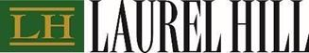

North American Toll Free & By Text Message

1-877-452-7184

Collect Calls & Text Messages Outside North America

416-304-0211

Email: assistance@laurelhill.com



Innisfree M&A Incorporated
501 Madison Avenue, 20th Floor
New York, New York 10022
Shareholders may call: +1 (877) 687-1871 (Toll-Free from the U.S. and Canada) or
+1 (412) 232-3651 (from other countries)
Banks and Brokers may call collect: +1 (212) 750-5833

Exhibit 99.2

THIS LETTER OF TRANSMITTAL MUST BE VALIDLY COMPLETED, DULY EXECUTED AND RETURNED TO THE DEPOSITARY, TSX TRUST COMPANY (“DEPOSITARY”). IT IS IMPORTANT THAT YOU VALIDLY COMPLETE, DULY EXECUTE AND RETURN THIS LETTER OF TRANSMITTAL ON A TIMELY BASIS IN ACCORDANCE WITH THE INSTRUCTIONS CONTAINED HEREIN.

LETTER OF TRANSMITTAL
WITH RESPECT TO THE
COMMON SHARES OF
BITFARMS LTD.

This Letter of Transmittal is for use by registered holders (“Bitfarms Canada Shareholders”) of common shares (the “Bitfarms Canada Shares”) in the capital of Bitfarms Ltd. (“Bitfarms Canada”) in connection with the proposed arrangement (the “Arrangement”) under Section 182 of the Business Corporations Act (Ontario) providing for, among other things, the exchange of each existing Bitfarms Canada Share for one share of common stock, par value U.S.$0.001 per share, of Keel Infrastructure Corp., a newly-incorporated entity formed under the laws of the State of Delaware in the United States of America (“Keel Infrastructure US”). Bitfarms Canada entered into an arrangement agreement with 1576430 B.C. Unlimited Liability Company (“AcquisitionCo”) and Keel Infrastructure US dated February 6, 2026 (the “Arrangement Agreement”), in regards to the Arrangement.

This Letter of Transmittal is for use by registered Bitfarms Canada Shareholders only and is not to be used by beneficial (non-registered) Bitfarms Canada Shareholders. A significant number of Bitfarms Canada Shareholders are beneficial Bitfarms Canada Shareholders because the Bitfarms Canada Shares they beneficially own are not registered in their names but are instead registered in the name of an intermediary (an “Intermediary”), such as a broker, custodian, nominee, bank, trust company, securities dealer or administrator, or in the name of a clearing agency of which the Intermediary is a participant. In Canada, the vast majority of such shares are registered under the name of CDS & Co (the registration name for CDS Clearing and Depositary Services Inc., which company acts as nominee for many Canadian brokerage firms). In the United States, the majority of such shares are registered in the name of Cede & Co., the nominee for the Depository Corporation Company, which is the United States equivalent of CDS Clearing and Depository Services Inc. If you are a beneficial Bitfarms Canada Shareholder, you should contact your Intermediary if you have questions regarding this process and carefully follow the instructions from the Intermediary that holds Bitfarms Canada Shares on your behalf in order to deposit your Bitfarms Canada Shares. You should not complete this Letter of Transmittal unless specifically instructed to do so by your Intermediary.

In order for registered Bitfarms Canada Shareholders to receive the Consideration (as defined below) for their Bitfarms Canada Shares, registered Bitfarms Canada Shareholders are required to deposit the certificates representing the Bitfarms Canada Shares held by them (if any) with the Depositary. This Letter of Transmittal, properly completed and duly executed, together with all other required documents, including the attached form of proxy, must accompany all certificates representing Bitfarms Canada Shares (if any) deposited pursuant to the Arrangement.

To properly complete this Letter of Transmittal, registered Bitfarms Canada Shareholders must: (i) Step 1 – complete the information regarding their Bitfarms Canada Shares; (ii) Step 2 - complete their delivery or pick-up instructions; (iii) Step 3 – submit a properly completed IRS Form W-9 or applicable series Form W-8; and (iv) Step 4 – acknowledge the authorizations and duly execute this Letter of Transmittal. Please read the instructions below in completing this Letter of Transmittal and any questions and requests for assistance may be directed to the Depositary at the telephone numbers, email address and locations set forth on the back page of this Letter of Transmittal.

Please note that the delivery of this Letter of Transmittal does not constitute a vote FOR the Arrangement Resolution or any other matters to be considered at the Meeting (as defined below). To exercise your right to vote at the Meeting (as defined below), you must attend the virtual Meeting in person or complete and return the form of proxy that accompanied the Circular to Bitfarms Canada’s transfer agent, TSX Trust Company, by Internet at www.voteproxyonline.com and entering the 12 digit control number, by mail delivery at 301 - 100 Adelaide Street West, Toronto, Ontario M5H 4H1, or by facsimile at (416) 595-9593. In order to be valid and acted upon at the Meeting, the duly completed form of proxy must be received prior to 9:00 a.m. (Toronto time) on March 18, 2026, or, if the Meeting is adjourned or postponed, be deposited with the Corporate Secretary of Bitfarms Canada or TSX Trust Company no later than 48 hours (excluding weekends and statutory holidays in Canada and the U.S.) before the Meeting is reconvened.

Bitfarms Canada, AcquisitionCo and Keel Infrastructure US will implement the Arrangement when all of the conditions to closing have been satisfied and/or waived. The Arrangement is subject to a number of closing conditions, some of which are beyond Bitfarms Canada’s, AcquisitionCo’s and/or Keel Infrastructure US’ control, and as a result, there can be no assurance that the Arrangement will be completed, nor can the exact timing of the implementation of the Arrangement be predicted with certainty. The Arrangement is subject to, among other things, the approval of Bitfarms Canada Shareholders at a special meeting of Bitfarms Canada Shareholders scheduled to be held on March 20, 2026 (as the same may be postponed or adjourned, the “Meeting”). If the Arrangement is approved, it is anticipated that the Arrangement will be completed on April 1, 2026.

Reference is made to the Notice of Special Meeting of Bitfarms Canada Shareholders and the Management Information Circular (the “Circular”), each of which is dated February 17, 2026. Bitfarms Canada Shareholders are strongly urged to read the Circular. The Circular and this Letter of Transmittal are available on Bitfarms Canada’s website at www.bitfarms.com as well as under its profile on SEDAR+ at www.sedarplus.com and on EDGAR at www.sec.gov. Capitalized terms used but not defined in this Letter of Transmittal have the meanings ascribed to such terms in the Circular.

If the Arrangement is not completed and the Arrangement Agreement is terminated, the Depositary will return to Bitfarms Canada Shareholders the certificate(s) enclosed with their Letters of Transmittal in accordance with the instructions provided in the Letters of Transmittal and Bitfarms Canada Shareholders will not be entitled to receive any Consideration for their Bitfarms Canada Shares.

General Information

Consideration

Under the Arrangement, each Bitfarms Canada Shareholder will be entitled to receive one share of Keel Infrastructure US Common Stock in exchange for each Bitfarms Canada Share held (the “Consideration”).

Should a Letter of Transmittal with all portions validly completed, together with, as applicable, accompanying certificate(s)/DRS Advice representing Bitfarms Canada Shares or any other documents as the Depositary may reasonably require, be received by the Depositary on or before the day that is three years less one day from the Effective Date, the relevant Bitfarms Canada Shareholder will be entitled to receive, for each Bitfarms Canada Share the Consideration to which the holder thereof is entitled in lieu of such certificate/DRS Advice as contemplated by Section 2.3 and Section 4.1 of the Plan of Arrangement.

All questions as to validity, form, eligibility (including timely receipt) and acceptance of any Bitfarms Canada Shares deposited pursuant to the Arrangement will be determined by Bitfarms Canada in its sole discretion. Bitfarms Canada reserves the right to reject any and all deposits which it determines not to be in proper form or which may be unlawful for it to accept under the laws of any jurisdiction. Bitfarms Canada reserves the right, if it so elects in its absolute discretion, to instruct the Depositary to waive any defect or irregularity contained in any Letter of Transmittal received by the Depositary. There will be no obligation on Bitfarms Canada, the Depositary or any other person to give notice of any defect or irregularity in any deposit and no liability will be incurred by any of them for failure to give such notice.

Cancellation of Rights

Certificates representing Bitfarms Canada Shares that are not forwarded to the Depositary together with a properly completed and signed Letter of Transmittal and all other required documents on or before the day that is three years less one day from the Effective Date (i) shall cease to represent a claim by or interest of any former Bitfarms Canada Shareholder of any kind or nature against or in AcquisitionCo, Keel Infrastructure US or Bitfarms Canada and (ii) on such date, all Keel Infrastructure US Common Stock to which such former holder was entitled to shall be deemed to have been surrendered to Keel Infrastructure US for cancellation.

2

TSX TRUST COMPANY (SEE BACK PAGE FOR ADDRESS, TELEPHONE NUMBER AND ADDITIONAL CONTACT PARTICULARS) OR YOUR FINANCIAL ADVISOR WILL BE ABLE TO ASSIST YOU IN COMPLETING THIS LETTER OF TRANSMITTAL

Please read the Circular and the instructions set out below carefully before completing this Letter of Transmittal. Delivery of this Letter of Transmittal to an address other than as set out on the back page of this Letter of Transmittal will not constitute a valid delivery. If Bitfarms Canada Shares are registered in different names, a separate Letter of Transmittal must be submitted for each different registered Bitfarms Canada Shareholder. See Instruction 2.

TO: | TSX TRUST COMPANY
AND TO: | BITFARMS LTD.
AND TO: | 1576430 B.C. UNLIMITED LIABILITY COMPANY
AND TO: | KEEL INFRASTRUCTURE CORP.

STEP 1

TRANSMITTAL FORM

All Bitfarms Canada Shareholders must complete this step.

In connection with the Arrangement, the undersigned hereby surrenders to you the Bitfarms Canada Shares listed below (and, if applicable, encloses the certificate(s)/direct registration system advice (“DRS Advice”) representing such Bitfarms Canada Shares).

List your Bitfarms Canada Share certificates. If you cannot locate your Bitfarms Canada Share certificates, please check the box indicating that the certificate is lost and review Instruction #7 for the procedure to replace lost or destroyed certificates.

Certificate Number(s)/DRS Advice Account Number | Name in Which Registered | Number of Bitfarms Canada Shares Deposited | Lost

3

STEP 2
DELIVERY/PICK-UP INSTRUCTIONS

All registered Bitfarms Canada Shareholders must complete this step.

PLEASE COMPLETE BOX “A” AND COMPLETE BOX “B”, AS APPLICABLE.
SEE INSTRUCTIONS 2, 3, 4 AND 5 BELOW.

BOX “A”  DELIVERY INSTRUCTIONS  ISSUE ANY DRS ADVICE in the name and to the address specified below:  (please print or type) |  | BOX “B”  PICK-UP INSTRUCTIONS  ISSUE ANY DRS ADVICE  in the name of the under-signed AND HOLD ANY DRS ADVICE FOR PICK-UP AT THE OFFICE OF THE DEPOSITARY, AT  ¡ TORONTO ¡ MONTREAL ¡ VANCOUVER ¡CALGARY  SEE INSTRUCTION SECTION 10 FOR OFFICE ADDRESSES  (please print or type)
(Name) |  | (Name)
(Street Address and Number) |  | (Street Address and Number)
(City Province or State) |  | (City Province or State)
(Country or Postal (or Zip) Code) |  | (Country or Postal (or Zip) Code)
(Telephone Business Hours) |  | (Telephone Business Hours)

4

STEP 3

To prevent backup withholding on any payment to a Bitfarms Canada Shareholder, such shareholder should complete and return a copy of an IRS Form W-9 (for U.S. Persons) or applicable IRS Form W-8 (for Non-U.S. Persons), which may be obtained from the IRS website (www.irs.gov).

5

STEP 4

AUTHORIZATION/SIGNATURE

All registered Bitfarms Canada Shareholders must complete this Step.

The undersigned:

1. | transmits herewith the certificate(s)/DRS Advice, if applicable, representing the Bitfarms Canada Shares described above (the “Deposited Shares”) for transfer upon the Arrangement becoming effective;

2. | surrenders to AcquisitionCo, effective at the Effective Date, all right, title and interest in and to the Deposited Shares and irrevocably appoints and constitutes the Depositary lawful attorney of the undersigned, with full power of substitution, to deliver the certificates/DRS Advice representing the Deposited Shares pursuant to the Arrangement and to effect the transfer of the Deposited Shares on the books of Bitfarms Canada;

3. | represents and warrants that (i) the undersigned is the registered holder of the Deposited Shares being deposited and has good title to the rights represented by the Deposited Shares free and clear of all mortgages, liens, charges, encumbrances, security interests and adverse claims, and together with all rights and benefits, and has full power and authority to execute and deliver this Letter of Transmittal and to deposit, sell, assign, transfer and deliver the Deposited Shares, (ii) the Deposited Shares have not been sold, assigned or transferred, nor has any agreement been entered into to sell, assign or transfer any such Deposited Shares to any other person, other than pursuant to the Arrangement, (iii) the surrender of the undersigned’s Deposited Shares complies with applicable laws, (iv) all information inserted by the undersigned into this Letter of Transmittal is complete, true and accurate, and (v) the delivery of the Consideration that the undersigned is entitled to receive pursuant to the Arrangement will completely discharge any and all obligations of Bitfarms Canada, AcquisitionCo, Keel Infrastructure US and the Depositary with respect to the matters contemplated by the Circular and this Letter of Transmittal. These representations and warranties shall survive the completion of the Arrangement and the delivery to the Depositary of the Deposited Shares;

4. | acknowledges that the undersigned has had the opportunity to review the Circular;

5. | acknowledges that the delivery of the Deposited Shares shall be effected, and the risk of loss and title to such Deposited Shares shall pass, only upon proper receipt thereof by the Depositary;

6. | revokes any and all authority, other than as granted in this Letter of Transmittal, whether as agent, attorney-in-fact, proxy or otherwise, previously conferred or agreed to be conferred by the undersigned at any time with respect to the Deposited Shares and no subsequent authority, whether as agent, attorney-in-fact, proxy or otherwise will be granted with respect to the Deposited Shares;

7. | will, upon request, execute any signature guarantees or additional documents deemed by the Depositary to be reasonably necessary or desirable to complete the transfer of the Deposited Shares;

8. | understands and acknowledges that no physical certificate(s) for Keel Infrastructure US Common Stock will be issued to Bitfarms Canada Shareholders. A Direct Registration Advice (“DRS Advice”) will be delivered by the Depositary to depositing shareholders. Keel Infrastructure US Common Stock will be held in the name of the applicable Bitfarms Canada Shareholders and registered electronically in Keel Infrastructure US’ records;

9. | instructs the Depositary, upon receipt of this Letter of Transmittal and of the certificate(s)/DRS Advice representing the Bitfarms Canada Shares, if applicable, deposited herewith and following the Effective Date of the Arrangement, to send a DRS Advice representing the shares of Keel Infrastructure US Common Stock, issued as the Consideration for the Deposited Shares, by first class mail, postage prepaid, or to hold such DRS Advice representing the shares of Keel Infrastructure US Common Stock for pick-up, in accordance with the instructions above. DRS Advice mailed in accordance with this paragraph will be deemed to have been delivered at the time of mailing;

10. | acknowledges that the Depositary will act as the agent of persons who have deposited Bitfarms Canada Shares herewith for the purposes of receiving DRS Statements for Keel Infrastructure US Common Stock pursuant to the Arrangement and transmitting such DRS Advices to such persons, and receipt thereof by the Depositary shall be deemed to constitute receipt thereof by persons depositing Bitfarms Canada Shares;

6

11. | acknowledges that each authority conferred or agreed to be conferred by the undersigned in this Letter of Transmittal shall survive the death or incapacity of the undersigned and any obligation of the undersigned hereunder shall be binding upon any heirs, personal representatives, successors and assigns of the undersigned;

12. | acknowledges that the authority herein conferred, coupled with an interest, is not intended to be an enduring power of attorney within the meaning of and governed by the Power of Attorney Act, or any similar power of attorney under equivalent legislation in any of the provinces or territories of Canada (an “EPOA”). The execution of this Letter of Transmittal shall not terminate any such EPOA granted by the undersigned previously and shall not be terminated by the execution by the undersigned in the future of an EPOA, and the undersigned hereby agrees not to take any action in future which results in the termination of the authority herein conferred;

13. | acknowledges that if the Arrangement is not completed or proceeded with, the enclosed certificate(s)/DRS Statement (if any) and all other ancillary documents (if any) will be returned forthwith to the undersigned in accordance with the instructions set out in Box “A” or Box “B” of Step 2, as applicable, or failing which, will be mailed to the address as it appears on the register of Bitfarms Canada Shareholders;

14. | acknowledges that the undersigned will not receive Consideration in respect of the Deposited Shares until the Arrangement is consummated and until the certificate(s) representing the Deposited Shares, if applicable, owned by the undersigned are received by the Depositary at the address set out on the back page of this Letter of Transmittal, together with such additional documents as the Depositary may require, and until the same are processed by the Depositary. It is further understood that no interest will accrue on the Consideration payable under the Arrangement for the Deposited Shares; and

15. | by reason of the use by the undersigned of this Letter of Transmittal in the English language, the undersigned and the recipients acknowledge that they are deemed to have required that any contract evidenced by the Arrangement as entered into through this Letter of Transmittal, as well as any documents related thereto, be drawn exclusively in the English language. En raison de l’usage de la présente lettre d’envoi en langue anglaise par le ou la soussigné(e), le ou la soussigné(e), et les destinataires sont réputés avoir exigé que tout contrat attesté par l’Arrangement, tel qu’il est accepté au moyen de cette lettre d’envoi, de même que tous les documents qui s’y rapportent, soient rédigés exclusivement en langue anglaise.

7

SHAREHOLDER SIGNATURE

 | Date: |  | , 20
Signature guaranteed by
(If required under Instruction 3):

Authorized Signature of Guarantor |  | Signature of Bitfarms Canada Shareholder or Authorized Representative – See Instruction 2 and 4
Name of Guarantor (please print or type) |  | Name of Bitfarms Canada Shareholder (please print or type)
Address of Guarantor (please print or type) |  | Business Taxpayer Identification, Social Insurance or Social Security Number of Bitfarms Canada Shareholder (please print or type)
 |  | Name of Authorized Representative, if applicable (please print or type)
 |  | Daytime telephone number of Bitfarms Canada Shareholder or Authorized Representative
 |  | Email address of Bitfarms Canada Shareholder or Authorized Representative

8

INSTRUCTIONS

1. | Use of Letter of Transmittal

 | a. | Should a Letter of Transmittal with all portions validly completed, together with, as applicable, accompanying certificate(s)/DRS Advice representing Bitfarms Canada Shares or any other documents as the Depositary may reasonably require, be received by the Depositary on or before the day that is three years less one day from the Effective Date, the relevant Bitfarms Canada Shareholder will be entitled to receive, for each Bitfarms Canada Share the Consideration to which the holder thereof is entitled in lieu of such certificate/DRS Advice as contemplated by Section 2.3 and Section 4.1 of the Plan of Arrangement. Bitfarms Canada Shareholders who do not deliver this Letter of Transmittal and, as applicable, the certificates representing the Bitfarms Canada Shares held by them and all other required documents to the Depositary on or before the date that is three years less one day from the Effective Date will lose their right to receive any Consideration for their Bitfarms Canada Shares under the Arrangement, and be deemed to have been surrendered to Keel Infrastructure US for cancellation.

 | b. | The method used to deliver this Letter of Transmittal and any accompanying certificates/DRS Advice representing Bitfarms Canada Shares is at the option and risk of the Bitfarms Canada Shareholder surrendering them. Delivery will be deemed effective only when such documents are actually received. Bitfarms Canada recommends that the necessary documentation be hand delivered to the Depositary at the address specified on the back page of this Letter of Transmittal, and a receipt obtained therefor; otherwise the use of registered mail with return receipt requested, and with proper insurance obtained, is recommended. Bitfarms Canada Shareholders whose Bitfarms Canada Shares are registered in the name of an Intermediary or clearing agency should contact that Intermediary or clearing agency for assistance in depositing those Bitfarms Canada Shares or clearing agency. Delivery to an office other than to the specified offices of the Depositary does not constitute delivery for this purpose. Do not send any certificates/DRS Advice representing Bitfarms Canada Shares or this Letter of Transmittal to Bitfarms Canada.

2. | Signatures

This Letter of Transmittal must be completed, dated and signed by the registered Bitfarms Canada Shareholder or by such holder’s duly authorized representative (in accordance with Instruction 4).

 | a. | If this Letter of Transmittal is signed by the registered owner(s) of the accompanying certificate(s), such signature(s) on this Letter of Transmittal must correspond with the name(s) as registered or as written on the face of such certificate(s), as applicable, without any change whatsoever, and the certificate(s) (if applicable) need not be endorsed. If such transmitted certificate(s) are owned of record by two or more joint owners, all such owners must sign this Letter of Transmittal.

 | b. | If this Letter of Transmittal is signed by a person other than the registered owner(s) of the accompanying certificate(s):

 | i. | such deposited shares must be endorsed or be accompanied by appropriate share transfer power(s) of attorney properly completed by the registered owner(s); and

 | ii. | the signature(s) on such endorsement or share transfer power(s) of attorney must correspond exactly to the name(s) of the registered owner(s) as registered or as appearing on the accompanying certificate(s)/DRS Advice and must be guaranteed as noted in Instruction 3.

 | c. | If any of the Deposited Shares are registered in different names on several certificates/DRS Advice, it will be necessary to complete, sign and submit as many separate Letters of Transmittal as there are different registrations of such Deposited Shares.

9

3. | Guarantee of Signatures

Except as provided below, no signature guarantee is required on this Letter of Transmittal if this Letter of Transmittal is signed by the registered holder(s) of Bitfarms Canada Shares surrendered herewith. If this Letter of Transmittal is signed by a person other than the registered owner(s) of the Bitfarms Canada Shares, such signature must be guaranteed by an Eligible Institution (as defined below), or in some other manner satisfactory to the Depositary (except that no guarantee is required if the signature is that of an Eligible Institution), as per Step 5.

An “Eligible Institution” means a Canadian Schedule I chartered bank, a member of the Securities Transfer Agent Medallion Program (STAMP), a member of the Stock Exchanges Medallion Program (SEMP) or a member of the New York Stock Exchange, Inc., Medallion Signature Program (MSP). Members of these programs are usually members of a recognized stock exchange in Canada and the United States, members of the Canadian Investment Regulatory Organization, members of the Financial Industry Regulatory Authority or banks and trust companies in the United States.

4. | Fiduciaries, Representatives and Authorizations

Where this Letter of Transmittal or any share transfer power(s) of attorney is executed by a person as an executor, administrator, trustee or guardian, or on behalf of a corporation, partnership or association or is executed by any other person acting in a representative capacity, such person should so indicate when signing and this Letter of Transmittal must be accompanied by satisfactory evidence of authority to act. Either Bitfarms Canada or the Depositary, in their sole discretion, may require additional evidence of authority or additional documentation.

5. | Delivery Instructions

In all cases, either Box “A” or Box “B” of Step 2 should be completed. If those boxes are not completed, the Consideration for the Bitfarms Canada Shares (or the certificate(s) or DRS Advice(s) in respect of the Bitfarms Canada Shares if the Arrangement is not completed) will be mailed to the address as it appears on the register of Bitfarms Canada Shareholders.

6. | Miscellaneous

 | a. | If the space on this Letter of Transmittal is insufficient to list all certificates or DRS Advices relating to Deposited Shares, additional certificate/DRS Advice numbers and numbers of Bitfarms Canada Shares may be included on a separate signed list affixed to this Letter of Transmittal as an appendix thereto.

 | b. | If Bitfarms Canada Shares are registered in different forms (e.g. “John Doe” and “J. Doe”), a separate Letter of Transmittal should be signed for each different registration.

 | c. | No alternative, conditional or contingent deposits of Bitfarms Canada Shares will be accepted.

 | d. | Additional copies of this Letter of Transmittal may be obtained from the Depositary at the office specified on the back page of this Letter of Transmittal. A copy of this Letter of Transmittal is also available on Bitfarms Canada’s website at www.bitfarms.com as well as under Bitfarms Canadas’s profile on SEDAR+ at www.sedarplus.com and on EDGAR at www.sec.gov.

 | e. | It is strongly recommended that prior to completing this Letter of Transmittal, the undersigned read the Circular and discuss any questions with his, her or its tax advisor.

 | f. | Bitfarms Canada reserves the right to instruct the Depositary to waive any defect or irregularity contained in any Letter of Transmittal received by it.

 | g. | This Letter of Transmittal will be construed in accordance with and governed by the laws of the Province of Ontario and the federal laws of Canada applicable therein.

10

7. | Destroyed, Lost or Stolen Certificates

If a share certificate has been lost, destroyed or stolen, this Letter of Transmittal should be completed as fully as possible and forwarded, together with a letter describing the loss, destruction or theft, to the Depositary. The Registered Shareholder will be required to complete and submit certain documentation, including a bond and/or indemnity, before payment for the Bitfarms Canada Shares can be received by the Registered Shareholder. [If a DRS Advice representing Bitfarms Canada Shares has been lost, stolen or destroyed, the holder can request a copy of the DRS Advice by contacting TSX Trust Company at (416) 342-1091 or toll-free at 1-866-600-5869 or by e-mail at tsxtis@tmx.com, with no bond indemnity required and such copy of the DRS Advice should be deposited with this Letter of Transmittal.

8. | Return of Certificates

If the Arrangement is not completed, your Bitfarms Canada Share certificate(s)/DRS Advice(s) will be promptly returned to you by the Depositary forthwith at the address shown below the signature of the Signatory in this Letter of Transmittal or, failing such address being specified, at the Bitfarms Canada Shareholder’s last address as it appears on the share register of Bitfarms Canada.

9. | Payment Entitlement Pickup Locations

Entitlements may be picked up at applicable TSX Trust Company office locations with Counter services. Pick-up instructions must be selected in Box “B”. Below are the applicable TSX Trust Company office locations:

Montreal | Toronto | Calgary | Vancouver
1701 - 1190 Avenue des Canadiens-de-Montreal, Montreal, QC H3B 0G7 | 301 - 100 Adelaide Street West, Toronto ON M5H 4H1 | Telus Sky Building 2110, 685 Centre Street SW, Calgary AB T2G 1S5 | 733 Seymour Street, Suite 2310, Vancouver, BC V6B 0S6

Privacy Notice

The Depositary is committed to protecting your personal information. In the course of providing services to you and its corporate clients, the Depositary receives non-public personal information about you from transactions performed by the Depositary for you, forms you send to the Depositary, other communications the Depositary has with you or your representatives, etc. This information could include your name, address, social insurance number, securities holdings and other financial information. The Depositary uses this to administer your account, to better serve your and its clients’ needs and for other lawful purposes relating to its services. Some of your information may be transferred to servicers in the U.S. for data processing and/or storage. The Depositary has prepared a privacy code to tell you more about its information practices, how your privacy is protected and how to contact its Chief Privacy Officer. The privacy code is available at the Depositary’s website, www.tsxtrust.com, or may be obtained upon written request submitted to the Depositary at: Chief Privacy Officer, TSX Trust Company, 301 - 100 Adelaide Street West, Toronto ON M5H 4H1. The Depositary will use the information you are providing in order to process your request and will treat your signature(s) as your consent to the Depositary so doing.

11

THE DEPOSITARY FOR THE ARRANGEMENT IS:

TSX TRUST COMPANY

By Registered Mail, Hand or by Courier

100 Adelaide Street, Suite 301
Toronto, ON M5H 4H1
Attention: Corporate Actions

Inquiries

Toll Free (North America): 1-866-600-5869
E-Mail: TSXTIS@tmx.com

Any questions and requests for assistance may be directed by
the Bitfarms Canada Shareholders to the Depositary at the telephone numbers, email address
and locations set out above.

12

Exhibit 99.3

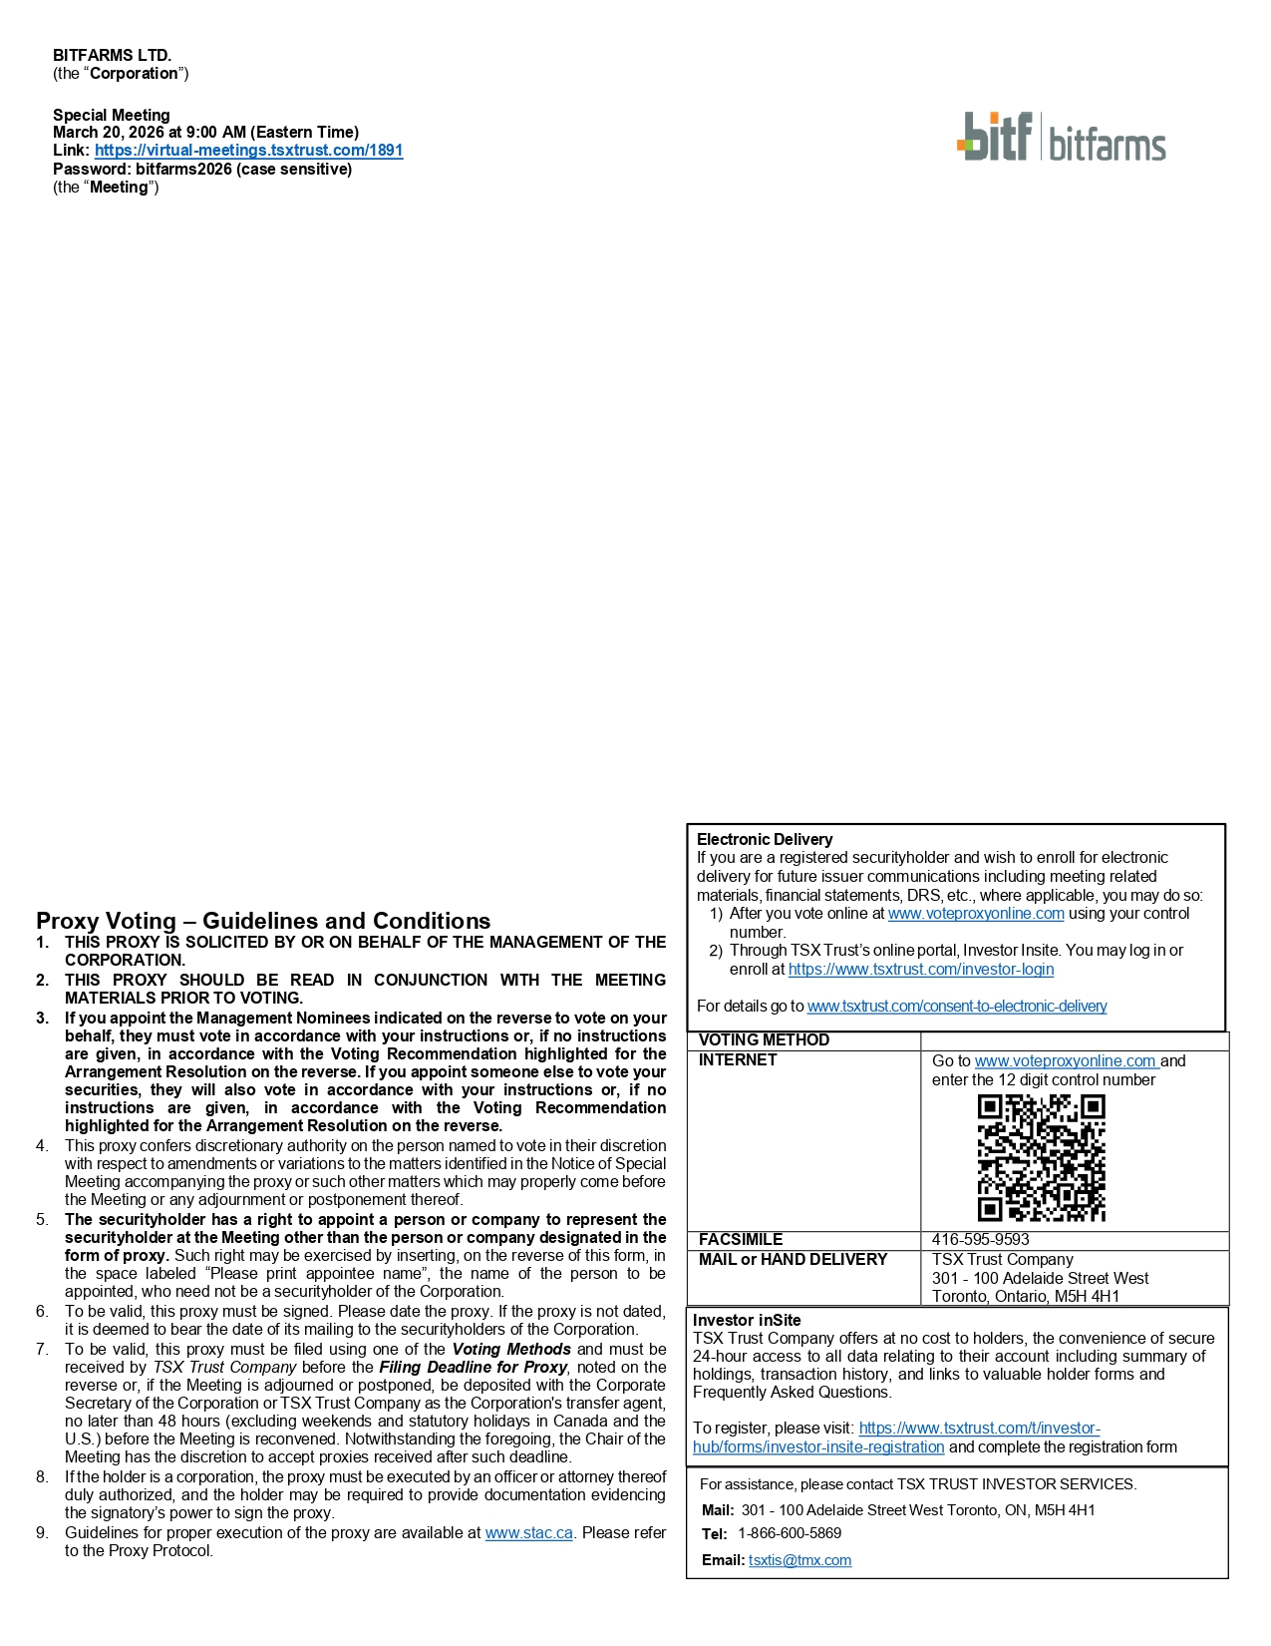
Proxy Voting – Guidelines and Conditions 1. THIS PROXY IS SOLICITED BY OR ON BEHALF OF THE MANAGEMENT OF THE CORPORATION . 2. THIS PROXY SHOULD BE READ IN CONJUNCTION WITH THE MEETING MATERIALS PRIOR TO VOTING . 3. If you appoint the Management Nominees indicated on the reverse to vote on your behalf, they must vote in accordance with your instructions or, if no instructions are given, in accordance with the Voting Recommendation highlighted for the Arrangement Resolution on the reverse . If you appoint someone else to vote your securities, they will also vote in accordance with your instructions or, if no instructions are given, in accordance with the Voting Recommendation highlighted for the Arrangement Resolution on the reverse . 4. This proxy confers discretionary authority on the person named to vote in their discretion with respect to amendments or variations to the matters identified in the Notice of Special Meeting accompanying the proxy or such other matters which may properly come before the Meeting or any adjournment or postponement thereof . 5. The securityholder has a right to appoint a person or company to represent the securityholder at the Meeting other than the person or company designated in the form of proxy . Such right may be exercised by inserting, on the reverse of this form, in the space labeled “Please print appointee name”, the name of the person to be appointed, who need not be a securityholder of the Corporation . 6. To be valid, this proxy must be signed . Please date the proxy . If the proxy is not dated, it is deemed to bear the date of its mailing to the securityholders of the Corporation . 7. To be valid, this proxy must be filed using one of the Voting Methods and must be received by TSX Trust Company before the Filing Deadline for Proxy , noted on the reverse or, if the Meeting is adjourned or postponed, be deposited with the Corporate Secretary of the Corporation or TSX Trust Company as the Corporation's transfer agent, no later than 48 hours (excluding weekends and statutory holidays in Canada and the U . S . ) before the Meeting is reconvened . Notwithstanding the foregoing, the Chair of the Meeting has the discretion to accept proxies received after such deadline . 8. If the holder is a corporation, the proxy must be executed by an officer or attorney thereof duly authorized, and the holder may be required to provide documentation evidencing the signatory’s power to sign the proxy . 9. Guidelines for proper execution of the proxy are available at www . stac . ca . Please refer to the Proxy Protocol . Electronic Delivery If you are a registered securityholder and wish to enroll for electronic delivery for future issuer communications including meeting related materials, financial statements, DRS, etc., where applicable, you may do so: After you vote online at www.voteproxyonline.com using your control number. Through TSX Trust’s online portal, Investor Insite. You may log in or enroll at https://www.tsxtrust.com/investor - login For details go to www.tsxtrust.com/consent - to - electronic - delivery VOTING METHOD Go to www.voteproxyonline.com and enter the 12 digit control number INTERNET 416 - 595 - 9593 FACSIMILE TSX Trust Company 301 - 100 Adelaide Street West Toronto, Ontario, M5H 4H1 MAIL or HAND DELIVERY Investor inSite TSX Trust Company offers at no cost to holders, the convenience of secure 24 - hour access to all data relating to their account including summary of holdings, transaction history, and links to valuable holder forms and Frequently Asked Questions. To register, please visit: https://www.tsxtrust.com/t/investor - hub/forms/investor - insite - registration and complete the registration form For assistance, please contact TSX TRUST INVESTOR SERVICES. Mail: 301 - 100 Adelaide Street West Toronto, ON, M5H 4H1 Tel: 1 - 866 - 600 - 5869 Email: tsxtis@tmx.com BITFARMS LTD. (the “ Corporation ”) Special Meeting March 20, 2026 at 9:00 AM (Eastern Time) Link: https://virtual - meetings.tsxtrust.com/1891 Password: bitfarms2026 (case sensitive) (the “ Meeting ”)

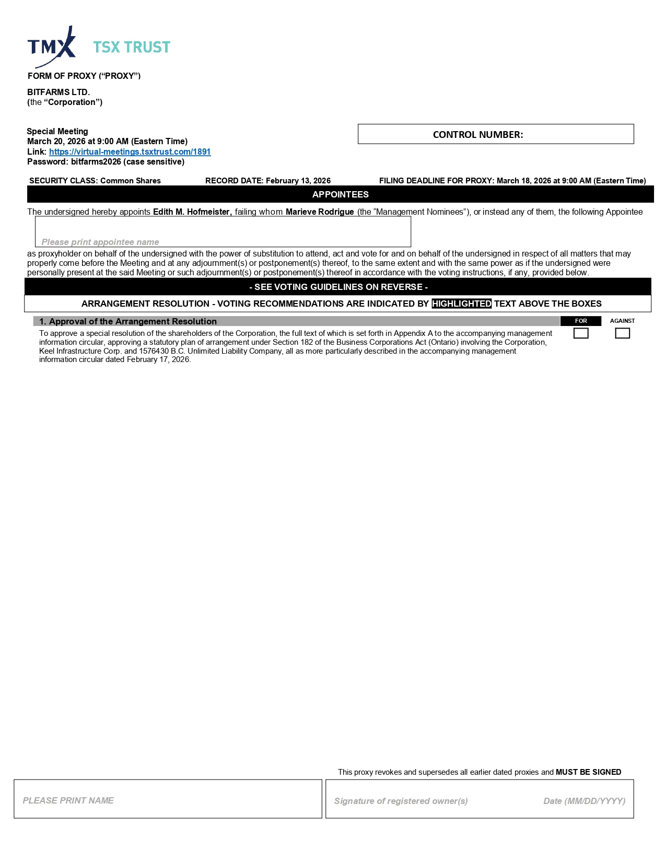
ARRANGEMENT RESOLUTION - VOTING RECOMMENDATIONS ARE INDICATED BY HIGHLIGHTED TEXT ABOVE THE BOXES FORM OF PROXY (“PROXY”) BITFARMS LTD. ( the “Corporation”) Special Meeting March 20, 2026 at 9:00 AM (Eastern Time) Link: https://virtual - meetings.tsxtrust.com/1891 Password: bitfarms2026 (case sensitive) SECURITY CLASS: Common Shares RECORD DATE: February 13, 2026 FILING DEADLINE FOR PROXY: March 18, 2026 at 9:00 AM (Eastern Time) The undersigned hereby appoints Edith M. Hofmeister, failing whom Marieve Rodrigue (the “Management Nominees”), or instead any of them, the following Appointee as proxyholder on behalf of the undersigned with the power of substitution to attend, act and vote for and on behalf of the undersigned in respect of all matters that may properly come before the Meeting and at any adjournment(s) or postponement(s) thereof, to the same extent and with the same power as if the undersigned were personally present at the said Meeting or such adjournment(s) or postponement(s) thereof in accordance with the voting instructions, if any, provided below. APPOINTEES Please print appointee name Signature of registered owner(s) Date (MM/DD/YYYY) This proxy revokes and supersedes all earlier dated proxies and MUST BE SIGNED PLEASE PRINT NAME - SEE VOTING GUIDELINES ON REVERSE - AGAINST FOR 1. Approval of the Arrangement Resolution To approve a special resolution of the shareholders of the Corporation, the full text of which is set forth in Appendix A to the accompanying management information circular, approving a statutory plan of arrangement under Section 182 of the Business Corporations Act (Ontario) involving the Corporation, Keel Infrastructure Corp. and 1576430 B.C. Unlimited Liability Company, all as more particularly described in the accompanying management information circular dated February 17, 2026. CONTROL NUMBER:

Exhibit 99.4

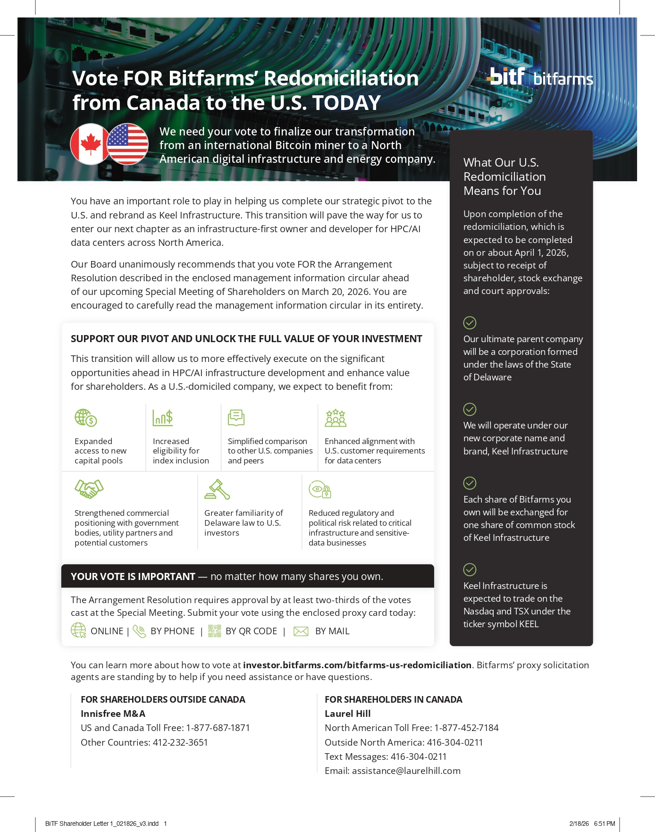
We need your vote to finalize our transformation from an international Bitcoin miner to a North American digital infrastructure and energy company. Vote FOR Bitfarms’ Redomiciliation from Canada to the U.S. TODAY Upon completion of the redomiciliation, which is expected to be completed on or about April 1, 2026, subject to receipt of shareholder, stock exchange and court approvals: Our ultimate parent company will be a corporation formed under the laws of the State of Delaware We will operate under our new corporate name and brand, Keel Infrastructure Each share of Bitfarms you own will be exchanged for one share of common stock of Keel Infrastructure Keel Infrastructure is expected to trade on the Nasdaq and TSX under the ticker symbol KEEL What Our U.S. Redomiciliation Means for You You have an important role to play in helping us complete our strategic pivot to the U . S . and rebrand as Keel Infrastructure . This transition will pave the way for us to enter our next chapter as an infrastructure - first owner and developer for HPC/AI data centers across North America . Our Board unanimously recommends that you vote FOR the Arrangement Resolution described in the enclosed management information circular ahead of our upcoming Special Meeting of Shareholders on March 20, 2026. You are encouraged to carefully read the management information circular in its entirety. SUPPORT OUR PIVOT AND UNLOCK THE FULL VALUE OF YOUR INVESTMENT This transition will allow us to more effectively execute on the significant opportunities ahead in HPC/AI infrastructure development and enhance value for shareholders. As a U.S. - domiciled company, we expect to benefit from: Expanded access to new capital pools Increased eligibility for index inclusion Simplified comparison to other U.S. companies and peers Enhanced alignment with U.S. customer requirements for data centers Strengthened commercial positioning with government bodies, utility partners and potential customers Greater familiarity of Delaware law to U . S . investors Reduced regulatory and political risk related to critical infrastructure and sensitive - data businesses YOUR VOTE IS IMPORTANT — no matter how many shares you own. The Arrangement Resolution requires approval by at least two - thirds of the votes You can learn more about how to vote at investor.bitfarms.com/bitfarms - us - redomiciliation . Bitfarms’ proxy solicitation agents are standing by to help if you need assistance or have questions. cast at the Special Meeting. Submit your vote using the enclosed proxy card today: ONLINE | BY PHONE | BY QR CODE | BY MAIL FOR SHAREHOLDERS OUTSIDE CANADA Innisfree M&A US and Canada Toll Free: 1 - 877 - 687 - 1871 Other Countries: 412 - 232 - 3651 FOR SHAREHOLDERS IN CANADA Laurel Hill North American Toll Free: 1 - 877 - 452 - 7184 Outside North America: 416 - 304 - 0211 Text Messages: 416 - 304 - 0211 Email: assistance@laurelhill.com BITF Shareholder Letter 1_021826_v3.indd 1 2/18/26 6:51 PM

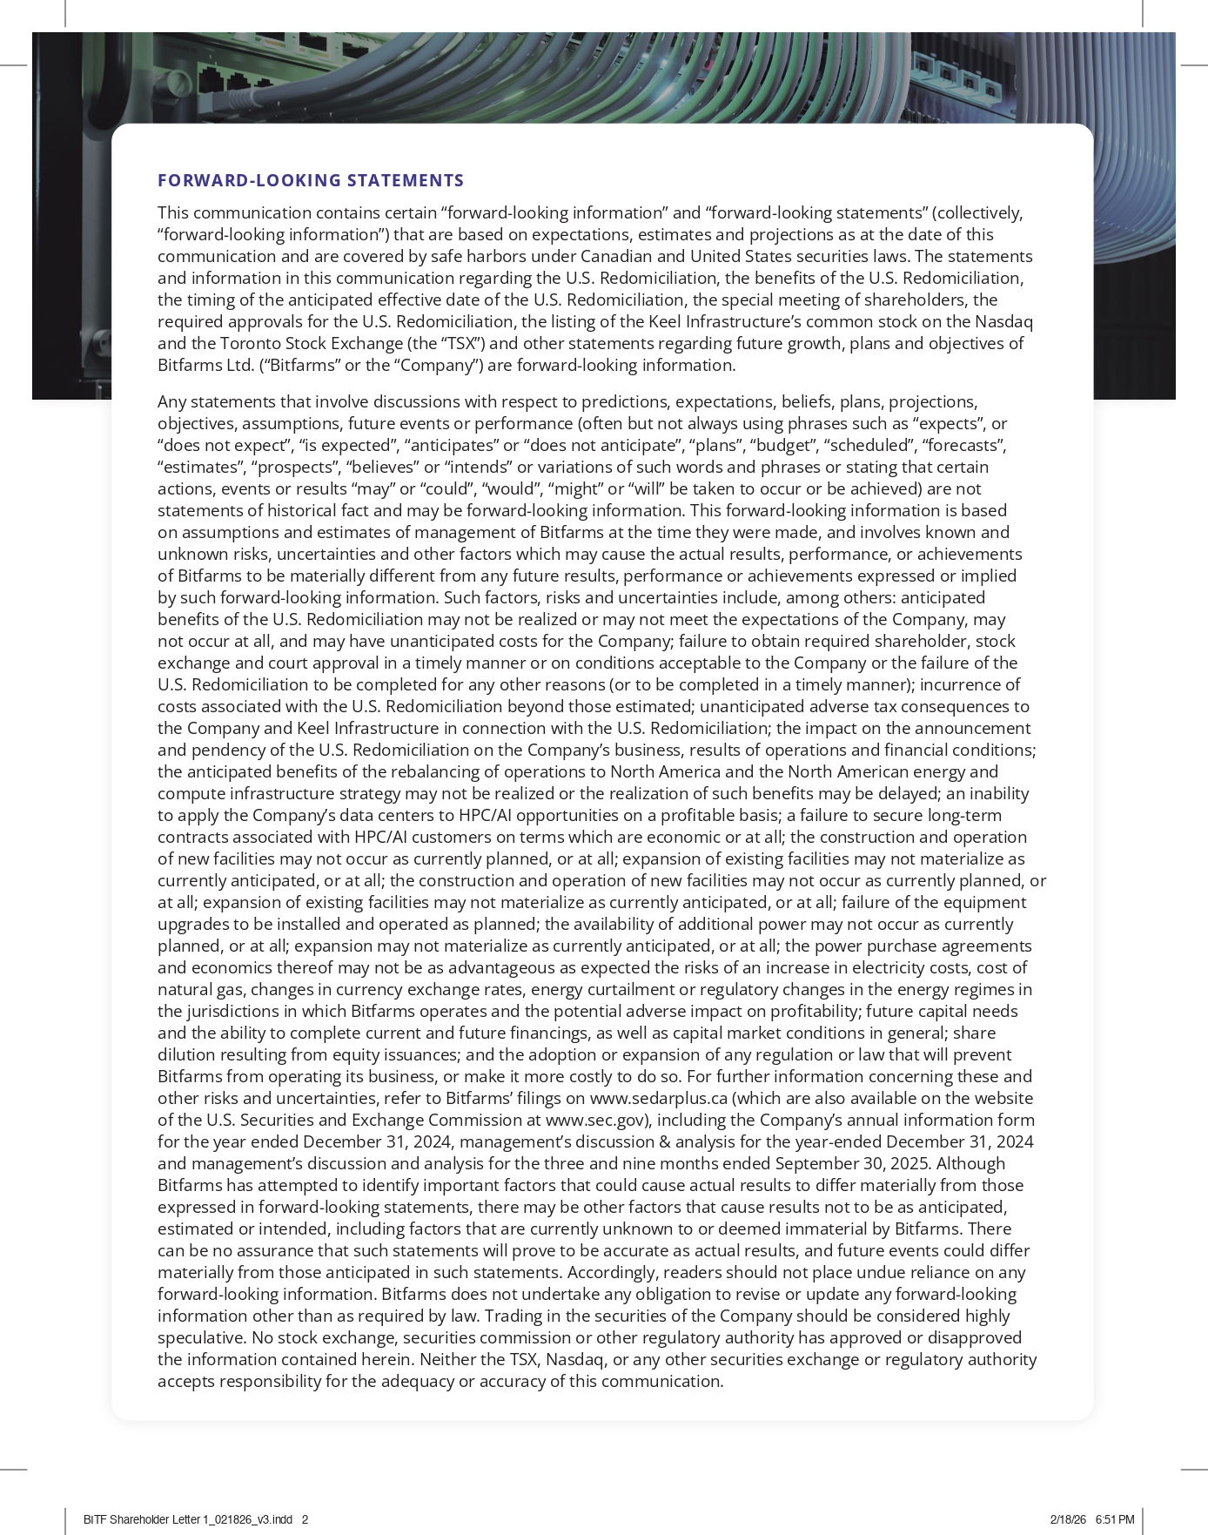
FORWARD - LOOKING STATEMENTS This communication contains certain “forward - looking information” and “forward - looking statements” (collectively, “forward - looking information”) that are based on expectations, estimates and projections as at the date of this communication and are covered by safe harbors under Canadian and United States securities laws. The statements and information in this communication regarding the U.S. Redomiciliation, the benefits of the U.S. Redomiciliation, the timing of the anticipated effective date of the U.S. Redomiciliation, the special meeting of shareholders, the required approvals for the U.S. Redomiciliation, the listing of the Keel Infrastructure’s common stock on the Nasdaq and the Toronto Stock Exchange (the “TSX”) and other statements regarding future growth, plans and objectives of Bitfarms Ltd. (“Bitfarms” or the “Company”) are forward - looking information. Any statements that involve discussions with respect to predictions, expectations, beliefs, plans, projections, objectives, assumptions, future events or performance (often but not always using phrases such as “expects”, or “does not expect”, “is expected”, “anticipates” or “does not anticipate”, “plans”, “budget”, “scheduled”, “forecasts”, “estimates”, “prospects”, “believes” or “intends” or variations of such words and phrases or stating that certain actions, events or results “may” or “could”, “would”, “might” or “will” be taken to occur or be achieved) are not statements of historical fact and may be forward - looking information. This forward - looking information is based on assumptions and estimates of management of Bitfarms at the time they were made, and involves known and unknown risks, uncertainties and other factors which may cause the actual results, performance, or achievements of Bitfarms to be materially different from any future results, performance or achievements expressed or implied by such forward - looking information. Such factors, risks and uncertainties include, among others: anticipated benefits of the U.S. Redomiciliation may not be realized or may not meet the expectations of the Company, may not occur at all, and may have unanticipated costs for the Company; failure to obtain required shareholder, stock exchange and court approval in a timely manner or on conditions acceptable to the Company or the failure of the U.S. Redomiciliation to be completed for any other reasons (or to be completed in a timely manner); incurrence of costs associated with the U.S. Redomiciliation beyond those estimated; unanticipated adverse tax consequences to the Company and Keel Infrastructure in connection with the U.S. Redomiciliation; the impact on the announcement and pendency of the U.S. Redomiciliation on the Company’s business, results of operations and financial conditions; the anticipated benefits of the rebalancing of operations to North America and the North American energy and compute infrastructure strategy may not be realized or the realization of such benefits may be delayed; an inability to apply the Company’s data centers to HPC/AI opportunities on a profitable basis; a failure to secure long - term contracts associated with HPC/AI customers on terms which are economic or at all; the construction and operation of new facilities may not occur as currently planned, or at all; expansion of existing facilities may not materialize as currently anticipated, or at all; the construction and operation of new facilities may not occur as currently planned, or at all; expansion of existing facilities may not materialize as currently anticipated, or at all; failure of the equipment upgrades to be installed and operated as planned; the availability of additional power may not occur as currently planned, or at all; expansion may not materialize as currently anticipated, or at all; the power purchase agreements and economics thereof may not be as advantageous as expected the risks of an increase in electricity costs, cost of natural gas, changes in currency exchange rates, energy curtailment or regulatory changes in the energy regimes in the jurisdictions in which Bitfarms operates and the potential adverse impact on profitability; future capital needs and the ability to complete current and future financings, as well as capital market conditions in general; share dilution resulting from equity issuances; and the adoption or expansion of any regulation or law that will prevent Bitfarms from operating its business, or make it more costly to do so. For further information concerning these and other risks and uncertainties, refer to Bitfarms’ filings on www.sedarplus.ca (which are also available on the website of the U.S. Securities and Exchange Commission at www.sec.gov), including the Company’s annual information form for the year ended December 31, 2024, management’s discussion & analysis for the year - ended December 31, 2024 and management’s discussion and analysis for the three and nine months ended September 30, 2025. Although Bitfarms has attempted to identify important factors that could cause actual results to differ materially from those expressed in forward - looking statements, there may be other factors that cause results not to be as anticipated, estimated or intended, including factors that are currently unknown to or deemed immaterial by Bitfarms. There can be no assurance that such statements will prove to be accurate as actual results, and future events could differ materially from those anticipated in such statements. Accordingly, readers should not place undue reliance on any forward - looking information. Bitfarms does not undertake any obligation to revise or update any forward - looking information other than as required by law. Trading in the securities of the Company should be considered highly speculative. No stock exchange, securities commission or other regulatory authority has approved or disapproved the information contained herein. Neither the TSX, Nasdaq, or any other securities exchange or regulatory authority accepts responsibility for the adequacy or accuracy of this communication. BITF Shareholder Letter 1_021826_v3.indd 2 2/18/26 6:51 PM

Exhibit 99.5



Bitfarms Announces Filing and Mailing of Materials for Special Meeting of Shareholders to Approve U.S. Redomiciliation Plan

U.S. Redomiciliation is an Important Step in Bitfarms’ Strategic Pivot and Rebrand as Keel Infrastructure
Board of Directors Unanimously Recommends Shareholders Vote FOR the Arrangement Resolution

Voting is Now Open: Bitfarms Shareholders are Encouraged to Vote Now in Support of the U.S. Redomiciliation

TORONTO, Ontario and NEW YORK, February 24, 2026 – Bitfarms Ltd. (NASDAQ/TSX: BITF) (“Bitfarms” or the “Company”), a North American digital infrastructure and energy company, today announced that its management information circular (the “Circular”) and related materials in connection with the Company’s upcoming special meeting of shareholders (the “Meeting”) have been filed publicly and are being mailed to shareholders.

Meeting Details

As previously announced, the Meeting will be held virtually at 9:00 a.m. (Eastern time) on March 20, 2026 to approve the Company’s plan of arrangement (the “Arrangement”), under which Bitfarms will redomicile from Canada to the United States (the “U.S. Redomiciliation”) and rebrand as Keel Infrastructure, subject to receipt of shareholder and court approvals. At the Meeting, Bitfarms shareholders will be asked to consider a special resolution (the “Arrangement Resolution”) to approve the proposed Arrangement.

The Company also announced that on February 13, 2026, it obtained an interim order (the “Interim Order”) from the Ontario Superior Court of Justice (Commercial List) authorizing various procedural matters, including the holding of the Meeting and the mailing of the Circular and related materials. The Meeting is to be held in accordance with the terms of the Interim Order.

“We are taking another important step toward completing our U.S. redomiciliation and entering our next phase as Keel Infrastructure,” said CEO Ben Gagnon. “Having conducted a thorough review of potential opportunities to enhance long-term shareholder value over the last year, the Board is confident this transition is the right path forward for our company as we complete our strategic pivot. We encourage our shareholders to review our management information circular for additional information about the value creation opportunities we believe we will unlock as a U.S.-domiciled company focused on HPC/AI infrastructure development.”

The Board unanimously recommends that shareholders vote “FOR” the Arrangement Resolution. As a U.S. domiciled company, Bitfarms expects to benefit from:

 | ● | Expanded access to new capital pools;

 | ● | Increased eligibility for index inclusion;

 | ● | Strengthened commercial positioning with government bodies, utility partners and potential customers;

 | ● | Enhanced alignment with U.S. customer requirements for data centers;

 | ● | Reduced regulatory and political risk related to critical infrastructure and sensitive-data businesses;

 | ● | Greater familiarity of Delaware law to U.S. investors; and

 | ● | Simplified comparison to other U.S. companies and peers.

Arrangement Details

To effect the U.S. Redomiciliation, each outstanding common share of Bitfarms will be exchanged for one share of common stock of Keel Infrastructure (“Keel Common Stock”) pursuant to the Arrangement. In connection with the U.S. Redomiciliation, the Toronto Stock Exchange (the “TSX”) has conditionally approved the Arrangement and the listing of Keel Common Stock, and upon completion of the U.S. Redomiciliation, Keel Common Stock is expected to trade on Nasdaq and the TSX under the ticker symbol KEEL, subject to fulfilling all of the listing requirements of the TSX and Nasdaq, respectively.

The U.S. Redomiciliation is not expected to impact the Company’s existing operations or facilities in Canada and the United States. Following completion of the U.S. Redomiciliation, Keel Infrastructure and its subsidiaries will carry on the business currently conducted by Bitfarms and its subsidiaries.

The U.S. Redomiciliation is expected to be completed on or about April 1, 2026, subject to obtaining shareholder and court approvals, as well as the satisfaction of all other conditions precedent.

Bitfarms’ Board of Directors Encourages Shareholders to Vote FOR the Arrangement Resolution Today

Your vote is important, no matter how many shares you own. The Arrangement Resolution requires approval by at least two-thirds of the votes cast at the Meeting. Shareholders can access the Meeting by visiting https://virtual-meetings.tsxtrust.com/1891 (password: bitfarms2026). The Company has fixed February 13, 2026 as the record date for determining those shareholders entitled to receive notice of and to vote at the Meeting. Even if you plan to attend the Meeting, the Company recommends that you vote your shares in advance of the proxy deadline of 9:00am (Eastern Time) on March 18, 2026. Additional details about how to vote can be found in the Circular or accessed at investor.bitfarms.com/bitfarms-us-redomiciliation.

If you need assistance or have questions about how to vote your shares, Bitfarms’ proxy solicitation agents are standing by to help. Shareholders in Canada can contact Laurel Hill Advisory Group by phone at 1-877-452-7184 (North American toll free) or 416-304-0211 (outside North America), by texting “INFO” to either number, or by email at assistance@laurelhill.com. Shareholders outside of Canada can contact Innisfree M&A Incorporated by phone at 1-877-687-1871 (for U.S. and Canada toll free) or 412-232-3651 (other countries).

The terms and conditions of the Arrangement have been disclosed in further detail in the Circular and related documents that have been mailed to shareholders, filed with the Canadian securities regulatory authorities and made available under the Company’s SEDAR+ profile at www.sedarplus.com, under the Company’s EDGAR profile at www.sec.gov and on the Company’s website at www.bitfarms.com. Shareholders are encouraged to carefully read the Circular in its entirety.

About Bitfarms Ltd.

Bitfarms is a North American digital infrastructure and energy company that builds and operates vertically integrated, data centers and energy infrastructure for high-performance computing, with a legacy Bitcoin mining operation.

Bitfarms’ 2.1 GW North American energy portfolio, comprised of energized, under development, and pipeline MW, is clustered in data center hotspots with robust access to power and fiber infrastructure.

Bitfarms was founded in 2017 and is a proven leader in digital infrastructure with operations throughout the Americas. Bitfarms is headquartered in New York, NY and Toronto, ON and traded on the Nasdaq and TSX.

To learn more about Bitfarms’ events, developments, and online communities:

www.bitfarms.com
http://x.com/Bitfarms_io
https://www.linkedin.com/company/bitfarms/

2

Forward-Looking Statements

This news release contains certain “forward-looking information” and “forward-looking statements” (collectively, “forward-looking information”) that are based on expectations, estimates and projections as at the date of this news release and are covered by safe harbors under Canadian and United States securities laws. The statements and information in this release regarding the U.S. Redomiciliation, the benefits of the U.S. Redomiciliation, the timing of the Meeting, the anticipated effective date of the U.S. Redomiciliation, the required approvals for the U.S. Redomiciliation, the listing of Keel Common Stock on the Nasdaq and the TSX and other statements regarding future growth, plans and objectives of Bitfarms are forward-looking information.

Any statements that involve discussions with respect to predictions, expectations, beliefs, plans, projections, objectives, assumptions, future events or performance (often but not always using phrases such as “expects”, or “does not expect”, “is expected”, “anticipates” or “does not anticipate”, “plans”, “budget”, “scheduled”, “forecasts”, “estimates”, “prospects”, “believes” or “intends” or variations of such words and phrases or stating that certain actions, events or results “may” or “could”, “would”, “might” or “will” be taken to occur or be achieved) are not statements of historical fact and may be forward-looking information. This forward-looking information is based on assumptions and estimates of management of Bitfarms at the time they were made, and involves known and unknown risks, uncertainties and other factors which may cause the actual results, performance, or achievements of Bitfarms to be materially different from any future results, performance or achievements expressed or implied by such forward-looking information. Such factors, risks and uncertainties include, among others: anticipated benefits of the U.S. Redomiciliation, including, but not limited to, expanded access to new capital pools, increased eligibility for index inclusion, strengthened commercial positioning with governmental bodies, utility partners and potential customers, enhanced alignment with U.S. customer requirements for data centers, reduced regulatory and political risk related to critical infrastructure and sensitive-data businesses, greater familiarity of Delaware law to U.S. investors and simplified comparison to other U.S. companies and peers, may not be realized or may not meet the expectations of the Company, may not occur at all, and may have unanticipated costs for the Company; failure to obtain required shareholder, and court approval in a timely manner or on conditions acceptable to the Company or the failure of the U.S. Redomiciliation to be completed for any other reasons (or to be completed in a timely manner); incurrence of costs associated with the U.S. Redomiciliation beyond those estimated; unanticipated adverse tax consequences to the Company and Keel Infrastructure in connection with the U.S. Redomiciliation; the impact on the announcement and pendency of the U.S. Redomiciliation on the Company’s business, results of operations and financial conditions; the anticipated benefits of the rebalancing of operations to North America and the North American energy and compute infrastructure strategy may not be realized or the realization of such benefits may be delayed; an inability to apply the Company’s data centers to HPC/AI opportunities on a profitable basis; a failure to secure long-term contracts associated with HPC/AI customers on terms which are economic or at all; the construction and operation of new facilities may not occur as currently planned, or at all; expansion of existing facilities may not materialize as currently anticipated, or at all; the construction and operation of new facilities may not occur as currently planned, or at all; expansion of existing facilities may not materialize as currently anticipated, or at all; failure of the equipment upgrades to be installed and operated as planned; the availability of additional power may not occur as currently planned, or at all; expansion may not materialize as currently anticipated, or at all; the power purchase agreements and economics thereof may not be as advantageous as expected the risks of an increase in electricity costs, cost of natural gas, changes in currency exchange rates, energy curtailment or regulatory changes in the energy regimes in the jurisdictions in which Bitfarms operates and the potential adverse impact on profitability; future capital needs and the ability to complete current and future financings, as well as capital market conditions in general; share dilution resulting from equity issuances; and the adoption or expansion of any regulation or law that will prevent Bitfarms from operating its business, or make it more costly to do so. For further information concerning these and other risks and uncertainties, refer to Bitfarms’ filings on www.sedarplus.ca (which are also available on the website of the U.S. Securities and Exchange Commission at www.sec.gov), including the Company’s annual information form for the year ended December 31, 2024, management’s discussion & analysis for the year-ended December 31, 2024 and management’s discussion and analysis for the three and nine months ended September 30, 2025. Although Bitfarms has attempted to identify important factors that could cause actual results to differ materially from those expressed in forward-looking statements, there may be other factors that cause results not to be as anticipated, estimated or intended, including factors that are currently unknown to or deemed immaterial by Bitfarms. There can be no assurance that such statements will prove to be accurate as actual results, and future events could differ materially from those anticipated in such statements. Accordingly, readers should not place undue reliance on any forward-looking information. Bitfarms does not undertake any obligation to revise or update any forward-looking information other than as required by law. Trading in the securities of the Company should be considered highly speculative. No stock exchange, securities commission or other regulatory authority has approved or disapproved the information contained herein. Neither the TSX, Nasdaq, or any other securities exchange or regulatory authority accepts responsibility for the adequacy or accuracy of this release.

Investor Relations Contact: | Media Contact:
Laine Yonker  investors@bitfarms.com | Tara Goldstein  tgoldstein@bitfarms.com

3

