As filed with the Securities and Exchange Commission on March 18, 2025

Registration No. 333-

UNITED STATES

SECURITIES AND EXCHANGE COMMISSION

Washington, D.C. 20549

FORM S-8

REGISTRATION STATEMENT UNDER

THE SECURITIES ACT OF 1933

BITFARMS LTD.

(Exact name of Registrant as specified in its charter)
Ontario |  |  |  |  | N/A
(State or other jurisdiction of |  |  |  |  | (I.R.S. Employer
incorporation or organization) |  |  |  |  | Identification No.)
 | 110 Yonge Street, Suite 1601
 | Toronto, Ontario M5C 1T4
(Address of Principal Executive Offices) (Zip Code)

Stronghold Digital Mining, Inc. Omnibus Incentive Plan

(Full title of the plans)

Cogency Global Inc.

122 E. 42nd Street, 18th Floor

New York, New York 10168

(Name and address of agent for service)

(800) 221-0102

(Telephone number, including area code, of agent for service)

 | Copy to
Christopher M. Barlow | Jeffrey Lucas
Skadden, Arps, Slate, Meagher & Flom LLP | Chief Financial Officer
One Manhattan West | Bitfarms Ltd.
New York, NY 10001 | 110 Yonge Street, Suite 1601
(212) 735-3000 | Toronto, ON M5C 1T4
 | (647) 259-1790

Indicate by check mark whether the registrant is a large accelerated filer, an accelerated filer, a non-accelerated filer, a smaller reporting company, or an emerging growth company. See the definitions of “large accelerated filer,” “accelerated filer,” “smaller reporting company,” and “emerging growth company” in Rule 12b-2 of the Exchange Act.

Large accelerated filer | ☒ | Accelerated filer | ☐
Non-accelerated filer | ☐ | Smaller reporting company | ☐
 |  | Emerging growth company | ☐

If an emerging growth company, indicate by check mark if the registrant has elected not to use the extended transition period for complying with any new or revised financial accounting standards provided pursuant to Section 7(a)(2)(B) of the Securities Act. ☐

EXPLANATORY NOTE

Bitfarms Ltd. (the “Company,” “Registrant,” “Bitfarms,” “us,” “we” or “our”) is filing this Registration Statement on Form S-8 to register up to 3,892,853 common shares of Bitfarms, no par value (“Common Shares”), issuable in connection with the Stronghold Digital Mining, Inc. Omnibus Incentive Plan (the “Plan”) under the Securities Act of 1933, as amended (the “Securities Act”).

On August 21, 2024, the Company, Stronghold Digital Mining, Inc. (“Stronghold”), Backbone Mining Solutions LLC, an indirect, wholly-owned subsidiary of Bitfarms (“BMS”) and HPC & AI Megacorp, Inc., a direct, wholly-owned subsidiary of BMS (“Merger Sub”), entered into an Agreement and Plan of Merger, which was amended by amendment no. 1 thereto dated as of September 12, 2024 (as amended, the “Merger Agreement”). The Merger Agreement provides that, subject to the terms and conditions set forth therein, Merger Sub will merge with and into Stronghold, with Stronghold surviving the merger as an indirect, wholly-owned subsidiary of Bitfarms (the “Merger”).

Pursuant to and subject to the terms of the Merger Agreement, upon the occurrence of the Merger, the Registrant assumed the Plan in accordance with its terms, including certain time-based restricted stock units and stock options of Stronghold outstanding under the Plan (the “Restricted Stock Units” and “Stock Options”, respectively), which the awards granted hereunder are payable in Common Shares, subject to the terms and conditions of the underlying award agreements. The aggregate number of the Common Shares subject to the Restricted Stock Units and Stock Options under the Plan is 1,890,302 shares. In addition, the Registrant has reserved 2,002,551 Common Shares, which constituted an unused share reserve under the Plan, that may be issued for future awards granted by the Registrant under the Plan.

PART I

INFORMATION REQUIRED IN THE SECTION 10(A) PROSPECTUS

The information specified in Item 1 and Item 2 of Part I of Form S-8 is omitted from this Registration Statement on Form S-8 (the “Registration Statement”) in accordance with the provisions of Rule 428 under the Securities Act and the introductory note to Part I of Form S-8. The documents containing the information specified in Part I of Form S-8 will be delivered to the participants in the equity benefit plans covered by this Registration Statement as specified by Rule 428(b)(1) under the Securities Act.

1

PART II

INFORMATION REQUIRED IN THE REGISTRATION STATEMENT

Item 3. Incorporation of Documents by Reference.

The following documents or excerpts thereof as indicated, filed by have been filed by the Company with the U.S. Securities and Exchange Commission (the “Commission”) are incorporated by reference into this Registration Statement:

- the Company’s Annual Report on Form 40-F, as amended by Amendment No. 1 thereto, for the fiscal year ended December 31, 2023, filed with the Commission on December 9, 2024;

- all other reports filed pursuant to Section 13(a) or 15(d) of the U.S. Securities Exchange Act of 1934, as amended (the “Exchange Act”), since December 31, 2023; and

- the description of the Company’s Common Shares included in the Company’s Registration Statement on Form 40-F, filed with the Commission on April 28, 2021 and amended on June 16, 2021 (File No. 001-40370), including any amendment thereto filed with the Commission for the purpose of updating such description.

All documents subsequently filed by the Company pursuant to Sections 13(a), 13(c), 14 and 15(d) of the Exchange Act, prior to the filing of a post-effective amendment which indicates that all securities offered hereby have been sold or which deregisters all securities offered hereby then remaining unsold, shall be deemed to be incorporated by reference herein and shall be deemed to be a part hereof from the date of the filing of such documents. In addition, any Report on Form 6-K of the Company hereafter furnished to the Commission pursuant to the Exchange Act shall be incorporated by reference into this Registration Statement if and to the extent provided in such document.

Item 4. Description of Securities.

Not applicable.

Item 5. Interests of Named Experts and Counsel.

Not applicable.

Item 6. Indemnification of Directors and Officers.

Section 136 of the Business Corporations Act (Ontario) (“OBCA”) provides for the indemnification of directors and officers of the Registrant. Under these provisions, the Registrant may indemnify a director or officer of the Registrant, a former director or officer, and may indemnify an individual who acts or acted at the Registrant’s request as a director or officer or in a similar capacity of another entity (each, an “Indemnified Person”) against all costs, charges and expenses, including an amount paid to settle an action or satisfy a judgment, reasonably incurred by the Indemnified Person in respect of any civil, criminal, administrative, investigative or other proceeding (other than in respect to an action by or on behalf of the Registrant to procure a judgment in its favor) in which the individual is involved because of that association with the Registrant or other entity, if the Indemnified Person fulfills the following two conditions: (a) he or she acted honestly and in good faith with a view to the best interests of the Registrant or in the best interests of such other entity as applicable and (b) in the case of a criminal or administrative action or proceeding that is enforced by a monetary penalty, he or she had reasonable grounds for believing that his or her conduct was lawful.

II-1

In respect of an action by or on behalf of the Registrant or such other entity to procure a judgment in its favor, the Registrant, with the approval of a court, may indemnify an Indemnified Person against all costs, charges and expenses reasonably incurred by him or her in connection with such action if he or she fulfills the conditions set out in clauses (a) and (b) of the previous sentence. Notwithstanding the foregoing, an Indemnified Person is entitled to indemnification from the Registrant in respect of all costs, charges and expenses reasonably incurred by him or her in connection with the defense of any civil, criminal, administrative, investigative or other proceeding to which he or she is made a party by reason of his or her association with the Registrant or such other entity if he or she fulfills the conditions in clauses (a) and (b) of this paragraph and was not judged by the court or other competent authority to have committed any fault or omitted to do anything that the individual ought to have done.

In accordance with the OBCA, the by-laws of the Registrant provide that the Registrant shall indemnify a director or officer of the Registrant, a former director or officer of the Registrant or another individual who acts or acted at the Registrant’s request as a director or officer, or an individual acting in a similar capacity, of another entity, against all costs, charges and expenses, including an amount paid to settle an action or satisfy a judgment, reasonably incurred by such person in respect of any civil, criminal, administrative or investigative action or other proceeding in which the individual is involved because of that association with the Registrant or other entity if the individual: (i) acted honestly and in good faith with a view to the best interests of the Registrant or in the best interests of such other entity as applicable; and (ii) in the case of a criminal or administrative action or proceeding that is enforced by a monetary penalty, had reasonable grounds for believing that the conduct was lawful.

A policy of directors’ and officers’ liability insurance is maintained by the Registrant that insures directors and officers against losses incurred as a result of claims against the directors and officers of the Registrant pursuant to the indemnity provisions under the Registrant’s articles and the OBCA.

Insofar as indemnification for liabilities arising under the Securities Act may be permitted to directors, officers or persons controlling the Registrant pursuant to the foregoing provisions, the Registrant has been informed that in the opinion of the Commission such indemnification is against public policy as expressed in the Securities Act and is therefore unenforceable.

Item 7. Exemption from Registration Claimed.

Not applicable.

Item 8. Exhibits.

The following exhibits are filed as part of this Registration Statement:

Exhibit No. |  | Description
4.1 |  | Articles of Bitfarms Ltd.
4.2 |  | Bylaws of Bitfarms Ltd.
4.3 |  | Stronghold Digital Mining, Inc. Omnibus Incentive Plan
4.4 |  | Amendment No. 1 to the Stronghold Digital Mining, Inc. Omnibus Incentive Plan
4.5 |  | Amendment No. 2 to the Stronghold Digital Mining, Inc. Omnibus Incentive Plan
4.6 |  | Amendment No. 3 to the Stronghold Digital Mining, Inc. Omnibus Incentive Plan
4.7 |  | Shareholder Rights Plan Agreement, dated as of July 24, 2024, between the Registrant and the TSX Trust Company, as Rights Agent
5.1 |  | Opinion of Peterson McVicar LLP
23.1 |  | Consent of Peterson McVicar LLP (included in Exhibit 5.1 to this Registration Statement)
23.2 |  | Consent of PricewaterhouseCoopers LLP
24.1 |  | Power of Attorney (included on page II-4 of this Registration Statement)
- Calculation of Filing Fee Table

II-2

Item 9. Undertakings.

- The undersigned Registrant hereby undertakes:

  - To file, during any period in which offers or sales are being made, a post-effective amendment to this Registration Statement:

(i) To include any prospectus required by Section 10(a)(3) of the Securities Act;

- To reflect in the prospectus any facts or events arising after the effective date of the Registration Statement (or the most recent post-effective amendment thereof) which, individually or in the aggregate, represent a fundamental change in the information set forth in the Registration Statement; and

- To include any material information with respect to the plan of distribution not previously disclosed in the Registration Statement or any material change to such information in the Registration Statement;

provided, however, that paragraphs (a)(1)(i) and (a)(1)(ii) of this section do not apply if the information required to be included in a post-effective amendment by those paragraphs is contained in reports filed with or furnished to the Commission by the Registrant pursuant to Section 13 or Section 15(d) of the Exchange Act that are incorporated by reference in the Registration Statement.

- That, for the purpose of determining any liability under the Securities Act, each such post-effective amendment shall be deemed to be a new Registration Statement relating to the securities offered therein, and the offering of such securities at that time shall be deemed to be the initial bona fide offering thereof.

- To remove from registration by means of a post-effective amendment any of the securities being registered which remain unsold at the termination of the offering.

- The undersigned Registrant hereby undertakes that, for purposes of determining any liability under the Securities Act, each filing of the Registrant’s annual report pursuant to Section 13(a) or Section 15(d) of the Exchange Act (and, where applicable, each filing of an employee benefit plan’s annual report pursuant to Section 15(d) of the Exchange Act ) that is incorporated by reference in the Registration Statement shall be deemed to be a new Registration Statement relating to the securities offered therein, and the offering of such securities at that time shall be deemed to be the initial bona fide offering thereof.

- Insofar as indemnification for liabilities arising under the Securities Act may be permitted to directors, officers and controlling persons of the Registrant pursuant to the foregoing provisions, or otherwise, the Registrant has been advised that in the opinion of the Commission such indemnification is against public policy as expressed in the Securities Act and is, therefore, unenforceable. In the event that a claim for indemnification against such liabilities (other than the payment by the Registrant of expenses incurred or paid by a director, officer or controlling person of the Registrant in the successful defense of any action, suit or proceeding) is asserted by such director, officer or controlling person in connection with the securities being registered, the Registrant will, unless in the opinion of its counsel the matter has been settled by controlling precedent, submit to a court of appropriate jurisdiction the question whether such indemnification by it is against public policy as expressed in the Securities Act and will be governed by the final adjudication of such issue.

II-3

SIGNATURES

Pursuant to the requirements of the Securities Act, the Registrant certifies that it has reasonable grounds to believe that it meets all of the requirements for filing on Form S-8 and has duly caused this Registration Statement to be signed on its behalf by the undersigned, thereunto duly authorized, in the City of Toronto, Province of Ontario, Country of Canada, on March 18, 2025.

BITFARMS LTD.

By: /s/ Benjamin Gagnon

Name: Benjamin Gagnon

Title: Chief Executive Officer & Director

POWER OF ATTORNEY

KNOW ALL PERSONS BY THESE PRESENTS, that each person whose signature appears below authorizes Benjamin Gagnon and Jeffrey Lucas as his or her attorney in fact and agent, with full power of substitution and resubstitution, to execute, in his or her name and on his or her behalf, in any and all capacities, this Registration Statement on Form S-8 and any amendment thereto (and any additional Registration Statement related thereto permitted by Rule 462(b) promulgated under the Securities Act of 1933 (and all further amendments including post-effective amendments thereto)) necessary or advisable to enable the Registrant to comply with the Securities Act of 1933, and any rules, regulations and requirements of the Securities and Exchange Commission, in respect thereof, in connection with the registration of the securities which are the subject of such Registration Statement, which amendments may make such changes in such Registration Statement as such attorney may deem appropriate, and with full power and authority to perform and do any and all acts and things whatsoever which any such attorney or substitute may deem necessary or advisable to be performed or done in connection with any or all of the above-described matters, as fully as each of the undersigned could do if personally present and acting, hereby ratifying and approving all acts of any such attorney or substitute.

Pursuant to the requirements of the Securities Act, this Registration Statement has been signed by the following persons in the capacities and on the dates indicated.

Signature |  | Title |  | Date
/s/ Benjamin Gagnon |  | Chief Executive Officer and Director |  | March 18, 2025
Benjamin Gagnon |  | (Principal Executive Officer)
/s/ Jeffrey P. Lucas |  | Chief Financial Officer |  | March 18, 2025
Jeffrey P. Lucas |  | (Principal Financial and Accounting Officer)
/s/ Brian Howlett |  | Independent Chairman |  | March 18, 2025
Brian Howlett |  |  |  | March 18, 2025
/s/ Andrew Chang |  | Director |  | March 18, 2025
Andrew Chang |  |  |  | March 18, 2025
/s/ Amy Freedman |  | Director |  | March 18, 2025
Amy Freedman |  |  |  | March 18, 2025
/s/ Edith M. Hofmeister |  | Director |  | March 18, 2025
Edit M. Hofmeister |  |  |  | March 18, 2025
/s/ Fanny Philip |  | Director |  | March 18, 2025
Fanny Philip
 |  | II-4

AUTHORIZED REPRESENTATIVE

Pursuant to the requirements of Section 6(a) of the Securities Act, the undersigned has signed this Registration Statement, solely in its capacity as the duly authorized representative of the Registrant in the United States, on March 18, 2025.

Cogency Global Inc.

(Authorized Representative in the United States)

By: /s/ Colleen A. De Vries

Name: Colleen A. De Vries

Title: Sr. Vice President on behalf of Cogency Global Inc.

II-5

Exhibit 4.1
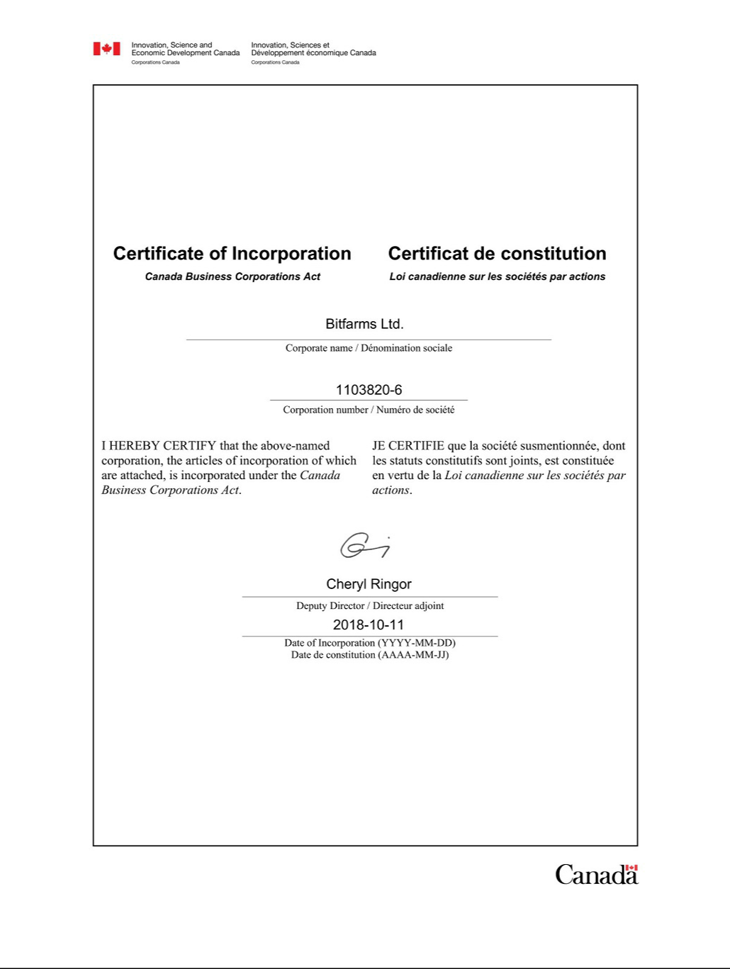

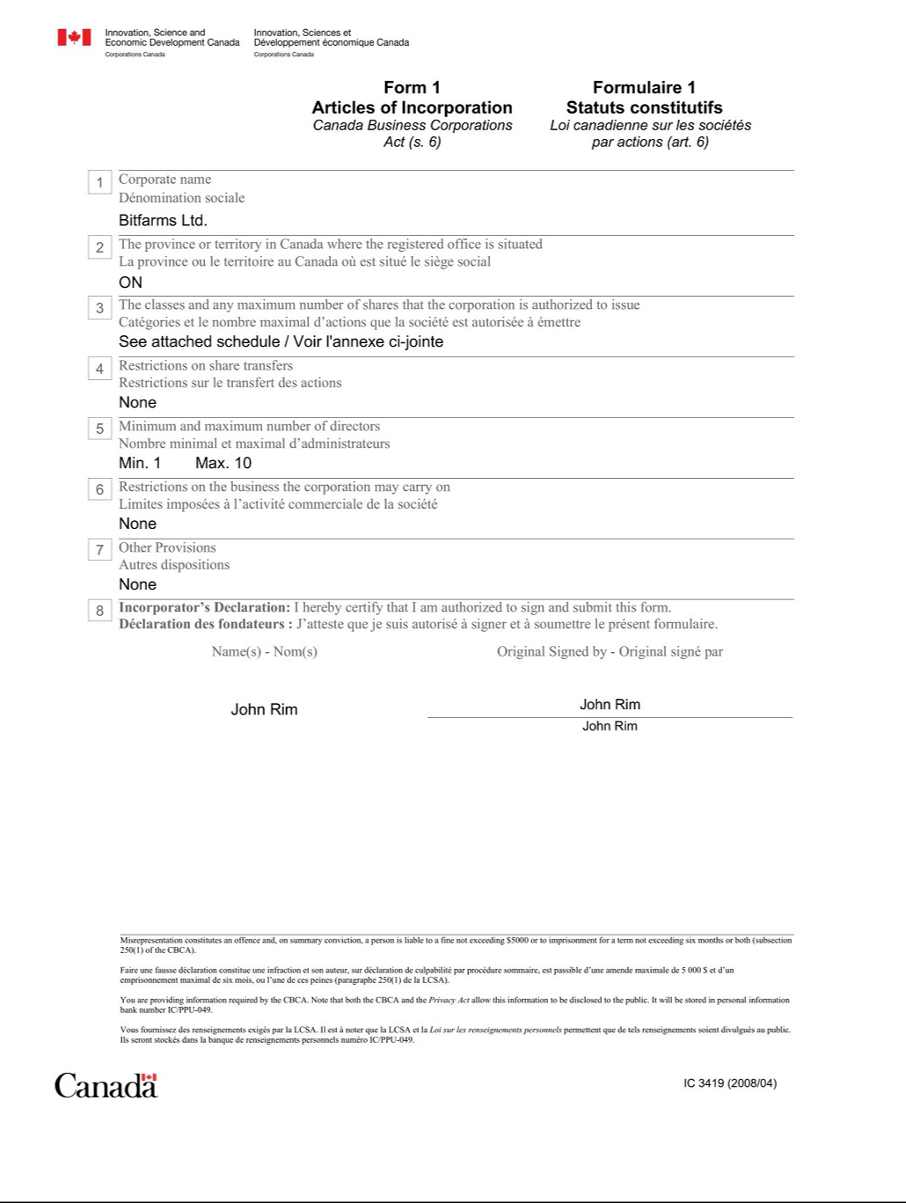

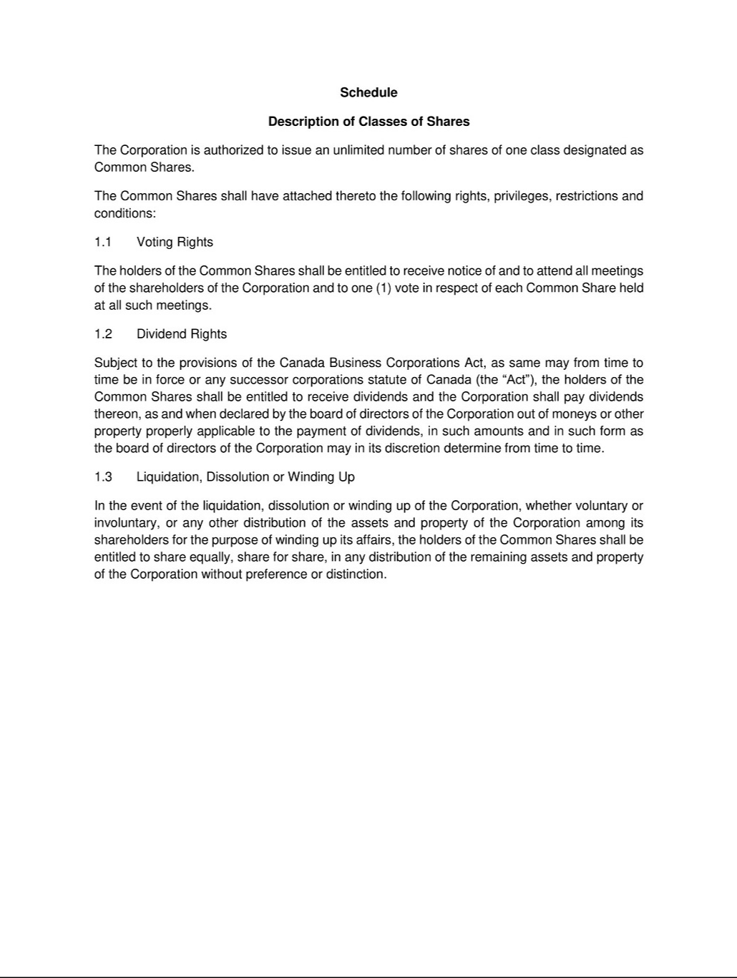

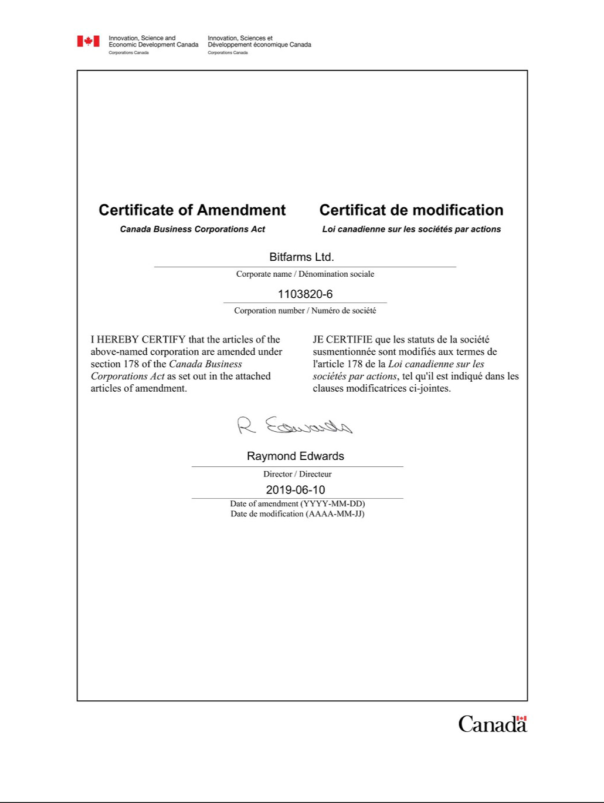

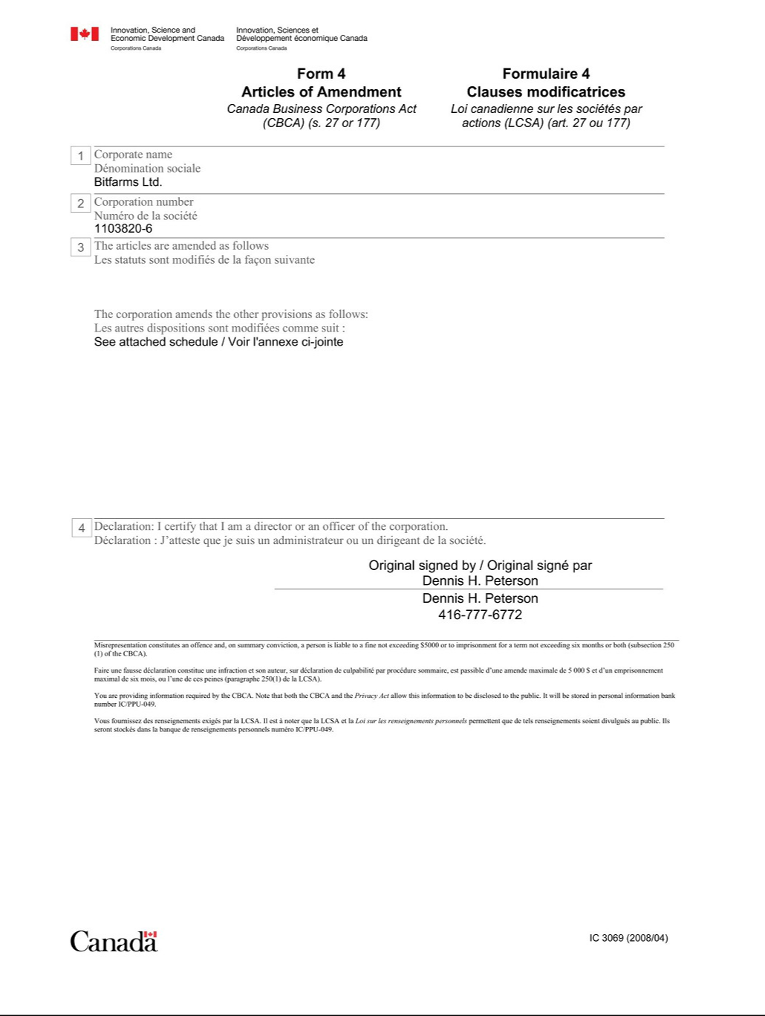



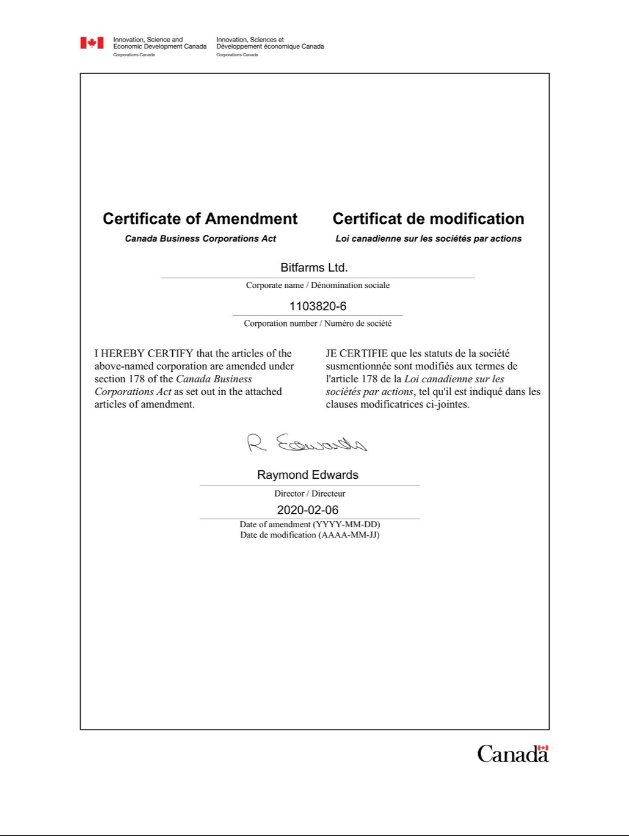

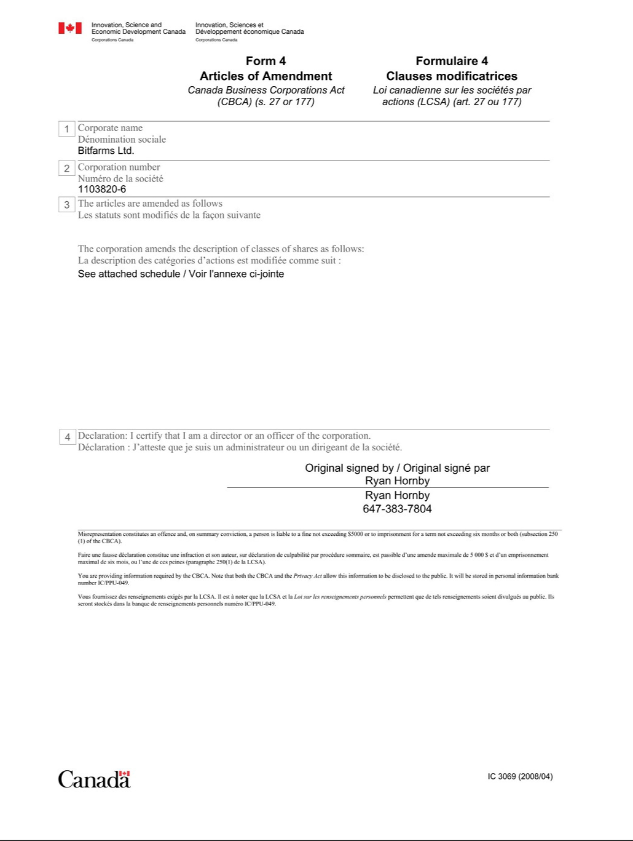

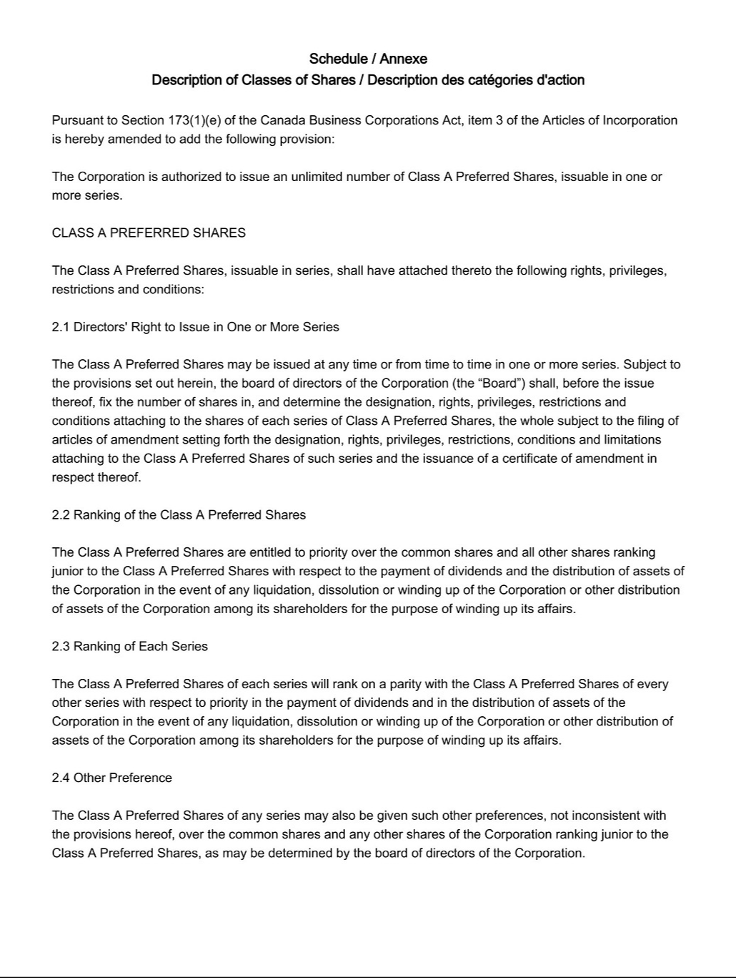

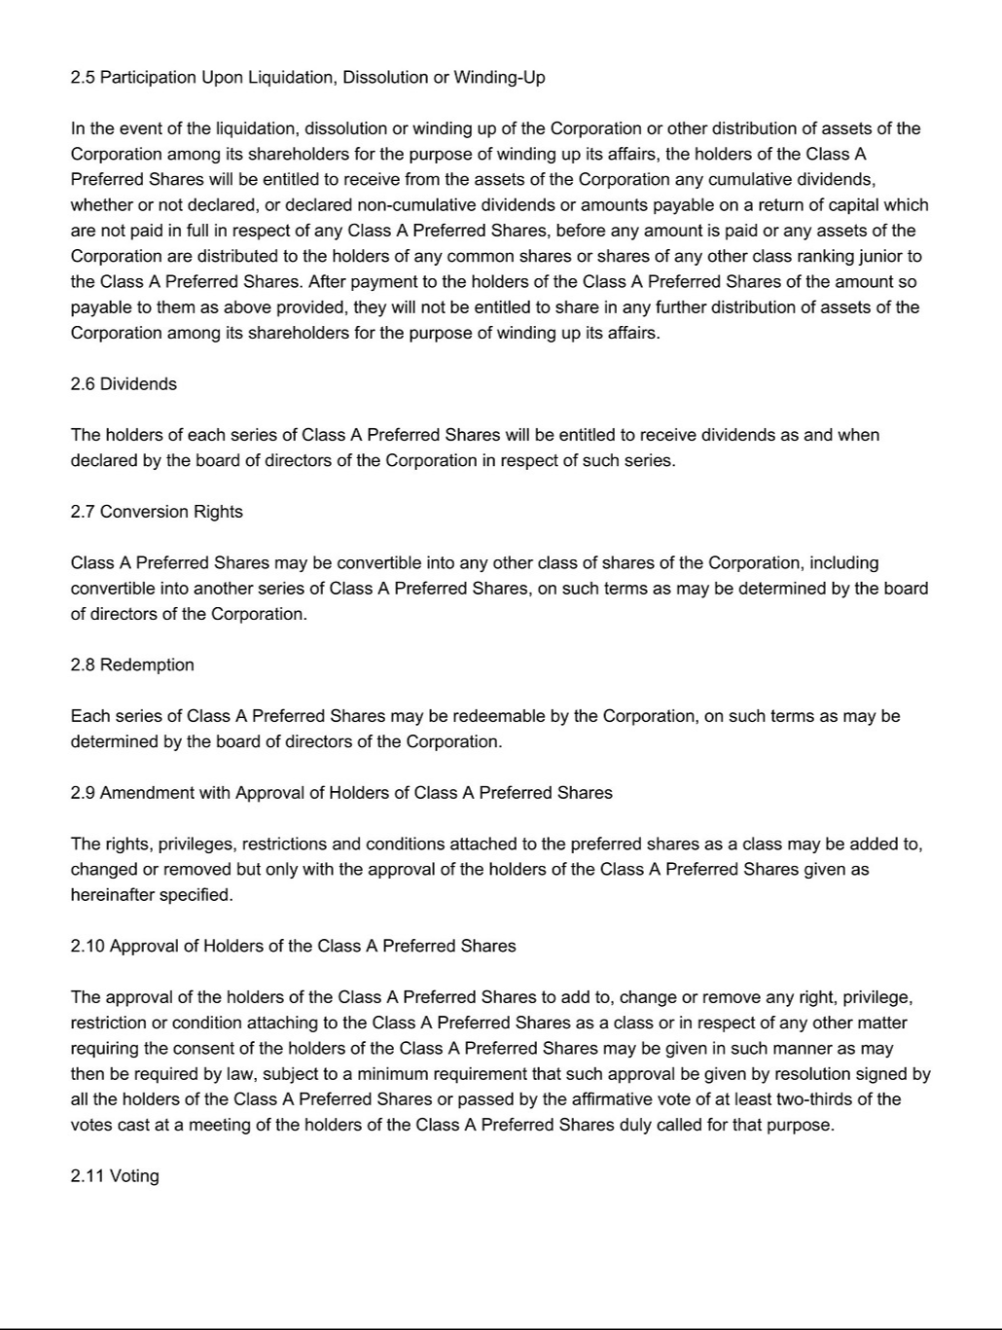



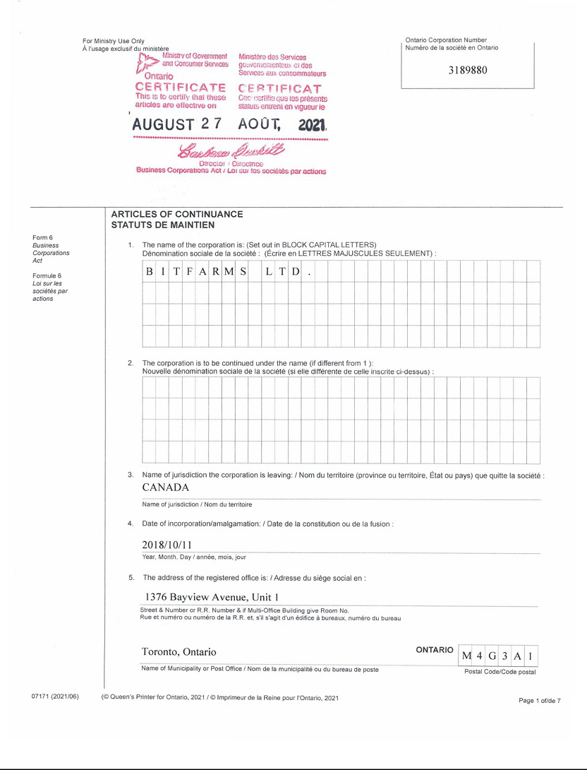

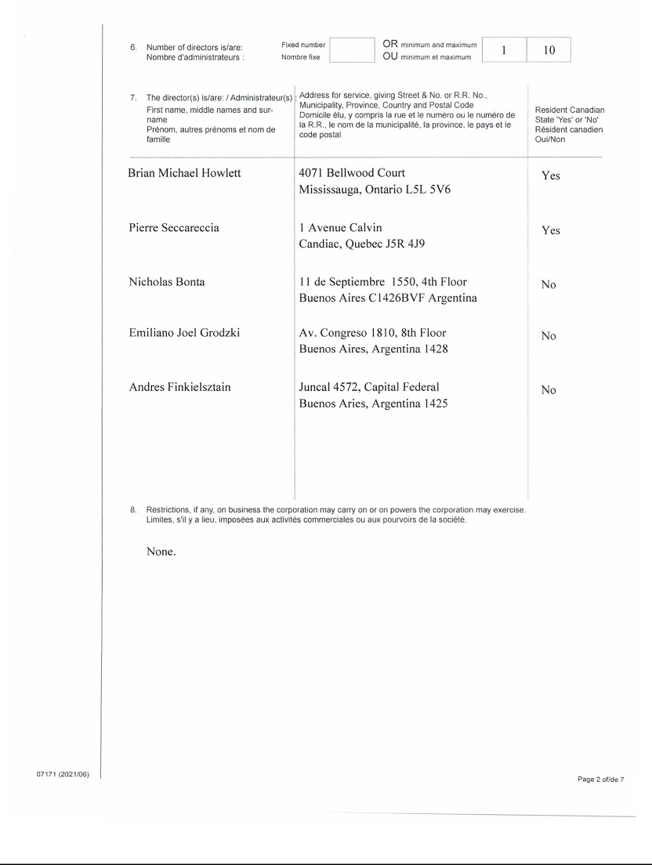





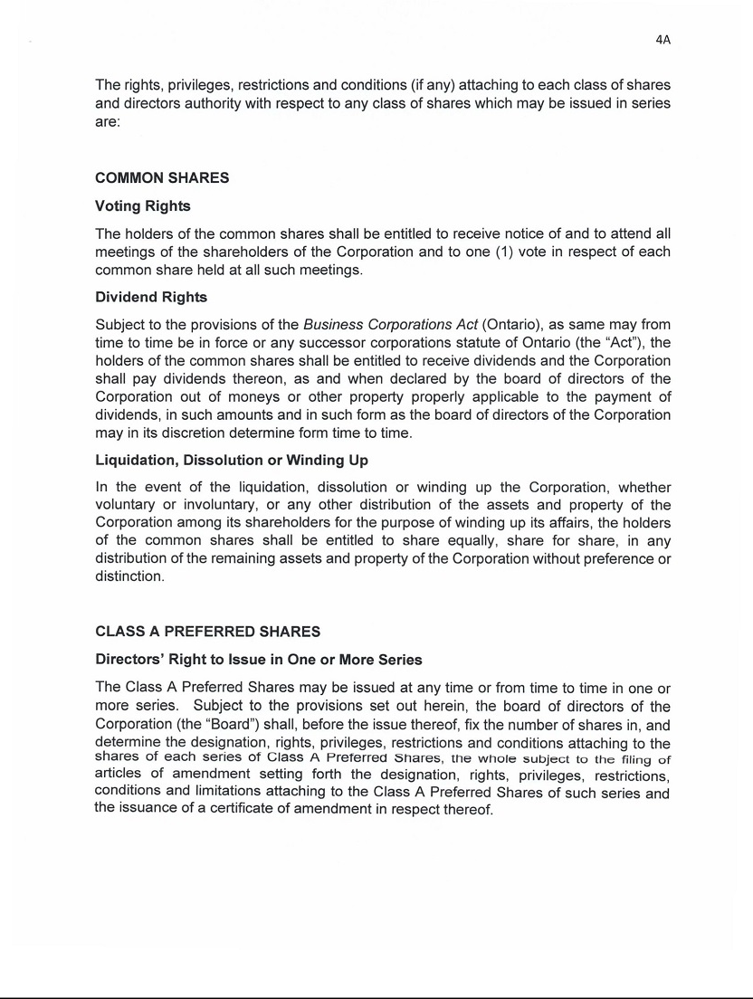

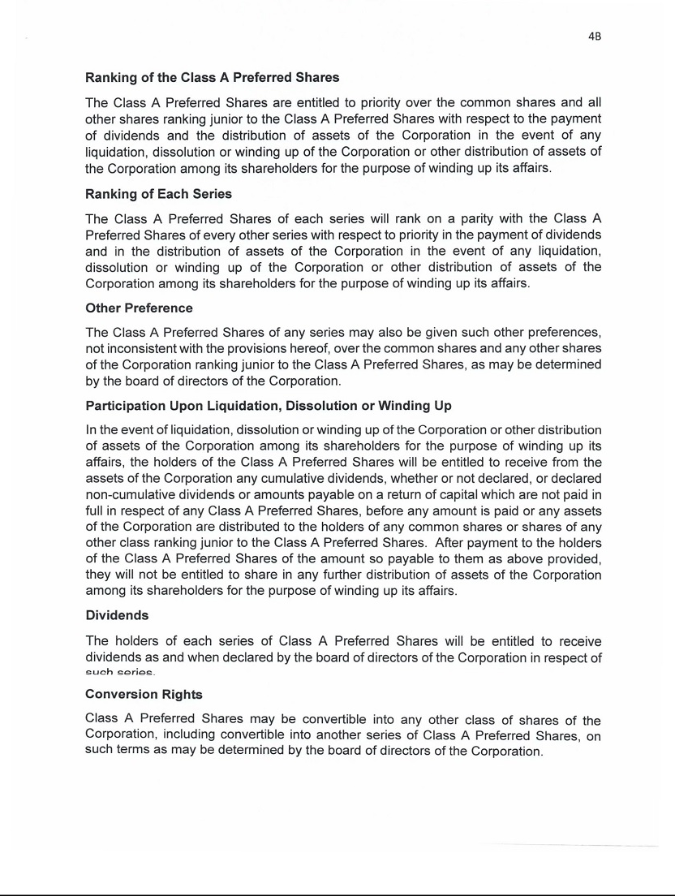

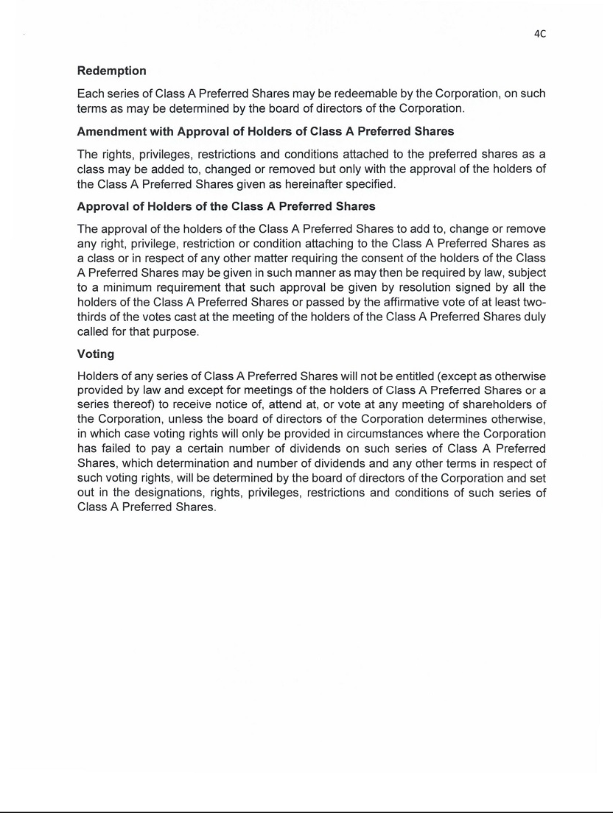





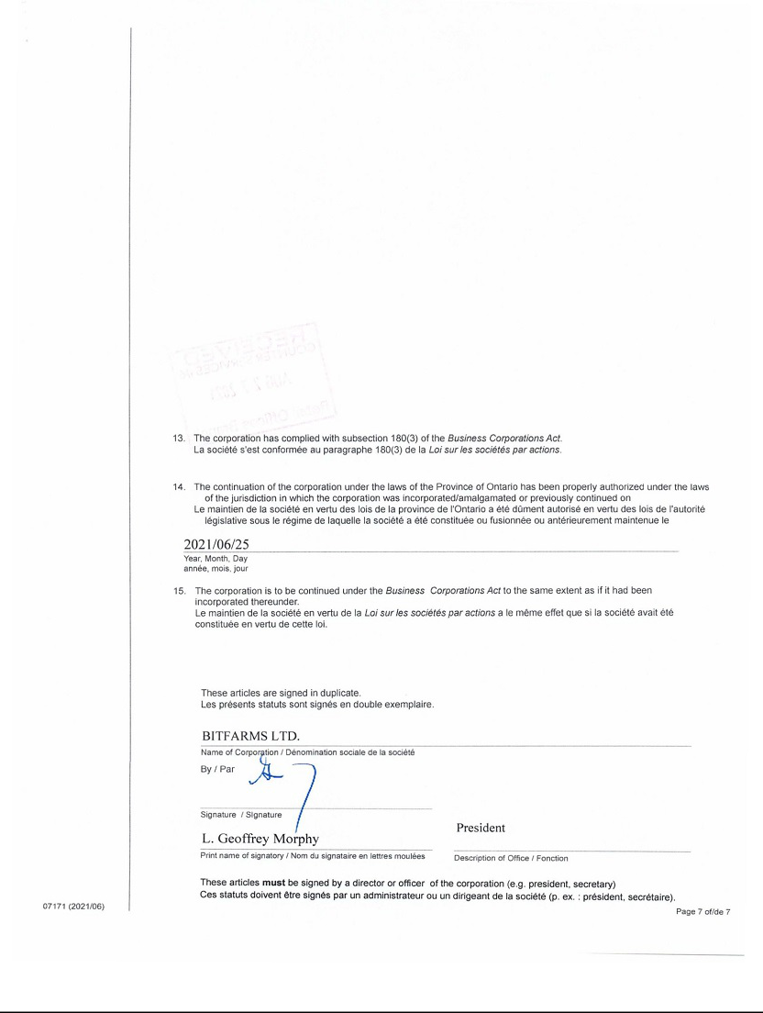

Exhibit 4.2

BY-LAW NO. 1

A by-law relating generally to the conduct of the business and affairs of

BITFARMS LTD.

(the “Corporation”)

C O N T E N T S

1. - Interpretation

- -General Business Matters

- -Meetings of Directors

- -Protection of Directors, Officers and Others

- -Meetings of Shareholders
8. | - | Shares
9. | - | Dividends
10. | - | Notices
- -Effective Date

BE IT ENACTED as a by-law of Bitfarms Ltd. as follows:

- INTERPRETATION

1.1 Definitions - In this by-law and all other by-laws and resolutions of the Corporation, unless the context otherwise requires:

“Act” means the Business Corporations Act (Ontario), including the Regulations made pursuant thereto, and any statute or regulations substituted therefor, as amended from time to time;

“appoint” includes “elect”, and vice versa

“articles” means the Articles of Incorporation and/or other constating documents of the Corporation as amended or restated from time to time;

“board” means the board of directors of the Corporation and “director” means a member of the board;

“by-laws” means this by-law and all other by-laws, including special by-laws, of the Corporation as amended from time to time and which are, from time to time, in force and effect;

“Corporation” means this Corporation, being the corporation to which the Articles pertain, and named “Bitfarms Ltd.”;

“meeting of shareholders” includes an annual meeting of shareholders and a special meeting of shareholders; “special meeting of shareholders” means a special meeting of all shareholders entitled to vote at an annual meeting of shareholders and a meeting of any class or classes of shareholders entitled to vote on the question at issue;

“recorded address” means, in the case of a shareholder, his address as recorded in the shareholders’ register; and in the case of joint shareholders, the address appearing in the shareholders’ register in respect of such joint holding or the first address so appearing if there is more than one; in the case of a director, officer, auditor or member of a committee of the board, his latest address as shown in the records of the Corporation or in the most recent notice filed under the Corporations Information Act, whichever is the more current. The secretary may change or cause to be changed the recorded address of any person in accordance with any information believed by him to be reliable.

1.2 Rules - In the interpretation of this by-law, unless the context otherwise requires, the following rules shall apply:

- Except where specifically defined herein, words, terms and expressions appearing in this by-law, including the terms “resident Canadian” and “unanimous shareholder agreement” shall have the meaning ascribed to them under the Act;

- Words importing the singular include the plural and vice versa;

- Words importing gender include the masculine, feminine and neuter genders;

- Words importing a person include an individual, sole proprietorship, partnership, unincorporated association, unincorporated syndicate, unincorporated organization, trust, body corporate, and a natural person in his capacity as trustee, executor, administrator, or other legal representative.

2

- GENERAL BUSINESS MATTERS

2.1 Registered Office - The shareholders may, by special resolution, from time to time change the municipality or geographic township within Ontario in which the registered office of the Corporation shall be located, but unless and until such special resolution has been passed, the registered office shall be where initially specified in the articles. The directors shall from time to time fix the location of the registered office within such municipality or geographic township.

2.2 Corporate Seal - The Corporation may, but need not, have a corporate seal; if adopted, such seal shall be in the form approved from time to time by the board.

2.3 Fiscal Year - Unless and until another date has been effectively determined, the fiscal year or financial year of the Corporation shall end on December 31st in each year.

2.4 Execution of Documents - Deeds, transfers, assignments, contracts, obligations and other instruments in writing requiring execution by the Corporation may be signed by any one officer or director.

Notwithstanding the foregoing, the board may from time to time direct the manner in which and the person or persons by whom a particular document or class of documents shall be executed. Any person authorized to sign any document may affix the corporate seal thereto.

2.5 Banking - All matters pertaining to the banking of the Corporation shall be transacted with such banks, trust companies or other financial organizations as the board may designate or authorize from time to time. All such banking business shall be transacted on behalf of the Corporation pursuant to such agreements, instructions and delegations of powers as may, from time to time, be prescribed by the board.

- DIRECTORS

3.1 Powers - Subject to the express provisions of a unanimous shareholder agreement, the directors shall manage or supervise the management of the business and affairs of the Corporation.

3.2 Transaction of Business - Business may be transacted by resolutions passed at meetings of directors or committees of directors at which a quorum is present or by resolution in writing, signed by all the directors entitled to vote on that resolution at a meeting of directors or a committee of directors. A copy of every such resolution in writing shall be kept with the minutes of the proceedings of the directors or committee of directors.

3.3 Number - Until changed in accordance with the Act, the board shall consist of that number of directors, being a minimum of one (1) and a maximum of ten (10), as determined from time to time by special resolution or, if the special resolution empowers the directors to determine the number, by resolution of the board.

3.4 Qualifications - Each director shall be an individual who is not less than 18 years of age. No person who is of unsound mind and has been so found by a court in Canada or elsewhere or who has the status of a bankrupt shall be a director. If a director acquires the status of a bankrupt or becomes of unsound mind and is so found, he shall thereupon cease to be a director. A director need not be a shareholder.

3

3.5 Election and Term - The election of directors shall take place at the first meeting of shareholders and at each annual meeting of shareholders and all the directors then in office shall retire, but, if qualified, shall be eligible for re-election. The number of directors to be elected at any such meeting shall be the number of directors then in office unless the directors or shareholders shall have otherwise determined in accordance with the Act. Where the shareholders adopt an amendment to the articles to increase the number or minimum number of directors, the shareholders may, at the meeting at which they adopt the amendment, elect the additional number of directors authorized by the amendment. The election shall be by resolution. If an election of directors is not held at the proper time, the incumbent directors shall continue in office until their successors are elected.

3.6 Resignation - A director who is not named in the articles may resign from office upon being giving a written resignation to the Corporation and such resignation becomes effective when received by the Corporation or at the time specified in the resignation, whichever is later. A director named in the articles shall not be permitted to resign his office unless at the time the resignation is to become effective a successor is elected or appointed.

3.7 Removal - Subject to the provisions of the Act, the shareholders may, by ordinary resolution passed at an annual or special meeting of shareholders, remove any director from office before the expiration of his term and may elect a qualified individual to fill the resulting vacancy for the remainder of the term of the director so removed, failing which such vacancy may be filled by the board. Notice of intention to pass such resolution shall be given in the notice calling the meeting.

3.8 Vacation of office - A director ceases to hold office when he dies, resigns, is removed from office by the shareholders, or becomes disqualified to serve as director.

3.9 Vacancies - Subject to the provisions of the Act, a vacancy on the board may be filled for the remainder of its term by a qualified individual by resolution of a quorum of the board. If there is not a quorum of directors or if a vacancy results from the failure to elect the number of directors required to be elected at any meeting of shareholders, the directors then in office shall forthwith call a special meeting of shareholders to fill the vacancy and, if they fail to call a meeting or if there are no directors then in office, the meeting may be called by any shareholder.

- MEETINGS OF DIRECTORS

4.1 Place of Meetings - Meetings of the board may be held at the registered office of the Corporation or at any other place within or outside of Ontario, and it is not necessary that, in any financial year of the Corporation, a majority of such meetings be held in Canada.

4.2 Participation by Telephone - With the unanimous consent of all of the directors present at or participating in the meeting, a director may participate in a meeting of the board or in a meeting of a committee of directors by means of such telephone, electronic or other communication facilities as permit all persons participating in the meeting to communicate with each other simultaneously and instantaneously, and a director participating in such a meeting by such means is deemed for the purposes of the Act and this by-law to be present at that meeting. A consent pursuant to this provision may be given before or after the meeting to which it relates and may be a “blanket” consent, relating to all meetings of the board and/or committees of the board and need not be in writing.

4

4.3 Calling of Meetings - In addition to any other provisions in the articles or by-laws of a Corporation for calling meetings of directors, a quorum of the directors may, at any time, call a meeting of any business, the general nature of which is specified in the notice calling the meeting. Where the Corporation has only one director, that director may constitute a meeting.

4.4 Notice of Meeting - Notice of the time and place for the holding of a meeting of the board shall be given to every director of the Corporation not less than two clear days (excluding Sundays and holidays as defined by the Interpretation Act) before the date of the meeting. Notwithstanding the foregoing, notice of a meeting shall not be necessary if all of the directors are present, and none objects to the holding of the meeting, or if those absent have waived notice of or have otherwise signified their consent to the holding of such meeting. Notice of an adjourned meeting is not required if the time and place of the adjourned meeting is announced at the original meeting.

4.5 First Meeting of New Board - Provided that a quorum of directors is present, a newly elected board may, without notice, hold its first meeting immediately following the meeting of shareholders at which such board is elected.

4.6 Regular Meetings - The board may appoint a day or days in any month or months for regular meetings of the board at a place and hour to be named. A copy of any resolution of the board fixing the place and time of such regular meetings of the board shall be sent to each director forthwith after being passed, but no other notice shall be required for any such regular meeting except where the Act requires the purpose thereof or the business to be transacted thereat to be specified.

4.7 Quorum - A majority of the directors elected to office constitutes a quorum at any meeting of the board.

4.8 Chairman - The Chairman of any meeting of the board shall be the first mentioned of such of the following officers as have been appointed and who is a director and is present at the meeting:

Chairman of the Board

President,

A Vice-President, or

Managing Director

If no such officer is present, the directors present shall choose one of their number to be Chairman of such meeting.

5

4.9 Votes to Govern - At all meetings of the board, every question shall be decided by a majority of the votes cast on the question; and in the case of an equality of votes, the Chairman of the meeting shall not be entitled to a second or casting vote.

4.10 Disclosure- Conflict of Interest - A director or officer of the Corporation who is a party to, or who is a director or an officer of, or has a material interest in any person who is a party to, a material contract or transaction or proposed material contract or transaction with the Corporation, shall disclose in writing to the Corporation or request to have entered in the minutes of meetings of directors the nature and extent of his interest. Disclosure, as aforesaid, shall be made at the time and in the manner required by the Act, and a director so having an interest in a contract or transaction shall, unless expressly permitted by the Act, not vote on any resolution to approve the contract or transaction.

4.11 Delegation by Directors (Committees) - The board may appoint from their number a managing director, or a committee of directors, and delegate to such managing director or committee any of the powers of the board except those which relate to matters over which a managing director or committee shall, pursuant to the Act, not have authority. Unless otherwise determined by the board, a committee shall have the power to fix its quorum at not less than a majority of its members, to elect its chairman and to regulate its procedure.

4.8 Remuneration and Expenses - Subject to the articles and any unanimous shareholder agreement, the board may fix the remuneration of the directors, which remuneration shall be in addition to any remuneration which may be payable to a director who serves the Corporation in any other capacity. The directors shall also be entitled to be reimbursed for travelling and other expenses properly incurred by them in attending meetings of the board, committees or shareholders and for such other out-of-pocket expenses incurred in respect of the performance of their duties as the board may from time to time determine.

- OFFICERS

5.1 Appointment - The board may from time to time designate the offices of the Corporation, appoint officers (and assistants to officers), specify their duties and, subject to the Act or the provisions of any unanimous shareholder agreement, delegate to such officers powers to manage the business and affairs of the Corporation. A director may be appointed to any office of the Corporation. Except for the chairman of the board and the managing director, an officer may but need not be a director. Two or more offices may be held by the same person.

5.2 Term of Office (Removal) - In the absence of a written agreement to the contrary, the board may remove, whether for cause or without cause, any officer of the Corporation. Unless so removed, an officer shall hold office until his successor is appointed or until his resignation, whichever shall first occur.

6

5.3 Terms of Employment, Duties and Remuneration - The terms of employment and remuneration of all officers elected or appointed by the board shall be determined from time to time and may be varied from time to time by the board. The fact that any officer or employee is a director or shareholder of the Corporation shall not disqualify him from receiving such remuneration as may be determined. All officers, in the absence of agreement to the contrary, shall be subject to removal by resolution of the Board of Directors at any time, with or without cause.

5.4 Description of Offices - Unless otherwise specified by the board (which may, subject to the Act, modify, restrict or supplement such duties and powers), the offices of the Corporation, if designated and if officers are appointed thereto, shall have the following duties and powers associated therewith:

- Chairman of the Board - The chairman of the board, if one is to be appointed, shall be a director. The board may assign to him any of the powers and duties which, pursuant to the by-laws, are capable of being assigned to the managing director or to the president. During the absence or disability of the Chairman of the Board, the President shall assume all his powers and duties.

- Managing Director - The managing director, if one is to be appointed, shall exercise such powers and have such authority as may be delegated to him by the Board in accordance with the provisions of Section 127 of the Act.

- President - The President shall be the chief executive officer of the Corporation unless otherwise determined by resolution of the Board of Directors and shall have responsibility for the general management and direction of the business and affairs of the Corporation, subject to the authority of the Board of Directors. Where no Chairman of the Board is elected or during the absence or inability to act of Chairman of the Board, the President, when present, shall preside at all meetings of shareholders, and if he is a director, at all meetings of the Board of Directors or meetings of a committee of directors;

- Vice-President - During the absence or inability of the President, his duties may be performed and his powers may be exercised by the Vice-President, or if there are more than one, by the Vice-President in order of seniority (as determined by the Board of Directors) save that no Vice-President shall preside at a meeting of the Board of Directors or at a meeting of shareholders who is not qualified to attend the meeting as a director or shareholder, as the case may be. A Vice-President shall also perform such duties and exercise such powers as the President may from time to time delegate to him or as the Board of Directors may prescribe;

- General Manager - The General Manager, if one be appointed, shall have the responsibility for the general management, and direction, subject to the authority of the Board of Directors and the supervision of the President, of the Corporation’s business and affairs and the power to appoint and remove any and all officers, employees and agents of the Corporation not appointed directly by the Board of Directors and to settle the terms of their employment and remuneration.

7

- Secretary - The secretary, when in attendance, shall be the secretary of all meetings of the board, shareholders and committees of the board and, whether or not he attends, the secretary shall enter or cause to be entered in the Corporation’s minute book, minutes of all proceedings at such meetings; he shall give, or cause to be given, as and when instructed, notices to shareholders, directors, auditors and members of committees; he shall be the custodian of the corporate seal as well as all books, papers, records, documents and other instruments belonging to the Corporation. He shall perform such other duties as may from time to time be prescribed by the Board of Directors;

- Treasurer - The treasurer shall be responsible for the maintenance of proper accounting records in compliance with the Act as well as the deposit of money, the safekeeping of securities and the disbursement of funds of the Corporation; whenever required, he shall render to the board an account of his transactions as treasurer and of the financial position of the Corporation.

The duties of all other officers of the Corporation shall be such as the terms of their engagement call for or the board requires of them. Any of the powers and duties of an officer to whom an assistant has been appointed may be exercised and performed by such assistant, unless the board otherwise directs.

5.5 Vacancies - If the office of the Chairman of the Board, Managing Director, President, Vice-President, Secretary, Assistant Secretary, Treasurer, Assistant Secretary, or any one of such offices, or any other office shall be or become vacant by reason of death, resignation, disqualification or otherwise, the Board of Directors by resolution shall in the case of the President or Secretary, and may in the case of any other office, appoint a person to fill such vacancy.

5.6 Agents and Attorneys - The board shall have power from time to time to appoint agents or attorneys for the Corporation in or out of Ontario with such powers of management, administration or otherwise (including the power to sub-delegate) as the board considers fit.

5.7 Disclosure- Conflict of Interest - An officer shall have the same duty to disclose his interest in a material contract or transaction or proposed material contract or transaction with the Corporation, as is, pursuant to the provisions of the Act and the by-laws, imposed upon directors.

8

- PROTECTION OF DIRECTORS, OFFICERS AND OTHERS

6.1 Standard of Care - Every director and officer of the Corporation in exercising his powers and discharging his duties shall act honestly and in good faith with a view to the best interests of the Corporation and shall exercise the care, diligence and skill that a reasonably prudent person would exercise in comparable circumstances. Every director and officer of the Corporation shall comply with the Act, the regulations, articles, by-laws and any unanimous shareholder agreement.

6.2 Limitation of Liability - Provided that the standard of care required of him has been satisfied, no director or officer shall be liable for the acts, receipts, neglects or defaults of any other director or officer or employee, or for joining in any receipt or other act for conformity, or for any loss, damage or expense happening to the Corporation through the insufficiency or deficiency of title to any property acquired for or on behalf of the Corporation, or for the insufficiency or deficiency of any security in or upon which any of the monies of the Corporation shall be invested, or for any loss or damage arising from the bankruptcy, insolvency or tortious acts of any person with whom any of the monies, securities or effects of the Corporation shall be deposited, or for any loss occasioned by any error of judgment or oversight on his part, or for any other loss, damage or misfortune which shall happen in the execution of the duties of his office or in relation thereto, unless the same are occasioned by his own willful neglect or default.

6.3 Indemnity of Directors and Officers - Subject to the Act, the Corporation shall indemnify a director or officer of the Corporation, a former director of officer of the Corporation or a person who acts or acted at the Corporation’s request as a director or officer of a body corporate of which the Corporation is or was a shareholder or creditor, and their heirs and legal representatives, against all costs, charges and expenses, including an amount paid to settle an action or satisfy a judgment, reasonably incurred by him in respect of any civil, criminal administrative, investigative or other action or proceeding to which he is made a party by reason of being or having been a director or officer of such corporation or body corporate if,

- they acted honestly and in good faith with a view to the best interests of the Corporation; and

- in the case of a criminal or administrative action or proceeding that is enforced by a monetary penalty, he had reasonable grounds for believing that his conduct was lawful.

The Corporation shall indemnify such person in all such other matters, actions, proceedings and circumstances as may be permitted by the Act or the law.

6.4 Insurance - Subject to the Act, the Corporation may purchase and maintain such insurance for the benefit of any person entitled to be indemnified by the Corporation pursuant to the immediately preceding section as the board may from time to time determine.

9

- MEETINGS OF SHAREHOLDERS

7.1 Annual Meetings - The board shall call, at such date and time as it determines, the first annual meeting of shareholders not later than eighteen months after the Corporation comes into existence and thereafter not later than fifteen months after holding the last preceding annual meeting, so as to consider the financial statements and reports required by the Act to be presented thereat, to elect directors, appoint auditors and to transact such other business as may properly be brought before the meeting.

7.2 Special Meetings - The board, the chairman of the board, the managing director or the president may at any time call a special meeting of shareholders for the transaction of any business which may properly be brought before such meeting of shareholders.

7.3 Place of Meetings - Meetings of shareholders shall be held at such place in or outside Ontario as the board determines or, in the absence of such a determination, at the place where the registered office of the Corporation is located.

7.4 Special Business - All business transacted at a special meeting or an annual meeting of shareholders, except consideration of the minutes of an earlier meeting, the financial statements and auditor’s report, election of directors and reappointment of the incumbent auditor constitutes special business.

7.5 Notice of Meetings - Notice of the time and place of a meeting of shareholders shall be sent not less than 10 days, or if the Corporation is an offering corporation, not less than twenty-one (21) days, but in either case not more than 50 days before the date of the meeting:

- to each shareholder entitled to vote at the meeting (according to the records of the Corporation at the close of business on the day preceding the giving of the notice);

- to each director; and

- to the auditor of the Corporation.

A meeting of shareholders may be held at any time without notice if all the shareholders entitled to vote thereat are present or represented by proxy and do not object to the holding of the meeting or those not so present by proxy have waived notice, if all the directors are present or have waived notice of or otherwise consent to the meeting and if the auditor, if any, is present or has waived notice of or otherwise consents to the meeting.

Notice of a meeting of shareholders at which special business is to be transacted shall state:

- the nature of that business in sufficient detail to permit the shareholder to form a reasoned judgment thereon; and

- the text of any special resolution or by-law to be submitted to the meeting.

In the event of the adjournment of a meeting, notice, if any is required, shall be given in accordance with the provisions of the Act.

7.6 Waiving Notice - A shareholder and any other person entitled to attend a meeting of shareholders may in any manner and at any time waive notice of a meeting of shareholders, and attendance of any such person at a meeting of shareholders is a waiver of notice of the meeting, except where such person attends a meeting for the express purpose of objecting to the transaction of any business on the grounds that the meeting is not lawfully called.

10

7.7 Persons Entitled to be Present - The only persons entitled to be present at a meeting of shareholders shall be those entitled to vote thereat, the directors and the auditor of the Corporation, if any and such other persons who are entitled or required under any provision of the Act, articles or by-laws of the Corporation to be present at the meeting. Any other person may be admitted only on the invitation of the chairman of the meeting or with the consent of the meeting.

7.8 Quorum - Two holders of shares entitled to vote at a meeting of shareholders, whether present in person or represented by proxy, constitute a quorum for the transaction of business at any meeting of shareholders. If a quorum is present at the opening of a meeting of shareholders, the shareholders present may proceed with the business of the meeting even if a quorum is not present throughout the meeting. If the Corporation has only one shareholder, or only one holder of any class or series of shares, the shareholder present in person or by proxy constitutes a meeting.

7.9 Right to Vote - Unless the articles otherwise provide, each share of the Corporation entitles the holder thereof to one vote at a meeting of shareholders. At each meeting of shareholders every shareholder shall be entitled to vote who is entered on the books of the Corporation as a holder of one or more shares carrying the right to vote at such meeting in accordance with a shareholder list which, in the case of a record date, shall be a list of those registered at the close of business on that record date, and where there is no record date, at the close of business on the day immediately preceding the day on which notice is given or, where no notice is given, those registered on the day on which the meeting is held. When a share or shares have been mortgaged or hypothecated, the person who mortgaged or hypothecated such share or shares (or his proxy) may nevertheless represent the shares at meetings and vote in respect thereof unless in the instrument creating the mortgage or hypothec, he has expressly empowered the holder of such mortgage or hypothec to vote thereon, in which case such holder (or his proxy) may attend meetings to vote in respect of such shares upon filing with the Secretary of the meeting sufficient proof of the terms of such instrument.

7.10 Representatives - An executor, administrator, committee of a mentally incompetent person, guardian or trustee and where a Corporation is such executor, administrator, committee, guardian or trustee, any person duly a proxy appointed for such corporation, upon filing with the secretary of the meeting sufficient proof of his appointment, shall represent the shares in his or its hands at all meetings of the shareholders of the Corporation and may vote accordingly as a shareholder in the same manner and to the same extent as the shareholder of record. Where two or more persons hold the same share or shares jointly, any one of such persons present at a meeting of shareholders has the right, in the absence of the other or others, to vote in respect of such share or shares but if more than one of such persons are present or represented by proxy and vote, they shall vote together as one on the share or shares jointly held by them.

7.11 Scrutineers - At each meeting of shareholders one or more scrutineers may be appointed by a resolution of the meeting or by the Chairman with the consent of the meeting to serve at the meeting. Such scrutineers need not be shareholders of the Corporation.

11

7.12 Proxies - Every shareholder entitled to vote at a meeting of shareholders may by means of a proxy appoint a proxyholder or one or more alternate proxyholders who need not be shareholders, as the shareholder’s nominee to attend and act at the meeting in the manner, to the extent and with the authority conferred by the proxy. A proxy shall be in writing, shall be executed by the shareholder or by his attorney authorized in writing or, if the shareholder is a body corporate, by an officer or attorney thereof duly authorized, and shall cease to be valid after the expiration of one year from the date thereof. The instrument appointing a proxy shall comply with the provisions of the Act and regulations thereto and shall be in such form as the Board of Directors may from time to time prescribe or in such other form as the Chairman of the meeting may accept as sufficient and shall be deposited with the Secretary of the meeting before any vote is cast under its authority, or at such earlier time and in such manner as the Board of Directors may prescribe in accordance with the Act.

7.13 Time for Deposit of Proxies - The Corporation shall recognize a proxy only if it has been deposited with the Corporation and it shall be so deposited before any vote is taken under its authority, or at such earlier time as the board, in compliance with the Act, prescribes and which has been specified in the notice calling the meeting.

7.14 Corporate Shareholders and Associations - As an alternative to depositing a proxy, a body corporate or an association may deposit a certified copy of a resolution of its directors or governing body authorizing an individual to represent it at meetings of shareholders of the Corporation.

7.15 Joint Shareholders - Where two or more persons hold shares jointly, one of those holders present at a meeting of shareholders may in the absence of the others vote the shares, but if two or more of those persons are present, in person or by proxy, they shall vote as one on the shares jointly held by them.

7.16 Votes to Govern - Subject to the Act, the articles, the by-laws and any unanimous shareholder agreement, all questions proposed for the consideration of the shareholders shall be determined by a majority of the votes cast thereon and, in case of an equality of votes, the chairman of the meeting shall not have a second or casting vote.

7.17 Show of Hands - Except where a ballot is demanded as hereafter set out, voting on any question proposed for consideration at a meeting of shareholders shall be by show of hands, and a declaration by the chairman as to whether or not the question or motion has been carried and an entry to that effect in the minutes of the meeting shall, in the absence of evidence to the contrary, be evidence of the fact without proof of the number or proportion of the votes recorded in favour of or against the motion.

7.18 Ballots - For any question proposed for consideration at a meeting of shareholders, either before or after a vote by show of hands has been taken, the chairman, or any shareholder or proxyholder may demand a ballot, in which case the ballot shall be taken in such manner as the chairman directs and the decision of the shareholders on the question shall be determined by the result of such ballot.

12

7.19 Resolution in Lieu of Meeting - Except where, pursuant to the Act, a written statement is submitted to the Corporation by a director or representations in writing are submitted to the Corporation by an auditor:

- a resolution in writing signed by all the shareholders entitled to vote on that resolution at a meeting of shareholders is as valid as if it had been passed at a meeting of the shareholders; and

- a resolution in writing dealing with all matters required by the Act to be dealt with at a meeting of shareholders, and signed by all the shareholders entitled to vote at that meeting, satisfies all the requirements of the Act relating to that meeting of shareholders.

7.20 One Shareholder - Where the Corporation has only one shareholder, all business which the Corporation may transact at an annual or special meeting of shareholders shall be transacted in the manner provided for in paragraph 7.19 hereof.

7.21 Adjournment - The Chairman of the meeting of shareholders may, with the consent of the meeting and subject to such conditions as the meeting may decide, or where otherwise permitted under the provisions of the Act, adjourn the meeting from time to time and from place to place.

- SHARES

8.1 Allotment - Subject to the Act, the articles and any unanimous shareholder agreement, the board may from time to time issue, allot or grant options to purchase the whole or any part of the authorized and unissued shares of the Corporation, at such times and to such persons and for such consideration as the board shall determine, provided that no share shall be issued until it is fully paid as provided by the Act.

8.2 Share Certificates - Share certificates and the form of stock transfer power shall be in such form as the board shall from time to time approve and shall be signed by the Chairman of the Board or the President or a Vice-President and the Secretary or Assistant Secretary holding office at the time of signing. Every shareholder of the Corporation is entitled upon request to a share certificate or to a non-transferable written acknowledgment of his right to obtain a share certificate in respect of the shares held by him.

Unless otherwise provided in the Articles, the Board may provide by resolution that all or any classes and series of shares or other securities shall be uncertified securities, provided that such resolution shall not apply to securities represented by a certificate until such certificate is surrendered to the Corporation.

13

The signature of the Chairman of the Board, the Vice-Chairman of the Board, the President or a Vice-President may be printed, engraved, lithographed or otherwise mechanically reproduced upon certificates for shares of the Corporation. Certificates so signed shall be deemed to have been manually signed by the Chairman of the Board, the Vice-Chairman of the Board, the President or the Vice-President whose signature is so printed, engraved, lithographed or otherwise mechanically reproduced thereon and shall be as valid to all intents and purposes as if they had been signed manually. Where the Corporation has appointed a trustee, registrar, transfer agent, branch transfer agent or other authenticating agent, for the shares of the Corporation the signature of the Secretary or Assistant Secretary may also be printed, engraved, lithographed or otherwise mechanically reproduced on certificates representing the shares (or the shares of the class or classes in respect of which any such appointment has been made) of the Corporation and when countersigned by or on behalf of a trustee, registrar, transfer agent, branch transfer agent or other authenticating agent such certificates so signed shall be as valid to all intents and purposes as if they had been signed manually. A share certificate containing the signature of a person which is printed, engraved, lithographed or otherwise mechanically reproduced thereon may be issued notwithstanding that the person has ceased to be an officer of the Corporation and shall be as valid as if he were an officer at the date of its issue.

8.3 Joint Shareholders - If two or more persons are registered as joint holders of any share, it shall be sufficient for the Corporation to issue one certificate in respect thereof and it shall also be sufficient for the Corporation to accept, from any one of such persons, receipts for the certificate or for any dividend, bonus, return of capital or other money payable or warrant issuable in respect of such share.

8.4 Deceased Shareholders - In the event of the death of a shareholder, the Corporation shall not be required to make an entry in its records in respect of such death and nor shall it be required to make any dividend or other payment in respect of such shares until such documents have been produced to the Corporation as are required by the Act and the law and as are reasonably required by the Corporation and its transfer agents.

8.5 Replacement of Share Certificates - Subject to the Act, the board may prescribe, either generally or for a particular instance, the conditions upon which a new share certificate may be issued to replace a share certificate which has been or is claimed to have been defaced, lost, stolen or destroyed.

8.6 Payment of Commission - The board may, from time to time, authorize the Corporation to pay a reasonable commission to any person in consideration of his purchasing or agreeing to purchase shares of the Corporation from the Corporation or from any other person, or for procuring or agreeing to procure purchasers for any such shares.

8.7 Lien for Indebtedness - Subject to the Act, the Corporation has a lien on shares registered in the name of a shareholder or his legal representative for a debt of that shareholder to the Corporation which lien may be enforced, subject to the articles and to any unanimous shareholder agreement, by the sale of such shares or by any other proceeding or remedy available by law to the Corporation and, until such indebtedness has been satisfied, the Corporation may refuse to register a transfer of any such shares.

8.8 Central Securities Register - A securities register and the register of transfers of the Corporation shall be kept at the registered office of the Corporation or such other office or place in Ontario as may from time to time be designated by resolution of the Board of Directors and a branch securities register or registers of transfers may be kept at such office or offices of the Corporation or other place or places, either in or outside Ontario, as may from time to time be designated by resolution of the Board of Directors.

8.9 Transfer of Securities - No transfer of shares shall be recorded or registered unless or until the certificate representing the shares to be transferred has been surrendered and cancelled.

14

- DIVIDENDS

9.1 Declaration - Subject to the Act, the articles and any unanimous shareholder agreement, the board may declare and the Corporation may pay dividends to the shareholders according to their respective rights and interests in the Corporation. Any such dividend may be paid by issuing fully paid shares of the Corporation or options or rights to acquire fully paid shares of the Corporation or, subject to the Act, the Corporation may pay a dividend in money or property.

9.2 Payment - A dividend payable in money shall be paid by cheque to the order of each registered holder of shares of the class or series in respect of which it has been declared and, unless the shareholder otherwise directs, mailed by prepaid ordinary mail to such registered holder at his last address appearing on the records of the Corporation. In the case of joint shareholders, unless they otherwise direct, the cheque shall be made payable to the order of all of such joint holders and mailed by prepaid ordinary mail to them at the address appearing on the records of the Corporation for them or, if addresses appear for more than one such joint holder, it shall be mailed to the first address so appearing. The mailing of such cheque as aforesaid, unless it is not honoured on presentation, shall satisfy and discharge the liability for the dividend to the extent of the aggregate of the sum represented by such cheque plus the amount of any tax which the Corporation is required to and does withhold. The board may prescribe, either generally or for a particular instance, the terms as to indemnity, reimbursement of expenses and evidence of non-receipt, upon which a replacement cheque may be issued to a person to whom a dividend cheque was sent and who claims that such cheque was not received or has been defaced, lost, stolen or destroyed.

- NOTICES

10.1 Method of Giving Notices - Any notice, communication or other document required to be given by the Corporation to a shareholder, director, officer, member of a committee of the board or auditor of the Corporation pursuant to the Act, the regulations, the articles or by-laws or otherwise shall be sufficiently given to such person if:

- delivered personally to him, in which case it shall be deemed to have been given when so delivered;

- delivered to his recorded address, in which case it shall be deemed to have been given when so delivered;

15

- mailed to him at his recorded address by prepaid ordinary mail, in which case it shall be deemed to have been given on the fifth day after it is deposited in a post office or public letter box; or

- sent to him at his recorded address by any means of prepaid transmitted or recorded communication, in which case it shall be deemed to have been given when dispatched or delivered to the appropriate communication company or agency or its representative for dispatch.

If a notice or document is sent to a shareholder by prepaid mail in accordance with this paragraph and the notice or document is returned on three consecutive occasions because the shareholder cannot be found, it shall not be necessary to send any further notices or documents to the shareholder until he informs the Corporation in writing of his new address.

10.2 Notice to Joint Shareholders - Notice required to be given to a shareholder where two or more persons are registered as joint holders of any share shall be sufficiently given to all of them if given to any one of them.

10.3 Notices Given to Predecessors - Every person who by transfer, death of a shareholder, operation of law or otherwise becomes entitled to shares, is bound by every notice in respect of such shares which was duly given to the registered holder of such shares from whom his title is derived prior to entry of his name and address in the records of the Corporation and prior to his providing to the Corporation the proof of authority or evidence of his entitlement as prescribed by the Act.

10.4 Computation of Time - In computing the date when notice must be given under any provision requiring a specified number of days’ notice of any meeting or other event, the date of giving the notice and the date of the meeting or other event shall be excluded.

10.5 Omissions and Errors - The accidental omission to give any notice to any shareholder, director, officer, member of a committee of the board or auditor, or the non-receipt of any notice by any such person or any error in any notice not affecting its substance shall not invalidate any action taken at any meeting to which the notice pertained or otherwise founded on such notice.

10.6 Waiver of Notice - Any shareholder, proxyholder, director, officer, member of a committee of the board or auditor may waive or abridge the time for any notice required to be given him, and such waiver or abridgement, whether given before or after the meeting or other event of which notice is required to be given shall cure any default in the giving or in the time of such notice, as the case may be. Any such waiver or abridgement shall be in writing except a waiver of notice of a meeting of shareholders or of the board or of a committee of the board, which may be given in any manner.

16

- EFFECTIVE DATE

11.1 Effective Date - Subject to its being confirmed by the shareholders, this by-law shall come into force when enacted by the board, subject to the provisions of the Act.

* * * * *

The foregoing by-law is hereby enacted by the directors of the Corporation as evidenced by the respective signatures hereto of all of the directors of the Corporation in accordance with the provisions of section 129(1) of the Business Corporations Act (Ontario).

Enacted by the board on this 27th day of August, 2021.
 | “Emiliano Joel Grodzki” |  |  |  | “Nicolas Bonta”
 | Emiliano Joel Grodzki |  |  |  | Nicolas Bonta
 |  |  | “Brian Howlett”
 |  |  | Brian Howlett
 | “Pierre Seccareccia” |  |  |  | “Andres Finkielsztain”
 | Pierre Seccareccia |  |  |  | Andres Finkielsztain
Confirmed by the shareholders of the Corporation on the 25th day of June, 2021.
 |  |  |  |  | “Emiliano Joel Grodzki”
 |  |  |  |  | Emiliano Joel Grodzki
 |  |  |  |  | Chief Executive Officer
17

AMENDED AND RESTATED BY-LAW NO. 2

A by-law respecting the borrowing of money,

the issuing of securities and the securing of liabilities by

BITFARMS LTD.

(herein called the “Corporation”)

BE IT ENACTED as a by-law of the Corporation as follows:

- Borrowing Powers - Without limiting the borrowing powers of the Corporation as set forth in the Act, the board may, subject to the articles and any unanimous shareholder agreement, from time to time, on behalf of the Corporation, without the authorization of the shareholders:

  - borrow money on the credit of the Corporation;

  - issue, re-issue, sell, pledge or hypothecate debt obligations of the Corporation, whether secured or unsecured;

  - give a guarantee on behalf of the Corporation to secure performance of an obligation of any person; and

  - mortgage, hypothecate, pledge or otherwise create a security interest in all or any property of the Corporation, owned or subsequently acquired, to secure any obligation of the Corporation or of any person.

- Delegation of Powers - The articles, the by-laws and any unanimous shareholder agreement, the board may, from time to time, delegate any or all of the powers hereinbefore specified, to a director, a committee of directors or one or more officers of the Corporation.

- Effective Date - Subject to its being confirmed by the shareholders, this by-law shall come into force when enacted by the board, subject to the provisions of the Act.

* * * * *

18

The foregoing by-law is hereby enacted by the directors of the Corporation as evidenced by the respective signatures hereto of all of the directors of the Corporation in accordance with the provisions of section 129(1) of the Business Corporations Act (Ontario).

Enacted by the board on this 27th day of August, 2021.
 | “Emiliano Joel Grodzki” |  |  |  | “Nicolas Bonta”
 | Emiliano Joel Grodzki |  |  |  | Nicolas Bonta
 |  |  | “Brian Howlett”
 |  |  | Brian Howlett
 | “Pierre Seccareccia” |  |  |  | “Andres Finkielsztain”
 | Pierre Seccareccia |  |  |  | Andres Finkielsztain
Confirmed by the shareholders of the Corporation on the 25th day of June, 2021.
 |  |  |  |  | “Emiliano Joel Grodzki”
 |  |  |  |  | Emiliano Joel Grodzki
 |  |  |  |  | Chief Executive Officer
19

BY-LAW NO. 3

BITFARMS LTD.

(the “Corporation”)

BY-LAW NO. 3

Advance Notice Requirement

for the Nomination of Directors

The purpose of this By-Law No. 3 is to ensure that shareholder meetings are conducted in an orderly and efficient manner and that all shareholders have access to the same information pertaining to all directors nominated for election so they may cast an informed vote. This section imposes certain deadlines by which shareholders submitting a nominee must provide the required information for such nomination to be eligible for election at a general or special meeting of shareholders.

BE IT ENACTED as a by-law of Bitfarms Ltd. (the “Corporation”) as follows:

- In this by-law:

  - “Act” means the Business Corporations Act (Ontario), and the regulations thereunder, as amended from time to time;

  - “Affiliate” means, in respect of any person, any other person that, directly or indirectly, controls, is controlled by or is under common control with the first mentioned person; and “control” means, with respect to the definition of “Affiliate”, the possession, directly or indirectly, by a person or group of persons acting in concert of the power to direct or cause the direction of the management and policies of another person, whether through the ownership of voting securities, contract, as a partner or general partner, or otherwise;

  - “Applicable Securities Laws” means the applicable securities legislation of each province and territory of Canada, as amended from time to time, the rules and regulations made or promulgated under any such statute, and the national instruments, multilateral instruments, policies, bulletins and notices of the securities commissions and similar regulatory authorities of each province and territory of Canada;

  - “Articles” means the articles attached to the Articles of Incorporation, as amended or restated from time to time;

  - “Board” means the board of directors of the Corporation;

  - “Business Day” means any day except Saturday, Sunday, any statutory holiday in the Province of Ontario, or any other day on which the principal chartered banks in the City of Toronto are closed for business.

  - “NI 54-101” means National Instrument 54-101 Communication with Beneficial Owners of Securities of a Reporting Issuer, as amended, supplemented, restated or replaced from time to time;

  - “Notice Date” means the date the Public Announcement of an annual shareholder meeting or special shareholder meeting (which is not also an annual shareholder meeting), as applicable, is made; and

  - “Public Announcement” means the filing under the Corporation’s profile on the System for Electronic Document Analysis and Retrieval at www.sedar.com of the notification of meeting and record date required by section 2.2 of NI 54-101.

20

- Subject only to the Act, the Articles and any other by-law of the Corporation, only persons who are nominated in accordance with this by-law shall be eligible for election as directors of the Corporation.

- At any annual meeting of shareholders or any special meeting of shareholders (where one of the purposes for which such special meeting was called was the election of directors), nominations of persons for election to the Board may be made:

  - by or at the direction of the Board or an authorized officer of the Corporation;

  - by one or more shareholders pursuant to a “proposal” made in accordance with the provisions of the Act, or a requisition by one or more of the shareholders made in accordance with the provisions of the Act; or

  - by any person (a “Nominating Shareholder”) who at the close of business on the date of the giving of the notice provided for below and at the close of business on the record date for notice of such meeting, is a registered or beneficial holder of one or more shares carrying the right to vote at such meeting, and who complies with the timing and notice procedures set forth below in this by-law.

- In addition to any other requirements under applicable law, the Articles and any other by-law of the Corporation, for a nomination to be made by a Nominating Shareholder, the Nominating Shareholder must have given notice thereof that is both timely (in accordance with section 5) and in proper written form (in accordance with section 6) to the Secretary of the Corporation.

- To be timely, a Nominating Shareholder’s notice to the Secretary of the Corporation must be made:

  - in the case of an annual meeting of shareholders, not fewer than 30 days nor more than 65 days prior to the date of the annual meeting of shareholders (but in any event, not prior to the Notice Date); provided, however, that in the event such meeting is called for a date that is fewer than 50 days after the Notice Date, notice by the Nominating Shareholder must be made not later than the close of business on the 10th day following the Notice Date; or

  - in the case of a special meeting of shareholders (which is not also an annual shareholder meeting) called for the purpose of electing directors (whether or not also called for other purposes), not later than the close of business on the 15th day following the Notice Date.

- To be in proper written form, a Nominating Shareholder’s notice to the Secretary of the Corporation must set forth:

  - as to each person whom the Nominating Shareholder proposes to nominate for election as a director: (i) the name, age, citizenship, business address and residential address of the person; (ii) the principal occupation or employment of the person; (iii) the class or series and number of shares in the capital of the Corporation which are controlled or directed or which are owned beneficially, directly or indirectly, or of record by the person as of the record date for notice of the meeting of shareholders (if such date shall have occurred) and as of the date of such notice; and (iv) any other information relating to the person that would be required to be disclosed in a dissident’s proxy circular in connection with solicitations of proxies for election of directors pursuant to the Act and Applicable Securities Laws; and

  - as to the Nominating Shareholder (which, for the purpose of this subsection (a), includes the Nominating Shareholder’s Affiliates): (i) the class or series and number of shares in the capital of the Corporation which are controlled or directed or which are owned beneficially, directly or indirectly, or of record by the Nominating Shareholder as of the record date for notice of the meeting of shareholders (if such date shall have occurred) and as of the date of such notice; (ii) full particulars regarding any proxy, contract, agreement, arrangement, understanding or relationship pursuant to which such Nominating Shareholder has a right to vote any shares of the Corporation; (iii) full particulars of any derivatives, hedges or other economic or voting interests (including short positions) relating to the Nominating Shareholder’s interest in shares in the capital of the Corporation; and (iv) any other information relating to such Nominating Shareholder that would be required to be made in a dissident’s proxy circular in connection with solicitations of proxies for election of directors pursuant to the Act and Applicable Securities Laws.

21

The Corporation may require any proposed nominee to furnish such other information as may reasonably be required by the Corporation to determine the eligibility of such proposed nominee to serve as a director of the Corporation or that could be material to a reasonable shareholder’s understanding of the independence, or lack thereof, of such proposed nominee. The Corporation may also require any proposed nominee to provide the Corporation with a written consent to be named as a nominee and to act as a director, if elected.

- No person shall be eligible for election as a director of the Corporation unless nominated in accordance with the provisions of this by-law; provided, however, that nothing in this by-law shall be deemed to preclude discussion by a shareholder (as distinct from nominating directors) at a meeting of shareholders of any matter that is properly before such meeting pursuant to the provisions of the Act or the discretion of the Chairman of the meeting.

- The Chairman of the meeting shall have the power and duty to determine whether a nomination was made in accordance with the procedures set forth in this by-law and, if any proposed nomination is not in compliance with the procedures set forth in this by-law, to declare that such defective nomination shall be disregarded.

- Notice given to the Secretary of the Corporation pursuant to this by-law may only be given by personal delivery, facsimile or email (at such fax number or email address as set forth on the Corporation’s profile on the System for Electronic Document Analysis and Retrieval at www.sedar.com), and shall be deemed to have been given and made (i) if personally delivered, only at the time it is served by personal delivery to the Secretary of the Corporation at the principal executive office of the Corporation or (ii) if transmitted by facsimile or email, if sent before 5:00 p.m. (Toronto time) on a Business Day, on such Business Day, and otherwise on the next Business Day.

- Notwithstanding the foregoing, the Board may, in its sole discretion, waive any requirement in this by-law.

- This by-law shall come into force when enacted by the Board in accordance with the Act.

* * * * *

Enacted by the board on this 27th day of August, 2021
 | “Emiliano Joel Grodzki” |  |  |  | “Nicolas Bonta”
 | Emiliano Joel Grodzki |  |  |  | Nicolas Bonta
 |  |  | “Brian Howlett”
 |  |  | Brian Howlett
 | “Pierre Seccareccia” |  |  |  | “Andres Finkielsztain”
 | Pierre Seccareccia |  |  |  | Andres Finkielsztain
Confirmed by the shareholders of the Corporation on the 25th day of June, 2021.
 |  |  |  |  | “Emiliano Joel Grodzki”
 |  |  |  |  | Emiliano Joel Grodzki
 |  |  |  |  | Chief Executive Officer
22

BY-LAW NO. 4

BITFARMS LTD.

(the “Corporation”)

By-Law No. 4

Forum Requirements for Complaints under the U.S. Securities Act of 1933

The purpose of this By-Law No. 4 is to provide that the federal district courts of the United States of America will be the exclusive forum for resolving any complaint asserting a cause of action arising under the Securities Act or the rules and regulations thereunder. Section 27 of the Exchange Act creates exclusive jurisdiction of the federal district courts of the United States of America over all suits brought to enforce any duty or liability created by the Exchange Act or the rules and regulations thereunder (including the general anti-fraud provisions thereof and thereunder), whereas Section 22 of the Securities Act creates concurrent jurisdiction for United States federal and state courts over all suits brought to enforce any duty or liability created by the Securities Act or the rules and regulations thereunder.

BE IT ENACTED as a by-law of Bitfarms Ltd. (the “Corporation”) as follows:

- Unless the Corporation consents in writing to the selection of an alternative forum, the federal district courts of the United States of America shall be the exclusive forum for the resolution of any complaint asserting a cause of action arising under the U.S. Securities Act of 1933, as amended, or any of the rules and regulations thereunder. Any person or entity purchasing or otherwise acquiring any interest in any security of the Corporation shall be deemed to have notice of and consented to this provision.

- This by-law shall come into force when enacted by the Board in accordance with the Act.

* * * * *

Enacted by the board on this 27th day of August, 2021.

 | “Emiliano Joel Grodzki” |  |  |  | “Nicolas Bonta”
 | Emiliano Joel Grodzki |  |  |  | Nicolas Bonta
 |  |  | “Brian Howlett”
 |  |  | Brian Howlett
 | “Pierre Seccareccia” |  |  |  | “Andres Finkielsztain”
 | Pierre Seccareccia |  |  |  | Andres Finkielsztain
Confirmed by the shareholders of the Corporation on the 25th day of June, 2021.
 |  |  |  |  | “Emiliano Joel Grodzki”
 |  |  |  |  | Emiliano Joel Grodzki
 |  |  |  |  | Chief Executive Officer
23

Exhibit 4.3

STRONGHOLD DIGITAL MINING, INC.

OMNIBUS INCENTIVE PLAN

- Purpose. The purpose of the Stronghold Digital Mining, Inc. Omnibus Incentive Plan (the “Plan”) is to provide a means through which (a) Stronghold Digital Mining, Inc., a Delaware corporation (the “Company”), and the Affiliates may attract, retain and motivate qualified persons as employees, directors and consultants, thereby enhancing the profitable growth of the Company and the Affiliates and (b) persons upon whom the responsibilities of the successful administration and management of the Company and the Affiliates rest, and whose present and potential contributions to the Company and the Affiliates are of importance, can acquire and maintain stock ownership or awards the value of which is tied to the performance of the Company, thereby strengthening their concern for the Company and the Affiliates. Accordingly, the Plan provides for the grant of Options, SARs, Restricted Stock, Restricted Stock Units, Stock Awards, Dividend Equivalents, Other Stock-Based Awards, Cash Awards, Substitute Awards, or any combination of the foregoing, as determined by the Committee in its sole discretion.

- Definitions. For purposes of the Plan, the following terms shall be defined as set forth below:

  - “Affiliate” means any corporation, partnership, limited liability company, limited liability partnership, association, trust or other organization that, directly or indirectly, controls, is controlled by, or is under common control with, the Company. For purposes of the preceding sentence, “control” (including, with correlative meanings, the terms “controlled by” and “under common control with”), as used with respect to any entity or organization, shall mean the possession, directly or indirectly, of the power (i) to vote more than 50% of the securities having ordinary voting power for the election of directors of the controlled entity or organization or (ii) to direct or cause the direction of the management and policies of the controlled entity or organization, whether through the ownership of voting securities, by contract, or otherwise.

  - “ASC Topic 718” means the Financial Accounting Standards Board Accounting Standards Codification Topic 718, Compensation – Stock Compensation, as amended or any successor accounting standard.

  - “Award” means any Option, SAR, Restricted Stock, Restricted Stock Unit, Stock Award, Dividend Equivalent, Other Stock-Based Award, Cash Award, or Substitute Award, together with any other right or interest, granted under the Plan.

  - “Award Agreement” means any written instrument (including any employment, severance or change in control agreement) that sets forth the terms, conditions, restrictions and/or limitations applicable to an Award, in addition to those set forth under the Plan.

  - “Board” means the Board of Directors of the Company.

  - “Cash Award” means an Award denominated in cash granted under Section 6(i).

- “Change in Control” means, except as otherwise provided in an Award Agreement, the occurrence of any of the following events after the Effective Date:

  - The acquisition by any individual, entity or group (within the meaning of Section 13(d)(3) or 14(d)(2) of the Exchange Act) of beneficial ownership (within the meaning of Rule 13d-3 promulgated under the Exchange Act) of 50% or more of either (x) the then-outstanding shares of Stock (the “Outstanding Stock”) or (y) the combined voting power of the then-outstanding voting securities of the Company entitled to vote generally in the election of directors (the “Outstanding Company Voting Securities”); provided, however, that for purposes of this clause (i), the following acquisitions shall not constitute a Change in Control: (A) any acquisition directly from the Company, (B) any acquisition by the Company or its subsidiaries, (C) any acquisition by any employee benefit plan (or related trust) sponsored or maintained by the Company or any entity controlled by the Company or (D) any acquisition by any entity pursuant to a transaction that complies with clauses (A), (B) and (C) of clause (iii) below;

  - The individuals constituting the Board on the Effective Date (the “Incumbent Directors”) cease for any reason (other than death or disability) to constitute at least majority of the Board; provided, however, that any individual becoming a director subsequent to the Effective Date whose election, or nomination for election, by the Company’s stockholders was approved by a vote of at least two-thirds of the Incumbent Directors (either by a specific vote or by approval of the proxy statement of the Company in which such person is named as a nominee for director, without objection to such nomination) will be considered as though such individual were an Incumbent Director, but excluding, for purposes of this proviso, any such individual whose initial assumption of office occurs as a result of an actual or threatened proxy contest with respect to election or removal of directors or other actual or threatened solicitation of proxies or consents by or on behalf of a “person” (as used in Section 13(d) of the Exchange Act), in each case, other than the Board, which individual, for the avoidance of doubt, shall not be deemed to be an Incumbent Director for purposes of this definition, regardless of whether such individual was approved by a vote of at least two-thirds of the Incumbent Directors;

  - Consummation of a reorganization, merger or consolidation or sale or other disposition of all or substantially all of the assets of the Company or an acquisition of assets of another entity (a “Business Combination”), in each case, unless, following such Business Combination, (A) the Outstanding Stock and Outstanding Company Voting Securities immediately prior to such Business Combination represent or are converted into or exchanged for securities which represent or are convertible into more than 50% of, respectively, the then-outstanding shares of common stock or common equity interests and the combined voting power of the then-outstanding voting securities entitled to vote generally in the election of directors or other governing body, as the case may be, of the entity resulting from such Business Combination (including, without limitation, an entity which as a result of such transaction owns the Company, or all or substantially all of the Company’s assets either directly or through one or more subsidiaries), (B) no individual, entity or group (within the meaning of Section 13(d)(3) or 14(d)(2) of the Exchange Act), excluding the Company, its subsidiaries and any employee benefit plan (or related trust) sponsored or maintained by the Company or the entity resulting from such Business Combination (or any entity controlled by either the Company or the entity resulting from such Business Combination), beneficially owns, directly or indirectly, 50% or more of, respectively, the then-outstanding shares of common stock or common equity interests of the entity resulting from such Business Combination or the combined voting power of the then-outstanding voting securities entitled to vote generally in the election of directors or other governing body of such entity except to the extent that such ownership results solely from direct or indirect ownership of the Company that existed prior to the Business Combination, and (C) at least a majority of the members of the board of directors or similar governing body of the entity resulting from such Business Combination were Incumbent Directors at the time of the execution of the initial agreement, or of the action of the Board, providing for such Business Combination; or

2

(iv) Approval by the stockholders of the Company of a complete liquidation or dissolution of the Company.

Notwithstanding any provision of this Section 2(g), for purposes of an Award that provides for a deferral of compensation under the Nonqualified Deferred Compensation Rules, to the extent the impact of a Change in Control on such Award would subject a Participant to additional taxes under the Nonqualified Deferred Compensation Rules, a Change in Control described in subsection (i), (ii), (iii) or (iv) above with respect to such Award will mean both a Change in Control and a “change in the ownership of a corporation,” “change in the effective control of a corporation,” or a “change in the ownership of a substantial portion of a corporation’s assets” within the meaning of the Nonqualified Deferred Compensation Rules as applied to the Company.

- “Change in Control Price” means the amount determined in the following clause (i), (ii), (iii), (iv) or (v), whichever the Committee determines is applicable, as follows: (i) the price per share offered to holders of Stock in any merger or consolidation, (ii) the per share Fair Market Value of the Stock immediately before the Change in Control or other event without regard to assets sold in the Change in Control or other event and assuming the Company has received the consideration paid for the assets in the case of a sale of the assets, (iii) the amount distributed per share of Stock in a dissolution transaction, (iv) the price per share offered to holders of Stock in any tender offer or exchange offer whereby a Change in Control or other event takes place, or (v) if such Change in Control or other event occurs other than pursuant to a transaction described in clauses (i), (ii), (iii), or (iv) of this Section 2(h), the value per share of the Stock that may otherwise be obtained with respect to such Awards or to which such Awards track, as determined by the Committee as of the date determined by the Committee to be the date of cancellation and surrender of such Awards. In the event that the consideration offered to stockholders of the Company in any transaction described in this Section 2(h) or in Section 8(e) consists of anything other than cash, the Committee shall determine the fair cash equivalent of the portion of the consideration offered which is other than cash and such determination shall be binding on all affected Participants to the extent applicable to Awards held by such Participants.

- “Code” means the Internal Revenue Code of 1986, as amended from time to time, including the guidance and regulations promulgated thereunder and successor provisions, guidance and regulations thereto.

3

- “Committee” means a committee of two or more directors designated by the Board to administer the Plan; provided, however, that, unless otherwise determined by the Board, the Committee shall consist solely of two or more Qualified Members.

- “Dividend Equivalent” means a right, granted to an Eligible Person under Section 6(g), to receive cash, Stock, other Awards or other property equal in value to dividends paid with respect to a specified number of shares of Stock, or other periodic payments.

- “Effective Date” means the date the Plan is approved by the Board and the Company’s stockholders.

- “Eligible Person” means any individual who, as of the date of grant of an Award, is an officer or employee of the Company or of any Affiliate, and any other person who provides services to the Company or any Affiliate, including directors of the Company; provided, however, that, any such individual must be an “employee” of the Company or any of its parents or subsidiaries within the meaning of General Instruction A.1(a) to Form S-8 if such individual is granted an Award that may be settled in Stock. An employee on leave of absence may be an Eligible Person.

- “Exchange Act” means the Securities Exchange Act of 1934, as amended from time to time, including the guidance, rules and regulations promulgated thereunder and successor provisions, guidance, rules and regulations thereto.

- “Fair Market Value” of a share of Stock means, as of any specified date, (i) if the Stock is listed on a national securities exchange, the closing sales price of the Stock, as reported on the stock exchange composite tape on that date (or if no sales occur on such date, on the last preceding date on which such sales of the Stock are so reported); (ii) if the Stock is not traded on a national securities exchange but is traded over the counter on such date, the average between the reported high and low bid and asked prices of Stock on the most recent date on which Stock was publicly traded on or preceding the specified date; or (iii) in the event Stock is not publicly traded at the time a determination of its value is required to be made under the Plan, the amount determined by the Committee in its discretion in such manner as it deems appropriate, taking into account all factors the Committee deems appropriate, including the Nonqualified Deferred Compensation Rules. Notwithstanding this definition of Fair Market Value, with respect to one or more Award types, or for any other purpose for which the Committee must determine the Fair Market Value under the Plan, the Committee may elect to choose a different measurement date or methodology for determining Fair Market Value so long as the determination is consistent with the Nonqualified Deferred Compensation Rules and all other applicable laws and regulations.

- “ISO” means an Option intended to be and designated as an “incentive stock option” within the meaning of Section 422 of the Code.

- “Nonqualified Deferred Compensation Rules” means the limitations and requirements of Section 409A of the Code, as amended from time to time, including the guidance and regulations promulgated thereunder and successor provisions, guidance and regulations thereto.

- “Nonstatutory Option” means an Option that is not an ISO.

4

  - “Option” means a right, granted to an Eligible Person under Section 6(b), to purchase Stock at a specified price during specified time periods, which may either be an ISO or a Nonstatutory Option.

  - “Other Stock-Based Award” means an Award granted to an Eligible Person under Section 6(h).

  - “Participant” means a person who has been granted an Award under the Plan that remains outstanding, including a person who is no longer an Eligible Person.

  - “Qualified Member” means a member of the Board who is (i) a “non-employee director” within the meaning of Rule 16b-3(b)(3), and

- “independent” under the listing standards or rules of the securities exchange upon which the Stock is traded, but only to the extent such independence is required in order to take the action at issue pursuant to such standards or rules.

  - “Restricted Stock” means Stock granted to an Eligible Person under Section 6(d) that is subject to certain restrictions and to a risk of

forfeiture.

  - “Restricted Stock Unit” means a right, granted to an Eligible Person under Section 6(e), to receive Stock, cash or a combination thereof at the end of a specified period (which may or may not be coterminous with the vesting schedule of the Award).

  - “Rule 16b-3” means Rule 16b-3, promulgated by the SEC under Section 16 of the Exchange Act.

  - “SAR” means a stock appreciation right granted to an Eligible Person under Section 6(c).

- “SEC” means the Securities and Exchange Commission.

- “Securities Act” means the Securities Act of 1933, as amended from time to time, including the guidance, rules and regulations promulgated thereunder and successor provisions, guidance, rules and regulations thereto.

- “Stock” means the Company’s Class A Common Stock, par value $0.0001 per share, and such other securities as may be substituted (or re-substituted) for Stock pursuant to Section 8.

- “Stock Award” means unrestricted shares of Stock granted to an Eligible Person under Section 6(f).

- “Substitute Award” means an Award granted under Section 6(j).

5

- Administration.

  - Authority of the Committee. The Plan shall be administered by the Committee except to the extent the Board elects to administer the Plan, in which case references herein to the “Committee” shall be deemed to include references to the “Board.” Subject to the express provisions of the Plan, Rule 16b-3 and other applicable laws, the Committee shall have the authority, in its sole and absolute discretion, to:

    - designate Eligible Persons as Participants;

    - determine the type or types of Awards to be granted to an Eligible Person;

    - determine the number of shares of Stock or amount of cash to be covered by Awards;

    - determine the terms and conditions of any Award, including whether, to what extent and under what circumstances Awards may be vested, settled, exercised, cancelled or forfeited (including conditions based on continued employment or service requirements or the achievement of one or more performance goals);

    - modify, waive or adjust any term or condition of an Award that has been granted, which may include the acceleration of vesting, waiver of forfeiture restrictions, modification of the form of settlement of the Award (for example, from cash to Stock or vice versa), early termination of a performance period, or modification of any other condition or limitation regarding an Award;

    - determine the treatment of an Award upon a termination of employment or other service relationship;

    - impose a holding period with respect to an Award or the shares of Stock received in connection with an Award;

    - interpret and administer the Plan and any Award Agreement;

    - correct any defect, supply any omission or reconcile any inconsistency in the Plan, in any Award, or in any Award

Agreement; and

    - make any other determination and take any other action that the Committee deems necessary or desirable for the

administration of the Plan.

The express grant of any specific power to the Committee, and the taking of any action by the Committee, shall not be construed as limiting any power or authority of the Committee. Any action of the Committee shall be final, conclusive and binding on all persons, including the Company, Affiliates, stockholders, Participants, beneficiaries, and permitted transferees under Section 7(a) or other persons claiming rights from or through a Participant.

6

- Exercise of Committee Authority. At any time that a member of the Committee is not a Qualified Member, any action of the Committee relating to an Award granted or to be granted to an Eligible Person who is then subject to Section 16 of the Exchange Act in respect of the Company where such action is not taken by the full Board may be taken either (i) by a subcommittee, designated by the Committee, composed solely of two or more Qualified Members, or (ii) by the Committee but with each such member who is not a Qualified Member abstaining or recusing himself or herself from such action; provided, however, that upon such abstention or recusal, the Committee remains composed solely of two or more Qualified Members. Such action, authorized by such a subcommittee or by the Committee upon the abstention or recusal of such non-Qualified Member(s), shall be the action of the Committee for purposes of the Plan. For the avoidance of doubt, the full Board may take any action relating to an Award granted or to be granted to an Eligible Person who is then subject to Section 16 of the Exchange Act in respect of the Company.

- Delegation of Authority. The Committee may delegate any or all of its powers and duties under the Plan to a subcommittee of directors or to any officer of the Company, including the power to perform administrative functions and grant Awards; provided, that such delegation does not (i) violate state or corporate law, or (ii) result in the loss of an exemption under Rule 16b-3(d)(1) for Awards granted to Participants subject to Section 16 of the Exchange Act in respect of the Company. Upon any such delegation, all references in the Plan to the “Committee,” other than in Section 8, shall be deemed to include any subcommittee or officer of the Company to whom such powers have been delegated by the Committee. Any such delegation shall not limit the right of such subcommittee members or such an officer to receive Awards; provided, however, that such subcommittee members and any such officer may not grant Awards to himself or herself, a member of the Board, or any executive officer of the Company or an Affiliate, or take any action with respect to any Award previously granted to himself or herself, a member of the Board, or any executive officer of the Company or an Affiliate. The Committee may also appoint agents who are not executive officers of the Company or members of the Board to assist in administering the Plan, provided, however, that such individuals may not be delegated the authority to grant or modify any Awards that will, or may, be settled in Stock.

- Limitation of Liability. The Committee and each member thereof shall be entitled to, in good faith, rely or act upon any report or other information furnished to him or her by any officer or employee of the Company or any Affiliate, the Company’s legal counsel, independent auditors, consultants or any other agents assisting in the administration of the Plan. Members of the Committee and any officer or employee of the Company or any Affiliate acting at the direction or on behalf of the Committee shall not be personally liable for any action or determination taken or made in good faith with respect to the Plan, and shall, to the fullest extent permitted by law, be indemnified and held harmless by the Company with respect to any such action or determination.

- Participants in Non-U.S. Jurisdictions. Notwithstanding any provision of the Plan to the contrary, to comply with applicable laws in countries other than the United States in which the Company or any Affiliate operates or has employees, directors or other service providers from time to time, or to ensure that the Company complies with any applicable requirements of foreign securities exchanges, the Committee, in its sole discretion, shall have the power and authority to: (i) determine which of the Affiliates shall be covered by the Plan; (ii) determine which Eligible Persons outside the United States are eligible to participate in the Plan; (iii) modify the terms and conditions of any Award granted to Eligible Persons outside the United States to comply with applicable foreign laws or listing requirements of any foreign exchange; (iv) establish sub-plans and modify exercise procedures and other terms and procedures, to the extent such actions may be necessary or advisable (any such sub-plans and/or modifications shall be attached to the Plan as appendices), provided, however, that no such sub-plans and/or modifications shall increase the share limitations contained in Section 4(a); and (v) take any action, before or after an Award is granted, that it deems advisable to comply with any applicable governmental regulatory exemptions or approval or listing requirements of any such foreign securities exchange. For purposes of the Plan, all references to foreign laws, rules, regulations or taxes shall be references to the laws, rules, regulations and taxes of any applicable jurisdiction other than the United States or a political subdivision thereof.

7

- Stock Subject to the Plan.

  - Number of Shares Available for Delivery. Subject to adjustment in a manner consistent with Section 8, (i) 4,752,000 shares of Stock plus (ii) any shares of Stock that are available for issuance under the Stronghold Digital Mining, Inc. 2021 Long Term Incentive Plan as of the Effective Date are reserved and available for delivery with respect to Awards, and such total shall be available for the issuance of shares upon the exercise of ISOs; provided, that, on January 1 of each calendar year occurring after the Effective Date and prior to the tenth anniversary of the Effective Date, the total number of shares of Stock reserved and available for delivery with respect to Awards under the Plan shall increase by a number of shares of Stock equal to the lesser of (x) 3% of the total number of shares of Stock outstanding as of December 31 of the immediately preceding calendar year and (y) such smaller number of shares of Stock as is determined by the Board.

  - Application of Limitation to Grants of Awards. Subject to Section 4(c), no Award may be granted if the number of shares of Stock that may be delivered in connection with such Award exceeds the number of shares of Stock remaining available under the Plan minus the number of shares of Stock issuable in settlement of or relating to then-outstanding Awards. The Committee may adopt reasonable counting procedures to ensure appropriate counting, avoid double counting (as, for example, in the case of tandem or Substitute Awards) and make adjustments if the number of shares of Stock actually delivered differs from the number of shares previously counted in connection with an Award.

  - Availability of Shares Not Delivered under Awards. If all or any portion of an Award expires or is cancelled, forfeited, exchanged, settled in cash or otherwise terminated, the shares of Stock subject to such Award (including (i) shares forfeited with respect to Restricted Stock, and (ii) the number of shares withheld or surrendered to the Company in payment of any exercise or purchase price of an Award or taxes relating to Awards) shall not be considered “delivered shares” under the Plan, shall be available for delivery with respect to Awards, and shall no longer be considered issuable or related to outstanding Awards for purposes of Section 4(b). If an Award may be settled only in cash, such Award need not be counted against any share limit under this Section 4.

  - Shares Available Following Certain Transactions. Substitute Awards granted in accordance with applicable stock exchange requirements and in substitution or exchange for awards previously granted by a company acquired by the Company or any subsidiary or with which the Company or any subsidiary combines shall not reduce the shares authorized for issuance under the Plan or the limitations on grants to non-employee members of the Board under Section 5(b), nor shall shares subject to such Substitute Awards be added to the shares available for issuance under the Plan as provided above (whether or not such Substitute Awards are later cancelled, forfeited or otherwise terminated).

8

  - Stock Offered. The shares of Stock to be delivered under the Plan shall be made available from (i) authorized but unissued shares of Stock, (ii) Stock held in the treasury of the Company, or (iii) previously issued shares of Stock reacquired by the Company, including shares purchased on the open market.

- Eligibility; Award Limitations for Non-Employee Members of the Board.

  - Awards may be granted under the Plan only to Eligible Persons.

  - In each calendar year during any part of which the Plan is in effect, a non-employee member of the Board may not be paid compensation, whether denominated in cash or Awards, for such individual’s service on the Board in excess of $750,000; provided, however, that for any calendar year in which a member of the Board (i) first commences service on the Board, (ii) serves on a special committee of the Board or (iii) serves as lead director, additional compensation, whether denominated in cash or Awards may be paid. For purposes of this Section 5(b), the value of Awards shall be determined, if applicable, pursuant to ASC Topic 718 on the date of grant and attributed to the compensation limit for the year in which the Award is granted. For the avoidance of doubt, the limits set forth in this Section 5(b) shall be without regard to grants of Awards or other payments, if any, made to a non-employee member of the Board during any period in which such individual was an employee of the Company or any of its Affiliates or was otherwise providing services to the Company or to any of its Affiliates other than in the capacity as a director of the Company. For the avoidance of doubt, any cash compensation that is deferred shall be counted toward this limit for the year in which it was first earned, and not when paid or settled, if later.

- Specific Terms of Awards.

  - General. Awards may be granted on the terms and conditions set forth in this Section 6. Awards granted under the Plan may, in the discretion of the Committee, be granted either alone, in addition to, or in tandem with any other Award. In addition, the Committee may impose on any Award or the exercise thereof, at the date of grant or thereafter (subject to Section 9(o)), such additional terms and conditions, not inconsistent with the provisions of the Plan, as the Committee shall determine, including subjecting such awards to service- or performance-based vesting conditions. Without limiting the scope of the preceding sentence, with respect to any performance-based conditions, (i) the Committee may use one or more business criteria or other measures of performance as it may deem appropriate in establishing any performance goals applicable to an Award, (ii) any such performance goals may relate to the performance of the Participant, the Company (on a consolidated basis), or to specified subsidiaries, business or geographical units or operating areas of the Company, (iii) the performance period or periods over which performance goals will be measured shall be established by the Committee, and (iv) any such performance goals and performance periods may differ among Awards granted to any one Participant or to different Participants. Except as otherwise provided in an Award Agreement, the Committee may exercise its discretion to reduce or increase the amounts payable under any Award.

9

- Options. The Committee is authorized to grant Options, which may be designated as either ISOs or Nonstatutory Options, to Eligible Persons on the following terms and conditions:

  - Exercise Price. Each Award Agreement evidencing an Option shall state the exercise price per share of Stock (the “Exercise Price”) established by the Committee; provided, however, that except as provided in Section 6(j) or in Section 8, the Exercise Price of an Option shall not be less than the greater of (A) the par value per share of the Stock or (B) 100% of the Fair Market Value per share of the Stock as of the date of grant of the Option (or in the case of an ISO granted to an individual who owns stock possessing more than 10% of the total combined voting power of all classes of stock of the Company or its parent or any of its subsidiaries, 110% of the Fair Market Value per share of the Stock on the date of grant). Notwithstanding the foregoing, the Exercise Price of a Nonstatutory Option may be less than 100% of the Fair Market Value per share of Stock as of the date of grant of the Option if the Option (1) does not provide for a deferral of compensation by reason of satisfying the short-term deferral exception set forth in the Nonqualified Deferred Compensation Rules or (2) provides for a deferral of compensation and is compliant with the Nonqualified Deferred Compensation Rules.

  - Time and Method of Exercise; Other Terms. The Committee shall determine the methods by which the Exercise Price may be paid or deemed to be paid, the form of such payment, including cash or cash equivalents, Stock (including previously owned shares or through a cashless exercise, i.e., “net settlement”, a broker-assisted exercise, or other reduction of the amount of shares otherwise issuable pursuant to the Option), other Awards or awards granted under other plans of the Company or any Affiliate, other property, or any other legal consideration the Committee deems appropriate (including notes or other contractual obligations of Participants to make payment on a deferred basis), the methods by or forms in which Stock will be delivered or deemed to be delivered to Participants, including the delivery of Restricted Stock subject to Section 6(d), and any other terms and conditions of any Option. In the case of an exercise whereby the Exercise Price is paid with Stock, such Stock shall be valued based on the Stock’s Fair Market Value as of the date of exercise. No Option may be exercisable for a period of more than ten years following the date of grant of the Option (or in the case of an ISO granted to an individual who owns stock possessing more than 10% of the total combined voting power of all classes of stock of the Company or its parent or any of its subsidiaries, for a period of more than five years following the date of grant of the ISO).

10

  - ISOs. The terms of any ISO granted under the Plan shall comply in all respects with the provisions of Section 422 of the Code. ISOs may only be granted to Eligible Persons who are employees of the Company or employees of a parent or any subsidiary corporation of the Company. Except as otherwise provided in Section 8, no term of the Plan relating to ISOs (including any SAR in tandem therewith) shall be interpreted, amended or altered, nor shall any discretion or authority granted under the Plan be exercised, so as to disqualify either the Plan or any ISO under Section 422 of the Code, unless notice has been provided to the Participant that such change will result in such disqualification. ISOs shall not be granted more than ten years after the earlier of the adoption of the Plan or the approval of the Plan by the Company’s stockholders. Notwithstanding the foregoing, to the extent that the aggregate Fair Market Value of shares of Stock subject to an ISO and the aggregate Fair Market Value of shares of stock of any parent or subsidiary corporation (within the meaning of Sections 424(e) and (f) of the Code) subject to any other incentive stock options of the Company or a parent or subsidiary corporation (within the meaning of Sections 424(e) and (f) of the Code) that are exercisable for the first time by a Participant during any calendar year exceeds $100,000, or such other amount as may be prescribed under Section 422 of the Code, such excess shall be treated as Nonstatutory Options in accordance with the Code. As used in the previous sentence, Fair Market Value shall be determined as of the date the ISO is granted. If a Participant shall make any disposition of shares of Stock issued pursuant to an ISO under the circumstances described in Section 421(b) of the Code (relating to disqualifying dispositions), the Participant shall notify the Company of such disposition within the time provided to do so in the applicable award agreement.

- SARs. The Committee is authorized to grant SARs to Eligible Persons on the following terms and conditions:

  - Right to Payment. An SAR is a right to receive, upon exercise thereof, the excess of (A) the Fair Market Value of one share of Stock on the date of exercise over (B) the grant price of the SAR as determined by the Committee.

- Grant Price. Each Award Agreement evidencing an SAR shall state the grant price per share of Stock established by the Committee; provided, however, that except as provided in Section 6(j) or in Section 8, the grant price per share of Stock subject to an SAR shall not be less than the greater of (A) the par value per share of the Stock or (B) 100% of the Fair Market Value per share of the Stock as of the date of grant of the SAR. Notwithstanding the foregoing, the grant price of an SAR may be less than 100% of the Fair Market Value per share of Stock subject to an SAR as of the date of grant of the SAR if the SAR (1) does not provide for a deferral of compensation by reason of satisfying the short-term deferral exception set forth in the Nonqualified Deferred Compensation Rules or (2) provides for a deferral of compensation and is compliant with the Nonqualified Deferred Compensation Rules.

- Method of Exercise and Settlement; Other Terms. The Committee shall determine the form of consideration payable upon settlement, the method by or forms in which Stock (if any) will be delivered or deemed to be delivered to Participants, and any other terms and conditions of any SAR. SARs may be either free-standing or granted in tandem with other Awards. No SAR may be exercisable for a period of more than ten years following the date of grant of the SAR.

- Rights Related to Options. An SAR granted in connection with an Option shall entitle a Participant, upon exercise, to surrender that Option or any portion thereof, to the extent unexercised, and to receive payment of an amount determined by multiplying (A) the difference obtained by subtracting the Exercise Price with respect to a share of Stock specified in the related Option from the Fair Market Value of a share of Stock on the date of exercise of the SAR, by (B) the number of shares as to which that SAR has been exercised. The Option shall then cease to be exercisable to the extent surrendered. SARs granted in connection with an Option shall be subject to the terms and conditions of the Award Agreement governing the Option, which shall provide that the SAR is exercisable only at such time or times and only to the extent that the related Option is exercisable and shall not be transferable except to the extent that the related Option is transferrable.

11

- Restricted Stock. The Committee is authorized to grant Restricted Stock to Eligible Persons on the following terms and conditions:

  - Restrictions. Restricted Stock shall be subject to such restrictions on transferability, risk of forfeiture and other restrictions, if any, as the Committee may impose. Except as provided in Section 7(a)(iii) and Section 7(a)(iv), during the restricted period applicable to the Restricted Stock, the Restricted Stock may not be sold, transferred, pledged, hedged, hypothecated, margined or otherwise encumbered by the Participant.

  - Dividends and Splits. As a condition to the grant of an Award of Restricted Stock, the Committee may allow a Participant to elect, or may require, that any cash dividends paid on a share of Restricted Stock be automatically reinvested in additional shares of Restricted Stock, applied to the purchase of additional Awards or deferred without interest to the date of vesting of the associated Award of Restricted Stock. Unless otherwise determined by the Committee and specified in the applicable Award Agreement, Stock distributed in connection with a Stock split or Stock dividend, and other property (other than cash) distributed as a dividend, shall be subject to restrictions and a risk of forfeiture to the same extent as the Restricted Stock with respect to which such Stock or other property has been distributed.

- Restricted Stock Units. The Committee is authorized to grant Restricted Stock Units to Eligible Persons on the following terms and

conditions:

  - Award and Restrictions. Restricted Stock Units shall be subject to such restrictions (which may include a risk of forfeiture) as

the Committee may impose.

  - Settlement. Settlement of vested Restricted Stock Units shall occur upon vesting or upon expiration of the deferral period specified for such Restricted Stock Units by the Committee (or, if permitted by the Committee, as elected by the Participant). Restricted Stock Units shall be settled by delivery of (A) a number of shares of Stock equal to the number of Restricted Stock Units for which settlement is due, or (B) cash in an amount equal to the Fair Market Value of the specified number of shares of Stock equal to the number of Restricted Stock Units for which settlement is due, or a combination thereof, as determined by the Committee at the date of grant or thereafter.

- Stock Awards. The Committee is authorized to grant Stock Awards to Eligible Persons as a bonus, as additional compensation, or in lieu of cash compensation any such Eligible Person is otherwise entitled to receive, in such amounts and subject to such other terms as the Committee in its discretion determines to be appropriate.

12

  - Dividend Equivalents. The Committee is authorized to grant Dividend Equivalents to Eligible Persons, entitling any such Eligible Person to receive cash, Stock, other Awards, or other property equal in value to dividends or other distributions paid with respect to a specified number of shares of Stock. Dividend Equivalents may be awarded on a free-standing basis or in connection with another Award (other than an Award of Restricted Stock or a Stock Award). The Committee may provide that Dividend Equivalents that are granted as free-standing awards shall be paid or distributed when accrued or at a later specified date and, if distributed at a later date, may be deemed to have been reinvested in additional Stock, Awards, or other investment vehicles or accrued in a bookkeeping account without interest, and subject to such restrictions on transferability and risks of forfeiture, as the Committee may specify. With respect to Dividend Equivalents granted in connection with another Award, absent a contrary provision in the Award Agreement, such Dividend Equivalents shall be subject to the same restrictions and risk of forfeiture as the Award with respect to which the dividends accrue and shall not be paid unless and until such Award has vested and been earned.

  - Other Stock-Based Awards. The Committee is authorized, subject to limitations under applicable law, to grant to Eligible Persons such other Awards that may be denominated or payable in, valued in whole or in part by reference to, or otherwise based on, or related to, Stock, as deemed by the Committee to be consistent with the purposes of the Plan, including convertible or exchangeable debt securities, other rights convertible or exchangeable into Stock, purchase rights for Stock, Awards with value and payment contingent upon performance of the Company or any other factors designated by the Committee, and Awards valued by reference to the book value of Stock or the value of securities of, or the performance of, specified Affiliates. The Committee shall determine the terms and conditions of such Other Stock-Based Awards. Stock delivered pursuant to an Other-Stock Based Award in the nature of a purchase right granted under this Section 6(h) shall be purchased for such consideration, paid for at such times, by such methods, and in such forms, including cash, Stock, other Awards, or other property, as the Committee shall determine.

  - Cash Awards. The Committee is authorized to grant Cash Awards, on a free-standing basis or as an element of, a supplement to, or in lieu of any other Award under the Plan to Eligible Persons in such amounts and subject to such other terms as the Committee in its discretion determines to be appropriate, including for purposes of any annual or short-term incentive or other bonus program.

  - Substitute Awards; No Repricing. Awards may be granted in substitution or exchange for any other Award granted under the Plan or under another plan of the Company or an Affiliate or any other right of an Eligible Person to receive payment from the Company or an Affiliate. Awards may also be granted under the Plan in substitution for awards held by individuals who become Eligible Persons as a result of a merger, consolidation or acquisition of another entity or the assets of another entity by or with the Company or an Affiliate. Such Substitute Awards referred to in the immediately preceding sentence that are Options or SARs may have an exercise price that is less than the Fair Market Value of a share of Stock on the date of the substitution if such substitution complies with the Nonqualified Deferred Compensation Rules and other applicable laws and exchange rules. The Company expressly reserves the right to, without the approval of the stockholders of the Company, amend the terms of outstanding Awards at any time determined in the Committee’s discretion to (i) reduce the Exercise Price or grant price of an outstanding Option or SAR, (ii) grant a new Option, SAR or other Award in substitution for, or upon the cancellation of, any previously granted Option or SAR that has the effect of reducing the Exercise Price or grant price thereof,

- exchange any Option or SAR for Stock, cash or other consideration when the Exercise Price or grant price per share of Stock under such Option or SAR exceeds the Fair Market Value of a share of Stock and (iv) take any other action that would be considered a “repricing” of an Option or SAR under the applicable listing standards of the national securities exchange on which the Stock is listed (if any).

13

- Certain Provisions Applicable to Awards.

  - Limit on Transfer of Awards.

    - Except as provided in Sections 7(a)(iii) and (iv), each Option and SAR shall be exercisable only by the Participant during the Participant’s lifetime, or by the person to whom the Participant’s rights shall pass by will or the laws of descent and distribution. Notwithstanding anything to the contrary in this Section 7(a), an ISO shall not be transferable other than by will or the laws of descent and distribution.

    - Except as provided in Sections 7(a)(i), (iii) and (iv), no Award, other than a Stock Award, and no right under any such Award, may be assigned, alienated, pledged, attached, sold or otherwise transferred or encumbered by a Participant and any such purported assignment, alienation, pledge, attachment, sale, transfer or encumbrance shall be void and unenforceable against the Company or any Affiliate.

    - To the extent specifically provided by the Committee and permitted pursuant to Form S-8 and the instructions thereto, an Award may be transferred by a Participant on such terms and conditions as the Committee may from time to time establish; provided, however, that no Award (other than a Stock Award) may be transferred to a third-party financial institution for value.

    - An Award may be transferred pursuant to a domestic relations order entered or approved by a court of competent jurisdiction upon delivery to the Company of a written request for such transfer and a certified copy of such order.

  - Form and Timing of Payment under Awards; Deferrals. Subject to the terms of the Plan and any applicable Award Agreement, payments to be made by the Company or any Affiliates upon the exercise or settlement of an Award may be made in such forms as the Committee shall determine in its discretion, including cash, Stock, other Awards or other property, and may be made in a single payment or transfer, in installments, or on a deferred basis (which may be required by the Committee or permitted at the election of the Participant on terms and conditions established by the Committee); provided, however, that any such deferred or installment payments will be set forth in the Award Agreement. Payments may include, without limitation, provisions for the payment or crediting of reasonable interest on installment or deferred payments or the grant or crediting of Dividend Equivalents or other amounts in respect of installment or deferred payments denominated in Stock.

  - Evidencing Stock. The Stock or other securities of the Company delivered pursuant to an Award may be evidenced in any manner deemed appropriate by the Committee in its sole discretion, including in the form of a certificate issued in the name of the Participant or by book entry, electronic or otherwise, and shall be subject to such stop transfer orders and other restrictions as the Committee may deem advisable under the Plan or the rules, regulations, and other requirements of the SEC, any stock exchange upon which such Stock or other securities are then listed, and any applicable federal, state or other laws, and the Committee may cause a legend or legends to be inscribed on any such certificates to make appropriate reference to such restrictions. Further, if certificates representing Restricted Stock are registered in the name of the Participant, the Company may retain physical possession of the certificates and may require that the Participant deliver a stock power to the Company, endorsed in blank, related to the Restricted Stock.

14

  - Consideration for Grants. Awards may be granted for such consideration, including services, as the Committee shall determine, but shall not be granted for less than the minimum lawful consideration.

  - Additional Agreements. Each Eligible Person to whom an Award is granted under the Plan may be required to agree in writing, as a condition to the grant of such Award or otherwise, to subject an Award that is exercised or settled following such Eligible Person’s termination of employment or service to a general release of claims and/or a noncompetition or other restricted covenant agreement in favor of the Company and the Affiliates, with the terms and conditions of such agreement(s) to be determined in good faith by the Committee.

- Subdivision or Consolidation; Recapitalization; Change in Control; Reorganization.

  - Existence of Plans and Awards. The existence of the Plan and the Awards granted hereunder shall not affect in any way the right or power of the Company, the Board or the stockholders of the Company to make or authorize any adjustment, recapitalization, reorganization or other change in the Company’s capital structure or its business, any merger or consolidation of the Company, any issue of debt or equity securities ahead of or affecting Stock or the rights thereof, the dissolution or liquidation of the Company or any sale, lease, exchange or other disposition of all or any part of its assets or business or any other corporate act or proceeding.

  - Additional Issuances. Except as expressly provided herein, the issuance by the Company of shares of stock of any class, including upon conversion of shares or obligations of the Company convertible into such shares or other securities, and in any case whether or not for fair value, shall not affect, and no adjustment by reason thereof shall be made with respect to, the number of shares of Stock subject to Awards theretofore granted or the purchase price per share of Stock, if applicable.

  - Subdivision or Consolidation of Shares. The terms of an Award and the share limitations under the Plan shall be subject to adjustment by the Committee from time to time, in accordance with the following provisions:

    - If at any time, or from time to time, the Company shall subdivide as a whole (by reclassification, by a Stock split, by the issuance of a distribution on Stock payable in Stock, or otherwise) the number of shares of Stock then outstanding into a greater number of shares of Stock or in the event the Company distributes an extraordinary cash dividend, then, as appropriate (A) the maximum number of shares of Stock available for delivery with respect to Awards and applicable limitations with respect to Awards provided in Section 4 and Section 5 (other than cash limits) shall be increased proportionately, and the kind of shares or other securities available for the Plan shall be appropriately adjusted, (B) the number of shares of Stock (or other kind of shares or securities) that may be acquired under any then-outstanding Award shall be increased proportionately, and (C) the price (including the Exercise Price or grant price) for each share of Stock (or other kind of shares or securities) subject to then-outstanding Awards shall be reduced proportionately, without changing the aggregate purchase price or value as to which outstanding Awards remain exercisable or subject to restrictions; provided, however, that in the case of an extraordinary cash dividend that is not an Adjustment Event, the adjustment to the number of shares of Stock and the Exercise Price or grant price, as applicable, with respect to an outstanding Option or SAR may be made in such other manner as the Committee may determine that is permitted pursuant to applicable tax and other laws, rules and regulations. Notwithstanding the foregoing, Awards that already have a right to receive extraordinary cash dividends as a result of Dividend Equivalents or other dividend rights will not be adjusted as a result of an extraordinary cash dividend.

15

  - If at any time, or from time to time, the Company shall consolidate as a whole (by reclassification, by reverse Stock split, or otherwise) the number of shares of Stock then outstanding into a lesser number of shares of Stock, then, as appropriate (A) the maximum number of shares of Stock available for delivery with respect to Awards and applicable limitations with respect to Awards provided in Section 4 and Section 5 (other than cash limits) shall be decreased proportionately, and the kind of shares or other securities available for the Plan shall be appropriately adjusted, (B) the number of shares of Stock (or other kind of shares or securities) that may be acquired under any then-outstanding Award shall be decreased proportionately, and (C) the price (including the Exercise Price or grant price) for each share of Stock (or other kind of shares or securities) subject to then-outstanding Awards shall be increased proportionately, without changing the aggregate purchase price or value as to which outstanding Awards remain exercisable or subject to restrictions.

- Recapitalization. In the event of any change in the capital structure or business of the Company or other corporate transaction or event that would be considered an “equity restructuring” within the meaning of ASC Topic 718 and, in each case, that would result in an additional compensation expense to the Company pursuant to the provisions of ASC Topic 718, if adjustments to Awards with respect to such event were discretionary or otherwise not required (each such an event, an “Adjustment Event”), then the Committee shall equitably adjust (i) the aggregate number or kind of shares that thereafter may be delivered under the Plan, (ii) the number or kind of shares or other property (including cash) subject to an Award, (iii) the terms and conditions of Awards, including the purchase price or Exercise Price of Awards and performance goals, as applicable, and (iv) the applicable limitations with respect to Awards provided in Section 4 and Section 5 (other than cash limits) to equitably reflect such Adjustment Event (“Equitable Adjustments”). In the event of any change in the capital structure or business of the Company or other corporate transaction or event that would not be considered an Adjustment Event, and is not otherwise addressed in this Section 8, the Committee shall have complete discretion to make Equitable Adjustments (if any) in such manner as it deems appropriate with respect to such other event.

16

- Change in Control and Other Events. In the event of a Change in Control or other changes in the Company or the outstanding Stock by reason of a recapitalization, reorganization, merger, consolidation, combination, exchange or other relevant change occurring after the date of the grant of any Award, the Committee, acting in its sole discretion without the consent or approval of any holder, may exercise any power enumerated in Section 3 (including the power to accelerate vesting, waive any forfeiture conditions or otherwise modify or adjust any other condition or limitation regarding an Award) and may also effect one or more of the following alternatives, which may vary among individual holders and which may vary among Awards held by any individual holder:

  - accelerate the time of exercisability of an Award so that such Award may be exercised in full or in part for a limited period of time on or before a date specified by the Committee, after which specified date all unexercised Awards and all rights of holders thereunder shall terminate;

  - redeem in whole or in part outstanding Awards by requiring the mandatory surrender to the Company by selected holders of some or all of the outstanding Awards held by such holders (irrespective of whether such Awards are then vested or exercisable) as of a date, specified by the Committee, in which event the Committee shall thereupon cancel such Awards and pay to each holder an amount of cash or other consideration per Award (other than a Dividend Equivalent or Cash Award, which the Committee may separately require to be surrendered in exchange for cash or other consideration determined by the Committee in its discretion) equal to the Change in Control Price, less the Exercise Price with respect to an Option and less the grant price with respect to an SAR, as applicable to such Awards; provided, however, that to the extent the Exercise Price of an Option or the grant price of an SAR exceeds the Change in Control Price, such Award may be cancelled for no consideration;

  - cancel Awards that remain subject to a restricted period as of the date of a Change in Control or other such event without payment of any consideration to the Participant for such Awards; or

  - make such adjustments to Awards then outstanding as the Committee deems appropriate to reflect such Change in Control or other such event (including the substitution, assumption, or continuation of Awards by the successor company or a parent or subsidiary thereof);

provided, however, that so long as the event is not an Adjustment Event, the Committee may determine in its sole discretion that no adjustment is necessary to Awards then outstanding. If an Adjustment Event occurs, this Section 8(e) shall only apply to the extent it is not in conflict with Section 8(d).

- General Provisions.

  - Tax Withholding. The Company and any Affiliate are authorized to withhold from any Award granted, or any payment relating to an Award, including from a distribution of Stock, taxes due or potentially payable in connection with any transaction involving an Award, and to take such other action as the Committee may deem advisable to enable the Company, the Affiliates and Participants to satisfy the payment of withholding taxes and other tax obligations relating to any Award in such amounts as may be determined by the Committee. The Committee shall determine, in its sole discretion, the form of payment acceptable for such tax withholding obligations, including the delivery of cash or cash equivalents, Stock (including through delivery of previously owned shares, net settlement, a broker-assisted sale, or other cashless withholding or reduction of the amount of shares otherwise issuable or delivered pursuant to the Award), other property, or any other legal consideration the Committee deems appropriate. Any determination made by the Committee to allow a Participant who is subject to Rule 16b-3 to pay taxes with shares of Stock through net settlement or previously owned shares shall be approved by either a committee made up of solely two or more Qualified Members or the full Board. If such tax withholding amounts are satisfied through net settlement or previously owned shares, the maximum number of shares of Stock that may be so withheld or surrendered shall be the number of shares of Stock that have an aggregate Fair Market Value on the date of withholding or surrender equal to the aggregate amount of such tax liabilities determined based on the greatest withholding rates for federal, state, foreign and/or local tax purposes, including payroll taxes, that may be utilized without creating adverse accounting treatment for the Company with respect to such Award, as determined by the Committee.

17

- Limitation on Rights Conferred under Plan. Neither the Plan nor any action taken hereunder shall be construed as (i) giving any Eligible Person or Participant the right to continue as an Eligible Person or Participant or in the employ or service of the Company or any Affiliate, (ii) interfering in any way with the right of the Company or any Affiliate to terminate any Eligible Person’s or Participant’s employment or service relationship at any time, (iii) giving an Eligible Person or Participant any claim to be granted any Award under the Plan or to be treated uniformly with other Participants and/or employees and/or other service providers, or (iv) conferring on a Participant any of the rights of a stockholder of the Company unless and until the Participant is duly issued or transferred shares of Stock in accordance with the terms of an Award.

- Governing Law; Submission to Jurisdiction. All questions arising with respect to the provisions of the Plan and Awards shall be determined by application of the laws of the State of Delaware, without giving effect to any conflict of law provisions thereof, except to the extent Delaware law is preempted by federal law. The obligation of the Company to sell and deliver Stock hereunder is subject to applicable federal and state laws and to the approval of any governmental authority required in connection with the authorization, issuance, sale, or delivery of such Stock. With respect to any claim or dispute related to or arising under the Plan, the Company and each Participant who accepts an Award hereby consent to the exclusive jurisdiction, forum and venue of the state and federal courts located in Wilmington, Delaware.

- Specific Performance. A breach of any of the provisions of the Plan or any associated Award Agreement by a Participant would cause irreparable harm to the Company and its Affiliates, and the damages relating to any such breach may be difficult to calculate. As such, the Company shall be entitled to pursue specific performance and other equitable relief, including an injunction to prevent a breach of any of the provisions of the Plan or any associated Award Agreement. The remedies described in this paragraph shall not be deemed to be the exclusive remedies available to the Company for a breach by a Participant of any of the provisions of the Plan or any associated Award Agreement, but shall be in addition to all other remedies available at law or equity.

18

- Severability and Reformation. If any provision of the Plan or any Award is or becomes or is deemed to be invalid, illegal, or unenforceable in any jurisdiction or as to any person or Award, or would disqualify the Plan or any Award under any law deemed applicable by the Committee, such provision shall be construed or deemed amended to conform to the applicable law or, if it cannot be construed or deemed amended without, in the determination of the Committee, materially altering the intent of the Plan or the Award, such provision shall be stricken as to such jurisdiction, person or Award and the remainder of the Plan and any such Award shall remain in full force and effect. If any of the terms or provisions of the Plan or any Award Agreement conflict with the requirements of Rule 16b-3 (as those terms or provisions are applied to Eligible Persons who are subject to Section 16 of the Exchange Act) or Section 422 of the Code (with respect to ISOs), then those conflicting terms or provisions shall be deemed inoperative to the extent they so conflict with the requirements of Rule 16b-3 (unless the Board or the Committee, as appropriate, has expressly determined that the Plan or such Award should not comply with Rule 16b-3) or Section 422 of the Code, in each case, only to the extent Rule 16b-3 and such sections of the Code are applicable. With respect to ISOs, if the Plan does not contain any provision required to be included herein under Section 422 of the Code, that provision shall be deemed to be incorporated herein with the same force and effect as if that provision had been set out at length herein; provided, further, that, to the extent any Option that is intended to qualify as an ISO cannot so qualify, that Option (to that extent) shall be deemed a Nonstatutory Option for all purposes of the Plan.

- Unfunded Status of Awards; No Trust or Fund Created. The Plan is intended to constitute an “unfunded” plan for certain incentive awards. Neither the Plan nor any Award shall create or be construed to create a trust or separate fund of any kind or a fiduciary relationship between the Company or any Affiliate and a Participant or any other person. To the extent that any person acquires a right to receive payments from the Company or any Affiliate pursuant to an Award, such right shall be no greater than the right of any general unsecured creditor of the Company or such Affiliate.

- Nonexclusivity of the Plan. Neither the adoption of the Plan by the Board nor its submission to the stockholders of the Company for approval shall be construed as creating any limitations on the power of the Board or a committee thereof to adopt such other incentive arrangements as it may deem desirable. Nothing contained in the Plan shall be construed to prevent the Company or any Affiliate from taking any corporate action which is deemed by the Company or such Affiliate to be appropriate or in its best interest, whether or not such action would have an adverse effect on the Plan or any Award made under the Plan. No employee, beneficiary or other person shall have any claim against the Company or any Affiliate as a result of any such action.

- Fractional Shares. No fractional shares of Stock shall be issued or delivered pursuant to the Plan or any Award, and the Committee shall determine in its sole discretion whether cash, other securities, or other property shall be paid or transferred in lieu of any fractional shares of Stock or whether such fractional shares of Stock or any rights thereto shall be cancelled, terminated, or otherwise eliminated with or without consideration.

19

- Interpretation. Headings are given to the Sections and subsections of the Plan solely as a convenience to facilitate reference. Such headings shall not be deemed in any way material or relevant to the construction or interpretation of the Plan or any provision thereof. Words in the masculine gender shall include the feminine gender, and, where appropriate, the plural shall include the singular and the singular shall include the plural. In the event of any conflict between the terms and conditions of an Award Agreement and the Plan, the provisions of the Plan shall control. The use herein of the word “including” following any general statement, term or matter shall not be construed to limit such statement, term or matter to the specific items or matters set forth immediately following such word or to similar items or matters, whether or not non-limiting language (such as “without limitation”, “but not limited to”, or words of similar import) is used with reference thereto, but rather shall be deemed to refer to all other items or matters that could reasonably fall within the broadest possible scope of such general statement, term or matter. References herein to any agreement, instrument or other document means such agreement, instrument or other document as amended, supplemented and modified from time to time to the extent permitted by the provisions thereof and not prohibited by the Plan.

- Facility of Payment. Any amounts payable hereunder to any individual under legal disability or who, in the judgment of the Committee, is unable to manage properly his financial affairs, may be paid to the legal representative of such individual, or may be applied for the benefit of such individual in any manner that the Committee may select, and the Company shall be relieved of any further liability for payment of such amounts.

- Conditions to Delivery of Stock. Nothing herein or in any Award Agreement shall require the Company to issue any shares with respect to any Award if that issuance would, in the opinion of counsel for the Company, constitute a violation of the Securities Act, any other applicable statute or regulation, or the rules of any applicable securities exchange or securities association, as then in effect. In addition, each Participant who receives an Award under the Plan shall not sell or otherwise dispose of Stock that is acquired upon grant, exercise or vesting of an Award in any manner that would constitute a violation of any applicable federal or state securities laws, the Plan or the rules, regulations or other requirements of the SEC or any stock exchange upon which the Stock is then listed. At the time of any exercise of an Option or SAR, or at the time of any grant of any other Award, the Company may, as a condition precedent to the exercise of such Option or SAR or settlement of any other Award, require from the Participant (or in the event of his or her death, his or her legal representatives, heirs, legatees, or distributees) such written representations, if any, concerning the holder’s intentions with regard to the retention or disposition of the shares of Stock being acquired pursuant to the Award and such written covenants and agreements, if any, as to the manner of disposal of such shares as, in the opinion of counsel to the Company, may be necessary to ensure that any disposition by that holder (or in the event of the holder’s death, his or her legal representatives, heirs, legatees, or distributees) will not involve a violation of the Securities Act, any other applicable state or federal statute or regulation, or any rule of any applicable securities exchange or securities association, as then in effect. Stock or other securities shall not be delivered pursuant to any Award until payment in full of any amount required to be paid pursuant to the Plan or the applicable Award Agreement (including any Exercise Price, grant price, or tax withholding) is received by the Company.

20

- Section 409A of the Code. It is the general intention, but not the obligation, of the Committee to design Awards to comply with or to be exempt from the Nonqualified Deferred Compensation Rules, and Awards will be operated and construed accordingly. Neither this Section 9(l) nor any other provision of the Plan is or contains a representation to any Participant regarding the tax consequences of the grant, vesting, exercise, settlement, or sale of any Award (or the Stock underlying such Award) granted hereunder, and should not be interpreted as such. In no event shall the Company be liable for all or any portion of any taxes, penalties, interest or other expenses that may be incurred by the Participant on account of non-compliance with the Nonqualified Deferred Compensation Rules. Notwithstanding any provision in the Plan or an Award Agreement to the contrary, in the event that a “specified employee” (as defined under the Nonqualified Deferred Compensation Rules) becomes entitled to a payment under an Award that would be subject to additional taxes and interest under the Nonqualified Deferred Compensation Rules if the Participant’s receipt of such payment or benefits is not delayed until the earlier of (i) the date of the Participant’s death, or (ii) the date that is six months after the Participant’s “separation from service,” as defined under the Nonqualified Deferred Compensation Rules (such date, the “Section 409A Payment Date”), then such payment or benefit shall not be provided to the Participant until the Section 409A Payment Date. Any amounts subject to the preceding sentence that would otherwise be payable prior to the Section 409A Payment Date will be aggregated and paid in a lump sum without interest on the Section 409A Payment Date. The applicable provisions of the Nonqualified Deferred Compensation Rules are hereby incorporated by reference and shall control over any Plan or Award Agreement provision in conflict therewith.

- Clawback. The Plan and all Awards granted hereunder are subject to any written clawback policies that the Company, with the approval of the Board or an authorized committee thereof, may adopt either prior to or following the Effective Date, including any policy adopted to conform to the Dodd-Frank Wall Street Reform and Consumer Protection Act of 2010 and rules promulgated thereunder by the SEC and that the Company determines should apply to Awards. Any such policy may subject a Participant’s Awards and amounts paid or realized with respect to Awards to reduction, cancelation, forfeiture or recoupment if certain specified events or wrongful conduct occur, including an accounting restatement due to the Company’s material noncompliance with financial reporting regulations or other events or wrongful conduct specified in any such clawback policy.

- Status under ERISA. The Plan shall not constitute an “employee benefit plan” for purposes of Section 3(3) of the Employee Retirement Income Security Act of 1974, as amended.

- Plan Effective Date and Term. The Plan was adopted by the Board to be effective on the Effective Date. No Awards may be granted under the Plan on and after the tenth anniversary of the Effective Date. However, any Award granted prior to such termination (or any earlier termination pursuant to Section 9(o)), and the authority of the Board or Committee to amend, alter, adjust, suspend, discontinue, or terminate any such Award or to waive any conditions or rights under such Award in accordance with the terms of the Plan, shall extend beyond such termination until the final disposition of such Award.

- Amendments to the Plan and Awards. The Committee may amend, alter, suspend, discontinue or terminate any Award or Award Agreement, the Plan or the Committee’s authority to grant Awards without the consent of stockholders or Participants, except that any amendment or alteration to the Plan, including any increase in any share limitation, shall be subject to the approval of the Company’s stockholders not later than the annual meeting next following such Committee action if such stockholder approval is required by any federal or state law or regulation or the rules of any stock exchange or automated quotation system on which the Stock may then be listed or quoted, and the Committee may otherwise, in its discretion, determine to submit other changes to the Plan to stockholders for approval; provided, that, without the consent of an affected Participant, no such Committee action may materially and adversely affect the rights of such Participant under any previously granted and outstanding Award. For purposes of clarity, any adjustments made to Awards pursuant to Section 8 will be deemed not to materially and adversely affect the rights of any Participant under any previously granted and outstanding Award and therefore may be made without the consent of affected Participants.

21

Exhibit 4.4

FIRST AMENDMENT TO THE

STRONGHOLD DIGITAL MINING, INC.

OMNIBUS INCENTIVE PLAN

THIS FIRST AMENDMENT (the “First Amendment”) to the Stronghold Digital Mining, Inc. Omnibus Incentive Plan, as may be amended from time to time (the “Plan”), has been adopted by Stronghold Digital Mining, Inc., a Delaware corporation (the “Company”). Capitalized terms used but not defined herein shall have the meanings assigned to them in the Plan.

W I T N E S S E T H:

WHEREAS, the Company previously adopted the Plan;

WHEREAS, Section 9(p) of the Plan provides that the board of directors of the Company (the “Board”) or the Compensation Committee of the Board may amend the Plan from time to time without the consent of any stockholders or Participants, except that any amendment or alteration to the Plan, that any amendment or alteration to the Plan, including any increase in any share limitation, shall be subject to the approval of the Company’s stockholders not later than the annual meeting next following such Committee action if such stockholder approval is required by any federal or state law or regulation or the rules of any stock exchange or automated quotation system on which the Stock may then be listed or quoted;

WHEREAS, the Board desires to amend the Plan to increase the number of shares of Stock available for delivery with respect to Awards; and

WHEREAS, the Board has determined that the First Amendment shall be made effective as of date the First Amendment is approved by the stockholders of the Company (such date, the “Amendment Effective Date”).

NOW, THEREFORE, the Plan shall be amended as of the Amendment Effective Date, as set forth below:

- Section 4(a) of the Plan is hereby deleted and replaced in its entirety with the following:

“Number of Shares Available for Delivery. Subject to adjustment in a manner consistent with Section 8, 1,106,951 shares of Stock are reserved and available for delivery with respect to Awards.¹ Such total shall be available for the issuance of shares upon the exercise of ISOs; provided, that, on January 1 of each calendar year occurring after the Effective Date and prior to the tenth anniversary of the Effective Date, the total number of shares of Stock reserved and available for delivery with respect to Awards under the Plan shall increase by a number of shares of Stock equal to the lesser of (i) 3% of the total number of shares of Stock outstanding as of December 31 of the immediately preceding calendar year and (ii) such smaller number of shares of Stock as is determined by the Board.”

RESOLVED FURTHER, that except as amended hereby, the Plan is specifically ratified and reaffirmed.

- The shares reserved and available for delivery reflect the 1-for-10 reverse stock split the Company effected on May 15, 2023 of its Stock and Class V common stock.

[Remainder of Page Intentionally Left Blank.]

Exhibit 4.5

SECOND AMENDMENT TO THE

STRONGHOLD DIGITAL MINING, INC.

OMNIBUS INCENTIVE PLAN

THIS SECOND AMENDMENT (the “Second Amendment”) to the Stronghold Digital Mining, Inc. Omnibus Incentive Plan, as may be amended from time to time (the “Plan”), has been adopted by Stronghold Digital Mining, Inc., a Delaware corporation (the “Company”). Capitalized terms used but not defined herein shall have the meanings assigned to them in the Plan.

W I T N E S S E T H:

WHEREAS, the Company previously adopted the Plan, effective October 19, 2021 and amended the Plan, effective January 18, 2023;

WHEREAS, Section 9(p) of the Plan provides that the board of directors of the Company (the “Board”) or the Compensation Committee of the Board (the “Committee”) may amend the Plan from time to time without the consent of any stockholders or Participants, except that any amendment or alteration to the Plan, including any increase in any share limitation, shall be subject to the approval of the Company’s stockholders not later than the next annual meeting following such Board or Committee action if such stockholder approval is required by any federal or state law or regulation or the rules of any stock exchange or automated quotation system on which the Stock may then be listed or quoted;

WHEREAS, the Board desires to amend the Plan to (i) limit the Committee’s discretion to accelerate vesting under the Plan, (ii) increase the number of shares of Stock available for delivery with respect to Awards, (iii) remove the “evergreen” feature for the number of shares of Stock available for delivery with respect to Awards, (iv) limit the ability for shares of Stock to be recycled back into the Plan, (iv) remove the “repricing” feature and the ability to exchange Awards without stockholder approval and (v) prohibit the cash buyout of Awards without stockholder approval; and

WHEREAS, the Board has determined that the Second Amendment shall be made effective as of, and contingent on, the date the Second Amendment is approved by the stockholders of the Company (such date, the “Amendment Effective Date”).

NOW, THEREFORE, the Plan shall be amended as of the Amendment Effective Date, as set forth below:

1. Section 3(a)(v) of the Plan is hereby deleted and replaced in its entirety with the following:

“modify, waive or adjust any term or condition of an Award that has been granted, which may include the waiver of forfeiture restrictions, modification of the form of settlement of the Award (for example, from cash to Stock or vice versa), early termination of a performance period, or modification of any other condition or limitation regarding an Award; provided that such modification, waiver or exercise shall not include an acceleration of vesting.”

2. Section 4(a) of the Plan is hereby deleted and replaced in its entirety with the following:

“Number of Shares Available for Delivery. Subject to adjustment in a manner consistent with Section 8, 2,306,951 shares of Stock are reserved and available for delivery with respect to Awards and such total shall be available for the issuance of shares upon the exercise of ISOs.”

3. Section 4(c) of the Plan is hereby deleted and replaced in its entirety with the following:

“Availability of Shares Not Delivered under Awards. Shares of Stock subject to an Award under the Plan that expires or is cancelled, forfeited, exchanged, settled in cash or otherwise terminated without the actual delivery of shares (Awards of Restricted Stock shall not be considered “delivered shares” for this purpose), will again be available for Awards. Notwithstanding the foregoing, (i) the number of shares tendered or withheld in payment of any exercise or purchase price of an Award or taxes relating to an Award, (ii) shares that were subject to an Option or an SAR but were not issued or delivered as a result of the net settlement or net exercise of such Option or SAR and (iii) shares repurchased on the open market with the proceeds of an Option’s exercise price, will not, in each case, be available for Awards.”

4. Section 6(j) of the Plan is hereby deleted and replaced in its entirety with the following:

“Substitute Awards. Awards may be granted in substitution or exchange for any other Award granted under the Plan or under another plan of the Company or an Affiliate or any other right of an Eligible Person to receive payment from the Company or an Affiliate. Awards may also be granted under the Plan in substitution for awards held by individuals who become Eligible Persons as a result of a merger, consolidation or acquisition of another entity or the assets of another entity by or with the Company or an Affiliate. Such Substitute Awards referred to in the immediately preceding sentence that are Options or SARs may have an exercise price that is less than the Fair Market Value of a share of Stock on the date of the substitution if such substitution complies with the Nonqualified Deferred Compensation Rules and other applicable laws and exchange rules.”

2

5. The following is added as a new Section 6(k) of the Plan:

“No Repricing. Except as provided in Section 6(j) or in Section 8, without the approval of the stockholders of the Company, the terms of outstanding Awards may not be amended to (i) reduce the Exercise Price or grant price of an outstanding Option or SAR, (ii) grant a new Option, SAR or other Award in substitution for, or upon the cancellation of, any previously granted Option or SAR that has the effect of reducing the Exercise Price or grant price thereof, (iii) exchange any Option or SAR for Stock, cash or other consideration when the Exercise Price or grant price per share of Stock under such Option or SAR exceeds the Fair Market Value of a share of Stock or (iv) take any other action that would be considered a “repricing” of an Option or SAR under the applicable listing standards of the national securities exchange on which the Stock is listed (if any).”

RESOLVED FURTHER, that the Second Amendment shall supersede any prior amendments to the Plan to the extent there is any conflict between the Second Amendment and such prior amendments; and

RESOLVED FURTHER, that except as amended hereby, the Plan is specifically ratified and reaffirmed.

[Remainder of Page Intentionally Left Blank.]

3

Exhibit 4.6

Privileged & Confidential

THIRD AMENDMENT TO THE

STRONGHOLD DIGITAL MINING, INC.

OMNIBUS INCENTIVE PLAN

March 14, 2025

WHEREAS, on August 21, 2024, Bitfarms Ltd., a corporation organized under the Business Corporations Act (Ontario) (the “Company”) entered

into that certain Agreement and Plan of Merger, dated as of August 21, 2024, as amended by Amendment No. 1 to the Agreement and Plan of Merger,

dated as of September 12, 2024 (the “Merger Agreement”), by and among the Company, Backbone Mining Solutions LLC, a Delaware limited liability

company and a wholly owned, indirect subsidiary of the Company (“BMS”), HPC & AI Megacorp, Inc., a Delaware corporation and a wholly owned,

direct subsidiary of BMS (“Merger Sub”), and Stronghold Digital Mining, Inc. (“Stronghold”). Under the terms of the Merger Agreement, the Company

will acquire all issued and outstanding equity of Stronghold through a merger, in which Merger Sub will merge with and into Stronghold pursuant to the

General Corporation Law of the State of Delaware, with Stronghold surviving the merger as a wholly owned, indirect subsidiary of the Company (the

“Merger”). Pursuant to the terms of the Merger Agreement, immediately prior to the Effective Time (as defined in the Merger Agreement), and without any

further action by the parties involved, each eligible share of Stronghold’s Class A common stock (“Stronghold Shares”) will be converted into the right to

receive 2.52 fully paid and nonassessable common shares of the Company, after which all Stronghold Shares will be automatically canceled and cease to

exist;

WHEREAS, in connection with the Merger, the board of directors of the Company (the “Board”) approved the assumption and sponsorship of the Stronghold Omnibus Incentive Plan, effective October 19, 2021, as amended by the First Amendment to the Stronghold Omnibus Incentive Plan, effective January 18, 2023, and as further amended by the Second Amendment to the Stronghold Omnibus Incentive Plan, effective June 18, 2024 (the “Assumed Plan”), effective as of the Effective Time; and

WHEREAS, Section 9(p) of the Assumed Plan generally provides that the Board may amend the Assumed Plan subject to the terms and conditions therein.

NOW, THEREFORE, the Company hereby amends the Assumed Plan as follows in this Third Amendment to the Stronghold Omnibus Incentive Plan (this “Amendment”), which Amendment shall become effective only upon the occurrence of the Effective Time and shall be null and void in the event that the Merger is not consummated:

- Section 1 (“Purpose”) is hereby deleted in its entirety and replaced as follows:

Purpose. The purpose of the Stronghold Digital Mining, Inc. Omnibus Incentive Plan (the “Plan”) is to provide a means through which (a) the Company may attract, retain and motivate qualified persons as employees, directors and consultants, thereby enhancing the profitable growth of the Company and the Affiliates and (b) persons upon whom the responsibilities of the successful administration and management of the Company and the Affiliates rest, and whose present and potential contributions to the Company and the Affiliates are of importance, can acquire and maintain stock ownership or awards the value of which is tied to the performance of the Company, thereby strengthening their concern for the Company and the Affiliates. Accordingly, the Plan provides for the grant of Options, SARs, Restricted Stock, Restricted Stock Units, Stock Awards, Dividend Equivalents, Other Stock-Based Awards, Cash Awards, Substitute Awards, or any combination of the foregoing, as determined by the Committee in its sole discretion.

Bitfarms Ltd., a corporation organized under the Business Corporations Act (Ontario) (“Bitfarms”), assumed the Plan effective as of Effective Time (as defined in the Merger Agreement), in connection with the closing of the transactions contemplated by that certain Agreement and Plan of Merger, dated August 21, 2024, as amended by Amendment No. 1 on September 12, 2024 (together with all schedules and exhibits, the “Merger Agreement”). The Merger Agreement was entered into by Bitfarms, Backbone Mining Solutions LLC, a Delaware limited liability company and wholly owned, indirect subsidiary of Bitfarms (“BMS”), HPC & AI Megacorp, Inc., a Delaware corporation and wholly owned, direct subsidiary of BMS (“Merger Sub”), and Stronghold Digital Mining, Inc., a Delaware corporation (“Stronghold”). Pursuant to the terms of the Merger Agreement, on March 14, 2025, Bitfarms acquired all issued and outstanding equity of Stronghold through a merger in which Merger Sub merged with and into Stronghold pursuant to the General Corporation Law of the State of Delaware, with Stronghold surviving the merger as a wholly owned, indirect subsidiary of Bitfarms (the “Merger”). Pursuant to the terms of the Merger Agreement, immediately prior to the Effective Time, and without any further action by the parties involved, each eligible share of Stronghold’s Class A common stock (“Stronghold Shares”) was converted into the right to receive 2.52 fully paid and nonassessable common shares of Bitfarms, after which all Stronghold Shares will be automatically canceled and cease to exist.

- Section 2 (“Definitions”) is hereby amended to include the following definition:

“Company” means, prior to the Effective Time, Stronghold Digital Mining, Inc., a Delaware corporation, and, at or following the Effective Time, Bitfarms Ltd., a corporation organized under the Business Corporations Act (Ontario).

- The definition of Eligible Person in Section 2 (“Definitions”) is hereby amended to include the following as the third sentence of such definition:

Notwithstanding any provision of this Plan to the contrary, “Eligible Person” shall not include any officer, director, employee or other person who provides services to Bitfarms Ltd. or its Subsidiaries who was employed, retained by or provided services to Bitfarms Ltd. or its Subsidiaries immediately prior to the Effective Time.

- The definition of Stock in Section 2 (“Definitions”) is hereby amended and restated as follows:

“Stock” means the common shares of the Company, no par value, and such other securities as may be substituted (or re-substituted) for Stock pursuant to Section 8.

- Except as amended hereby, the Plan shall remain in full effect.

Exhibit 4.7

SHAREHOLDER RIGHTS PLAN AGREEMENT

DATED AS OF

JULY 24, 2024

BETWEEN

BITFARMS LTD.

AND

TSX TRUST COMPANY

AS RIGHTS AGENT

 | TABLE OF CONTENTS
 |  | Page
Article 1 INTERPRETATION |  | 3
1.1 | Certain Definitions | 3
1.2 | Currency | 12
1.3 | Number and Gender | 12
1.4 | Headings | 12
1.5 | Statutory References | 13
1.6 | Calculation of Number and Percentage of Beneficial Ownership of Outstanding Voting Shares | 13
1.7 | Acting Jointly or in Concert | 13
Article 2 THE RIGHTS |  | 13
2.1 | Legend on Share Certificates | 13
2.2 | Initial Exercise Price; Exercise of Rights; Detachment of Rights | 13
2.3 | Adjustments to Exercise Price; Number of Rights | 15
2.4 | Date on Which Exercise Is Effective | 18
2.5 | Execution, Authentication, Delivery and Dating of Rights Certificates | 18
2.6 | Registration, Transfer and Exchange | 19
2.7 | Mutilated, Destroyed, Lost and Stolen Rights Certificates | 19
2.8 | Persons Deemed Owners of Rights | 19
2.9 | Delivery and Cancellation of Certificates | 20
2.10 | Agreement of Rights Holders | 20
2.11 | Rights Certificate Holder Not Deemed a Shareholder | 20
Article 3 ADJUSTMENTS TO THE RIGHTS |  | 21
3.1 | Flip-in Event | 21
Article 4 THE RIGHTS AGENT |  | 22
4.1 | General | 22
4.2 | Merger, Amalgamation or Consolidation or Change of Name of Rights Agent | 22
4.3 | Duties of Rights Agent | 22
4.4 | Change of Rights Agent | 24
4.5 | Compliance with Anti-Money Laundering Legislation | 24
4.6 | Privacy Legislation | 24
4.7 | Liability | 24
Article 5 MISCELLANEOUS |  | 24
5.1 | Redemption and Waiver | 24
5.2 | Expiration | 26
5.3 | Issuance of New Rights Certificates | 26
5.4 | Supplements and Amendments | 26
5.5 | Fractional Rights and Fractional Shares | 27
5.6 | Rights of Action | 27
5.7 | Regulatory Approvals | 27
5.8 | Notice of Proposed Actions | 28
5.9 | Notices | 28
5.10 | Rights of Board and Corporation | 28
5.11 | Costs of Enforcement | 29
5.12 | Successors | 29
5.13 | Benefits of this Agreement | 29
5.14 | Governing Law | 29
5.15 | Language | 29
5.16 | Severability | 29
5.17 | Effective Date | 29
5.18 | Reconfirmation | 29
5.19 | Determinations and Actions by the Board of Directors | 29
5.20 | Declaration as to Non-Canadian Holders and Non-U.S. Holders | 30
5.21 | Time of the Essence | 30
5.22 | Execution in Counterparts | 30
ATTACHMENT 1 |  | 32
FORM OF ASSIGNMENT |  | 34
FORM OF ELECTION TO EXERCISE |  | 36
CERTIFICATE |  | 37
NOTICE |  | 38
 | 2

SHAREHOLDER RIGHTS PLAN AGREEMENT

THIS SHAREHOLDER RIGHTS PLAN AGREEMENT is made as of July 24, 2024 between Bitfarms Ltd. (the “Corporation”), a corporation continued under the laws of the Province of Ontario, and TSX Trust Company, a trust company existing under the laws of Canada and registered to carry on business in all provinces and territories of Canada (the “Rights Agent”).

WHEREAS the Board of Directors, in the exercise of its fiduciary duties to the Corporation, has determined that it is in the best interests of the Corporation to adopt a shareholder protection rights plan (the “Rights Plan”) to prevent, to the extent possible, a creeping takeover of the Corporation and to ensure, to the extent possible, the fair treatment of all shareholders in connection with any take-over bid for the securities of the Corporation, and to ensure that the Board of Directors is provided with sufficient time to evaluate unsolicited take-over bids and to explore and develop alternatives to maximize shareholder value;

AND WHEREAS in order to implement the Rights Plan as established by this Agreement (as hereinafter defined), the Board of Directors has:

- authorized the issuance, effective at the close of business (Toronto time) on August 6, 2024 (the “Record Time”), of one Right (as hereinafter defined) in respect of each Common Share (as hereinafter defined) outstanding at the Record Time;

- authorized the issuance of one Right in respect of each Voting Share of the Corporation issued after the Record Time and prior to the earlier of the Separation Time (as hereinafter defined) and the Expiration Time (as hereinafter defined); and

- authorized the issuance of Rights Certificates (as hereinafter defined) to holders of Rights pursuant to the terms and subject to the conditions set forth herein;

AND WHEREAS each Right entitles the holder thereof, after the Separation Time, to purchase securities of the Corporation pursuant to the terms and subject to the conditions set forth herein;

AND WHEREAS the Corporation desires to appoint the Rights Agent to act on behalf of the Corporation and the holders of Rights, and the Rights Agent is willing to so act, in connection with the issuance, transfer, exchange and replacement of Rights Certificates, the exercise of Rights and other matters referred to herein;

AND WHEREAS the foregoing recitals are made as representations and statements of fact by the Corporation and not by the Rights Agent.

NOW THEREFORE in consideration of the premises and the respective covenants and agreements set forth herein, and subject to such covenants and agreements, the parties hereby agree as follows:

ARTICLE 1

INTERPRETATION

1.1 Certain Definitions

For purposes of this Agreement, the following terms have the meanings indicated:

- “Acquiring Person” shall mean any Person who is the Beneficial Owner of 20% or more of the outstanding Voting Shares; provided, however, that the term “Acquiring Person” shall not include:

  - the Corporation or any Subsidiary of the Corporation;

  - any Person who becomes the Beneficial Owner of 20% or more of the outstanding Voting Shares as a result of one or any combination of:

    - a Voting Share Reduction;

    - a Permitted Bid Acquisition;

    - an Exempt Acquisition;

    - a Pro Rata Acquisition; or

    - a Convertible Security Acquisition;

3

provided, however, that if a Person becomes the Beneficial Owner of 20% or more of the outstanding Voting Shares by reason of one or any combination of the operation of Paragraphs (A), (B), (C), (D) or (E) above and such Person’s Beneficial Ownership of Voting Shares thereafter increases by more than 1% of the number of Voting Shares outstanding (other than pursuant to one of a Voting Share Reduction, a Permitted Bid Acquisition, an Exempt Acquisition, a Pro Rata Acquisition or a Convertible Security Acquisition or any combination thereof), then as of the date such Person becomes the Beneficial Owner of such additional Voting Shares, such Person shall become an “Acquiring Person”;

  - for a period of ten days after the Disqualification Date, any Person who becomes the Beneficial Owner of 20% or more of the outstanding Voting Shares as a result of such Person becoming disqualified from relying on Subsection 1.1(f)(B) solely because such Person is making or has announced a current intention to make a Take-over Bid, either alone or by acting jointly or in concert with any other Person. For the purposes of this definition, “Disqualification Date” means the first date of public announcement that any Person is making or intends to make a Take-over Bid;

  - an underwriter or member of a banking or selling group that becomes the Beneficial Owner of 20% or more of the Voting Shares in connection with a distribution of securities of the Corporation pursuant to an underwriting agreement with the Corporation; or

  - a Person (a “Grandfathered Person”) who is the Beneficial Owner of 20% or more of the outstanding Voting Shares determined as at the Effective Date, provided, however, that this exception shall not be, and shall cease to be, applicable to a Grandfathered Person in the event that such Grandfathered Person shall, after the Effective Date, become the Beneficial Owner of any additional Voting Shares that increases its Beneficial Ownership of Voting Shares by more than 1% of the number of Voting Shares outstanding, other than through one of a Permitted Bid Acquisition, an Exempt Acquisition, a Voting Share Reduction, a Pro Rata Acquisition or a Convertible Security Acquisition or any combination thereof; and provided, further, that a Person shall cease to be a Grandfathered Person in the event that such Person ceases to Beneficially Own 20% or more of the then outstanding Voting Shares at any time after the Effective Date;

- “Affiliate”, when used to indicate a relationship with a specified Person, shall mean a Person that directly, or indirectly through one or more intermediaries, controls, or is controlled by, or is under common control with, such specified Person;

- “Agreement” shall mean this shareholder rights plan agreement dated as of July 24, 2024 between the Corporation and the Rights Agent, as amended or supplemented from time to time; “hereof”, “herein”, “hereto” and similar expressions mean and refer to this Agreement as a whole and not to any particular part of this Agreement;

- “annual cash dividend” shall mean cash dividends paid in any fiscal year of the Corporation to the extent that such cash dividends do not exceed, in the aggregate on a per share basis, in any fiscal year, the greater of:

  - 200% of the aggregate amount of cash dividends, on a per share basis, declared payable by the Corporation on its Common Shares in its immediately preceding fiscal year;

  - 300% of the arithmetic mean of the aggregate amounts of the cash dividends, on a per share basis, declared payable by the Corporation on its Common Shares in its three immediately preceding fiscal years; and

  - 100% of the aggregate consolidated net income of the Corporation, before extraordinary items, for its immediately preceding fiscal year divided by the number of Common Shares outstanding as at the end of such fiscal year;

- “Associate” shall mean, when used to indicate a relationship with a specified Person, a spouse of that Person, any Person of the same or opposite sex with whom that Person is living in a conjugal relationship outside marriage, a child of that Person and a relative of that Person if that relative has the same residence as that Person;

- A Person shall be deemed the “Beneficial Owner” of, and to have “Beneficial Ownership” of, and to “Beneficially Own”:

  - any securities as to which such Person or any of such Person’s Affiliates or Associates is the owner at law or in equity;

  - any securities as to which such Person or any of such Person’s Affiliates or Associates has the right to become the owner at law or in equity (where such right is exercisable within a period of 60 days, whether or not on condition or on the happening of any contingency) pursuant to any agreement, arrangement, pledge or understanding, whether or not in writing, or upon the exercise of any conversion, exchange or purchase right (other than the Rights) attaching to a Convertible Security, including but not limited to any lock-up agreement or similar agreement, arrangement or understanding that is not a Permitted Lock-Up Agreement; other than pursuant to (x) customary agreements between the Corporation and underwriters or between underwriters and/or banking group members and/or selling group members with respect to a distribution of securities by the Corporation, and

(y) pledges of securities in the ordinary course of business; and

4

- any securities which are Beneficially Owned within the meaning of Subsections 1.1(f)(i) or (ii) by any other Person with which such Person is acting jointly or in concert;

provided, however, that a Person shall not be deemed the “Beneficial Owner” of, or to have “Beneficial Ownership” of, or to “Beneficially Own”, any security:

- where such security has been deposited or tendered pursuant to any Take-over Bid or where the holder of such security has agreed pursuant to a Permitted Lock-Up Agreement to deposit or tender such security pursuant to a Take-over Bid, in each case made by such Person, made by any of such Person’s Affiliates or Associates or made by any other Person acting jointly or in concert with such Person, until such deposited or tendered security has been taken up or paid for, whichever shall first occur;

- where such Person, any of such Person’s Affiliates or Associates or any other Person referred to in Subsection 1.1(f) (iii), holds such security provided that:

  - the ordinary business of any such Person (the “Investment Manager”) includes the management of mutual funds or investment funds for others (which others, for greater certainty, may include or be limited to one or more employee benefit plans or pension plans and/or includes the acquisition or holding of securities for a non-discretionary account of a Client by a dealer or broker registered under applicable securities laws to the extent required) and such security is held by the Investment Manager in the ordinary course of such business and in the performance of such Investment Manager’s duties for the account of any other Person or Persons (a “Client”);

  - such Person (the “Trust Company”) is licensed to carry on the business of a trust company under applicable laws and, as such, acts as trustee or administrator or in a similar capacity in relation to the estates of deceased or incompetent Persons (each an “Estate Account”) or in relation to other accounts (each an “Other Account”) and holds such security in the ordinary course of such duties for such Estate Accounts or for such Other Accounts;

  - such Person is a pension plan or fund registered under the laws of Canada or any province thereof or the laws of the United States of America (a “Plan”) or is a Person established by statute for purposes that include, and the ordinary business or activity of such Person (the “Statutory Body”) includes, the management of investment funds for employee benefit plans, pension plans, insurance plans of various public bodies; or

  - such Person (the “Administrator”) is the administrator or trustee of one or more Plans and holds such security for the purposes of its activities as an Administrator;

provided, in any of the above cases, that the Investment Manager, the Trust Company, the Statutory Body, the Administrator or the Plan, as the case may be, is not then making and has not then announced an intention to make a Take-over Bid (other than an Offer to Acquire Voting Shares or other securities by means of a distribution by the Corporation or by means of ordinary market transactions (including prearranged trades) executed through the facilities of a stock exchange or organized over-the-counter market), alone or by acting jointly or in concert with any other Person;

- only because such Person or any of such Person’s Affiliates or Associates is (1) a Client of the same Investment Manager as another Person on whose account the Investment Manager holds such security, (2) an Estate Account or an Other Account of the same Trust Company as another Person on whose account the Trust Company holds such security, or (3) a Plan with the same Administrator as another Plan on whose account the Administrator holds such security provided, however, that such Person is not then making and has not then announced an intention to make a Take-over Bid (other than an Offer to Acquire Voting Shares or other securities by means of a distribution by the Corporation or by means of ordinary market transactions (including prearranged trades) executed through the facilities of a stock exchange or organized over the counter market), alone or by acting jointly or in concert with any other Person;

5

    - only because such Person is (1) a Client of an Investment Manager and such security is owned at law or in equity by the Investment Manager, (2) an Estate Account or an Other Account of a Trust Company and such security is owned at law or in equity by the Trust Company or (3) a Plan and such security is owned at law or in equity by the Administrator of the Plan provided, however, that such Person is not then making and has not then announced an intention to make a Take-over Bid (other than an Offer to Acquire Voting Shares or other securities by means of a distribution by the Corporation or by means of ordinary market transactions (including prearranged trades) executed through the facilities of a stock exchange or organized over the counter market), alone or by acting jointly or in concert with any other Person; or

    - where such person is the registered holder of securities as a result of carrying on the business of or acting as a nominee of a securities depository provided, however, that such Person is not then making and has not then announced an intention to make a Take-over Bid (other than an Offer to Acquire Voting Shares or other securities by means of a distribution by the Corporation or by means of ordinary market transactions (including prearranged trades) executed through the facilities of a stock exchange or organized over the counter market), alone or by acting jointly or in concert with any other Person;

- “Board of Directors” shall mean the board of directors of the Corporation or any duly constituted and empowered committee thereof;

- “Business Day” shall mean any day other than a Saturday, Sunday or a day on which banking institutions in Toronto, Ontario are authorized or obligated by law to close;

- “Canadian Dollar Equivalent” of any amount which is expressed in United States dollars shall mean on any day the Canadian dollar equivalent of such amount determined by reference to the U.S.-Canadian Exchange Rate in effect on such date;

- “close of business” on any given date shall mean the time on such date (or, if such date is not a Business Day, the time on the next succeeding Business Day) at which the principal office of the transfer agent for the Common Shares (or, after the Separation Time, the principal transfer office of the Rights Agent) is closed to the public; provided, however, that for the purposes of the definitions of “Competing Permitted Bid” and “Permitted Bid”, “close of business” on any date means 11:59 p.m. (local time at the place of deposit) on such date (or, if such date is not a Business Day, 11:59 p.m. (local time at the place of deposit) on the next succeeding Business Day);

- “Common Shares” shall mean the common shares in the capital of the Corporation as presently constituted, as such shares may be subdivided, consolidated, reclassified or otherwise changed from time to time;

- “Competing Permitted Bid” shall mean a Take-over Bid which also complies with the following additional provisions:

  - the Take-over Bid is made after a Permitted Bid or another Competing Permitted Bid has been made and prior to the expiry, termination or withdrawal of such Permitted Bid or Competing Permitted Bid;

  - the Take-over Bid complies with all of the provisions of a Permitted Bid other than the condition set forth in Subsection (iii) of the definition of a Permitted Bid; and

  - no Voting Shares are taken up or paid for pursuant to the Take-over Bid prior to the close of business on the date that is the last day of the initial deposit period that the Offeror must allow securities to be deposited under the Take-over Bid pursuant to NI 62-104;

provided that, should a Competing Permitted Bid cease to be a Competing Permitted Bid because it ceases to meet any or all of the requirements mentioned above prior to the time it expires (after giving effect to any extension) or is withdrawn, then any acquisition of Voting Shares made pursuant to such Competing Permitted Bid, including any acquisition of Voting Shares made prior to such time, shall not be a Permitted Bid Acquisition.

- A specified Person is “controlled” by another Person or two or more Persons acting jointly or in concert if:

  - in the case of a body corporate, securities entitled to vote in the election of directors carrying more than 50 percent of the votes for the election of directors are held, directly or indirectly, by or on behalf of the other Person or Persons and the votes carried by such securities are entitled, if exercised, to elect a majority of the board of directors of such body corporate;

  - in the case of a partnership other than a limited partnership, more than 50 percent of the interests in such partnership are held, directly or indirectly, by the other Person or Persons;

6

- in the case of a limited partnership, the other Person or each of the other Persons is the general partner of the limited partnership; or

- in the case of a specified Person that is not a body corporate, a partnership or a limited partnership, more than 50 percent of the voting interests of such entity are held, directly or indirectly, by or for the benefit of the other Person or Persons;

and “controls”, “controlling” and “under common control with” shall be interpreted accordingly;

- “Convertible Security” shall mean a security convertible, exercisable or exchangeable into a Voting Share and a “Convertible Security Acquisition” shall mean an acquisition by a Person of Voting Shares upon the exercise, conversion or exchange of a Convertible Security received by a Person pursuant to a Permitted Bid Acquisition, an Exempt Acquisition or a Pro Rata Acquisition;

- “Co-Rights Agents” shall have the meaning ascribed thereto in Subsection 4.1(a);

- “Disposition Date” shall have the meaning ascribed thereto in Subsection 5.1(d);

- “Dividend Reinvestment Acquisition” shall mean an acquisition of Voting Shares of any class pursuant to a Dividend Reinvestment Plan;

- “Dividend Reinvestment Plan” shall mean a regular dividend reinvestment or other plan of the Corporation made available by the Corporation to holders of its securities where such plan permits the holder to direct that some or all of:

  - dividends paid in respect of shares of any class of the Corporation;

  - proceeds of redemption of shares of the Corporation;

  - interest paid on evidences of indebtedness of the Corporation; or

  - optional cash payments;

be applied to the purchase from the Corporation of Voting Shares;

- “Effective Date” shall mean July 24, 2024;

- “Election to Exercise” shall have the meaning ascribed thereto in Subsection 2.2(d)(ii);

- “Exempt Acquisition” shall mean an acquisition by a Person of Voting Shares and/or Convertible Securities:

  - in respect of which the Board of Directors has waived the application of Section 3.1 pursuant to the provisions of Subsections 5.1(b), (c) or (d);

  - pursuant to a distribution of Voting Shares and/or Convertible Securities made by the Corporation (A) to the public pursuant to a prospectus or similar document, provided that such Person does not thereby become the Beneficial Owner of a greater percentage of Voting Shares so offered than the percentage of Voting Shares Beneficially Owned by such Person immediately prior to such distribution, or (B) pursuant to a distribution, provided that (x) all necessary stock exchange approvals for such private placement have been obtained and such distribution complies with the terms and conditions of such approvals, and (y) such Person does not thereby become the Beneficial Owner of Voting Shares equal in number to more than 25% of the Voting Shares outstanding immediately prior to the distribution and, in making this determination, the securities to be issued to such Person on the distribution shall be deemed to be held by such Person but shall not be included in the aggregate number of Voting Shares outstanding immediately prior to the distribution; or

  - pursuant to an amalgamation, merger, arrangement or other statutory procedure requiring shareholder approval;

- “Exercise Price” shall mean, as of any date, the price at which a holder may purchase the securities issuable upon exercise of one whole Right which, until adjustment thereof in accordance with the terms hereof, shall be:

  - until the Separation Time, an amount equal to three times the Market Price, from time to time, per Common Share; and

7

  - from and after the Separation Time, an amount equal to three times the Market Price, as at the Separation Time, per Common Share;

- “Expansion Factor” shall have the meaning ascribed thereto in Subsection 2.3(a)(x);

- “Expiration Time” means the earlier of:

  - the Termination Time; and

  - the date of termination of this Agreement pursuant to Sections 5.17 or 5.18;

- “Fiduciary” shall mean, when acting in that capacity, a trust company registered under the trust company legislation of Canada or any province thereof, a trust company organized under the laws of any state of the United States of America, a portfolio manager registered under the securities legislation of one or more provinces of Canada or an investment adviser registered under the United States Investment Advisers Act of 1940 or any other securities legislation of the United States of America or any state of the United States of America;

- “Flip-in Event” shall mean a transaction in or pursuant to which any Person becomes an Acquiring Person;

- “holder” shall have the meaning ascribed thereto in Section 2.8;

- “Independent Shareholders” shall mean holders of Voting Shares, other than:

  - any Acquiring Person;

  - any Offeror, other than a Person who, by virtue of Subsection 1.1(f)(iii)(B), is not deemed to Beneficially Own such Voting Shares at the relevant time;

  - any Affiliate or Associate of such Acquiring Person or Offeror;

  - any Person acting jointly or in concert with such Acquiring Person or Offeror; and

  - any employee benefit plan, deferred profit sharing plan, stock participation plan and any other similar plan or trust for the benefit of employees of the Corporation or a Subsidiary of the Corporation, unless the beneficiaries of the plan or trust direct the manner in which the Voting Shares are to be voted or direct whether the Voting Shares are to be tendered to a Take-over Bid;

- “Market Price” per share of any securities on any date of determination shall mean the average of the daily closing prices per share of such securities (determined as described below) on each of the 20 consecutive Trading Days through and including the Trading Day immediately preceding such date; provided, however, that if an event of a type analogous to any of the events described in Section 2.3 hereof shall have caused the closing prices used to determine the Market Price on any Trading Days not to be fully comparable with the closing price on such date of determination or, if the date of determination is not a Trading Day, on the immediately preceding Trading Day, each such closing price so used shall be appropriately adjusted in a manner analogous to the applicable adjustment provided for in Section 2.3 hereof in order to make it fully comparable with the closing price on such date of determination or, if the date of determination is not a Trading Day, on the immediately preceding Trading Day. The closing price per share of any securities on any date shall be:

  - the closing board lot sale price or, in case no such sale takes place on such date, the average of the closing bid and asked prices for each of such securities as reported by the securities exchange or national securities quotation system on which such securities are listed or admitted for trading on which the largest number of such securities were traded during the most recently completed calendar year;

  - if for any reason none of such prices is available on such day or the securities are not listed or admitted to trading on a securities exchange or on a national securities quotation system, the last sale price or, in case no such sale takes place on such date, the average of the high bid and low asked prices for each of such securities in the over-the-counter market, as quoted by any reporting system then in use (as selected by the Board of Directors); or

8

- if for any reason none of such prices is available on such day or the securities are not listed or admitted to trading on a securities exchange or quoted by any such reporting system, the average of the closing bid and asked prices as furnished by a professional market maker making a market in the securities selected in good faith by the Board of Directors;

provided, however, that if for any reason none of such prices is available on such day, the closing price per share of such securities on such date means the fair value per share of such securities on such date as determined by a nationally or internationally recognized investment dealer or investment banker with respect to the fair value per share of such securities. The Market Price shall be expressed in Canadian dollars and, if initially determined in respect of any day forming part of the 20 consecutive Trading Day period in question in United States dollars, such amount shall be translated into Canadian dollars on such date at the Canadian Dollar Equivalent thereof;

- “NI 62-104” means National Instrument 62-104 – Take-Over Bids and Issuer Bids;

- “Nominee” shall have the meaning ascribed thereto in Subsection 2.2(c);

- “OBCA” shall mean the Business Corporations Act (Ontario);

- “Offer to Acquire” shall include:

  - an offer to purchase or a solicitation of an offer to sell Voting Shares or a public announcement of an intention to make such an offer or solicitation; and

  - an acceptance of an offer to sell Voting Shares, whether or not such offer to sell has been solicited;

or any combination thereof, and the Person accepting an offer to sell shall be deemed to be making an Offer to Acquire to the Person that made the offer to sell;

- “Offeror” shall mean a Person who has made a public announcement of a current intention to make or who is making a Take-over Bid but only so long as the Take-over Bid so announced or made has not been withdrawn or terminated or has not expired;

- “Permitted Bid” shall mean a Take-over Bid, made by an Offeror by way of take-over bid circular, which also complies with the following additional provisions:

  - the Take-over Bid is made to all holders of Voting Shares on the books of the Corporation, other than the Offeror;

  - no Voting Shares are taken up or paid for pursuant to the Take-over Bid unless more than 50% of the Voting Shares held by Independent Shareholders (x) shall have been deposited or tendered pursuant to the Take-over Bid and not withdrawn and (y) have previously been or are taken up at the same time;

  - no Voting Shares are taken up or paid for pursuant to the Take-over Bid prior to the close of business on the date that is no earlier than the earlier of (A) 105 days following the date of the Take-over Bid and (B) the last day of the initial deposit period that the Offeror must allow securities to be deposited under the Take-over Bid pursuant to NI 62-104;

  - Voting Shares may be deposited pursuant to such Take-over Bid at any time during the period of time between the date of the Take-over Bid and the date on which Voting Shares may be taken up and paid for and any Voting Shares deposited pursuant to the Take-over Bid may be withdrawn until taken up and paid for; and

  - if on the date on which Voting Shares may be taken up and paid for under the Take-over Bid, more than 50% of the Voting Shares held by Independent Shareholders have been deposited or tendered pursuant to the Take-over Bid and not withdrawn, the Offeror makes a public announcement of that fact and the Take-over Bid is extended to remain open for deposits and tenders of Voting Shares for not less than ten days from the date of such public announcement.

For purposes of this Agreement, (A) should a Take-over Bid which qualified as a Permitted Bid cease to be a Permitted Bid because it ceases to meet any or all of the requirements mentioned above prior to the time it expires (after giving effect to any extension) or is withdrawn, any acquisition of Voting Shares made pursuant to such Take-over Bid shall not be a Permitted Bid Acquisition and (B) the term “Permitted Bid” shall include a Competing Permitted Bid;

- “Permitted Bid Acquisition” shall mean an acquisition of Voting Shares made pursuant to a Permitted Bid or a Competing Permitted Bid;

9

- “Permitted Lock-Up Agreement” shall mean an agreement between a Person and one or more holders of Voting Shares pursuant to which such holders (each a “Locked-Up Person”) agree to deposit or tender Voting Shares to a Take-over Bid (the “Lock-Up Bid”) made or to be made by such Person or any of such Person’s Affiliates or Associates or any other Person with which such Person is acting jointly or in concert, provided that:

  - the terms of such agreement are publicly disclosed and a copy of such agreement is made available to the public (including the Corporation) not later than the date of the Lock-Up Bid or, if the Lock-Up Bid has been made prior to the date on which such agreement is entered into, not later than the first business day following the date of such agreement;

  - the agreement permits a Locked-Up Person to terminate its obligation to deposit or tender Voting Shares to or not to withdraw such Voting Shares from the Lock-Up Bid, in order to tender or deposit the Voting Shares to another Take-over Bid or to support another transaction:

    - where the price or value of the consideration per Voting Share offered under such other Take-over Bid or transaction:

      - is greater than the price or value of the consideration per Voting Share at which the Locked-Up Person has agreed to deposit or tender Voting Shares to the Lock-Up Bid; or

      - exceeds by as much as or more than a specified amount (the “Specified Amount”) the price or value of the consideration per Voting Share at which the Locked-Up Person has agreed to deposit or tender Voting Shares to the Lock-Up Bid, provided that such Specified Amount is not greater than 7% of the price or value of the consideration per Voting Share at which the Locked-Up Person has agreed to deposit or tender Voting Shares to the Lock-Up Bid; and

    - if the number of Voting Shares offered to be purchased under the Lock-Up Bid is less than 100% of the Voting Shares held by Independent Shareholders, where the number of Voting Shares to be purchased under such other Take-over Bid or transaction at a price or value per Voting Share that is not less than the price or value per Voting Share offered under the Lock-Up Bid:

      - is greater than the number of Voting Shares that the Offeror has offered to purchase under the Lock-Up Bid; or

      - exceeds by as much as or more than a specified number (the “Specified Number”) the number of Voting Shares that the Offeror has offered to purchase under the Lock-Up Bid, provided that the Specified Number is not greater than 7% of the number of Voting Shares offered to be purchased under the Lock-Up Bid,

and, for greater clarity, the agreement may contain a right of first refusal or require a period of delay to give such Person an opportunity to at least match a higher price or value in another Take-over Bid or transaction or other similar limitation on a Locked-up Person’s right to withdraw Voting Shares from the agreement, so long as the limitation does not preclude the exercise by the Locked-up Person of the right to withdraw Voting Shares during the period of the other Take-over Bid or transaction; and

- no “break-up” fees, “top-up” fees, penalties, expenses or other amounts that exceed in aggregate the greater of:

  - the cash equivalent of 3% of the price or value of the consideration payable under the Lock-Up Bid to a Locked-Up Person; and

  - 50% of the amount by which the price or value of the consideration received by a Locked-Up Person under another Take-over Bid or transaction exceeds the price or value of the consideration that the Locked-Up Person would have received under the Lock-Up Bid,

shall be payable by such Locked-Up Person pursuant to the agreement if the Locked-Up Person fails to deposit or tender Voting Shares to the Lock-Up Bid, withdraws Voting Shares previously tendered thereto or supports another transaction;

- “Person” shall include an individual, body corporate, firm, partnership, syndicate or other form of unincorporated association, trust, trustee, executor, administrator, legal personal representative, group, unincorporated organization, a government and its agencies or instrumentalities, or other entity whether or not having legal personality;

10

- “Pro Rata Acquisition” shall mean an acquisition by a Person of Voting Shares pursuant to:

  - a Dividend Reinvestment Acquisition;

  - a stock dividend, stock split or other event in respect of securities of the Corporation of one or more particular classes or series pursuant to which such Person becomes the Beneficial Owner of Voting Shares on the same pro rata basis as all other holders of securities of the particular class, classes or series; or

  - the acquisition or the exercise by the Person of rights to purchase Voting Shares issued by the Corporation to all holders of securities of the Corporation (other than holders resident in any jurisdiction where such issuance is restricted or impractical as a result of applicable law) of one or more particular classes or series pursuant to a rights offering provided that such rights are acquired directly from the Corporation and not from any other Person; or

  - a distribution of Voting Shares or of Convertible Securities made pursuant to a prospectus or by way of a private placement or a conversion or exchange of any Convertible Security;

provided, however, that such Person does not thereby acquire a greater percentage of such Voting Shares or of Convertible Securities so offered than such Person’s percentage of Voting Shares Beneficially Owned immediately prior to such acquisition;

- “Record Time” shall have the meaning set forth in the recitals hereto;

- “Redemption Price” shall have the meaning attributed thereto in Subsection 5.1(a);

- “Right” shall mean a right to purchase a Common Share, upon the terms and subject to the conditions set forth in this Agreement;

- “Rights Certificate” shall mean a certificate representing the Rights after the Separation Time, which shall be substantially in the form attached hereto as Attachment 1;

- “Rights Plan” shall have the meaning set forth in the recitals hereto;

- “Rights Register” shall have the meaning ascribed thereto in Subsection 2.6(a)

- “Securities Act” shall mean the Securities Act (Ontario);

- “Separation Time” shall mean, subject to Subsection 5.1(d), the close of business on the tenth Trading Day after the earlier of:

  - the Stock Acquisition Date;

  - the date of the commencement of or first public announcement of the current intention of any Person (other than the Corporation or any Subsidiary of the Corporation) to commence a Take-over Bid (other than a Permitted Bid or a Competing Permitted Bid); and

  - the date on which a Permitted Bid or Competing Permitted Bid ceases to qualify as such;

or such later time as may be determined by the Board of Directors, provided that, if any Take-over Bid referred to in Subsection 1.1(uu)

(ii) above expires, is not made, is cancelled, terminated or otherwise withdrawn prior to the Separation Time, such Take-over Bid shall be deemed, for the purposes of this definition, never to have been commenced, made or announced and further provided that if the Board of Directors determines, pursuant to Section 5.1, to waive the application of Section 3.1 to a Flip-in Event, then the Separation Time in respect of such Flip-in Event shall be deemed never to have occurred and further provided that if the foregoing results in the Separation Time being prior to the Record Time, the Separation Time shall be the Record Time;

- “Stock Acquisition Date” shall mean the first date of public announcement or disclosure by the Corporation or an Acquiring Person of facts indicating that a Person has become an Acquiring Person which for the purposes of this definition shall include, without limitation, a report filed pursuant to Part 5 of NI 62-104, Section 4.5 of National Instrument 62-103 – The Early Warning System and Related Take-Over Bid and Insider Reporting Issues or Section 13(d) of the 1934 Exchange Act announcing or disclosing such information;

11

- “Subsidiary” a Person is a Subsidiary of another Person if:

  - it is controlled by:

    - that other; or

    - that other and one or more Persons each of which is controlled by that other; or

    - two or more Persons each of which is controlled by that other; or

  - it is a Subsidiary of a Person that is that other’s Subsidiary;

- “Take-over Bid” shall mean an Offer to Acquire Voting Shares or Convertible Securities, if, assuming that the Voting Shares or Convertible Securities subject to the Offer to Acquire are acquired and are Beneficially Owned at the date of such Offer to Acquire by the Person making such Offer to Acquire, the Voting Shares Beneficially Owned by the Person making the Offer to Acquire would constitute in the aggregate 20% or more of the outstanding Voting Shares at the date of the Offer to Acquire;

- “Termination Time” shall mean the time at which the right to exercise Rights shall terminate pursuant to Section 5.1(g);

- “Trading Day”, when used with respect to any securities, shall mean a day on which the securities exchange or national securities quotation system on which such securities are listed or admitted to trading on which the largest number of such securities were traded during the most recently completed calendar year is open for the transaction of business or, if the securities are not listed or admitted to trading on any securities exchange, a Business Day;

- “U.S. – Canadian Exchange Rate” on any date shall mean:

  - if on such date the Bank of Canada sets an average noon spot rate of exchange for the conversion of one United States dollar into Canadian dollars, such rate; and

  - in any other case, the rate for such date for the conversion of one United States dollar into Canadian dollars which is calculated in the manner which shall be determined by the Board of Directors from time to time acting in good faith;

- “U.S. Dollar Equivalent” of any amount which is expressed in Canadian dollars means on any day the United States dollar equivalent of such amount determined by reference to the U.S.-Canadian Exchange Rate in effect on such date;

- “Voting Share Reduction” shall mean an acquisition or redemption by the Corporation of Voting Shares which, by reducing the number of Voting Shares outstanding, increases the percentage of outstanding Voting Shares Beneficially Owned by any Person to 20% or more of the Voting Shares then outstanding;

- “Voting Shares” shall mean the Common Shares and any other shares in the capital of the Corporation entitled to vote generally in the election of all directors;

- “1933 Securities Act” means the Securities Act of 1933 of the United States, as amended, and the rules and regulations thereunder, and any comparable or successor laws or regulations thereto; and

- “1934 Exchange Act” means the Securities Exchange Act of 1934 of the United States, as amended, and the rules and regulations thereunder, and any comparable or successor laws or regulations thereto.

1.2 Currency

All sums of money which are referred to in this Agreement are expressed in lawful money of Canada, unless otherwise specified.

1.3 Number and Gender

Wherever the context will require, terms (including defined terms) used herein importing the singular number only shall include the plural and vice versa and words importing any one gender shall include all others.

1.4 Headings

The division of this Agreement into Articles, Sections, Subsections, Paragraphs, Subparagraphs or other portions hereof and the insertion of headings, subheadings and a table of contents are for convenience of reference only and shall not affect the construction or interpretation of this Agreement.

12

1.5 Statutory References

Unless the context otherwise requires, any reference to a specific section, subsection, clause or rule of any act or regulation shall be deemed to refer to the same as it may be amended, reenacted or replaced or, if repealed and there shall be no replacement therefor, to the same as it is in effect on the date of this Agreement.

1.6 Calculation of Number and Percentage of Beneficial Ownership of Outstanding Voting Shares

- For purposes of this Agreement, in determining the percentage of outstanding Voting Shares with respect to which a Person is or is deemed to be the Beneficial Owner, all unissued Voting Shares of which such Person is deemed to be the Beneficial Owner shall be deemed to be outstanding.

- For purposes of this Agreement, the percentage of Voting Shares Beneficially Owned by any Person shall be and be deemed to be the product (expressed as a percentage) determined by the formula:

100 x A/B where:

A = the number of votes for the election of directors of the Corporation generally attaching to the Voting Shares Beneficially Owned by such Person; and

B = the number of votes for the election of directors of the Corporation generally attaching to all outstanding Voting Shares.

The percentage of outstanding Voting Shares represented by any particular group of Voting Shares acquired or held by any Person shall be determined in like manner mutatis mutandis.

1.7 Acting Jointly or in Concert

For purposes of this Agreement a Person is acting jointly or in concert with every Person who is a party to an agreement, commitment, arrangement or understanding, whether formal or informal or written or unwritten, with the first Person to acquire or Offer to Acquire any Voting Shares or Convertible Securities (other than: (a) customary agreements with and between underwriters and/or banking group members and/or selling group members with respect to a distribution of securities by the Corporation; (b) pledges of securities in the ordinary course of business; and (c) Permitted Lock-Up Agreements).

ARTICLE 2

THE RIGHTS

2.1 Legend on Share Certificates

Certificates representing Voting Shares which are issued after the Record Time but prior to the earlier of the Separation Time and the Expiration Time, shall also evidence one Right for each Voting Share represented thereby until the earlier of the Separation Time or the Expiration Time and shall have impressed on, printed on, written on or otherwise affixed to them the following legend:

Until the earlier of the Separation Time or the Expiration Time (as both terms are defined in the Shareholder Rights Agreement referred to below), this certificate also evidences and entitles the holder hereof to certain Rights as set forth in a Shareholder Rights Plan Agreement dated as of July 24, 2024, as may be amended or supplemented from time to time (the “Shareholder Rights Agreement”), between Bitfarms Ltd. (the “Corporation”) and TSX Trust Company, as Rights Agent, the terms of which are incorporated herein by reference and a copy of which is on file at the principal executive offices of the Corporation. Under certain circumstances set out in the Shareholder Rights Agreement, the Rights may be amended or redeemed, may expire or may become void (if, in certain cases they are “Beneficially Owned” by an “Acquiring Person” as such terms are defined in the Shareholder Rights Agreement, whether currently held by or on behalf of such Person or a subsequent holder) or may be evidenced by separate certificates and no longer evidenced by this certificate. The Corporation will mail or arrange for the mailing of a copy of the Shareholder Rights Agreement to the holder of this certificate without charge as soon as practicable after the receipt of a written request therefor.

2.2 Initial Exercise Price; Exercise of Rights; Detachment of Rights

- Subject to adjustment as herein set forth, each Right will entitle the holder thereof, from and after the Separation Time and prior to the Expiration Time, to purchase one Common Share for the Exercise Price, or its U.S. Dollar Equivalent, as at the Business Day immediately preceding the Separation Time (which Exercise Price and number of Common Shares are subject to adjustment as set forth below). Notwithstanding any other provision of this Agreement, any Rights held by the Corporation or any of its Subsidiaries shall be void.

13

- Until the Separation Time:

  - the Rights shall not be exercisable and no Right may be exercised; and

  - each Right will be evidenced by the certificate for the associated Voting Share registered in the name of the holder thereof (which certificate shall also be deemed to represent a Rights Certificate) and will be transferable only together with, and will be transferred by a transfer of, such associated Voting Share.

- From and after the Separation Time and prior to the Expiration Time:

  - the Rights shall be exercisable; and

  - the registration and transfer of Rights shall be separate from and independent of Voting Shares.

Promptly following the Separation Time, the Corporation will prepare or cause to be prepared and the Rights Agent will, as soon as

reasonably practicable, mail to each holder of record of Voting Shares as of the Separation Time and, in respect of each Convertible

Security converted into Voting Shares after the Separation Time and prior to the Expiration Time, promptly after such conversion, the

Corporation will prepare or cause to be prepared and the Rights Agent will mail to the holder so converting (other than in either case a

person indicated by the Corporation in writing to be an Acquiring Person and any Transferee whose rights are or become null and void

pursuant to Section 3.1(b) and, in respect of any Rights Beneficially Owned by such Acquiring Person or Transferee which are not held

of record by such Acquiring Person or Transferee, the holder of record of such Rights as indicated by the Corporation in writing (a

“Nominee”)), at such holder’s address as shown by the records of the Corporation (the Corporation hereby agreeing to furnish copies of

such records to the Rights Agent for this purpose):

- a Rights Certificate appropriately completed, representing the number of Rights held by such holder at the Separation Time or at the time of conversion, as applicable, and having such marks of identification or designation and such legends, summaries or endorsements printed thereon as the Corporation may deem appropriate and as are not inconsistent with the provisions of this Agreement, or as may be required to comply with any law, rule or regulation or judicial or administrative order made pursuant thereto or with any rule or regulation of any self-regulatory organization, stock exchange or quotation system on which the Rights may from time to time be listed or traded, or to conform to usage; and

- a disclosure statement prepared by the Corporation describing the Rights,

provided that a Nominee shall be sent the materials provided for in (x) and (y) only in respect of all Voting Shares held of record by it which are not Beneficially Owned by an Acquiring Person. In order for the Corporation to determine whether any Person is holding Voting Shares which are Beneficially Owned by another Person, the Corporation may require such first Person to furnish such information and documentation as the Corporation deems necessary.

- Rights may be exercised, in whole or in part, on any Business Day after the Separation Time and prior to the Expiration Time by submitting to the Rights Agent at its office in Toronto, Canada or any other office of the Rights Agent in cities designated from time to time for that purpose by the Corporation with the approval of the Rights Agent:

  - the Rights Certificate evidencing such Rights;

  - an election to exercise such Rights (an “Election to Exercise”) substantially in the form attached to the Rights Certificate appropriately completed and duly executed by the holder or such holder’s executors or administrators or other personal representatives or such holder’s or their legal attorney duly appointed by an instrument in writing in form and executed in a manner satisfactory to the Rights Agent; and

  - payment by certified cheque, banker’s draft, money order or wire transfer payable to the order of the Rights Agent, of a sum equal to the Exercise Price multiplied by the number of Rights being exercised and a sum sufficient to cover any transfer tax or charge which may be payable in respect of any transfer involved in the transfer or delivery of Rights Certificates or the issuance or delivery of certificates for Common Shares in a name other than that of the holder of the Rights being exercised.

14

- Upon receipt of a Rights Certificate, together with a completed Election to Exercise executed in accordance with Subsection 2.2(d)(ii), which does not indicate that such Right is null and void as provided by Subsection 3.1(b), and payment as set forth in Subsection 2.2(d) (iii), the Rights Agent (unless otherwise instructed by the Corporation in the event that the Corporation is of the opinion that the Rights cannot be exercised in accordance with this Agreement) will thereupon as soon as practicable:

  - requisition from the transfer agent certificates representing the number of such Common Shares to be purchased (the Corporation hereby irrevocably authorizing its transfer agent to comply with all such requisitions);

  - when appropriate, requisition from the Corporation the amount of cash, if any, to be paid in lieu of issuing fractional Common Shares;

  - after receipt of the certificates referred to in Subsection 2.2(e)(i), deliver the same to or upon the order of the registered holder of such Rights Certificates, registered in such name or names as may be designated by such holder;

  - when appropriate, after receipt, deliver the cash referred to in Subsection 2.2(e)(ii) to or to the order of the registered holder of such Rights Certificate; and

  - remit to the Corporation all payments received on the exercise of Rights.

For greater certainty, unless the Rights Agent shall have been notified in accordance with Subsection 2.3(j) hereof, it shall be entitled to assume that there has been no adjustment to the Exercise Price or the number of Rights.

- In case the holder of any Rights shall exercise less than all the Rights evidenced by such holder’s Rights Certificate, a new Rights Certificate evidencing the Rights remaining unexercised (subject to the provisions of Subsection 5.5(a)) will be issued by the Rights Agent to such holder or to such holder’s duly authorized assigns.

- The Corporation covenants and agrees that it will:

  - cause to be reserved and kept available out of its authorized and unissued Common Shares the number of Common Shares that, as provided in this Agreement, will from time to time be sufficient to permit the exercise in full of all outstanding Rights;

  - take all such action as may be necessary and within its power to ensure that all Common Shares delivered upon exercise of Rights shall, at the time of delivery of the certificates for such Common Shares (subject to payment of the Exercise Price), be duly and validly authorized, executed, issued and delivered as fully paid and non-assessable;

  - take all such action as may be necessary and within its power to comply with the requirements of the OBCA, the Securities Act and the other applicable securities laws or comparable legislation of each of the provinces and territories of Canada, the 1933 Securities Act, the 1934 Exchange Act, and any other applicable law, rule or regulation, in connection with the issuance and delivery of the Rights, the Rights Certificates and the issuance of any Common Shares upon exercise of Rights;

  - use reasonable efforts to cause all Common Shares issued upon exercise of Rights to be listed on the stock exchanges and markets on which such Common Shares were traded immediately prior to the Stock Acquisition Date;

  - pay when due and payable, if applicable, any and all federal, provincial, state and municipal transfer taxes and charges (not including any income or capital taxes of the holder or exercising holder or any liability of the Corporation to withhold tax) which may be payable in respect of the original issuance or delivery of the Rights Certificates, or certificates for Common Shares to be issued upon exercise of any Rights, provided that the Corporation shall not be required to pay any transfer tax or charge which may be payable in respect of any transfer involved in the transfer or delivery of Rights Certificates or the issuance or delivery of certificates for Common Shares issued upon the exercise of Rights in a name other than that of the holder of the Rights being transferred or exercised; and

  - after the Separation Time, except as permitted by Sections 5.1 and 5.4, not take (or permit any Subsidiary to take) any action if at the time such action is taken it is reasonably foreseeable that such action will diminish substantially or otherwise eliminate the benefits intended to be afforded by the Rights.

2.3 Adjustments to Exercise Price; Number of Rights

The Exercise Price, the number and kind of securities subject to purchase upon exercise of each Right and the number of Rights outstanding are subject to adjustment from time to time as provided in this Section 2.3 and in Article 3.

- In the event the Corporation shall at any time after the Effective Date and prior to the Expiration Time:

  - declare or pay a dividend on Common Shares payable in Common Shares or Convertible Securities in respect thereof other than pursuant to any Dividend Reinvestment Plan;

15

- subdivide or change the then outstanding Common Shares into a greater number of Common Shares;

- consolidate or change the then outstanding Common Shares into a smaller number of Common Shares; or

- issue any Common Shares (or Convertible Securities in respect thereof) in respect of, in lieu of or in exchange for existing Common Shares except as otherwise provided in this Section 2.3,

then the Exercise Price and the number of Rights outstanding (or, if the payment or effective date therefor shall occur after the Separation Time, the securities purchasable upon exercise of Rights) shall be adjusted as of the payment or effective date in the manner set forth below.

If the Exercise Price and number of Rights outstanding are to be adjusted:

- the Exercise Price in effect after such adjustment will be equal to the Exercise Price in effect immediately prior to such adjustment divided by the number of Common Shares (or other capital stock) (the “Expansion Factor”) that a holder of one Common Share immediately prior to such dividend, subdivision, change, consolidation or issuance would hold thereafter as a result thereof; and

- each Right held prior to such adjustment will become that number of Rights equal to the Expansion Factor, and the adjusted number of Rights will be deemed to be distributed among the Common Shares with respect to which the original Rights were associated (if they remain outstanding) and the shares issued in respect of such dividend, subdivision, change, consolidation or issuance, so that each such Common Share (or other capital stock) will have exactly one Right associated with it.

For greater certainty, if the securities purchasable upon exercise of Rights are to be adjusted, the securities purchasable upon exercise of each Right after such adjustment will be the securities that a holder of the securities purchasable upon exercise of one Right immediately prior to such dividend, subdivision, change, consolidation or issuance would hold thereafter as a result of such dividend, subdivision, change, consolidation or issuance.

Adjustments made pursuant to this Section 2.3(a) shall be made successively, whenever an event referred to in this Section 2.3(a) occurs.

If, after the Effective Date and prior to the Expiration Time, the Corporation shall issue any shares of capital stock other than Common Shares in a transaction of a type described in Subsections 2.3(a)(i) or 2.3(a)(iv), shares of such capital stock shall be treated herein as nearly equivalent to Common Shares as may be practicable and appropriate under the circumstances and the Corporation and the Rights Agent agree to amend this Agreement in order to effect such treatment.

If an event occurs which would require an adjustment under both this Section 2.3 and Section 3.1, the adjustment provided for in this Section 2.3 shall be in addition to, and shall be made prior to, any adjustment required under Section 3.1.

In the event the Corporation shall at any time after the Effective Date and prior to the Separation Time issue any Common Shares otherwise than in a transaction referred to in this Subsection 2.3(a), each such Common Share so issued shall automatically have one new Right associated with it, which Right shall be evidenced by the certificate representing such associated Common Share.

- In the event the Corporation shall at any time after the Effective Date and prior to the Separation Time fix a record date for the issuance of rights, options or warrants (other than Rights) to all holders of Common Shares entitling them (for a period expiring within 45 calendar days after such record date) to subscribe for or purchase Common Shares (or Convertible Securities in respect of Common Shares) at a price per Common Share (or, in the case of a Convertible Security, having a conversion, exchange or exercise price per share, including the price required to be paid to purchase such Convertible Security) less than the Market Price per Common Share on such record date, the Exercise Price to be in effect after such record date shall be determined by multiplying the Exercise Price in effect immediately prior to such record date by a fraction:

  - the numerator of which shall be the number of Common Shares outstanding on such record date plus the number of Common Shares that the aggregate offering price of the total number of Common Shares so to be offered (and/or the aggregate initial conversion, exchange or exercise price of the Convertible Securities, including the price required to be paid to purchase such Convertible Securities) would purchase at such Market Price per Common Share; and

16

- the denominator of which shall be the number of Common Shares outstanding on such record date plus the number of additional Common Shares to be offered for subscription or purchase (or into which the Convertible Securities so to be offered are initially convertible, exchangeable or exercisable).

In case such subscription price may be paid by delivery of consideration, part or all of which may be in a form other than cash, the value of such consideration shall be as determined in good faith by the Board of Directors, whose determination shall be described in a statement filed with the Rights Agent and shall be binding on the Rights Agent and the holders of Rights. Such adjustment shall be made successively whenever such a record date is fixed, and in the event that such rights, options or warrants are not so issued, or if issued, are not exercised prior to the expiration thereof, the Exercise Price shall be readjusted to the Exercise Price which would then be in effect if such record date had not been fixed, or to the Exercise Price which would be in effect based upon the number of Common Shares (or securities convertible into, or exchangeable or exercisable for Common Shares) actually issued upon the exercise of such rights, options or warrants, as the case may be.

For purposes of this Agreement, the granting of the right to purchase Common Shares (whether from treasury or otherwise) pursuant to any Dividend Reinvestment Plan or any employee benefit, stock option or similar plans shall be deemed not to constitute an issue of rights, options or warrants by the Corporation; provided, however, that, in the case of any Dividend Reinvestment Plan or share purchase plan, the right to purchase Common Shares is at a price per share of not less than 90% of the current market price per share (determined as provided in such plans) of the Common Shares.

- In the event the Corporation shall at any time after the Effective Date and prior to the Separation Time fix a record date for the making of a distribution to all holders of Common Shares (including any such distribution made in connection with a merger or amalgamation) of evidences of indebtedness, cash (other than an annual cash dividend or a dividend paid in Common Shares, but including any dividend payable in securities other than Common Shares), assets or rights, options or warrants (excluding rights, options or warrants expiring within 45 calendar days after such record date) to purchase Common Shares or Convertible Securities in respect of Common Shares, the Exercise Price in effect after such record date shall be equal to the Exercise Price in effect immediately prior to such record date less the fair market value (as determined in good faith by the Board of Directors) of the portion of the evidences of indebtedness, cash, assets, rights, options or warrants so to be distributed applicable to the securities purchasable upon exercise of one Right. Such adjustment shall be made successively whenever such a record date is fixed.

- Notwithstanding anything herein to the contrary, no adjustment in the Exercise Price shall be required unless such adjustment would require an increase or decrease of at least one per cent in the Exercise Price; provided, however, that any adjustments which by reason of this Subsection 2.3(d) are not required to be made shall be carried forward and taken into account in any subsequent adjustment. All calculations under Section 2.3 shall be made to the nearest cent or to the nearest ten-thousandth of a share. Any adjustment required by Section 2.3 shall be made as of:

  - the payment or effective date for the applicable dividend, subdivision, change, combination or issuance, in the case of an adjustment made pursuant to Subsection 2.3(a); or

  - the record date for the applicable dividend or distribution, the case of an adjustment made pursuant to Subsection 2.3(b) or (c), subject to readjustment to reverse the same if such distribution shall not be made.

- In the event the Corporation shall at any time after the Effective Date and prior to the Separation Time issue any shares of capital stock (other than Common Shares), or rights, options or warrants to subscribe for or purchase any such capital stock, or securities convertible into or exchangeable for any such capital stock, in a transaction referred to in Subsection 2.3(a)(i) or (iv) or Subsections 2.3(b) or (c), if the Board of Directors acting in good faith determines that the adjustments contemplated by Subsections 2.3(a), (b) and (c) in connection with such transaction will not appropriately protect the interests of the holders of Rights, the Board of Directors may determine what other adjustments to the Exercise Price, number of Rights and/or securities purchasable upon exercise of Rights would be appropriate and, notwithstanding Subsections 2.3(a), (b) and (c), such adjustments, rather than the adjustments contemplated by Subsections 2.3(a),

(b) and (c), shall be made. Subject to Subsections 5.4(b) and (c), the Corporation and the Rights Agent may, with the prior approval of the holders of the Common Shares, amend this Agreement as appropriate to provide for such adjustments.

- Each Right originally issued by the Corporation subsequent to any adjustment made to the Exercise Price hereunder shall evidence the right to purchase, at the adjusted Exercise Price, the number of Common Shares purchasable from time to time hereunder upon exercise of a Right immediately prior to such issue, all subject to further adjustment as provided herein.

- Irrespective of any adjustment or change in the Exercise Price or the number of Common Shares issuable upon the exercise of the Rights, the Rights Certificates theretofore and thereafter issued may continue to express the Exercise Price per Common Share and the number of Common Shares which were expressed in the initial Rights Certificates issued hereunder.

17

- In any case in which this Section 2.3 shall require that an adjustment in the Exercise Price be made effective as of a record date for a specified event, the Corporation may elect to defer until the occurrence of such event the issuance to the holder of any Right exercised after such record date the number of Common Shares and other securities of the Corporation, if any, issuable upon such exercise over and above the number of Common Shares and other securities of the Corporation, if any, issuable upon such exercise on the basis of the Exercise Price in effect prior to such adjustment; provided, however, that the Corporation shall deliver to such holder an appropriate instrument evidencing such holder’s right to receive such additional shares (fractional or otherwise) or other securities upon the occurrence of the event requiring such adjustment.

- Notwithstanding anything contained in this Section 2.3 to the contrary, the Corporation shall be entitled to make such reductions in the Exercise Price, in addition to those adjustments expressly required by this Section 2.3, as and to the extent that in their good faith judgment the Board of Directors shall determine to be advisable, in order that any:

  - consolidation or subdivision of Common Shares;

  - issuance (wholly or in part for cash) of Common Shares or securities that by their terms are convertible into or exchangeable for Common Shares;

  - stock dividends; or

  - issuance of rights, options or warrants referred to in this Section 2.3,

hereafter made by the Corporation to holders of its Common Shares, subject to applicable taxation laws, shall not be taxable to such shareholders or shall subject such shareholders to a lesser amount of tax.

- Whenever an adjustment to the Exercise Price is made pursuant to this Section 2.3, the Corporation shall:

  - promptly prepare a certificate setting forth such adjustment and a brief statement of the facts accounting for such adjustment; and

  - promptly file with the Rights Agent and with each transfer agent for the Common Shares a copy of such certificate and mail a brief summary thereof to each holder of Rights who requests a copy;

Failure to file such certificate or to cause such notice to be given as aforesaid, or any defect therein, shall not affect the validity of any such adjustment or change.

2.4 Date on Which Exercise Is Effective

Each Person in whose name any certificate for Common Shares or other securities, if applicable, is issued upon the exercise of Rights shall for all purposes be deemed to have become the absolute holder of record of the Common Shares or other securities, if applicable, represented thereon, and such certificate shall be dated the date upon which the Rights Certificate evidencing such Rights was duly surrendered in accordance with Subsection 2.2(d) (together with a duly completed Election to Exercise) and payment of the Exercise Price for such Rights (and any applicable transfer taxes and other governmental charges payable by the exercising holder hereunder) was made; provided, however, that if the date of such surrender and payment is a date upon which the Common Share transfer books of the Corporation are closed, such Person shall be deemed to have become the record holder of such shares on, and such certificate shall be dated, the next succeeding Business Day on which the Common Share transfer books of the Corporation are open.

2.5 Execution, Authentication, Delivery and Dating of Rights Certificates

- The Rights Certificates shall be executed on behalf of the Corporation by its Chair of the Board, Chief Executive Officer, President, Chief Financial Officer or any Vice-President and by its Corporate Secretary or any Assistant Secretary under the corporate seal of the Corporation reproduced thereon. The signature of any of these officers on the Rights Certificates may be manual or facsimile. Rights Certificates bearing the manual or facsimile signatures of individuals who were at any time the proper officers of the Corporation shall bind the Corporation, notwithstanding that such individuals or any of them have ceased to hold such offices either before or after the countersignature and delivery of such Rights Certificates.

- Promptly after the Corporation learns of the Separation Time, the Corporation will notify the Rights Agent of such Separation Time and will deliver Rights Certificates executed by the Corporation and disclosure statements describing the Rights to the Rights Agent for countersignature, and the Rights Agent shall countersign (manually or by facsimile signature in a manner satisfactory to the Corporation) and send such Rights Certificates and disclosure statements to the holders of the Rights pursuant to Subsection 2.2(c) hereof. No Rights Certificate shall be valid for any purpose until countersigned by the Rights Agent as aforesaid.

- Each Rights Certificate shall be dated the date of countersignature thereof.

18

2.6 Registration, Transfer and Exchange

- After the Separation Time, the Corporation will cause to be kept a register (the “Rights Register”) in which, subject to such reasonable regulations as it may prescribe, the Corporation will provide for the registration and transfer of Rights. The Rights Agent, at its office in the City of Toronto, is hereby appointed registrar for the Rights (the “Rights Registrar”) for the purpose of maintaining the Rights Register for the Corporation and registering Rights and transfers of Rights as herein provided and the Rights Agent hereby accepts such appointment. In the event that the Rights Agent shall cease to be the Rights Registrar, the Rights Agent will have the right to examine the Rights Register at all reasonable times.

- After the Separation Time and prior to the Expiration Time, upon surrender for registration of transfer or exchange of any Rights Certificate, and subject to the provisions of Subsection 2.6(d), the Corporation will execute, and the Rights Agent will countersign and deliver, in the name of the holder or the designated transferee or transferees, as required pursuant to the holder’s instructions, one or more new Rights Certificates evidencing the same aggregate number of Rights as did the Rights Certificates so surrendered.

- All Rights issued upon any registration of transfer or exchange of Rights Certificates shall be the valid obligations of the Corporation, and such Rights shall be entitled to the same benefits under this Agreement as the Rights surrendered upon such registration of transfer or exchange.

- Every Rights Certificate surrendered for registration of transfer or exchange shall be duly endorsed, or be accompanied by a written instrument of transfer in form satisfactory to the Corporation or the Rights Agent, as the case may be, duly executed by the holder thereof or such holder’s attorney duly authorized in writing. As a condition to the issuance of any new Rights Certificate under this Section 2.6, the Corporation may require the payment of a sum sufficient to cover any tax or other governmental charge that may be imposed in relation thereto and any other expenses (including the reasonable fees and expenses of the Rights Agent) connected therewith.

2.7 Mutilated, Destroyed, Lost and Stolen Rights Certificates

- If any mutilated Rights Certificate is surrendered to the Rights Agent prior to the Expiration Time, the Corporation shall execute and the Rights Agent shall countersign and deliver in exchange therefor a new Rights Certificate evidencing the same number of Rights as did the Rights Certificate so surrendered.

- If there shall be delivered to the Corporation and the Rights Agent prior to the Expiration Time:

  - evidence to their reasonable satisfaction of the destruction, loss or theft of any Rights Certificate; and

  - such security or indemnity as may be reasonably required by each of them in their sole discretion to save each of them and any of their agents harmless,

then, in the absence of notice to the Corporation or the Rights Agent that such Rights Certificate has been acquired by a bona fide purchaser, the Corporation shall execute and upon the Corporation’s request the Rights Agent shall countersign and deliver, in lieu of any such destroyed, lost or stolen Rights Certificate, a new Rights Certificate evidencing the same number of Rights as did the Rights Certificate so destroyed, lost or stolen.

- As a condition to the issuance of any new Rights Certificate under this Section 2.7, the Corporation may require the payment of a sum sufficient to cover any tax or other governmental charge that may be imposed in relation thereto and any other expenses (including the reasonable fees and expenses of the Rights Agent) connected therewith.

- Every new Rights Certificate issued pursuant to this Section 2.7 in lieu of any destroyed, lost or stolen Rights Certificate shall evidence the contractual obligation of the Corporation, whether or not the destroyed, lost or stolen Rights Certificate shall be at any time enforceable by anyone, and shall be entitled to all the benefits of this Agreement equally and proportionately with any and all other Rights duly issued hereunder.

2.8 Persons Deemed Owners of Rights

The Corporation, the Rights Agent and any agent of the Corporation or the Rights Agent may deem and treat the Person in whose name a Rights Certificate (or, prior to the Separation Time, the associated Common Share certificate) is registered as the absolute owner thereof and of the Rights evidenced thereby for all purposes whatsoever. As used in this Agreement, unless the context otherwise requires, the term “holder” of any Right shall mean the registered holder of such Right (or, prior to the Separation Time, of the associated Common Share).

19

2.9 Delivery and Cancellation of Certificates

All Rights Certificates surrendered upon exercise or for redemption, registration of transfer or exchange shall, if surrendered to any Person other than the Rights Agent, be delivered to the Rights Agent and, in any case, shall be promptly cancelled by the Rights Agent. The Corporation may at any time deliver to the Rights Agent for cancellation any Rights Certificates previously countersigned and delivered hereunder which the Corporation may have acquired in any manner whatsoever, and all Rights Certificates so delivered shall be promptly cancelled by the Rights Agent. No Rights Certificate shall be countersigned in lieu of or in exchange for any Rights Certificates cancelled as provided in this Section 2.9, except as expressly permitted by this Agreement. The Rights Agent shall, subject to applicable laws, destroy all cancelled Rights Certificates and, upon request of the Corporation, deliver a certificate of destruction to the Corporation.

2.10 Agreement of Rights Holders

Every holder of Rights, by accepting the same, consents and agrees with the Corporation and the Rights Agent and with every other holder of Rights:

- to be bound by and subject to the provisions of this Agreement, as amended from time to time in accordance with the terms hereof, in respect of all Rights held;

- that prior to the Separation Time, each Right will be transferable only together with, and will be transferred by a transfer of, the associated Voting Share certificate representing such Right;

- that after the Separation Time, the Rights Certificates will be transferable only on the Rights Register as provided herein;

- that prior to due presentment of a Rights Certificate (or, prior to the Separation Time, the associated Voting Share certificate) for registration of transfer, the Corporation, the Rights Agent and any agent of the Corporation or the Rights Agent may deem and treat the Person in whose name the Rights Certificate (or, prior to the Separation Time, the associated Voting Share certificate) is registered as the absolute owner thereof and of the Rights evidenced thereby (notwithstanding any notations of ownership or writing on such Rights Certificate or the associated Voting Share certificate made by anyone other than the Corporation or the Rights Agent) for all purposes whatsoever, and neither the Corporation nor the Rights Agent shall be affected by any notice to the contrary;

- that such holder of Rights has waived his right to receive any fractional Rights or any fractional shares or other securities upon exercise of a Right (except as provided herein);

- that, subject to the provisions of Section 5.4, without the approval of any holder of Rights or Voting Shares and upon the sole authority of the Board of Directors, acting in good faith, this Agreement may be supplemented or amended from time to time pursuant to and as provided herein; and

- that notwithstanding anything in this Agreement to the contrary, neither the Corporation nor the Rights Agent shall have any liability to any holder of a Right or any other Person as a result of its inability to perform any of its obligations under this Agreement by reason of preliminary or permanent injunctions or other order, decree or ruling issued by a court of competent jurisdiction or by a governmental, regulatory or administrative agency or commission, or any statute, rule, regulation or executive order promulgated or enacted by any governmental authority prohibiting or otherwise restraining performance of such obligation.

2.11 Rights Certificate Holder Not Deemed a Shareholder

No holder, as such, of any Rights or Rights Certificate shall be entitled to vote, receive dividends or be deemed for any purpose whatsoever the holder of any Common Share or any other share or security of the Corporation which may at any time be issuable on the exercise of the Rights represented thereby, nor shall anything contained herein or in any Rights Certificate be construed or deemed or confer upon the holder of any Right or Rights Certificate, as such, any right, title, benefit or privilege of a holder of Common Shares or any other shares or securities of the Corporation or any right to vote at any meeting of shareholders of the Corporation whether for the election of directors or otherwise or upon any matter submitted to holders of Common Shares or any other shares of the Corporation at any meeting thereof, or to give or withhold consent to any action of the Corporation, or to receive notice of any meeting or other action affecting any holder of Common Shares or any other shares of the Corporation except as expressly provided herein, or to receive dividends, distributions or subscription rights, or otherwise, until the Right or Rights evidenced by Rights Certificates shall have been duly exercised in accordance with the terms and provisions hereof.

20

ARTICLE 3

ADJUSTMENTS TO THE RIGHTS

3.1 Flip-in Event

- Subject to Subsection 3.1(b) and Section 5.1, in the event that prior to the Expiration Time a Flip-in Event shall occur, each Right shall constitute, effective at the close of business on the tenth Trading Day after the Stock Acquisition Date, the right to purchase from the Corporation, upon exercise thereof in accordance with the terms hereof, that number of Common Shares having an aggregate Market Price on the date of consummation or occurrence of such Flip-in Event equal to twice the Exercise Price for an amount in cash equal to the Exercise Price (such right to be appropriately adjusted in a manner analogous to the applicable adjustment provided for in Section 2.3 in the event that after such consummation or occurrence, an event of a type analogous to any of the events described in Section 2.3 shall have occurred).

- Notwithstanding anything in this Agreement to the contrary, upon the occurrence of any Flip-in Event, any Rights that are or were Beneficially Owned on or after the earlier of the Separation Time or the Stock Acquisition Date by:

  - an Acquiring Person (or any Affiliate or Associate of an Acquiring Person or any other Person acting jointly or in concert with an Acquiring Person or any Affiliate or Associate of such other Person); or

  - a transferee or other successor in title, directly or indirectly, (a “Transferee”) of Rights held by an Acquiring Person (or any Affiliate or Associate of an Acquiring Person or any other Person acting jointly or in concert with an Acquiring Person or any Affiliate or Associate of such other Person), where such Transferee becomes a transferee concurrently with or subsequent to the Acquiring Person becoming such in a transfer that the Board of Directors acting in good faith has determined is part of a plan, arrangement or scheme of an Acquiring Person (or any Affiliate or Associate of an Acquiring Person or any other Person acting jointly or in concert with an Acquiring Person or any Affiliate or Associate of such other Person), that has the purpose or effect of avoiding Subsection 3.1(b)(i),

shall become null and void without any further action, and any holder of such Rights (including any Transferee) shall thereafter have no right to exercise such Rights under any provision of this Agreement and further shall thereafter not have any other rights whatsoever with respect to such Rights, whether under any provision of this Agreement or otherwise. The holder of any Rights represented by a Rights Certificate which is submitted to the Rights Agent upon exercise or for registration or transfer or exchange which does not contain the necessary certifications set forth in the Rights Certificate establishing that such Rights are not null and void under this Subsection 3.1(b) shall be deemed to be an Acquiring Person for the purposes of this Subsection 3.1 and such Rights shall become null and void.

- From and after the Separation Time, the Corporation shall do all such acts and things as shall be necessary and within its power to ensure compliance with the provisions of this Section 3.1, including without limitation, all such acts and things as may be required to satisfy the requirements of the OBCA, the Securities Act and the other applicable securities laws or comparable legislation of each of the provinces and territories of Canada and in any other jurisdiction where the Corporation is subject to such laws and the rules of the stock exchanges or quotation systems where the Common Shares are listed or quoted at such time in respect of the issue of Common Shares upon the exercise of Rights in accordance with this Agreement.

- Any Rights Certificate that represents Rights Beneficially Owned by a Person described in either Subsection 3.1(b)(i) or (ii) or transferred to any Nominee of any such Person, and any Rights Certificate issued upon transfer, exchange, replacement or adjustment of any other Rights Certificate referred to in this sentence, shall contain or will be deemed to contain the following legend:

The Rights represented by this Rights Certificate were issued to a Person who was an Acquiring Person or an Affiliate or an Associate of an Acquiring Person (as such terms are defined in the Shareholder Rights Agreement) or a Person who was acting jointly or in concert with an Acquiring Person or an Affiliate or Associate of such Person. This Rights Certificate and the Rights represented hereby are void or shall become void in the circumstances specified in Subsection 3.1(b) of the Shareholder Rights Agreement.

provided, however, that the Rights Agent shall not be under any responsibility to ascertain the existence of facts that would require the imposition of such legend but shall impose such legend only if instructed to do so by the Corporation in writing or if a holder fails to certify upon transfer or exchange in the space provided on the Rights Certificate that such holder is not a Person described in such legend and provided further that the fact that such legend does not appear on a certificate is not determinative of whether any Rights represented thereby are void under this Section.

21

ARTICLE 4

THE RIGHTS AGENT

4.1 General

- The Corporation hereby appoints the Rights Agent to act as agent for the Corporation and the holders of the Rights in accordance with the terms and conditions hereof, and the Rights Agent hereby accepts such appointment. The Corporation may from time to time appoint such co-Rights Agents (“Co-Rights Agents”) as it may deem necessary or desirable. In the event the Corporation appoints one or more Co-Rights Agents, the respective duties of the Rights Agent and Co-Rights Agents shall be as the Corporation may determine with the approval of the Rights Agent and the Co-Rights Agent. The Corporation agrees to pay to the Rights Agent reasonable compensation for all services rendered by it hereunder and, from time to time, on demand of the Rights Agent, its reasonable expenses and counsel fees and other disbursements reasonably incurred in the administration and execution of this Agreement and the exercise and performance of its duties hereunder (including the fees and disbursements of any expert or advisor retained by the Rights Agent pursuant to Section 4.3(a)). The Corporation also agrees to indemnify the Rights Agent, and its officers, directors, employees, affiliates and agents for, and to hold it and them harmless against, any loss, liability or expense, incurred without gross negligence, bad faith or wilful misconduct on the part of the Rights Agent or such persons, for anything done or omitted by the Rights Agent or such persons in connection with the acceptance and administration of this Agreement, including legal costs and expenses, which right to indemnification will survive the termination of this Agreement and the resignation or removal of the Rights Agent. Any liability of the Rights Agent will be limited in the aggregate to an amount equal to the annual fee paid by the Corporation pursuant to this Agreement.

- The Rights Agent shall be protected and shall incur no liability for or in respect of any action taken, suffered or omitted by it in connection with its administration of this Agreement in reliance upon any certificate for Common Shares, Rights Certificate, certificate for other securities of the Corporation, instrument of assignment or transfer, power of attorney, endorsement, affidavit, letter, notice, direction, consent, certificate, statement, or other paper or document believed by it to be genuine and to be signed, executed and, where necessary, verified or acknowledged, by the proper Person or Persons.

- The Corporation shall inform the Rights Agent in a reasonably timely manner of events which may materially affect the administration of this Agreement by the Rights Agent and, at any time upon request, shall provide to the Rights Agent an incumbency certificate certifying the then current officers of the Corporation.

4.2 Merger, Amalgamation or Consolidation or Change of Name of Rights Agent

- Any corporation into which the Rights Agent may be merged or amalgamated or with which it may be consolidated, or any corporation resulting from any merger, amalgamation, statutory arrangement or consolidation to which the Rights Agent is a party, or any corporation succeeding to the shareholder or stockholder services business of the Rights Agent, will be the successor to the Rights Agent under this Agreement without the execution or filing of any paper or any further act on the part of any of the parties hereto, provided that such corporation would be eligible for appointment as a successor Rights Agent under the provisions of Section 4.4 hereof. In case at the time such successor Rights Agent succeeds to the agency created by this Agreement any of the Rights Certificates have been countersigned but not delivered, any successor Rights Agent may adopt the countersignature of the predecessor Rights Agent and deliver such Rights Certificates so countersigned; and in case at that time any of the Rights Certificates have not been countersigned, any successor Rights Agent may countersign such Rights Certificates in the name of the predecessor Rights Agent or in the name of the successor Rights Agent; and in all such cases such Rights Certificates will have the full force provided in the Rights Certificates and in this Agreement.

- In case at any time the name of the Rights Agent is changed and at such time any of the Rights Certificates shall have been countersigned but not delivered, the Rights Agent may adopt the countersignature under its prior name and deliver Rights Certificates so countersigned; and in case at that time any of the Rights Certificates shall not have been countersigned, the Rights Agent may countersign such Rights Certificates either in its prior name or in its changed name; and in all such cases such Rights Certificates shall have the full force provided in the Rights Certificates and in this Agreement.

4.3 Duties of Rights Agent

The Rights Agent undertakes the duties and obligations imposed by this Agreement upon the following terms and conditions, all of which the Corporation and the holders of certificates for Common Shares and the holders of Rights Certificates, by their acceptance thereof, shall be bound:

- the Rights Agent may retain and consult with legal counsel (who may be legal counsel for the Corporation) and the opinion of such counsel will be full and complete authorization and protection to the Rights Agent as to any action taken or omitted by it in good faith and in accordance with such opinion and the Rights Agent may also consult with such other experts as the Rights Agent may reasonably consider necessary or appropriate to properly carry out the duties and obligations imposed under this Agreement (at the expense of the Corporation) and the Rights Agent shall be entitled to act and rely in good faith on the advice of any such expert;

22

- whenever in the performance of its duties under this Agreement, the Rights Agent deems it necessary or desirable that any fact or matter be proved or established by the Corporation prior to taking or suffering any action hereunder, such fact or matter (unless other evidence in respect thereof be herein specifically prescribed) may be deemed to be conclusively proved and established by a certificate signed by a Person believed by the Rights Agent to be the Chair of the Board, Chief Executive Officer, President, Chief Financial Officer, any Vice-President, Treasurer, Corporate Secretary or any Assistant Secretary of the Corporation and delivered to the Rights Agent; and such certificate will be full authorization to the Rights Agent for any action taken or suffered in good faith by it under the provisions of this Agreement in reliance upon such certificate;

- the Rights Agent will be liable hereunder only for its own gross negligence, bad faith or wilful misconduct;

- the Rights Agent will not be liable for or by reason of any of the statements of fact or recitals contained in this Agreement or in the certificates for Common Shares or the Rights Certificates (except its countersignature thereof which countersignature shall not be construed as a representation or warranty by the Rights Agent as to the validity of this Agreement or the Rights Certificate (except the due certification thereof)), or be required to verify the same, but all such statements and recitals are and will be deemed to have been made by the Corporation only;

- the Rights Agent will not be under any responsibility in respect of the validity of this Agreement or the execution and delivery hereof (except the due authorization, execution and delivery hereof by the Rights Agent) or in respect of the validity or execution of any certificate for a Common Share or Rights Certificate (except its countersignature thereof, which countersignature shall not be construed as a representation or warranty by the Rights Agent as to the validity of this Agreement or the Rights Certificate (except the due certification thereof)); nor will it be responsible for any breach by the Corporation of any covenant or condition contained in this Agreement or in any Rights Certificate; nor will it be responsible for any change in the exercisability of the Rights (including the Rights becoming void pursuant to Subsection 3.1(b) hereof) or any adjustment required under the provisions of Section 2.3 hereof or responsible for the manner, method or amount of any such adjustment or the ascertaining of the existence of facts that would require any such adjustment (except with respect to the exercise of Rights after receipt of the certificate contemplated by Section 2.3 describing any such adjustment or any written notice from the Corporation or any holder that a Person has become an Acquiring Person); nor will it by any act hereunder be deemed to make any representation or warranty as to the authorization of any Common Shares to be issued pursuant to this Agreement or any Rights or as to whether any Common Shares will, when issued, be duly and validly authorized, executed, issued and delivered and fully paid and non-assessable;

- the Corporation agrees that it will perform, execute, acknowledge and deliver or cause to be performed, executed, acknowledged and delivered all such further and other acts, instruments and assurances as may reasonably be required by the Rights Agent for the carrying out or performing by the Rights Agent of the provisions of this Agreement;

- the Rights Agent is hereby authorized and directed to accept instructions in writing with respect to the performance of its duties hereunder from any individual believed by the Rights Agent to be the Chair of the Board, President, Chief Executive Officer, Chief Financial Officer, any Vice-President, Treasurer, Corporate Secretary or any Assistant Secretary of the Corporation, and to apply to such individuals for advice or instructions in connection with its duties, and it shall not be liable for any action taken or suffered by it in good faith in accordance with instructions of any such individual. It is understood that instructions to the Rights Agent shall, except where circumstances make it impractical or the Rights Agent otherwise agrees, be given in writing and, where not in writing, such instructions shall be confirmed in writing as soon as practicable after the giving of such instructions;

- the Rights Agent and any shareholder or stockholder, director, officer or employee of the Rights Agent may buy, sell or deal in Common Shares, Rights or other securities of the Corporation or become pecuniarily interested in any transaction in which the Corporation may be interested, or contract with or lend money to the Corporation or otherwise act as fully and freely as though it were not Rights Agent under this Agreement. Nothing herein shall preclude the Rights Agent from acting in any other capacity for the Corporation or for any other legal entity;

- the Rights Agent shall have no obligation to ensure or verify compliance with any applicable laws or regulatory requirements on the issue, exercise or transfer of any Rights or Common Shares issuable upon the exercise thereof. The Rights Agent shall be entitled to process all transfers and exercises of Rights upon the presumption that such transfers or exercises are permissible pursuant to all applicable laws and regulatory requirements;

- the Rights Agent shall have no obligation to ensure that the legends appearing on the Rights Certificates or Common Shares comply with regulatory requirements or securities laws of any applicable jurisdiction; and

- the Rights Agent may execute and exercise any of the rights or powers hereby vested in it or perform any duty hereunder either itself or by or through its attorneys or agents, and the Rights Agent will not be answerable or accountable for any act, default, neglect or misconduct of any such attorneys or agents or for any loss to the Corporation resulting from any such act, default, neglect or misconduct, provided reasonable care was exercised in the selection and continued employment thereof.

23

4.4 Change of Rights Agent

The Rights Agent may resign and be discharged from its duties under this Agreement upon 60 days’ notice (or such lesser notice as is acceptable to the Corporation) in writing mailed to the Corporation and to each transfer agent of Common Shares by registered or certified mail and to the holders of Rights in accordance with Section 5.9. The Corporation may remove the Rights Agent upon 30 days’ notice in writing, mailed to the Rights Agent and to each transfer agent of the Common Shares by registered or certified mail and to the holders of Rights in accordance with Section 5.9. If the Rights Agent should resign or be removed or otherwise become incapable of acting, the Corporation will appoint a successor to the Rights Agent. If the Corporation fails to make such appointment within a period of 30 days after such removal or after it has been notified in writing of such resignation or incapacity by the resigning or incapacitated Rights Agent, then by prior written notice to the Corporation the resigning Rights Agent (at the Corporation’s expense) or the holder of any Rights (which holder shall, with such notice, submit such holder’s Rights Certificate, if any, for inspection by the Corporation), may apply, at the Corporation’s expense, to any court of competent jurisdiction for the appointment of a new Rights Agent. Any successor Rights Agent, whether appointed by the Corporation or by such a court, shall be a corporation incorporated under the laws of Canada or a province thereof authorized to carry on the business of a trust company in the Province of Ontario. After appointment, the successor Rights Agent will be vested with the same powers, rights, duties and responsibilities as if it had been originally named as Rights Agent without further act or deed; but the predecessor Rights Agent shall, upon payment in full of any outstanding amounts owing by the Corporation to the Rights Agent under this Agreement, deliver and transfer to the successor Rights Agent any property at the time held by it hereunder, and execute and deliver any further assurance, conveyance, act or deed necessary for the purpose. Not later than the effective date of any such appointment, the Corporation will file notice thereof in writing with the predecessor Rights Agent and each transfer agent of the Common Shares, and mail a notice thereof in writing to the holders of the Rights in accordance with Section 5.9. Failure to give any notice provided for in this Section 4.4, however, or any defect therein, shall not affect the legality or validity of the resignation or removal of the Rights Agent or the appointment of any successor Rights Agent, as the case may be.

4.5 Compliance with Anti-Money Laundering Legislation

The Rights Agent shall retain the right not to act and shall not be liable for refusing to act if, due to a lack of information or for any other reason, the Rights Agent reasonably determines that such an act might cause it to be in non-compliance with any applicable anti-money laundering, anti-terrorist or economics sanctions legislation, regulation or guideline. Further, should the Rights Agent reasonably determine at any time that its acting under this Agreement has resulted in it being in non-compliance with any applicable anti-money laundering, anti-terrorist or economics sanctions legislation, regulation or guideline, then it shall have the right to resign on 10 days’ prior written notice to the Corporation, provided: (i) that the Rights Agent’s written notice shall describe the circumstances of such non-compliance; and (ii) that if such circumstances are rectified to the Rights Agent’s satisfaction within such 10 day period, then such resignation shall not be effective.

4.6 Privacy Legislation

The parties acknowledge that federal and/or provincial legislation that addresses the protection of individual’s personal information (collectively, “Privacy Laws”) applies to obligations and activities under this Agreement. Despite any other provision of this Agreement, neither party will take or direct any action that would contravene, or cause the other to contravene, applicable Privacy Laws. The Corporation will, prior to transferring or causing to be transferred personal information to the Rights Agent, obtain and retain required consents of the relevant individuals to the collection, use and disclosure of their personal information, or will have determined that such consents either have previously been given upon which the parties can rely or are not required under the Privacy Laws. The Rights Agent will use commercially reasonable efforts to ensure that its services hereunder comply with Privacy Laws.

4.7 Liability

Notwithstanding any other provision of this Agreement, and whether such losses or damages are foreseeable or unforeseeable, the Rights Agent shall not be liable under any circumstances whatsoever for any (a) breach by any other party of securities law or other rule of any securities regulatory authority, (b) lost profits or (c) special, indirect, incidental, consequential, exemplary, aggravated or punitive losses or damages.

ARTICLE 5

MISCELLANEOUS

5.1 Redemption and Waiver

- The Board of Directors acting in good faith may, with the prior approval of the holders of Voting Shares or of the holders of Rights given in accordance with Section 5.1(i) or (j), as the case may be, at any time prior to the occurrence of a Flip-in Event as to which the application of Section 3.1 has not been waived pursuant to the provisions of this Section 5.1, elect to redeem all but not less than all of the then outstanding Rights at a redemption price of $0.00001 per Right appropriately adjusted in a manner analogous to the applicable adjustment provided for in Section 2.3 in the event that an event of the type analogous to any of the events described in Section 2.3 shall have occurred (such redemption price being herein referred to as the “Redemption Price”).

24

- The Board of Directors acting in good faith may, with the prior approval of the holders of Voting Shares given in accordance with Section 5.1(i), determine, at any time prior to the occurrence of a Flip-in Event as to which the application of Section 3.1 has not been waived pursuant to this Section 5.1, if such Flip-in Event would occur by reason of an acquisition of Voting Shares otherwise than pursuant to a Take-over Bid made by means of a take-over bid circular to all holders of record of Voting Shares and otherwise than in the circumstances set forth in Subsection 5.1(d), to waive the application of Section 3.1 to such Flip-in Event. In the event that the Board of Directors proposes such a waiver, the Board of Directors shall extend the Separation Time to a date subsequent to and not more than ten Business Days following the meeting of shareholders called to approve such waiver.

- The Board of Directors acting in good faith may, until the occurrence of a Flip-in Event upon prior written notice delivered to the Rights Agent, determine to waive the application of Section 3.1 to such particular Flip-in Event provided that the Flip-in Event would occur by reason of a Take-over Bid made by way of take-over bid circular sent to all holders of Voting Shares (which for greater certainty shall not include the circumstances described in Subsection 5.1(d)); provided that if the Board of Directors waives the application of Section 3.1 to a particular Flip-in Event pursuant to this Subsection 5.1(c), the Board of Directors shall be deemed to have waived the application of Section 3.1 to any other Flip-in Event subsequently occurring by reason of any Take-over Bid which is made by means of a take-over bid circular to all holders of Voting Shares prior to the expiry of any Take-over Bid in respect of which a waiver is, or is deemed to have been, granted under this Subsection 5.1(c).

- Notwithstanding the provisions of Subsections 5.1(b) and (c) hereof, upon written notice to the Rights Agent, the Board of Directors may waive the application of Section 3.1 in respect of the occurrence of any Flip-in Event if the Board of Directors has determined within ten Trading Days following a Stock Acquisition Date that a Person became an Acquiring Person by inadvertence and without any intention to become, or knowledge that it would become, an Acquiring Person under this Agreement, and in the event such waiver is granted by the Board of Directors, such Stock Acquisition Date shall be deemed not to have occurred. Any such waiver pursuant to this Subsection

5.1(d) must be on the condition that such Person, within 14 days after the foregoing determination by the Board of Directors or such earlier or later date as the Board of Directors may determine (the “Disposition Date”), has reduced its Beneficial Ownership of Voting Shares such that the Person is no longer an Acquiring Person. If the Person remains an Acquiring Person at the close of business on the Disposition Date, the Disposition Date shall be deemed to be the date of occurrence of a further Stock Acquisition Date and Section 3.1 shall apply thereto.

- The Board of Directors shall, without further formality, be deemed to have elected to redeem the Rights at the Redemption Price on the date that a Person which has made a Permitted Bid, a Competing Permitted Bid or a Take-over Bid in respect of which the Board of Directors has waived, or is deemed to have waived, pursuant to Subsection 5.1(c) the application of Section 3.1, takes up and pays for Voting Shares in connection with such Permitted Bid, Competing Permitted Bid or Take-over bid, as the case may be.

- Where a Take-over Bid that is not a Permitted Bid is withdrawn or otherwise terminated after the Separation Time has occurred and prior to the occurrence of a Flip-in Event, the Board of Directors may elect to redeem all the outstanding Rights at the Redemption Price. Upon the Rights being redeemed pursuant to this Subsection 5.1(f), all the provisions of this Agreement shall continue to apply as if the Separation Time had not occurred and Rights Certificates representing the number of Rights held by each holder of record of Common Shares as of the Separation Time had not been mailed to each such holder and for all purposes of this Agreement the Separation Time shall be deemed not to have occurred and the Corporation shall be deemed to have issued replacement Rights to the holders of its then outstanding Common Shares.

- If the Board of Directors elects or is deemed to have elected to redeem the Rights, and, in circumstances in which Subsection 5.1(a) is applicable, such redemption is approved by the holders of Voting Shares or the holders of Rights in accordance with Subsection 5.1(i) or (j), as the case may be, the right to exercise the Rights, will thereupon, without further action and without notice, terminate and the only right thereafter of the holders of Rights shall be to receive the Redemption Price.

- Within ten Business Days after the Board of Directors elects or is deemed to elect to redeem the Rights or if Subsection 5.1(a) is applicable within ten Business Days after the holders of Common Shares or the holders of Rights have approved a redemption of Rights in accordance with Section 5.1(i) or (j), as the case may be, the Corporation shall give notice of redemption to the holders of the then outstanding Rights by mailing such notice to each such holder at his last address as it appears upon the registry books of the Rights Agent or, prior to the Separation Time, on the registry books of the transfer agent for the Voting Shares. Any notice which is mailed in the manner herein provided shall be deemed given, whether or not the holder receives the notice. Each such notice of redemption will state the method by which the payment of the Redemption Price will be made. The Corporation may not redeem, acquire or purchase for value any Rights at any time in any manner other than specifically set forth in this Section 5.1 or in connection with the purchase of Common Shares prior to the Separation Time.

- If a redemption of Rights pursuant to Subsection 5.1(a) or a waiver of a Flip-in Event pursuant to Section 5.1(b) is proposed at any time prior to the Separation Time, such redemption or waiver shall be submitted for approval to the holders of Voting Shares. Such approval shall be deemed to have been given if the redemption or waiver is approved by the affirmative vote of a majority of the votes cast by Independent Shareholders represented in person or by proxy at a meeting of such holders duly held in accordance with applicable laws and the Corporation’s by-laws.

25

- If a redemption of Rights pursuant to Subsection 5.1(a) is proposed at any time after the Separation Time, such redemption shall be submitted for approval to the holders of Rights. Such approval shall be deemed to have been given if the redemption is approved by holders of Rights by a majority of the votes cast by the holders of Rights represented in person or by proxy at and entitled to vote at a meeting of such holders. For the purposes hereof, each outstanding Right (other than Rights which are Beneficially Owned by any Person referred to in Subsections (i) to (v) inclusive of the definition of Independent Shareholders) shall be entitled to one vote, and the procedures for the calling, holding and conduct of the meeting shall be those, as nearly as may be, which are provided in the Corporation’s by-laws and the OBCA, with respect to meetings of shareholders of the Corporation.

- The Corporation shall not be obligated to make a payment of the Redemption Price to any holder of Rights unless such holder is entitled to receive at least $10 in respect of all of the Rights held by such holder.

5.2 Expiration

No Person shall have any rights whatsoever pursuant to this Agreement or in respect of any Right after the Expiration Time, except the Rights Agent as specified in Section 4.1 of this Agreement.

5.3 Issuance of New Rights Certificates

Notwithstanding any of the provisions of this Agreement or the Rights to the contrary, the Corporation may, at its option, issue new Rights Certificates evidencing Rights in such form as may be approved by the Board of Directors to reflect any adjustment or change in the number or kind or class of securities purchasable upon exercise of Rights made in accordance with the provisions of this Agreement.

5.4 Supplements and Amendments

- The Corporation may, without the prior approval of the holders of Voting Shares or Rights, make amendments to this Agreement:

  - to correct any clerical or typographical error;

  - which are required to maintain the validity of this Agreement as a result of any change in any applicable legislation or regulations or rules thereunder; or

  - to cure any ambiguity, to correct or supplement any provision herein which may be defective or inconsistent with any other provision herein, or to make any other provisions with respect to matters or questions arising under this Agreement, provided that such action pursuant to this paragraph (iii) shall not adversely affect the interests of the holders of Voting Shares or Rights in any material respect.

Notwithstanding anything in this Section 5.4 to the contrary, no such supplement or amendment shall be made to the provisions of Article 4 except with the written concurrence of the Rights Agent to such supplement or amendment.

- Subject to Subsection 5.4(a), the Corporation may, with the prior approval of the holders of Voting Shares, at any time before the Separation Time, supplement, amend, vary, rescind or delete any of the provisions of this Agreement and the Rights (whether or not such action would materially adversely affect the interests of the holders of Rights generally). Any approval of the holders of Voting Shares shall be deemed to have been given if the action requiring such approval is authorized by the affirmative vote of a majority of the votes cast by Independent Shareholders present or represented at and entitled to be voted at a meeting of the holders of Voting Shares duly called and held in compliance with applicable laws and the articles and by-laws of the Corporation.

- Subject to Subsection 5.4(a), the Corporation may, with the prior approval of the holders of Rights, at any time on or after the Separation Time, supplement, amend, vary, rescind or delete any of the provisions of this Agreement and the Rights (whether or not such action would materially adversely affect the interests of the holders of Rights generally). Any approval of the holders of Rights shall be deemed to have been given if the action requiring such approval is authorized by the affirmative votes of the holders of Rights present or represented at and entitled to be voted at a meeting of the holders of Rights and representing a majority of the votes cast in respect thereof. For the purposes hereof, each outstanding Right (other than Rights which are void pursuant to the provisions hereof) shall be entitled to one vote, and the procedures for the calling, holding and conduct of the meeting shall be those, as nearly as may be, which are provided in the Corporation’s by-laws and the OBCA, with respect to meetings of shareholders of the Corporation.

26

- Any amendments made by the Corporation to this Agreement pursuant to Subsection 5.4(a)(ii) shall:

  - if made before the Separation Time, be submitted to the shareholders of the Corporation at the next meeting of shareholders and the shareholders may, by the majority referred to in Subsection 5.4(b), confirm or reject such amendment;

  - if made after the Separation Time, be submitted to the holders of Rights at a meeting to be called for on a date not later than immediately following the next meeting of shareholders of the Corporation and the holders of Rights may, by resolution passed by the majority referred to in Subsection 5.4(c), confirm or reject such amendment.

Any such amendment shall be effective from the date of the resolution of the Board of Directors adopting such amendment, until it is confirmed or rejected or until it ceases to be effective (as described in the next sentence) and, where such amendment is confirmed, it continues in effect in the form so confirmed. If such amendment is rejected by the shareholders or the holders of Rights or is not submitted to the shareholders or holders of Rights as required, then such amendment shall cease to be effective from and after the termination of the meeting (or any adjournment of such meeting) at which it was rejected or to which it should have been but was not submitted or from and after the date of the meeting of holders of Rights that should have been but was not held, and no subsequent resolution of the Board of Directors to amend this Agreement to substantially the same effect shall be effective until confirmed by the shareholders or holders of Rights as the case may be.

- The Corporation shall give notice in writing to the Rights Agent of any supplement, amendment, deletion, variation or rescission to this Agreement pursuant to this Section 5.4 within five Business Days of the date of any such supplement, amendment, deletion, variation or rescission, provided that failure to give such notice, or any defect therein, shall not affect the validity of any such supplement, amendment, deletion, variation or rescission.

- Any amendment or supplement to this Agreement shall be subject to the receipt of any requisite approvals or consent from any applicable regulatory authority including, without limitation, any necessary approvals of any stock exchange on which the Common Shares are listed for trading.

5.5 Fractional Rights and Fractional Shares

- The Corporation shall not be required to issue fractions of Rights or to distribute Rights Certificates which evidence fractional Rights. After the Separation Time, in lieu of issuing fractional Rights, the Corporation shall pay to the holders of record of the Rights Certificates (provided the Rights represented by such Rights Certificates are not void pursuant to the provisions of Subsection 3.1(b), at the time such fractional Rights would otherwise be issuable), an amount in cash equal to the fraction of the Market Price of one whole Right that the fraction of a Right that would otherwise be issuable is of one whole Right.

- The Corporation shall not be required to issue fractions of Common Shares upon exercise of Rights or to distribute certificates which evidence fractional Common Shares. In lieu of issuing fractional Common Shares, the Corporation shall pay to the registered holders of Rights Certificates, at the time such Rights are exercised as herein provided, an amount in cash equal to the fraction of the Market Price of one Common Share that the fraction of a Common Share that would otherwise be issuable upon the exercise of such Right is of one whole Common Share at the date of such exercise.

- The Rights Agent shall have no obligation to make any payments in lieu of issuing fractions of Rights or Common Shares pursuant to paragraph (a) or (b) above, respectively, unless and until the Corporation shall have provided to the Rights Agent the amount of cash to be paid in lieu of issuing such fractional Rights or Common Shares, as the case may be.

5.6 Rights of Action

Subject to the terms of this Agreement, all rights of action in respect of this Agreement, other than rights of action vested solely in the Rights Agent, are vested in the respective holders of the Rights. Any holder of Rights, without the consent of the Rights Agent or of the holder of any other Rights, may, on such holder’s own behalf and for such holder’s own benefit and the benefit of other holders of Rights enforce, and may institute and maintain any suit, action or proceeding against the Corporation to enforce such holder’s right to exercise such holder’s Rights, or Rights to which such holder is entitled, in the manner provided in such holder’s Rights Certificate and in this Agreement.

Without limiting the foregoing or any remedies available to the holders of Rights, it is specifically acknowledged that the holders of Rights would not have an adequate remedy at law for any breach of this Agreement and will be entitled to specific performance of the obligations under, and injunctive relief against actual or threatened violations of the obligations of any Person subject to, this Agreement.

5.7 Regulatory Approvals

Any obligation of the Corporation or action or event contemplated by this Agreement shall be subject to the receipt of any requisite approval or consent from any governmental or regulatory authority, including without limiting the generality of the foregoing, any necessary approvals of the Toronto Stock Exchange, or any other applicable stock exchange or market or national securities quotation system. For greater certainty, unless advised in writing by the Corporation to the contrary, the Rights Agent shall be entitled to assume that all such required approvals and consents have been obtained.

27

5.8 Notice of Proposed Actions

In case the Corporation shall propose after the Separation Time and prior to the Expiration Time to effect or permit (in cases where the Corporation’s permission is required) any Flip-in Event or to effect the liquidation, dissolution or winding up of the Corporation or the sale of all or substantially all of the Corporation’s assets, then, in each such case, the Corporation shall give to each holder of a Right, in accordance with Section 5.9 hereof, a notice of such proposed action, which shall specify the date on which such Flip-in Event, liquidation, dissolution, or winding up is to take place, and such notice shall be so given at least 20 Business Days prior to the date of taking of such proposed action by the Corporation.

5.9 Notices

- Notices or demands authorized or required by this Agreement to be given or made by the Rights Agent or by the holder of any Rights to or on the Corporation shall be sufficiently given or made if delivered, sent by registered or certified mail, postage prepaid (until another address is filed in writing with the Rights Agent), or sent by email or other form of recorded electronic communication, charges prepaid and confirmed in writing, as follows:

Bitfarms Ltd.

c/o Peterson McVicar LLP

110 Yonge Street, Suite 1601 Toronto, Ontario M5C 1T4

Attention: Dennis Peterson

Email: dhp@petelaw.com

- Notices or demands authorized or required by this Agreement to be given or made by the Corporation or by the holder of any Rights to or on the Rights Agent shall be sufficiently given or made if delivered, sent by registered or certified mail, postage prepaid (until another address is filed in writing with the Corporation), or sent by email or other form of recorded electronic communication, charges prepaid and confirmed in writing, as follows:

TSX Trust Company

301 – 100 Adelaide Street West Toronto, Ontario M5H 1S3

Attention: Vice President, Trust Services

Email: tmxestaff-corporatetrust@tmx.com

- Notices or demands authorized or required by this Agreement to be given or made by the Corporation or the Rights Agent to or on the holder of any Rights shall be sufficiently given or made if delivered or sent by first class mail, postage prepaid, addressed to such holder at the address of such holder as it appears upon the register of the Rights Agent or, prior to the Separation Time, on the register of the Corporation for its Common Shares. Any notice which is mailed or sent in the manner herein provided shall be deemed given, whether or not the holder receives the notice.

- Any notice given or made in accordance with this Section 5.9 shall be deemed to have been given and to have been received on the day of delivery, if so delivered, on the third Business Day (excluding each day during which there exists any general interruption of postal service due to strike, lockout or other cause) following the mailing thereof, if so mailed, and on the day of telegraphing, telecopying or sending of the same by other means of recorded electronic communication (provided such sending is during the normal business hours of the addressee on a Business Day and if not, on the first Business Day thereafter). Each of the Corporation and the Rights Agent may from time to time change its address for notice by notice to the other given in the manner aforesaid.

5.10 Rights of Board and Corporation

Without limiting the generality of the foregoing, nothing contained herein shall be construed to suggest or imply that the Board of Directors shall not be entitled to recommend that holders of Voting Shares reject or accept any Take-over Bid or take any other action (including, without limitation, the commencement, prosecution, defence or settlement of any litigation and the submission of additional or alternative Take-over Bids or other proposals to the holders of Voting Shares) with respect to any Take-over Bid or otherwise that the Board of Directors believes is necessary or appropriate in the exercise of its fiduciary duties.

28

5.11 Costs of Enforcement

The Corporation agrees that if the Corporation fails to fulfil any of its obligations pursuant to this Agreement, then the Corporation will reimburse the holder of any Rights for the costs and expenses (including legal fees) incurred by such holder, on a solicitor and his or her own client basis, to enforce his or her rights pursuant to any Rights or this Agreement.

5.12 Successors

All the covenants and provisions of this Agreement by or for the benefit of the Corporation or the Rights Agent shall bind and enure to the benefit of their respective successors and assigns hereunder.

5.13 Benefits of this Agreement

Nothing in this Agreement shall be construed to give to any Person other than the Corporation, the Rights Agent and the holders of the Rights any legal or equitable right, remedy or claim under this Agreement; further, this Agreement shall be for the sole and exclusive benefit of the Corporation, the Rights Agent and the holders of the Rights.

5.14 Governing Law

This Agreement and each Right issued hereunder shall be deemed to be a contract made under the laws of the Province of Ontario and for all purposes shall be governed by and construed in accordance with the laws of such Province applicable to contracts to be made and performed entirely within such Province.

5.15 Language

Les parties aux présentes ont exigé que la présente convention ainsi que tous les documents et avis qui s’y rattachent ou qui en coulent soient redigés en langue anglaise. The parties hereto have required that this Agreement and all documents and notices related thereto or resulting therefrom be drawn up in English.

5.16 Severability

If any term or provision hereof or the application thereof to any circumstance shall, in any jurisdiction and to any extent, be invalid or unenforceable, such term or provision shall be ineffective only as to such jurisdiction and to the extent of such invalidity or unenforceability in such jurisdiction without invalidating or rendering unenforceable or ineffective the remaining terms and provisions hereof in such jurisdiction or the application of such term or provision in any other jurisdiction or to circumstances other than those as to which it is specifically held invalid or unenforceable.

5.17 Effective Date

This Agreement is effective and in full force and effect in accordance with its terms and conditions from and after the Effective Date. If this Agreement is not confirmed by resolution passed by a majority of the votes cast by the Independent Shareholders who vote in respect of such confirmation at a meeting of shareholders to be held not later than six months from the Effective Date, then this Agreement and all outstanding Rights shall terminate and be void and of no further force and effect on and from the date which is the earlier of (a) the date of termination of the meeting called to consider the confirmation of this Agreement and (b) six months from the Effective Date.

5.18 Reconfirmation

This Agreement must be reconfirmed by a resolution passed by a majority of the votes cast by Independent Shareholders who vote in respect of such reconfirmation at every third annual meeting of the Corporation following the meeting at which this Agreement is confirmed. If this Agreement is not so reconfirmed or is not presented for reconfirmation at such annual meeting, then this Agreement and all outstanding Rights shall terminate and be void and of no further force and effect on and from the date of termination of the applicable annual meeting; provided that termination shall not occur if a Flip-in Event has occurred (other than a Flip-in Event which has been waived) prior to the date upon which this Agreement would otherwise terminate pursuant to this Section 5.18.

5.19 Determinations and Actions by the Board of Directors

All actions, calculations and determinations (including all omissions with respect to the foregoing) which are done or made or approved by the Board of Directors in connection herewith, in good faith, shall not subject the Board of Directors or any director of the Corporation to any liability to the holders of the Rights.

29

5.20 Declaration as to Non-Canadian Holders and Non-U.S. Holders

If in the opinion of the Board of Directors (who may rely upon the advice of counsel) any action or event contemplated by this Agreement would require compliance by the Corporation with the securities laws or comparable legislation of a jurisdiction outside Canada or the United States, the Board of Directors acting in good faith shall take such actions as it may deem appropriate to ensure that such compliance is not required, including without limitation establishing procedures for the issuance to a Canadian resident Fiduciary of Rights or securities issuable on exercise of Rights, the holding thereof in trust for the Persons entitled thereto (but reserving to the Fiduciary or to the Fiduciary and the Corporation, as the Corporation may determine, absolute discretion with respect thereto) and the sale thereof and remittance of the proceeds of such sale, if any, to the Persons entitled thereto. In no event shall the Corporation or the Rights Agent be required to issue or deliver Rights or securities issuable on exercise of Rights to persons who are citizens, residents or nationals of any jurisdiction other than Canada or the United States, in which such issue or delivery would be unlawful without registration of the relevant Persons or securities for such purposes.

5.21 Time of the Essence

Time shall be of the essence in this Agreement.

5.22 Execution in Counterparts

This Agreement may be executed in any number of counterparts and each of such counterparts shall for all purposes be deemed to be an original, and all such counterparts shall together constitute one and the same instrument.

[Signature page follows]

30

IN WITNESS WHEREOF, the parties hereto have caused this Agreement to be duly executed as of the date first above written.

BITFARMS LTD.

By:

Name:

Title:

TSX TRUST COMPANY

By:

Name:

Title:

By:

Name:

Title:

31

ATTACHMENT 1

BITFARMS LTD.

SHAREHOLDER RIGHTS PLAN AGREEMENT

[Form of Rights Certificate]

Certificate No. _____ ________ Rights

THE RIGHTS ARE SUBJECT TO REDEMPTION, AT THE OPTION OF THE CORPORATION, AND AMENDMENT OR TERMINATION ON THE TERMS SET FORTH IN THE SHAREHOLDER RIGHTS PLAN AGREEMENT. UNDER CERTAIN CIRCUMSTANCES (SPECIFIED IN SUBSECTION 3.1(b) OF THE SHAREHOLDER RIGHTS PLAN AGREEMENT), RIGHTS BENEFICIALLY OWNED BY AN ACQUIRING PERSON OR CERTAIN RELATED PARTIES, OR TRANSFEREES OF AN ACQUIRING PERSON OR CERTAIN RELATED PARTIES, MAY BECOME VOID.

Rights Certificate

This certifies that ________, or registered assigns, is the registered holder of the number of Rights set forth above, each of which entitles the registered

holder thereof, subject to the terms, provisions and conditions of the Shareholder Rights Plan Agreement dated as of July 24, 2024, as the same may be amended or supplemented from time to time (the “Shareholder Rights Agreement”), between Bitfarms Ltd., a corporation continued under the laws of the Province of Ontario (the “Corporation”) and TSX Trust Company, a trust company existing under the laws of Canada (the “Rights Agent”) (which term shall include any successor Rights Agent under the Shareholder Rights Agreement), to purchase from the Corporation at any time after the Separation Time (as such term is defined in the Shareholder Rights Agreement) and prior to the Expiration Time (as such term is defined in the Shareholder Rights Agreement), one fully paid common share of the Corporation (a “Common Share”) at the Exercise Price referred to below, upon presentation and surrender of this Rights Certificate with the Form of Election to Exercise (in the form provided hereinafter) duly executed and submitted to the Rights Agent, together with payment of the Exercise Price by certified cheque, bank draft or money order payable to the Corporation, at the Rights Agent’s principal office in any of the city of Toronto. Until adjustment thereof in certain events as provided in the Shareholder Rights Agreement, the Exercise Price shall be:

- until the Separation Time, an amount equal to three times the Market Price (as such term is defined in the Shareholder Rights Agreement), from time to time, per Common Share; and

- from and after the Separation Time, an amount equal to three times the Market Price, as at the Separation Time, per Common Share.

In certain circumstances described in the Shareholder Rights Agreement, each Right evidenced hereby may entitle the registered holder thereof to purchase or receive assets, debt securities or shares in the capital of the Corporation other than Common Shares, or more or less than one Common Share, all as provided in the Shareholder Rights Agreement.

This Rights Certificate is subject to all of the terms and provisions of the Shareholder Rights Agreement, which terms and provisions are incorporated herein by reference and made a part hereof and to which Shareholder Rights Agreement reference is hereby made for a full description of the rights, limitations of rights, obligations, duties and immunities thereunder of the Rights Agent, the Corporation and the holders of the Rights Certificates. Copies of the Shareholder Rights Agreement are on file at the registered office of the Corporation and are available upon request.

This Rights Certificate, with or without other Rights Certificates, upon surrender at any of the offices of the Rights Agent designated for such purpose, may be exchanged for another Rights Certificate or Rights Certificates of like tenor and date evidencing an aggregate number of Rights equal to the aggregate number of Rights evidenced by the Rights Certificate or Rights Certificates surrendered. If this Rights Certificate shall be exercised in part, the registered holder shall be entitled to receive, upon surrender hereof, another Rights Certificate or Rights Certificates for the number of whole Rights not exercised.

Subject to the provisions of the Shareholder Rights Agreement, the Rights evidenced by this Rights Certificate may be, and under certain circumstances are required to be, redeemed by the Corporation at a redemption price of $0.00001 per Right.

No fractional Common Shares will be issued upon the exercise of any Right or Rights evidenced hereby, but in lieu thereof a cash payment will be made, as provided in the Shareholder Rights Agreement.

32

No holder of this Rights Certificate, as such, shall be entitled to vote or receive dividends or be deemed for any purpose the holder of Common Shares or of any other securities which may at any time be issuable upon the exercise hereof, nor shall anything contained in the Shareholder Rights Agreement or herein be construed to confer upon the holder hereof, as such, any of the Rights of a shareholder of the Corporation or any right to vote for the election of directors or upon any matter submitted to shareholders at any meeting thereof, or to give or withhold consent to any corporate action, or to receive notice of meetings or other actions affecting shareholders (except as provided in the Shareholder Rights Agreement), or to receive dividends or subscription rights, or otherwise, until the Rights evidenced by this Rights Certificate shall have been exercised as provided in the Shareholder Rights Agreement.

This Rights Certificate shall not be valid or obligatory for any purpose until it shall have been countersigned by the Rights Agent.

WITNESS the facsimile signature of the proper officer of the Corporation.

Date:

BITFARMS LTD.

By:

Countersigned:

TSX TRUST COMPANY

By:

Authorized Signature

By:

Authorized Signature

33

FORM OF ASSIGNMENT

(To be executed by the registered holder if such holder desires to transfer the Rights Certificate.)

FOR VALUE RECEIVED hereby sells, assigns and transfers unto

(Please print name and address of transferee.)

the Rights represented by this Rights Certificate, together with all right, title and interest therein, and does hereby irrevocably constitute and appoint

_______________________, as attorney, to transfer the within Rights on the books of the Corporation, with full power of substitution.

Dated:

Signature

(Please print name of Signatory)

Signature Guaranteed: (Signature must correspond to name as written upon the face of this Rights Certificate in every particular, without alteration or enlargement or any change whatsoever.) Such signature must be guaranteed by an Eligible Institution (see below)

An “Eligible Institution” means a Canadian Schedule I chartered bank, a member of the Securities Transfer Association Medallion Program (STAMP), a member of the Stock Exchange Medallion Program (SEMP) or a member of the New York Stock Exchange, Inc. Medallion Signature Program (MSP). Members of these programs are usually members of a recognized stock exchange in Canada or the United States, members of the Investment Industry Regulatory Organization of Canada, members of the Financial Industry Regulatory Authority, Inc. or banks and trust companies in the United States.

34

CERTIFICATE

(To be completed if true.)

The undersigned hereby represents, for the benefit of all holders of Rights and Common Shares, that the Rights evidenced by this Rights Certificate are not, and, to the knowledge of the undersigned, have never been, Beneficially Owned by an Acquiring Person or an Affiliate or Associate thereof or by any Person acting jointly or in concert therewith. Capitalized terms shall have the meaning ascribed thereto in the Shareholder Rights Agreement.

Signature

(Please print name of Signatory)

(To be attached to each Rights Certificate.)

35

FORM OF ELECTION TO EXERCISE

(To be executed by the registered holder if such holder desires to exercise the Rights Certificate.)

TO: __________________________

The undersigned hereby irrevocably elects to exercise _____________________________ whole Rights represented by the attached Rights Certificate to

purchase the Common Shares or other securities, if applicable, issuable upon the exercise of such Rights and requests that certificates for such securities be issued in the name of:

(Name)

(Address)

(City and Province or State)

Social Insurance Number or other taxpayer identification number.

Dated:

Signature

(Please print name of Signatory)

If such number of Rights shall not be all the Rights evidenced by this Rights Certificate, a new Rights Certificate for the balance of such Rights shall be registered in the name of and delivered to:

(Name)

(Address)

(City and Province or State)

Social Insurance Number or other taxpayer identification number.

Dated:

Signature

(Please print name of Signatory)

Signature Guaranteed: (Signature must correspond to name as written upon the face of this Rights Certificate in every particular, without alteration or enlargement or any change whatsoever.) Such signature must be guaranteed by an Eligible Institution (see below)

An “Eligible Institution” means a Canadian Schedule I chartered bank, a member of the Securities Transfer Association Medallion Program (STAMP), a member of the Stock Exchange Medallion Program (SEMP) or a member of the New York Stock Exchange, Inc. Medallion Signature Program (MSP). Members of these programs are usually members of a recognized stock exchange in Canada or the United States, members of the Investment Industry Regulatory Organization of Canada, members of the Financial Industry Regulatory Authority, Inc. or banks and trust companies in the United States.

36

CERTIFICATE

(To be completed if true.)

The undersigned hereby represents, for the benefit of all holders of Rights and Common Shares, that the Rights evidenced by this Rights Certificate are not, and, to the knowledge of the undersigned, have never been, Beneficially Owned by an Acquiring Person or an Affiliate or Associate thereof or by any Person acting jointly or in concert therewith. Capitalized terms shall have the meaning ascribed thereto in the Shareholder Rights Agreement.

Signature

(Please print name of Signatory)

(To be attached to each Rights Certificate.)

37

NOTICE

In the event the certification set forth above in the Forms of Assignment and Election to Exercise is not completed, the Corporation will deem the Beneficial Owner of the Rights evidenced by this Rights Certificate to be an Acquiring Person or an Affiliate or Associate thereof (as defined in the Shareholder Rights Agreement). No Rights Certificates shall be issued in exchange for a Rights Certificate owned or deemed to have been owned by an Acquiring Person or an Affiliate or Associate thereof, or by a Person acting jointly or in concert with an Acquiring Person or an Affiliate or Associate thereof.

38

Exhibit 5.1


March 18, 2025

Bitfarms Ltd.

110 Yonge Street, Suite 1601,

Toronto, Ontario, M5C 1T4, Canada

Dear Sirs / Mesdames:

RE: Bitfarms Ltd.

Registration Statement on Form S-8

We have acted as Canadian counsel to Bitfarms Ltd. (“Bitfarms” or the “Corporation”), a corporation organized pursuant to the Business Corporations Act (Ontario)(the “OBCA”), in connection with the Registration Statement on Form S-8 (the “Registration Statement “) filed on March 12, 2025 with the U.S. Securities and Exchange Commission (the “SEC “) under the U.S. Securities Act of 1933, as amended (the “Act”), and the rules and regulations thereunder, relating to the registration of up to 3,892,853 common shares of Bitfarms, no par value (“Shares”), issuable in connection with the Stronghold Digital Mining, Inc. Omnibus Incentive Plan and Stronghold Digital Mining, Inc. Amended and Restated 2021 Long Term Incentive Plan (the “Plans”). This opinion is being delivered in connection with the Registration Statement, to which this opinion appears as an exhibit.

We have examined the Registration Statement and the exhibits thereto and the Plan and, for the purposes of this opinion, we have also examined originals or copies of, certified or otherwise identified to our satisfaction, and relied upon, the following documents (collectively, the “Documents”):

- the certificate of continuance, articles of incorporation, and by-laws of the Corporation;

- certain resolutions of the Corporation’s directors relating to the matters referred to herein;

- a certificate of status dated March 18, 2025 issued by the Director under the OBCA with respect to the Corporation;

- a certificate of an officer of the Corporation; and

- such other documents, statutes, regulations, public and corporate records as we have deemed appropriate to give this opinion.

With respect to the accuracy of factual matters material to this opinion, we have relied upon the Documents, without independent investigation of the matters provided for therein for the purpose of providing our opinion.

In such examination, we have assumed without any independent investigation the genuineness of all signatures, the legal capacity of natural persons, the authenticity of all documents submitted to us as originals, the conformity to original documents of all documents submitted to us as duplicates or certified or conformed copies, and the authenticity of the originals of all such latter documents. We have also assumed that at or prior to the time of the issuance and delivery of any Shares, the Registration Statement will have been declared effective under the Act and that such Registration Statement will not have been modified or rescinded, and that there will not have occurred any change in law affecting the validity of the issuance of the Shares. We have not, however, undertaken any independent investigation as to any factual matter set forth in any of the foregoing and as to questions of fact in respect of the opinions hereinafter expressed, we have relied solely upon the Documents.

We are qualified to carry on the practice of law in the Province of Ontario and we express no opinion as to any laws, or matters governed by any laws, other than the laws of the Province of Ontario and the federal laws of Canada applicable therein.

Based and relying upon the foregoing, and subject to the qualifications, assumptions and limitations stated herein, we are of the opinion that the issuance of the Shares has been duly authorized and, when the Shares shall have been issued in accordance with the terms of the Plans, the Shares will be validly issued as fully paid and non-assessable.

We hereby consent to the filing of this opinion as an exhibit to the Registration Statement. In giving the foregoing consent, we do not admit that we are in the category of persons whose consent is required under Section 7 of the Act or the rules and regulations of the SEC promulgated thereunder.

Yours truly,

(signed) “Peterson McVicar LLP”

Peterson McVicar LLP

Exhibit 23.2

Consent of Independent Registered Public Accounting Firm

We hereby consent to the incorporation by reference in this Registration Statement on Form S-8 of Bitfarms Ltd. (the Company) of our report dated December 9, 2024, relating to the restated consolidated financial statements, which appears in Exhibit 99.2 to the Company’s Amended Annual Report on Form 40-F/A for the year ended December 31, 2023.

We also consent to reference to us under the heading “Interests of Experts,” which appears in the Annual Information Form filed as Exhibit 99.1 of the Bitfarms Ltd.’s Amended Annual Report on Form 40-F/A for the year ended December 31, 2023, which is incorporated by reference in such Registration Statement.

/s/ PricewaterhouseCoopers LLP

Chartered Professional Accountants, Licensed Public Accountants

Toronto, Canada

March 18, 2025

Exhibit 107

CALCULATION OF FILING FEE TABLES

S-8

Bitfarms Ltd.

Table 1: Newly Registered and Carry Forward Securities

 |  |  |  |  |  |  |  |  |  |  |  |  | Proposed
 |  |  |  |  |  |  |  |  | Fee |  |  |  | Maximum |  |  |  |  | Maximum |  |  |  | Amount of
 |  |  |  |  |  |  |  |  | Fee |  | Amount |  | Offering
Line Item Type |  | Security Type |  | Security Class Title |  |  | Notes |  | Calculation |  |  |  | Price Per |  |  |  |  | Aggregate |  | Fee Rate |  | Registration
 |  |  |  |  |  |  | Notes |  | Rule |  | Registered |  |  | Unit |  |  |  | Offering Price |  | Fee Rate |  |  | Fee
 |  |  |  |  | Newly Registered Securities
Fees to be Paid |  | Equity |  | Common shares, no | (1) |  |  |  | Other | 3,892,551 |  |  | $ | 1.14 |  | $ |  | 4,437,508.14 |  | 0.0001531 |  | $ | 679.38
 |  |  |  | par value
Fees to be Paid |  | Equity |  | Common shares, no | (2) |  |  |  | Other | 302 |  |  | $ | 15.75 |  | $ |  | 4,756.50 |  | 0.0001531 |  | $ | 0.73
 |  |  |  | par value
 |  |  |  |  |  |  |  |  |  | Total Offering Amounts:
 |  |  |  |  |  |  |  |  |  |  |  |  |  |  |  |  | $ | 4,442,264.64 |  |  |  |  | 680.11
 |  |  |  |  |  |  |  |  | Total Fees Previously Paid: |  |  |  |  |  |  |  |  |  |  |  |  |  | 0.00
 |  |  |  |  |  |  |  |  |  |  | Total Fee Offsets: |  |  |  |  |  |  |  |  |  |  |  | 0.00
 |  |  |  |  |  |  |  |  |  |  | Net Fee Due: |  |  |  |  |  |  |  |  |  |  | $ | 680.11

__________________________________________

Offering Note(s)

- In accordance with Rule 416(a) under the Securities Act of 1933, as amended (the “Securities Act”), the registration statement to which this exhibit relates shall also cover such indeterminate number of additional common shares, no par value (the “Common Shares”) of Bitfarms Ltd. (the “Registrant”) as may become issuable under the Stronghold Digital Mining, Inc. Omnibus Incentive Plan (the “Plan”) as a result of any stock split, stock distribution, recapitalization or similar transaction effected without the Registrant’s receipt of consideration that result in an increase in the number of outstanding Common Shares. Represents 2,002,551 Common Shares reserved for issuance in connection with awards issuable under the Plan and 1,890,000 Common Shares issuable upon exercise of certain time-based restricted stock units outstanding under the Plan. Estimated solely for the purpose of calculating the registration fee pursuant to Rule 457(c) and (h) under the Securities Act on the basis of the average of the high and low sale prices of the Common Shares on the Nasdaq Stock Market LLC on March 13, 2025, which was $1.14. Represents 302 Common Shares issuable pursuant to stock options granted under the Plan that have not yet been exercised.

- Represents 302 Common Shares issuable pursuant to stock options granted under the Plan that have not yet been exercised. In accordance with paragraph (h)(1) of Rule 457 under the Securities Act, the maximum offering price per Common Share is the option exercise price.

